Maimoona Mohsin
Experimental Design and Learning
(Note: You will find my final answers here. Q1-3 are on one down. There are Separate do files for Q4 and Q5) – Everything has been uploaded on canvas

Question 1
Using the data, address the following questions –
- What is the mean student attendance for schools located in the “South”?

Variable | Obs Mean Std. dev. Min Max
-------------+---------------------------------------------------------
attendance | 1,181 177.4776 3.140854 158 180

the mean attendance for schools located in the south region is 177.47

- Among students enrolled in high school, what proportion have a primary teacher who teaches a tested subject, i.e. “tested” = 1?

Variable | Obs Mean Std. dev. Min Max
-------------+---------------------------------------------------------
tested | 1,379 .4423495 .4968455 0 1

According to the data, 44.23% of high school students have a primary teacher who teaches a tested subject

- What is the mean gpa of all students in the district?

Variable | Obs Mean Std. dev. Min Max
-------------+---------------------------------------------------------
gpa | 4,490 3.60144 .23159 2.974333 3.769334

the mean gpa of students turns out to be 3.6 according to the data

- What is the mean attendance for each middle school?
The mean attendance at Joseph Darby Middle School is 177.44, at Mahatma Gandhi Middle School is 177.33, and at Malala Yousafzai Middle School is 177.55.

Question 2
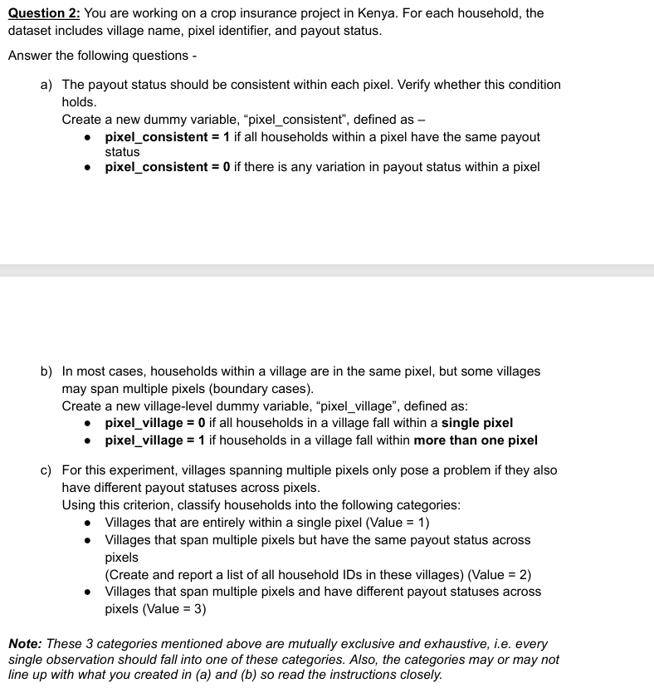

(Part a)
pixel_consi |
stent | Freq. Percent Cum.
------------+-----------------------------------
1 | 958 100.00 100.00
------------+-----------------------------------
Total | 958 100.00
The results shows that that payout status is fully consistent within pixels: all households within a given pixel have the same payout value. All 958 households are located in pixels with consistent payout status.

Part (b)

pixel_villa |
ge | Freq. Percent Cum.
------------+-----------------------------------
0 | 834 87.06 87.06
1 | 124 12.94 100.00
------------+-----------------------------------
Total | 958 100.00

For this part, I found that that 87.1% of households are located in villages that fall entirely within a single pixel, while 12.9% (remaining) are in villages that span multiple pixels

Part (c)

village_typ |
e | Freq. Percent Cum.
------------+-----------------------------------
1 | 834 87.06 87.06
2 | 50 5.22 92.28
3 | 74 7.72 100.00
------------+-----------------------------------
Total | 958 100.00

About 87% live in villages fully contained within a single pixel. Around 5% live in villages spanning multiple pixels where payout status is consistent across pixels. However, approximately 8% of households are in villages that span multiple pixels and experience differing payout statuses across pixel units

Question 3

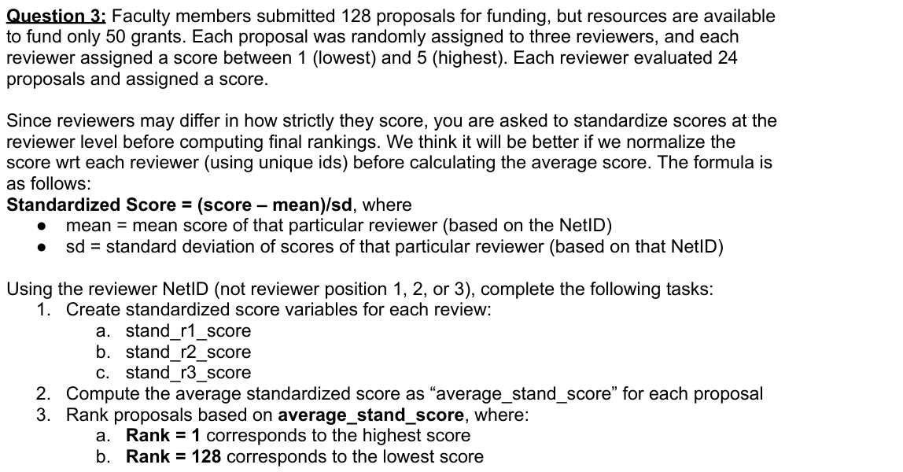

Part 1 (a) (b) (c)
To account for differences in how strictly reviewers assign scores, I standardized each reviewer’s scores at the reviewer level using the reviewer NetID. For each reviewer, I computed the mean and standard deviation of the scores they assigned, and then transformed each raw score into a standardized score using the formula (score − mean) / standard deviation. Steps and commands are in my do file

Part 2
I computed the average standardized score for each proposal by averaging the three reviewer-specific standardized scores. I believe, two proposals had missing reviewer information and therefore did not receive an average standardized scor, stata basically dropped those 2 values. This is what I got at the end
. summarize average_stand_score

Variable | Obs Mean Std. dev. Min Max
-------------+---------------------------------------------------------
average_st~e | 126 -.0070905 .5793816 -1.369347 1.047073

Part 3
I ranked proposals in descending order of their average standardized score, assigning rank 1 to the proposal with the highest average standardized score.
When I see the results I get 126 observations, and not 128 as I believe stata dropped two values as they were missing

Variable | Obs Mean Std. dev. Min Max
-------------+---------------------------------------------------------
rank | 126 63.5 36.51712 1 126

Question 4
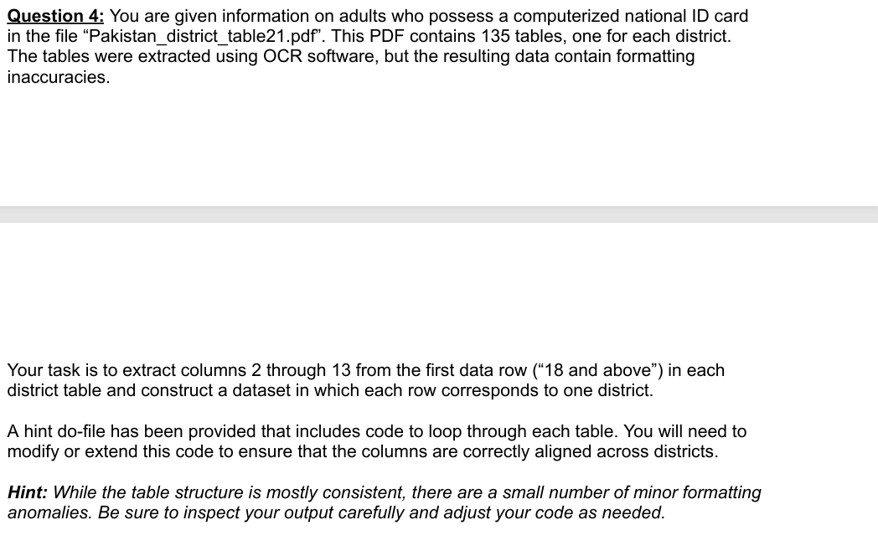
I looped over all 135 district tables in the excel and extracted columns 2 through 13 from the first data row (“18 and above”). Because the tables were generated via OCR, some values were missing or not reported in the original source. I cleaned the extracted data by converting non-numeric placeholders to missing values and verified column alignment using internal consistency checks. For all districts with complete information, totals were consistent with subgroup counts, indicating correct column alignment.

QUESTION 5
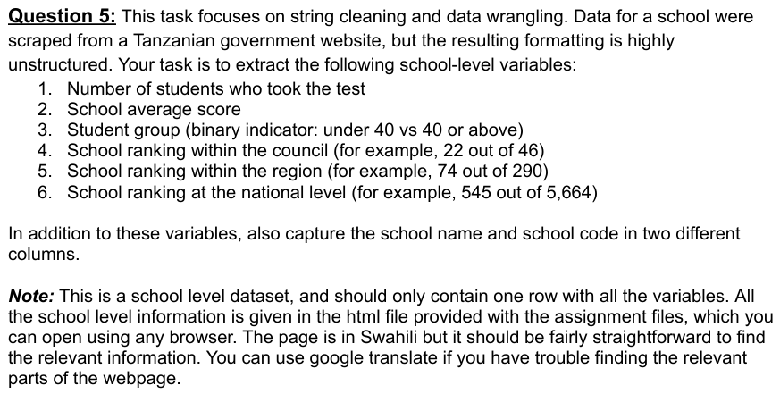
- 16 students took the examination.
- The school’s average score was 217.375.
- The school falls into the “under 40 students” group
- The school ranked 22 out of 46 schools within its council.
- The school ranked 74 out of 290 schools within its region.
- At the national level, the school ranked 545 out of 5,664 schools.
- I believe the school’s name is ALBEHIJE PRIMARY SCHOOL, with school code PS0101114.

