Anurita Srivastava
Assignment Stata 1

Q.1
- 177.4776
- .4423495
- 3.60144

| school attend~e |
|-------------------------------------------|
1. | Joseph Darby Middle School 177.4408 |
2. | Mahatma Ghandi Middle School 177.3344 |
3. | Malala Yousafzai Middle School 177.5479 |
+—————————————————————+

Q.2
a) Yes
pixel_consi |
stent | Freq. Percent Cum.
------------+-----------------------------------
1 | 958 100.00 100.00
------------+-----------------------------------
Total | 958 100.00

b)
pixel_village | Freq. Percent Cum.
-----------------------+-----------------------------------
Single pixel village | 834 87.06 87.06
Multiple pixel village | 124 12.94 100.00
-----------------------+-----------------------------------
Total | 958 100.00
c) 262 unique IDs

+-----------+
| hhid |
|-----------|
1. | 110100103 |
2. | 110100403 |
3. | 110100504 |
4. | 110100906 |
5. | 110101004 |
|-----------|
6. | 110101208 |
7. | 110101302 |
….
…
…
258. | 162835809 |
259. | 162835912 |
260. | 162836010 |
|-----------|
261. | 131336109 |
262. | 131336211 |
+-----------+

Q.3
a) Variable | Obs Mean Std. dev. Min Max
-------------+---------------------------------------------------------
stand_r1_s~e | 128 .0096909 1.018803 -2.887616 1.408524
stand_r2_s~e | 128 -.0309361 1.023669 -2.744481 1.408524
stand_r3_s~e | 128 .0212454 .900148 -2.842069 1.200618

b) Variable | Obs Mean Std. dev. Min Max
-------------+---------------------------------------------------------
average_st~e | 128 4.60e-08 .6301353 -2.177107 1.095271

c) unique rank |
of |
(-average_s |
tand_score) | Freq. Percent Cum.
------------+-----------------------------------
1 | 1 0.78 0.78
2 | 1 0.78 1.56
3 | 1 0.78 2.34
4 | 1 0.78 3.12
5 | 1 0.78 3.91
6 | 1 0.78 4.69 ….. so on
…..

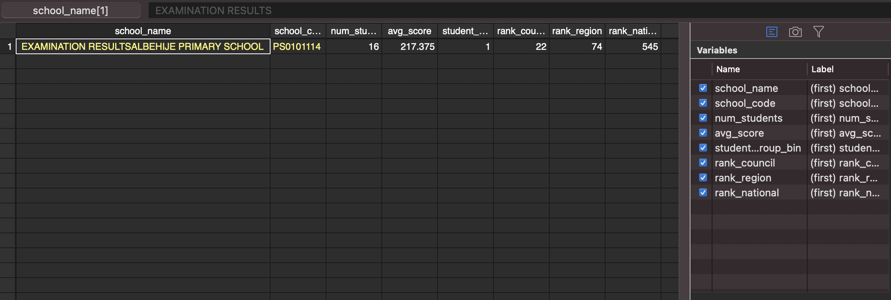
Q.5

