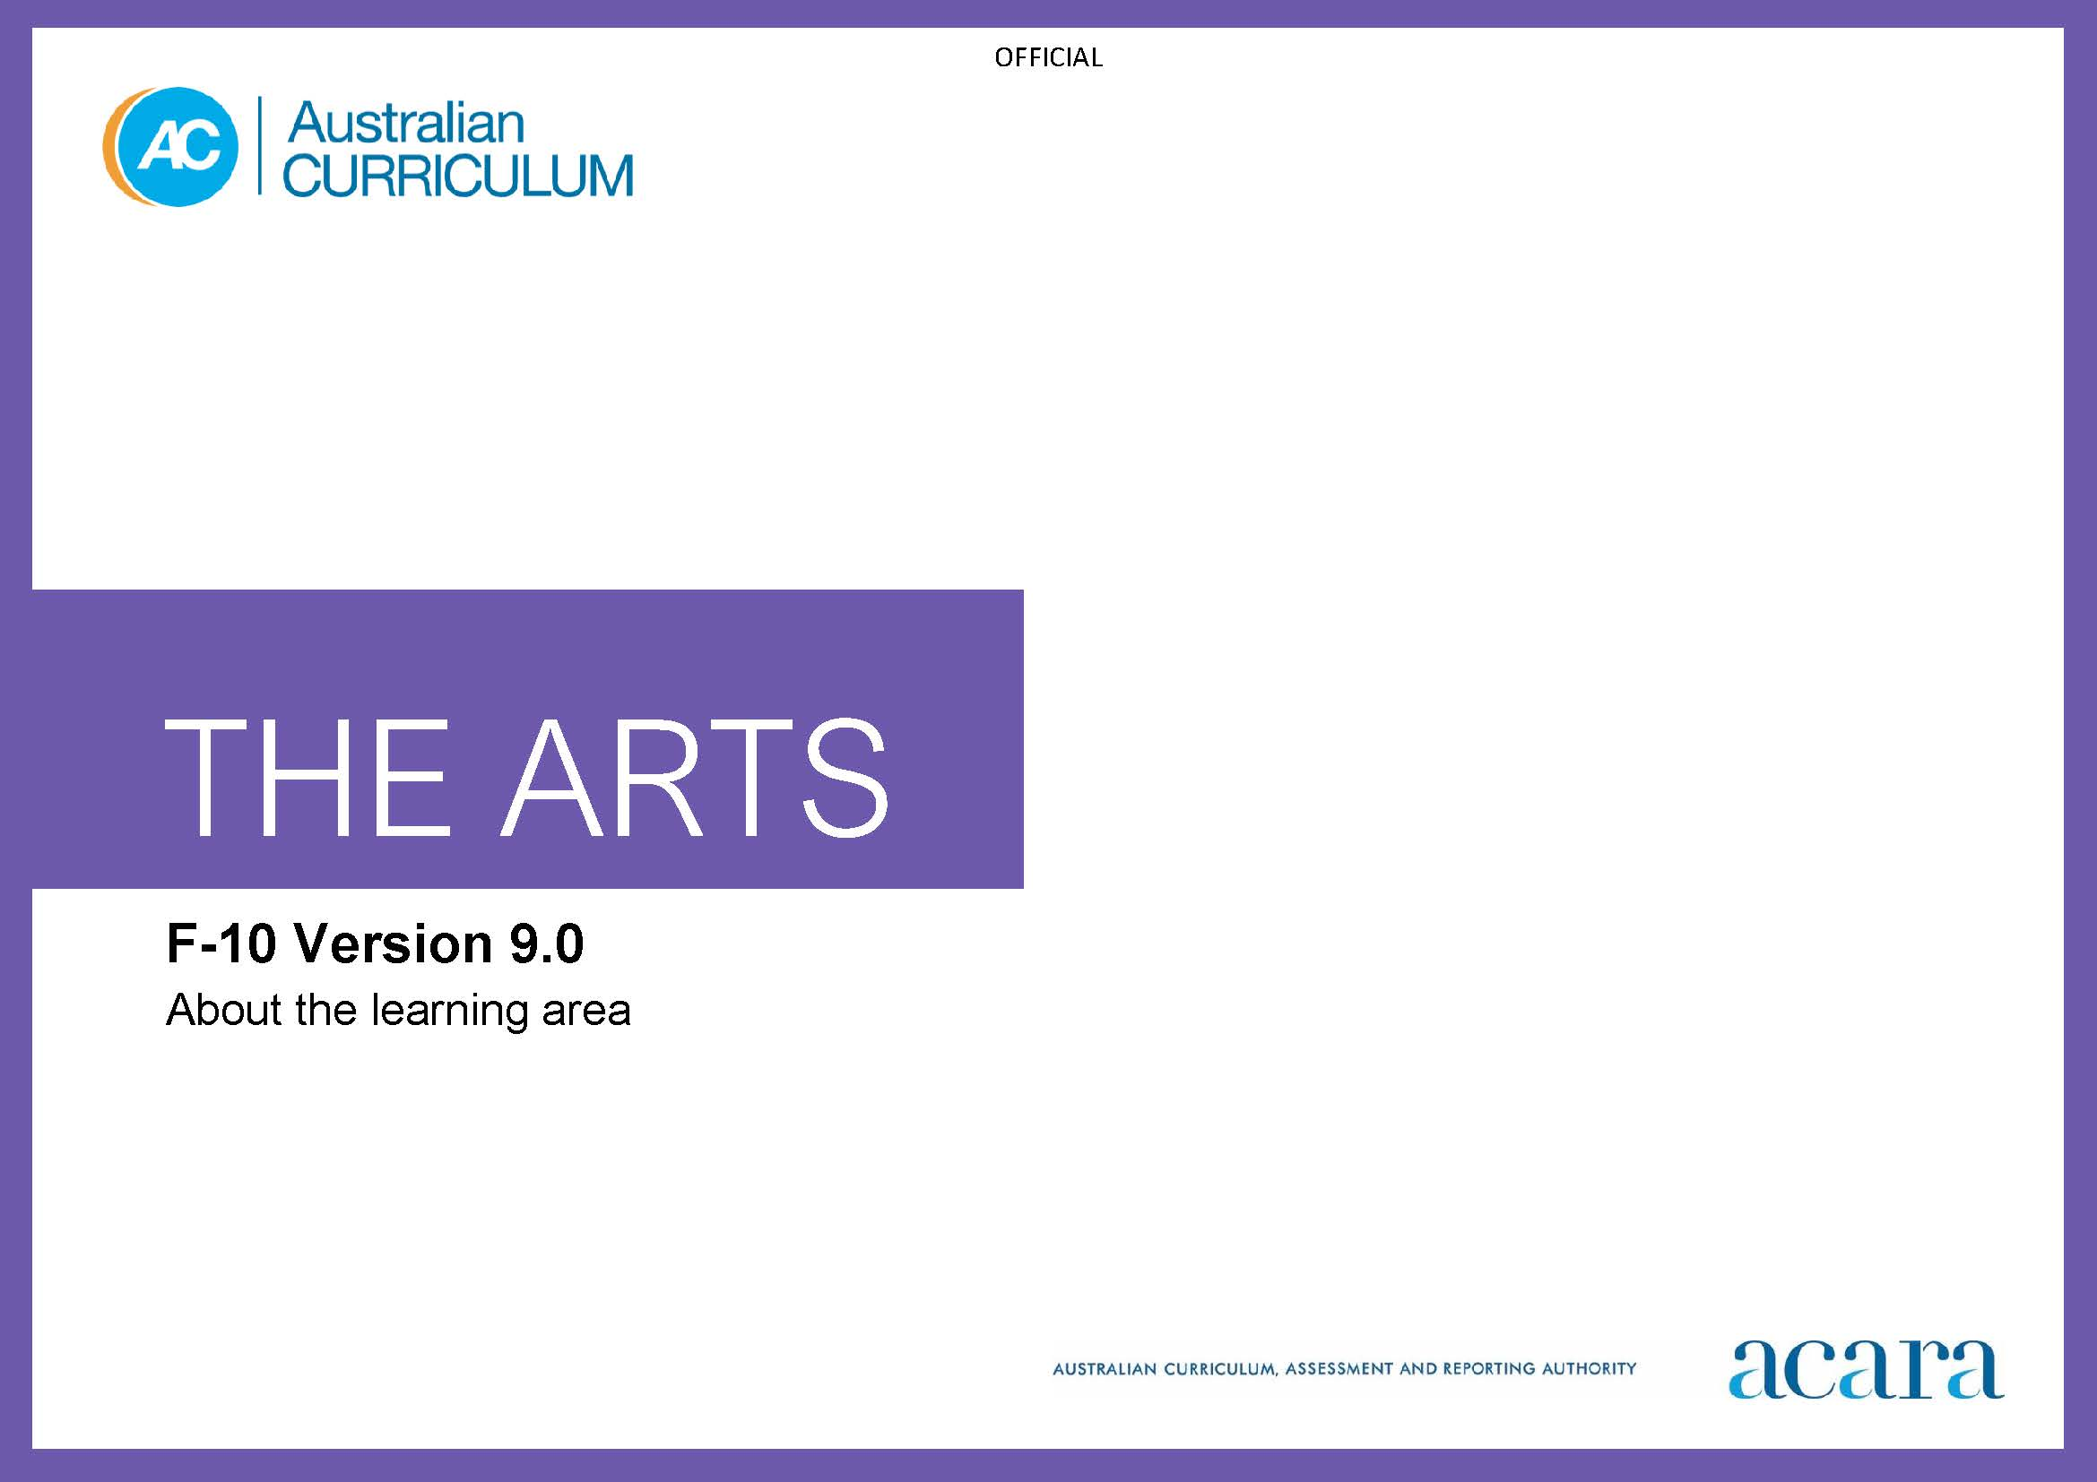

Copyright and Terms of Use Statement
© Australian Curriculum, Assessment and Reporting Authority 2022
The material published in this work is subject to copyright pursuant to the Copyright Act 1968 (Cth) and is owned by the Australian Curriculum, Assessment and Reporting Authority (ACARA) (except to the extent that copyright is held by another party, as indicated).
The viewing, downloading, displaying, printing, reproducing (such as by making photocopies) and distributing of these materials is permitted only to the extent permitted by, and is subject to the conditions imposed by, the terms and conditions of using the ACARA website (see, especially, clauses 2, 3 and 4 of those terms and conditions). The terms and conditions can be viewed at https://www.acara.edu.au/contact-us/copyright

TABLE OF CONTENTS
F–10 AUSTRALIAN CURRICULUM: THE ARTS 4
About the arts Learning Area 4
Introduction 4
Rationale 4
Aims 5
Structure 5
Key considerations 8
Key connections 13
Resources 18

F–10 AUSTRALIAN CURRICULUM: THE ARTS

About the arts Learning Area

Introduction
The Australian Curriculum: The Arts comprises 5 subjects:
- Dance
- Drama
- Media Arts
- Music
- Visual Arts.
The Arts curriculum is written on the basis that all students will study The Arts from Foundation to the end of Year 8. State and territory school authorities or individual schools will determine how the curriculum is implemented. There is flexibility for schools to develop teaching programs that may involve integrated units within The Arts and/or across the curriculum. Schools may also form partnerships with the arts industry to complement provision of The Arts curriculum.
- In primary school, the curriculum has been developed to allow for the study of the 5 arts subjects from Foundation to Year 6.
- In Years 7 and 8, the curriculum has been written to allow students to experience one or more arts subjects in depth.
- In Years 9 and 10, the curriculum is written to allow students to specialise in one or more arts subjects.

Rationale
The arts are as old as humanity. They are part of every culture and central to the diverse and continuing cultures of First Nations Australians. Through the arts, people share stories, ideas, knowledge and understanding. The arts engage our senses and give us ways to imagine, celebrate, communicate and challenge ways of knowing, being, doing and becoming.
Participating in quality arts experiences and practices enriches our social and emotional wellbeing. It fosters development of our imagination and enables us to reach our creative and intellectual potential. The distinctive languages, knowledges and practices of each arts subject in the Australian Curriculum enable learners to play, explore, question, challenge and imagine new possibilities as they create, embody, design, represent, collaborate and communicate ideas, emotions, observations and experiences. The arts foster rich cross-curriculum opportunities for learners as they grow in their understanding of self and others, and as they make sense of, interpret and respond to their real and imagined worlds.
Rich in tradition, the arts play a major role in the development and expressions of diverse cultures and communities, locally, nationally and globally. The exploration of cultures and histories through Arts learning strengthens understanding of Australia’s cultural diversity and develops critical intercultural understandings to inform decision-making and aesthetic choices. Students communicate meaningful ideas in conventional and innovative arts forms. They use arts knowledge, practice and understandings to learn and make meaning as artists and as audiences, taking opportunities to engage with arts organisations, creative industries and arts professionals.
Through the arts, students learn to express their ideas, thoughts, questions, understandings and opinions. They develop aesthetic knowledge and learn that the creative and critical processes of each Arts subject are essential to learning in, about and through The Arts.
The arts are core to the development of creative, confident, compassionate and resilient individuals who can think and reflect critically, celebrate and challenge ideas, people and events, and work towards making a difference in sustaining and reimagining their own and their communities’ futures.

Aims
The Arts aims to develop students’:
- creativity, critical thinking, aesthetic knowledge and understanding about arts practices
- knowledge and skills to imagine, observe, express, respond to and communicate ideas and perspectives in meaningful ways
- use of available resources and materials including digital tools
- empathy for multiple perspectives and understanding of personal, local, regional, national and global histories and traditions through the arts
- engagement with the diverse and continuing cultures, arts works and practices of First Nations Australians
- understanding of local, regional, national and global cultures, and their arts histories and traditions, through engaging with the worlds of artists, arts works, audiences and arts professions.
These aims are extended and complemented by specific aims for each subject in The Arts.

Structure
The Arts is presented in 2-year band levels from Year 1 to Year 10, with Foundation being presented as a single year.
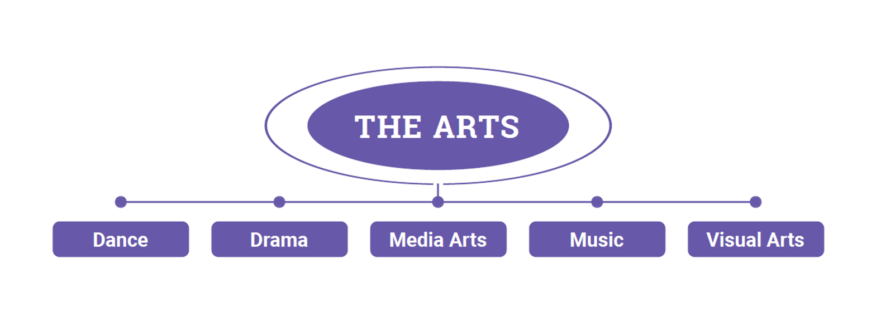
Figure 1: The Arts subjects
In Dance, students use the body to communicate and express meaning through purposeful movement. Dance practice integrates choreography, performance, and responding to dance and dance making. Students experience and explore dance created and performed across diverse contexts, styles and forms, and build understanding of how dance uses the body and movement to communicate ideas and meaning.
In Drama, students create, perform and respond to drama as artists and audiences. They learn to use, manage and manipulate the elements and conventions of drama across a range of dramatic forms and styles. Students learn in, through and about drama as they create dramatic action and communicate dramatic meaning.
In Media Arts, students use images, sound, text, interactive elements and technologies to creatively explore, produce and interpret stories about people, ideas and the world around them. They explore the diverse cultural, social and organisational influences on media practices, and draw on this understanding when producing and responding to media arts works.
In Music, students listen to, compose and perform music from a diverse range of styles, cultures, traditions and contexts. They create, organise, manipulate and share sounds in time and space, and critically analyse music. Music practices are aurally based and focus on developing and applying knowledge and skills through sustained musical engagement and experiences.
In Visual Arts, students learn in, through and about visual arts practices, including the fields of art, craft and design. They experience and explore visual artworks created by artists working in diverse contexts, styles and forms, and build understanding of the significance and impact of visual arts practice and culture for themselves and local and global communities.
In The Arts, in Foundation to Year 6, achievement standards are provided for each subject and for the learning area. The learning area achievement standard may be useful when schools are teaching integrated Arts programs and help with manageability of reporting in the primary years.
Strands
In The Arts, content is organised in each of the 5 subjects under 4 interrelated strands. The 4 strands are:
- Exploring and responding
- Developing practices and skills
- Creating and making
- Presenting and performing.
Exploring and responding
In this strand students learn as artists and as audience. They explore:
- ideas, practices, works and contexts for the arts in the lives of individuals and groups across cultures, times, places and communities
- the diversity of how, where and why people create, make, perform, present and respond across arts forms, and the roles that the arts play in lives, cultures and communities
- the diversity and significance of the arts for First Nations Australian Peoples, cultures and communities
- ways in which the arts communicate cultural and aesthetic knowledge, purpose, meaning and emotion
- ways in which the arts develop empathy and understanding of multiple perspectives, across personal, local, regional, national and global contexts.
They respond using arts practices and forms, language, imagery, sounds, movement and/or digital tools.
Developing practices and skills
This strand is about developing practices and skills in and across Arts subjects through play, imagination, experimentation and creative and critical thinking. As artists and as audiences, students develop creative and critical practices including:
- creative skills for
- using and manipulating the elements, principles, conventions and/or processes of arts forms
- using available materials and technologies to develop and communicate ideas, perspectives and/or meaning
- critical skills in observing, reflecting, analysing, evaluating and/or documenting their own and others’ arts-making practices, using language and/or embodied practices.
Creating and making
In this strand, as artists, students apply subject-specific and multi-arts creative processes. Students create and make:
- individual and/or collaborative work using available resources/materials in diverse existing, emerging and innovative forms, styles and/or genres
- new work, which may be refined and realised, or may be presented as a work in progress
- interpretations of work created by others and interpretations of their own work as performers; interpreting involves informed observation, analysis, reflection and evaluation.
Presenting and performing
This strand is about artists sharing work and ideas with audiences in ways that are appropriate to the work and the artist’s intentions. Presenting includes exhibiting or screening. Students:
- share their work using available spaces, materials, technologies and/or digital tools
- plan, select, design and rehearse their presentations and performances
- employ technical, expressive and performance skills (as appropriate)
- observe and, as appropriate, participate in interactions between artists and audiences.

Key considerations
The big ideas central to The Arts curriculum are:
- all students have creative and expressive potential
- making and responding are interwoven creative processes that happen through the practices of The Arts subjects
- creative processes are flexible and cyclical; they involve doing and knowing
- artists learn from work they experience, and they are an audience for their own work
- exploring, investigating, reflecting on and interpreting their own and others’ works, cultures, worlds, ideas and contexts allows students to learn in, through and about The Arts
- aesthetic knowledge is developed through embodied and critical engagement across cognitive, sensory and physical domains
- critical engagement with arts works and practices develops empathy and contributes to the lives of people, cultures and communities.
Learning through the practices of Dance, Drama, Media Arts, Music and Visual Arts
Arts learning involves deep engagement through the continuing and emerging practices of The Arts subjects. Understanding how the practices of each subject are being used in dynamic and innovative ways across cultures and communities supports students’ understanding of how they can contribute to their world. Schools make decisions about the subjects and forms students engage in within their Arts learning. For example, students may explore and create:
- arts works that exist in physical, digital or virtual spaces
- individual or collaborative arts works
- arts works that use materials and technologies in traditional and/or innovative ways
- arts works in traditional, conceptual, site-specific, hybrid, multimodal or trans-disciplinary forms
- arts works where the audience is a co-creator with the artist.
Creative processes
Creative processes are flexible and involve cyclical stages. The order of these stages may vary, and each can be revisited and repeated as needed. Stages in a creative process can include exploration, response, experimentation, skill/process development, transformation (literal or abstract), analysis, creation, reflection, presentation, performance, interpretation, communication and/or sharing.
Contexts
The Arts provides flexibility for teachers to plan learning that enables students to engage with examples of arts practice from diverse cultures, times, places and/or other contexts. This can include examination of works and practices that are representative of past, current and emerging arts traditions, forms and genres/styles. For example, learning may focus on:
- artists who represent a diverse range of cultures, genders, contexts, times, places and/or settings; such as living artists including those from local, regional or national communities; artists whose work is celebrated; artists who hold a place of significance within a culture or community; emerging artists and/or those whose work is innovative and/or challenging
- artists who work with a diverse range of media, materials and techniques, equipment and instruments, technologies, genres/styles and/or forms
- artists, activists and/or advocates whose practice focuses on using the arts to take action to address current issues; such as social, environmental and/or political issues
- artists who work individually and/or collaboratively, within and/or across disciplines, locally and/or globally
- examples of the diverse roles the arts play for people, cultures and communities; such as arts works, events, traditions and/or practices that are significant, celebrated and/or controversial.
Protocols for engaging First Nations Australians
When planning teaching activities involving engagement with First Nations Australians and/or arts works or cultural expressions created by First Nations Australians, teachers should follow protocols that describe principles, procedures and behaviours for recognising and respecting First Nations Australians and their intellectual and cultural property.
Teachers should use approved resources, appropriate to their location, such as those that may be provided by their state or territory school system, or First Nations Australians education consultative groups, or other protocols accredited by First Nations Australians; for example, information about Indigenous Cultural and Intellectual Property (ICIP) and protocols for respecting these rights in Australia is available on the Australia Council for the Arts website.
While the Australian Curriculum uses the terms “First Nations Australians” and “Aboriginal First Nations Peoples”, there may be other terms that First Nations Australians of a particular area or location prefer. It is important to use the terms preferred in a particular area or location.
Meeting the needs of diverse learners
The Australian Curriculum values diversity by providing for multiple means of representation, action, expression and engagement and allows schools the flexibility to respond to the diversity of learners within their community.
All schools have a responsibility when implementing the Australian Curriculum to ensure that students’ learning is inclusive, and relevant to their experiences, abilities and talents.
For some students with diverse languages, cultures, abilities and talents it may be necessary to provide a range of curriculum adjustments so they can access age-equivalent content in the Australian Curriculum and participate in learning on the same basis as their peers. Adjustments to the delivery of The Arts may involve but are not limited to:
- providing multi-sensory visual, auditory, tactile, and/or kinaesthetic experiences and resources
- using resources and strategies such as picture cues or illustrative signs and labels for words such as key-subject terms, or steps in a process
- providing modified arts tools or accessible equipment or using approaches that enable students to participate in arts-making activities
- acknowledging equivalent terminology; for example, cultural or geographic differences in terminology
- designing open-ended tasks that provide flexibility and can be completed at different levels of complexity
- showcasing the practice of artists/performers who have adapted “typical” practice to suit their needs or whose work reflects aspects of their life, such as physical or mental health.
Materials, technologies and forms
The Arts gives teachers flexibility to plan learning activities that focus on arts works, artists, practices and contexts from diverse cultures, times and places. Teachers also make decisions about which forms, stimulus and other materials, digital tools and other resources will be used in arts learning.
The curriculum is designed to facilitate an inclusive approach that:
- recognises the diverse physical, sensory or cognitive abilities students use to experience arts works and practice
- allows students to learn in a culturally inclusive and supportive environment free from prejudice and discrimination. Culturally inclusive learning recognises the language, culture, practices, rituals, knowledges and beliefs of each student and their families.
- uses available resources including digital tools.
Immersive technologies
When using immersive technologies such as Augmented Reality (AR), Virtual Reality (VR), Mixed Reality (MR) or Extended Reality (XR), for Arts learning, consideration must be given to the manufacturer’s guidelines. Teachers should consider the physical, cognitive, linguistic, emotional, social and moral developmental stage of learners before using immersive technologies in their classrooms. The eSafety Commissioner provides explicit advice on the risks of immersive technologies use in their position statement, https://www.esafety.gov.au/about-us/tech-trends-and-challenges/immersive-tech.
Viewpoints
Viewpoints are an inquiry tool for considering the arts from multiple perspectives, as artist or as audience. Students use questions based on Viewpoints to initiate and guide their explorations and responses, creative and critical practices, evaluation and reflection, and to inform decisions about performance/presentation of their work. For example, they may develop questions based on Viewpoints to:
- frame wondering, reasoning and reflecting
- explore ideas and make decisions
- explore and develop empathy for multiple perspectives
- express and celebrate identities, ideas and meaning
- think deeply about their own arts works and art created by others.

Viewpoints provide perspectives and contexts such as:
- Personal and imaginative – fostering students’ agency and voice through reflecting on ideas and putting thoughts into action; reflecting on and responding to their own art making; observing, exploring and responding to arts works and practices
- Cultures and worlds – thinking as artists and as audience about contexts for arts practice; considering, for example, social, cultural, historical and/or environmental ideas and meanings that arts works and/or experiences represent and/or communicate
- Conventions and processes – developing practices, acquiring knowledge, reflecting, creating, developing language to communicate ideas, exploring techniques, responding to ideas and materials before, during and after arts making and/or critiquing.
As they create and respond to arts works and experiences, students develop questions to explore ideas, perspectives and/or meaning. They think and make decisions as artists and as audience. Questions based on Viewpoints encourage students to consider a range of perspectives and to think deeply about their own arts works and art created by others. The sample questions in Table 1 can be adapted to suit specific learning contexts
Table 1: Sample Viewpoint questions
Viewpoints
Personal and imaginative | Cultures and worlds | Conventions and processes
- Am I the artist?  - Who made this artwork?  - What do I want to know or notice about my artwork?  - What do I want others to know about my artwork?  - Who is the audience for this artwork?  - How can I shape my artwork to share my point of view?  - Why is this artwork working out successfully? What am I doing creatively?  - How do I feel about …?  - What would happen if …?  - Who can I discuss my next step with?  - How can I …? What will I need to think about?  - What does this work mean to me? How does it represent my identity? | - What are artworks?  - Why do artists make work? For whom?  - What is this artwork about?  - What do I know about the cultural context for this work? What do I want to know? What do I need to know?  - What are the cultural responsibilities of the artist who made this work?  - Is this work challenging stereotypes or ideas?  - Where, why and how was this work originally made and presented to audiences?  - What is this work saying about social structures such as those associated with identity, religion, politics, gender or class?  - What was happening in the world when this work was being made?  - What about this work situates it as being created in a particular time or place?  - How does this work communicate with audiences?  - How does our understanding of a culture or community help us communicate effectively?  - Is my understanding of the work similar or different to understandings of other audiences? How? Why?  - When I create or perform a work, what is my cultural message?  - How does this work relate to my culture? To my life?  - How can we ensure that artworks are preserved for future generations?  - How can we use the arts to inspire positive action and change?  - What do we mean when we say that arts works speak across time and place? | - How am I planning to communicate my message through my work?  - What would I like people to feel as they experience my work?  - What do I need to know about this material?  - Is there a skill I need to practise before I begin creating my work?  - What do I need to know about the conventions of this style or form? Am I planning to use …?  - What content am I planning on including in my performance?  - Is this all going according to plan?  - What alterations have I made along the way?  - Did someone give me an idea or some input while I was creating this work? How can I /should I acknowledge their contribution?  - What am I learning about this technique / process / form / material ...?  - Am I pleased with the outcome of my art making / performance?  - How does my work show my skill to others?  - Does my work communicate my original ideas? What changed during the process? Why did I decide to make those changes?  - What did I learn about … by making this work, presenting this performance …?

Key connections
General capabilities
General capabilities equip young Australians with the knowledge, skills, behaviours and dispositions to live and work successfully. General capabilities support and deepen student engagement with learning area content and are best developed within the context of learning areas.
Opportunities to develop general capabilities in learning area content vary. In addition to Literacy and Numeracy which are fundamental to all learning areas, The Arts provides opportunities to connect with each of the other general capabilities. General capabilities are identified in content descriptions when they are developed or applied through Arts content. They are also identified in content elaborations when they offer opportunities to add depth and richness to student learning.

Literacy
In The Arts, students use literacy to develop, apply and communicate their knowledge and skills as artists and as audiences. Through arts learning students enhance and extend their literacy skills as they create, compose, design, analyse, comprehend, discuss, interpret or evaluate their own and others’ arts works. Each subject in The Arts requires students to learn and use specific terminology with increasing complexity and sophistication as they move through the curriculum. Students learn that Arts terminology is dynamic and flexible, can be symbolic, is not always expressed through words and varies according to context.
Numeracy
In The Arts, students select and use relevant numeracy knowledge and skills to plan, design, make, interpret, analyse and evaluate arts works. Across The Arts subjects, students recognise and use: number to calculate and estimate; spatial reasoning to solve problems involving space, patterns, symmetry, 2D shapes and 3D objects; scale and proportion to show and describe positions, pathways and movements; and measurement to explore length, area, volume, capacity, time, mass and angles. Students work with a range of numerical concepts to organise, analyse and create representations of data such as diagrams, charts, tables, graphs and motion capture, relevant to their own or others’ arts works.
Digital Literacy
Digital Literacy can be developed in each of The Arts subjects through:
- experiencing arts works that are created or accessed using digital tools
- making arts works using available digital devices, tools or production techniques
- using digital tools and online or networked spaces and environments for sharing and engaging with arts works, artists and audiences
- using digital tools to develop skills and practice (individual and collaborative).
Critical and Creative Thinking
Students develop critical and creative thinking as they make and respond to arts works, ideas and practices in different contexts. As artists, students develop questions, imagine, consider various options and alternatives and make decisions, acting on possibilities when interpreting and generating ideas. As audiences, students think critically and creatively about their work and the work of other artists. They reflect, analyse, critique and evaluate their thinking about arts works and the roles that The Arts play in the lives of people, cultures and communities.
Personal and Social capability
In The Arts, students develop personal and social capability as they make and respond to arts works, ideas and practices. When working with others, students develop social management skills and empathy for multiple perspectives as they communicate effectively, collaborate, make decisions that meet the needs of themselves and others, and demonstrate leadership as they create arts works. As artists and as audiences, students develop self-awareness and self-management skills when they set goals, work collaboratively, reflect upon various arts practices, and build resilience, adaptability, and perseverance while thinking about their work and the work of other artists.
Intercultural Understanding
Students develop intercultural understanding as they consider the influence and impact of cultural identities and traditions on the practices and thinking of artists and audiences. As artists, students develop empathy by exploring their own cultural identities and those of others, learning to appreciate the diversity of cultures and contexts in which artists and audiences live. As audiences, students engage with arts works from diverse cultural sources, and are able to consider accepted roles, images, objects, sounds, beliefs and practices in new ways. They take opportunities to use their arts practice to respond to biases, stereotypes, prejudice and discrimination.
Ethical Understanding
Students develop ethical understanding as they explore and respond to arts works that present, examine and/or challenge values, rights and responsibilities, and ethical norms. As artists students can create work that explores ethical issues or communicates a personal ethical outlook. Students may use their arts practice to help them manage context, conflict or uncertainty.
Cross-curriculum priorities
Cross-curriculum priorities support the Australian Curriculum to be a relevant, contemporary and engaging curriculum that reflects national, regional and global contexts. Cross-curriculum priorities are incorporated through learning area content; they are not separate learning areas or subjects. They provide opportunities to enrich the content of the learning areas, where most appropriate and authentic, allowing students to engage with and better understand their world.
Opportunities to apply cross-curriculum priorities to learning area content vary. All 3 cross-curriculum priorities are relevant to The Arts curriculum. They are embedded in content descriptions where they are core to the delivery of the content in The Arts. They are also identified in content elaborations where they offer opportunities to add depth and richness to student learning.
Aboriginal and Torres Strait Islander Histories and Cultures
Through The Arts, students learn about the central place of the arts in the oldest continuous living cultures in the world. They explore how First Nations Australians recognise and communicate connections to Country/Place through cultural expressions that draw on belief systems connected to the lands, seas, skies and waterways.
Students learn about the distinctiveness and diversity of First Nations Australians’ cultural practices and expressions that represent unique ways of being, knowing, thinking and doing. They learn how First Nations Australians are using materials, forms and technologies in innovative ways to create arts works that celebrate, challenge and communicate ideas and perspectives. Students explore ways in which First Nations Australians combine movement, sound, language and visual content to tell stories and share knowledge. They learn that arts works that carry cultural knowledge are known as cultural expressions: “expressions that result from the creativity of individuals, groups and societies, and that have cultural content”. UNESCO, 2017
Through The Arts curriculum, students learn that First Nations Australian cultures have internationally enshrined rights to ensure that these diverse cultures can be maintained, controlled, protected and developed. They also learn about rights relating to Indigenous Cultural and Intellectual Property and how these rights can be protected through respectful application of protocols.
As they examine ways in which First Nations Australians continue to practise and revitalise their cultures, students also learn about the impact of historical and contemporary events on their cultures. Students learn about the significant and ongoing contributions of First Nations Australians to Australian identity and how these contributions are acknowledged locally, nationally and globally. Showcasing and celebrating these contributions to Australia’s cultural life allows students to engage with the voices of First Nations Australians. It also encourages collaboration with artists, creative practitioners and knowledge holders from First Nations Australian communities.
Asia and Australia’s Engagement with Asia
In The Arts, students can examine arts forms and practices that reflect the rich and diverse cultures, belief systems and traditions of the Asia region. They can explore traditional, contemporary and emerging media, forms and practices, and relationships between artists and audiences across Australia and Asia. They consider the local, regional and global influence of arts and cultural practices created and experienced across the region. Students can also investigate the role of the arts in developing, maintaining and transforming cultural beliefs and practices, and communicating an understanding of the rich cultural diversity of the Asia region. They reflect on the intrinsic value of these arts works and artists’ practices as well as their place and value within contexts and communities.
Sustainability
Through The Arts, students can explore how ideas and perspectives about issues such as living sustainably, equity and social justice are represented in arts works from all times and places. Engaging with these arts works and practices builds students’ ability to appreciate diverse world views and provides opportunities for them to explore the importance of the arts to cultural sustainability. As artists, students can create work individually or collaboratively to communicate their ideas about sustainable futures and/or to contribute to community action for sustainable futures. Students are encouraged to explore how artists’ practices change over time in response to, for example, ideas and the availability of materials or technological innovation. They consider how these changes contribute to the maintenance and/or revitalisation of culturally-driven arts practice. They are encouraged to consider sustainable practice when selecting and using materials and processes to create their work.

Learning areas
Each subject in The Arts provides opportunities to integrate or connect content to all other learning areas.
The Arts and English
The Arts and English share a focus on communicating ideas and perspectives in oral, aural, written and visual modes, with an awareness of purpose and audience. Both learning areas develop students’ speaking, listening, visual literacy and writing skills as they individually or collaboratively develop, create and share their work.
The Arts and Humanities and Social Sciences
Through The Arts and Humanities and Social Sciences students explore and share stories, ideas and understandings about culture, identity and relationships. They develop respect and empathy for diverse perspectives and ways of seeing the world. As artists, students can explore ideas and perspectives relevant to the themes and issues that they encounter through Humanities and Social Sciences.
The Arts and Languages
The Arts and Languages share a focus on the communication of stories, ideas, perspectives and cultures. Both learning areas help students to explore relationships between people, cultures and identities, and how these are exemplified in and through artistic and linguistic practices and behaviours.
The Arts and Technologies
There are similarities and connections between aspects of the Design and Technologies curriculum and each of The Arts subjects. Some connections occur through use of materials such as fabrics and fibre to create arts works and/or designed products. Other connections occur through use of design processes typically in forms such as graphic, sonic or kinaesthetic design. Technologies such as 3D printing or modelling can be used to create arts works or production elements; for example, projections/video and/or use of immersive technologies.
The Digital Technologies curriculum focuses on using digital tools and systems to create solutions. In each of The Arts subjects, students can use digital tools and systems to create works in traditional and emerging forms. In The Arts, students may use skills and knowledge learnt through Digital Technologies to develop their arts practice. For example, they might use programming to create or manipulate patterns and algorithms, images, songs, text, speech/language, or movement sequences. Different digital tools give students a variety of levels of creative control.
The Arts and Mathematics
The Arts and Mathematics share understandings about pattern, measurement and spatial reasoning. In The Arts this knowledge is used for creating and exploring arts works. Mathematics and The Arts both give students opportunities to learn about natural and constructed environments through observation and modelling. Students can use movement, sound, language, and/or visual content in conventional and innovative arts forms to communicate mathematical understandings.
The Arts and Science
The Arts and Science each allow students to learn about, respond to and make sense of the world. As artists, students can use scientific knowledge to create arts works in conventional and innovative arts forms. Scientists and artists work collaboratively to communicate scientific understandings.
The Arts and Health and Physical Education
The Arts and Health and Physical Education both allow students to develop self-awareness and explore personal and social identities and relationships. The 2 learning areas encourage lifelong participation through engagement, and taking action across communities and environments. Students’ movement capabilities are developed through Dance, Drama, Music and Health and Physical Education.

Resources
A scope and sequence representation of the curriculum, the glossary, and comparative information about Version 8.4 and Version 9.0 are available as a download from the Australian Curriculum Version 9.0 website.
Support Resource exploring examples of knowledge and skills in The Arts
There is a support resource providing examples of knowledge and skills in The Arts to assist teachers to unpack the curriculum. This resource includes examples of Viewpoint questions to ask, and a sequence for the introduction and development of knowledge and skills in each Arts subject. These documents are available as downloads.

