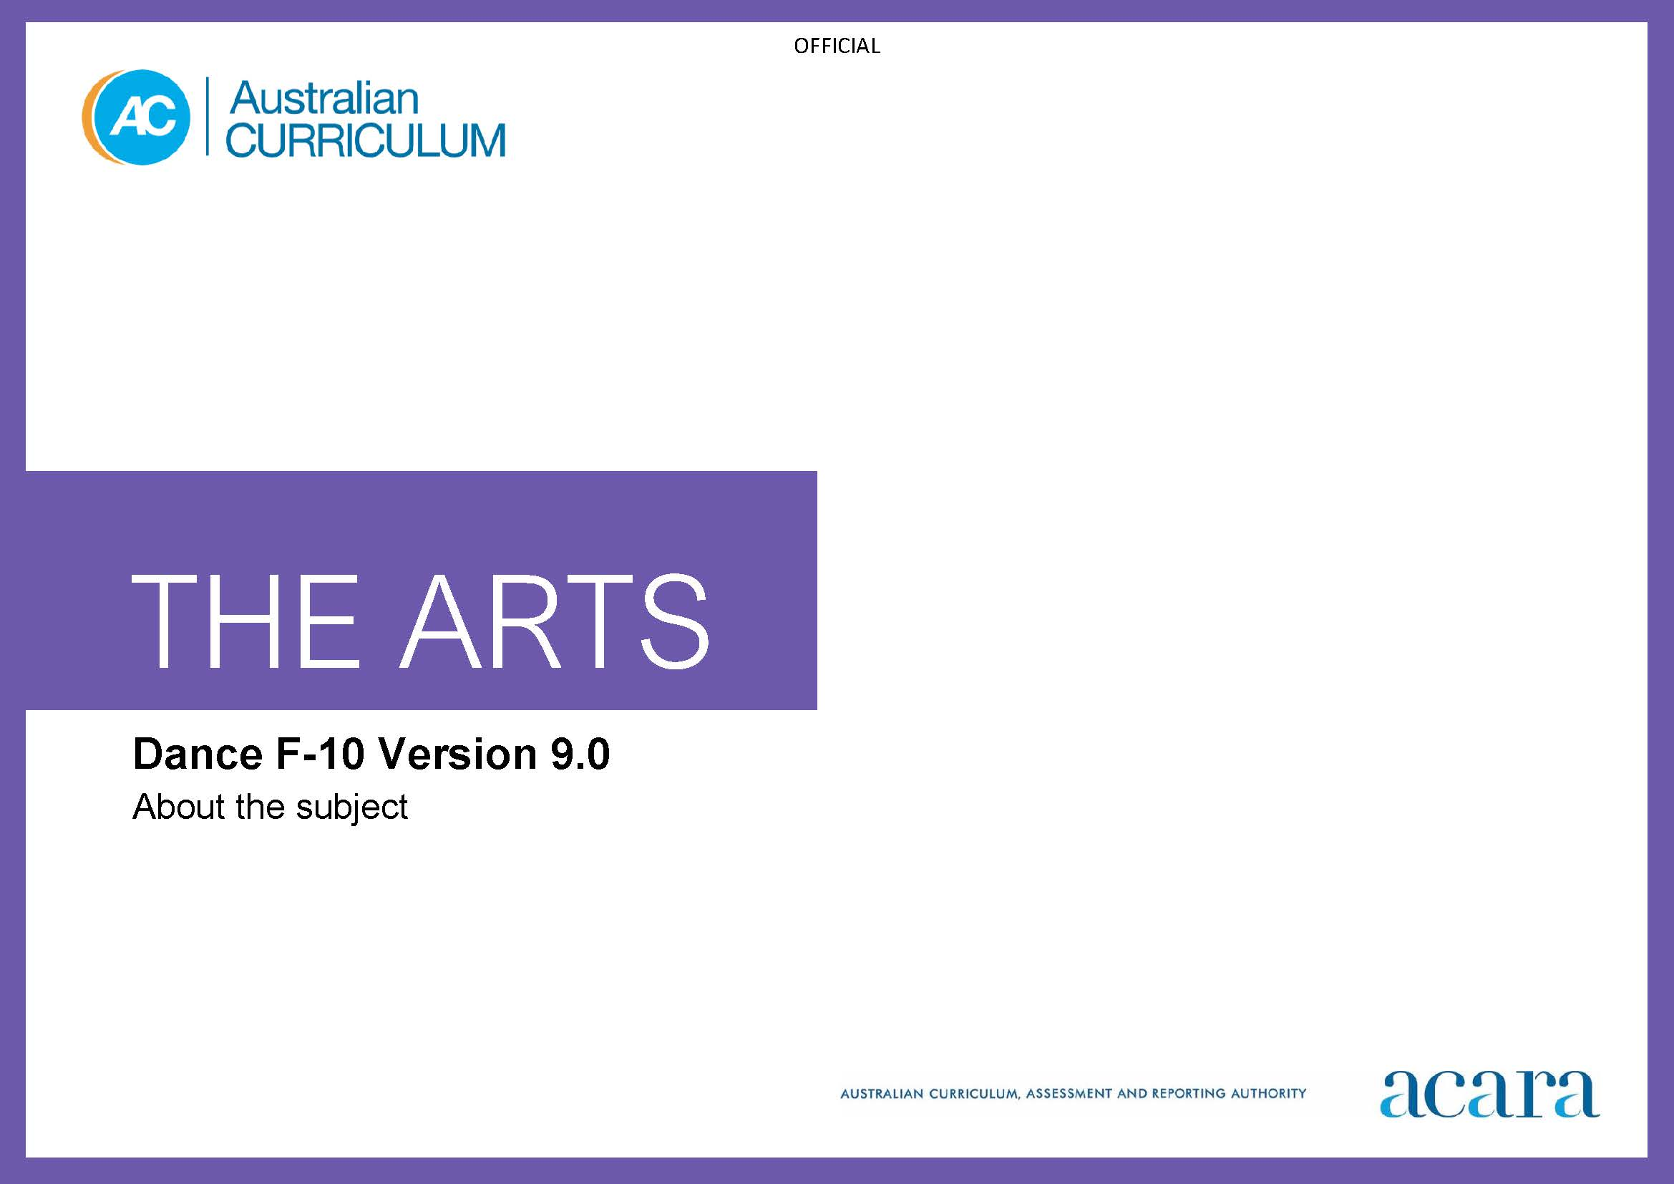

Copyright and Terms of Use Statement
© Australian Curriculum, Assessment and Reporting Authority 2022
The material published in this work is subject to copyright pursuant to the Copyright Act 1968 (Cth) and is owned by the Australian Curriculum, Assessment and Reporting Authority (ACARA) (except to the extent that copyright is held by another party, as indicated).
The viewing, downloading, displaying, printing, reproducing (such as by making photocopies) and distributing of these materials is permitted only to the extent permitted by, and is subject to the conditions imposed by, the terms and conditions of using the ACARA website (see, especially, clauses 2, 3 and 4 of those terms and conditions). The terms and conditions can be viewed at https://www.acara.edu.au/contact-us/copyright

TABLE OF CONTENTS
F–10 AUSTRALIAN CURRICULUM: THE ARTS – Dance 4
About Dance 4
Rationale 4
Aims 4
Structure 5
Key considerations 7

F–10 AUSTRALIAN CURRICULUM: THE ARTS – Dance

About Dance

Rationale
Dance is expressive movement with purpose and form that communicates ideas and stories of personal and cultural identity through the body. Early sensory experience of the body and movement through dance is fundamental to the development of kinaesthetic knowledge and contributes to students’ foundational aesthetic understanding. In Dance, using the body as the instrument of expression and movement as the medium, students represent, celebrate, question and communicate personal, social, emotional, spiritual and physical human experience.
Like all art forms, dance has the capacity to engage, inspire and enrich all students, exciting the imagination and motivating students to reach their creative and expressive potential. Dance encourages students to develop a movement vocabulary with which to explore and refine imaginative ways of moving. Digital tools enhance access to learning experiences for choreography, performance and responding.
Dance is a central element in the diversity and continuity of local and global cultures, particularly the cultures of First Nations Australians. Through dance, First Nations Australians express connection to, and responsibility for, Country/Place and challenge the impact of other cultures on their ways of knowing, being, doing and becoming.
In Dance, students individually and collaboratively choreograph, rehearse, perform and respond as they engage with dance practice and practitioners in their own and others’ cultures and communities. Students use the elements of dance to explore and practise choreographic, technical and expressive skills for choreography and performance. Through these practices, students examine dance from diverse viewpoints to build their knowledge and understanding of dance, movement and the body. They respond to their own and others’ dances using physical and verbal communication to recognise and represent ideas, thoughts and feelings. Active participation as dancers, choreographers and audiences promotes positive artistic, creative, cognitive, aesthetic and cultural benefits that can impact students’ lifelong health, wellbeing and social inclusion.

Aims
Dance aims to develop students’:
- body awareness and technical and expressive skills to communicate through movement confidently, creatively and intelligently
- choreographic and performance skills, and skills for responding to their own and others’ dances
- aesthetic, artistic and cultural understanding of dance in past and contemporary contexts as choreographers, performers and audiences
- respect for and knowledge of the diverse purposes, traditions, histories and cultures of dance as active participants and informed audiences.

Structure
Dance is presented in 2-year band levels from Year 1 to Year 10, with Foundation presented as a single year.
Curriculum content is organised under 4 interrelated strands:
- Exploring and responding
- Developing practices and skills
- Creating and making
- Presenting and performing.
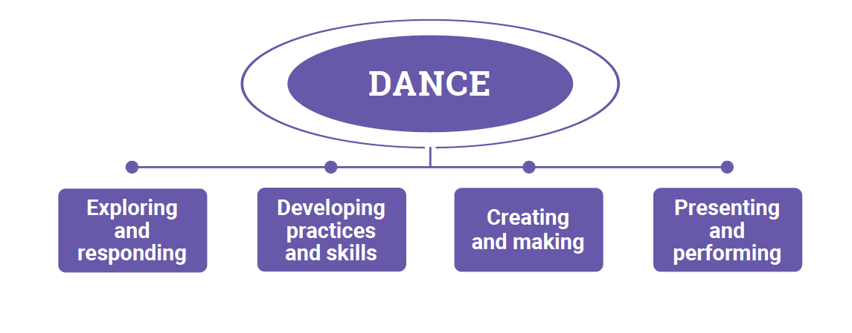
Figure 1: The Arts – Dance content structure
Exploring and responding
In this strand, students learn as choreographers and performers and as audience. They explore:
- dance and contexts for dance in the lives of individuals and groups across cultures, times, places and communities
- the diversity of how, where and why people choreograph, perform, present and respond to dance
- the diversity and significance of dance for First Nations Australian Peoples, cultures and communities
- how dance communicates cultural and aesthetic knowledge, purpose, meaning and emotion
- how dance develops empathy and understanding of multiple perspectives.
They respond using dance practices and forms, imagery, sounds, movement, language and/or digital tools.
Developing practices and skills
This strand is about developing practices and skills for choreographing, performing and responding to dance. Students develop knowledge and understanding through play, imagination, experimentation, and creative and critical thinking. They learn and apply safe dance practice, using their bodies and, as appropriate, digital tools, to develop creative and critical practices including:
- creative skills and confidence for choreographing and performing dance, using the elements of dance, fundamental movement skills, choreographic devices, technical and expressive skills, style- or genre-specific techniques (in Years 7–10) and, as appropriate, available production elements and/or digital tools
- critical skills for observing, reflecting on, analysing, evaluating and responding to their own and others’ dance practices using language/terminology and/or embodied practices.
Creating and making
In this strand, as artists, students apply dance and multi-arts creative processes to choreograph dance. As audience, they reflect on their work as it develops; for example, through observation, analysis, reflection and evaluation.
Students individually and/or collaboratively use their bodies, the elements of dance, choreographic devices, processes such as improvisation and/or digital tools to:
- choreograph dances in forms and styles of interest and relevance
- interpret, arrange and re-imagine dance choreographed by others.
Presenting and performing
In this strand, students perform dance they have choreographed and/or their interpretations of dance choreographed by other people, in informal and/or formal settings and in available physical or virtual spaces. Some performances will be refined; others will be presentations/demonstrations of work-in-progress. Students:
- plan, select, design and/or rehearse their presentations and performances
- use technical and expressive skills and, in Years 7–10, genre or style-specific techniques to engage audiences and communicate intentions.

Key considerations
Elements of Dance
The elements of dance – time, space, dynamics and relationships – work together and underpin all dance activity.
Dance practices: choreography, performance and responding
In Dance, students learn through the integrated practices of choreography, performance and responding.
Choreography is the creative process for making dance. Students, as artists, explore and shape their ideas using processes such as improvising, exploring, reimagining, selecting, and/or structuring movement to communicate their intentions. As audience, students use reflective practice to evaluate and refine their work.
Performing involves practising, rehearsing, refining and applying technical and expressive skills and/or genre-/style-specific techniques. As audience, students use reflective practice to evaluate and refine their work.
Students respond to dance they experience as audience and as artist. As audience students explore and respond to dance and dance practices from across cultures, times and places. As artist they consider and evaluate influences of the dance they have experienced on their choreography and performance. As they respond, students can use questions based on Viewpoints to:
- frame wondering, reasoning and reflecting
- explore ideas and make decisions
- value multiple perspectives
- express and celebrate identities, ideas and meanings
- think deeply about their own dance practices and dance choreographed and performed by others.
Safe dance practice encourages and promotes physical health and emotional wellbeing. It includes physical and psychological dimensions and should be applied at all times in dance learning.

Materials
Movement is the essential material of dance. Movement begins with the body and body awareness, including the use of body bases, body parts and body zones. The body uses movement vocabulary developed by using the elements of dance to express and give form to feelings and ideas in choreography and performance. Production components such as performance spaces, costumes, props, lighting, sets, sound and multimedia elements may be incorporated in dance.
Through dance learning students develop their skills for performing movement in safe and meaningful ways. They learn and develop fundamental movement skills; acquire, use and combine technical and expressive skills; and, particularly in Years 7–10, learn genre-/style-based techniques to build their movement vocabulary.
Types of dance
Students explore dance from a range of cultures, times and places. They explore, choreograph and perform dances in diverse genres, styles and/or forms that are representative of the 3 main types of dance:
- dance created/choreographed to be performed to an audience (for example, forms of theatrical dance such as ballet, tap; exhibition dance such as ballroom or traditional dance; local dance traditions, storytelling dance, dances that depict traditional practices or stories, folk dance; and dance choreographed for screen-based works such as films or games)
- participatory dance for personal and social purposes and not intended for a broader audience (for example, dance for exercise, social dance crazes)
- dance performed or participated in for a specific purpose such as spiritual devotion or ceremonial rites (for example, dance in traditional celebrations or festivals or as part of a cultural ceremony such as a wedding).
Across F–10 students broaden their experiences of dance genres and styles and use these as a springboard for their own choreography and performance. They also consider how dance can communicate and challenge ideas about issues and concepts, such as themes and ideas relevant to the cross-curriculum priorities or other learning areas.

