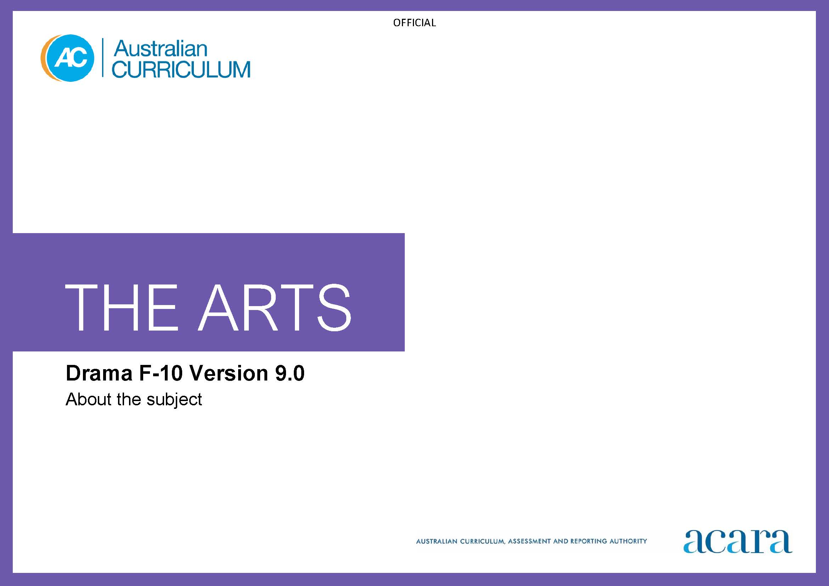

Copyright and Terms of Use Statement
© Australian Curriculum, Assessment and Reporting Authority 2022
The material published in this work is subject to copyright pursuant to the Copyright Act 1968 (Cth) and is owned by the Australian Curriculum, Assessment and Reporting Authority (ACARA) (except to the extent that copyright is held by another party, as indicated).
The viewing, downloading, displaying, printing, reproducing (such as by making photocopies) and distributing of these materials is permitted only to the extent permitted by, and is subject to the conditions imposed by, the terms and conditions of using the ACARA website (see, especially, clauses 2, 3 and 4 of those terms and conditions). The terms and conditions can be viewed at https://www.acara.edu.au/contact-us/copyright
TABLE OF CONTENTS
F–10 AUSTRALIAN CURRICULUM: THE ARTS – DRAMA 3
About Drama 3
Rationale 3
Aims 3
Structure 4
Key considerations 6

F–10 AUSTRALIAN CURRICULUM: THE ARTS – DRAMA

About Drama

Rationale
Drama uniquely explores and communicates the human condition through the enactment of real and imagined worlds. Drama responds to our need to share and enact stories, and create and make meaning across cultures, times, places and communities.
Drama is directly linked to play, the root of all creativity in children. At its core, drama is about taking on roles and “standing in the shoes” of another, and imagining and communicating with the world through different perspectives. Taking on roles involves an act of the imagination that relies on a learner’s ability to empathise and understand others. Actively taking on roles in a range of contexts, situations, and across different times and places fosters students’ development of personal, cultural and social understandings as they imagine, empathise and communicate through deep experiential learning. Drama is a powerful form of communication involving affective, sensory and aesthetic modes.
In Drama, students work individually and collaboratively as artists and audiences to create, perform and respond to drama. It is an active, embodied and aesthetically rich subject that engages students cognitively and affectively as they learn in, through and about drama.
Drama is central to the diversity and continuity of local and global cultures, particularly the cultures of First Nations Australians. Through drama, First Nations Australians celebrate and express connection to and responsibility for Country/Place.
Drama uniquely develops a suite of knowledge and understanding, and capabilities including creativity, imagination, collaboration, critical thinking, communication, empathy, agility, confidence and expression. Drama learning involves a range of processes including devising, writing, rehearsing, presenting, performing, analysing and evaluating. Drama is accessible to all and engages students as they learn about themselves, their peers and the world.

Aims
Drama aims to develop students’:
- confidence and self-esteem to explore, depict and celebrate human experience, take risks and challenge their own creativity through drama
- knowledge and understanding in controlling, applying and analysing the elements, processes, forms, styles and techniques of drama to engage audiences and create meaning
- sense of curiosity, aesthetic knowledge, enjoyment and achievement through exploring and playing roles, and imagining situations, actions and ideas as drama makers and audiences
- knowledge and understanding of traditional and contemporary drama as critical and active participants and audiences.

Structure
Drama is presented in 2-year band levels from Year 1 to Year 10, with Foundation being presented as a single year.
Curriculum content is organised under 4 interrelated strands:
- Exploring and responding
- Developing practices and skills
- Creating and making
- Presenting and performing.
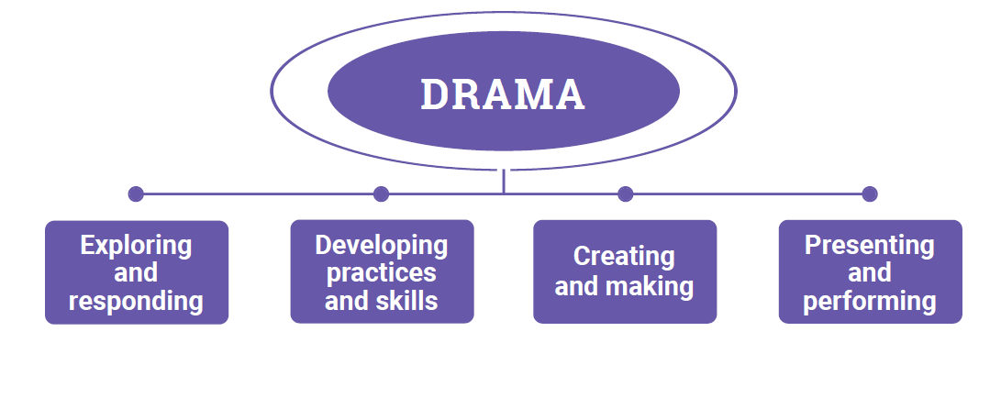
Figure 1: The Arts – Drama content structure
Exploring and responding
In this strand, students learn as artists and as audience. They explore:
- drama works and contexts for drama in the lives of individuals and groups across cultures, times, places and communities
- the diversity of how, where and why people create, perform, and respond to drama
- the diversity and significance of drama for First Nations Australian Peoples, cultures and communities
- how drama communicates cultural and aesthetic knowledge, ideas, purpose, meaning and emotion
- how drama develops empathy and understanding of multiple perspectives.
They respond using drama practices and forms, imagery, sounds, movement, language and/or digital tools.
Developing practices and skills
This strand is about developing practices and skills for creating, performing and responding to drama. Students develop knowledge, skills and understanding of these practices through play, imagination, experimentation, and creative and critical thinking. They work individually and collaboratively to develop creative and critical practices including:
- creative practices, skills and confidence for imagining, improvising, devising, interpreting and performing drama, using the elements of drama, conventions associated with styles/forms, processes for making drama, and available materials and technologies including digital tools
- critical practices for observing, reflecting on, analysing, evaluating and responding to their own and others’ drama and drama practices, using language/terminology and/or embodied practices.
Creating and making
In this strand, as artists, students apply drama and/or multi-arts creative processes. As audience, they reflect on their work as it develops; for example, through observation, analysis, reflection and evaluation. Students create and make:
- drama in a range of improvised, devised and scripted forms and styles, individually or collaboratively
- work that is refined and realised, and other work that may not be resolved
- interpretations of scripted drama or texts.
In Drama, creating and making can include improvising, devising, playing, acting, interpreting, directing, rehearsing and/or scripting.
Presenting and performing
In this strand, students use acting and, as appropriate, take on creative and/or technical design/production roles to share drama and ideas with audiences, using available materials and technologies. They:
- share informal and/or formal performances of their work in available spaces
- plan, select, design and/or rehearse their performances.

Key considerations
Elements of drama
The elements of drama are the foundational building blocks of all drama and can include role, situation, language, place, movement, time, character, relationships, voice, tension, space, mood/atmosphere, contrast, symbol and focus. The elements of drama work dynamically together to create dramatic action and dramatic meaning. Other elements of drama may be included, particularly at Years 9–10; for example, to align with senior secondary courses.
Drama practices: creating, performing and responding
Students learn drama knowledge, skills and processes through creating, performing and responding to drama.
In their drama, students develop their understanding of processes including dramatic playing, role-playing, improvising, process drama, interpreting scripts, rehearsing and directing, and responding to drama as audience. As students progress, particularly in Years 7–10, they develop performance skills and engage with specific processes of drama practice such as acting, directing, scriptwriting, dramaturgy, designing, producing, managing and critical analysis.
Throughout their drama learning students use questions based on Viewpoints as an inquiry tool for considering their drama practice from multiple perspectives, as artist or as audience. Students can use questions based on Viewpoints to:
- frame wondering, reasoning and reflecting
- explore ideas and make decisions
- explore and develop empathy for multiple perspectives
- express and celebrate identities, ideas and meanings
- think deeply about their own drama practices and drama created and/or performed by others that they experience.
Forms and styles
Drama form is the way drama is structured. Students learn in and through improvised, devised and scripted forms. Drama forms are shaped by the application of the elements of drama within particular contexts or for particular purposes. Conventions are associated with different forms.
Drama styles are categories in which dramatic action is expressed or performed. Each drama style has distinctive characteristics that can be influenced by particular time periods, countries or culture, ideological or social movements or particular theatre makers. Each style has a set of drama conventions that can be identified, used and manipulated.
In each band, students create, perform and respond to drama from a range of forms and styles, across a range of contexts or for particular purposes.
Materials and technologies
The materials for Drama begin with the body and voice. Students use, apply and manipulate the elements of drama to create and perform drama. Production components such as performance spaces, costumes, props, lighting, sets, sound and multimedia elements may also be incorporated in drama.
In Drama, materials enable:
- creation of setting/s for dramatic play; for example, use of open-ended materials such as buttons, recycled materials, string/cord, lengths of paper, and large and small-sized boxes to create a space-station or another imagined space
- communication of place; for example, using a length of material to represent a river
- communication of role through use of a costume item or a prop
- symbolism and relationships; for example, use of red fabric or rostra blocks of various heights to indicate power and/or status
- transformation; for example, using calico cloth to indicate a baby and then transforming it into a picnic blanket or a shawl within the same performance
- communication of time and time-shifts; for example, using props and costumes to indicate the period of the performance.
In Drama, technologies enable:
- on-screen viewing of live or recorded drama from diverse cultures, times and places to broaden awareness of the possibilities of drama as an art form or to support processes of analysis (for example)
- stimulus prior to improvising, devising and/or developing drama using screen-based styles, such as cinematic theatre
- collaborative practices such as scriptwriting, planning drama or character development
- reflection, evaluation or refinement of “work in progress”; for example, using video of a rehearsal to consider refinements and next steps
- use of available devices to support reflection and responding; for example, capturing freeze frames and asking students (as audience) to reflect on whether or not the intended meaning is being communicated through the dramatic action
- use of projections (text or still/moving image) to contribute to or juxtapose with live action to enhance dramatic meaning, and use of lighting (including torches or hand-held LED lights) and recorded sound to create and/or manipulate mood/atmosphere.

