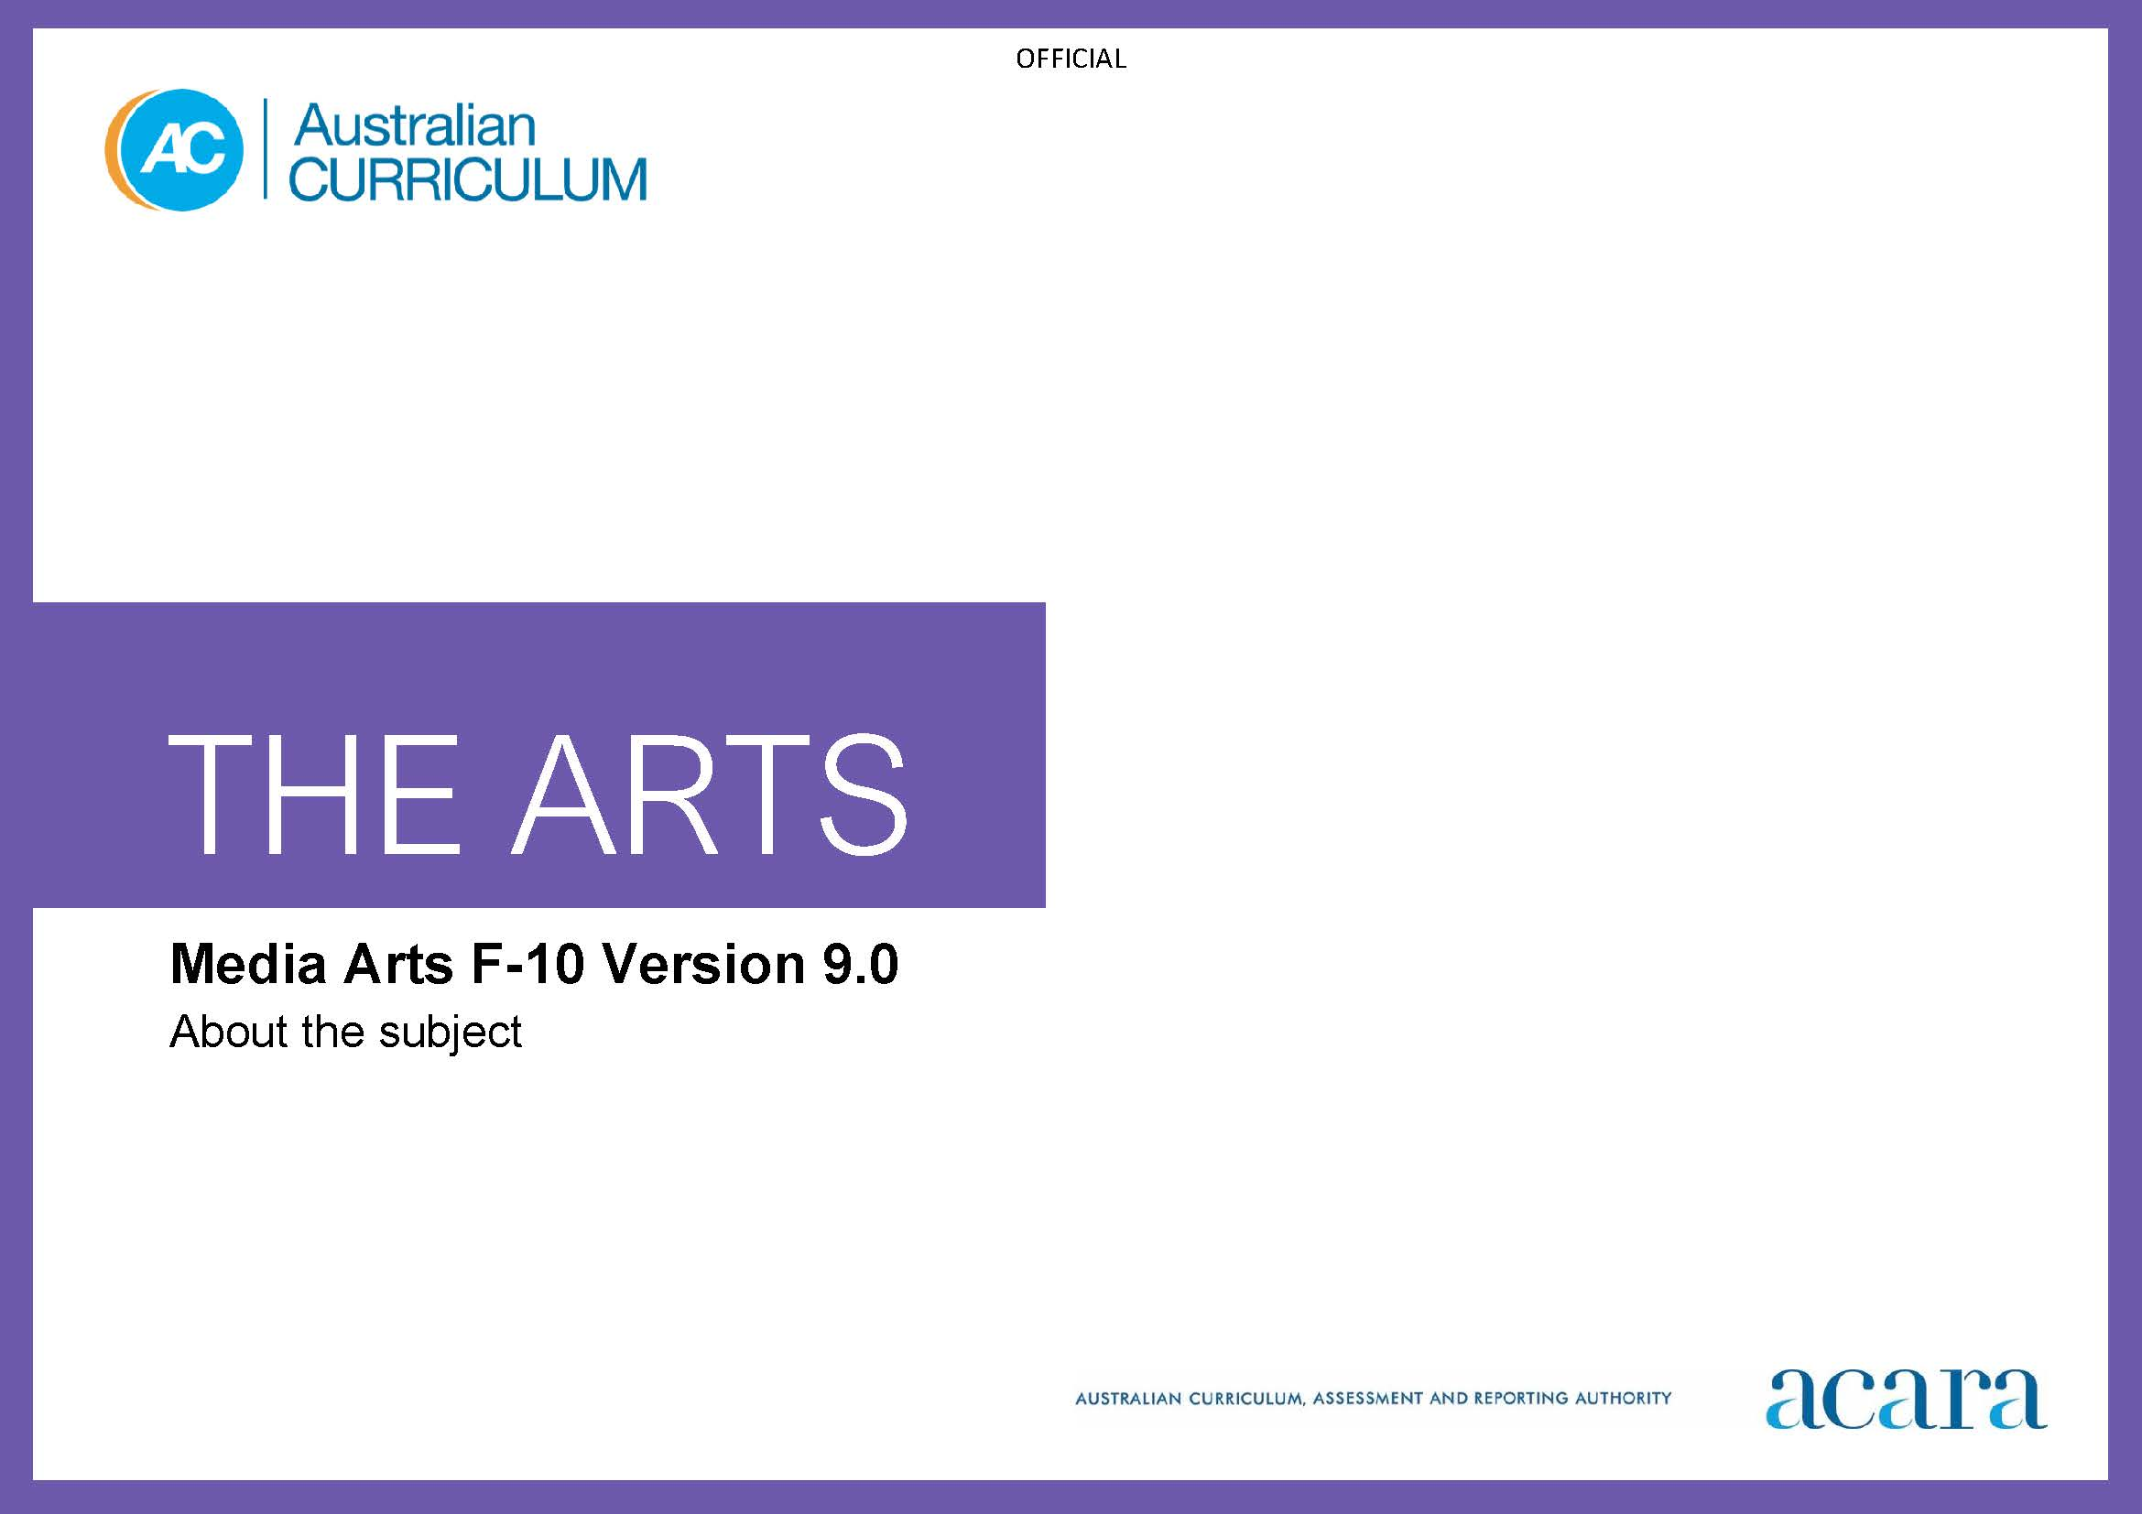

Copyright and Terms of Use Statement
© Australian Curriculum, Assessment and Reporting Authority 2022
The material published in this work is subject to copyright pursuant to the Copyright Act 1968 (Cth) and is owned by the Australian Curriculum, Assessment and Reporting Authority (ACARA) (except to the extent that copyright is held by another party, as indicated).
The viewing, downloading, displaying, printing, reproducing (such as by making photocopies) and distributing of these materials is permitted only to the extent permitted by, and is subject to the conditions imposed by, the terms and conditions of using the ACARA website (see, especially, clauses 2, 3 and 4 of those terms and conditions). The terms and conditions can be viewed at https://www.acara.edu.au/contact-us/copyright
TABLE OF CONTENTS
F–10 AUSTRALIAN CURRICULUM: THE ARTS – MEDIA ARTS 3
About MEDIA ARTS 3
Rationale 3
Aims 3
Structure 4
Key considerations 6

F–10 AUSTRALIAN CURRICULUM: THE ARTS – MEDIA ARTS

About MEDIA ARTS

Rationale
In Media Arts, communication, storytelling and persuasion are used to connect audiences, purposes and ideas. Media Arts explores concepts and viewpoints, and examines, interprets and analyses media practices that represent the world from diverse perspectives. Media artists work collaboratively and use traditional and emerging media technologies and creative processes to plan, produce and distribute media arts works.
Through the creative use of materials and technologies to convey meaning, students manipulate still and moving images, text, sound and interactive elements. They construct representations and communicate or challenge understandings, ideas and positions.
Media arts plays an important role in sustaining cultural diversity and continuing local and global cultures, particularly the cultures of First Nations Australians. It offers opportunities to use media platforms to celebrate, maintain or revitalise ways of knowing, being, doing, belonging and becoming. Through media arts, First Nations Australians celebrate and express connection to and responsibility for Country/Place.
Media arts recognises that media forms can operate at either a mass level, where media is shared one way, or at an interpersonal level, where communication occurs between individuals and among online communities. Students critically reflect on the role of the media in society and consider how their own media use is shaped by the practices of media institutions. They develop awareness and understanding of ways that media institutions use information collected from users to create communities and to mediate users’ media choices.
Students learn to be critically aware of the ways that media is used culturally, how it might be negotiated by different audiences, and the impact it can have on their own understanding of the world.

Aims
Media Arts aims to develop students’:
- enjoyment and confidence to participate in, experiment with and interpret the media-rich culture and communications practices that surround them
- creative and critical thinking skills through engagement as producers and consumers of media
- aesthetic knowledge and a sense of curiosity and discovery as they explore images, text and sound to express ideas, concepts and stories for different audiences
- knowledge and understanding of their active participation in existing and evolving local and global media cultures.

Structure
Media Arts is presented in 2-year band levels from Year 1 to Year 10, with Foundation presented as a single year.
Curriculum content is organised under 4 interrelated strands:
- Exploring and responding
- Developing practices and skills
- Creating and making
- Presenting and performing.
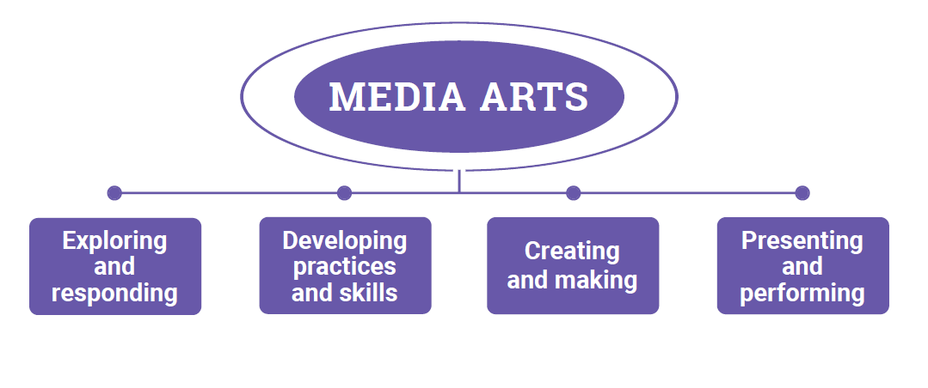
Figure 1: The Arts – Media Arts content structure
Exploring and responding
In this strand, students learn as artists and as audiences. They explore:
- media arts works and media contexts in the lives of individuals and groups across cultures, times, places and communities
- the diversity of how, where and why people create, make, distribute and respond to media arts works
- the diversity and significance of media arts for First Nations Australian Peoples, cultures and communities
- how media arts works communicate cultural and aesthetic knowledge, purpose, meaning and emotion
- how media arts develops empathy and understanding of multiple perspectives.
They respond using media arts practices and forms, images, sounds, movement, language and/or digital tools.
Developing practices and skills
This strand is about developing practices and skills for producing and responding to media arts. Students develop skills through play, experimentation and creative and critical thinking. They develop creative and critical practices including:
- creative skills and confidence to imagine, use and manipulate visual, aural and interactive elements, media languages and technologies to create representations that communicate stories, narratives, ideas and meaning
- safe and ethical use of production processes using available resources
- critical skills in observing, reflecting, analysing and evaluating their own and others’ media arts practices, using language/terminology and embodied practices.
Creating and making
In this strand, as artists, students apply media arts and/or multi-arts production processes. As audience, they reflect on their work as it develops; for example, through observation, analysis, reflection, evaluation and considering the relationships their work creates with audiences.
Students use media arts concepts and production processes to construct representations and produce media arts works in a range of forms, styles and/or genres.
Presenting and performing
In this strand, students share (exhibit/screen/publish/distribute) their media arts work using available spaces and resources. Students may also work collaboratively to produce multi-arts works. Students:
- share their work using available spaces, materials and technologies
- plan and design their presentations, considering audiences and institutional practices
- observe and, as appropriate, participate in interactions between media arts works and audiences.

Key considerations
Media Arts concepts
There are 6 concepts fundamental to Media Arts. They are: media technologies, representations, audiences, institutions, media languages and relationships. Together, the media arts concepts provide a framework for students to engage with and create media arts works in existing or emerging forms and to consider media arts practices.
The media arts concepts, although discussed independently, are interrelated. Students engage with each of the concepts at varying levels of depth in all bands.
Media technologies
Media technologies are integral to media arts practices. Students:
- use a range of available digital (hardware, software, recording devices, etc.) and non-digital (pencils, paper, instruments, props, etc.) tools as they create and respond
- produce media arts works using available technology and reflect on how the technology they use enables or constrains the choices available in the making of their media arts work
- reflect critically on developments across media technologies and consider responsible/ethical media practices and how media arts are used for diverse purposes across cultures, communities, times and places.
Representations
Representations are present in all media arts works. All media arts works are constructed and media artists build representations of people, places, concepts/themes and/or events. Students:
- examine the construction of representations in media artworks and build their own
- reflect critically on the impact of repeated representations and how they change over time and across contexts
- consider the ways people learn with and from others through values and attitudes embedded in representations in media arts works.
Audiences
A consideration of audience is a critical aspect of Media Arts practice. Students:
- consider the audience/s that media arts works are made for (target audience), how audiences might interpret the work and differences in interpretations across audiences; for example, media arts works, including their own work, may be interpreted in different ways by different audiences
- examine how audiences come together or take polarised positions; for example, as fans of popular culture, and the practices involved in belonging to such groups.
Institutions
Media institutions include broadcasting companies, print and digital newspaper and magazine publishers, film/screen and music production companies and other production/publishing companies. Media institutions can be local, national or global and owned/controlled by individuals, corporations or governments. The diversity of media institutions is evolving and dynamic. Students:
- explore how individuals, communities, organisations and institutions engage in practices that influence media production for economic, political or social gain; for example, the roles institutions play in engaging audiences, manipulating audience behaviour; how new media trends are promoted, such as ways individuals can share “news” or become “the news”
- investigate how media arts works are distributed (shared with audiences). For example, they explore differences in the ways that distribution happens via channels such as cinemas or television compared to distribution via online spaces, and they consider issues such as ownership, privacy and economic benefit (who earns money, merchandising, payment for access etc.)
- consider their own engagement with media and explore responsible media practice/ethical implications of their practices and ways they are influenced by media institutions.
Media languages
Media languages include the still and/or moving images, sounds, texts and/or interactive elements used to tell a story. Meaning is created through the use of:
- technical codes which are often connected to the capabilities/functions of equipment or digital tools such as cameras or software. They can include, for example, shot size and angles, camera movements, editing techniques, music and sound effects and/or lighting
- symbolic codes which are used to suggest or imply meaning to an audience through a shared social or cultural understanding. These are conveyed through what is seen and heard, including, for example, locations, settings, costumes and/or use of colour
- conventions which are the shared understandings that help to build stories. Story principles contain conventions of narrative; for example, narrative structure and character development. Genre conventions are the established techniques for constructing a type of story; for example, drama, comedy, horror or western.
Students make informed choices about how they can combine and shape the use of codes and conventions in their media arts works to communicate ideas, perspectives and/or meaning to audiences.
Relationships
Relationships are embedded in all media arts practices. In Media Arts students explore and reflect on:
- relationships created within media forms; for example, fan groups or online communities
- the ways people learn with and from others through the media
- their own motivations and the relationships they hope to build; for example, relationships they hope to build with audiences
- how online and mobile platforms are developing and the impacts this is having on production and distribution practices, and how they construct their relationships with users to engage them on platforms
- relationships they develop with various media forms as audience; for example, they consider the relationships they establish and maintain through online and mobile platforms and develop their understanding of relationships between producer, time, place and audience.
Throughout their Media Arts learning students use questions based on Viewpoints as an inquiry tool for considering their own and others’ use of media arts concepts from multiple perspectives. Students can use questions based on Viewpoints to:
- frame wondering, reasoning and reflecting
- explore ideas and make decisions
- explore and develop empathy for multiple perspectives
- express and celebrate identities, ideas and meaning
- think deeply about their own media arts practices and media arts works by others that they experience.
Media Arts forms
Media arts works use a diverse range of print, moving image, audio and hybrid/trans-disciplinary forms. Forms are often specific to styles or genres; for example, action films or hobby magazines, and they continue to evolve in response to technological and other developments.
Production processes
In the media arts, production processes include 3 key stages during the creation of media arts works.
- Pre-production: for example, planning, developing ideas, investigation/research, considering techniques they will use to ensure the media arts work will engage the intended audience and making choices about the form, intention, genre and/or style of the work
- Production: for example, using digital tools and/or other equipment to create/capture images, sound and text that will be used in the media arts work
- Post-production: for example, editing, reviewing/reflecting and refining to ensure that the work communicates planned intentions, distribution and/or interactions with audience/s.
Other stages in a production process such as development and/or distribution may be considered, particularly in Years 7–10 as appropriate.

