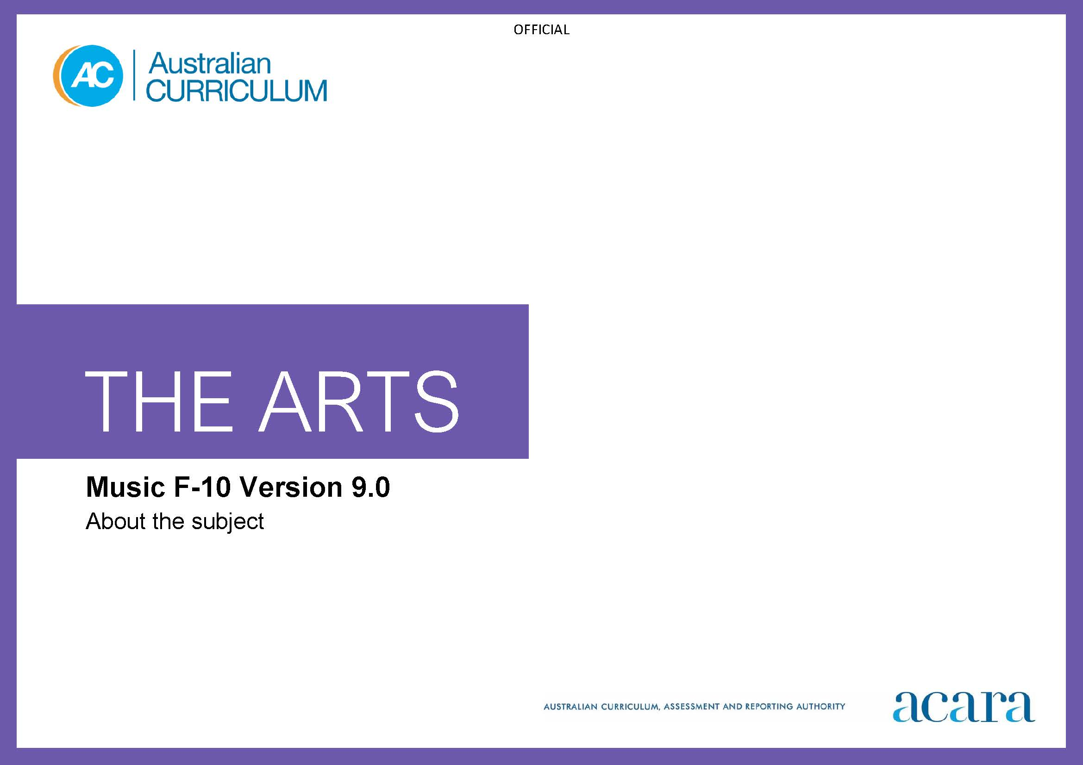

Copyright and Terms of Use Statement
© Australian Curriculum, Assessment and Reporting Authority 2022
The material published in this work is subject to copyright pursuant to the Copyright Act 1968 (Cth) and is owned by the Australian Curriculum, Assessment and Reporting Authority (ACARA) (except to the extent that copyright is held by another party, as indicated).
The viewing, downloading, displaying, printing, reproducing (such as by making photocopies) and distributing of these materials is permitted only to the extent permitted by, and is subject to the conditions imposed by, the terms and conditions of using the ACARA website (see, especially, clauses 2, 3 and 4 of those terms and conditions). The terms and conditions can be viewed at https://www.acara.edu.au/contact-us/copyright

TABLE OF CONTENTS
F–10 AUSTRALIAN CURRICULUM: THE ARTS – MUSIC 3
About MUSIC 3
Rationale 3
Aims 3
Structure 4
Key considerations 6

F–10 AUSTRALIAN CURRICULUM: THE ARTS – MUSIC

About MUSIC

Rationale
Music’s raw material is sound. In music, sounds are combined and shaped into a meaningful form. Music exists distinctively in every historical and contemporary culture, and is a basic, shared expression and communication of human experience. Sharing music and ideas about music across cultures, times, places and communities builds knowledge and enhances empathy. Engagement with music from diverse settings develops an understanding that the same music can be deeply moving for many people and yet have different meaning for each.
Music has the capacity to motivate, inspire and enrich the lives of all students. Students participate in music learning individually and collectively as listeners, composers and performers. Music learning is embodied learning. It has a significant and unique impact on the creative, sensorimotor, cognitive, emotional, sociocultural and personal competencies of students.
Music is a significant element in the diversity and continuity of local and global cultures, particularly the cultures of First Nations Australians. Through music, First Nations Australians express connection to Country/Place, challenge the impact of other cultures on their ways of knowing, being, doing and becoming, contribute to the global music community, and advocate for change.
Students’ active participation in music, through continuous and developmentally sequential music learning, encourages skills and aesthetic knowledge of increasing depth and complexity over time. Practical engagement with music develops capabilities that can be gained in no other way.
As independent and collaborative learners, students integrate listening, composing and performing activities, using established and emerging technologies. Music learning enhances students’ capacity to perceive and understand musical concepts, and to recognise music’s contribution in shaping their identity and their ability to explore personal, local and global issues and ideas. Through the study of music, students increasingly value the power of music in its ability to transform the heart, soul, mind and spirit of individuals and communities.

Aims
Music aims to develop students’:
- confidence to be creative, innovative, thoughtful, skilful and informed musicians
- knowledge and skills for listening with intent and purpose, composing and performing
- aesthetic knowledge and respect for music and music practices across global communities, cultures and musical traditions
- understanding of music as an aural art form as they acquire skills to become independent music learners.

Structure
Music is presented in 2-year band levels from Year 1 to Year 10, with Foundation presented as a single year.
Curriculum content is organised under 4 interrelated strands:
- Exploring and responding
- Developing practices and skills
- Creating and making
- Presenting and performing.
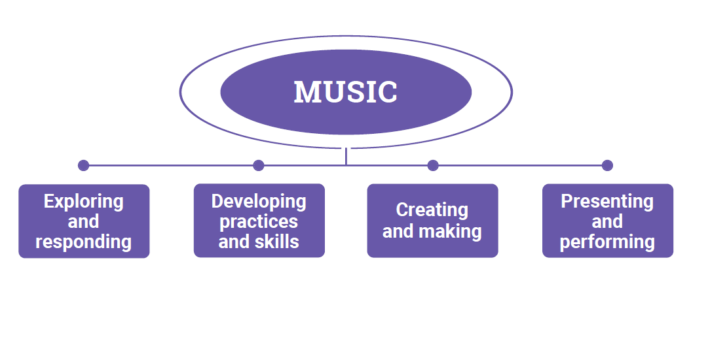
Figure 1: The Arts – Music content structure
Exploring and responding
In this strand, students learn as listeners, composers and performers. They explore:
- diverse examples of how, where and why people create, make, perform, present and respond to music
- music and contexts/roles for music in the lives of individuals and groups across cultures, times, places and communities
- the diversity and significance of music for First Nations Australian Peoples, cultures and communities
- how music communicates cultural and aesthetic knowledge, purpose, meaning and emotion
- how music develops empathy and understanding of multiple perspectives.
They respond using music practices and forms, imagery, sounds, movement, language and/or digital tools.
Developing practices and skills
Students develop practices and skills for listening to, composing, performing and responding to music. They develop knowledge and understanding through play, imagination, experimentation, creative and critical thinking, and practice. They use their voices, instruments, safe practice principles and guidelines, materials such as scores, sheet music, amplification equipment and, as appropriate, digital tools, to develop creative and critical practices including:
- creative skills and confidence for interpreting, performing and composing music, using the elements of music, listening and aural skills, vocal and instrumental techniques, and available materials/digital tools
- critical skills for listening to, observing, reflecting on, analysing and evaluating their own and others’ music practices, using language/terminology and embodied practices.
Creating and making
In this strand, as artists, students apply music-specific or multi-arts creative processes to compose music and to interpret music for performance. As audiences, they reflect on their work as it develops; for example, through observation, using aural skills, analysis, reflection and evaluation.
Students individually and/or collaboratively, using available voices, instruments (acoustic, electric, digital and/or environmental) and/or digital tools:
- compose in forms and styles of interest and relevance such as songwriting, improvisation, genre-specific forms such as chamber music, music production, arranging/re-imagining, music for specific purposes or occasions, or music for multi-arts works
- interpret music composed and/or performed by others
- use manual and/or digital tools to notate, document and/or record their compositions and/or interpretations.
Presenting and performing
In this strand, students perform their compositions and interpretations of music composed by other people in informal and/or formal settings in available physical or virtual spaces. Some performances will be refined; others will be presentations/demonstrations of work-in-progress. Students:
- plan, select, design and rehearse their presentations and performances
- use technical skills and manipulate expressive elements of music to engage audiences and communicate intentions.

Key considerations
Elements of music

The elements of music – duration/time (including beat and rhythm), pitch, dynamics and expression, form and structure, timbre and texture – underpin all music learning.

Musical ideas are conceived, organised and shaped by aspects and combinations of the elements of music. Other elements of music may be included, particularly at Years 9–10; for example, to align with senior secondary courses.
Music practices: Listening
Throughout their music learning, students listen to/experience, analyse, evaluate, perform and compose music from diverse cultures, styles, traditions and contexts. They learn to recognise their subjective preferences and appreciate other people’s diverse perspectives of music. These experiences inform students’ approaches to composing and interpreting music as performers and their responses to music they experience. As they develop their music knowledge and skills, students develop their own musical voice as composers and their own style as performers.
Purposeful or active listening skills engage the listener’s mind, senses and emotions. They are used when listening for enjoyment, analysing, responding to, reflecting on, evaluating, composing and/or performing music. Aural skills are listening skills used to identify and/or analyse specific elements of music, such as the duration of a note, the interval (distance) between 2 notes or the structure/quality of a chord. Aural skills complement purposeful or active listening and can be used when listening, composing and/or performing.
Music practices: Composing
Composing describes the practices and processes used to create music works. It can include, for example, songwriting, improvising, arranging/re-imagining/re-inventing, music production, and/or generating. Composing involves creative processes such as developing ideas/intentions or identifying purpose, evaluating/analysing ideas from other music, manipulating elements of music to organise and shape music ideas and/or using compositional devices; for example, to structure or extend the music.
Notating, documenting and/or recording
Notating, documenting and/or recording involves using available and relevant methods and tools to preserve music for future use. Forms and methods of notating, documenting and/or recording include staff notation, graphic notation, scores, charts, lead-sheets, audio and/or audio-visual recordings. These forms and methods are often associated with genres/styles. Notating, documenting and/or recording can involve using symbols, images and/or use of digital tools.
Music practices: Performing

Students perform for audiences (of one or more) in informal settings such as in classes or lessons, to peers or teachers. They may also present formal performances in a school or public setting. Formats for performances include live (indoor/outdoor), streamed and/or recorded.
Instruments
Students use available instruments for performing and composing. Instruments can include voice/body, acoustic or electric string, wind, percussion, or keyboard instruments, digital instruments and/or environmental sounds.
Responding
In music, students respond to musical experiences and ideas through the practices of listening, composing and performing. They use questions based on Viewpoints as an inquiry tool for considering their responses and music practice from multiple perspectives, as artist or as audience. Students can use questions based on Viewpoints to:
- frame wondering, reasoning and reflecting
- explore ideas and make decisions
- explore and develop empathy for multiple perspectives
- express and celebrate identities, ideas and meaning
- think deeply about their own music practices and works and music composed and performed by others that they experience.

