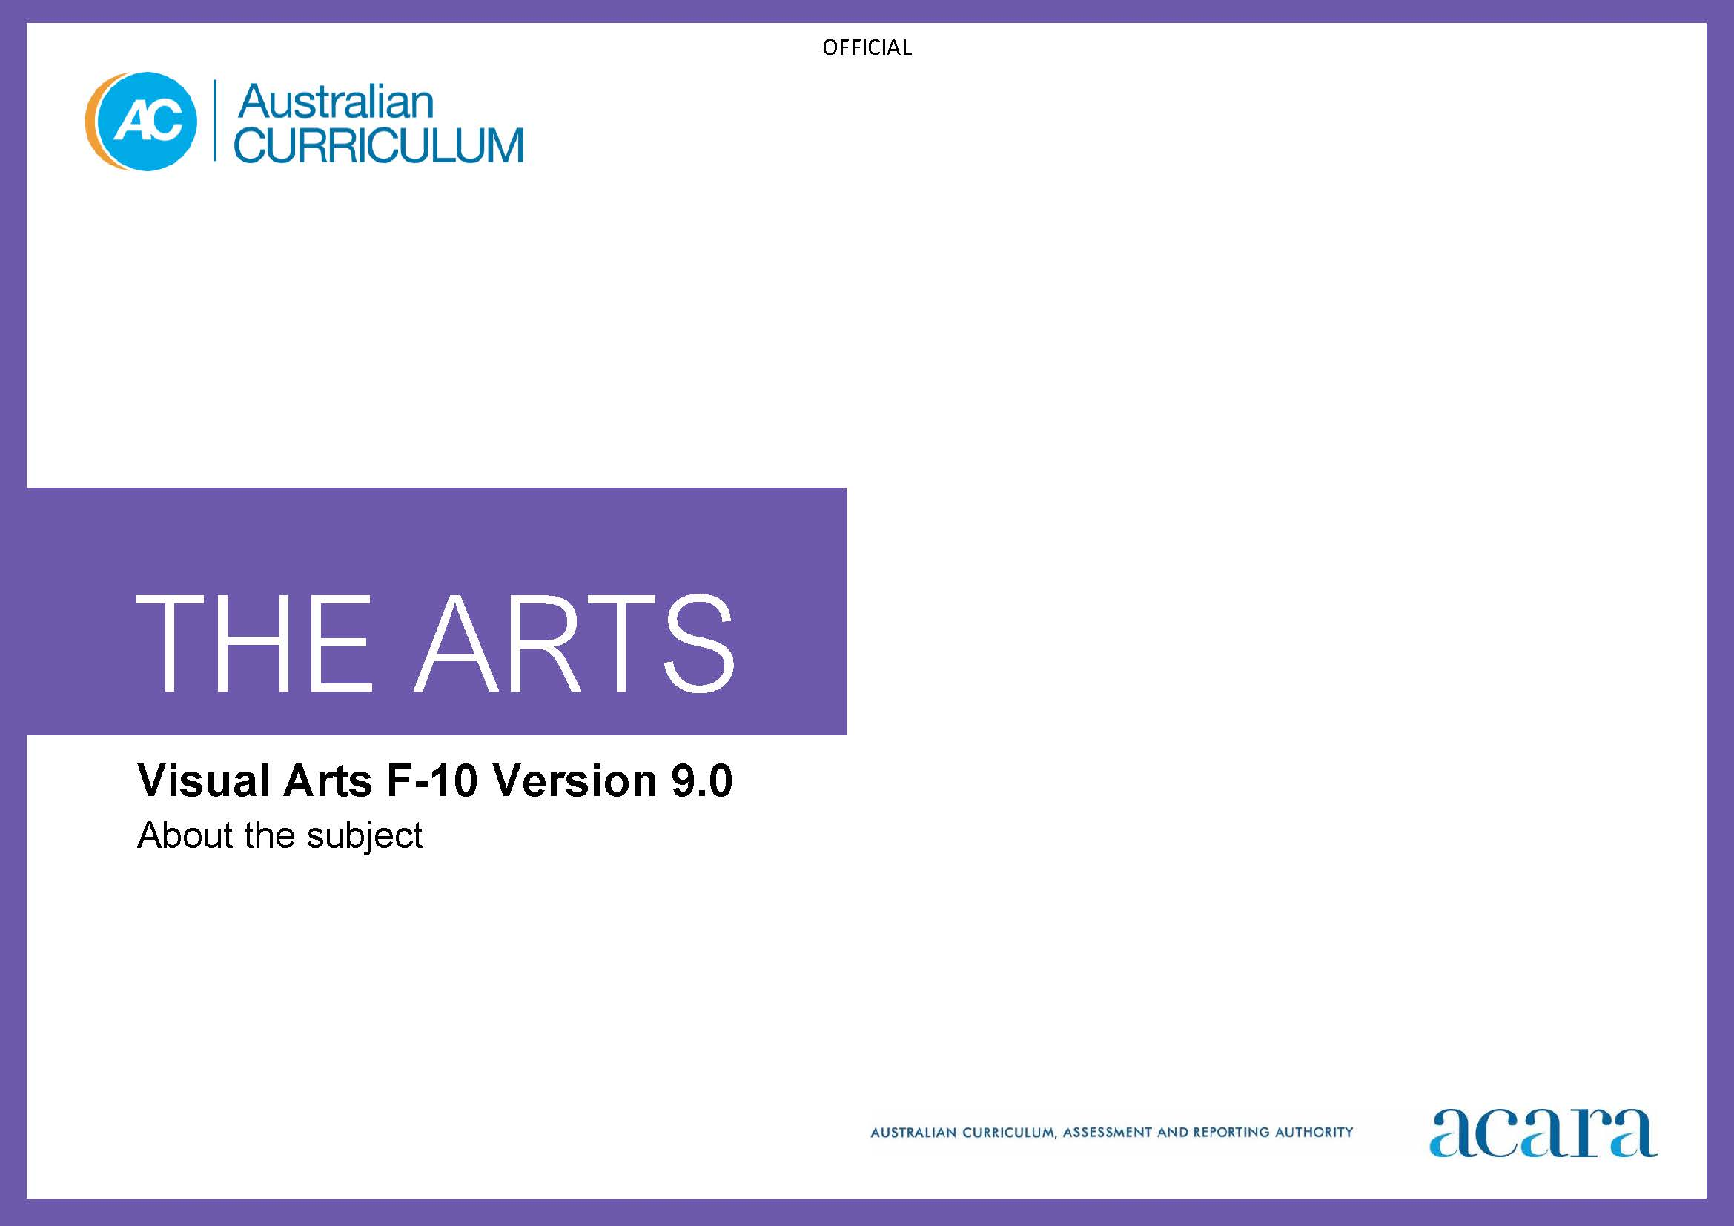

Copyright and Terms of Use Statement
© Australian Curriculum, Assessment and Reporting Authority 2022
The material published in this work is subject to copyright pursuant to the Copyright Act 1968 (Cth) and is owned by the Australian Curriculum, Assessment and Reporting Authority (ACARA) (except to the extent that copyright is held by another party, as indicated).
The viewing, downloading, displaying, printing, reproducing (such as by making photocopies) and distributing of these materials is permitted only to the extent permitted by, and is subject to the conditions imposed by, the terms and conditions of using the ACARA website (see, especially, clauses 2, 3 and 4 of those terms and conditions). The terms and conditions can be viewed at https://www.acara.edu.au/contact-us/copyright

TABLE OF CONTENTS
F–10 AUSTRALIAN CURRICULUM: THE ARTS – VISUAL ARTS 3
About VISUAL ARTS 3
Rationale 3
Aims 3
Structure 4
Key considerations 6

F–10 AUSTRALIAN CURRICULUM: THE ARTS – VISUAL ARTS

About VISUAL ARTS

Rationale
Visual arts contribute to the fields of art, craft and design. Learning in, through and about these fields, students engage critically using creative processes and artistic practices to communicate and make meaning.
Visual arts processes and practices provide insights into the impacts culture can have on ways of knowing, doing and being in Australia and the world. Investigating these impacts is integral for fostering students’ ability to discern and understand the unique ways visual arts practice and process can be both related and distinct to learning about culture.
Visual arts are central to the diverse and continuing cultural practices of First Nations Australians. Through visual arts, First Nations Australian artists articulate and express connection to, and responsibility for, Country/Place.
Learning about visual techniques, technologies, skills and media of First Nations Australian and local and global artists, craftspeople and designers supports students to develop their own artworks with integrity and understanding of distinctions between art and culture. Students explore different perspectives to develop and expand perceptual, conceptual and cultural understanding, critical reasoning and practical skills. From this, students develop confident and proficient practices to achieve a personally responsive and distinctive visual aesthetic.
Students understand how creative industries contribute to personal, cultural, community and economic wellbeing. In Visual Arts, students learn to recognise and cultivate unique literacies, practices and processes to grapple with ideas, intricacies and dilemmas. The interrelationship between making and responding invites students to investigate, contextualise and make meaningful connections between personal and global viewpoints as they apply visual arts knowledge, frameworks and practical skills.
Investigating artworks and practices prepares students to respectfully recognise, articulate and acknowledge artistic and cultural influences. In exploring how, why, where and for whom artists, craftspeople and designers produce artworks, students recognise and appreciate the tensions, complexities and significance of visual arts histories, theories and practices.

Aims
Visual Arts aims to develop students’:
- conceptual and perceptual ideas and representations through design and inquiry processes
- knowledge and skills in using visual conventions, visual arts processes and materials
- critical and creative thinking skills through engagement with and development of visual arts practice
- respect for and acknowledgement of the diverse roles, innovations, traditions, histories and cultures of artists, craftspeople and designers; visual arts as social and cultural practices; and industry as artists and audiences
- confidence, curiosity, imagination and enjoyment
- personal expression through engagement with visual arts practice and ways of representing and communicating.

Structure
Visual Arts is presented in 2-year band levels from Year 1 to Year 10, with Foundation presented as a single year.
Curriculum content is organised under 4 interrelated strands:
- Exploring and responding
- Developing practices and skills
- Creating and making
- Presenting and performing.
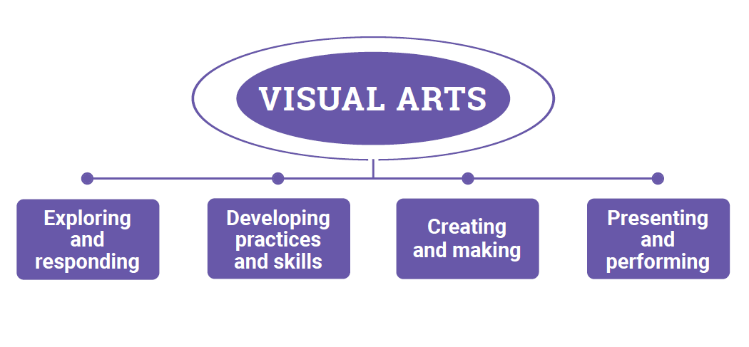
Figure 1: The Arts – Visual Arts content structure
Exploring and responding
In this strand students learn as artists and as audience. They explore:
- visual arts practices in community, studio and/or industry settings across local, regional, national and global contexts
- visual artworks and their display in physical and virtual, formal and/or informal settings
- the diversity of where, why and how people create, make and engage with visual arts
- the diversity and significance of visual arts for First Nations Australian Peoples, cultures and communities
- how visual arts communicate cultural and aesthetic knowledge, ideas, purpose, meaning and emotion
- how visual arts develop empathy and understanding of multiple perspectives.
They respond using visual arts practices, materials and forms, imagery, sounds, movement, language and/or digital tools.
Developing practices and skills
This strand is about developing practices and skills for exploring, creating and responding to visual arts. Students develop knowledge and understanding through play, imagination, experimentation, and creative and critical thinking. They develop creative and critical practices including:
- creative skills and confidence for using, experimenting with and manipulating visual conventions, visual arts process and materials for personal expression, and communicating visually in diverse 2D, 3D and/or 4D (time-based) visual arts forms and styles
- critical skills in observing, documenting, problem-solving, reflecting on, analysing and evaluating their own and others’ visual arts practices using language/terminology and/or embodied practices.
Creating and making
In this strand, as artists, students use visual conventions, visual arts–specific and/or multi-arts creative processes, and visual arts materials. As audiences, they reflect on their work as it develops; for example, through observation, analysis, reflection and evaluation. Students create and make visual artworks by:
- selecting, refining and resolving ideas and intentions for visual artworks
- identifying ideas and influences that will inform their work from, for example, other artists’ artworks and practices, experiences, themes or concepts
- selecting and manipulating visual conventions, visual arts processes and materials to represent ideas, perspectives and/or meaning.

Presenting and performing
In this strand, students present visual artworks to audiences. They make decisions about:
- if, when and how their visual artworks and/or visual arts practices will be shared with others
- where the work could be displayed or exhibited; for example, in formal, informal, physical or virtual spaces.

Key considerations
Artists
Artists include visual artists, craftspeople and designers.
Artists work individually and collaboratively using diverse visual arts practices to create artworks. Students investigate the practice and artworks of artists working in diverse forms across cultures, contexts, times and places. Students learn as artists as they develop their own visual arts practice.
Artworks
Visual artworks include art, craft works and/or design works.
An artwork is an outcome of an artist’s practice. An artwork may be a completed product or a work in progress. Artworks can be experienced in person and/or digitally; for example, by visiting galleries, exhibition spaces or public places, or by accessing artworks in online gallery spaces or in printed media such as arts journals. Students may use strategies such as questions based on Viewpoints, frames, frameworks or lenses to analyse and interpret artworks and artists’ practices from multiple perspectives.
Visual Arts practices
Visual arts practices are the ways that artists go about their work. Visual arts practices include:
- examining other artists’ works and practices; for example, identifying and analysing influences or considering how artists are using and adapting arts processes
- developing creative and critical thinking when observing and analysing artists’ works, and when documenting and reflecting on their own visual arts practice
- developing ideas, studio practice and collaboration
- experimenting with and developing knowledge and skills in using visual conventions, visual arts processes and materials
- creating artworks that represent ideas, perspectives and/or meaning
- considering where, how and why they share their artworks and ideas with audiences.
Throughout their Visual Arts learning, students use questions based on Viewpoints as an inquiry tool for considering their visual arts practice from multiple perspectives, as artist or as audience. Students can use questions based on Viewpoints to:
- frame wondering, reasoning and reflecting
- explore ideas and make decisions
- explore and develop empathy for multiple perspectives
- express and celebrate identities, ideas and meaning
- think deeply about their own visual arts practices and visual artworks created by others that they experience.
Materials
In Visual Arts, students manipulate and adapt a wide range of materials and technologies to make 2D, 3D and 4D works. These may include:
- physical materials such as paint, dyes, charcoal and/or clay
- contemporary or emerging materials such as digital media
- organic and/or recycled/repurposed materials such as dry leaves, recycled cardboard or plastic, fabric/textiles or household objects.
Visual artists adapt and expand their practice to encompass and embrace new materials and ways of working.
Visual conventions
Visual conventions are traditional, cultural and/or stylistic ways of working in visual arts, craft and design. They reflect agreed expectations for various art forms such as painting or sculpture and are impacted by factors such as the time and culture they were created in and the choice of materials. They include the elements and principles of art/design. Visual conventions are dynamic and evolve as visual art forms and practices evolve over time.
Visual Arts forms
Visual arts forms embrace traditional, cultural and/or stylistic forms. Forms used in visual arts learning may include but are not limited to: painting, drawing, sculpture, ceramics, printmaking, mixed media, textiles, photography and installation in one, 2, 3 and 4 dimensions. Visual arts forms develop and evolve as artists adapt and explore new technologies and ways of working.

Visual Arts processes
Visual arts processes are the processes used to create artworks. They include methods, tools, techniques and technologies relevant to the selected visual arts form and are continually evolving.
Exhibiting and curating
Exhibitions/displays of artworks are the display of work for audiences and can be formal or informal.
Curating refers to the process of selecting and organising material, such as artworks and aspects of artists’ practice that communicates the artists’ processes, ideas, intentions and/or perspectives. Curating can be part of the process for preparing for informal or formal exhibiting.

