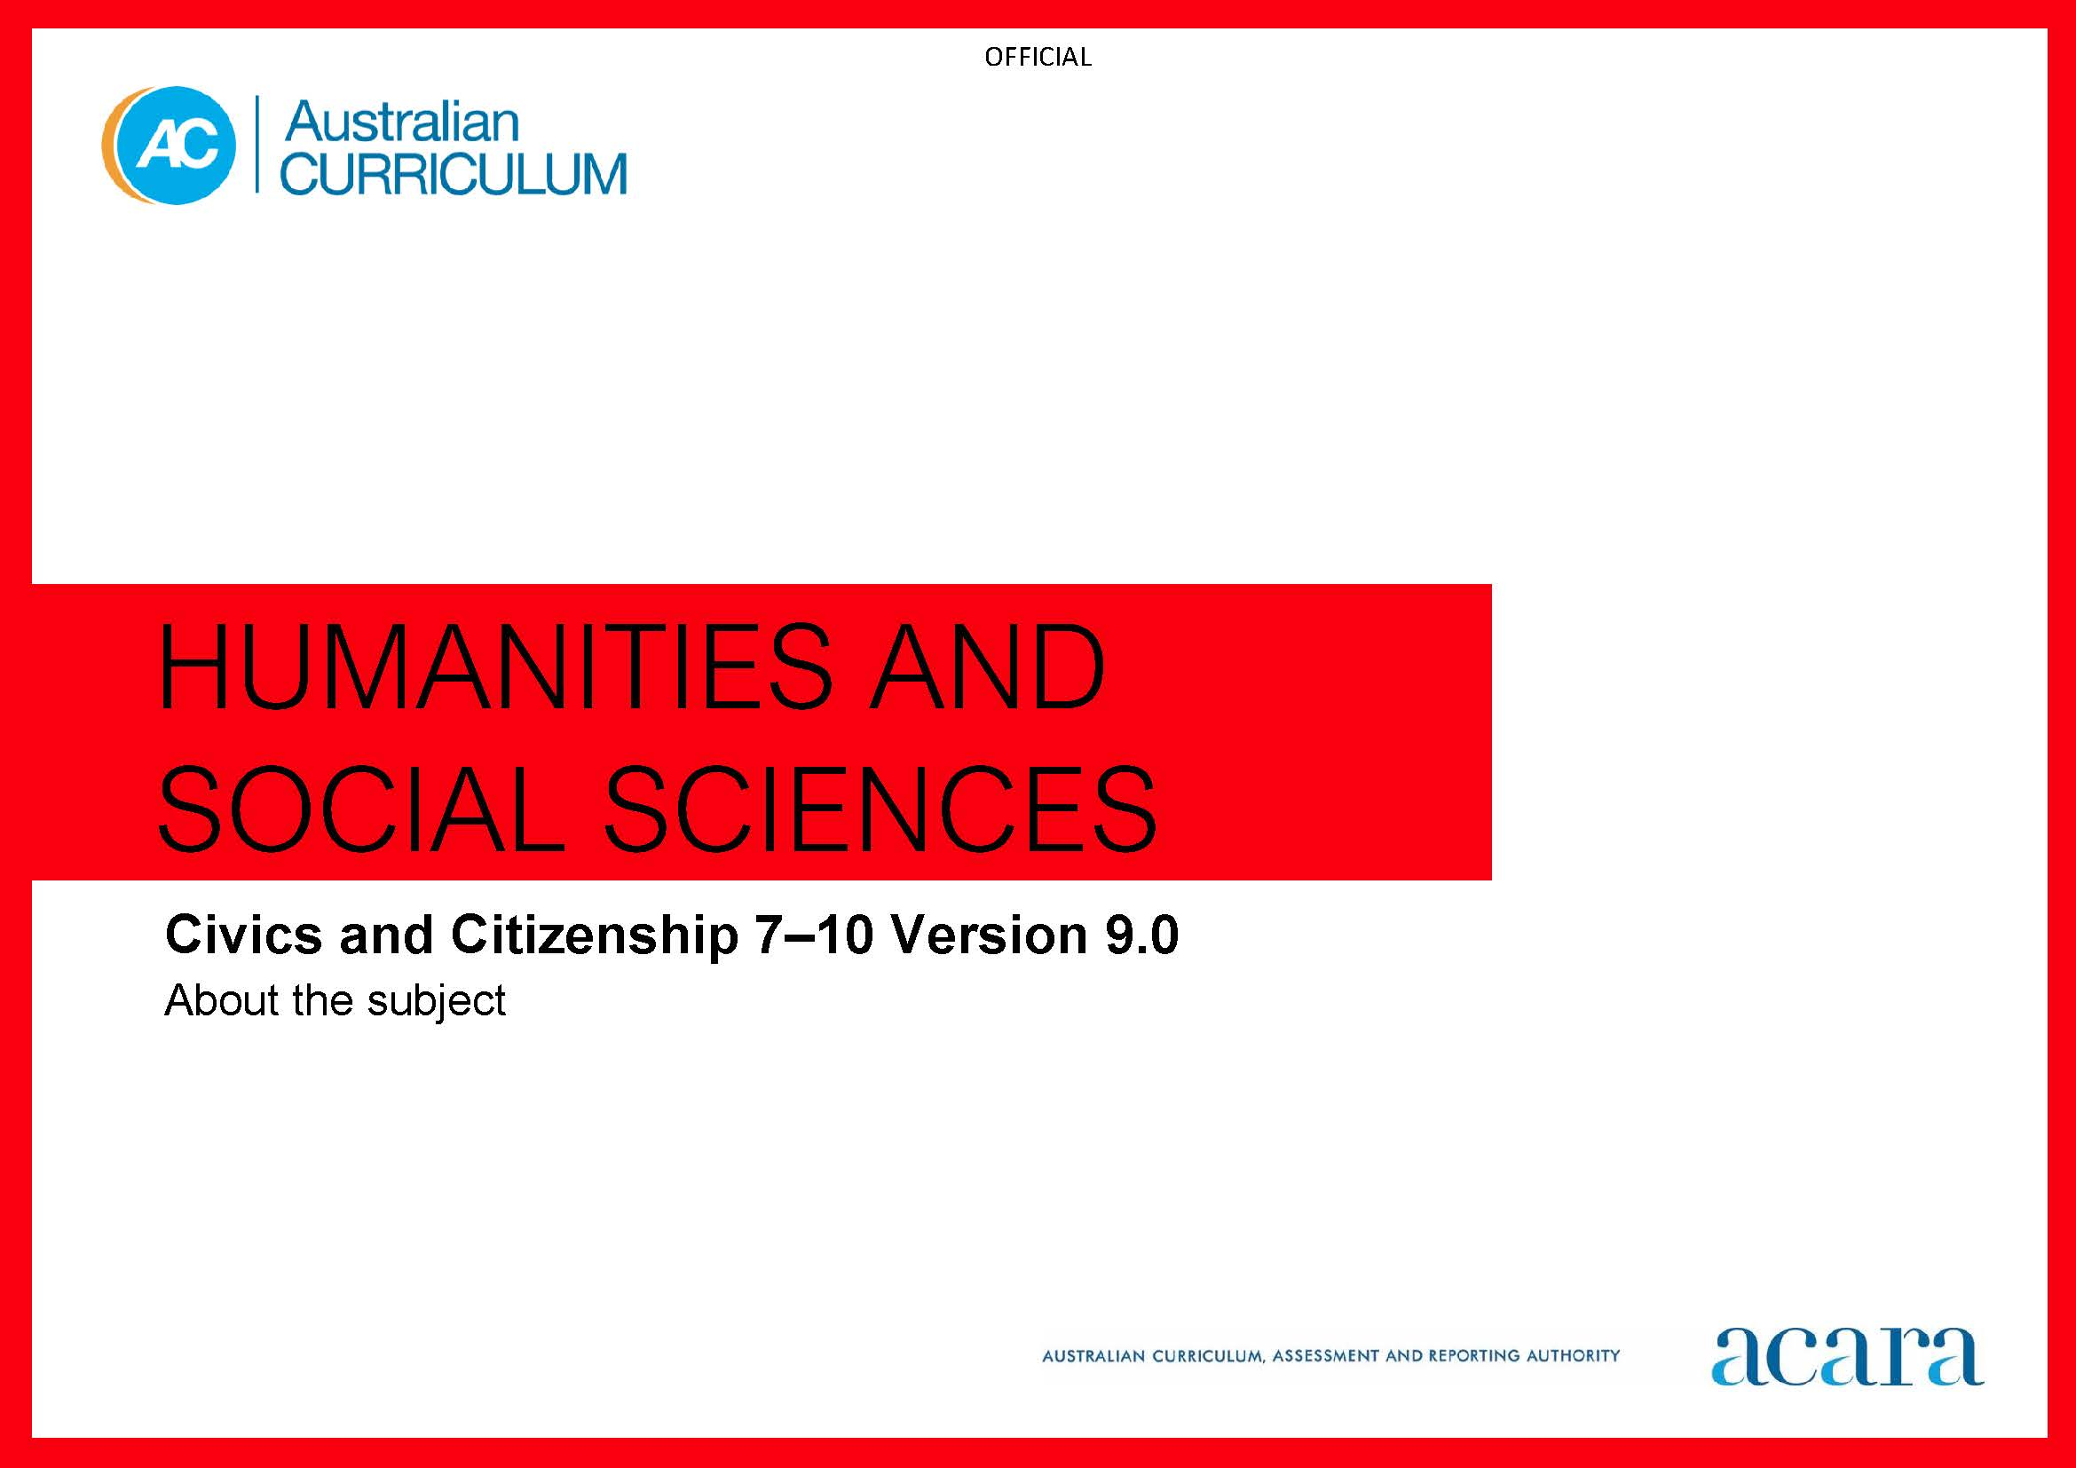

Copyright and Terms of Use Statement
© Australian Curriculum, Assessment and Reporting Authority 2022
The material published in this work is subject to copyright pursuant to the Copyright Act 1968 (Cth) and is owned by the Australian Curriculum, Assessment and Reporting Authority (ACARA) (except to the extent that copyright is held by another party, as indicated).
The viewing, downloading, displaying, printing, reproducing (such as by making photocopies) and distributing of these materials is permitted only to the extent permitted by, and is subject to the conditions imposed by, the terms and conditions of using the ACARA website (see, especially, clauses 2, 3 and 4 of those terms and conditions). The terms and conditions can be viewed at https://www.acara.edu.au/contact-us/copyright

TABLE OF CONTENTS
F–10 AUSTRALIAN CURRICULUM: HUMANITIES AND SOCIAL SCIENCES – CIVICS AND CITIZENSHIP 3
ABOUT CIVICS AND CITIZENSHIP YEARS 7–10 3
Rationale 3
Aims 4
Structure 4
Key considerations 8

F–10 AUSTRALIAN CURRICULUM: HUMANITIES AND SOCIAL SCIENCES – CIVICS AND CITIZENSHIP

ABOUT CIVICS AND CITIZENSHIP YEARS 7–10

Rationale
A deep understanding of Australia’s federal system of government and the liberal democratic values that underpin it is essential for students to become active and informed citizens who can participate in and sustain Australia’s democracy.
Civics and Citizenship provides students with opportunities to investigate political and legal systems, and explore the nature of citizenship, diversity and identity in contemporary society. Emphasis is placed on the federal system of government, derived from the Westminster and Washington systems, and the liberal democratic values that underpin it, such as freedom, equality and the rule of law. The curriculum explores how the people, as citizens, choose their governments; how the system safeguards democracy by vesting people with civic rights and responsibilities; how laws and the legal system protect people’s rights; and how individuals and groups can influence civic life.
The curriculum recognises that Australia is a secular nation with a culturally diverse, multi-faith society and a Christian heritage. The curriculum promotes inclusivity by developing students’ understanding of broader values such as respect, civility, equity, justice and responsibility. It acknowledges the experiences and contributions of First Nations Australians and their identities within contemporary Australia. While the curriculum strongly focuses on the Australian context, students also reflect on Australia’s position and international obligations, and the role of citizens today, both within Australia and in an interconnected world.
Through the study of Civics and Citizenship, students develop inquiry skills, values and dispositions that enable them to be active and informed citizens who question, understand and contribute to the world they live in. The curriculum offers opportunities for students to develop a wide range of skills by investigating contemporary civics and citizenship issues, and fostering civic participation and engagement.
The Civics and Citizenship curriculum aims to reinforce students’ appreciation and understanding of what it means to be a citizen. It fosters responsible participation in Australia’s democracy and explores ways in which students can actively shape their lives, value belonging to a diverse and dynamic society, and positively contribute locally, nationally, regionally and globally. As reflective, active and informed decision-makers, students will be well placed to contribute to an evolving and healthy democracy that fosters the wellbeing of Australia as a democratic nation.

Aims
Civics and Citizenship aims to ensure students develop:
- a lifelong sense of belonging and engagement with civic life as active and informed citizens, in the context of Australia as a secular democratic nation with a dynamic, culturally diverse, multi-faith society that has a Christian heritage, and distinct First Nations Australian histories and cultures
- knowledge, understanding and appreciation of the values, principles, institutions and practices of Australia’s system of democratic government and law, and the role of the citizen in Australian government and society
- an understanding of the concepts of active citizenship, democracy, global citizenship, legal systems, and identity and diversity
- skills including questioning and research; analysis, evaluation and interpretation; civic participation and decision-making; and communicating
- the capabilities and dispositions to participate responsibly in the civic life of their nation at a local, regional and global level, and as individuals in a globalised world.

Structure
Civics and Citizenship is organised in 2 interrelated strands:
- Knowledge and understanding
- Skills.
Civics and Citizenship is presented in year levels for Knowledge and understanding content and in bands for Skills content from Year 7 to Year 10. The 2 strands are interrelated and should be programmed and taught in an integrated way. The content descriptions of the 2 strands have been written so that this integration is possible at each year.
Under each strand, curriculum content is further organised into sub-strands.
Figure 1 outlines the strands and sub-strands.

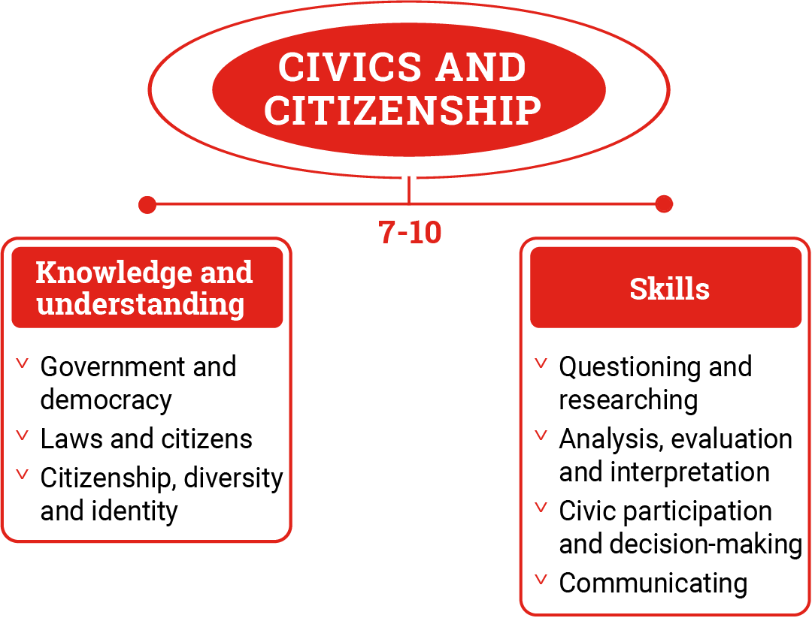
Figure 1: Civics and Citizenship content structure
Knowledge and understanding strand
The Knowledge and understanding strand comprises 3 sub-strands:
Government and democracy
Students study Australian democracy and the key institutions, processes and roles that people play in Australia’s system of government.
Laws and citizens
Students examine Australia’s legal system, the creation of laws, and the rights and legal obligations of Australian citizens.
Citizenship, diversity and identity
Students explore the shared values of Australian citizenship in a society founded on and influenced by Christian traditions and heritage, and First Nations Australians and their histories and cultures. They also explore Australia as a culturally diverse and multi-faith society, factors that shape identity and obligations for citizens in a globalised world.
The sub-strands can be taught separately or together through the exploration of a contemporary issue.
Skills strand
This strand is organised in 2-year bands under 4 sub-strands:
Questioning and researching
Students develop and modify questions to investigate Australia’s political and legal systems, and contemporary civic issues. They locate, sort and evaluate information, data and ideas from a range of sources.
Analysis, evaluation and interpretation
Students analyse information, data and ideas to evaluate different perspectives, beliefs and interpretations about civic, political and legal issues, systems and processes.
Civic participation and decision-making
Students evaluate the methods and strategies related to making decisions about civic participation or action.
Communicating
Students communicate civic and citizenship knowledge, concepts and terms to develop descriptions, explanations and arguments. They use evidence from sources to describe and explain civic and citizenship topics and to develop evidence-based arguments.
Concepts
The Knowledge and understanding and Skills strands develop the following concepts with increasing complexity across Years 7–10.
Active citizenship
Citizens are entitled to certain rights, privileges and responsibilities; therefore, being an active citizen requires engagement and informed participation in the civic and political activities of society at local, state, national, regional and global levels.
Democracy
Democracy is a system of government where power is vested in the people. The will of the majority is accepted and exercised directly or indirectly through elected representatives, who may remove and replace political leaders and governments in free, fair and regular elections.
Global citizenship
Students recognise that in addition to having rights and responsibilities flowing from our Australian citizenship, we also live in an increasingly interdependent world, where citizens’ concerns transcend geographical or political borders, and people can exercise rights and responsibilities at a global level.
Legal systems
Students understand the function of legal systems, the rule of law and its application. They also understand equality before the law, and the importance of judicial independence and objectivity leading to the law being perceived as fair.
Identity and diversity
Identity is a person’s sense of who they are, and conception and expression of their individuality or association with a group, culture, state, nation or a region of the world, regardless of their legal citizenship status. Students’ understanding of diversity includes acknowledgement of Australia as a culturally diverse, multi-faith and cohesive society.

Key considerations
Inquiry questions
Inquiry questions are examples and provide a framework for developing students’ knowledge, understanding and skills. They allow for connections to be made within and across the strands of Knowledge and understanding and Skills. Inquiry questions provided for each year level are examples only and may be used or adapted to suit local contexts.
Contemporary issues
The study of Civics and Citizenship is a contemporary study. Discussions surrounding contemporary issues and engaging in real-world case studies are important for learning that is relevant and meaningful. The discussion of issues can build democratic values such as tolerance, and enhanced civic knowledge, and civic participation and engagement. Engaging students in contemporary issues provides opportunities for student voice and agency. Using contemporary issues enables students to engage with key political, legal, social and economic issues, and to become active and informed citizens.
Making connections between what is learned in class and events or issues that are occurring in the students’ local area, Australia and the world is vital to the study of Civics and Citizenship. Understanding the contemporary landscape is important for being able to bring complex issues into the classroom, use them accurately and to facilitate class discussions. The curriculum can be taught through relevant and contemporary contexts, real-world issues and current affairs by integrating current events, issues and case studies into teaching and learning programs through the Knowledge and understanding strand. The selection of contemporary issues, examples and case studies used in learning activities should be within the recent memory of students to provide the opportunity for increased relevance and student engagement. Students explore contemporary issues through approaches such as class discussions, debates, civic action, role-plays, volunteering, student participatory research, community service and advocacy.
Active citizenship
Active citizenship focuses on the actions that citizens can take to improve their community. “Community” may refer to the school community, the local community, the state, the nation or the global community. The nature of active citizenship will differ between schools. Active citizenship may be as small as improving a classroom recycling program or include large school community social service programs, student leadership programs, volunteer programs and partnership programs with local councils or groups outside the school.
The curriculum encourages students to consider the ways they can participate in school, local, state, national and global communities. They are also asked to consider actions, options and responses in relation to contemporary issues and issues of community concern, and to develop action plans to address these.

