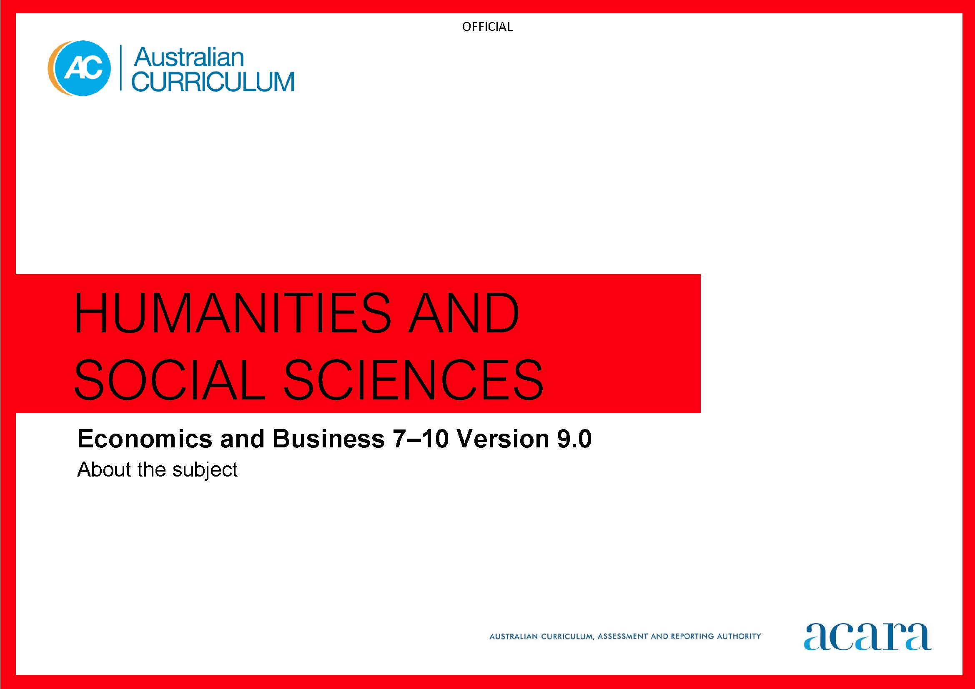

Copyright and Terms of Use Statement
© Australian Curriculum, Assessment and Reporting Authority 2022
The material published in this work is subject to copyright pursuant to the Copyright Act 1968 (Cth) and is owned by the Australian Curriculum, Assessment and Reporting Authority (ACARA) (except to the extent that copyright is held by another party, as indicated).
The viewing, downloading, displaying, printing, reproducing (such as by making photocopies) and distributing of these materials is permitted only to the extent permitted by, and is subject to the conditions imposed by, the terms and conditions of using the ACARA website (see, especially, clauses 2, 3 and 4 of those terms and conditions). The terms and conditions can be viewed at https://www.acara.edu.au/contact-us/copyright

TABLE OF CONTENTS
F–10 AUSTRALIAN CURRICULUM: HUMANITIES AND SOCIAL SCIENCES – ECONOMICS AND BUSINESS 4
ABOUT ECONOMICS AND BUSINESS YEARS 7–10 4
Rationale 4
Aims 4
Structure 5
Key considerations 8

F–10 AUSTRALIAN CURRICULUM: HUMANITIES AND SOCIAL SCIENCES – ECONOMICS AND BUSINESS

ABOUT ECONOMICS AND BUSINESS YEARS 7–10

Rationale
Global flows of people, resources, finances and information produce social, economic, political and environmental complexities and challenges. Consequently, Australia needs enterprising individuals and businesses who embrace opportunities, make informed decisions and contribute to the common good. Young Australians will also face several social, economic, environmental and ethical challenges in their lifetimes, which will impact on their lives and choices. It is critical that students are equipped with the knowledge, understanding and skills to respond to such challenges.
Economics and Business develops the knowledge, understanding and skills that will equip students to shape their social and economic futures. It also aids in the development of prosperous, sustainable and equitable Australian and global economies. Through studying economics and business, students learn to make informed decisions and to appreciate the effects of these decisions on individuals, businesses, and environmental and social systems.
Thinking about and responding to contemporary economic and business issues requires an understanding of resource allocation and economic decision-making, the operation of the business environment, the ways entrepreneurs create solutions, the nature and future of work, and the factors influencing decision-making in consumer and financial contexts.
Economics and Business develops a range of skills that foster enterprising individuals who can effectively embrace change; seek innovation; work with others; show initiative, flexibility and leadership; plan, organise and manage risk; and use resources efficiently.

Aims
Economics and Business aims to ensure students develop:
knowledge and understanding of the nature and operation of the work and business environments within the Australian economy, and factors influencing decision-making, their impacts and appropriate responses
an understanding of the concepts of resource allocation and economic decision-making, the business environment, entrepreneurship, work and work futures, and consumer and financial literacy
a sense of what it is to participate in the economy, contribute to work and business environments, and make informed decisions in relation to contemporary issues drawn from local, national, Asian and global contexts
an appreciation of economic and business issues affecting contemporary Australian society, an understanding of how Australia and Asia are interdependent through economic and business connections, and consideration of sustainable patterns of living
skills to engage in inquiries, including questioning and researching, interpreting and analysing, decision-making, and communicating
capabilities to engage in everyday life, including critical and creative thinking, ethical understanding, and personal and social competence.

Structure
Economics and Business is organised under 2 interrelated strands:
Knowledge and understanding
Skills.
Economics and Business is presented in year levels for Knowledge and understanding content and in bands for Skills content from Year 7 to Year 10. The 2 strands are interrelated and should be programmed and taught in an integrated way. The content descriptions of the 2 strands have been written so that this integration is possible at each year.
Under the Skills strand, curriculum content is further organised into sub-strands.
Figure 1 outlines the strands and sub-strands.

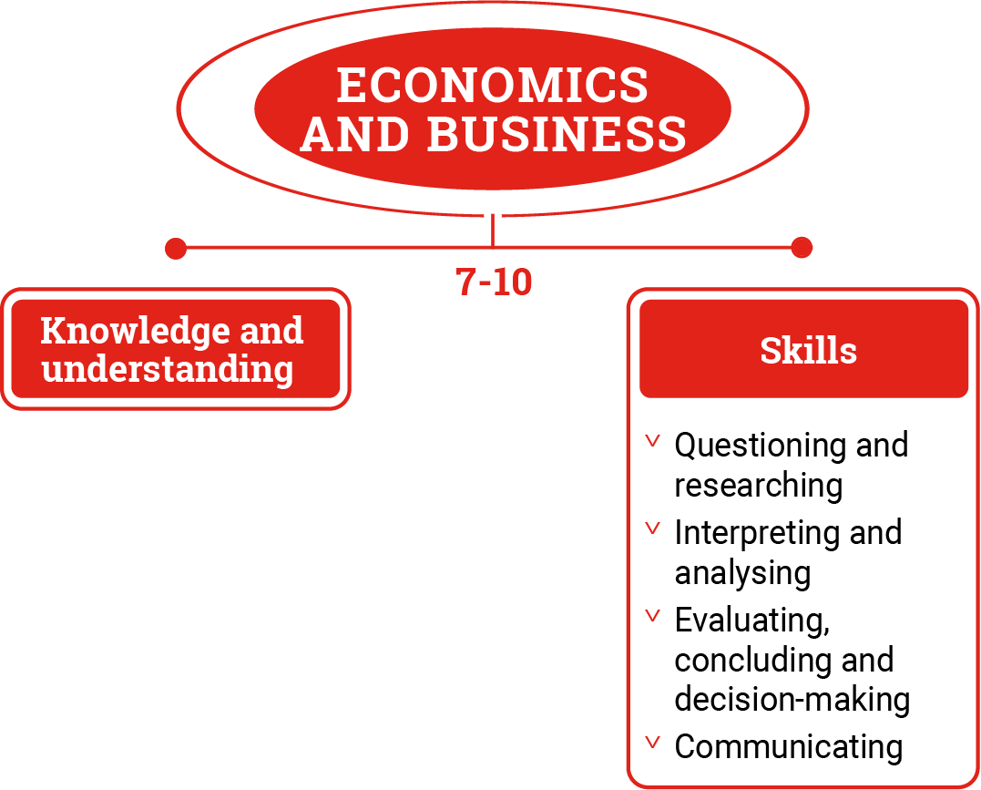
Figure 1: Economics and Business content structure
Knowledge and understanding strand
The Knowledge and understanding strand provides the content and contexts that are developed in increasing complexity across Years 7–10.
Economic and business knowledge refers to the facts, principles, theories and models developed in economics and business. Economic and business understanding is the ability to see the relationships between economic and business concepts, content and contexts.

Skills strand
This strand is organised in 2-year bands under 4 sub-strands:
Questioning and researching
Students develop and modify questions to investigate contemporary economic and business issues. They locate, select and analyse information and data from a range of sources for relevance and reliability.
Interpreting and analysing
Students interpret and analyse information and data about economic and business issues, trends and cause-and-effect relationships. They make predictions about consumer and financial impacts.
Evaluating, concluding and decision-making
Students develop and evaluate a response to an economic and business issue, using cost-benefit analysis or criteria to decide on a course of action.
Communicating
When investigating contemporary economic and business issues, students use relevant economic and business knowledge, research findings, concepts and terms to create descriptions, explanations and reasoned responses.
Concepts
The Knowledge and understanding and Skills strands develop the following concepts with increasing complexity across Years 7–10.
Resource allocation and decision-making
Students learn about the process of choosing between competing alternatives to satisfy unlimited needs and wants with limited resources, through an understanding of scarcity, market systems and opportunity cost, recognising the interdependence of decisions made, as well as the effects of these decisions on individuals, communities and the environment.
The business environment
Students learn about how businesses plan, respond to opportunities and the effects of changing economic conditions, and make economic decisions, through an understanding of the production and exchange of goods and services, markets and trade relationships, the creation and maintenance of competitive advantage, and the interdependence of sectors within the economy.

Entrepreneurship
Students learn about the innovative thinking and calculated risk-taking of individuals and groups developing and implementing creative business solutions, through an understanding of the role of leadership, teamwork and collaborative effort in creating and maintaining competitive advantage, managing the workforce, and improving productivity in a range of business contexts.
Work and work futures
Students learn about the contribution of work to human and financial wellbeing and a prosperous society, through an understanding of the types of work, factors influencing the work environment, the rights and responsibilities of participants in the work environment, and processes businesses use to manage the workforce.
Consumer and financial literacy
Students learn about how consumer and financial decision-making affect human and financial wellbeing, our society and sense of security for the future, through an understanding of the rights and responsibilities of individuals and businesses, planning and budgeting processes, risk management, and factors influencing decision-making.

Key considerations
Inquiry questions
Inquiry questions provide a framework for developing students’ knowledge, understanding and skills. They allow for connections to be made within and across the 2 strands. Inquiry questions provided for each year level are examples only and may be used or adapted to suit local contexts.
Selecting contexts for study
Making connections between the context for study identified in the year level description and economic and business issues that are occurring in the students’ local area, Australia, the significant nations of Asia, and the world is vital to the teaching of this curriculum.
Developing consumer and financial literacy capability
Opportunities to develop capability in consumer and financial literacy are important. The selection of real-world consumer and financial situations, and use of appropriate resources, support the teaching and learning of Economics and Business.

An integrated approach to planning a teaching and learning program
Economics and Business education develops understandings of the economic and business systems, processes and contemporary issues, as well as focusing on decision-making and its effects on individuals, businesses, and environmental and social systems. The challenges of economic decision-making and their impacts are investigated. The curriculum develops understanding of economic concepts such as scarcity, opportunity cost, economic sectors and interdependence as well as business concepts, such as the influence of entrepreneurship, cause-and-effect relationships, cost-benefit analysis, and consumer and financial impacts.
When planning teaching and learning programs, the concepts should be used to develop an integrated approach and interrelate the Economics and Business knowledge, understandings and skills. At each year level, some content descriptions develop economics concepts and principles, while other content descriptions apply these concepts to work and business environments as well as consumer and financial context

