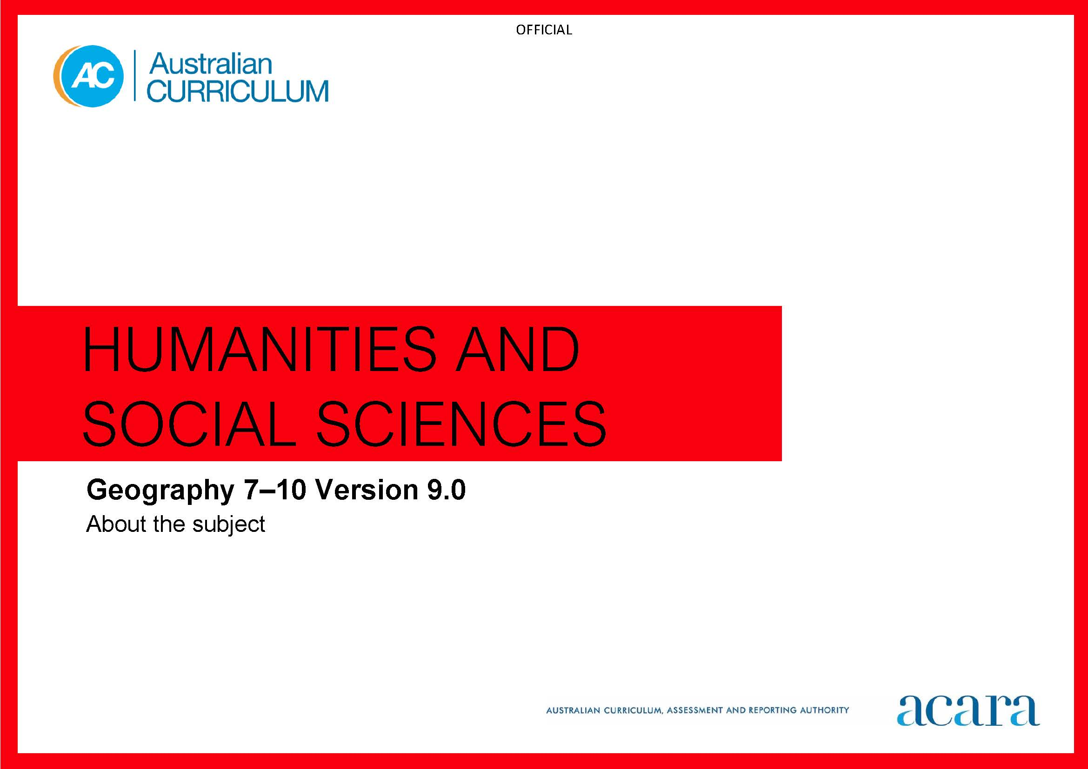

Copyright and Terms of Use Statement
© Australian Curriculum, Assessment and Reporting Authority 2022
The material published in this work is subject to copyright pursuant to the Copyright Act 1968 (Cth) and is owned by the Australian Curriculum, Assessment and Reporting Authority (ACARA) (except to the extent that copyright is held by another party, as indicated).
The viewing, downloading, displaying, printing, reproducing (such as by making photocopies) and distributing of these materials is permitted only to the extent permitted by, and is subject to the conditions imposed by, the terms and conditions of using the ACARA website (see, especially, clauses 2, 3 and 4 of those terms and conditions). The terms and conditions can be viewed at https://www.acara.edu.au/contact-us/copyright

TABLE OF CONTENTS
F–10 AUSTRALIAN CURRICULUM: HUMANITIES AND SOCIAL SCIENCES – GEOGRAPHY 3
ABOUT GEOGRAPHY YEARS 7–10 3
Rationale 3
Aims 3
Structure 4
Key considerations 8

F–10 AUSTRALIAN CURRICULUM: HUMANITIES AND SOCIAL SCIENCES – GEOGRAPHY

ABOUT GEOGRAPHY YEARS 7–10

Rationale
In a world of increasing global integration and international mobility, it is critical to sustainability and human wellbeing that young Australians develop a holistic understanding of the world. This requires deep knowledge and understanding of why the world is the way it is and the interconnections between people, places and environments over time.
Geography inspires curiosity and wonder about the diversity of the world’s people, places and environments. Geography features a structured way of exploring, analysing and understanding the characteristics of the places that make up our world. This enables students to question why the world is the way it is and reflect on their relationships with and responsibilities for the world.
Geography provides students with opportunities to develop a wide range of general skills, capabilities and dispositions that can be applied in everyday life and at work. The subject helps students to develop geospatial technologies and digital tools; an appreciation and respect for social and cultural diversity; a capacity for teamwork; and an ability to solve problems, and to think critically and creatively.
Through the study of Geography, students become informed and responsible members of their local and global communities. They learn to act ethically to sustain and improve natural and social environments, and engage in the global community.

Aims
Geography aims to ensure that students develop:
- a sense of wonder and curiosity about, and respect for, places, people, cultures and environments throughout the world
- a deep geographical knowledge of their own locality, Australia, the countries of Asia and the world
- the ability to inquire and think geographically, using the geographical concepts of place, space, environment, scale, change, interconnections and sustainability
- the capacity to be competent, critical and creative users of geographical methods and skills, including questioning and researching, interpreting and analysing, concluding and decision-making, and communicating effectively
- an appreciation for the nature of geographical phenomena and challenges, and their impact on people’s lives, places and environments
- capabilities to engage in everyday life, including critical and creative thinking, ethical understanding and intercultural understanding.

Structure
Geography is organised into 2 interrelated strands:
- Knowledge and understanding
- Skills.
Geography is presented in year levels for Knowledge and understanding content and in bands for Skills content from Year 7 to Year 10. The 2 strands are interrelated and should be programmed and taught in an integrated way. The content descriptions of the 2 strands have been written so that this integration is possible at each year.
Under each strand, curriculum content is further organised into sub-strands.
It is expected that all sub-strands are studied in each year level in Years 7–8 and if taught as an elective in Years 9–10.
The strands and sub-strands are shown in Figure 1.

Figure 1: Geography content structure

Knowledge and understanding strand
At each year level, the content in the Knowledge and understanding strand is organised under 2 sub-strands, which form the 2 topics to be studied in that year.
Geographical knowledge refers to the facts, generalisations, principles, theories and models developed in Geography. This knowledge is dynamic and its interpretation can be contested, with opinions and conclusions supported by evidence and logical argument.
Geographical understanding is the ability to see the relationships between aspects of knowledge and to construct explanatory frameworks to illustrate these relationships. It is also the ability to apply this knowledge to new situations or to solve new problems.
Skills strand
Geographical skills are the methods that geographers use in their investigations of geographical phenomena and challenges. These skills involve the use of primary research, including fieldwork, and secondary research materials.
Key skills include asking questions, using geographical methods, recording and representing data and information, using geospatial technologies and digital tools, interpreting and analysing data and information, evaluating and decision-making, proposing strategies or responses, and communicating conclusions.
This strand is organised in 2-year bands under 4 sub-strands:
Questioning and researching using geographical methods
Students develop and modify questions, and collect, organise and compare geographical data and information from primary research methods, including fieldwork, and secondary research materials. They record and represent geographical data and information in a range of formats.
Interpreting and analysing geographical data and information
Students explain patterns and trends in data and information, make generalisations and predictions, and infer relationships.
Concluding and decision-making
Students evaluate data and information to draw and justify conclusions about the impact of the geographical challenge or phenomenon. They develop and decide on a strategy, taking account of environmental, economic, social or other criteria, and predict outcomes and impacts.
Communicating
Students create descriptions, explanations and responses, using geographical knowledge and methods, geographical tools as appropriate, and concepts and terms that incorporate and acknowledge research findings.
Concepts
In Years 7–10, students build on their understanding of the following concepts and apply this understanding to the study of places and environments at a range of scales, from local to global, and in a range of locations. These concepts are the key ideas involved in teaching students to think geographically:
Place
The understanding of how places are defined and conceptualised, how their characteristics can be explained, and the influence they have on our lives and on the outcomes of environmental processes and human activities.
Space
The influence of location and distance on people and places, using patterns and trends in distributions to identify causes and consequences, and understanding how people organise space.
Environment
The significance of the environment to people and other living things, understanding how it works, and the influence of the environment on people and of people on the environment.
Scale
The level at which an investigation occurs: personal, local, regional, national or global.
Change
The understanding of causes of phenomena, by finding out how they have changed over time, and using this knowledge to think about how they might change in the future.
Interconnections
The interconnections between people, places and environments; and the way processes and phenomena are influenced by their relationships, interactions and interdependencies within and between places, across a variety of scales.
Sustainability
The maintenance of the capacity of environments to continue to support human life and wellbeing into the future, including environmental, economic, demographic and social sustainability of places.

Key considerations
Inquiry questions
Inquiry questions provide a framework for developing students’ knowledge, understanding and skills. They allow for connections to be made within and across the Geography strands of Knowledge and understanding and Skills. Inquiry questions provided for each year level are examples only and may be used or adapted to suit local contexts.
Primary research methods, including fieldwork
It is important that students have the opportunity to conduct active and first-hand collection, examination, interpretation and analysis of materials in relation to geographical questions. These studies can be conducted from outside the classroom at a local scale, and provide opportunities for the collection of data and application of geographical skills.
Use of geospatial technologies and digital tools
Geography learning experiences are enriched by using geospatial technologies and digital tools. These enable the collection, storage, mapping, representation and visualisation of the occurrence of geographical phenomena and challenges for interpretation and analysis of causes, effects and responses.
For example, students can use geographical information systems (GIS) and global positioning systems (GPS) to create, manage, represent and analyse spatial data. They can view and analyse spatial data through remote sensing and in 3D, and manage and represent geographical data and information in a range of formats.
Selecting contexts for study
When studying Geography, consideration should be given to including and balancing local, regional, national and global scales. It is recommended to include studies of places and environments that are relevant to the focus of each unit at the time. They should be drawn from a range of global locations. The selection of studies should also consider the places relevant to the context of the school and its students.

