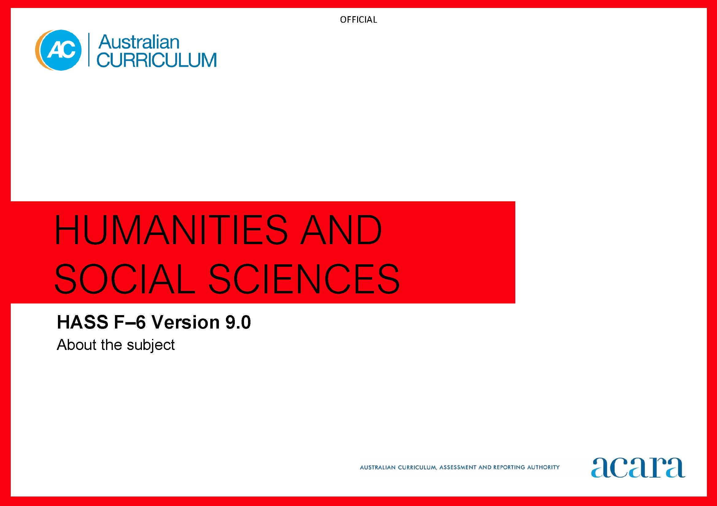

Copyright and Terms of Use Statement
© Australian Curriculum, Assessment and Reporting Authority 2022
The material published in this work is subject to copyright pursuant to the Copyright Act 1968 (Cth) and is owned by the Australian Curriculum, Assessment and Reporting Authority (ACARA) (except to the extent that copyright is held by another party, as indicated).
The viewing, downloading, displaying, printing, reproducing (such as by making photocopies) and distributing of these materials is permitted only to the extent permitted by, and is subject to the conditions imposed by, the terms and conditions of using the ACARA website (see, especially, clauses 2, 3 and 4 of those terms and conditions). The terms and conditions can be viewed at https://www.acara.edu.au/contact-us/copyright

TABLE OF CONTENTS
F–10 AUSTRALIAN CURRICULUM: HUMANITIES AND SOCIAL SCIENCES: F–6 4
About HASS F–6 4
Rationale 4
Aims 4
Structure 5
Key considerations 9

F–10 AUSTRALIAN CURRICULUM: HUMANITIES AND SOCIAL SCIENCES: F–6

About HASS F–6

Rationale
In a world that is increasingly culturally diverse and dynamically interconnected, it is important that students in Foundation to Year 6 develop a deep understanding of their world, past and present. They will continue to strengthen a range of learning dispositions to respond personally and collectively to current and future challenges in innovative and informed ways.
Humanities and Social Sciences (HASS) F–6 plays an important role in harnessing students’ curiosity and imagination about the world they live in. It empowers them to value their belonging and contribution to their community and beyond. HASS F–6 encompasses the knowledge and understandings of History, Geography, Civics and Citizenship, and Economics and Business. It gives students a deep understanding of the world they live in, past and present, and encourages them to appreciate and respect social, cultural and religious diversity.
HASS F–6 supports the development of a range of skills that enable students to question, think critically, consider perspectives, solve problems, make decisions and communicate effectively. Students are given opportunities to develop an understanding of the concepts that underpin the disciplines of HASS. They then apply these concepts when investigating historical, geographical, civic, and economic and business contexts relevant to their lives. These skills are developed holistically through connection to key knowledge and understandings outlined in the curriculum.

Aims
HASS F–6 aims to ensure that students develop:
- foundational knowledge and skills for History, Geography, Civics and Citizenship, and Economics and Business to support their learning in discipline-specific HASS subjects from Years 7–10
- an understanding of the concepts applied to disciplinary and/or cross-disciplinary inquiries
- a sense of their personal world, wider community, country, region and the world in terms of key historical, geographical, civic, and economic and business contexts
- an appreciation of the nature of both past and contemporary Australian society that values the contributions of the histories and cultures of First Nations Australians, Australia’s Western and Christian heritage, and the diversity of other migrant cultures and groups to our prosperous, democratic nation
- skills to engage in inquiries, including questioning, researching, interpreting, analysing, evaluating, decision-making and communicating
- capabilities to engage in everyday life, including critical and creative thinking, ethical understanding and intercultural understanding.

Structure
HASS F–6 is organised under 2 interrelated strands:
- Knowledge and understanding
- Skills.
HASS F–6 is presented in year levels for Knowledge and understanding content and in bands for Skills content from Foundation to Year 6.
The 2 strands are interrelated and should be programmed and taught in an integrated way. The content descriptions of the 2 strands have been written so that this integration is possible at each year. The Knowledge and understanding strand provides the contexts through which the concepts and skills are developed in increasing complexity across Foundation to Year 6.
Under each strand, curriculum content is further organised into sub-strands.
The strands and sub-strands are illustrated in Figure 1.
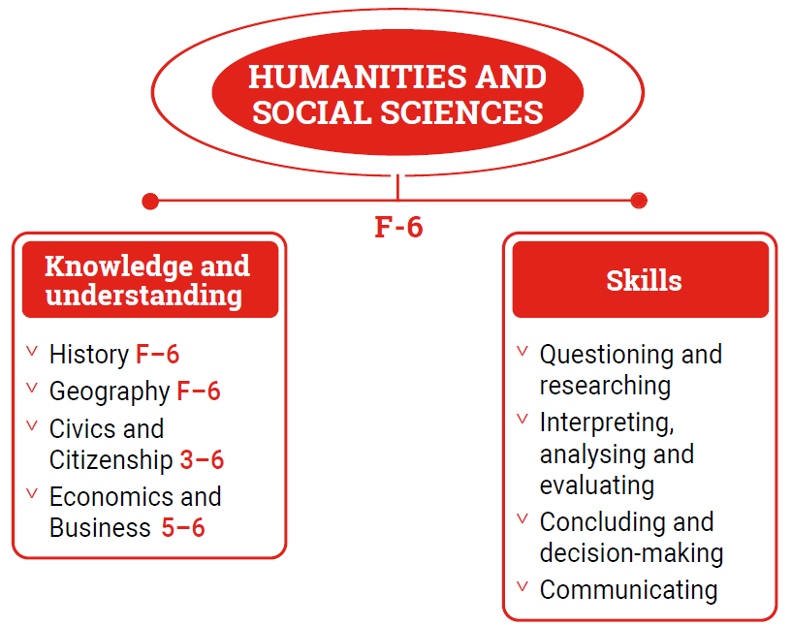
Figure 1: Humanities and Social Sciences F–6 content structure
Knowledge and understanding strand
The Knowledge and understanding strand is organised under the 4 sub-strands:
- History
- Geography
- Civics and Citizenship
- Economics and Business.
The sub-strands of History and Geography exist from Foundation to Year 6, the sub-strand of Civics and Citizenship is introduced in Year 3, and the sub-strand of Economics and Business is introduced in Year 5.
Skills strand
This strand is organised in 2-year bands under 4 sub-strands. Students apply these skills to investigate events, developments, issues and phenomena, both historical and contemporary.
Questioning and researching
Students develop questions about events, people, places, ideas, developments, issues and/or phenomena that relate to their developing understanding of disciplinary concepts (before, during and after stages of inquiry). These questions guide their investigations, satisfy curiosity and revisit findings. Students identify and collect information, evidence and/or data from primary and secondary sources, including observations. They organise, sequence, sort and categorise them in a range of discipline-appropriate formats.
Interpreting, analysing and evaluating
Students explore information, evidence and data to identify and interpret features, patterns, trends and relationships, key points, facts and opinions, points of view, perspectives and interpretations. They identify the purpose and intent of sources and determine their accuracy and reliability.
Concluding and decision-making
Students propose explanations for events, developments, issues and/or phenomena, draw evidence-based conclusions, and use criteria and democratic processes to make informed decisions and judgements. They work respectfully with others and reflect on learning to suggest courses of action in response to an issue or problem. They predict possible and preferred effects of actions.
Communicating
Students select ideas and findings from sources including visual materials, and use relevant terms and conventions, to present narratives, observations, descriptions and explanations.
Concepts
In the Knowledge and understanding and Skills strands, students develop an understanding of the concepts of:
Significance
Students learn about the importance that is assigned to an issue, event, development, person, place, process, interaction or system over time and place.

Continuity and change
Students learn about aspects of society, such as institutions, ideas, values and problems, that remain/ed the same and/or change/d over certain periods of time (some point in the past and the present) or in the past (2 points in the past).
Cause and effect
Students identify the long- and short-term causes and the intended and unintended consequences of an event, decision, process, interaction or development.
Place and space
Students explore the characteristics of places (spatial, social, economic, physical, environmental) and how these characteristics are organised spatially (location, pattern).
Interconnections
Students examine the components of various systems such as social systems, resource systems and natural systems, and the connections within and between them, including how they impact on each other.
Identity and diversity
Students understand the factors, including values and traditions, that shape personal and shared identity, and the diversity of Australia as a culturally diverse and multi-faith society.
Democracy and citizenship
Students learn about the key democratic and legal institutions, processes, rights and roles that underpin Australian democracy, and the responsibilities and obligations of citizens in local, regional, national and global communities.
Resource allocation and making choices
Students understand the process of using available or limited resources for competing alternative uses, and the choices that individuals and societies make to satisfy needs and wants.

Key considerations
Inquiry questions
Inquiry questions provide a framework for developing students’ knowledge, understanding and skills. They allow for connections to be made within and across the HASS Knowledge and understanding sub-strands of History, Geography, Civics and Citizenship, Economics and Business, and other learning areas. Inquiry questions provided for each year level are examples only and may be used or adapted to suit local contexts.
Connecting HASS concepts across the primary curriculum
HASS F–6 has been flexibly designed to suit a range of implementation approaches and classroom contexts. Knowledge and understanding content descriptions support the development of conceptual understanding. HASS concepts provide opportunities to connect learning within HASS sub-strands, across sub-strands, and with other learning areas. Some of the major connections are outlined below:
- The concept of significance in History connects to significant places in Geography, and the impact of significant people and events on contemporary Australian democracy in Civics and Citizenship.
- The focus on continuity and change and cause and effect in History connects to changes in places in Geography, and to understanding patterns of continuity and change in the world in Science.
- The concept of interconnections in Geography aligns to the allocation of resources and consumer choices in Economics and Business. It also connects to ecosystems in Science, and food and fibre production in Design and Technologies.
- The understanding of the natural, managed and constructed features of places in Geography connects to an understanding of the form and function of materials in Science, and materials and technologies in Design and Technologies.
- A focus on the human characteristics of places around the world in Geography connects to the cultural dimensions of The Arts and Languages.
- The concept of identity and diversity in Civics and Citizenship connects to identity in Health and Physical Education, and to the exploration of diverse expressions of identity and culture through The Arts and Languages.
- Active citizenship may be connected to contexts from Geography, Economics and Business, Science, and Design and Technologies.
- Informed consumer and financial choices link to understandings in Mathematics, and Design and Technologies.

