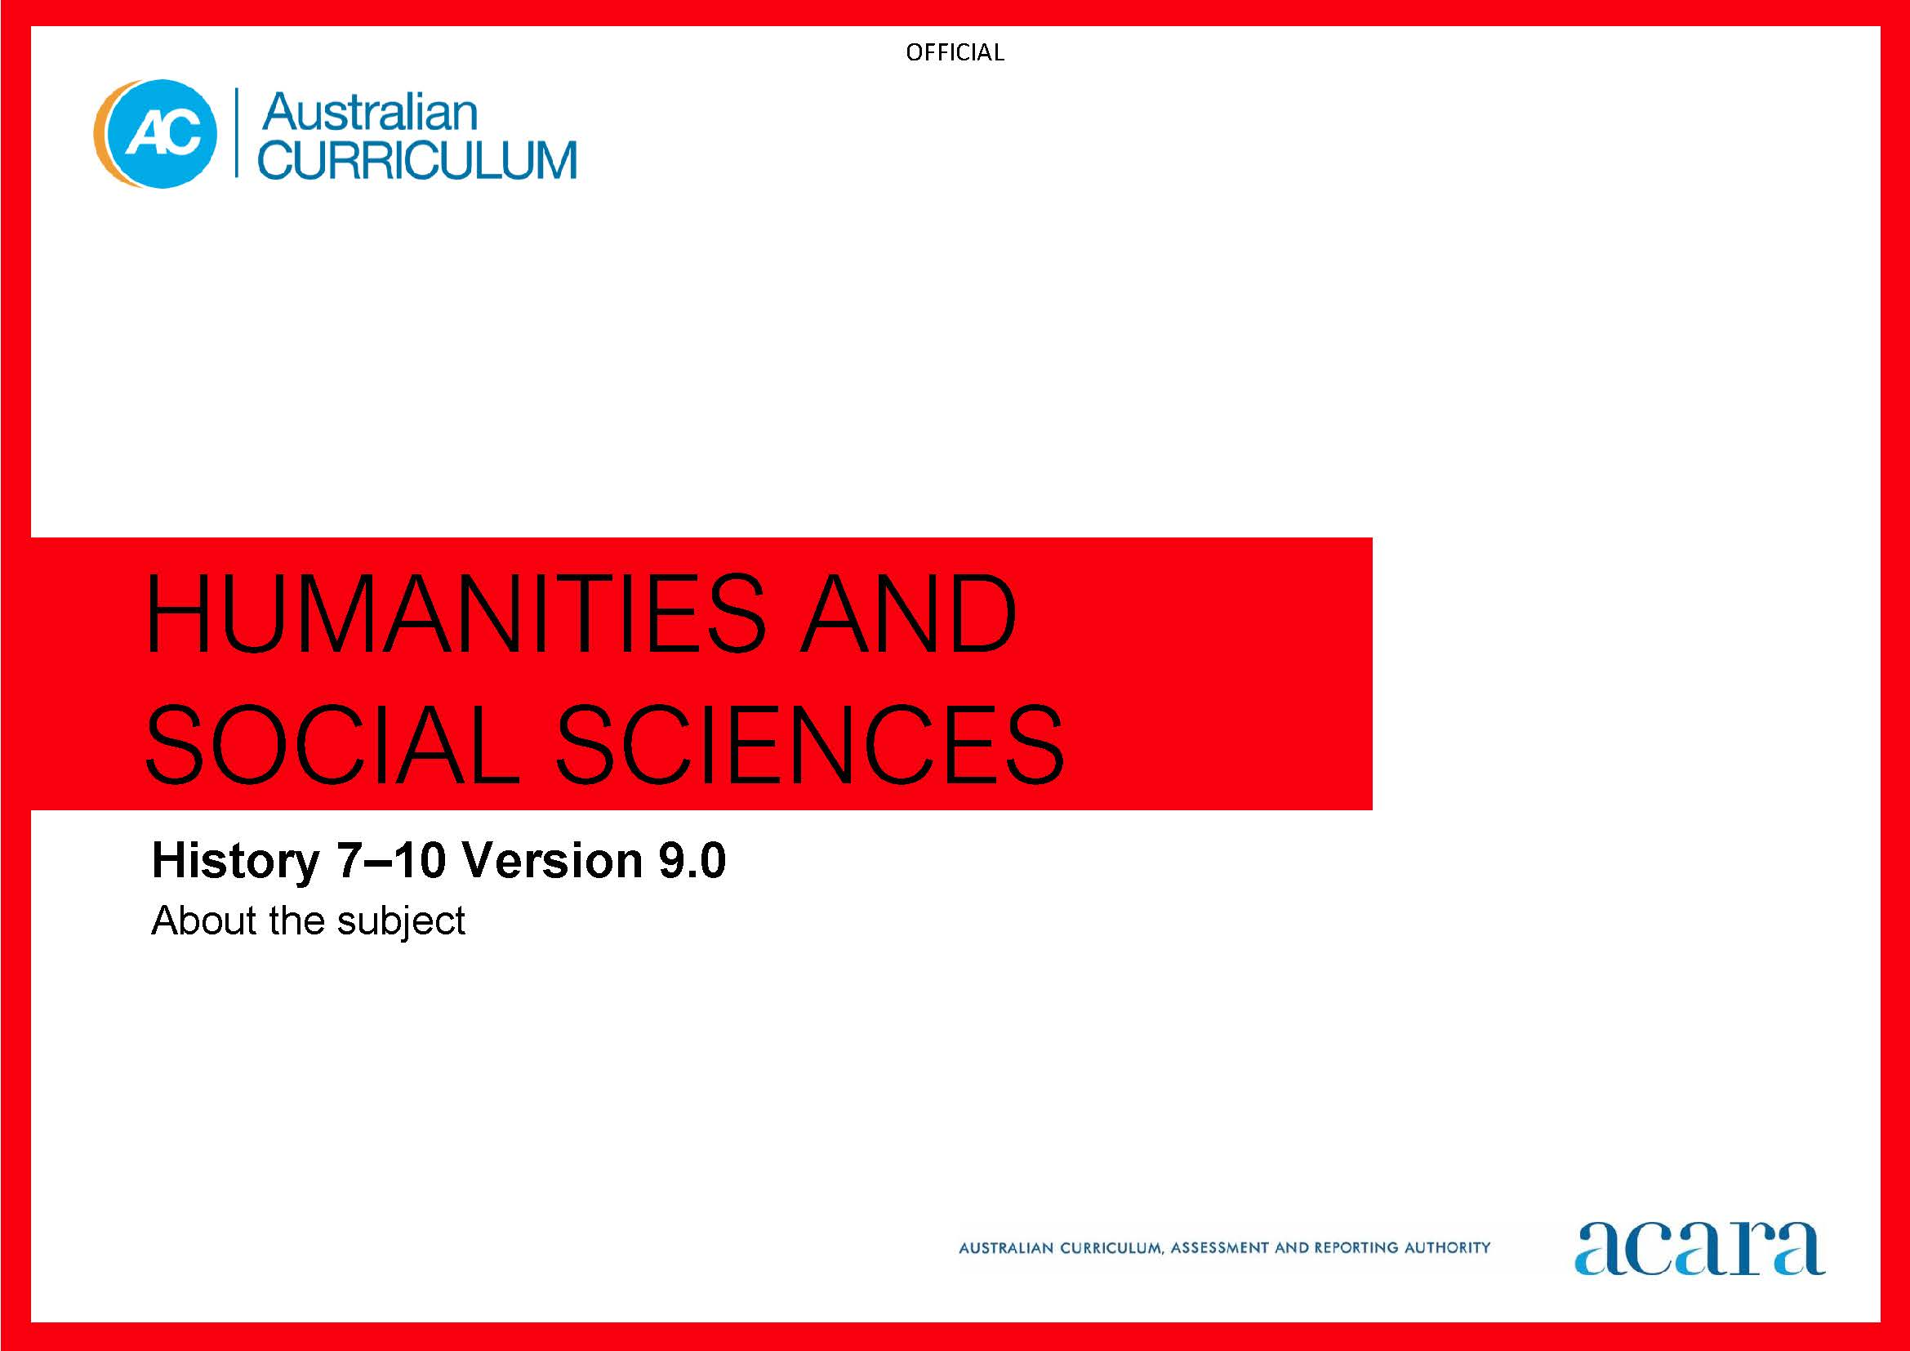
Nzies

Copyright and Terms of Use Statement
© Australian Curriculum, Assessment and Reporting Authority 2022
The material published in this work is subject to copyright pursuant to the Copyright Act 1968 (Cth) and is owned by the Australian Curriculum, Assessment and Reporting Authority (ACARA) (except to the extent that copyright is held by another party, as indicated).
The viewing, downloading, displaying, printing, reproducing (such as by making photocopies) and distributing of these materials is permitted only to the extent permitted by, and is subject to the conditions imposed by, the terms and conditions of using the ACARA website (see, especially, clauses 2, 3 and 4 of those terms and conditions). The terms and conditions can be viewed at https://www.acara.edu.au/contact-us/copyright

TABLE OF CONTENTS
F–10 AUSTRALIAN CURRICULUM: HUMANITIES AND SOCIAL SCIENCES – HISTORY 3
ABOUT HISTORY YEARS 7–10 3
Rationale 3
Aims 3
Structure 4
Key considerations 8

F–10 AUSTRALIAN CURRICULUM: HUMANITIES AND SOCIAL SCIENCES – HISTORY

ABOUT HISTORY YEARS 7–10

Rationale
History is a disciplined process of inquiry into the past that develops students’ knowledge, curiosity and imagination about the past. The application of history is an essential characteristic of any society or community and contributes to its sense of shared identity. History promotes the understanding of societies, events, movements, ideas and developments that have shaped humanity from the earliest times. It helps students appreciate how the world and its people and environments have changed, as well as the significant continuities that exist to the present day.
As a discipline, history has its own methods and procedures that make it different from other ways of understanding human experience. The study of history is based on evidence derived from remains of the past. While always seeking truth, the study of history is interpretative by nature, promotes debate and encourages thinking about human values, including present and future challenges. The process of historical inquiry develops transferable skills such as the ability to ask relevant questions, critically analyse and interpret sources, consider context, explain different perspectives, develop and substantiate interpretations with evidence, and communicate effectively.
History takes a world history approach within which the history of Australia is taught. It does this to equip students for the world in which they live on local, regional and global levels. An understanding of world history enhances students’ appreciation of Australian history. It enables them to develop an understanding of the past and present experiences of Australian First Nations Peoples, their identities and the continuing value of their cultures. It also helps students to appreciate Australia’s distinctive path of social, political, economic and cultural development, its position in the Asia and Pacific regions, and its global interrelationships. This knowledge and understanding are essential for informed and active participation in Australia’s diverse society and for creating rewarding personal and collective futures.

Aims
History aims to ensure that students develop:
- interest in, and enjoyment of, historical study for lifelong learning and work, including their capacity and willingness to be informed and active citizens
- knowledge, understanding and appreciation of the past and the forces that shape civilisations, societies and environments, including Western civilisation, Australian First Nations Peoples’ early societies, and Australian and Asian societies

- the understanding and use of the historical concepts of evidence, perspectives, interpretations and contestability, continuity and change, cause and effect, and significance
- capacity to undertake historical inquiry, including skills for questioning and research, using historical sources, historical perspectives and interpretations, and communicating a historical explanation.

Structure
History is organised under 2 interrelated strands:
- Knowledge and understanding
- Skills.
History is presented in year levels for Knowledge and understanding content and in bands for Skills content from Year 7 to Year 10.
The 2 strands are interrelated and should be programmed and taught in an integrated way. The content descriptions of the 2 strands have been written so that this integration is possible at each year.
Under each strand, curriculum content is further organised into sub-strands.
The strands and sub-strands are illustrated in Figure 1.
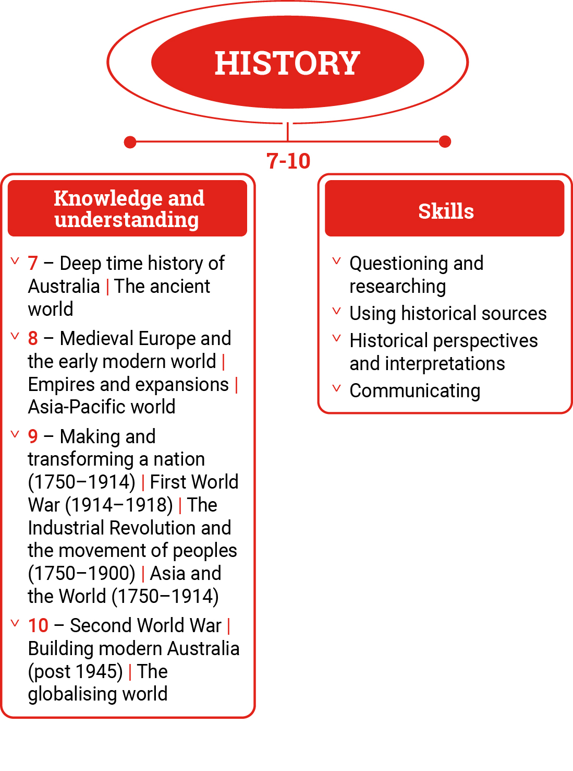
Figure 1: History content structure
Knowledge and understanding strand
This strand includes a range of scales from local to world history. It outlines a study of civilisations, societies, events, movements and developments that have shaped world history from the time of the earliest human communities to the present day.
The content of this strand is organised by sub-strands that focus on particular civilisations, societies, events, movements or developments.
The sub-strands are expected to be taught in depth. In each year level, students will be taught the content from at least 2 sub-strands including Deep time history of Australia and the ancient world in Year 7, Medieval Europe and the early modern world in Year 8, Making and transforming the Australian nation (1759–1914) and the First World War in Year 9, and the Second World War and Building modern Australia (1945 – present) in Year 10.
In some sub-strands there is a choice of topics. The content descriptions for sub-strands with 2 or more topics need to be read in conjunction with the relevant content elaborations, which are linked to specific topics. The content elaborations provide the context and content for the topics in the sub-strands.
Skills strand
This strand is organised in 2-year bands under 4 sub-strands to promote the following skills of historical thinking.
Questioning and researching
Students develop historical questions, and plan and conduct research processes, including locating, identifying and comparing primary and secondary sources.
Using historical sources
Students identify the origin and content of sources, and explain the purpose and context of primary and secondary sources. They explain the usefulness of primary and secondary sources, and the reliability of the information as evidence.
Historical perspectives and interpretations
Students use historical thinking and draw on the concepts of cause and effect, continuity and change, and historical significance to develop an understanding of the past. They identify and analyse multiple long- and short-term causes and effects, observing patterns of continuity and change, and the intended and unintended effects of those changes. They compare perspectives in sources and explain how these are influenced by significant events, ideas, locations, beliefs and values. They analyse and account for different and contested historical interpretations.
Communicating
Students communicate historical knowledge, concepts and terms to develop descriptions, explanations and historical arguments. They incorporate evidence from historical sources to describe and explain the past and to develop arguments, and use appropriate text and referencing conventions.
Concepts
In Years 7–10, students build their understanding of the following concepts in both the Knowledge and understanding and Skills strands. These concepts are the key ideas involved in teaching students to think historically.
Evidence
Evidence is the information obtained from interpreting and analysing primary and secondary sources that can be used to support, revise or challenge a particular historical explanation, interpretation or argument.
Perspectives
Historical perspectives are the positions from which people view events, developments and issues, and explain why people and groups at certain times have particular points of view. These views are shaped by people’s beliefs, values, culture, gender, age, location and experiences.
Interpretations and contestability
Explanations of the past about specific people, groups, events or developments use evidence from historical sources. Contestability occurs when particular interpretations about the past are open to debate; for example, as a result of a lack of evidence, the discovery of new evidence, different perspectives of historians, public commentators or groups.
Continuity and change
Aspects of society, such as institutions, ideas, values and problems remain the same and/or change over certain periods of time (some point in the past and the present) or in the past (2 points in the past).
Cause and effect
Cause and effect includes the long- and short-term causes, and the intended and unintended consequences of an event, decision, process, interaction or development.
Significance
Importance is assigned to an issue, event, development, person, group, place, society, process, interaction or system over time and place. The importance is determined by the prominence of the event, development or issue at the time, its scope and depth, its long-term consequences and its ability to explain issues in the present.

Key considerations
Inquiry questions
Inquiry questions provide a framework for developing students’ historical knowledge, understanding and skills. They allow for connections to be made within and across the History strands. Students may use these questions to guide a historical inquiry about significant events, periods and eras, individuals, groups, ideas, places and developments. Students can use inquiry questions to shape inquiries about cause and effect, continuity and change, and historical significance. Inquiry questions provided for each year level are examples only and may be used or adapted to suit the historical contexts.
Historical sources
Using primary and secondary historical sources is foundational to historical thinking and inquiry, and to students’ understanding of the past. Primary sources are the building blocks of historical thinking and are fundamental to students’ understanding and interpretation of the past. Secondary sources, such as textbooks or historical interpretations made by historians or commentators, often draw on primary sources to present arguments or interpretations about the past. When using historical sources, students draw on historical perspectives and interpretations as evidence when constructing arguments about the past.
In developing teaching activities, teachers should select both primary sources (including historical perspectives) and secondary sources (including historical interpretations). Teachers should also consider selecting a range of source types, including written, visual, audio, audio-visual and artefacts; source forms such as speeches, newspapers, political cartoons, photos, paintings, radio and film recordings; and material culture. Students should be working towards using multiple sources, and different types and forms of sources. The number of historical sources used will depend on the level(s) and student proficiency in using historical sources. Using historical sources requires source identification, contextualisation, attribution, analysis and corroboration with other sources. Students’ interrogation of historical sources should be used as evidence to support their own historical interpretations, inquiries and arguments about the past.
Australian history within a world history approach
Australian history should not be considered in isolation but examined as part of wider global processes. These include the mass emigration of people, development of settler colonies, encounters with Indigenous peoples, development of liberal democracies and the creation of political systems, economic development, war and conflict, and global civil rights movements. When planning teaching and learning programs, it is important to contextualise national history within a wider, sometimes global, context.
In Years 7–10, students should study a balanced range of topics to develop an understanding of Australian First Nations Peoples’ histories and cultures, the foundations of Western civilisation, Australian history and the history of our Asia-Pacific region. Students should consider the significant events, people, groups and ideas in Australian history. They should make links between how global events can shape and influence national events and ideas, and explore Australian developments in a wider transnational and comparative context.

