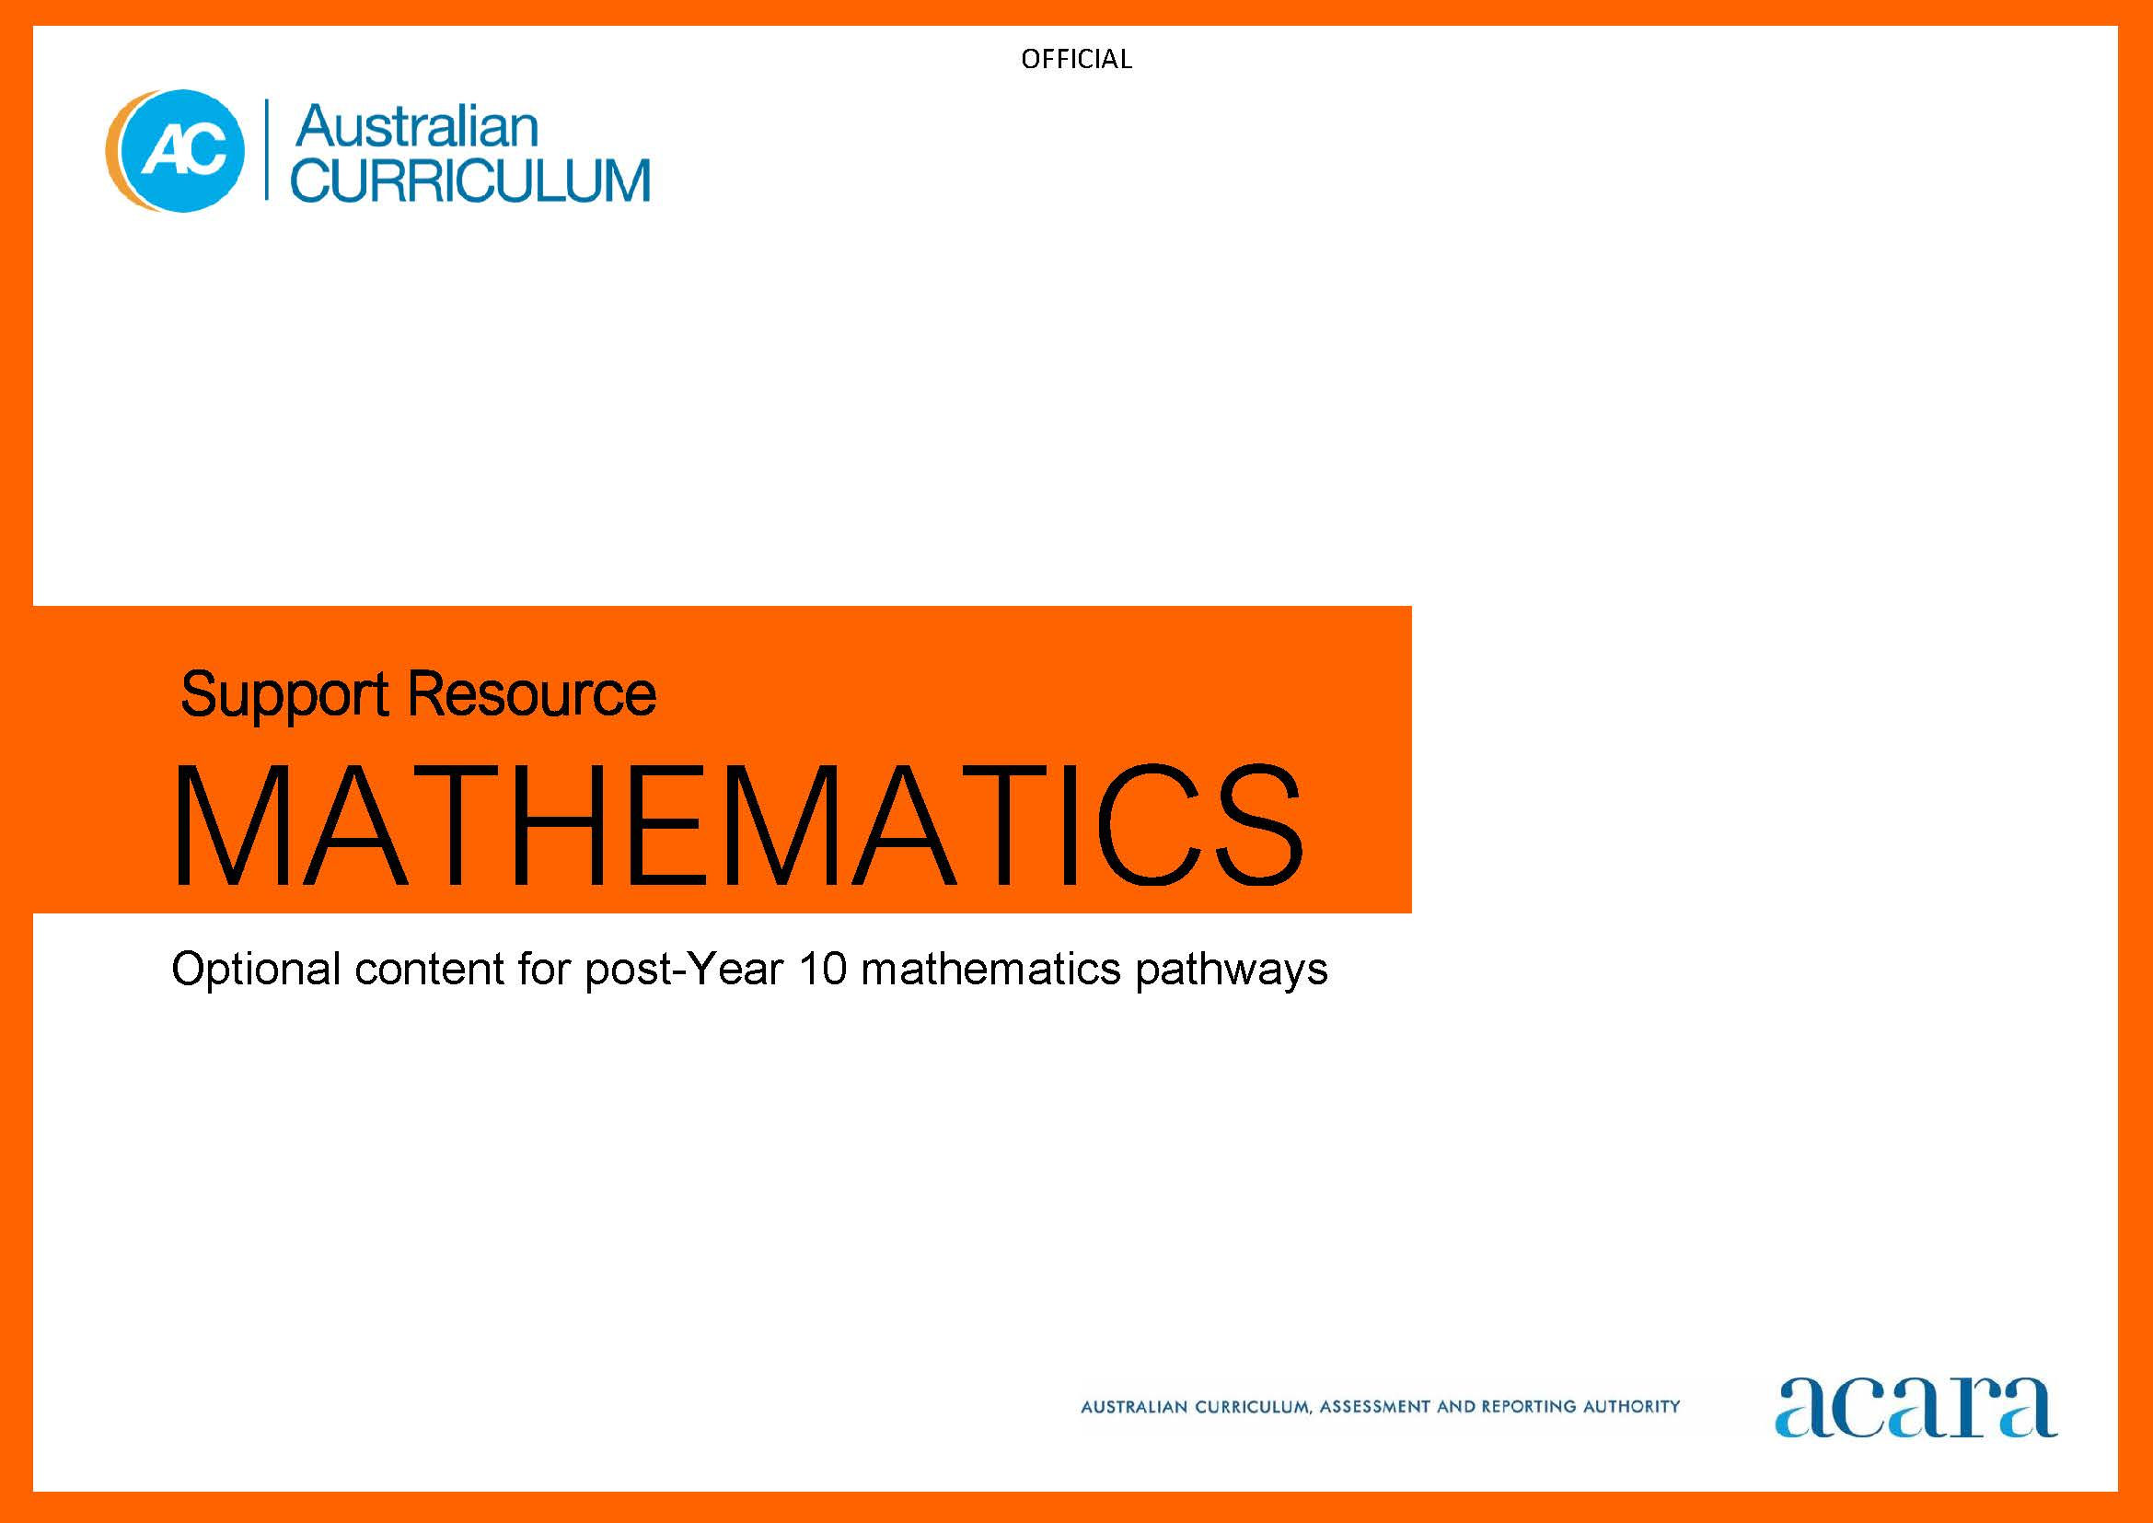

Copyright and Terms of Use Statement
© Australian Curriculum, Assessment and Reporting Authority 2022
The material published in this work is subject to copyright pursuant to the Copyright Act 1968 (Cth) and is owned by the Australian Curriculum, Assessment and Reporting Authority (ACARA) (except to the extent that copyright is held by another party, as indicated).
The viewing, downloading, displaying, printing, reproducing (such as by making photocopies) and distributing of these materials is permitted only to the extent permitted by, and is subject to the conditions imposed by, the terms and conditions of using the ACARA website (see, especially, clauses 2, 3 and 4 of those terms and conditions). The terms and conditions can be viewed at https://www.acara.edu.au/contact-us/copyright

F–10 AUSTRALIAN CURRICULUM: Mathematics

Optional content for post -Year 10 mathematics pathways

Introduction
The Australian Curriculum: Mathematics F – 10 provides students with essential mathematical knowledge, skills, procedures and processes in number, algebra, measurement, space, statistics and probability.
It develops the numeracy capabilities that all students need in their personal, work and civic lives, and provides the fundamentals on which mathematical specialties and professional applications of mathematics are built.
In Year 10, students also consider possible pathways to study senior secondary mathematics.
Preparation for subsequent study of subjects based on ACARA’s Mathematical Methods Units 1 and 2 can be supported by further development of aspects of mathematics from Year 10. This provides a basis for building understanding that underpins these and equivalent courses of study.
The following advice provides suggestions for further content and skill development in this regard, with some illustrative examples.
Teachers can draw on these suggestions as applicable to support students with additional content to extend and enrich their study of the Year 10 Mathematics curriculum.
OPTIONAL CONTENT FOR POST -YEAR 10 MATHEMATICS PATHWAYS
Strand: Number
Suggested content | Illustrative examples
operations on numbers involving fractional exponents and surds | - explaining that $\sqrt{a}= a^{\frac{1}{2}}= a^{0.5 }$for $a≥0 ,$generalizing to $\sqrt[n]{a}=a^{\frac{1}{n}}$, and evaluating corresponding expressions; for example, $\sqrt{10}= {10}^{0.5}≈3.162 ,$ $2^{5}=32 so {32}^{\frac{1}{5}}= \sqrt[5]{32}=2$  - explaining that $a^{\frac{m}{n}}= {\left(a^{\frac{1}{n}}\right)}^{m}= {\left(\sqrt[n]{a}\right)}^{m}= \sqrt[n]{a^{m}}={\left(a^{m}\right)}^{\frac{1}{n}}$ and evaluating corresponding expressions; for example, $8^{\frac{2}{3}}={\left(\sqrt[3]{8}\right)}^{2}= 2^{2}=4 and 8^{\frac{2}{3}}= \sqrt[3]{8^{2}}=\sqrt[3]{64}=4$  - using the $y^{x}$ and $\sqrt[x]{y}=y^{\frac{1}{x}}$ functions of technology to evaluate expressions involving decimal exponents and surds approximately, for example, ${10}^{3.47}≈2951.21$,  $\sqrt[3]{78} ≈4.273$, ${200}^{0.7}≈40.8057$  - showing that $\sqrt{a+b}≠\sqrt{a}+\sqrt{b}$ and $\sqrt{a- b} ≠\sqrt{a}- \sqrt{b}$for $a, b>0$, for example,  $\sqrt{16+9}=\sqrt{25}=5 but \sqrt{16}+\sqrt{9}=4+3=7$ and $\sqrt{16-9}=\sqrt{7} ≈2.646, but \sqrt{16}-\sqrt{9}=4-3=1$  - calculating with products and quotients of square roots, including simplifying square roots of natural numbers that have perfect square factors, for example, $\sqrt{96}=\sqrt{16 ×6}=\sqrt{16}× \sqrt{6}=4\sqrt{6}$ , and rationalizing expressions involving square roots, for example, $\sqrt{\frac{13}{5}}=\frac{\sqrt{13}}{\sqrt{5}}=\frac{\sqrt{13}}{\sqrt{5}}×\frac{\sqrt{5}}{\sqrt{5}}=\frac{\sqrt{13}×\sqrt{5}}{\sqrt{5}×\sqrt{5}}=\frac{\sqrt{65}}{5}$  - performing the four arithmetic operations with surds of the form $a+b\sqrt{n }$where n is a natural number, including rationalising the denominator of a quotient, for example,  $$\frac{\left(3+\sqrt{7}\right)}{\left(3-\sqrt{7}\right)}=\frac{\left(3+\sqrt{7}\right)}{\left(3-\sqrt{7}\right)}×\frac{\left(3+\sqrt{7}\right)}{\left(3+\sqrt{7}\right)}=\frac{16+6\sqrt{7}}{2}=8+3\sqrt{7}$$

Strand: Algebra
Suggested content | Illustrative examples
simplification of combinations of linear expressions with rational coefficients and the solution of related equations | - simplifying sums and differences of linear expressions of the form $\frac{ax+b}{c}$ where  $a and b$ are integers, and $c$ is a non-zero integer, for example, $\frac{6x-11}{2}-\frac{7x}{4}+\frac{9-5x}{3}=\frac{-5x-30}{12}$  - solving equations involving sums and differences of linear expressions with rational coefficients, for example $\frac{-2x}{3}+\frac{4}{9}= \frac{11}{5}\left(7x-1\right) ⇒-30x+20=693x-99 ⇒x=\frac{119}{723} ,$and verifying the solution
algebraic representations of quadratic functions of the form  $f\left(x\right)=ax^{2}+bx+c$ | - connecting the expanded and transformed representations of a quadratic function by completing the square, for example, $x^{2}+3x+1= {\left(x+\frac{3}{2}\right)}^{2}-\frac{5}{4}$  and $2x^{2}+8x-5=2{\left(x+2\right)}^{2}-13$
where$a, b and c$are non-zero integers, and their transformation to the form $f\left(x\right)=a{\left(x+h\right)}^{2}+k$ $where h and k$ are non-zero rational numbers, and the solution of related equations | - deriving the quadratic formula and applying it to solve quadratic equations, using the discriminant to identify the number and nature of the roots of a quadratic equation, and verifying solutions  - identifying what can be known about the graph of a quadratic function by considering its coefficients, the discriminant and symmetry to assist sketching by hand  - recognising conjugate pairs of irrational roots of a quadratic equation and their location with respect to the axis of symmetry of the graph of the corresponding function
the graphs of $y=\sin{(x)}$ and $y=\cos{(x)}$as functions of a real variable and the solution of related equations | - exploring the use of the unit circle and animations to show the periodic, symmetric, and complementary nature of the sine and cosine functions  - graphing the sine and cosine functions over different domains of a real variable, including negative values  - establishing relationships between Pythagoras’ theorem, the unit circle, trigonometric ratios, and angles in half-square triangles and equilateral triangles  - approximating values of the sine and cosine functions from a suitably scaled diagram of the unit circle, and solving equations of the form $\text{sin}\left(x\right)=\frac{1}{√2}$ and $\text{cos}\left(x\right)=-0.73$ over a specified interval graphically
the inverse relationship between exponential functions and logarithmic functions and the solution of related equations | - using the definition of a logarithm and the exponent laws to establish the logarithm laws  - evaluating ${10}^{x}$ for decimal values of $x$and relating this to a logarithm base 10 scale; solving exponential equations algebraically using base 10 logarithms; for example, $5 000×{1.01}^{x}=10 000⟹x= \frac{\log_{10}(2)}{\log_{10}(1.01)}≈69.66,$ and connecting to the graph of the corresponding function

Strand: Measurement
Suggested content | Illustrative examples
the effect of increasingly small changes in the value of variables on the average rate of change and in relation to limiting values | - using the gradient of the line segment between two distinct points as a measure of rate of change to obtain numerical approximations to instantaneous speed and interpreting ‘tell me a story’ piecewise linear position-time graphs

Strand: Space
Suggested content | Illustrative examples
relationships between angles and various lines associated with circles (radii, diameters, chords, tangents) | - identifying relationships, angles between tangents and chords, angles subtended by a chord with respect to the centre of a circle, and with respect to a point on the circumference of a circle, including using dynamic geometric software  - exploring how deductive reasoning and diagrams are used in proving geometric theorems related to circles

Strand: Statistics
Suggested content | Illustrative examples
measures of spread, their interpretation and usefulness with respect to different data distributions | - comparing the use of quantiles, percentiles, and cumulative frequency to analyse the distribution of data  - comparing measures of spread for different data distributions, such as mean or median absolute deviations with standard deviations, and exploring the effect of outliers

Strand: Probability
Suggested content | Illustrative examples
counting principles, and factorial notation as a representation that provides efficient counting in multiplicative contexts, including calculations of probabilities | - applying the multiplication principle to problems involving combinations including probabilities related to sampling with and without replacement, and representing these using tree diagrams  - understanding that a set with $n$ elements has $2^{n}$ different subsets formed by considering each element for inclusion or not in combination, and that these can be systematically listed using a tree diagram or a table, for example, the set $\{a, b, c\}$ has $2^{3}=8$subsets which are {$∅, \left\{a\right\}, \left\{b\right\}, \left\{c\right\}, \left\{a, b\right\}, \left\{a, c\right\}, \left\{b, c\right\}, \left\{a, b, c\right\}$}.  - using the definition of $n$! to represent and calculate in contexts that involve choices from a set for example, how many different combinations of 3 playing cards from a pack? How many if the suits are ignored? How many with and without replacement?  - performing calculations on numbers expressed in factorial form, such as $\frac{n!}{r!}$ to evaluate the number of possible arrangements of $n$ objects in a row, $r$ of which are identical, for example 5 objects, 3 of which are identical, can be arranged in a row in  $\frac{5!}{3!}=\frac{5 ×4 ×3 ×2 ×1}{3 ×2 ×1}=$ 20 different ways

