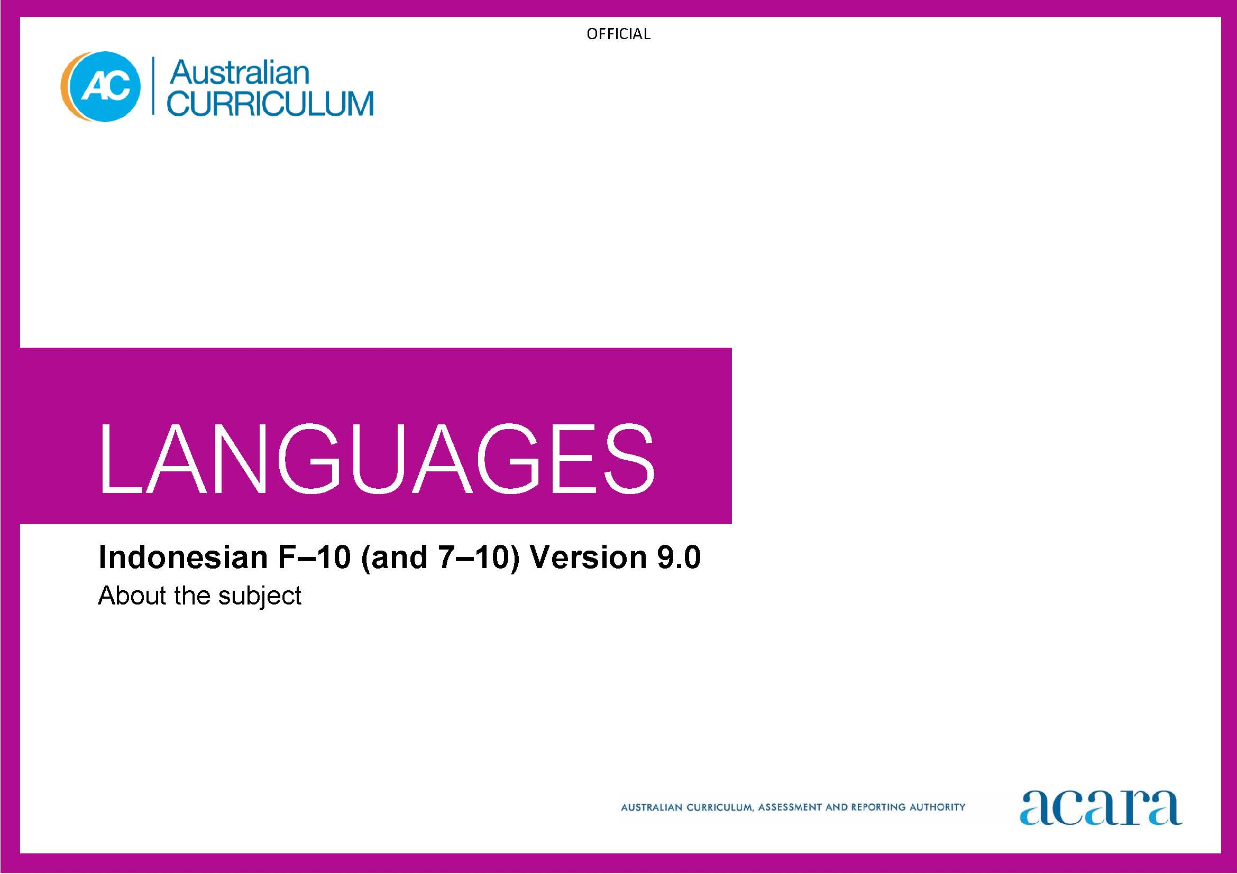

Copyright and Terms of Use Statement
© Australian Curriculum, Assessment and Reporting Authority 2022
The material published in this work is subject to copyright pursuant to the Copyright Act 1968 (Cth) and is owned by the Australian Curriculum, Assessment and Reporting Authority (ACARA) (except to the extent that copyright is held by another party, as indicated).
The viewing, downloading, displaying, printing, reproducing (such as by making photocopies) and distributing of these materials is permitted only to the extent permitted by, and is subject to the conditions imposed by, the terms and conditions of using the ACARA website (see, especially, clauses 2, 3 and 4 of those terms and conditions). The terms and conditions can be viewed at https://www.acara.edu.au/contact-us/copyright

TABLE OF CONTENTS
F–10 AUSTRALIAN CURRICULUM: LANGUAGES – INDONESIAN 3
ABOUT INDONESIAN 3
Introduction 3
Rationale 3
Structure 3

F–10 AUSTRALIAN CURRICULUM: LANGUAGES – INDONESIAN

ABOUT INDONESIAN

Introduction
The Australian Curriculum: Indonesian is pitched to second language learners, that is, the dominant group of learners in the current Australian context for whom Indonesian is an additional language.
Students of Indonesian in Australian schools come from a range of backgrounds. For most students it is their first experience of learning Indonesian, while some may have existing connections to Indonesian as background speakers of the language.

Rationale
Indonesian has been the official language of Indonesia since the country’s independence. It is a standardised language, spoken throughout the Indonesian archipelago. It is closely related to Malay and other variants used in Malaysia, Singapore, Brunei and southern Thailand.
Contact between First Nations Peoples of northern Australia and the peoples of the islands now known as Indonesia has been in place for several centuries with the sharing of art, commerce, cuisine, culture and language. As Australia’s largest neighbour in the Asia-Pacific region of Southeast Asia, commercial, cultural and linguistic ties between Indonesia and Australia continue to be of significance.
Indonesian has been taught in some Australian schools and universities since the 1950s and relations between Indonesia and Australia continue to grow in the area of education as well as trade and cultural exchanges. Australia has a strong diplomatic presence in Indonesia and significant numbers of Australians travel to Indonesia for education, business and leisure. There is an increasing number of Indonesian-speaking communities across Australia.
The Indonesian language uses a Romanised script and has phonetic pronunciation so speakers of English can predict how to say, read or write Indonesian words. Learning Indonesian enhances students’ understanding of language learning strategies and develops an appreciation of the language and cultures of Indonesian-speaking communities. Knowledge of Indonesian language and culture enriches travel experiences, increases employment opportunities, and promotes understanding of diverse attitudes, beliefs and values.

Structure
Indonesian has been developed as a Second Language Learner Pathway which caters for students learning Indonesian as a second or additional language.
The Second Language Learner Pathway includes 2 sequences:
- Foundation to Year 10
- Years 7 to 10.
Teachers use the curriculum to cater for learners of different backgrounds by making appropriate adjustments to differentiate learning experiences.
Content in Indonesian is organised under 2 interrelated strands, each with a number of sub-strands. The strands and sub-strands are presented in Figure 1.
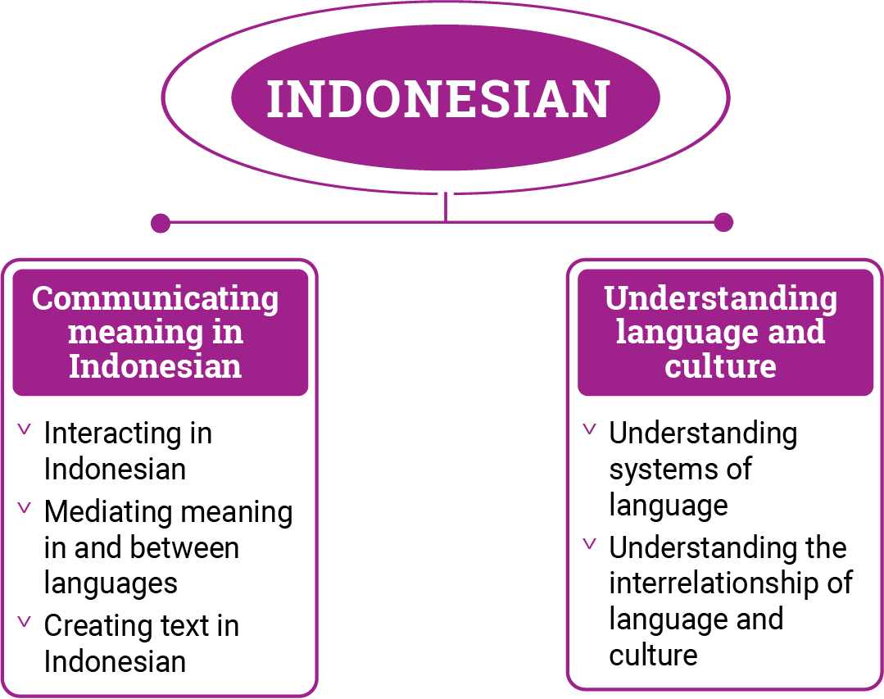
Figure 1: Indonesian content structure

Strand: Communicating meaning in Indonesian
This involves students learning to use language for communicative purposes in interpreting, creating and exchanging meaning. There are 3 sub-strands.
Interacting in Indonesian
Exchanging ideas, opinions, experiences, thoughts and feelings in non-verbal, spoken and written interactions; participating in planning, negotiating, deciding and taking action.
Mediating meaning in and between languages
Obtaining, processing, interpreting and conveying information through a range of spoken, written and multimodal texts; moving between languages and cultures non-verbally, orally and in writing, recognising different interpretations.
Creating text in Indonesian
Creating a range of spoken, written and multimodal texts for specific contexts, purposes and audiences.
Strand: Understanding language and culture
This involves students learning to analyse and understand language and culture as resources for interpreting and shaping meaning in intercultural exchange. There are 2 sub-strands.
Understanding systems of language
Understanding the linguistic features of Indonesian, including sound, writing, grammatical and textual conventions.
Understanding the interrelationship of language and culture
Analysing and reflecting on the role of language and culture in shaping meaning and identity.

