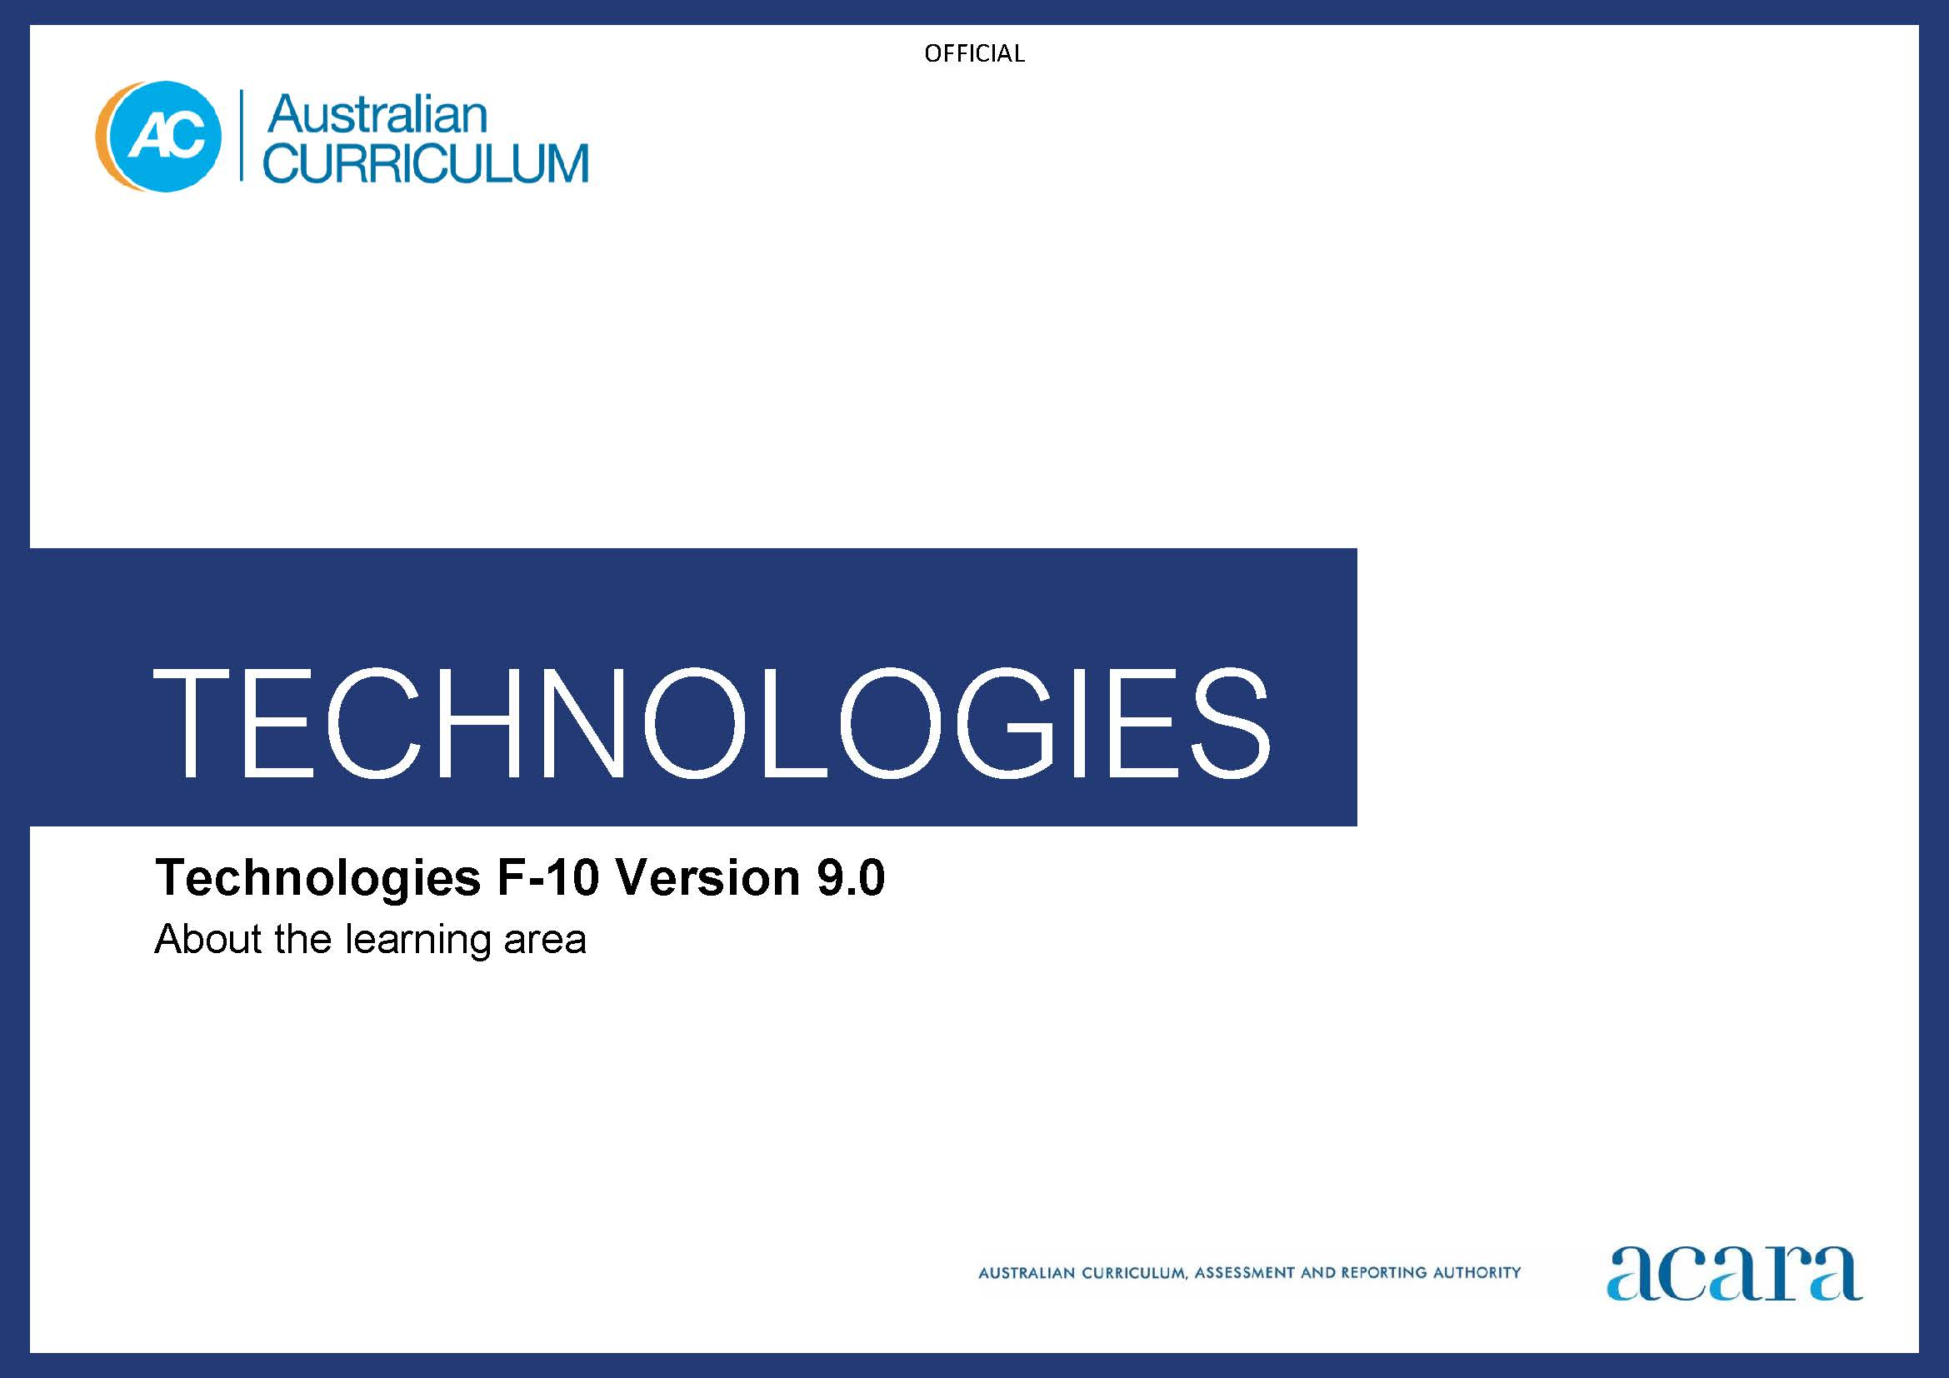

Copyright and Terms of Use Statement
© Australian Curriculum, Assessment and Reporting Authority 2022
The material published in this work is subject to copyright pursuant to the Copyright Act 1968 (Cth) and is owned by the Australian Curriculum, Assessment and Reporting Authority (ACARA) (except to the extent that copyright is held by another party, as indicated).
The viewing, downloading, displaying, printing, reproducing (such as by making photocopies) and distributing of these materials is permitted only to the extent permitted by, and is subject to the conditions imposed by, the terms and conditions of using the ACARA website (see, especially, clauses 2, 3 and 4 of those terms and conditions). The terms and conditions can be viewed at https://www.acara.edu.au/contact-us/copyright

TABLE OF CONTENTS
F–10 AUSTRALIAN CURRICULUM: TECHNOLOGIES 3
ABOUT THE LEARNING AREA 3
Introduction 3
Rationale 3
Aims 4
Structure 5
Key considerations 7
Key connections 11
Resources 17

F–10 AUSTRALIAN CURRICULUM: TECHNOLOGIES

ABOUT THE LEARNING AREA

Introduction
The Australian Curriculum: Technologies Foundation to Year 10 comprises 2 subjects:
- Design and Technologies, in which students use design thinking and technologies to generate and produce designed solutions for authentic needs and opportunities
- Digital Technologies, in which students use computational thinking and information systems to define, design and implement digital solutions for authentic problems.
Technologies is written on the basis that all students will study the 2 subjects from Foundation to the end of Year 8.
In Years 9 and 10, student access to Technologies subjects will be determined by state and territory authorities or individual schools. Subjects may continue with Design and Technologies and Digital Technologies, as outlined in Technologies, or subjects relating to specific aspects of the curriculum such as technologies contexts.
The curriculum for each of Design and Technologies and Digital Technologies describes the distinct knowledge, understanding and skills of the subject. Students should have the opportunity to develop a comprehensive understanding of traditional, contemporary and emerging technologies. There is flexibility for schools to develop teaching programs that integrate both Technologies subjects and other learning areas. This may be particularly important for primary school programs.

Rationale
Technologies enrich and impact on the lives of people and societies globally. They can play an important role in transforming, restoring and sustaining societies and natural, managed and constructed environments.
Australia needs enterprising individuals who can make discerning decisions about the development and use of technologies, develop solutions to complex challenges and contribute to sustainable patterns of living. Therefore, all young Australians should develop capacity for action and a critical appreciation of how technologies are developed and can contribute to societies.
Technologies ensures that all students benefit from learning about and working with the traditional, contemporary and emerging technologies that shape our world. Students have opportunities to consider the impact of technological solutions on equity including unconscious bias, ethics, and personal and social values.
By applying their knowledge and practical skills and processes when using technologies and other resources, students create innovative solutions. In creating solutions, as well as responding to the designed world, students consider desirable sustainable patterns of living, and contribute to preferred futures for themselves and others. They work independently and collaboratively to develop knowledge, understanding and skills to respond creatively to current and future needs and opportunities.
The practical nature of the Technologies learning area engages students in critical and creative thinking including understanding interrelationships in systems when solving complex problems. The learning area’s systematic approach to experimentation, problem-solving, prototyping and evaluation instils in students the value of planning and reviewing processes to transform ideas into solutions.
Learning in Technologies is also important for a diverse and capable science, technology, engineering and mathematics (STEM) workforce. STEM learning involves explicit teaching of knowledge and skills in each learning area: Science, Technologies and Mathematics. A transdisciplinary approach can enhance the application of students’ scientific and mathematical literacy, design and computational thinking, problem-solving and collaboration skills. Developing STEM competencies enables students to develop, model, analyse and improve solutions to real-world problems. It supports students to access further study and a variety of careers and jobs.

Aims
Technologies aims to develop the knowledge, understanding and skills to ensure that, individually and collaboratively, students:
- investigate, design, plan, manage, create and evaluate solutions
- are creative, innovative and enterprising when using traditional, contemporary and emerging technologies, and understand how technologies have developed over time
- make informed and ethical decisions about the role, impact and use of technologies in their own lives, the economy, environment and society for a sustainable future
- engage confidently with and responsibly select and manipulate appropriate technologies – tools, equipment, processes, materials, data, systems and components − when designing and creating solutions
- analyse and evaluate needs, opportunities or problems to identify and create solutions.

Structure
Technologies is presented in 2-year band levels from Year 1 to Year 10, with Foundation being presented as a single year.
Content in Design and Technologies and Digital Technologies is organised under 2 related strands:
- Knowledge and understanding
- Processes and production skills.
Under each strand, curriculum content is further organised into sub-strands.
Students apply skills from the Processes and production skills strand to the content from the Knowledge and understanding strand. The similar strand structure of each subject supports an integrated approach to teaching Technologies.
In addition to achievement standards for each subject there is a Technologies learning area achievement standard for Foundation to Year 8. The learning area achievement standard may help with manageability of reporting, particularly in primary years. It may also be useful when schools are teaching integrated Digital Technologies and Design and Technologies units.
Core concepts
The Technologies core concepts are the big ideas, understandings, skills or processes that are central to learning in Technologies. They give clarity and direction about what content matters most in the learning area. Technologies core concepts are common to both subjects. Subject-specific core concepts have also been identified. The Technologies core concepts are illustrated in Figure 1 and described below.
Learning in Technologies is about: creating solutions for preferred futures using systems and data; design thinking, systems thinking and computational thinking; and technologies processes and production skills, project management skills, and enterprise skills and innovation; taking into account interactions and impact.
Students create solutions using an iterative approach. In each subject they evaluate, collaborate on and manage ideas, processes and production through the content descriptions of the Investigating and defining; Generating and designing and Producing and implementing sub-strands. These 3 sub-strands are where computational, design and systems thinking are mainly addressed. Systems thinking is addressed equally in both subjects. In Design and Technologies there is a focus on design thinking. In Digital Technologies there is a focus on computational thinking in these 3 skills sub-strands as well as in the Data representation sub-strand (in Knowledge and understanding).

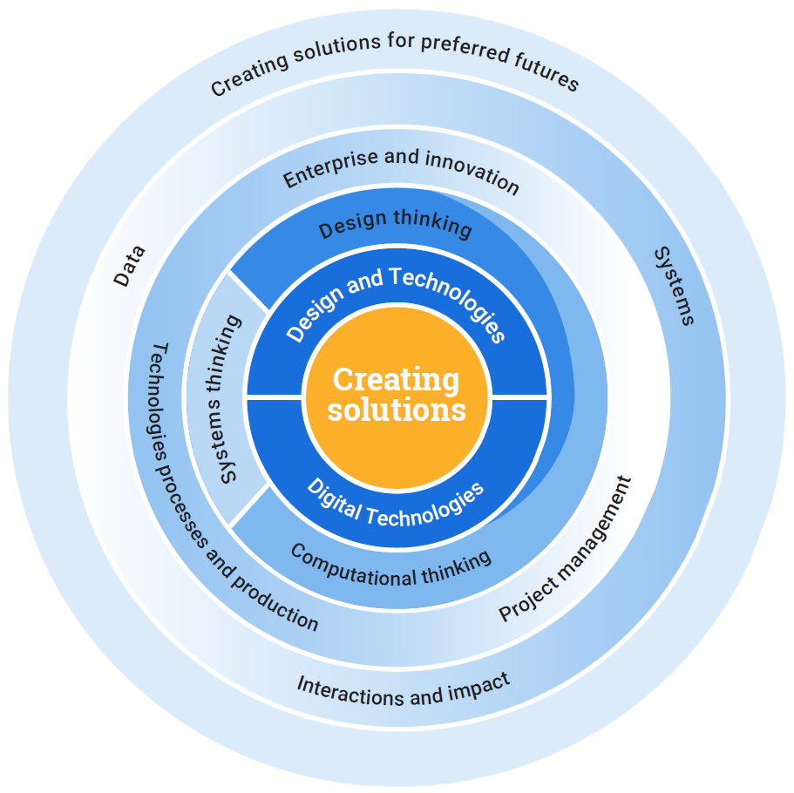
Figure 1: Overview of Technologies core concepts
Creating solutions for preferred futures is the overarching core concept. It involves identifying compelling visions of the future and making considered design decisions taking into account diversity; ethics; and economic, environmental and social sustainability factors. This overarching core concept is developed through the following core concepts:
- Systems comprise the structure, properties, behaviour and interactivity of people and components (inputs, processes and outputs) within and between natural, managed, constructed and digital environments.
- Data can be acquired, interpreted and represented to help inform decision-making and can be manipulated, stored and communicated by digital systems.
- Interactions and impact need to be considered when creating solutions; this involves examining the relationships between components of technologies systems, sustainability and the effects of design decisions on users.
- Systems thinking helps people to think holistically about the interactions and interconnections that shape the behaviour of systems.
- Computational thinking helps people to organise data logically by breaking down problems into parts; defining abstract concepts; and designing and using algorithms, patterns and models.
- Design thinking helps people to empathise and understand needs, opportunities and problems; generate, iterate and represent innovative,
user-centred ideas; and analyse and evaluate those ideas.
- Technologies processes and production skills help people to safely create solutions for a range of purposes and involve investigating and defining, generating and designing, producing and implementing, evaluating, and collaborating and managing.
- Project management skills help people to successfully and efficiently plan, manage and complete projects to meet identified design criteria.
- Enterprise skills and innovation help people to identify opportunities to take action and create change; follow through on initiatives; and generate new ideas, processes and solutions.

Key considerations
Protocols for engaging First Nations Australians
When planning teaching activities involving engagement with First Nations Australians, teachers should follow protocols that describe principles, procedures and behaviours for recognising and respecting First Nations Australians and their intellectual property. Teachers should use approved resources such as those that may be provided by their state or territory school system, or First Nations Australian education consultative groups, or other protocols accredited by First Nations Australians.
While the Australian Curriculum uses the terms “First Nations Australians” and “Australian First Nations Peoples” there may be other terms that First Nations Australians of a particular area or location prefer. It is important to use the terms preferred in a particular area or location.
Meeting the needs of diverse learners
The Australian Curriculum values diversity by providing for multiple means of representation, action, expression and engagement and allows schools the flexibility to respond to the diversity of learners within their community. All schools have a responsibility when implementing the Australian Curriculum to ensure that students’ learning is inclusive, and relevant to their experiences, abilities and talents.
For some students with diverse languages, cultures, abilities and talents it may be necessary to provide a range of curriculum adjustments so they can access age-equivalent content in the Australian Curriculum and participate in learning on the same basis as their peers. Depending on the ability and interests of each student, adjustments to the tools, equipment, processes, materials, systems and components used in Technologies may be necessary to provide equitable opportunities for students or to provide a safer learning experience.
The broad content and having high expectations for all learners allows for the creation of solutions through many modalities, with appropriate adjustment. Assistive technologies and augmentative and alternative communication devices should be made available as and where appropriate.
Adjustments to the delivery of Technologies could involve actions such as:
- providing innovation opportunities and scaffolding of resources for students to access and engage in learning at their own pace as a review or extension activity
- acknowledging the assistive technology continuum of no tech, low tech, mid tech or high tech when planning learning experiences
- designing open-ended tasks that provide flexibility and can be completed at different levels of complexity
- selecting Technologies content in keeping with the goals of the student, maintaining high expectations and considering safety, including adjusting the types of materials, equipment and digital tools used.
Safety
Identifying and managing risk in the Technologies learning area addresses the safe use of technologies as well as risks that can affect project timelines. It covers all necessary aspects of health, safety and injury prevention and, in any Technologies situation, the use of potentially dangerous materials, tools and equipment. It includes ergonomics, online safety, and ethical and legal considerations when communicating and collaborating online.
Technologies learning experiences may involve the use of potentially hazardous substances and hazardous equipment. It is the responsibility of the school to ensure that duty of care is exercised in relation to the health and safety of all students and that school practices meet the requirements of the Work Health and Safety Act 2011 and Work Health and Safety Regulations 2011 in addition to relevant state or territory health and safety guidelines.
In implementing projects with a focus on food, care also must be taken with regard to food safety and specific food allergies that may result in anaphylactic reactions. The Australasian Society of Clinical Immunology and Allergy has published guidelines for prevention of anaphylaxis in schools, preschools and childcare. Some states and territories have their own specific guidelines that should be followed.
When planning to incorporate immersive technologies – augmented reality, virtual reality, mixed reality or extended reality – in learning experiences, teachers should consider the manufacturer’s guidelines as well as other issues including the physical, cognitive, linguistic, emotional, social and moral developmental stage of learners. See the eSafety Commissioner’s explicit advice on the risks of immersive technologies use in its position statement: www.esafety.gov.au/about-us/tech-trends-and-challenges/immersive-tech
The use of drones (remotely piloted aircraft) or model aircraft for educational purposes at education institutions is considered “flying for fun” under Civil Aviation Safety Authority (CASA) guidelines; however, teachers should also consider their education jurisdiction’s governance standards. CASA’s Drones at school webpage www.casa.gov.au/drones/drones-at-school lists requirements and tips for teachers and educators on issues such as health, safety and privacy for any drone operation. State and territory school education authorities can give further and more detailed advice on drones in schools.
Privacy and security
Identifying and managing the implications of and concerns related to the collection and generation of data through automated and non-automated processes addresses the risks that can affect secure engagement with digital systems.
Privacy includes recognising the risks that are faced online and the mitigation strategies involved in managing them. In Australia, guidance on best practice for privacy is informed by the Australian Privacy Principles, the cornerstone of the privacy protection framework in the Privacy Act 1988. For more information visit: www.oaic.gov.au/privacy/australian-privacy-principles
Security covers the development of appropriate technical, social, cognitive, communicative and decision-making skills to address online and network security risks. It includes data security, and ethical and legal considerations when working with and designing digital systems. When engaging with and designing digital systems, identifying and managing security threats and mitigation in a data-intensive world is paramount.
In Australia, guidance on best practice for cyber security is informed by the cyber security principles. These principles provide strategic guidance on how individuals and organisations can protect their systems and data from cyber threats.
For more information visit: www.cyber.gov.au/acsc/view-all-content/guidance
Copyright
Identifying and managing the implications of copyright and intellectual property in the Technologies learning area addresses the ethical and legal responsibilities around ownership and repurposing of designs and digital content. It covers all necessary aspects of plagiarism, copyright, fair dealing and licensing and, in any Technologies situation, the respect of intellectual property rights.
In Australia, copyright law is contained in the Copyright Act 1968. For more copyright information and resources see:
Smartcopying: https://smartcopying.edu.au
Australian Copyright Council: www.copyright.org.au
Australian Digital Alliance: https://digital.org.au
Creative Commons Australia: https://creativecommons.org.au
Short Guide to Copyright: www.infrastructure.gov.au/media-centre/publications/short-guide-copyright
Intellectual property
Intellectual property laws include protection for registered designs, products and plant varieties and should be respected when students are designing solutions (including digital systems and repurposing computer code).
For more information and resources visit IP Australia: www.ipaustralia.gov.au
See Smartcopying https://smartcopying.edu.au/contact-us for relevant contact details.
For more information about relevant guidelines for safety, cyber security, copyright and intellectual property, teachers should contact their state or territory education authority.
Designing for safety and equity
There are opportunities in Technologies for students to apply Safety by Design principles and universal design principles when designing solutions.
Safety by Design focuses on the ways designers of digital solutions can minimise online threats by anticipating, detecting and eliminating online harms before they occur. This proactive and preventive approach focuses on embedding safety into the culture of the design process. It emphasises accountability and aims to foster more positive, civil and rewarding online experiences for everyone.
For more information go to the Office of the eSafety Commissioner. The Safety by Design Vision for Young People is available at: www.esafety.gov.au/about-us/safety-by-design/principles-and-background
The eSafety Commissioner also has specific advice for educators via its Toolkit for Schools resources: www.esafety.gov.au/educators/toolkit-schools
The 7 Principles of Universal Design were developed to guide the design of environments, products and communications. The universal design principles provide an opportunity to create solutions that respond to the changing circumstances of people and to changes in technologies. When students apply the principles, they create products that change and adapt for everyone. In Technologies, the 7 principles may be applied to evaluate existing designed and digital solutions, guide students through the design process and provide them with guidance on the characteristics which support products, services and environments so they are more accessible and usable by consumers.
For more information and to further explore these principles visit: https://universaldesignaustralia.net.au

Key connections
General capabilities
General capabilities equip young Australians with the knowledge, skills, behaviours and dispositions to live and work successfully. General capabilities support and deepen student engagement with learning area content and are best developed within the context of
learning areas.
Opportunities to develop general capabilities in learning area content vary. In addition to Literacy and Numeracy which are fundamental to all learning areas, all of the other general capabilities have relevance and application to Technologies. The general capabilities are identified in content descriptions when they are developed or applied through the Technologies content. They are also identified in content elaborations when they offer opportunities to add depth and richness to student learning.
Literacy
Learning in Technologies requires students to apply literacy knowledge and skills to listen to, interpret, evaluate, respond to and create a range of increasingly challenging procedural and explanatory texts, such as patterns, recipes, manuals, instructions and specifications, and persuasive texts such as marketing materials for a new product.
In Technologies students integrate and evaluate content presented in diverse media and formats; interpret, analyse and assess descriptions, reports and data; and navigate texts to locate information. Students recognise and appropriately use technical symbols, icons and key terms which may have generic uses as well as context-specific uses in technical topics.
Students create clear and coherent informative, explanatory and persuasive texts using precise vocabulary and terminology, appropriate structures and formats, and a range of visual and diagrammatic elements. They develop and organise texts using a format and style appropriate to particular tasks and audiences. They produce and publish a range of texts including annotated engineering or technical drawings, software instructions and programs, project outlines, briefs and management plans in which information and ideas are accurate, relevant, supported by evidence and examples, and cited,
where needed.
Numeracy
Students develop the capacity to interpret and use mathematical knowledge and skills in a range of real-life situations. They use number to calculate, measure and estimate; interpret and draw conclusions from statistics; measure and record throughout the process of generating and iterating ideas; develop, refine and test concepts; and cost and sequence when making products and managing projects. In using software, materials, tools and equipment, students work with the concepts of number, geometry, scale, proportion, measurement and volume. They use 3-dimensional models, create accurate technical drawings, work with digital models and use computational thinking in decision-making processes when designing and creating
best-fit solutions.
Digital Literacy
Digital Technologies explicitly supports the development of digital literacy across the curriculum. Together, Digital Literacy and Digital Technologies give students the opportunity to become discerning users, productive creators, critical analysts and effective developers of digital solutions. Digital literacy is context dependent and involves students developing the knowledge and skills needed to learn effectively in the digital world. Development of digital literacy allows students to operate and manage digital systems and practise digital safety and wellbeing while investigating, creating and communicating. As students develop digital literacy skills, they build their understanding of how to utilise digital tools when designing digital solutions. While specific elements of Digital Literacy are addressed in Digital Technologies, concepts and skills are consolidated and extended across all learning areas and subjects including Design and Technologies.
In Design and Technologies students learn how to operate specific digital tools to help them realise their design ideas. This occurs, for example, when investigating needs or opportunities, or researching and analysing information. It also occurs when they generate and communicate design ideas, processes and solutions (from basic drawing and modelling programs to computer-aided design or manufacture, rapid prototyping and creating simulations). And also, when they develop plans, schedules and processes; and collaborate online to create innovative and enterprising designed solutions.
Critical and Creative Thinking
Students develop critical and creative thinking as they imagine, generate, iterate and critically evaluate ideas. They develop reasoning and the capacity for abstraction through challenging problems. Students analyse problems, refine concepts and reflect on the decision-making process by engaging in systems, design and computational thinking. They identify, explore and clarify technologies information and use that knowledge in a range of situations.
Students think critically and creatively about possible, probable and preferred futures. They consider how data, information, systems, materials, tools and equipment (past and present) impact on our lives, and how these elements might be better designed and managed. Experimenting, drawing, modelling, designing and working with equipment and software helps students to build their visual and spatial thinking and to create solutions, products, services and environments.
Personal and Social capability
Students develop personal and social capability as they engage in project management and design and production activities in a collaborative workspace. They direct their own learning, plan and carry out investigations, and become independent learners who can apply design thinking, and technologies understanding and skills when making decisions. They develop social skills through working cooperatively in teams, sharing resources and processes, making group decisions, resolving conflict and showing leadership. Designing and innovation involve a degree of risk-taking, and as students work with the uncertainty of sharing new ideas, they develop resilience.
Students consider past and present impacts of decisions on people, communities and environments and develop social responsibility through understanding of, empathy with and respect for others. They develop an understanding of diversity by researching and identifying user needs. Students reflect on the impact that digital tools and environments such as social media can have on their personal wellbeing and apply appropriate strategies in face-to-face and digital environments.
Ethical Understanding
Students develop the capacity to understand and apply ethical and socially responsible principles when collaborating with others and creating, sharing and using technologies. Using an ethical lens, they investigate past, current and future local, national, regional and global technological priorities. When engaged in systems thinking, students evaluate their findings against criteria that include ethical issues. They explore complex issues associated with technologies and consider possibilities and ethical implications.
They learn about safe and ethical procedures for investigating and working with people, animals, data and materials. They consider the rights of others and their responsibilities in using sustainable practices that protect the planet and its life forms. They learn to appreciate and value the part they play in the social and natural systems they live in. Students consider their own roles and responsibilities as discerning citizens and learn to detect bias and inaccuracies. Understanding the protection of data, intellectual property and individual privacy helps students to be respectful creators.
Intercultural Understanding
The Technologies learning area gives students opportunities to consider how diverse communities use technologies, including their impact and potential to transform people’s lives. It enables students to explore ways that people use technologies to interact with one another when cultures intersect. Students can investigate how cultures, identity and traditions influence the design of products, services and environments. They have opportunities to design solutions to challenges at local, national, regional and global levels. This may involve reflecting on culture and cultural diversity, engaging with cultural and linguistic diversity and navigating intercultural contexts. Students apply their understanding of the influence of cultures on interactions when working or collaborating with others, and when creating solutions to needs, opportunities and problems.
Cross-curriculum priorities
Cross-curriculum priorities support the Australian Curriculum to be a relevant, contemporary and engaging curriculum that reflects national, regional and global contexts. Cross-curriculum priorities are incorporated through learning area content; they are not separate learning areas or subjects. They provide opportunities to enrich the content of the learning areas, where most appropriate and authentic, allowing students to engage with and better understand their world.
Opportunities to apply cross-curriculum priorities to learning area content vary. All 3 cross-curriculum priorities have relevance and meaning to the Technologies learning area. The cross-curriculum priority of Sustainability is embedded in content descriptions where it is core to the delivery of the content in Design and Technologies and Digital Technologies. The Aboriginal and Torres Strait Islander Histories and Cultures and Asia and Australia’s Engagement with Asia cross-curriculum priorities are identified in content elaborations where they offer opportunities to add depth and richness to student learning.
Aboriginal and Torres Strait Islander Histories and Cultures
In Design and Technologies students can explore some of the designs and technologies of the oldest continuous living cultures in the world. Through varied and engaging contexts, students can learn how proven designed solutions from long ago endure today and can at times inspire contemporary solutions.
The engineering principles and systems employed by First Nations Australians today, and in the past, provide culturally relevant and engaging contexts for all students to investigate how First Nations Australians have been successful at sustaining the world’s oldest continuous living cultures. Students can investigate how First Nations Australians’ knowledges of natural materials have developed over millennia and have culminated in deep knowledge of their properties and performance. Likewise, students have the opportunity to explore successful systems that First Nations Australians have developed to join materials for the design and production of a diverse range of essential, effort-reducing technologies. Students can investigate the diverse food and fibre production techniques developed by First Nations Australian communities before colonisation and see how this capacity has sustained Aboriginal Australia for over 60,000 years and through numerous major climatic and environmental shifts. They have opportunities to explore how First Nations Australians have long successfully developed complete diets that meet nutritional requirements and see how foods were and continue to be investigated for their nutritional and medicinal qualities.
Through Digital Technologies students can gain insights into how First Nations Australians are often at the forefront of adopting digital systems, and also learn how they often endure the inequities of digital system performance and capabilities, especially when living on Country/Place far from the nation’s city centres. Students can explore how many First Nations Australians are embracing digital tools as a means to maintain, control, protect and further develop culture through the digitisation of cultural expressions. They have opportunities to examine the complexities of data and the need for ethical protocols when using systems to acquire, manage and analyse data. Students can explore how First Nations Australian ranger groups use computational, design and systems thinking in their contributions to preferred futures such as restoring damaged environments and the monitoring and protection of endangered and vulnerable species. Through the context of material culture production techniques such as weaving, students can be introduced to designing algorithms and exploring how such practices can be converted into programmable automation.
Asia and Australia’s Engagement with Asia
Technologies provides a range of authentic contexts to explore and appreciate the significant contribution that the people and countries of Asia make to global technological advancement and the impact that Australia’s technological advances have on the countries of Asia. Students can explore how engagement with diverse cultures is facilitated in pioneering research linked to development of innovative technologies and the interconnected technological systems that influence contemporary regional relationships and provide opportunities for collaboration and exchange. This research is exemplified in initiatives designed to solve complex global challenges and push innovative boundaries for new and emerging formats. Continuing collaboration and engagement with the peoples of Asia encourages development of advanced manufacturing processes linked to automotive, electronic and robotic technologies, food and fibre, medical advances and gaming and eSports to support effective regional and global citizenship. Students have the opportunity to understand the important contributions that traditional technologies and the use of local materials and sophisticated craft-based fabrication techniques have made in helping communities in diverse locations to create sustainable modes of existence.
Sustainability
When students identify and analyse a problem, need or opportunity; generate ideas and concepts; and create solutions in Technologies, they give consideration to sustainability by anticipating and balancing economic, environmental and social impacts. The curriculum focuses on the knowledge, understanding and skills necessary to creatively design for effective sustainability action, taking into account issues such as resource depletion and climate change. The learning area gives students opportunities to explore their own and competing viewpoints, values and interests. Understanding systems enables students to work with complexity, uncertainty and risk; make connections between disparate ideas and concepts; self-critique; and propose creative solutions that enhance sustainability. Students learn to appreciate local and global impact of design decisions. They reflect on past and current practices and assess new and emerging technologies from a sustainability perspective to design solutions for preferred futures.
Learning area connections
Technologies provides opportunities to integrate or connect content to many learning areas or subjects in transdisciplinary learning or to enhance transfer of knowledge, understanding and skills from other learning areas.
Technologies and Science
Technologies complements Science by focusing on creating preferred futures. Science develops the key ideas of patterns, order and organisation, stability and change, scale and measurement, matter and energy, and systems as key aspects of a scientific view of the world. Students draw on these ideas when producing solutions and considering the role of technologies in society.
Design and Technologies draws on concepts from biological, chemical and physical sciences to solve problems and design solutions to meet needs and opportunities. There are relationships between each Technologies context and the Science Knowledge and understanding sub-strands.
The Digital Technologies curriculum gives students the knowledge and skills to automate how they collect, store and analyse scientific data. Links with the Science curriculum allow for applications of scientific concepts through modelling, critiquing and applying prior knowledge to designing real-world solutions that are meaningful to students.
Technologies and Mathematics
Technologies provides contexts within which Mathematics understanding, fluency, logical reasoning, analytical thought and problem-solving skills can be applied and developed.
Design and Technologies gives students opportunities to interpret and use mathematical knowledge and skills in a range of real-life situations. Students use number to quantify, measure and estimate; interpret and draw conclusions from statistics; measure and record throughout the process of generating ideas; develop, refine and test concepts; and cost and sequence when making products and managing projects. They use 2-dimensional and 3-dimensional models, create accurate technical drawings, work with digital models and use computational thinking in decision-making processes when designing and creating designed solutions.
Digital Technologies and Mathematics share a focus on computational thinking, in particular in data acquisition and interpretation, models and simulations, and generalising. The Digital Technologies curriculum supports students to apply the knowledge and skills that underpin pattern recognition, data acquisition, and interpretation and representation, which form the basis of the Mathematics strand, Statistics. Digital Technologies develops students’ basic understanding of algorithms in the early years, which Mathematics then builds on. The implementation, design and creation of algorithms form an integral part of a computational approach to learning in Digital Technologies and Mathematics.
Technologies and Health and Physical Education
The Technologies curriculum takes account of what students learn in Health and Physical Education (HPE). In the HPE Personal, social and community health strand, students learn about food and nutrition. In the Design and Technologies sub-strand, Technologies context: Food specialisations, students learn about preparing food for healthy eating and the technologies associated with processing food for human consumption.
In Digital Technologies, students have an opportunity to apply their knowledge and skills developed in the Personal, social and community health strand and the Interacting with others sub-strand. In particular, students apply their knowledge of privacy, safety (seeking help and engaging respectfully) and consent and use their developing skills as they expand their communication and collaboration experience into online and networked environments.
Technologies and The Arts
Technologies complements The Arts curriculum, particularly in the application of the elements and principles of art/design, and aspects of aesthetics and user experiences which are incorporated into the design processes in Technologies content.
Similarities and connections exist between aspects of the Design and Technologies curriculum and each of The Arts subjects. Some links occur through use of materials to create arts works and designed solutions. Others occur through the use of design processes, typically in graphic, sonic and kinaesthetic design forms. Graphical representation techniques such as sketching, 3D printing or models and simulations can be used to create arts works or production elements such as props and set items.
The Digital Technologies curriculum focuses on using digital systems (hardware and software) to create solutions. In each of the Arts subjects students can use digital systems to create works in traditional, contemporary and emerging forms. In The Arts, students may use skills and knowledge learnt through Digital Technologies to develop their arts practice. For example, they might implement programs to create or manipulate patterns and algorithms, images, songs, text, speech or language, or movement sequences.
Technologies and Humanities and Social Sciences
Technologies knowledge, understanding and skills can be applied using a range of contexts from the Humanities and Social Sciences (HASS) curriculum. From the early years, students explore cause and effect and interact with environments and digital systems as they explore places, spaces and interconnections – particularly as they use materials, equipment and digital systems to create solutions. Students strengthen their Technologies understanding and skills as they study the environmental characteristics of places, processes, and human significance.
Through Design and Technologies, concepts and learning that are addressed in HASS subjects are contextualised through the design and production of products, services and environments that relate to sustainability, the environment and society. Students create products and systems that measure and further develop their understanding of the influences of climate and weather conditions. They consolidate their understanding of sustainability as they investigate the significance to humans of the biophysical environment and design and manage projects that enhance their understanding of the fine balance between the environment and human endeavour; for example, in Food and fibre production. As students engage in authentic activities that allow them to design, produce and evaluate solutions for managed and constructed environments, they consider cause and effect of processes and interconnections between natural and resource systems.
In Digital Technologies students sort information, find patterns and interact with digital systems as they develop spatial understandings. They use directional language; and acquire, interpret and represent data related to people, interactions and systems.
Technologies and English
Learning in Technologies places a high priority on accurate and clear communication. Technologies is supported by and in turn reinforces the learning of literacy skills. Students need to describe objects and events; interpret descriptions; read and give instructions; generate and explore ideas with others; write design briefs and specifications, marketing texts, evaluation and variation reports; and participate in group discussions.

Resources
A scope and sequence representation of the curriculum, the glossary, and comparative information about Version 8.4 and Version 9.0 are available as a download from the Australian Curriculum Version 9.0 website.

