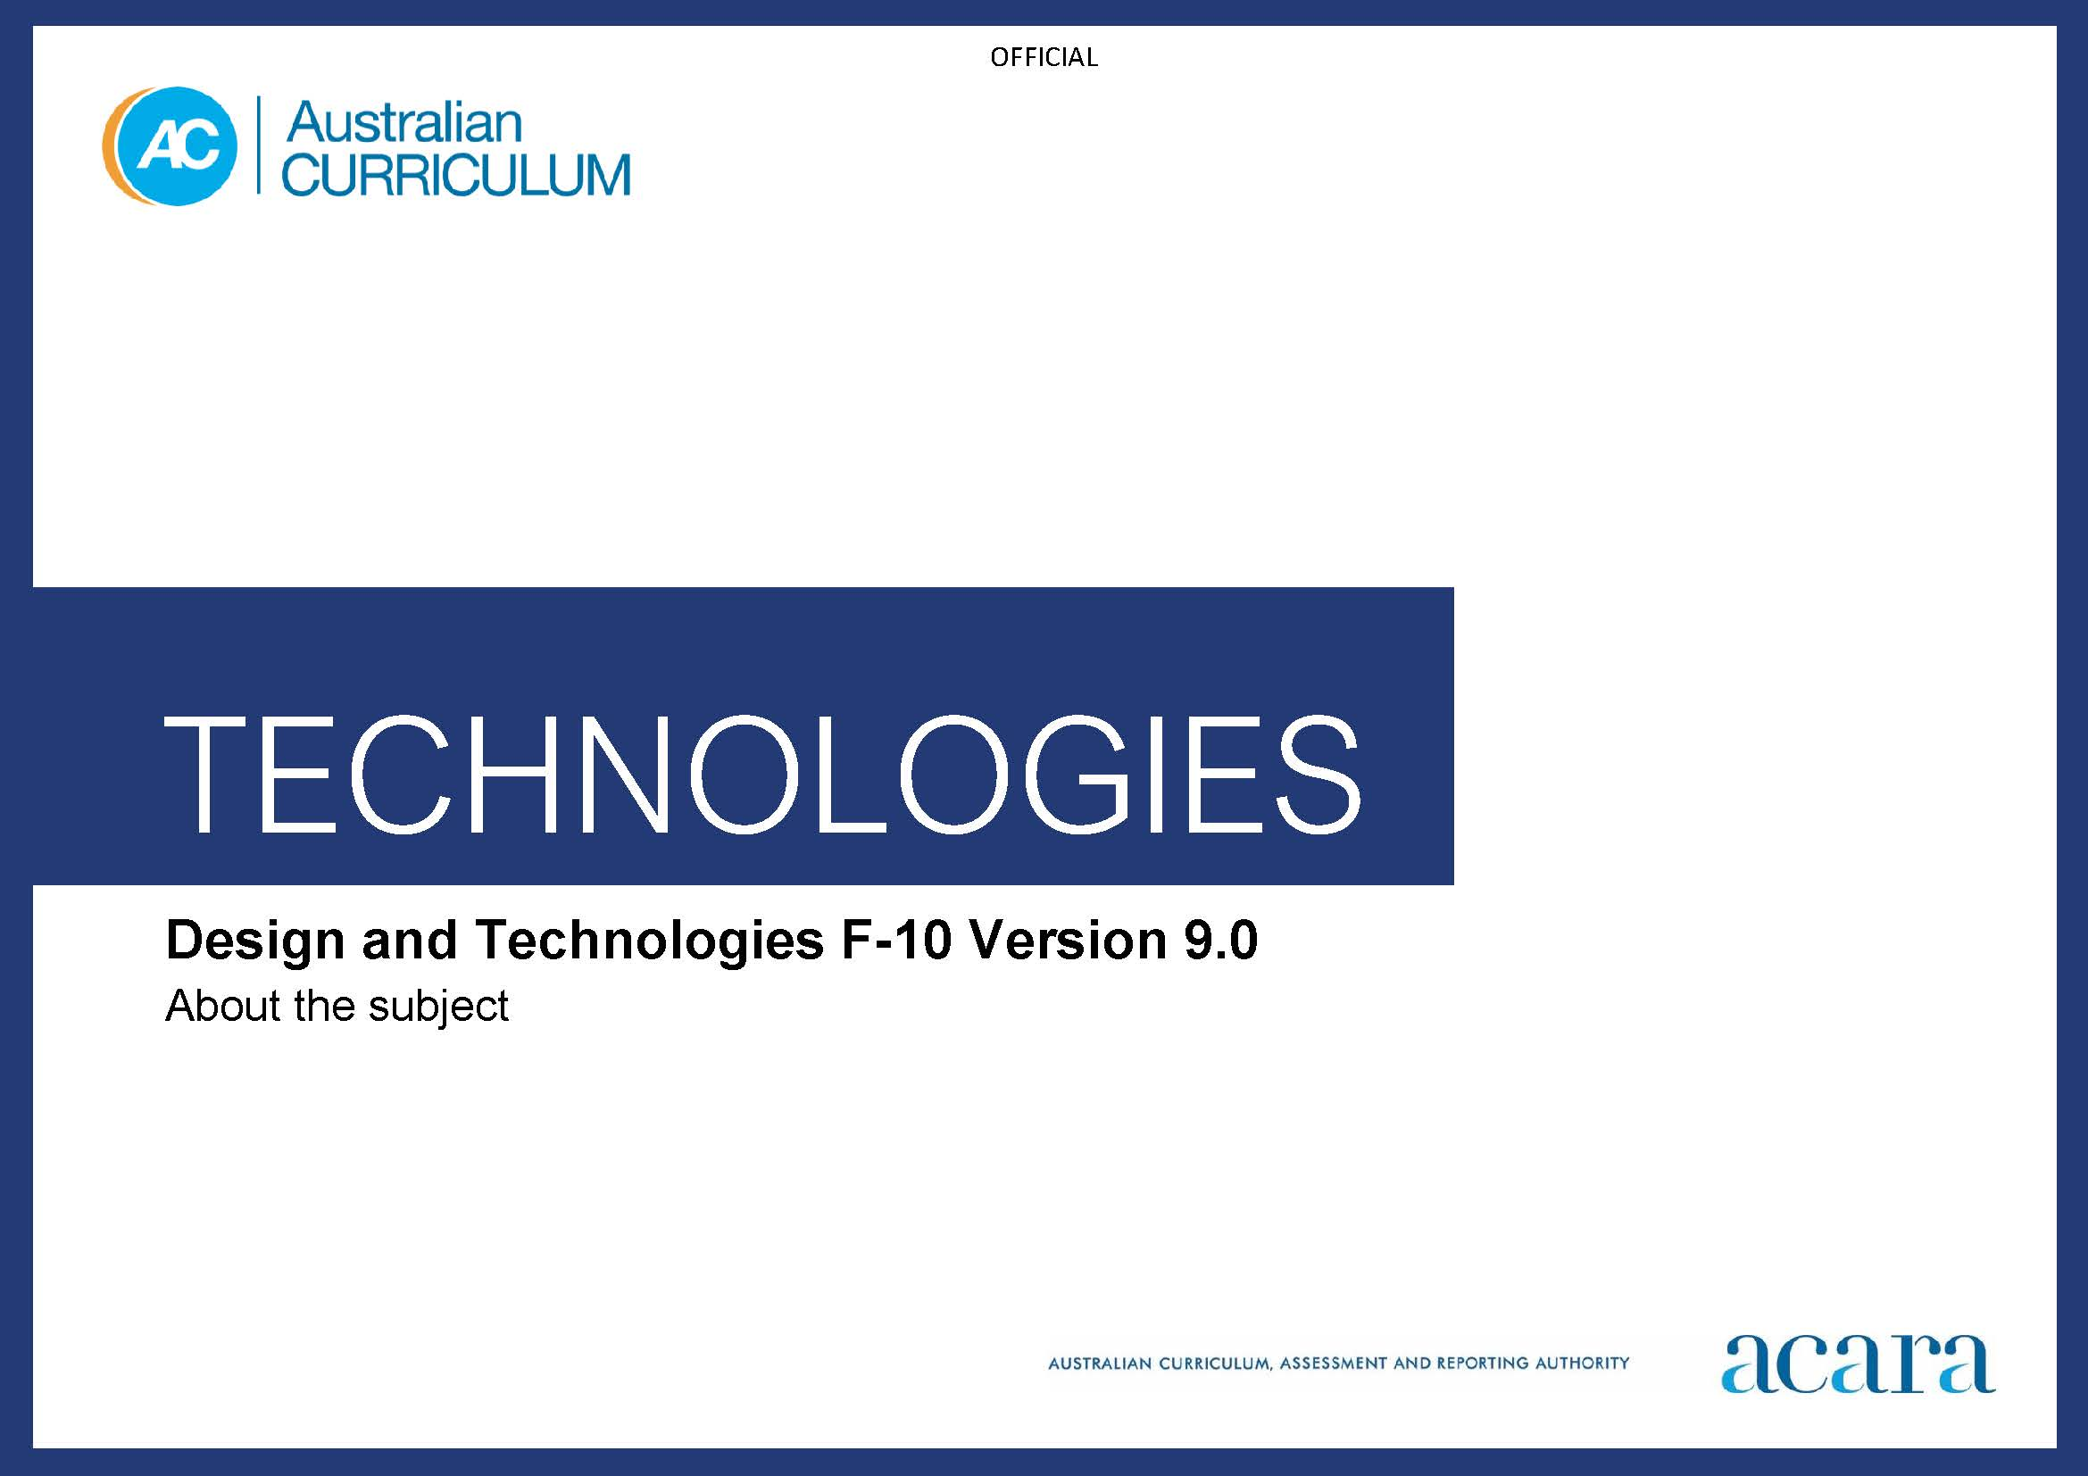

Copyright and Terms of Use Statement
© Australian Curriculum, Assessment and Reporting Authority 2022
The material published in this work is subject to copyright pursuant to the Copyright Act 1968 (Cth) and is owned by the Australian Curriculum, Assessment and Reporting Authority (ACARA) (except to the extent that copyright is held by another party, as indicated).
The viewing, downloading, displaying, printing, reproducing (such as by making photocopies) and distributing of these materials is permitted only to the extent permitted by, and is subject to the conditions imposed by, the terms and conditions of using the ACARA website (see, especially, clauses 2, 3 and 4 of those terms and conditions). The terms and conditions can be viewed at https://www.acara.edu.au/contact-us/copyright

TABLE OF CONTENTS
F–10 AUSTRALIAN CURRICULUM: TECHNOLOGIES – DESIGN AND TECHNOLOGIES 3
ABOUT DESIGN AND TECHNOLOGIES 3
Rationale 3
Aims 3
Structure 4
Key considerations 11

F–10 AUSTRALIAN CURRICULUM: TECHNOLOGIES – DESIGN AND TECHNOLOGIES

ABOUT DESIGN AND TECHNOLOGIES

Rationale
In an increasingly technological and complex world, we need citizens with the knowledge and confidence to analyse and creatively respond to design opportunities and challenges including for a circular economy. Knowledge, understanding and skills involved in the design, development and use of technologies are influenced by and can play a role in enriching and transforming societies and our natural, managed and constructed environments.
Design and Technologies enables students to become creative and responsive designers. When students consider ethical, legal, aesthetic and functional factors and the economic, environmental and social impacts of technological change, and how the choice and use of technologies contributes to a sustainable future, they are developing the knowledge, understanding and skills to become discerning decision-makers.
Design and Technologies engages students in creating quality designed solutions for identified needs and opportunities across a range of technologies contexts. Students manage projects independently and collaboratively from conception to realisation. They apply design and systems thinking and design processes to investigate, generate, evaluate, iterate and improve design ideas, processes and solutions. They plan and produce (make) designed solutions. They develop a sense of pride, satisfaction and enjoyment from their ability to design and produce innovative designed products, services and environments.
Design and Technologies gives students authentic learning challenges that foster curiosity, confidence, persistence, innovation, creativity, respect and cooperation. It motivates young people and engages them in learning experiences that are transferable to family and home, constructive leisure activities, community contribution and the world of work.

Aims
Design and Technologies aims to develop the knowledge, understanding and skills to ensure that, individually and collaboratively, students:
- develop confidence as critical users of technologies and designers and producers of designed solutions
- investigate, generate, iterate and analyse ethical and innovative designed solutions for sustainable futures
- use design and systems thinking to generate design ideas and communicate these to a range of audiences
- produce designed solutions suitable for a range of technologies contexts by selecting and manipulating a range of tools, equipment, materials, systems and components creatively, competently and safely; and managing processes
- evaluate processes and designed solutions and transfer knowledge and skills to new situations
- understand the roles and responsibilities of people in design and technologies occupations and how they contribute to society.

Structure
Content in Design and Technologies is organised under 2 related strands:
- Knowledge and understanding – the use, development and impact of technologies and design ideas across a range of technologies contexts
- Processes and production skills – the skills needed to create designed solutions.
Together, the 2 strands provide students with knowledge, understanding and skills through which they can safely and ethically design, plan, manage, produce and evaluate products, services and environments. Teaching and learning programs should balance and integrate both strands. Students learn about technologies and society through different technologies contexts (Knowledge and understanding) as they create designed solutions (Processes and production skills). Under each strand, curriculum content is further organised in sub-strands.
Figure 1 shows the strand and sub-strand structure for Design and Technologies.
Figure 1: Design and Technologies content structure
The Knowledge and understanding strand comprises up to 5 sub-strands, depending on the band. The Technologies and society sub-strand is common across all bands. The 4 other sub-strands are Technologies contexts. For these, each band level description outlines how the prescribed technologies contexts are addressed.
The Processes and production skills strand comprises 5 sub-strands for Years 3–10: Investigating and defining, Generating and designing, Producing and implementing, Evaluating and Collaborating and managing. In Foundation and Years 1 and 2 there are not content descriptions for the individual Processes and production skills sub-strands.
The sub-strands are not intended to be equally weighted or to be addressed sequentially. They are structural organisers. The sub-strands should be addressed as an iterative design process including design thinking, where students evaluate, collaborate and manage throughout the process. The focus is on creating solutions so there may need to be more time allocated to the Producing and implementing sub-strand. Teachers make decisions about the time required to address each content description depending on the needs of their students. It is not expected that equivalent time will be allocated to each content description. Teachers will determine the ways in which content can be integrated across the 2 strands as well as how content can be integrated with other learning areas. In Foundation, a separate sub-strand has been created: Designing and making.
Knowledge and understanding strand
This strand focuses on developing the underpinning knowledge and understanding of technologies (tools, equipment, processes, materials, systems and components) across technologies contexts and the relationship between technologies and society.
Technologies contexts provide a framework within which students can gain knowledge and understanding about the characteristics and properties of technologies and systems and how they can be used to create innovative designed solutions.
Content is organised into 5 sub-strands:

Technologies and society
This sub-strand focuses on how people use and develop technologies taking into account sustainability (economic, environmental, social), ethical, legal, aesthetic and functional factors and the impact of technologies on individuals; families; local, regional and global communities; the economy; and the environment – now and into the future.

Engineering principles and systems
This sub-strand focuses on how energy and forces (for example, chemical, mechanical, frictional, electromagnetic, electrostatic and gravitational) can be used to create and control light, sound, heat and movement in products and systems. Engineering provides opportunities for students to make sense of and integrate scientific and mathematical principles and concepts through the application of engineering design processes and practical skills enabling the design and production of sustainable engineered solutions.
Students should have the opportunity to understand how sustainable engineered products, services and environments can be designed and produced as some resources diminish and environments change. They should progressively develop knowledge and understanding of how forces and the properties of materials affect the behaviour and performance of designed engineering solutions.

Food and fibre production
Food and fibre are the human-produced or harvested resources used to sustain life and are produced in managed environments such as farms, gardens and plantations or harvested from wild populations. Challenges for world food and fibre production include an increasing world population and an uncertain climate and competition for resources such as land and water. These pose challenges for economic, environmental and social sustainability; and ethical considerations.
Students should have the opportunity to engage in these challenges by understanding the processes of food and fibre production and by investigating innovative and sustainable ways of supplying agriculturally produced raw materials. They should progressively develop knowledge and understanding about the managed systems that produce food and fibre through creating designed solutions.

Food specialisations
This sub-strand includes the application of nutrition principles (as described in HPE) and knowledge about food, its systems and technologies, selection and preparation; and contemporary technology-related food issues. Community awareness of and interest in accessing quality nutritious food from ethical and sustainable food systems is increasing. Individuals and communities should be empowered to make informed food selection and preparation choices to meet their needs.
Students should have the opportunity to appreciate the importance of having access to and eating a variety of foods, and a sound understanding of nutrition principles. They should develop an understanding of contemporary technology-related food issues, such as the supply and consumption of food that reflects ethical and sustainable practices; and skills in food preparation when making food decisions to support health eating. They should progressively develop knowledge and understanding about food, food systems and technologies, and how to make informed and appropriate food preparation choices when experimenting with and preparing food.

Materials and technologies specialisations
This sub-strand focuses on a broad range of traditional, contemporary and emerging materials and specialist areas that typically involve extensive use of technologies. We depend on designed products, services and environments for communication, housing, employment, healthcare, recreation and transport; however, we also face increasing concerns related to long-term sustainability.
Students should have the opportunity to develop the confidence to make decisions about processes and solutions that are ethical and sustainable. They can do this by learning about and working with materials, components and production processes. Students progressively develop knowledge and understanding of the characteristics and properties of a range of materials, either when investigating particular materials or through producing designed solutions for a technologies specialisation; for example, advanced manufacturing, architecture, electronics, exhibition design, fashion design, graphic design, product design, service design (infrastructure, leisure, transport) and textiles design.

Processes and production skills strand
The Processes and production skills strand is based on design thinking, design processes and production processes and skills. This strand reflects a process of design and would typically be addressed through identifying needs or opportunities and may involve developing a design brief. It focuses on creating designed solutions.
Content is organised into 5 sub-strands. These are the skills that students will use throughout a design project. If students have been taught content from these sub-strands in one technologies context, they may not need to be taught the same content again but rather they apply their skills to the next technologies context. Note in Foundation and Years 1 and 2 there are not content descriptions for each sub-strand.

Investigating and defining
This sub-strand involves students analysing, exploring and investigating information, needs and opportunities. As creators and citizens they will critically reflect on the intention, purpose and operation of technologies and designed solutions. Analysing encourages students to examine values, and question and review processes and systems. Students reflect on how decisions they make may have implications for individuals, society and the local and global environment, now and in the future. They explore and investigate technologies, systems, products, services and environments as they consider needs and opportunities. They progressively develop effective investigation strategies and consider the contribution of technologies to their lives and make judgements about them. Students develop design criteria in response to needs and opportunities and may respond to or develop design briefs.

Generating and designing
This sub-strand involves students in developing and communicating design ideas for a range of audiences. Students generate and iterate ideas, make choices, weigh up options, consider alternatives and document various design ideas and possibilities. They use critical and creative thinking strategies to generate, evaluate and document ideas to meet needs or opportunities that have been identified by an individual, a group or a wider community. Generating creative and innovative ideas involves thinking differently; it entails proposing new approaches to existing solutions and identifying new design opportunities considering preferred futures. Generating and developing ideas involves identifying various competing factors that may influence and dictate the focus of the idea. Students evaluate, justify and synthesise what they learn and discover. They use graphical representation techniques when they sketch, draw, model, simulate and design ideas that focus on well-considered designed solutions.

Producing and implementing
This sub-strand involves students learning and applying a variety of skills and techniques to make designed solutions to meet specific purposes and user needs. Students apply knowledge about components and materials and their characteristics and properties to ensure their suitability for use. They learn about the importance of adopting safe work practices. They develop accurate production skills to achieve quality designed solutions. Students develop the capacity to select and use appropriate tools, equipment, processes, materials, systems and components; and use work practices that respect the need for sustainability. The use of modelling and prototyping to accurately develop simple and complex simulated or physical models supports the production of successful designed solutions.

Evaluating
Evaluating occurs throughout a design process. It involves students reviewing design ideas, processes and solutions; and seeking feedback and making judgements throughout a design process and about the quality and effectiveness of their and others’ designed solutions. Students identify design criteria for needs or opportunities in the investigating and defining stage and then use these criteria to consider the implications and consequences of actions and decision-making throughout the process. They determine effective ways to test, judge and improve their ideas, concepts and designed solutions. They reflect on processes and transfer their learning to other design needs or opportunities.

Collaborating and managing
This sub-strand involves students learning to work cooperatively and to manage time and other resources to effectively create designed solutions. Progressively, students develop the ability to communicate and share ideas throughout the process, negotiate roles and responsibilities and make compromises to work effectively as a team. Students work individually and in groups to plan, organise and monitor timelines, activities and the use of resources. They progress from planning steps in a project through to more complex project management activities that consider various factors such as time, cost, risk assessment and management and quality control. Collaborating and managing occur throughout a design process.
Technologies contexts and types of designed solutions
Students should have the opportunity to produce 3 types of designed solutions (products, services and environments) in a number of Technologies contexts. The different types of designed solutions have been specified to give students opportunities to engage with a broad range of design thinking and production skills. The combination of technologies contexts and types of designed solutions is a school decision.
In Foundation students should have the opportunity to produce at least one type of designed solution. From Years 1 to 8 students should have the opportunity to produce all types of designed solutions (products, services and environments) in each band through the prescribed Technologies contexts. In Years 9 and 10 students should have the opportunity to create at least 4 designed solutions focused on one or more of the 4 Technologies contexts. The types of designed solutions in Years 9 and 10 are a school decision.
Foundation
By the end of Foundation students should have had the opportunity to produce at least one type of designed solution for one of the Technologies contexts or one identified by the school.

Years 1–2
By the end of Year 2 students should have had the opportunity to create 3 types of designed solutions, and addressed each of the 2 combined Technologies contexts:
- Engineering principles and systems; Materials and technologies specialisations
- Food and fibre production; Food specialisations.
Years 3–4
By the end of Year 4 students should have had the opportunity to create 3 types of designed solutions, and addressed each of the 2 combined Technologies contexts:
- Engineering principles and systems; Materials and technologies specialisations
- Food and fibre production; Food specialisations.
Years 5–6
By the end of Year 6 students should have had the opportunity to create 3 types of designed solutions, and addressed each of these 3 Technologies contexts:
- Engineering principles and systems
- Food and fibre production; Food specialisations
- Materials and technologies specialisations.
Years 7–8
By the end of Year 8 students should have had the opportunity to create at least 3 types of designed solutions, and addressed each of the 4 Technologies contexts:
- Engineering principles and systems
- Food and fibre production
- Food specialisations
- Materials and technologies specialisations.
Years 9–10
By the end of Year 10 students should have had the opportunity to create at least 4 designed solutions focused on one or more of the 4 Technologies contexts.
Core concepts
Underpinning the Design and Technologies curriculum are the core concepts of the Technologies learning area. The subject-specific core concepts for Design and Technologies are:
- engineering principles and systems: to design and create engineered solutions involves knowledge and understanding of scientific and mathematical principles and concepts through the application of engineering design processes and practical skills.
- food and fibre production: to design and create food and fibre production solutions to support current and future access to food and fibre products involves knowledge and understanding of the sustainable management of the environments in which they are produced.
- food specialisations: to design and create solutions to maintain and enhance individual and community health involves knowledge and understanding of what constitutes healthy and sustainable food systems to make informed food selection and preparation choices.
- materials and technologies specialisations: to design and create solutions involves knowledge and understanding of characteristics and properties of a range of materials, components and production technologies.

Key considerations
Animal ethics and biosecurity
Any teaching activities that involve caring for, using or interacting with animals must comply with the Australian code for the care and use of animals for scientific purposes 2013, the Australian Animal Welfare Standards and Guidelines, the National Livestock Identification System, the Biosecurity Act 2015 and various other Acts in order to protect Australia’s animal, plant and human health status, in addition to relevant state or territory guidelines. The Australian Government and state and territory governments may have extra legislation for animal ethics, protection of native animals and plants and biosecurity of animals and plants that could affect how schools use animals and plants.
When state and territory curriculum authorities integrate the Australian Curriculum into local courses, they will include more specific advice on the care and use of, or interaction with, animals and plants. Schools must ensure they are aware of and comply with all state, territory and Commonwealth legislation or regulation about the use of animals and plants in schools. For more information about relevant guidelines on animals and plants or to access the local animal ethics committee, teachers should contact their state or territory education authority.
Australian code for the care and use of animals for scientific purposes:
www.nhmrc.gov.au/about-us/publications/australian-code-care-and-use-animals-scientific-purposes
Australian Animal Welfare Standards and Guidelines: www.animalwelfarestandards.net.au
Biosecurity in Australia: www.agriculture.gov.au/biosecurity/australia
National Livestock Identification System: www.nlis.com.au
Plant Health Australia: www.planthealthaustralia.com.au
Information is correct as at 1 September 2021.
Food and nutrition in the Australian Curriculum
In the Australian Curriculum students learn about food and nutrition in both Health and Physical Education (HPE) and Design and Technologies. In the HPE curriculum students develop knowledge and understanding of nutrition principles to enable them to make healthy food choices and consider the range of influences on these choices. In Design and Technologies students learn about the characteristics and properties of food and then apply this knowledge along with the nutrition principles learnt in HPE to the selection and preparation of food to design and produce healthy food solutions for specific purposes and consumers.
Beyond Year 8 students may choose to study a food-related subject offered by states and territories or they may have the opportunity in Design and Technologies to design and produce solutions in a food specialisation context.
Home economics
Some states and territories offer Home Economics as a subject, or home economics related subjects. Home Economics supports students to develop the capacity to make decisions, solve problems and respond critically and creatively to practical concerns of individuals, families and communities in local, regional and global contexts. In the Australian Curriculum elements of learning in home economics draw from content in HPE and Technologies.

