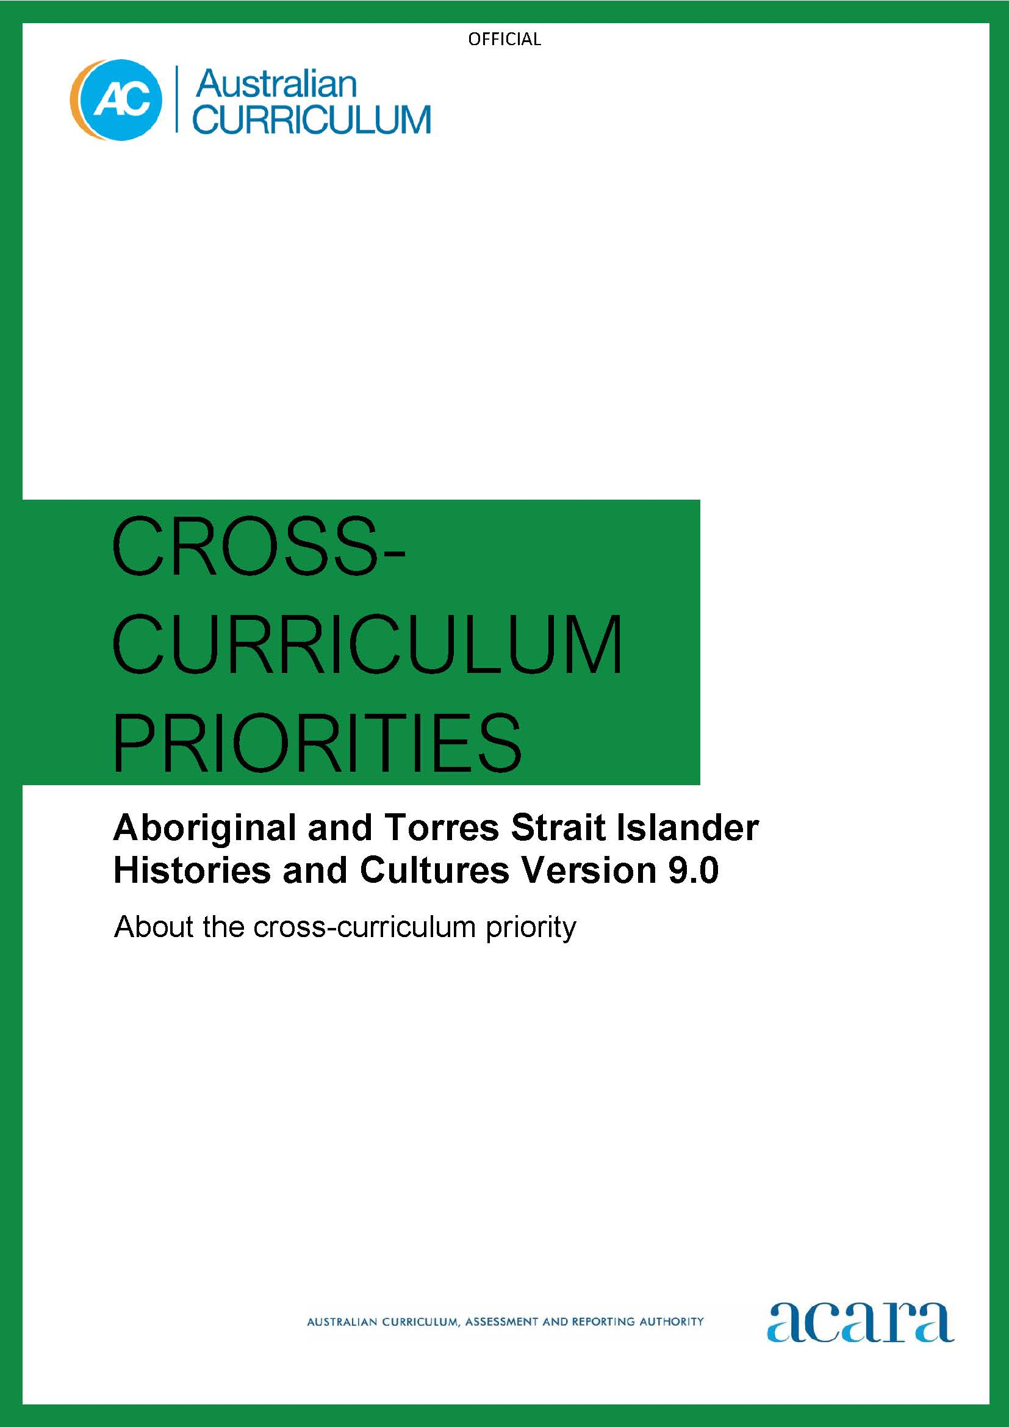

Copyright and Terms of Use Statement
© Australian Curriculum, Assessment and Reporting Authority 2022
The material published in this work is subject to copyright pursuant to the Copyright Act 1968 (Cth) and is owned by the Australian Curriculum, Assessment and Reporting Authority (ACARA) (except to the extent that copyright is held by another party, as indicated).
The viewing, downloading, displaying, printing, reproducing (such as by making photocopies) and distributing of these materials is permitted only to the extent permitted by, and is subject to the conditions imposed by, the terms and conditions of using the ACARA website (see, especially, clauses 2, 3 and 4 of those terms and conditions). The terms and conditions can be viewed at https://www.acara.edu.au/contact-us/copyright

F–10 Australian curriculum: cross-curriculum priorities – aboriginal and Torres strait islander histories and cultures

Introduction
The Australian Curriculum sets consistent national standards to improve learning outcomes for all young Australians. The Australian Curriculum, Assessment and Reporting Authority (ACARA) acknowledges the gap in learning outcomes between First Nations Australian students and their non–First Nations peers. ACARA recognises the need for the Australian Curriculum to provide every possible opportunity to “close the gap”.
The Australian Curriculum is working towards addressing these 2 distinct needs in Aboriginal and Torres Strait Islander education. Through the Aboriginal and Torres Strait Islander Histories and Cultures cross-curriculum priority, the Australian Curriculum:
…provides Aboriginal and Torres Strait Islander students with the ability to see themselves, their identities and cultures reflected in the curriculum; and allows all students to engage in reconciliation, respect and recognition of the world’s oldest continuous living cultures.
The Aboriginal and Torres Strait Islander Histories and Cultures cross-curriculum priority provides opportunities for all students to deepen their knowledge of Australia by learning about the world’s oldest continuous living cultures. Through the Australian Curriculum, students learn that contemporary First Nations Australian communities are strong, resilient, rich and diverse.
The Aboriginal and Torres Strait Islander Histories and Cultures cross-curriculum priority engages with Australian First Nations Peoples’ knowledges, experiences, values and perspectives. ACARA, through its Aboriginal and Torres Strait Islander Education Advisory Group, sought the voices of Australian First Nations Peoples to ensure the sensitive and appropriate identification of the essential aspects of Aboriginal and Torres Strait Islander Histories and Cultures that all Australians should know.
Using respectful and culturally responsive language is an essential component of reconciliation and strengthening relationships between Australian First Nations Peoples and the wider Australian community. A critical step to becoming culturally responsive is the basic recognition that existing collective nouns used to describe Aboriginal and Torres Strait Islander Peoples are increasingly being rejected by many First Nations Peoples of Australia.
“Indigenous” and “Aboriginal” are broad terms imposed on Australian First Nations Peoples without consultation. For many Aboriginal Peoples and Torres Strait Islander Peoples and their communities, the terms “First Nations Australians” and “Australian First Nations Peoples” are widely accepted to collectively refer to both distinct groups of peoples. These terms encapsulate the cultural diversity of both the First Peoples of Australia (Aboriginal Peoples) and the First Nations Peoples of the Torres Strait (Torres Strait Islander Peoples) that existed prior to colonisation.
The Australian Curriculum preferences use of the terms “First Nations Australians” and “Australian First Nations Peoples” to collectively describe Aboriginal Peoples and Torres Strait Islander Peoples. The terms ensure the culturally sensitive and appropriate identification of the essential aspects of Aboriginal and Torres Strait Islander Histories and Cultures.
While the Australian Curriculum uses the terms “First Nations Australians” and “Australian First Nations Peoples”, there may be other terms that First Nations Australians of a particular area or location prefer. It is important to use the terms preferred in a particular area or location.

Structure
The framework for the Aboriginal and Torres Strait Islander Histories and Cultures cross-curriculum priority is illustrated in Figure 1.
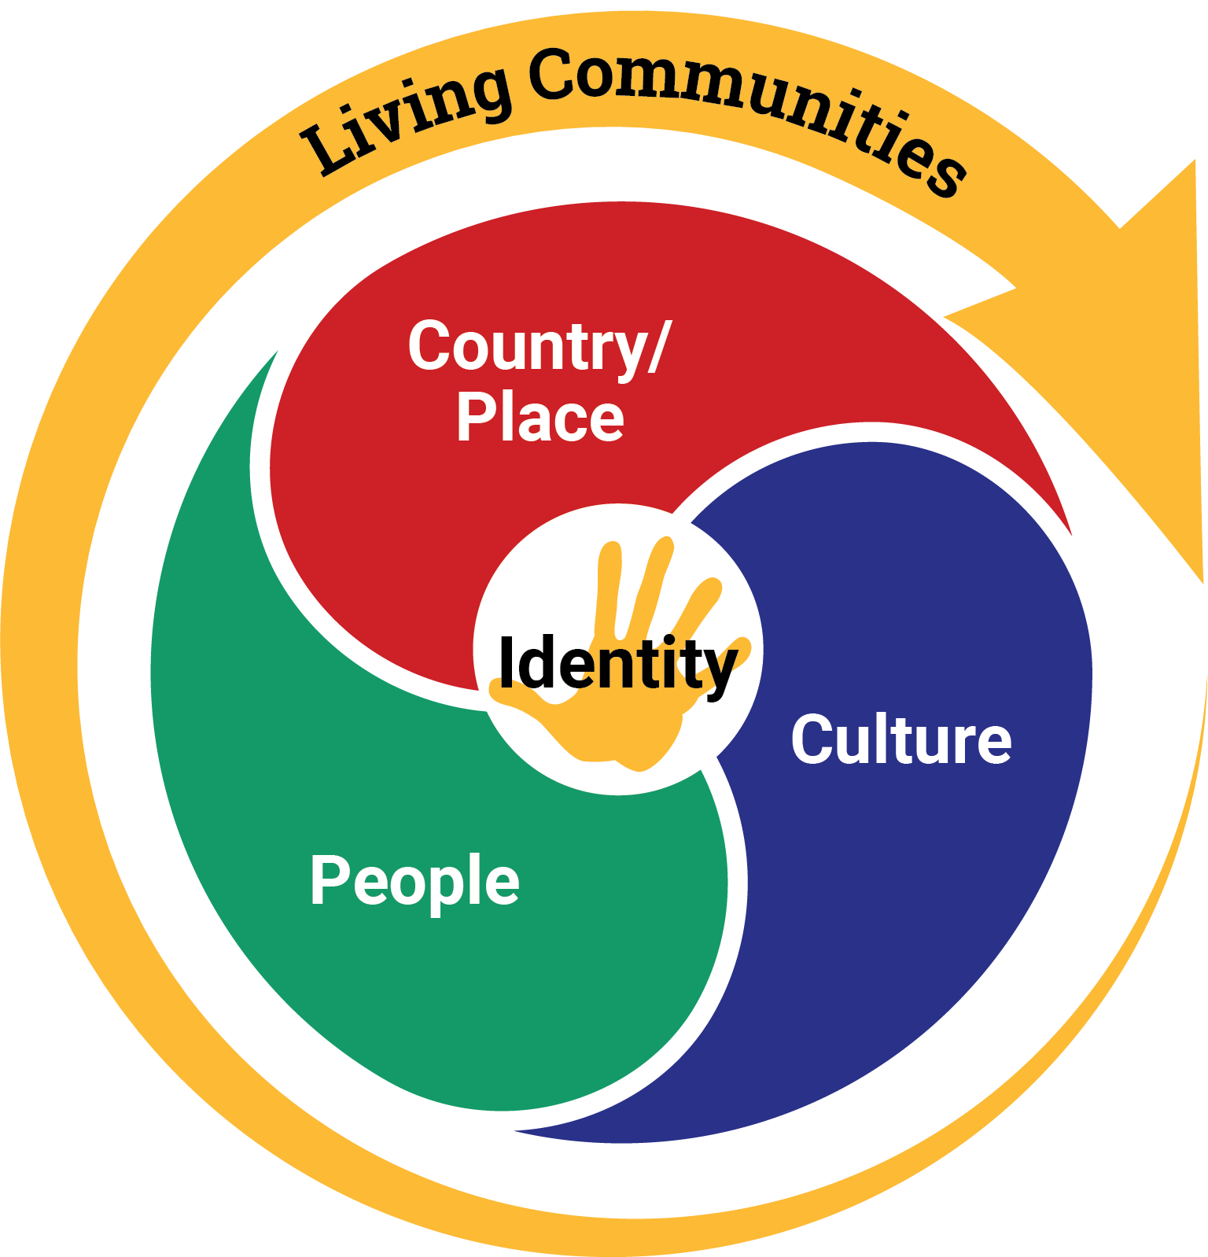
Figure 1: Framework for the Aboriginal and Torres Strait Islander Histories and Cultures cross-curriculum priority
Figure 1 depicts Living Communities and Identity as central to Aboriginal and Torres Strait Islander Histories and Cultures. Australians should know that Australian First Nations Peoples form significant, diverse and resilient living communities within contemporary society.
To further explore and understand Australian First Nations Peoples’ living communities and identities, the framework articulates and supports the acquisition of deeper knowledge and understanding through the 3 interconnected aspects of Country/Place, Culture and People.

Country/Place
- Recognises the special connection to Country/Place and celebrates the unique belief systems that connect Australian First Nations Peoples physically and spiritually to Country/Place.
- Positions First Nations Australians as the Traditional Owners of Country/Place and highlights how native title law recognises the rights and interests of both the First Peoples of Australia and the First Nations Peoples of the Torres Strait in Country/Place.
- Acknowledges the impacts of colonisation and the doctrine of terra nullius on First Nations Australians’ ownership of, and access to, Country/Place.

Culture
- Examines the cultural diversity of the First Peoples of Australia and the First Nations Peoples of the Torres Strait, including their unique ways of ways of being, knowing, thinking and doing.
- Recognises Australia’s First Peoples as belonging to the world’s oldest continuous cultures and acknowledges the many historic and enduring impacts on the cultures of First Nations Australians.
- Clarifies that the cultures of First Nations Australians are not static and have internationally enshrined special rights that ensure they can be maintained, controlled, protected and developed.

People
- Acknowledges the occupation of the Australian continent by the First Peoples of Australia for more than 60,000 years.
- Highlights that Australia has 2 distinct First Nations Peoples, each encompassing a diversity of nations and peoples.
- Examines the sophisticated social organisation systems, protocols, kinship structures and the significant contributions of First Nations Australians’ histories and cultures on a local, national and global scale.
The Aboriginal and Torres Strait Islander Histories and Cultures cross-curriculum priority has 3 sets of organising ideas to explain each of the 3 aspects of Country/Place, Culture and People. Together, they identify what many First Nations Australians believe is essential cultural knowledge that all Australians should know.

Organising ideas
Country/Place
These organising ideas recognise the special connection of First Nations Australians to Country/Place and acknowledge the impacts of colonisation on their ownership of, and access to, Country/Place.
- First Nations communities of Australia maintain a deep connection to, and responsibility for, Country/Place and have holistic values and belief systems that are connected to the land, sea, sky and waterways. (A_TSICP1)
- The occupation and colonisation of Australia by the British, under the now overturned doctrine of terra nullius, were experienced by First Nations Australians as an invasion that denied their occupation of, and connection to, Country/Place. (A_TSICP2)
- The First Peoples of Australia are the traditional owners of Country/Place, protected in Australian Law by the Native Title Act 1993 which recognises pre-existing sovereignty, continuing systems of law and customs, and connection to Country/Place. This recognised legal right provides for economic sustainability and a voice into the development and management of Country/Place. (A_TSICP3)

Culture
These organising ideas examine the cultural diversity of the First Peoples of Australia and the First Nations Peoples of the Torres Strait, and recognise Australian First Nations Peoples as belonging to the world’s oldest continuous cultures.
- First Nations Australian societies are diverse and have distinct cultural expressions such as language, customs and beliefs. As First Nations Peoples of Australia, they have the right to maintain, control, protect and develop their cultural expressions, while also maintaining the right to control, protect and develop culture as Indigenous Cultural and Intellectual Property. (A_TSIC1)
- First Nations Australians’ ways of life reflect unique ways of being, knowing, thinking and doing. (A_TSIC2)
- The First Peoples of Australia (Aboriginal Peoples) belong to the world’s oldest continuous cultures. First Nations Australians demonstrate resilience in the maintenance, practice and revitalisation of culture despite the many historic and enduring impacts of colonisation, and continue to celebrate and share the past, present and future manifestations of their cultures. (A_TSIC3)
People
These organising ideas recognise that Australia has 2 distinct First Nations Peoples, each encompassing a diversity of nations and peoples, and examine the significant contributions of First Nations Australians histories and cultures on a local, national and global scale.
- Australia has 2 distinct First Nations Peoples; each encompasses a diversity of nations across Australia. Aboriginal Peoples are the first peoples of Australia and have occupied the Australian continent for more than 60,000 years. Torres Strait Islander Peoples are the First Nations Peoples of the Torres Strait and have occupied the region for over 4,000 years. (A_TSIP1)
- First Nations Australians have sophisticated political, economic and social organisation systems, which include family and kinship structures, laws, traditions, customs, land tenure systems, and protocols for strong governance and authority. (A_TSIP2)
- The significant and ongoing contributions of First Nations Australians and their histories and cultures are acknowledged locally, nationally and globally. (A_TSIP3)
Version 9.0 organising ideas of the Aboriginal and Torres Strait Islander Histories and Cultures cross-curriculum priority is set out in Table 1.

Table 1: Organising ideas of the Aboriginal and Torres Strait Islander Histories and Cultures cross-curriculum priority version 9.0
Version 9.0 organising ideas
Country/Place
First Nations communities of Australia maintain a deep connection to, and responsibility for, Country/Place and have holistic values and belief systems that are connected to the land, sea, sky and waterways. (A_TSICP1)
The occupation and colonisation of Australia by the British, under the now overturned doctrine of terra nullius, were experienced by First Nations Australians as an invasion that denied their occupation of, and connection to, Country/Place. (A_TSICP2)
The First Peoples of Australia are the traditional owners of Country/Place, protected in Australian Law by the Native Title Act 1993 which recognises pre-existing sovereignty, continuing systems of law and customs, and connection to Country/Place. This recognised legal right provides for economic sustainability and a voice into the development and management of Country/Place. (A_TSICP3)
Culture
First Nations Australian societies are diverse and have distinct cultural expressions such as language, customs and beliefs. As First Nations Peoples of Australia they have the right to maintain, control, protect and develop their cultural expressions, while also maintaining the right to control, protect and develop culture as Indigenous Cultural and Intellectual Property. (A_TSIC1)
First Nations Australians’ ways of life reflect unique ways of being, knowing, thinking and doing. (A_TSIC2)
The First Peoples of Australia (Aboriginal Peoples) belong to the world’s oldest continuous cultures. First Nations Australians demonstrate resilience in the maintenance, practice and revitalisation of culture despite the many historic and enduring impacts of colonisation, and continue to celebrate and share the past, present and future manifestations of their cultures. (A_TSIC3)
People
Australia has 2 distinct First Nations Peoples; each encompasses a diversity of nations across Australia. Aboriginal Peoples are the first peoples of Australia and have occupied the Australian continent for more than 60,000 years. Torres Strait Islander Peoples are the First Nations Peoples of the Torres Strait and have occupied the region for over 4,000 years. (A_TSIP1)
First Nations Australians have sophisticated political, economic and social organisation systems, which include family and kinship structures, laws, traditions, customs, land tenure systems and protocols for strong governance and authority. (A_TSIP2)
The significant and ongoing contributions of First Nations Australians and their histories and cultures are acknowledged locally, nationally and globally. (A_TSIP3)

Council of Australian Governments, Education Council (2019) Alice Springs (Mparntwe) Education Declaration, p 15.

