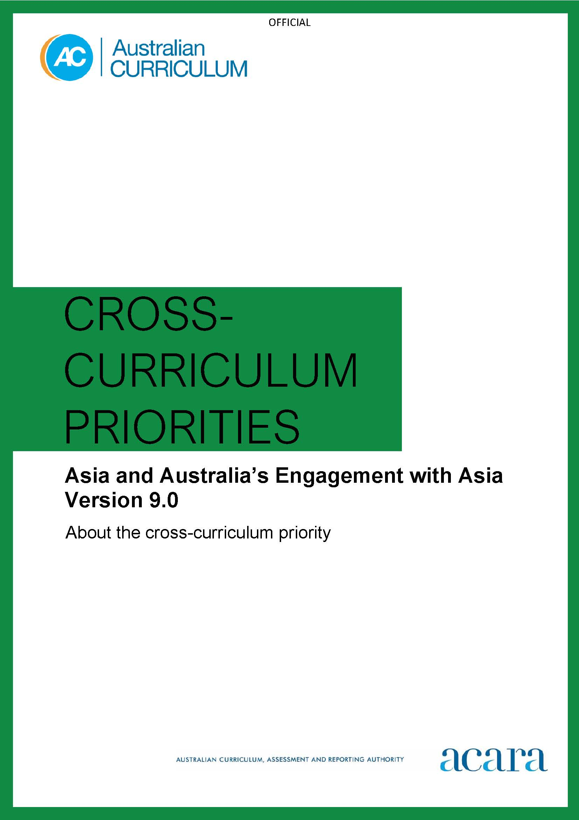

Copyright and Terms of Use Statement
© Australian Curriculum, Assessment and Reporting Authority 2022
The material published in this work is subject to copyright pursuant to the Copyright Act 1968 (Cth) and is owned by the Australian Curriculum, Assessment and Reporting Authority (ACARA) (except to the extent that copyright is held by another party, as indicated).
The viewing, downloading, displaying, printing, reproducing (such as by making photocopies) and distributing of these materials is permitted only to the extent permitted by, and is subject to the conditions imposed by, the terms and conditions of using the ACARA website (see, especially, clauses 2, 3 and 4 of those terms and conditions). The terms and conditions can be viewed at https://www.acara.edu.au/contact-us/copyright

F–10 australian curriculum: cross-curriculum priorities – ASIA AND AUSTRALIA’S ENGAGEMENT WITH ASIA

Introduction

The Asia region exerts significant influence globally and in Australia. Young people need to develop the knowledge, skills, capabilities and attitudes to effectively navigate and contribute to our regional neighbourhood.

Asia is our part of the world. Knowing, understanding and growing engagement with Asia are foundational for young people as Australia seeks to strengthen its ties in the Asia region. Australians require intercultural understanding, empathy and confidence to contribute to, and understand, Asia–Australia engagement.

To know Asia and its diversity, students need an insight into the societies, beliefs, histories, cultures, languages and environments of the nations within the region. They need to develop understanding of the region’s contemporary challenges and opportunities. Knowledge, understanding and active engagement between Australia and Asia counteract unintended assumptions and stereotypes, and build positive relationships when guided by critical thinking, respect and reflection.

Students develop understanding that Asia’s global significance and strategic influence continue to expand. Asia is the most populous region in the world, home to two-thirds of the world’s people. The region is the largest producer and consumer of goods and services in the world. Current historic shifts in global innovation networks and economic, security and technology systems, alongside global environmental and social challenges, heighten the need for Asia–Australia engagement.

Australia increasingly seeks opportunities to engage with Asia strategically, politically, culturally and economically. People, environments, economies, technologies, transport and communications systems, security, cultures and histories of Asia and Australia are interdependent. These deep connections are reflected in historical relationships developed over thousands of years, and contemporary relationships. Popular culture can provide opportunities for Asia–Australia engagement, particularly through the arts and media.

Connection and collaboration are essential for young people to understand Asia–Australia engagement. The opportunities provided by travel initiatives, study programs, the internet and online forums generate diverse cultural perspectives and experiences. Students become informed and active citizens across local, regional and global communities, and contribute to Australia’s social, intellectual and creative capital.

Defining Asia
Asia can be described in terms of cultural, religious, historical and language boundaries or commonalities.
Different geographical definitions can be applied to Asia to identify subregions:
- North-East Asia includes China, Taiwan, Japan, Mongolia, North Korea, South Korea.
- South-East Asia includes Brunei Darussalam, Cambodia, Indonesia, Laos, Malaysia, Myanmar (Burma), the Philippines, Singapore, Thailand, Timor-Leste, Vietnam.
- South Asia includes Afghanistan, Bangladesh, Bhutan, India, the Maldives, Nepal, Pakistan, Sri Lanka.
- Central Asia includes Kazakhstan, Kyrgyzstan, Tajikistan, Turkmenistan, Uzbekistan.
- West Asia includes Bahrain, Iran, Iraq, Israel, Jordan, Kuwait, Lebanon, Oman, Palestinian Territories, Qatar, Saudi Arabia, Syrian Arab Republic, Turkey, United Arab Emirates, Yemen.
Note: Short country names rather than official country names have been used.
Different geographic regions of Asia, or parts of it, can also be referred to:
- Asia-Pacific describes countries across Asia, inclusive of Australasia and the Pacific Island nations.
- Indo-Pacific includes the combined Indian Ocean and Pacific Ocean, and the land masses that surround them.
- ASEAN (Association of South-East Asian Nations) includes nations which are part of a regional intergovernmental organisation comprising the 11 South-East Asian nations with Australia included as an ASEAN partner.

Structure
The Asia and Australia’s Engagement with Asia cross-curriculum priority is based on 3 sets of organising ideas:

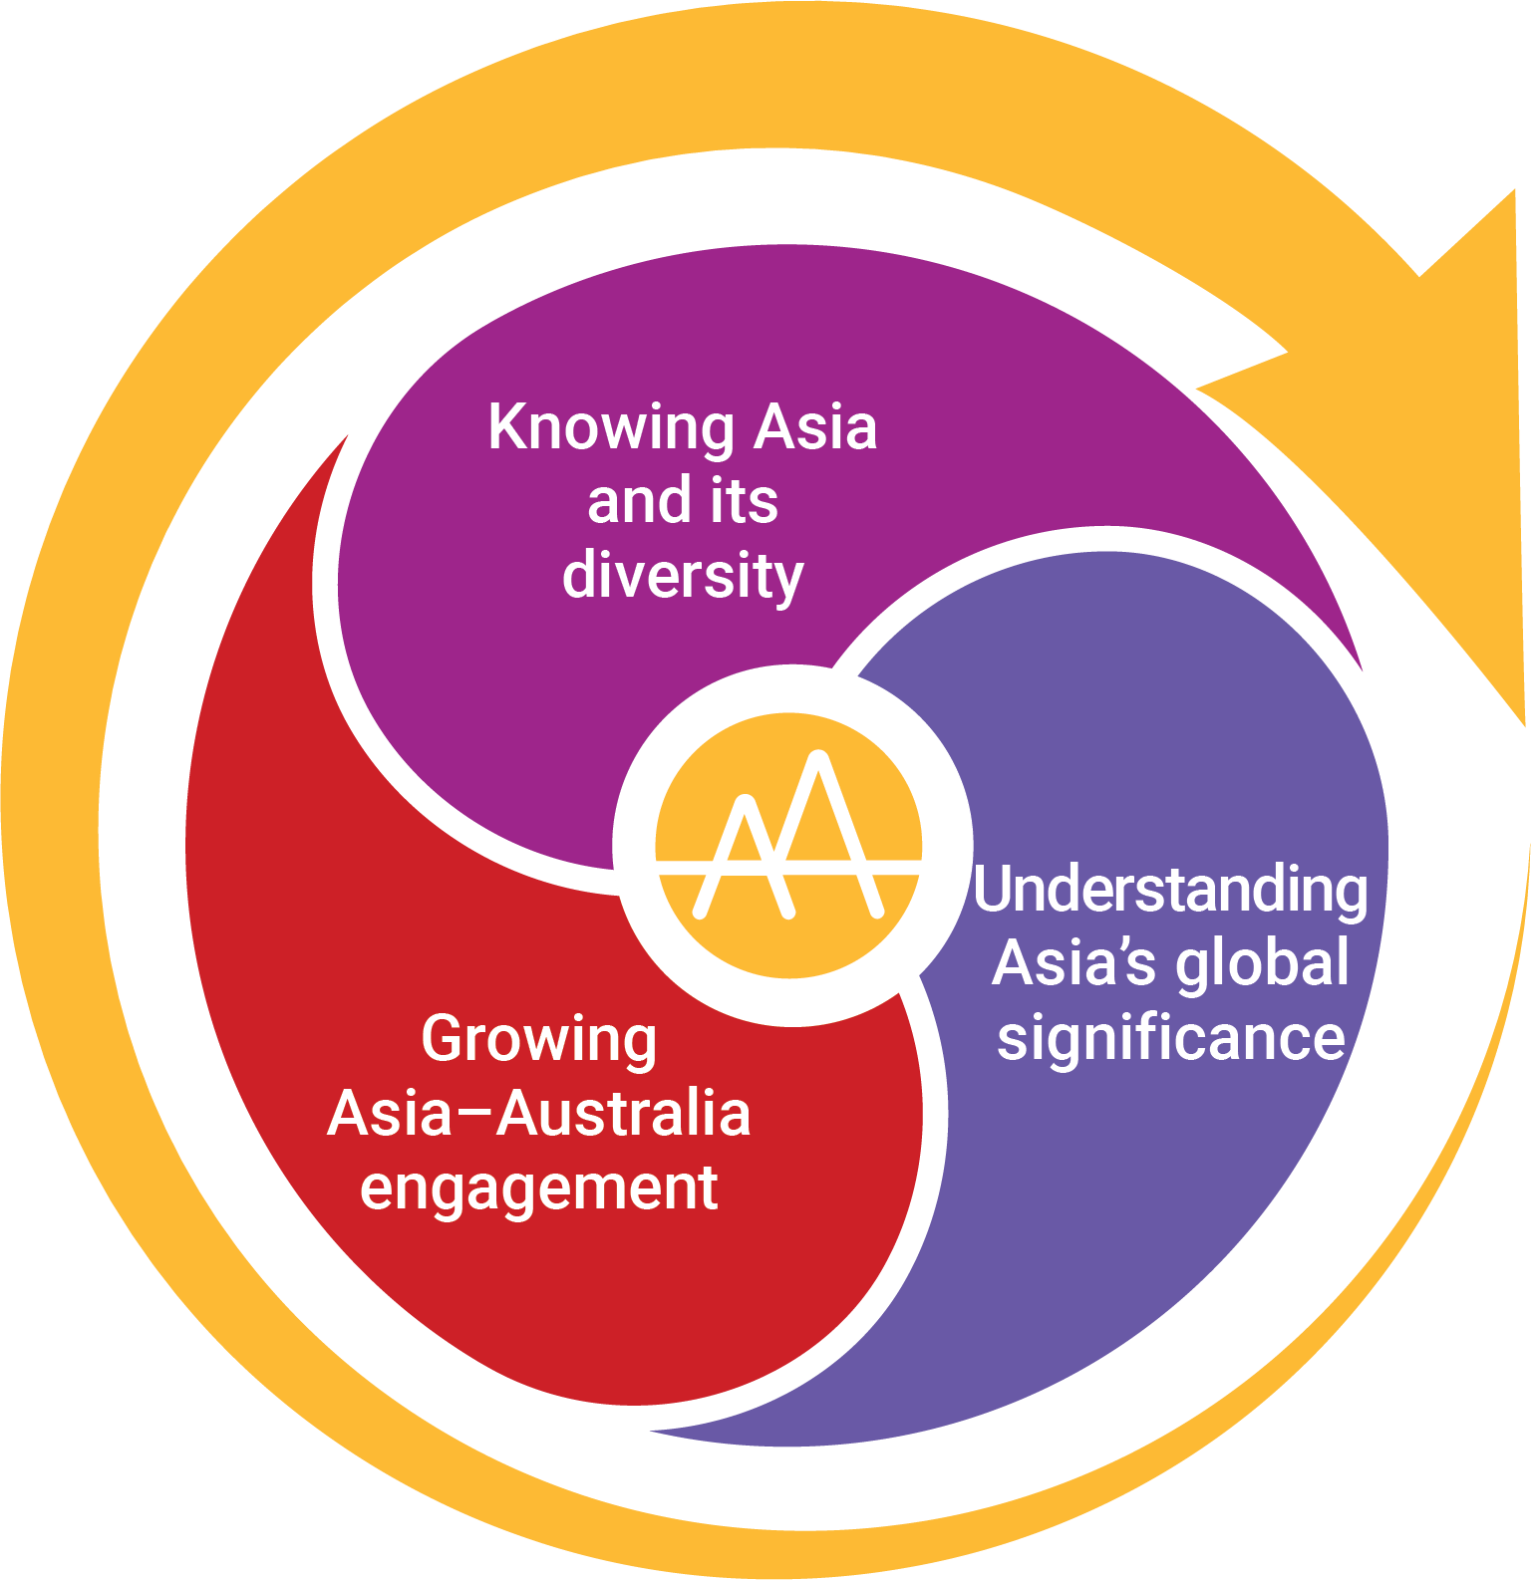
Figure 1: Framework for the Asia and Australia’s Engagement with Asia cross-curriculum priority

Knowing Asia and its diversity
These organising ideas emphasise the need to appreciate the backgrounds, experiences, stories, religions, beliefs and perspectives within and among the nations of the Asia region and the interconnections with Australia. It is supported by understanding Asia and Australia’s interconnected environments, natural, managed and constructed, and the political, financial and technological systems that drive relationships.

Understanding Asia’s global significance
These organising ideas examine the ways in which different significant nations in Asia have effected change and contributed to global developments., with human endeavour expressed through aesthetic, creative, political, economic and scientific pursuits. Highlighting key individuals, events, developments or nations reinforces how they have contributed to Asia’s global significance.

Growing Asia–Australia engagement
These organising ideas include the relationship-building contribution of Australians with Asian heritage and explore how active connections between young people and Asia’s diverse communities can be deepened and contribute to global citizenship. Interaction builds empathy, respects cultural and linguistic differences, and leads to collaborative opportunities and outcomes. These active connections provide the lived experiences of global citizenship for young Australians, including through popular culture, and nurture relationships that reflect the historical and contemporary interdependency of Australia and the nations of Asia.

Organising ideas
Knowing Asia and its diversity
- People of the Asia region are diverse in backgrounds, experiences, stories, religions, beliefs and perspectives. (AAK1)
- The interrelationships between people and the diverse environments and systems across the Asia region have global implications. (AAK2)
Understanding Asia’s global significance
- The nations of Asia influence historical and contemporary global relationships, including international responses to global developments and events. (AAU1)
- The peoples of Asia shape human endeavour through aesthetic, creative, political, sporting, economic, technological and scientific domains. (AAU2)
Growing Asia–Australia engagement
- Australia’s developing and deepening relationships with the peoples of Asia influence both mutual understandings and expressions of citizenship and culture nationally, regionally and globally. (AAG1)
- Australia and Asia are interdependent through a range of historical and contemporary connections. (AAG2)
Version 9.0 organising ideas of the Asia and Australia’s Engagement with Asia cross-curriculum priority is set out in Table 1.

Table 1: Organising ideas of the Asia and Australia’s engagement with Asia cross-curriculum priority version 9.0
Version 9.0 organising ideas
Knowing Asia and its diversity
Peoples of the Asia region are diverse in backgrounds, experiences, stories, religions, beliefs and perspectives. (AAK1)
The interrelationships between people and the diverse environments and systems across the Asia region have global implications. (AAK2)
Understanding Asia’s global significance
The nations of Asia influence historical and contemporary global relationships, including international responses to global developments and events. (AAU1)
The peoples of Asia shape human endeavour through aesthetic, creative, political, sporting, economic, technological and scientific domains. (AAU2)
Growing Asia–Australia engagement
Australia’s developing and deepening relationships with the peoples of Asia influence both mutual understandings and expressions of citizenship and culture nationally, regionally and globally. (AAG1)
Australia and Asia are interdependent through a range of historical and contemporary connections. (AAG2)

