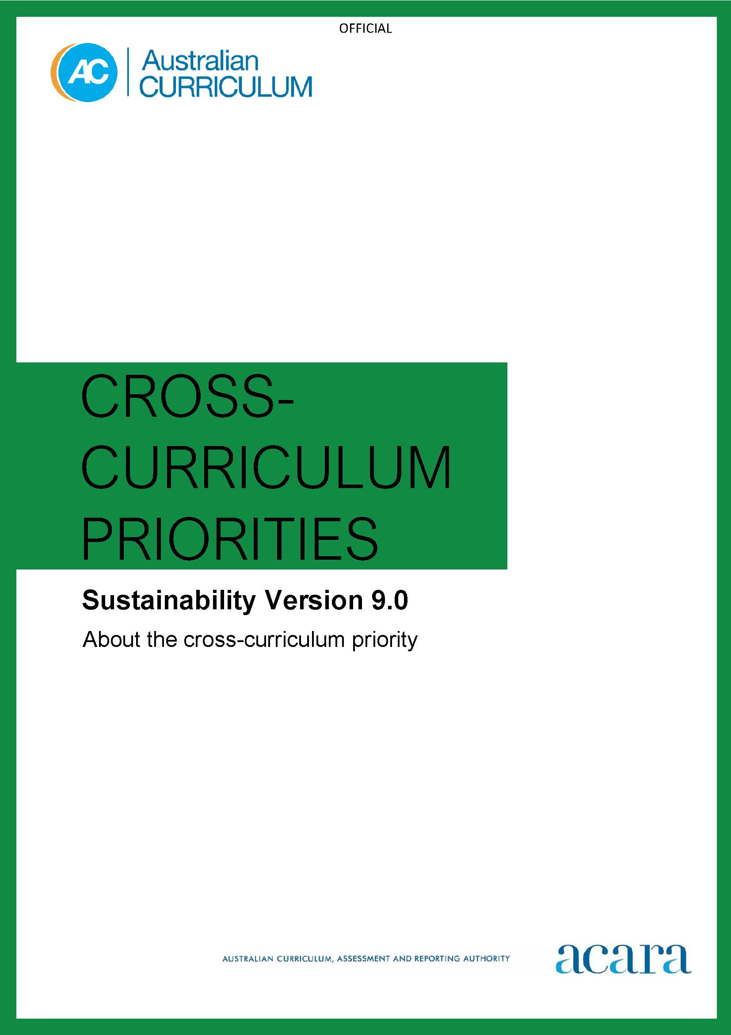

Copyright and Terms of Use Statement
© Australian Curriculum, Assessment and Reporting Authority 2022
The material published in this work is subject to copyright pursuant to the Copyright Act 1968 (Cth) and is owned by the Australian Curriculum, Assessment and Reporting Authority (ACARA) (except to the extent that copyright is held by another party, as indicated).
The viewing, downloading, displaying, printing, reproducing (such as by making photocopies) and distributing of these materials is permitted only to the extent permitted by, and is subject to the conditions imposed by, the terms and conditions of using the ACARA website (see, especially, clauses 2, 3 and 4 of those terms and conditions). The terms and conditions can be viewed at https://www.acara.edu.au/contact-us/copyright

F–10 australian curriculum: cross-curriculum priorities – sustainability

Introduction
Sustainability addresses the ongoing capacity of Earth to maintain all life. Sustainable patterns of living seek to meet the needs of the present generation without compromising the needs of future generations.
Actions to improve sustainability may be individual or collective endeavours shared across local, national and global communities. They necessitate a renewed and balanced approach to the way humans interact with each other and the environment. Actions should reflect values of care, respect and responsibility, and require individuals and communities to recognise, adapt to and manage change.
Young people require the knowledge and skills to engage with contemporary issues such as climate change, biodiversity loss, equitable access to resources, and preservation of cultural and language diversity. They are looking for social, economic and political models that provide solutions to these issues.
The Sustainability cross-curriculum priority explores the knowledge, skills, values and world views necessary for people to act in ways that contribute to a sustainable future. Designing solutions and actions for a sustainable future requires an understanding of the ways environmental, social and economic systems interact, and an ability to make balanced judgements based on present and future impacts.
The Sustainability cross-curriculum priority is futures-oriented and encourages students to reflect on how they interpret and engage with the world. It is designed to raise student awareness about informed action to create a more environmentally and socially just world.

Structure
The Sustainability cross-curriculum priority is based on 4 sets of organising ideas.
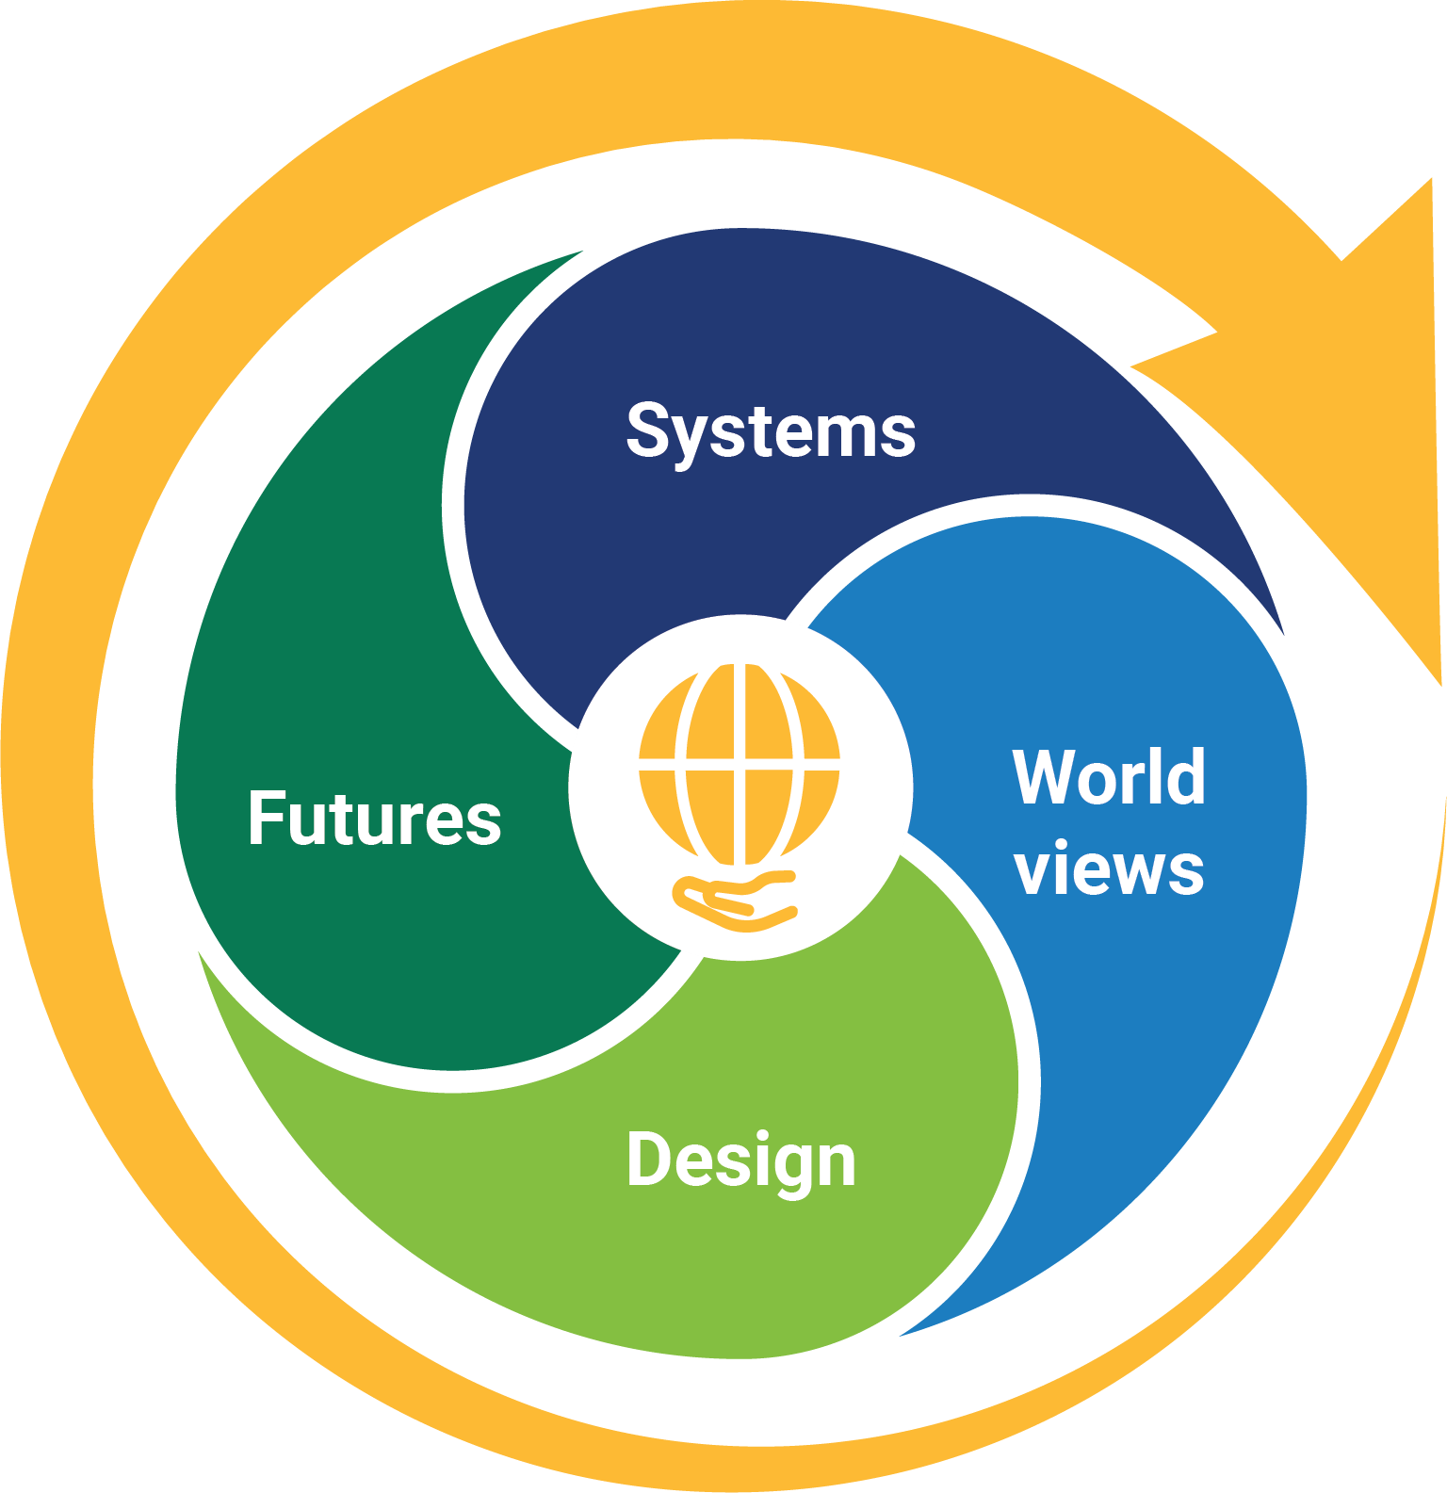
Figure 1: Framework for the Sustainability cross-curriculum priority

Systems
These organising ideas address the interdependence of Earth’s systems (geosphere, biosphere, hydrosphere and atmosphere) that support all life on Earth, and social and economic systems.
World views
These organising ideas address the role of world views (sets of attitudes, values and beliefs) that shape individual and community ideas about how the world works and our role in the world.
Design
These organising ideas address the role of innovation and creativity in sustainably designed solutions, including products, environments and services, that aim to reduce present and future impacts or to restore the health or diversity of environmental, social and economic systems.
Futures
These organising ideas address ways of thinking and acting that seek to empower young people to design action that will lead to an equitable, sustainable and inclusive future.

Organising ideas
Systems
- All life forms, including human life, are connected through Earth’s systems (geosphere, biosphere, hydrosphere and atmosphere) on which they depend for their wellbeing and survival. (SS1)
- Sustainable patterns of living require the responsible use of resources, maintenance of clean air, water and soils, and preservation or restoration of healthy environments. (SS2)
- Social, economic and political systems influence the sustainability of Earth’s systems. (SS3)
World views
- World views that recognise the interdependence of Earth’s systems, and value diversity, equity and social justice, are essential for achieving sustainability. (SW1)
- World views are formed by experiences at personal, local, national and global levels, and are linked to individual, community, business and political actions for sustainability. (SW2)
Design
- Sustainably designed products, environments and services aim to minimise the impact on or restore the quality and diversity of environmental, social and economic systems. (SD1)
- Creative and innovative design is integral to the identification of new ways of sustainable living. (SD2)
- Sustainable design requires an awareness of place, past practices, research and technological developments, and balanced judgements based on projected environmental, social and economic impacts. (SD3)

Futures
- Sustainable futures are achieved through informed individual, community, business and political action that values local, national and global equity and fairness across generations into the future. (SF1)
- Sustainable futures require individuals to seek information, identify solutions, reflect on and evaluate past actions, and collaborate with and influence others as they work towards a desired change. (SF2)
Version 9.0 organising ideas of the Sustainability cross-curriculum priority is set out in Table 1.

Table 1: Organising ideas of the Sustainability cross-curriculum priority version 9.0
Version 9.0 organising ideas
Systems
All life forms, including human life, are connected through Earth’s systems (geosphere, biosphere, hydrosphere and atmosphere) on which they depend for their wellbeing and survival. (SS1)
Sustainable patterns of living require the responsible use of resources, maintenance of clean air, water and soils, and preservation or restoration of healthy environments. (SS2)
Social, economic and political systems influence the sustainability of Earth’s systems. (SS3)
World views
World views that recognise the interdependence of Earth’s systems, and value diversity, equity and social justice, are essential for achieving sustainability. (SW1)
World views are formed by experiences at personal, local, national and global levels, and are linked to individual, community, business and political actions for sustainability. (SW2)
Design
Sustainably designed products, environments and services aim to minimise the impact on or restore the quality and diversity of environmental, social and economic systems. (SD1)
Creative and innovative design is integral to the identification of new ways of sustainable living. (SD2)
Sustainable design requires an awareness of place, past practices, research and technological developments, and balanced judgements based on projected environmental, social and economic impacts. (SD3)
Futures
Sustainable futures are achieved through informed individual, community, business and political action that values local, national and global equity and fairness across generations into the future. (SF1)
Sustainable futures require individuals to seek information, identify solutions, reflect on and evaluate past actions, and collaborate with and influence others as they work towards a desired change. (SF2)

