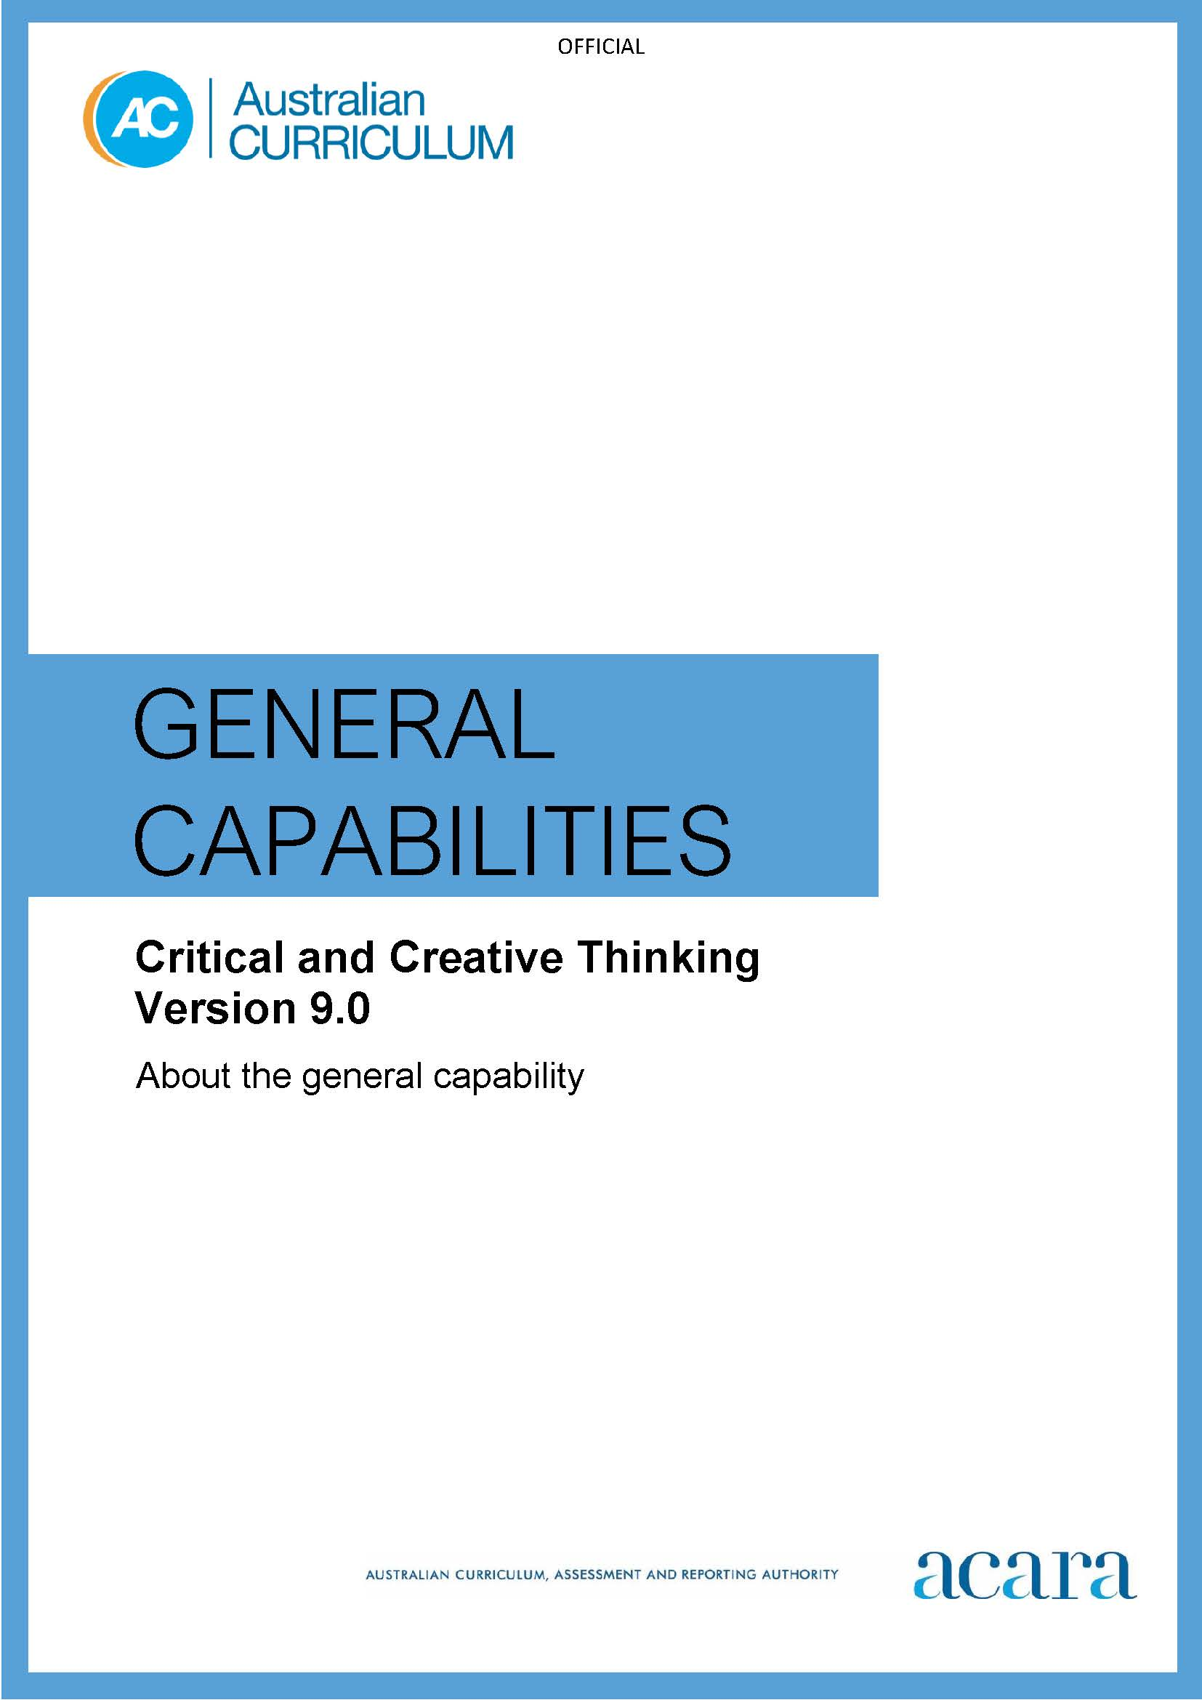

Copyright and Terms of Use Statement
© Australian Curriculum, Assessment and Reporting Authority 2022
The material published in this work is subject to copyright pursuant to the Copyright Act 1968 (Cth) and is owned by the Australian Curriculum, Assessment and Reporting Authority (ACARA) (except to the extent that copyright is held by another party, as indicated).
The viewing, downloading, displaying, printing, reproducing (such as by making photocopies) and distributing of these materials is permitted only to the extent permitted by, and is subject to the conditions imposed by, the terms and conditions of using the ACARA website (see, especially, clauses 2, 3 and 4 of those terms and conditions). The terms and conditions can be viewed at https://www.acara.edu.au/contact-us/copyright

F–10 AUSTRALIAN CURRICULUM: general capabilities – CRITICAL and creative thinking

Introduction

Critical and creative thinking represent 2 important ways of thinking that work together to help students inquire into the world around them.

Critical thinking involves students analysing and assessing possibilities against criteria for judgement. They construct and evaluate arguments, and use information, evidence and logic to draw reasoned conclusions and to solve problems.

Creative thinking involves students learning to generate and apply new ideas, and see existing situations in new ways. They identify alternative explanations and possibilities, and create new links to generate successful outcomes.

Dispositions such as inquisitiveness, reasonableness, intellectual flexibility, open- and fair-mindedness, and a readiness to try new ways of doing things are enhanced by critical and creative thinking. Students consider alternatives and develop persistence throughout the learning continuum.

Structure
The Critical and Creative Thinking learning continuum is organised into 4 elements, as shown in Figure 1:
- Inquiring
- Generating
- Analysing
- Reflecting.

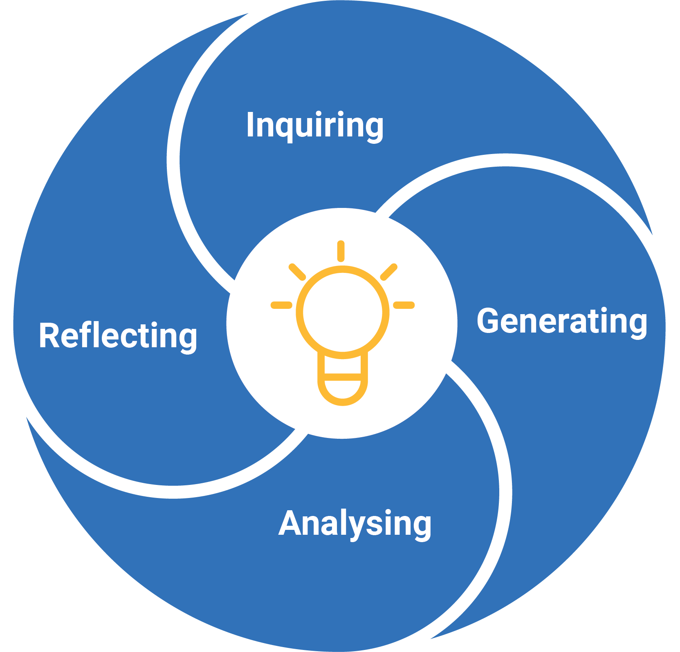
Figure 1: Critical and Creative Thinking elements
Inquiring
This element is organised into 2 sub-elements:
- Develop questions – students narrow or expand the focus of their thinking and explore ideas and concepts critically and creatively. When they develop different kinds of questions, students can further their inquiry. They can find more information about a topic and form a better understanding of how something works or why something is the way it is.
- Identify, process and evaluate information – students seek information from a range of sources, make decisions about expert or personal opinion and understand which sources are trustworthy, relevant and useful.
Generating
This element is organised into 3 sub-elements:
- Create possibilities – students explore and combine ideas to create innovative solutions, and adapt and present ideas in new ways, as they engage with learning area content.
- Consider alternatives – students examine different and creative ways to approach tasks, and make recommendations on preferred options and actions.
- Put ideas into action – students experiment with ideas, modify and adapt approaches, and evaluate options and actions in a range of situations.
Analysing
This element is organised into 3 sub-elements:
- Interpret concepts and problems – students interpret concepts, ideas, theories and problems, and deconstruct them into their component parts, to gain a deeper understanding of the context or situation.
- Draw conclusions and provide reasons – students reach a conclusion or make a choice for action by connecting to learning area knowledge and understanding. The act of justifying a conclusion also requires the provision of a reason or the development of an argument in support of the conclusion or action.
- Evaluate actions and outcomes – students consider the choices made when they solve problems or attempt learning area tasks, and evaluate solutions and outcomes to help plan for future action.
Reflecting
This element is organised into 2 sub-elements:
- Think about thinking (metacognition) – students identify, describe and evaluate the thinking and learning strategies that they use to complete activities. They reflect on the ways that their thinking, and the approaches they take, may be influenced by external contributions or viewpoints.
- Transfer knowledge – students make connections between their current knowledge and skills, and new contexts where they can adapt and use what they already know and can do. Both critical and creative thinking are involved, and new contexts can include other learning areas of the curriculum.
Version 9.0 of the Critical and Creative Thinking learning continuum is set out in Table 1.

Table 1: Critical and Creative Thinking learning continuum version 9.0
INQUIRING
Sub-element | Level 1 (Foundation) | Level 2  (Years 1–2) | Level 3  (Years 3–4) | Level 4  (Years 5–6) | Level 5  (Years 7–8) | Level 6  (Years 9–10)
Develop questions | develop questions to explore a familiar idea or topic  questions developed reflect their curiosity about the world | develop questions to explore a familiar idea or topic  questions developed are fit for the purpose of the investigation | develop questions to examine unfamiliar ideas and topics  questions developed support the process of improving knowledge and understanding about a topic or investigation | develop questions to examine unfamiliar ideas and topics  questions developed focus on improving understanding about a topic and clarifying information about processes or procedures | develop questions to investigate complex issues and topics  questions developed assist in forming an understanding of why phenomena or issues arise | develop questions to investigate complex issues and topics  questions developed facilitate increasing understanding of abstract ideas and concepts
Identify, process and evaluate information | identify and explore relevant points in information provided on a topic  prioritise the information that is most relevant to the topic of study | identify and explore relevant information from a range of sources, including visual information and digital sources  identify and explain similarities and differences in selected information | identify and examine relevant information and opinion from a range of sources, including visual information and digital sources  condense and combine selected information related to the topic of study | identify and examine relevant information and opinion from a range of sources, including visual information and digital sources  compare information and opinion that can be verified against claims based on personal preference | identify and clarify significant information and opinion from a range of sources, including visual information and digital sources  evaluate the accuracy, validity and relevance of the information and opinion to the topic of study | identify and clarify significant information and opinion from a range of sources, including visual information and digital sources  evaluate the information selected to determine bias and reliability

GENERATING
Create possibilities | use imagination to create possibilities by exploring and connecting ideas in ways that are new to them | create possibilities by connecting or creatively expanding on ideas in ways that are new to them | create possibilities by connecting or creatively expanding on new and known ideas in a variety of ways | create possibilities by changing, combining or elaborating on new and known ideas in a variety of creative ways | create possibilities by adapting, combining or elaborating on new and known ideas, and proposing a range of different or creative combinations | create possibilities by connecting or adapting complex ideas and proposing innovative and detailed variations or combinations
Consider alternatives | consider alternatives by suggesting a different way to approach a given task or problem | consider alternatives and explore different or creative ways to approach a task or problem | consider alternatives by comparing different or creative ways to approach a task, issue or problem and recommend a preferred option | consider alternatives by challenging or creatively adjusting existing ideas in situations where current approaches do not work and recommend a preferred option | consider alternatives by creatively adapting ideas when information is limited or conflicting and recommend a preferred option | consider alternatives by creatively revising and modifying ideas and recommendations when circumstances change
Put ideas into action | put ideas into action through trial-and-error experiences | put ideas into action by experimenting with options and predicting possible results | put ideas into action by predicting an outcome, trialling options and assessing their effectiveness | put ideas into action by predicting potential or future outcomes and systematically testing a range of options | put ideas into action by making predictions, testing and evaluating options, and reconsidering approaches in complex or unfamiliar situations | put ideas into action by making predictions, testing and evaluating options, proposing modifications and adapting approaches in complex or unfamiliar situations

ANALYSING
Interpret concepts and problems | identify the main parts of a concept or problem | identify the main parts of a concept or problem and describe how these relate to each other | identify and prioritise significant elements and relationships within a concept or problem | identify the relevant and significant aspects of a concept or problem, understanding that approaches may change depending on the subject or learning area | identify the relevant aspects of a concept or problem, recognising gaps or missing elements necessary for understanding by using approaches and strategies suitable for the context | identify the objective and subjective aspects of a complex concept or problem, with sensitivity to context
Draw conclusions and provide reasons | draw conclusions and make choices when completing tasks and identify the reasons for choices made | draw conclusions and make choices when completing tasks and explain the reasons for choices made | draw conclusions and make choices when completing tasks, using observation and prior knowledge to provide reasons and construct arguments for choices made | draw conclusions and make choices when completing tasks, using discipline knowledge to provide reasons and evaluate arguments for choices made | draw conclusions and make choices when completing tasks by connecting evidence from within and across discipline areas to provide reasons and evaluate arguments for choices made | draw conclusions and make choices when completing tasks, using analysis of complex evidence and arguments before making recommendations
Evaluate actions and outcomes | evaluate whether they are satisfied with the outcome of tasks or actions | evaluate whether they have accomplished what they set out to achieve, including using a given set of criteria to support decisions | evaluate the outcome of a task by explaining ideas, conclusions and actions, including using a given set of criteria to support decisions | evaluate the effectiveness of a course of action or the outcome of a task, including using a given or co-developed set of criteria to support decisions | evaluate the effectiveness of a course of action or the outcome of a task and account for expected and unexpected results, including using a given or co-developed set of criteria to support decisions | evaluate the effectiveness of a course of action to achieve desired outcomes and suggest improvements, including using a personally developed set of criteria to support judgements and decisions

REFLECTING
Think about thinking (metacognition) | identify thinking and learning strategies used when completing activities and drawing conclusions | identify and describe thinking and learning strategies they have used when completing activities and drawing conclusions | select, describe and reflect on the thinking and learning strategies and processes used when completing activities and drawing conclusions | identify and reflect on thinking and assumptions when completing activities or drawing conclusions  invite alternative perspectives or feedback in order to improve future outcomes | reflect on the thinking and processes used when completing activities or drawing conclusions  invite alternative perspectives and feedback, and consider reasonable criticism to adjust thinking and approaches | reflect on the thinking and processes used when completing activities and drawing conclusions  identify possible limitations in their own positions by considering opposing viewpoints, reasonable criticism and feedback
Transfer knowledge | connect ideas and information between familiar learning experiences | use ideas and information from a previous experience to inform similar learning experiences | use aspects of knowledge and skills gained in one setting to inform learning in a new setting or context | apply aspects of knowledge and skills gained in one context to a new or unrelated context to achieve a specific purpose | transfer knowledge and skills gained in previous experiences to both similar and different contexts, and explain reasons for decisions and choices made | identify, plan and justify opportunities to transfer knowledge into new contexts

