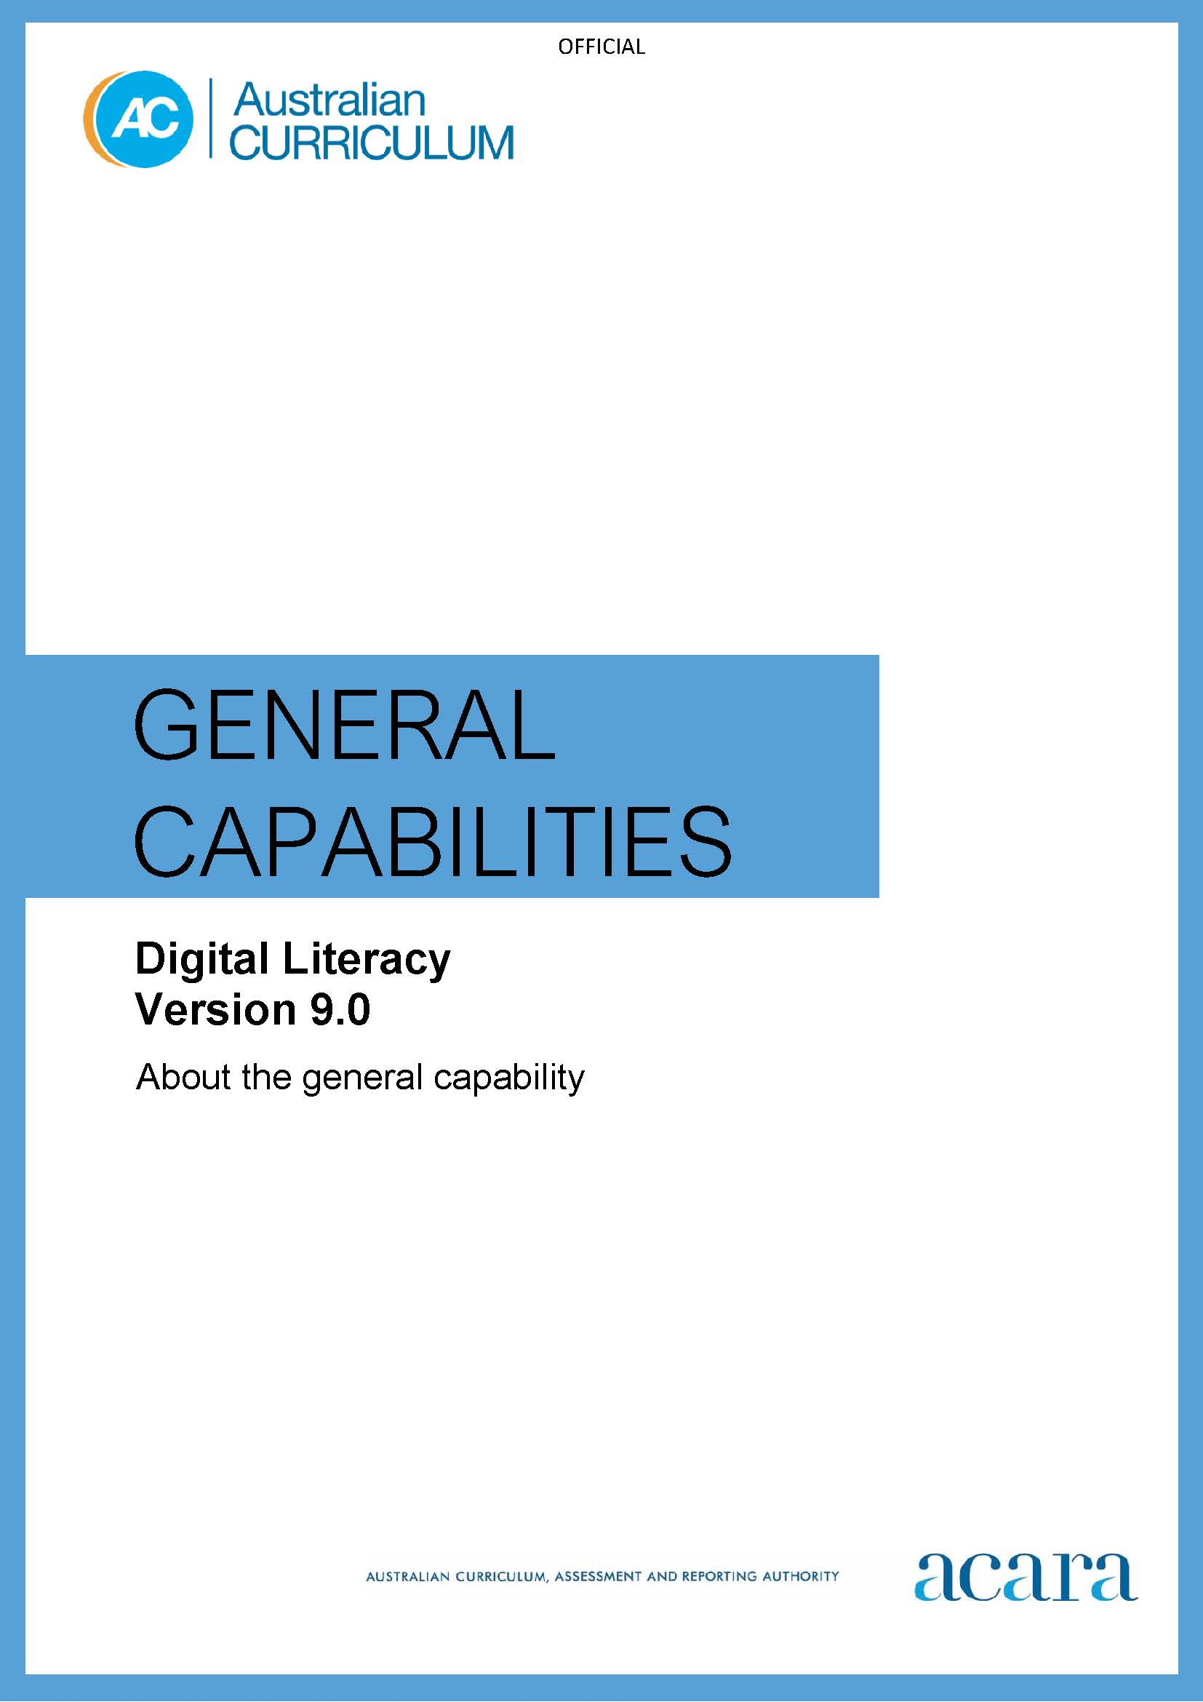

Copyright and Terms of Use Statement
© Australian Curriculum, Assessment and Reporting Authority 2022
The material published in this work is subject to copyright pursuant to the Copyright Act 1968 (Cth) and is owned by the Australian Curriculum, Assessment and Reporting Authority (ACARA) (except to the extent that copyright is held by another party, as indicated).
The viewing, downloading, displaying, printing, reproducing (such as by making photocopies) and distributing of these materials is permitted only to the extent permitted by, and is subject to the conditions imposed by, the terms and conditions of using the ACARA website (see, especially, clauses 2, 3 and 4 of those terms and conditions). The terms and conditions can be viewed at https://www.acara.edu.au/contact-us/copyright

F–10 AUSTRALIAN CURRICULUM: general capabilities – DIGITAL LITERACY

Introduction
Digital literacy encompasses the knowledge and skills students need to create, manage, communicate and investigate data, information and ideas, and solve problems. It assists students to work collaboratively at school and in their lives beyond school.
Digital literacy involves students critically identifying and appropriately selecting and using digital devices or systems, and learning to make the most of the technologies available to them. Students adapt to new ways of doing things as technologies evolve, and protect the safety of themselves and others in digital environments.

Structure
The Digital Literacy learning continuum is organised into 4 elements, as shown in Figure 1:
- Practising digital safety and wellbeing
- Investigating
- Creating and exchanging
- Managing and operating.

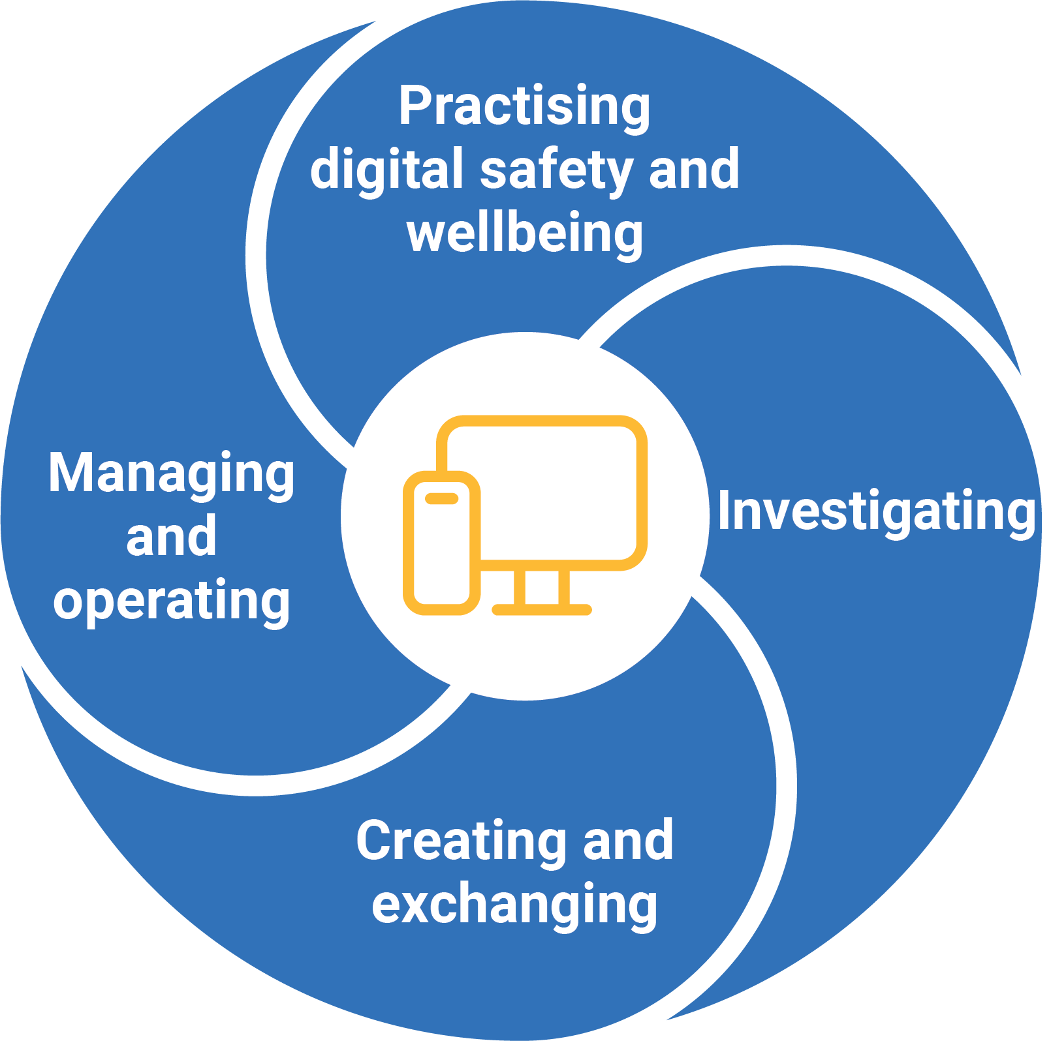

Figure 1: Digital Literacy elements

Practising digital safety and wellbeing
This element is organised into 3 sub-elements:
- Manage online safety – students develop the appropriate technical, social, cognitive, communicative and decision-making skills to address online risks. They recognise the content risks that they face online, such as hurtful user-generated content, and the strategies involved in dealing with them.
- Manage digital privacy and identity – students recognise the importance of controlling and shaping their own digital identity. They create and curate their online identities to positively tell their stories, while recognising how personal use of digital media may have implications for their digital footprint.
- Manage digital wellbeing – students consider the nature and impact of digital tool use. They develop understanding that behaviours such as excessive screen time, digital workload, distraction and multitasking can have an impact on their health, work productivity, wellbeing and lifestyles. They understand the benefits and risks of digital participation in relation to health and wellbeing outcomes.
Investigating
This element is organised into 3 sub-elements:
- Locate information – students curate information from digital resources. They effectively use research strategies to locate information and other resources. Students articulate their information and content needs, and effectively navigate information and content they encounter.
- Acquire and collate data – students understand how data can be generated and how to process data based on statistical understanding. They create or use algorithms to recognise significant patterns and improve decision-making processes. They explore relevant data sets, and read, manage and process data from a variety of sources.
- Interpret data – students create and build knowledge by analysing data and communicating its meaning to others, using various data visualisation tools. They present patterns, trends and analytical insights from data to facilitate problem-solving and decision-making.
Creating and exchanging
This element is organised into 3 sub-elements:
- Plan – students use digital tools to plan and manage a process that considers design constraints and risks.
- Create, communicate and collaborate – students execute plans for the design of digital content and to develop, test and refine models to create original products. Students recognise different types of peer-to-peer communication and collaboration strategies, tools and formats, and decide which methods are most effective for individual or collaborative goals.

- Respect intellectual property – students understand the ethical and legal responsibilities around ownership and remixing of digital content; for example, plagiarism, copyright, fair dealing and licensing. They demonstrate responsibility and respect for others by protecting their own digital creations and crediting others’ content when appropriate.
Managing and operating
This element is organised into 3 sub-elements:
- Manage content – students interact with information and data, save content using appropriate and logical conventions, and retrieve content from personal, networked and cloud spaces.
- Protect content – students identify potential threats and implement relevant cyber security practices, such as using secure passwords. They use technology without compromising their data and devices.
- Select and operate tools – students apply technical knowledge and skills to select, use and troubleshoot appropriate digital tools. They develop an understanding of hardware and software components, and the operations of appropriate digital systems, including their functions, processes and procedures.

Version 9.0 of the Digital Literacy learning continuum is set out in Table 1.

Table 1: Digital Literacy learning continuum version 9.0
Sub-element | Level 1 (Foundation) | Level 2  (Years 1–2) | Level 3  (Years 3–4) | Level 4  (Years 5–6) | Level 5  (Years 7–8) | Level 6  (Years 9–10)
PRACTISING DIGITAL SAFETY AND WELLBEING
Manage online safety | use online tools that are safe or only used under direct supervision, seeking help from trusted adults when feeling unsafe | use online tools that are age appropriate or only used under supervision, seeking help from trusted adults when feeling unsafe | report negative or harmful online behaviour by seeking help from trusted adults | report negative or harmful online behaviour to trusted adults, know how to report it in online tools  recognise when to step away from negative online social interactions | identify online abuse and bullying and report them to trusted adults, appropriate authorities and in online tools  stop engaging in negative online social interactions | engage in safe, legal and ethical online behaviour and defuse negative online social interactions  recognise the benefits and risks of anonymity online
Manage digital privacy and identity | recognise their personal data and that data (including text, images, and video) can be seen by others when shared online | recognise that online tools (website and apps) store their personal data, which may give an impression of them | identify their digital footprint (personal data stored by online tools)  recognise that their digital identity represents them online and can give a negative impression  give and seek consent before sharing online with peers and trusted adults | recognise the permanence of their digital footprint and digital identity, and the associated risks, including to their reputation  give and seek consent before sharing online in trusted groups | recognise that their digital footprint is valuable, used by online tools for targeting, and that data shared online is no longer under their control  consider who they trust with their data and review privacy policies before giving consent, and seek consent before sharing online | recognise that their actions contribute to their passive digital footprint  manage their digital identity by controlling privacy, connections and group settings, and curating posts  consent selectively to data collection after assessing the benefits and risks of an online tool privacy policy
Manage digital wellbeing | follow adult directions for the use of digital tools at school and home | follow agreed rules for the healthy use of digital tools and apply them at school and home | follow an agreed code of conduct for the healthy use of digital tools | follow an agreed code of conduct for the healthy and productive use of digital tools, considering the impact of tool use on wellbeing | develop routines to support their balanced and constructive use of digital tools  identify indicators of unhealthy usage | self-regulate the use of digital tools to purposefully enhance their wellbeing  identify how tools are designed to capture their attention
INVESTIGATING
Locate information | use simple digital tools to explore sorting data and information provided as part of learning experiences | locate information through search engines and in documents by applying search terms, and select relevant information | locate information through search engines and in documents by applying specific search terms, and select and retrieve relevant information from multiple sources | locate information through search engines and in documents by applying specific search terms based on set criteria, and select and retrieve relevant information from multiple sources | locate, select and retrieve relevant information from multiple sources, exploring advanced search functions and targeted criteria | locate relevant information by applying advanced search functions across multiple sources involving purposefully selected and contextually specific terms and criteria
Acquire and collate data |  | collect data by counting, measuring and observing with familiar digital tools | collect and access data using a range of digital tools and methods in response to a defined question | collect and access data, using a range of digital tools and methods in response to a defined question or problem | collect and access data from a range of sources, using specialised digital tools in response to problems, and evaluate it for relevance | collect and evaluate quantitative and qualitative data using specialised digital tools and processes in the context of identified problems

Interpret data |  | classify and group data using familiar digital tools to answer simple questions | organise, summarise and visualise data using a range of digital tools to identify patterns and answer questions | analyse and visualise data using a range of digital tools to identify patterns and make predictions | analyse and visualise data by selecting and using a range of digital tools to infer relationships and make predictions | analyse and visualise multidimensional data by selecting and using a range of interactive tools to draw conclusions and make predictions
CREATING AND EXCHANGING
Plan |  | use simple digital tools to contribute to a basic plan to complete a task | use familiar digital tools to develop and follow a basic plan to complete a task | select and use digital tools to develop and follow a plan to complete individual tasks and group projects | use simple planning tools to develop and follow a plan to complete individual and collaborative projects | use project management tools to develop and track a plan to complete individual and collaborative projects
Create, communicate and collaborate | use simple digital tools to create content | experiment with the features of familiar digital tools to create content | use the core features of a range of digital tools to create content and communicate and collaborate with peers and trusted adults | select and control a variety of features in appropriate digital tools to create content and communicate and collaborate with trusted groups | select and control advanced features of appropriate digital tools to independently create content and effectively communicate and collaborate with wider groups | select and control the features of digital tools to purposefully create content and effectively communicate and collaborate, inclusive of diverse groups

Respect intellectual property | identify who owns class data | recognise ownership of products that others produce or that are produced collaboratively | respect products created by someone else by acknowledging when they use them and use strategies such as indicating the source | respect intellectual property by identifying the legal obligations regarding the ownership and appropriate use of products, exploring copyright protocols and applying some referencing conventions | respect intellectual property by applying practices that comply with ethical and legal obligations, referencing conventions and copyright protocols | respect intellectual property by identifying and applying practices that meet legal and ethical obligations, referencing conventions, copyright and trademark protocols
MANAGING AND OPERATING
Manage content | save and retrieve content in an app | save and retrieve content with an agreed name | save and retrieve content in agreed locations with an appropriate name | store content using appropriate names and folders for ease of retrieval | store and backup content online for access and editing from multiple devices | store content systematically online for access and editing (with version history) from multiple devices and ensure data is reliably backed up
Protect content |  | save and access content in their individual school account | save and access content in shared folders using their individual school account | protect content when sharing with peers and trusted adults by setting appropriate access controls | protect content when sharing by selecting appropriate access controls for individuals and shared links for wider groups | protect content when sharing by purposefully selecting appropriate access controls for individuals and groups

Select and operate tools | use simple digital tools to explore tasks and consolidate learning  seek help when encountering a problem | use familiar digital tools to complete tasks and consolidate learning  attempt to solve a problem before seeking help | select and use a range of digital tools to complete tasks  attempt to solve a problem individually and with peers before seeking help | select and use the core features of digital tools to efficiently complete tasks  troubleshoot basic problems and identify repetitive tasks to automate | select and use the advanced or unfamiliar features of digital tools to efficiently complete tasks  troubleshoot common problems and automate repetitive tasks | select and operate advanced and emerging digital tools confidently  troubleshoot common problems systematically and seek to improve efficiency by developing new skills

