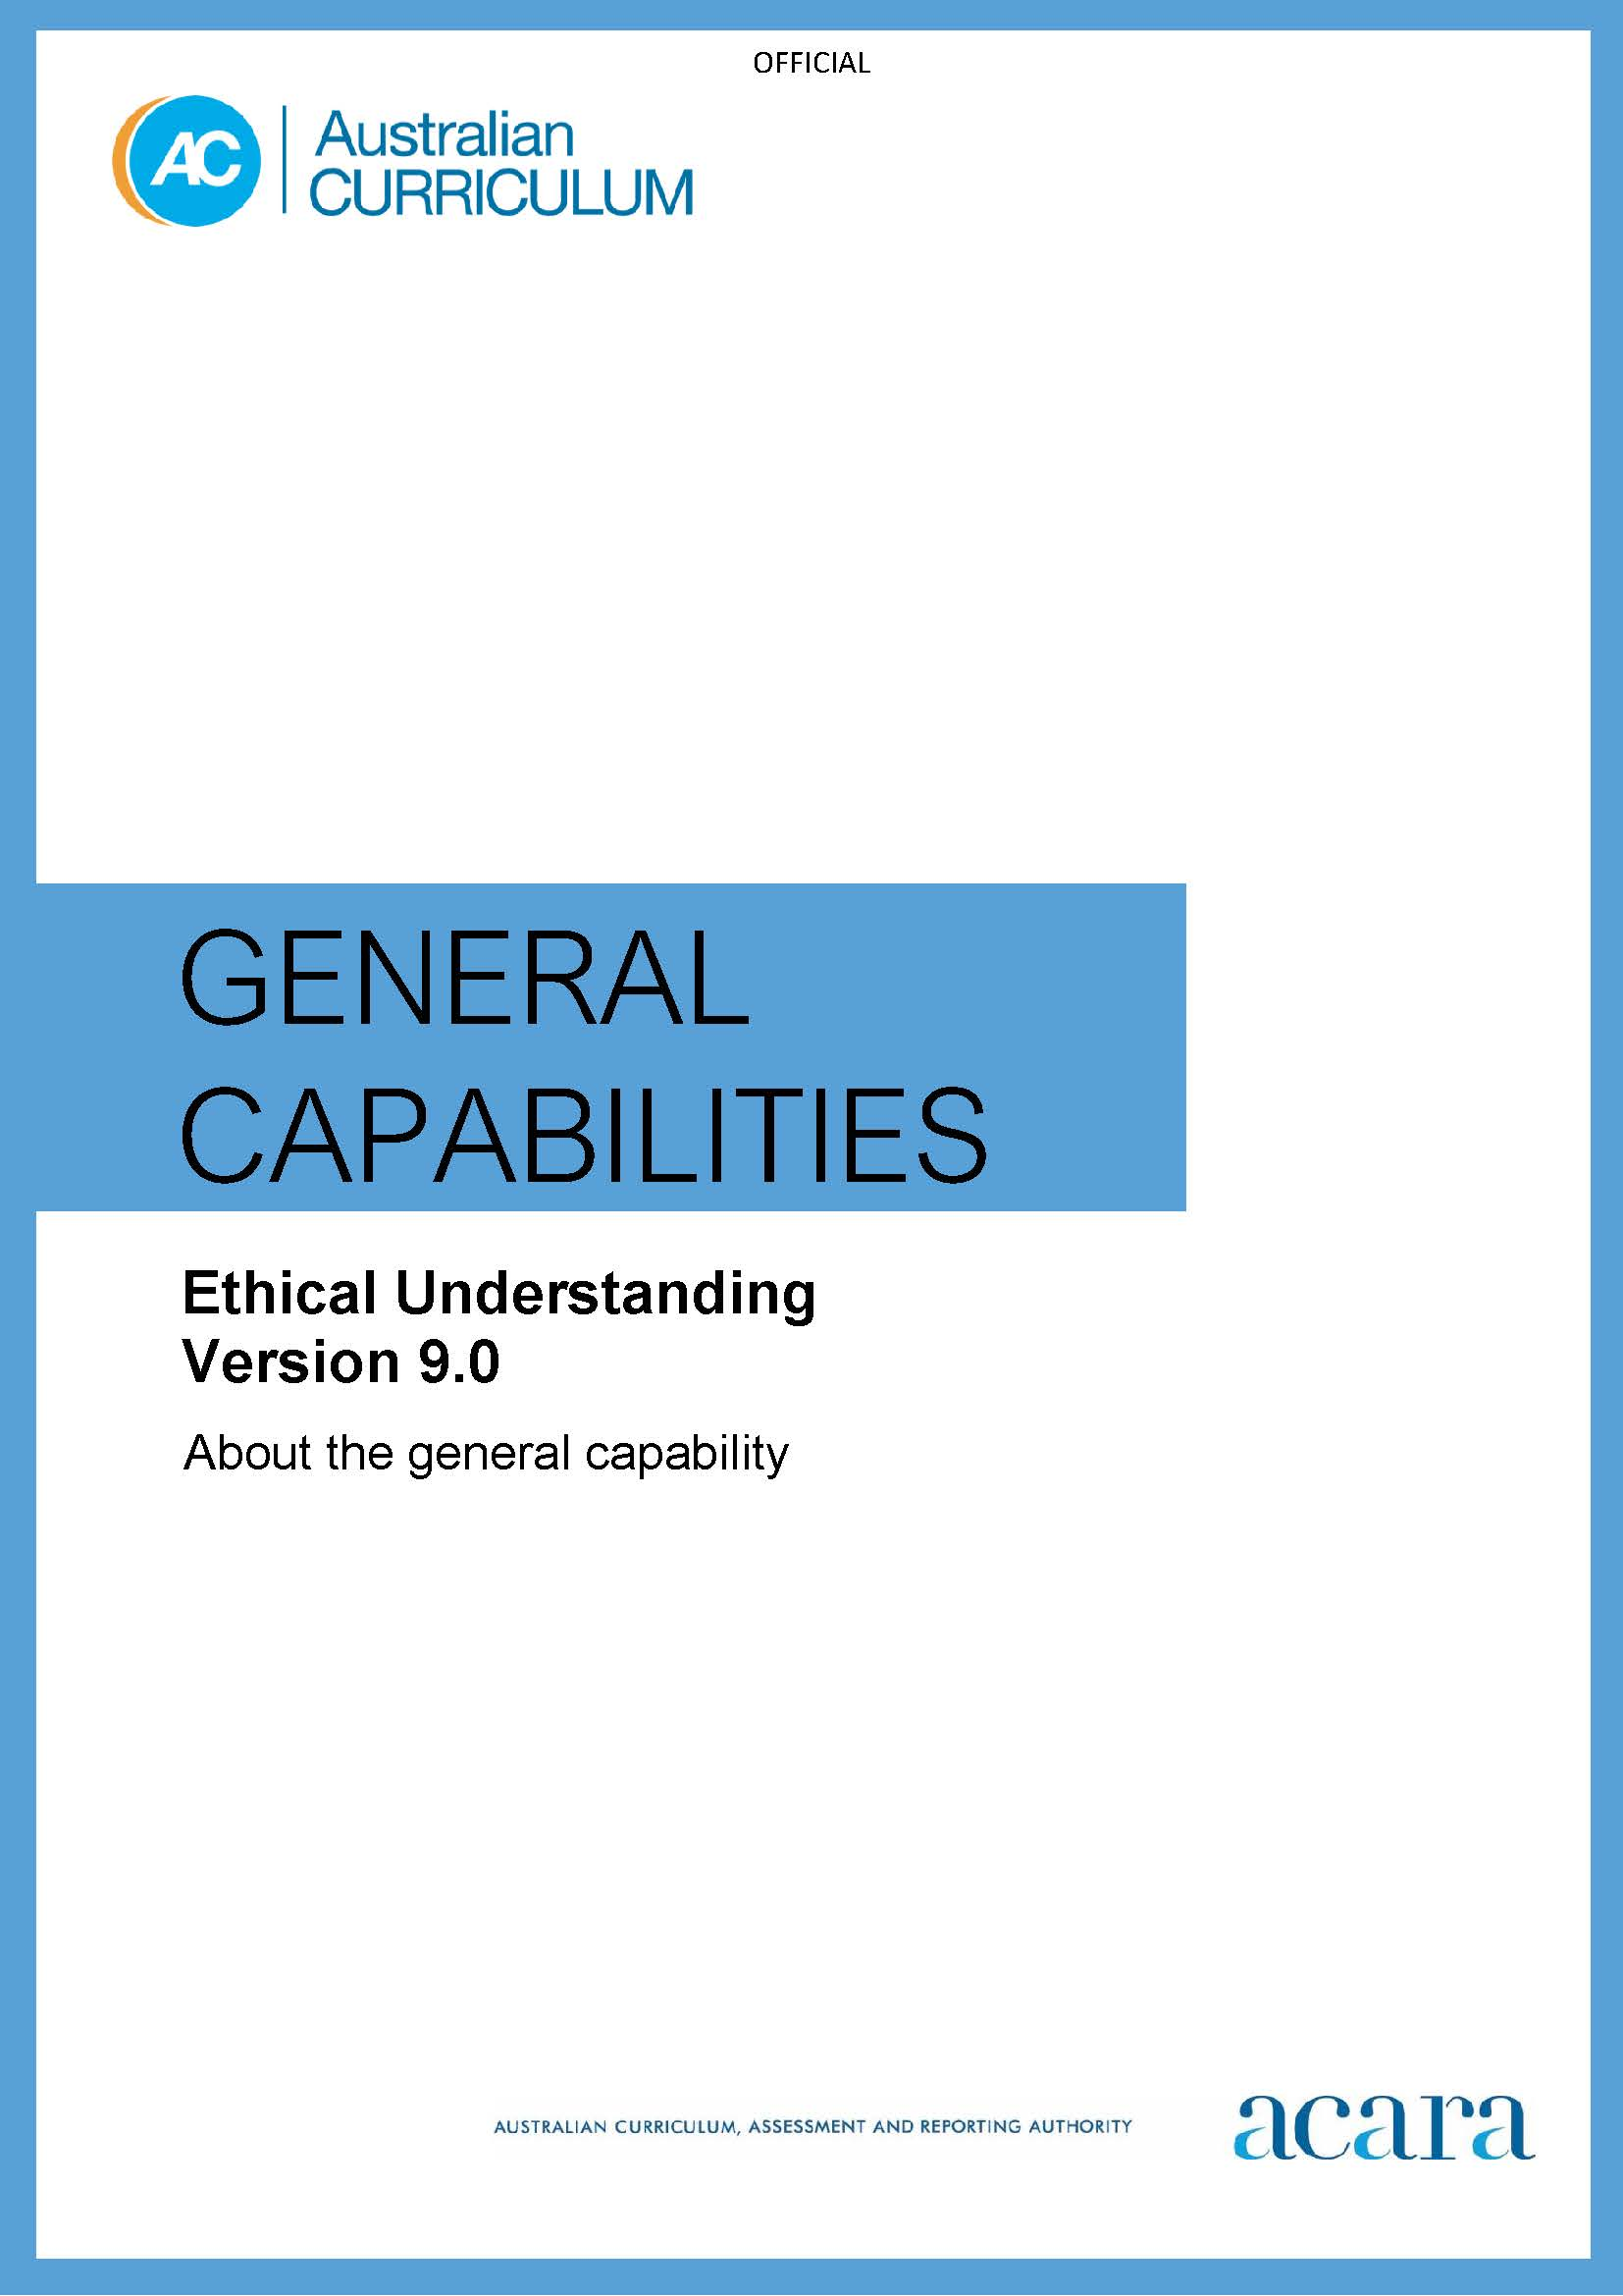

Copyright and Terms of Use Statement
© Australian Curriculum, Assessment and Reporting Authority 2022
The material published in this work is subject to copyright pursuant to the Copyright Act 1968 (Cth) and is owned by the Australian Curriculum, Assessment and Reporting Authority (ACARA) (except to the extent that copyright is held by another party, as indicated).
The viewing, downloading, displaying, printing, reproducing (such as by making photocopies) and distributing of these materials is permitted only to the extent permitted by, and is subject to the conditions imposed by, the terms and conditions of using the ACARA website (see, especially, clauses 2, 3 and 4 of those terms and conditions). The terms and conditions can be viewed at https://www.acara.edu.au/contact-us/copyright

F–10 AUSTRALIAN CURRICULUM: general capabilities – ethical understanding

Introduction

Ethical understanding encompasses the knowledge and skills students require to identify ethical concepts, understand different ethical perspectives and apply ethical thinking in response to issues.

Ethical understanding involves students building a strong personal and socially oriented ethical outlook that helps them to manage context, conflict and uncertainty. They develop an awareness of the influence that their values and behaviour have on others.

Ethical understanding involves students exploring ethical issues and interactions with others, discussing ideas and learning to be accountable as members of a democratic community.

Ethical understanding is developed through the investigation of a range of questions drawn from various contexts in the curriculum.

Structure
The Ethical Understanding learning continuum is organised into 2 elements, as shown in Figure 1:
- Understanding ethical concepts and perspectives
- Responding to ethical issues.
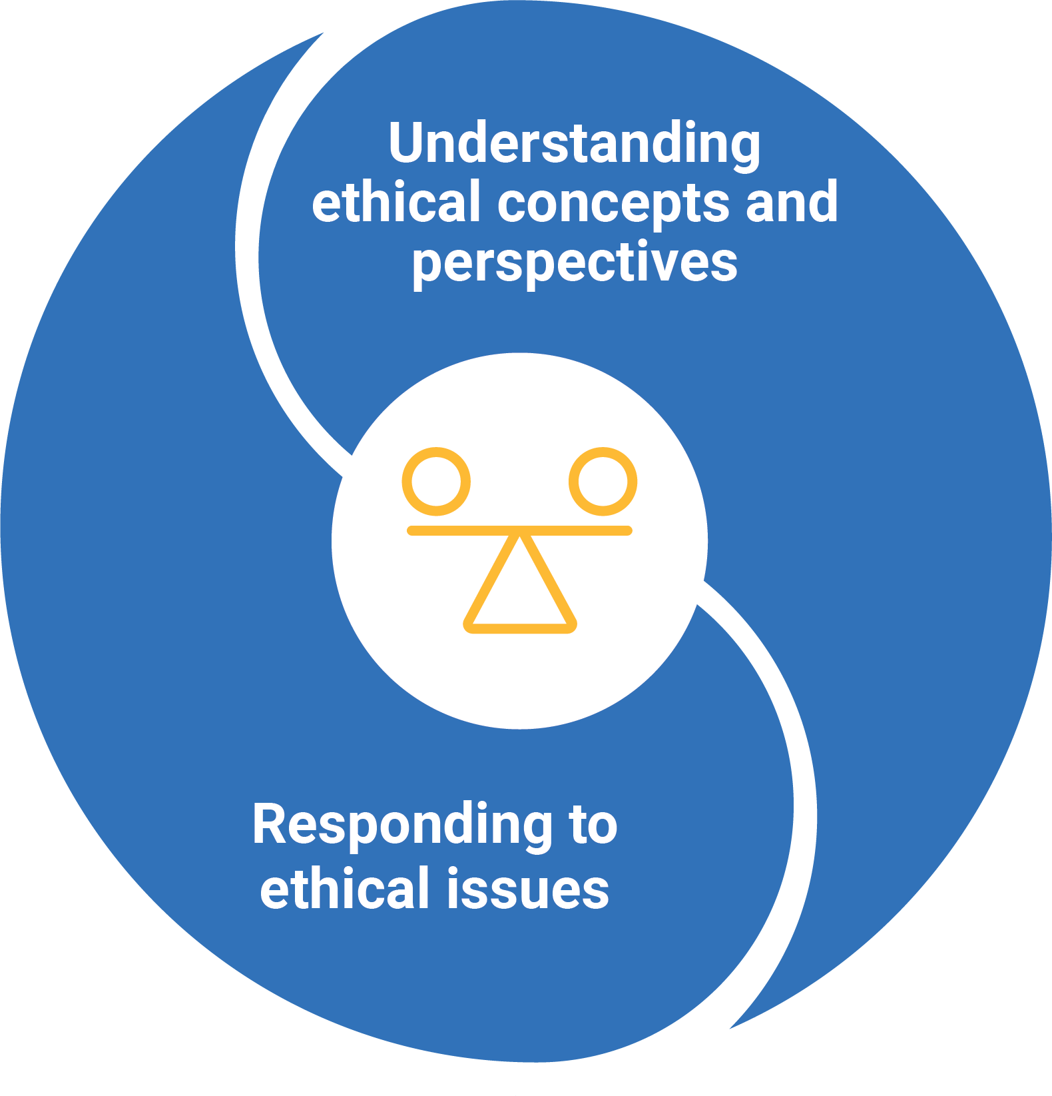

Figure 1: Ethical Understanding elements

Understanding ethical concepts and perspectives
This element is organised into 3 sub-elements:
- Explore ethical concepts – students identify and examine ethical concepts. They discuss and examine the dimensions of ethical concepts and how they relate to the actions we take in a range of situations.
- Examine values, rights and responsibilities, and ethical norms – students understand the role that values, rights and responsibilities, and norms have in ethical decisions. They consider how a range of values relate to established norms of ethical behaviour.
- Recognise influences on ethical behaviour and perspectives – students recognise the interrelationship of factors that impact their ethical behaviour and perspectives. They consider how factors such as reason, emotions, habits of behaviour, character traits, obligations and duties impact ethically considered responses.
Responding to ethical issues
This element is organised into 3 sub-elements:
- Explore ethical perspectives and frameworks – students develop an understanding of different ethical frameworks and how these inform ethical perspectives and decision-making. Ethical frameworks include approaches that address the role of consequences on ethical actions; approaches that deal with issues of duty, justice and fairness; and approaches that focus on virtues in the ethical decision-making process.
- Explore ethical issues – students bring together their understanding of the first 4 sub-elements of the Ethical Understanding learning continuum to investigate ethical issues. They apply their understanding of ethical concepts, values, rights and responsibilities, norms, ethical frameworks and perspectives to curriculum-related ethical contexts.
- Make and reflect on ethical decisions – students recognise the factors that impact on ethical decisions, determine alternative responses to an issue, and consider how these may impact potential outcomes.

Version 9.0 of the Ethical Understanding learning continuum is set out in Table 1.

Table 1: Ethical Understanding learning continuum version 9.0
Sub-element | Level 1 (Foundation) | Level 2  (Years 1–2) | Level 3  (Years 3–4) | Level 4  (Years 5–6) | Level 5  (Years 7–8) | Level 6  (Years 9–10)
UNDERSTANDING ETHICAL CONCEPTS AND PERSPECTIVES
Explore ethical concepts | identify examples of ethical concepts such as right and wrong | identify ethical concepts, such as honesty and fairness, and describe actions and behaviours associated with these | identify ethical concepts, such as respect and tolerance, and describe how a situation or context affects actions and behaviour | identify and describe ethical concepts, such as truth and justice, and explain how perspectives may vary according to the situation or context | analyse the similarities and differences between ethical concepts, such as integrity, loyalty and equality, in a range of situations and contexts | evaluate the consistency in meaning of ethical concepts, such as trust, freedom and rights and responsibilities, in a range of situations and contexts
Examine values, rights and responsibilities, and ethical norms | identify examples of values, rights and responsibilities | identify values, rights and responsibilities, and shared expectations, and explain why they are important | describe how values, rights and responsibilities, and shared expectations influence responses and decision-making | describe how the relationships between values, rights and responsibilities, and ethical norms influence responses and decisions related to ethical issues | describe the relationship between the role of individual and community values, rights and responsibilities, and ethical norms when responding to ethical issues | describe the importance of values, rights and responsibilities when reaching a position on an ethical issue, and evaluate their role in challenging and defending ethical norms
Recognise influences on ethical behaviour and perspectives | identify examples of how emotions affect behaviour | identify how emotions and behaviour interact, and share examples of when they match and when they do not | explain how emotions can affect behaviour and decision-making in different situations | explain how habits and behaviour shape character and examine how they inform ethical perspectives | explain how different traits such as honesty, trust, courage and selfishness interact with responsibilities or duties to determine ethically appropriate responses | explore and analyse examples of the tensions between conflicting positions on issues of personal, social and global importance

RESPONDING TO ETHICAL ISSUES
Explore ethical perspectives and frameworks | identify examples of different consequences and explain how these might affect the way people behave or act | identify the similarities and differences between values such as caring, compassion and empathy | describe the differences and connections between rights and responsibilities, and care and respect, and how these affect decision-making | describe how ethical frameworks that use consequences, virtues and duties guide ethical decision-making | explain how different ethical frameworks support developing ethical perspectives and inform ethical decision-making | analyse and utilise different ethical frameworks when responding to ethical issues and making ethical decisions
Explore ethical issues | identify different ethical problems or issues from examples such as stories | identify different perspectives and approaches when discussing ethical issues from a given example | use examples to describe how people may have different values and perspectives that they apply to an ethical issue | describe how ethical perspectives or approaches to ethical issues may vary in different situations | analyse the relationships between values, ethical perspectives and ethical frameworks when responding to ethical issues | apply knowledge of ethical concepts, values, perspectives and frameworks when responding to ethical issues
Making and reflecting on ethical decisions | identify the links between people’s wants and needs and their choices and actions | identify examples of how perspectives and values influence decision-making | describe decision-making processes with reference to ethical perspectives and values | consider alternative ethical responses to an issue when making and reflecting on ethical decisions | consider how values and beliefs influence approaches to ethical issues, and analyse how these affect outcomes | analyse biases when applying ethical concepts, values and ethical frameworks, in order to explore and evaluate ethical decisions

