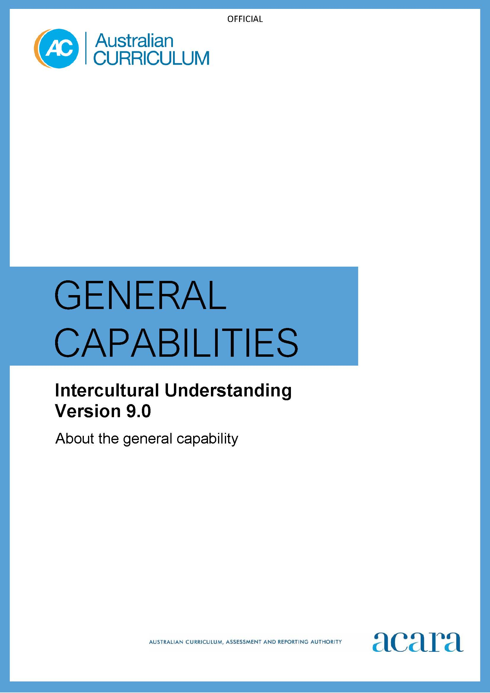

Copyright and Terms of Use Statement
© Australian Curriculum, Assessment and Reporting Authority 2022
The material published in this work is subject to copyright pursuant to the Copyright Act 1968 (Cth) and is owned by the Australian Curriculum, Assessment and Reporting Authority (ACARA) (except to the extent that copyright is held by another party, as indicated).
The viewing, downloading, displaying, printing, reproducing (such as by making photocopies) and distributing of these materials is permitted only to the extent permitted by, and is subject to the conditions imposed by, the terms and conditions of using the ACARA website (see, especially, clauses 2, 3 and 4 of those terms and conditions). The terms and conditions can be viewed at https://www.acara.edu.au/contact-us/copyright

F–10 AUSTRALIAN CURRICULUM: general capabilities – intercultural understanding

Introduction

Intercultural understanding encompasses the behaviours and dispositions that students need to understand what happens and what to do when cultures intersect.

Through learning to value their own cultural perspectives and practices and those of others, young people are supported to become responsible local and global citizens. They are equipped for living and working in an interconnected world.

Intercultural understanding involves students developing the knowledge and skills needed to reflect on culture and cultural diversity, engage with cultural and linguistic diversity, and navigate intercultural contexts.

Structure
The Intercultural Understanding learning continuum is organised into 3 elements, as shown in Figure 1:
- Reflecting on culture and cultural diversity
- Engaging with cultural and linguistic diversity
- Navigating intercultural contexts.

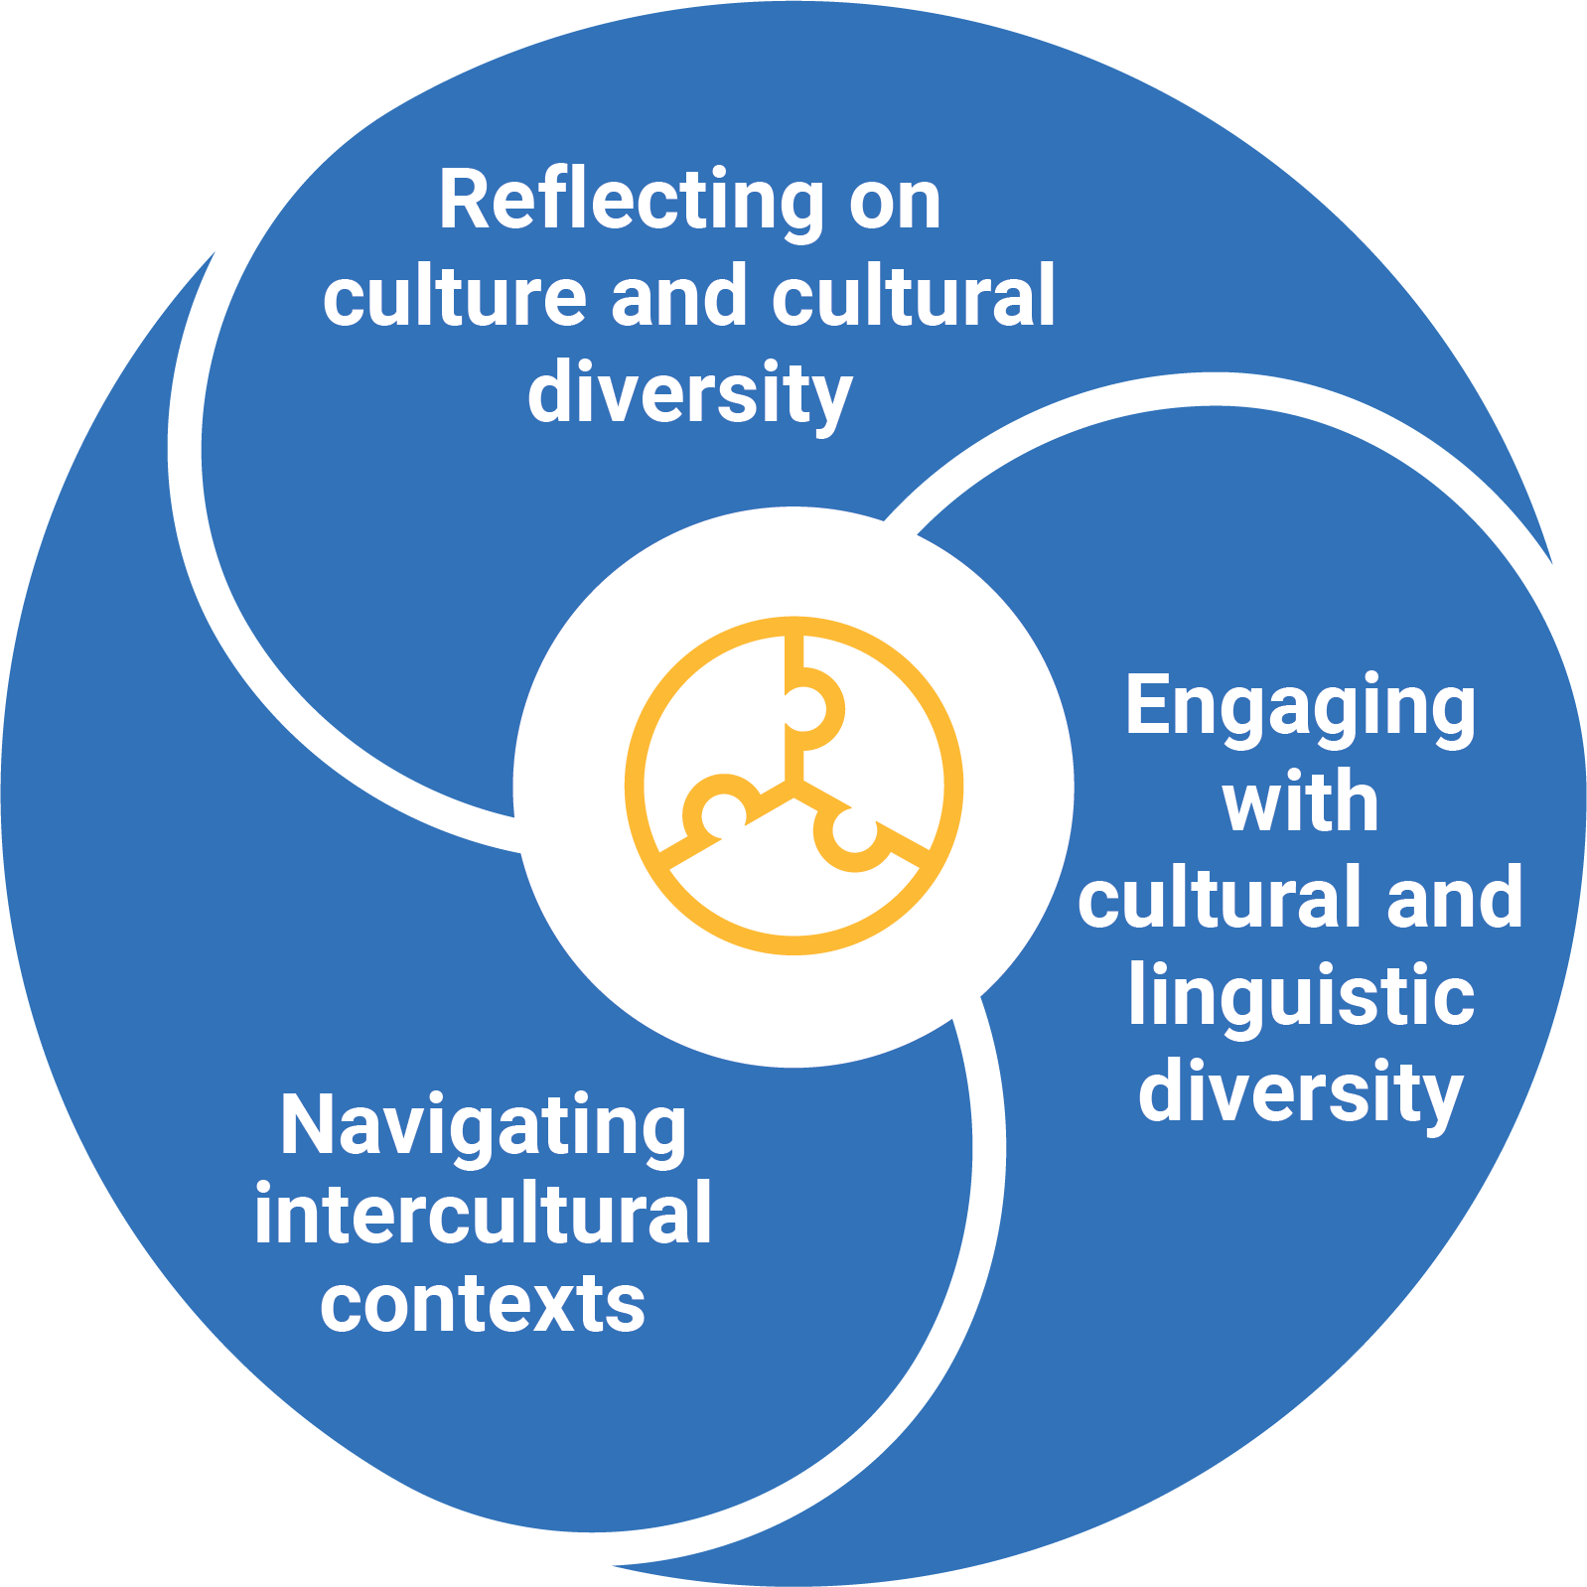

Figure 1: Intercultural Understanding elements

Reflecting on culture and cultural diversity
This element is organised into 3 sub-elements:
- Reflect on the relationship between cultures and identities – students discuss their own cultural identities and draw connections with those of others. They transition from familiar to less familiar contexts, and explore cultural continuity and change. They examine how people experience intercultural contexts differently.
- Examine cultural perspectives and world views – students analyse how these are shaped, preserved or transmitted over time and place.
- Explore the influence of cultures on interactions – students reflect on how their cultural identities relate to others and how others’ cultural identities relate to them.
Engaging with cultural and linguistic diversity
This element is organised into 3 sub-elements:
- Communicate responsively – students learn to tailor their communication in a range of contexts, demonstrating sensitivity and respect for cultural and linguistic diversity. They use their understanding of this diversity to keep communication open, flexible and focused on constructive processes and outcomes.
- Develop multiple perspectives – students build self-awareness of their own perspectives towards issues and sharpen their skills in perspective-taking. They consider representation and acknowledge that multiple perspectives exist for any given issue. They learn that perspectives influence how people interpret and interact with the world around them.
- Develop empathy – students reflect on their thoughts and feelings when taking on a range of perspectives. They learn to mediate perspectives to pursue inclusive and equitable outcomes.
Navigating intercultural contexts
This element is organised into 3 sub-elements:
- Consider responses to intercultural experiences – students understand their own and others’ responses to intercultural experiences and reflect on how these responses are shaped, and influence individuals and their relationships. They learn to propose alternative responses to improve communication outcomes.
- Respond to biases, stereotypes, prejudices and discrimination – students examine their origin, respectfully challenging prejudicial and discriminatory behaviour, and propose action to promote the wellbeing of people while valuing their cultural identities.
- Adapt in intercultural exchanges – students apply their learning in a range of interactions, using their understanding of culture and cultural diversity, and skills in perspective-taking and empathy.

Version 9.0 of the Intercultural Understanding learning continuum is set out in Table 1.

Table 1: Intercultural Understanding learning continuum version 9.0
REFLECTING ON CULTURE AND CULTURAL DIVERSITY
Sub-element | Level 1 (Foundation) | Level 2  (Years 1–2) | Level 3  (Years 3–4) | Level 4  (Years 5–6) | Level 5  (Years 7–8) | Level 6  (Years 9–10)
Reflect on the relationship between cultures and identities | identify cultural practices that are important to themselves, family and friends, and describe what they experience | explore examples of cultural practices that draw themselves, family and friends together, identifying how respect is conveyed | describe the similarities and differences in beliefs, values and cultural practices in the community, sharing how belonging grows | examine how beliefs, values and cultural practices convey meaning and influence people’s sense of identity and belonging | identify and describe beliefs, values and cultural practices that have changed over time and those that have remained the same, drawing on examples from within, between and across cultural groups | evaluate examples of beliefs, values and cultural practices for connections between cultures and identities, including their own
Examine cultural perspectives and world views | identify what family and friends value in familiar intercultural contexts | describe how people express agreement or disagreement about what they value within familiar intercultural contexts | compare how beliefs and cultural practices influence the values of different groups within familiar intercultural contexts | examine the factors that influence cultural perspectives presented within intercultural contexts | analyse the reasons, experiences and understandings that inform diverse cultural perspectives and world views in a range of intercultural contexts | evaluate how common and conflicting values within and across cultural and linguistic groups affect the presentation of cultural perspectives and world views
Explore the influence of cultures on interactions | identify ways in which cultures, including their own, interact | describe how their cultural identities influence interactions with others | understand how cultural and linguistic diversity affect interactions within their community | examine the influence of cultural and linguistic diversity on familiar interactions, and identify opportunities or challenges for relationship-building | explain the influence of cultural and linguistic diversity on unfamiliar interactions, identifying opportunities to show respect for cultural traditions | analyse the influence of culture on interactions within and across cultural and linguistic groups, developing opportunities for exchange and collaboration
ENGAGING WITH CULTURAL AND LINGUISTIC DIVERSITY
Communicate responsively | notice the use of different languages they, their family or community members use to communicate | identify and use verbal and non-verbal communication, recognising that these may have different meanings for familiar cultural and linguistic groups | initiate verbal and non-verbal communication, comparing how members of familiar cultural and linguistic groups respond | select strategies for open, flexible and focused communication in unfamiliar settings, considering their effect on building understanding | select and use strategies for open, flexible and focused communication, including understanding how cultural perspectives and world views affect communication within, between and across cultural and linguistic groups | apply communication strategies in culturally and linguistically diverse contexts, understanding how language and culture are interrelated or connected
Develop multiple perspectives | listen to, and share opinions and reflections on, familiar topics and intercultural experiences | identify opinions on familiar topics and intercultural experiences, recognising reasons for different perspectives | discuss different perspectives on familiar topics and intercultural experiences, describing how people’s thinking and behaviour may be influenced by a range of factors | examine how cultural beliefs or practices influence their own perspectives, and those of others, when discussing unfamiliar topics | consider multiple perspectives held on unfamiliar topics, identifying commonality and difference, and describe how perspectives may be influenced by cultural beliefs and practices | analyse unfamiliar topics and develop respectful responses, reconciling different cultural perspectives
Develop empathy | notice their own feelings, and the feelings of others, during familiar intercultural experiences | describe their own feelings and responses, and those of others, when discussing familiar intercultural experiences | describe how listening to, and understanding others, supports respectful intercultural experiences and interactions | examine how showing empathy during intercultural experiences supports relationship-building and sustains respectful interactions | use perspective-taking, mutual understanding and respect to sustain interactions in diverse intercultural experiences | analyse diverse experiences of intercultural contexts, understanding how these contexts influence their own and others’ feelings, motivations and actions
NAVIGATING IN INTERCULTURAL CONTEXTS
Consider responses to intercultural contexts | notice how they, and their family members, respond in unfamiliar intercultural contexts | describe how past intercultural experiences affect how they understand and respond to new experiences | examine the influence of past intercultural experiences on what they learn about themselves and others | explain how intercultural experiences affect what they learn about relationship-building and interactions | analyse how cultural representations in a range of intercultural contexts influence self-awareness of culturally appropriate behaviour | apply learning to improve communication outcomes in unfamiliar intercultural contexts, considering and developing alternative responses
Respond to biases, stereotypes, prejudices and discrimination | identify examples of acceptance and inclusion within friendship groups | discuss examples of stereotypical statements used in familiar intercultural exchanges, reflecting on their feelings and responses | describe the effects of stereotyping on people in familiar intercultural exchanges, identifying actions to change perceptions | examine how biases and stereotypes affect familiar intercultural exchanges, identifying actions that demonstrate understanding and respect | analyse the origins of biases, stereotypes and prejudices affecting interactions and the representation of groups, proposing actions to build awareness of experiences or impacts | apply learning to promote the wellbeing of people within unfamiliar intercultural exchanges, proposing actions to challenge biases, stereotypes, prejudices and discrimination
Adapt in intercultural exchanges | identify how people show respect in intercultural exchanges | consider different responses to intercultural exchanges, practising ways to show respect and develop empathy | use perspective-taking to develop understanding, examining how familiar intercultural exchanges influence thinking and behaviour | modify interactions in unfamiliar intercultural exchanges, demonstrating respect for, and understanding of, cultural diversity | modify responses to unfamiliar intercultural exchanges to negotiate and sustain interactions that develop mutual understanding | apply learning to the challenges and benefits of interacting in a culturally diverse society, adapting thinking and behaviour to develop mutual understanding

