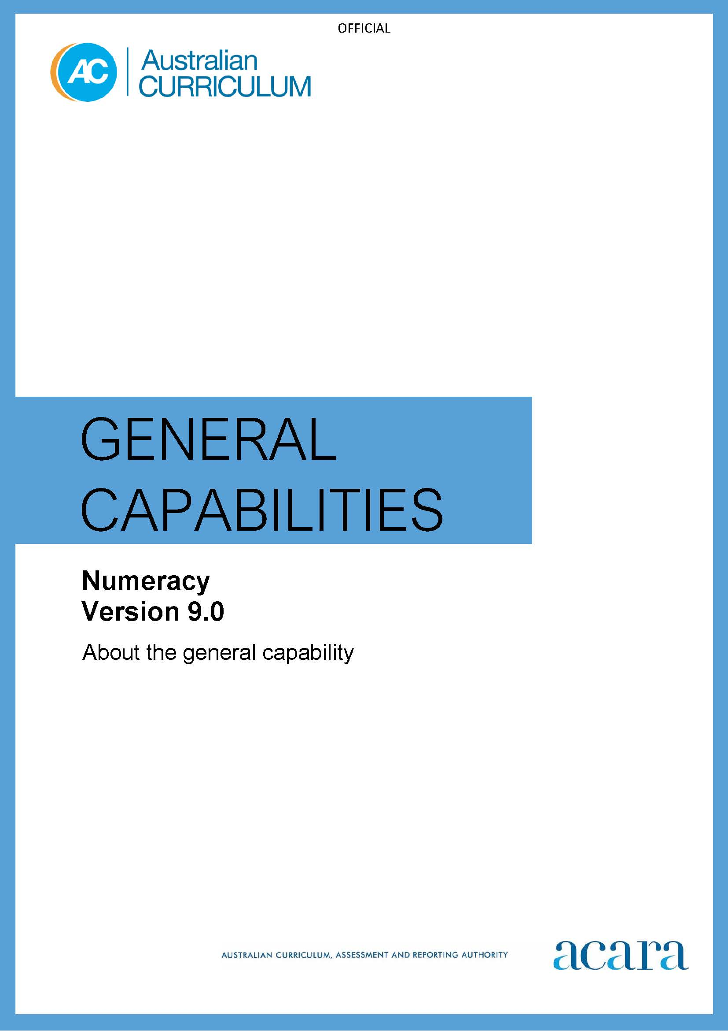

Copyright and Terms of Use Statement
© Australian Curriculum, Assessment and Reporting Authority 2024
The material published in this work is subject to copyright pursuant to the Copyright Act 1968 (Cth) and is owned by the Australian Curriculum, Assessment and Reporting Authority (ACARA) (except to the extent that copyright is held by another party, as indicated).
The viewing, downloading, displaying, printing, reproducing (such as by making photocopies) and distributing of these materials is permitted only to the extent permitted by, and is subject to the conditions imposed by, the terms and conditions of using the ACARA website (see, especially, clauses 2, 3 and 4 of those terms and conditions). The terms and conditions can be viewed at https://www.acara.edu.au/contact-us/copyright

TABLE OF CONTENTS
F–10 AUSTRALIAN CURRICULUM: GENERAL CAPABILITIES – NUMERACY 3
Introduction 3
Structure 4
Numeracy and the Australian Curriculum: Mathematics 5
NUMBER SENSE AND ALGEBRA 5
Number and place value 5
Counting processes 5
Additive strategies 5
Multiplicative strategies 6
Interpreting fractions 6
Proportional thinking 6
Number patterns and algebraic thinking 6
Understanding money 6
MEASUREMENT AND GEOMETRY 11
Understanding units of measurement 11
Understanding geometric properties 11
Positioning and locating 11
Measuring time 11
STATISTICS AND PROBABILITY 15
Understanding chance 15
Interpreting and representing data 15
APPENDIX 1: NUMERACY LEARNING PROGRESSION 19
Number sense and algebra 19
Measurement and geometry 40
Statistics and probability 50
APPENDIX 2: PLANNING FOR TEACHING MATHEMATICS 55
The Australian Curriculum: Mathematics and the Numeracy learning progression 55
Using the Numeracy learning progression with the Australian Curriculum: Mathematics 55

F–10 australian curriculum: general capabilities – numeracy

Introduction
What is numeracy?
Numeracy is fundamental to a student’s ability to learn at school and to engage productively in society.
It involves the recognition, formulation and interpretation of mathematics, and its application to real-world problems and contexts.
Through the Australian Curriculum, students become numerate as they develop the knowledge and skills to use mathematics confidently across learning areas at school and in their lives more broadly.
What is the Numeracy general capability?
The Version 9.0 Australian Curriculum: Numeracy general capability is presented as a Numeracy learning progression. It describes the observable indicators of increasing complexity in students’ understanding of, and skills in, key numeracy concepts. The Numeracy learning progression includes the elements of Number sense and algebra, Measurement and geometry, and Statistics and probability.
The Numeracy learning progression gives a comprehensive and fine-grained description of key elements of numeracy development. It is a conceptual tool that can help teachers to develop targeted teaching and learning programs for students who are working at, above or below the year-level expectation.
The Numeracy learning progression complements the Australian Curriculum: Mathematics. It is designed to help teachers ascertain the stage of learning reached, identify any gaps in skills and knowledge, and plan for the next step to progress learning.
How can you use the Numeracy learning progression?
Numeracy development influences student success in many areas of learning at school. Applying mathematical skills and knowledge across the curriculum can enrich the study of other learning areas and helps to develop a broader and deeper understanding of numeracy. It is essential that the mathematical ideas with which students interact are relevant to their lives. Students need opportunities to recognise that mathematics is constantly used outside the mathematics classroom and that numerate people apply mathematical skills in a wide range of familiar and unfamiliar situations.
The Numeracy learning progression can be used to support students to successfully engage with the numeracy demands of the Foundation to Year 10 Australian Curriculum. Students may demonstrate different rates of progress as they develop specific elements of numeracy and may therefore need support to engage in the Australian Curriculum.
Teachers can use the progression to support the development of targeted teaching and learning programs and to set clear learning goals for individual students. For example, teaching decisions can be based on judgements about student capability that relate to a single indicator rather than all indicators at a level.

Structure
Elements and sub-elements
The Numeracy general capability is organised into 3 elements as shown in Figure 1.
- Number sense and algebra
- Measurement and geometry
- Statistics and probability.

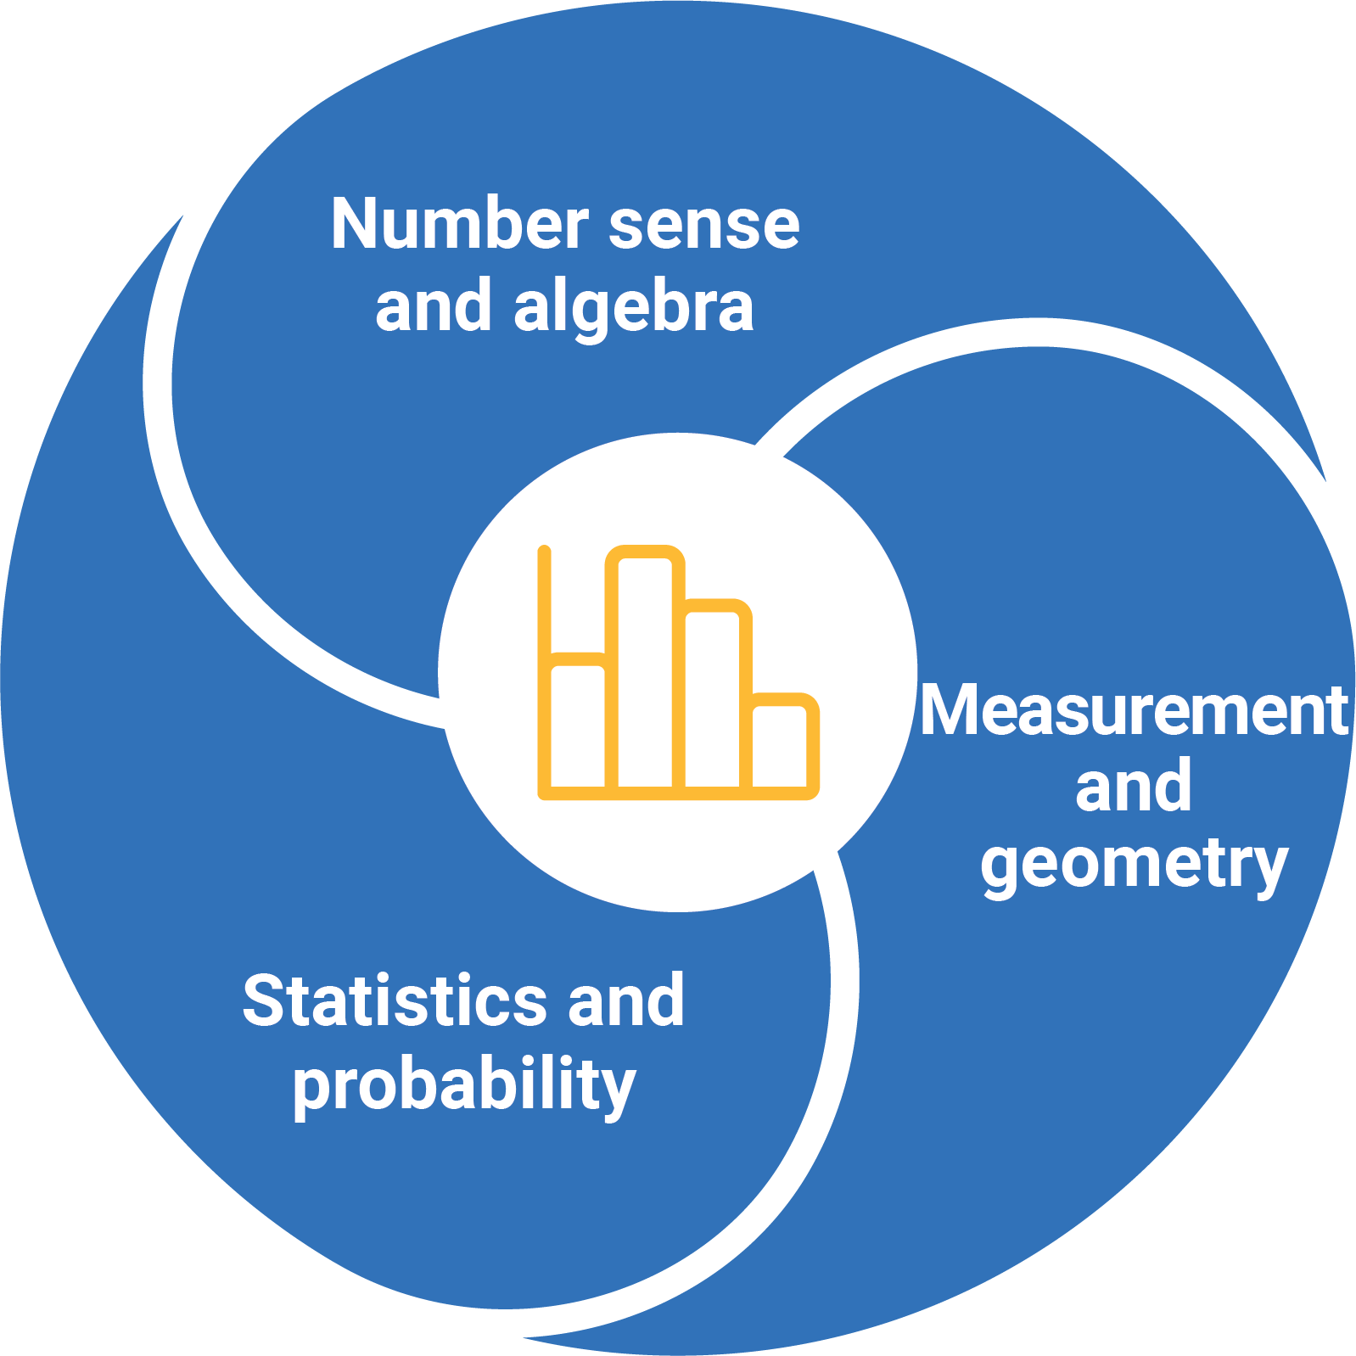

Figure 1: Numeracy learning progression elements
Each element includes sub-elements that represent evidence-based aspects of numeracy development.
The sub-elements are organised into progression levels. The number of levels in each sub-element varies, and is determined by available research and evidence. For example, the Number and place value sub-element (Number sense and algebra) has 10 levels, while the Positioning and locating sub-element (Measurement and geometry) has 5 levels. This means that students may enter and exit levels over quite different time frames.
Some sub-elements represent constrained skills, which are those that can be learned in a limited amount of time. Once they are achieved, they require no further teaching. These are Counting processes, Additive strategies and Interpreting fractions. Some students may require a longer period of time to achieve these skills. The other sub-elements represent unconstrained skills, which continue to develop.

Numeracy and the Australian Curriculum: Mathematics
The content descriptions and achievement standards of the Mathematics curriculum F–10 are the reference points for the teaching and learning of all aspects of Mathematics F–10. The numeracy expectation of the Mathematics curriculum at each year level has been aligned to the Numeracy learning progression. The alignment is to a sub-element level of the progression and so it is likely that only some of the indicators will relate to a particular content description. This alignment of numeracy expectation has also been used to ensure a similar expectation applies across the other learning areas.
The sections that follow use a series of diagrams to explain the Numeracy sub-elements, the levels of the Numeracy learning progression and their relationship to the Australian Curriculum: Mathematics. For more information, see Appendix 1: Numeracy learning progression and Appendix 2: Planning for teaching Mathematics.

Number sense and algebra
The Number sense and algebra element includes 8 sub-elements.
These sub-elements are:
- Number and place value
- Counting processes
- Additive strategies
- Multiplicative strategies
- Interpreting fractions
- Proportional thinking
- Number patterns and algebraic thinking
- Understanding money.

Number and place value
This sub-element describes how students become increasingly able to recognise, read, represent, order and interpret numbers within our place value number system, expressed in different ways. It outlines key understandings needed to process, communicate and interpret quantitative information in a variety of contexts.

Counting processes
This sub-element describes how students become increasingly able to count both verbally, through the stable order of a counting sequence, and perceptually through counting collections. As students make the link between counting “how many” and the quantities represented by numbers, they begin to understand cardinality and the purpose of counting.

Additive strategies
This sub-element describes how students become increasingly able to think additively, represent a wide range of additive situations, and choose and use computational strategies for different purposes.
The ability to understand the nature of change to a quantity, where numbers are treated as the sum of their parts, is essential to becoming a fluent user of number.

Multiplicative strategies
This sub-element describes how students become increasingly able to think multiplicatively and use multiplicative strategies in computation to solve problems related to a range of multiplicative situations. Students are introduced to division through equal sharing and equal grouping situations.

Interpreting fractions
This sub-element emphasises the development of fraction sense, which is foundational to learning how to reason proportionally. Students become increasingly able to recognise the part-whole description of a fraction. They also recognise and use fractions as numbers, measures, operators, ratios and as a division.

Proportional thinking
This sub-element addresses the proportional relationships between quantities. The ability to reason proportionally requires students to think multiplicatively and work with percentages, rates and ratios, and proportions.

Number patterns and algebraic thinking
This sub-element describes how students become increasingly able to identify and describe repeating and growing patterns in the environment and other everyday contexts. Students develop the capacity to generalise as they learn to recognise, represent, describe and use patterns for prediction and decision-making.

Understanding money
This sub-element addresses the financial numeracy skills that support students to become financially literate members of society. Financial decisions require the capacity to carry out calculations with money and apply their knowledge to purchasing, budgeting and justification for the use of money.

Figure 2 represents the alignment of the Number sense and algebra sub-elements with the Australian Curriculum: Mathematics Years F–2 levels. There are often multiple Numeracy learning progression levels within a Mathematics curriculum year level. The progression levels may span across year levels of the curriculum. The number of progression levels is determined by the research evidence and is not the same for each sub-element.
Note: *The sub-element of Interpreting fractions does not apply to the Foundation and Year 1 curriculum. The sub-element Proportional thinking does not apply to the Foundation, Year 1 or Year 2 curriculum.
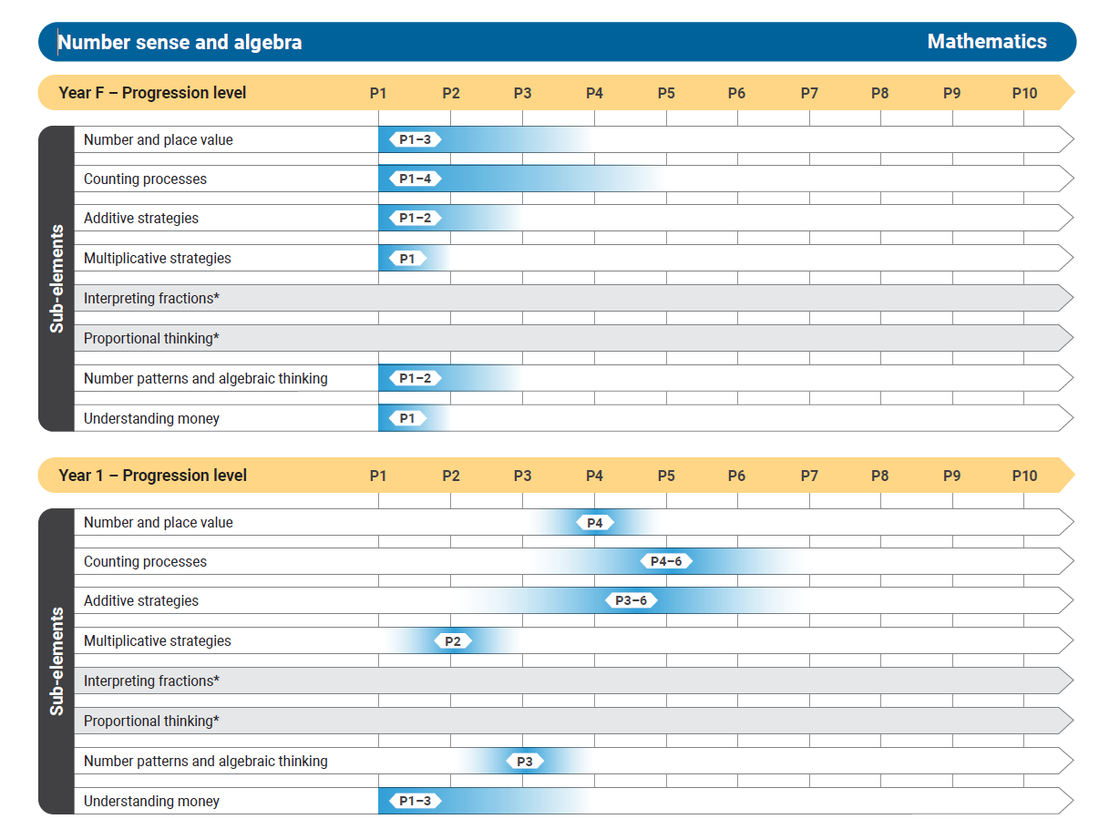
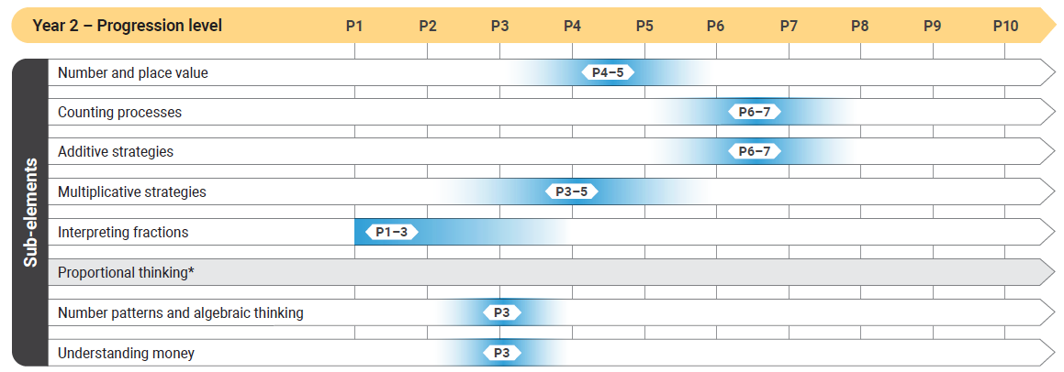
Figure 2: Number sense and algebra F–2

Figures 3a and 3b represent the alignment of the Number sense and algebra sub-elements with the Australian Curriculum: Mathematics Years 3–6 levels. There are often multiple Numeracy progression levels within a Mathematics curriculum year level. The progression levels may span across year levels of the curriculum. The number of progression levels is determined by the research evidence and is not the same for each sub-element.
Note: *The sub-element of Proportional thinking does not apply to the Year 3 or Year 4 curriculum.
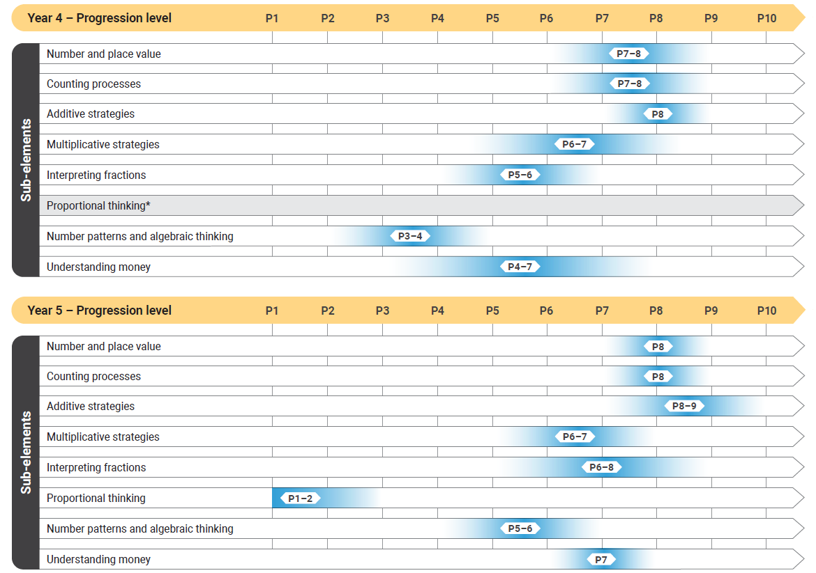
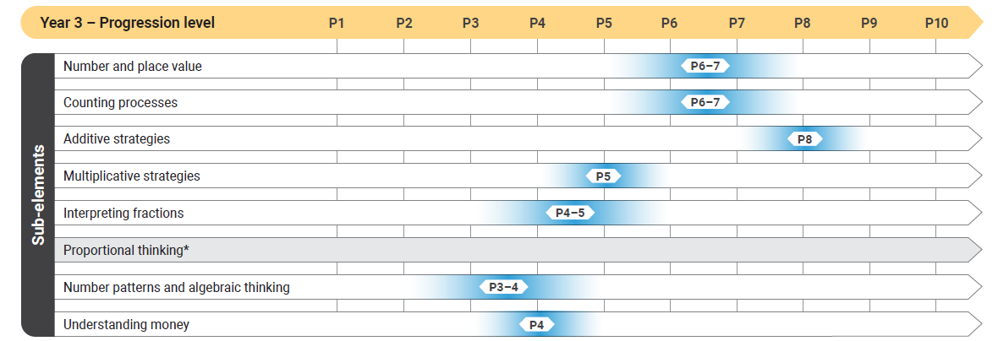

Figure 3a: Number sense and algebra Years 3–5

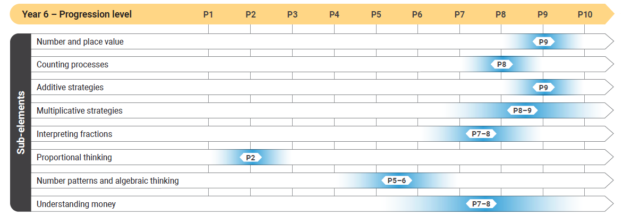
Figure 3b: Number sense and algebra Year 6

Figures 4a and 4b represent the alignment of the Number sense and algebra sub-elements with the Australian Curriculum: Mathematics Years 7–10 levels. There are often multiple Numeracy progression levels within a Mathematics curriculum year level. The progression levels may span across year levels of the curriculum. The number of progression levels is determined by the research evidence and is not the same for each sub-element.
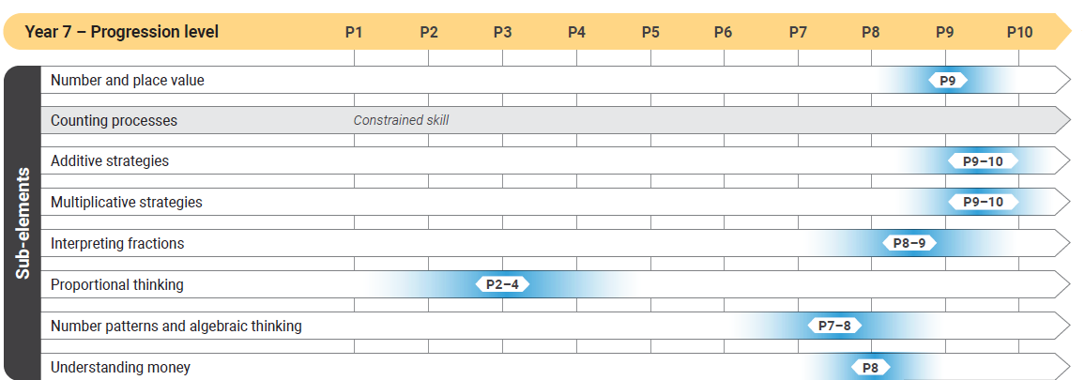
Note: *The sub-element levels for Counting processes, Additive strategies and Interpreting fractions do not apply to the curriculum beyond Year 7, Year 8 and Year 9 respectively.

Figure 4a: Number sense and algebra Year 7

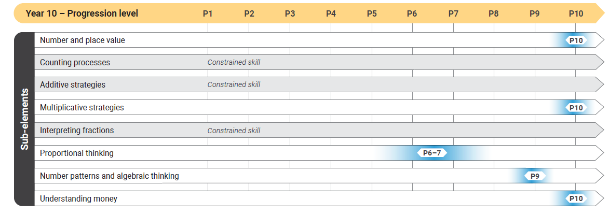
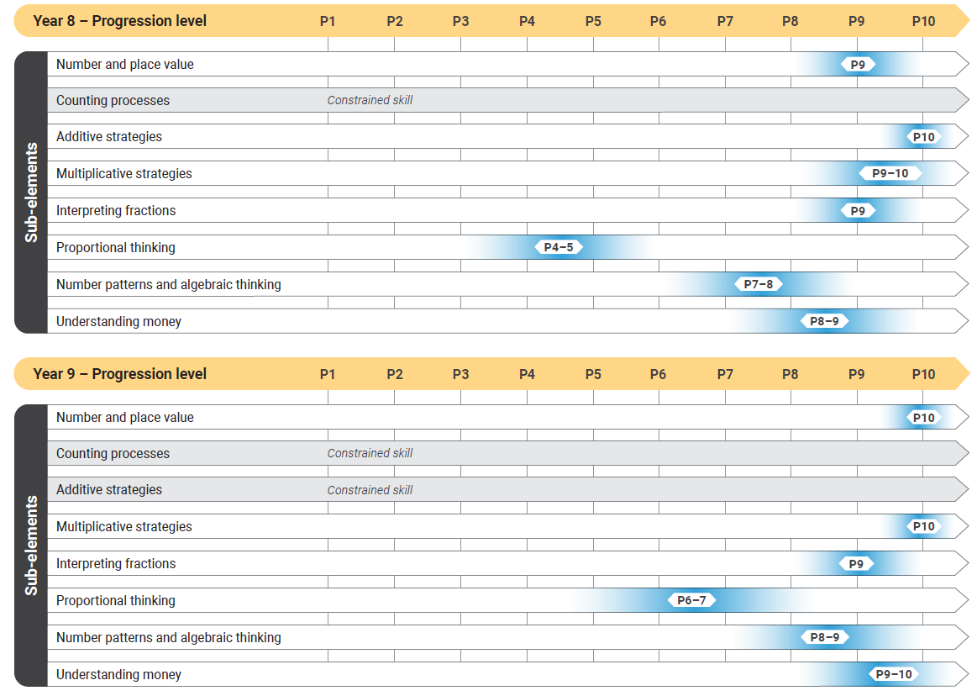
Figure 4b: Number sense and algebra Years 8–10

Measurement and geometry
The Measurement and geometry element includes 4 sub-elements.
These sub-elements are:
- Understanding units of measurement
- Understanding geometric properties
- Positioning and locating
- Measuring time.

Understanding units of measurement
This sub-element describes how students become increasingly able to identify attributes that can be measured and the units by which they are measured. They initially use direct comparison to recognise and understand what it means to have more or less of a particular attribute. Then they progress to using informal units, and then metric and other formal units.

Understanding geometric properties
This sub-element describes how students become increasingly able to identify the properties of shapes and objects, and how they can be combined or transformed. They develop an understanding of how objects are represented using a combination of shapes. Knowledge of angle properties and line and rotational symmetry helps students to recognise how shapes are used to create patterns.

Positioning and locating
This sub-element describes how students become increasingly able to recognise the attributes of position and location. They learn to use positional language to describe themselves and objects in the environment using maps, plans and coordinates. Students learn to reason with representations of shapes and objects regarding position and location. They learn to visualise and orientate objects to solve problems in spatial contexts.

Measuring time
This sub-element describes how students become increasingly aware of reading and describing the passage of time and how elapsed time or duration can be measured. They learn to apply units and conventions associated with measuring and recording the sequencing and duration of time.

Figure 5 represents the alignment of the Measurement and geometry sub-elements with the Australian Curriculum: Mathematics Years F–2 levels. There are often multiple Numeracy learning progression levels within a Mathematics curriculum year level. The progression levels may span across year levels of the curriculum. The number of progression levels is determined by the research evidence and is not the same for each sub-element.
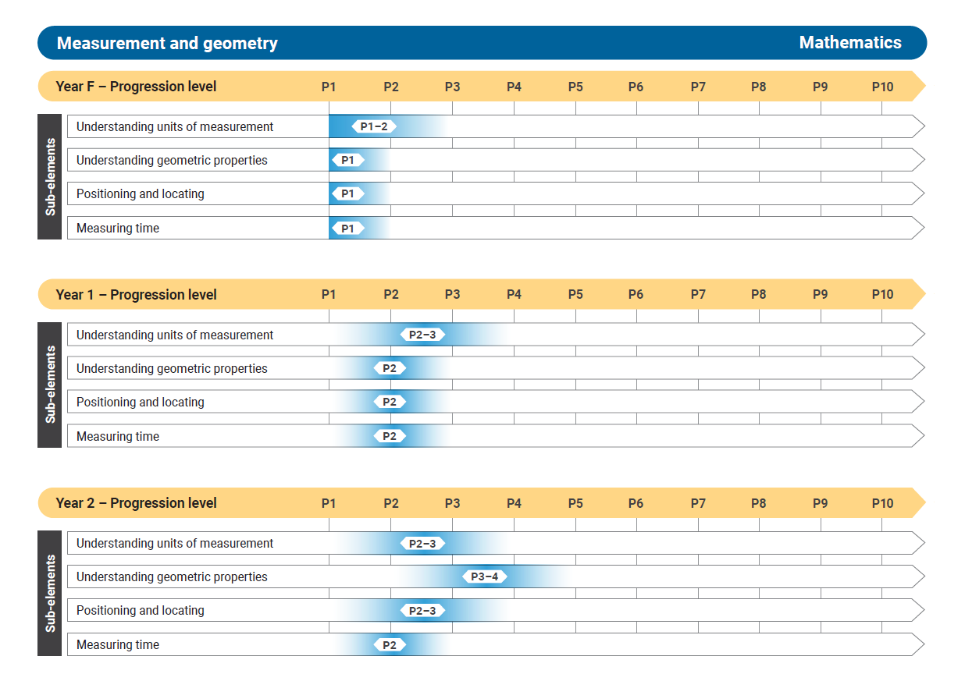

Figure 5: Measurement and geometry F–2

Figure 6 represents the alignment of the Measurement and geometry sub-elements with the Australian Curriculum: Mathematics Years 3–6 levels. There are often multiple Numeracy learning progression levels within a Mathematics curriculum year level. The progression levels may span across year levels of the curriculum. The number of progression levels is determined by the research evidence and is not the same for each sub-element.
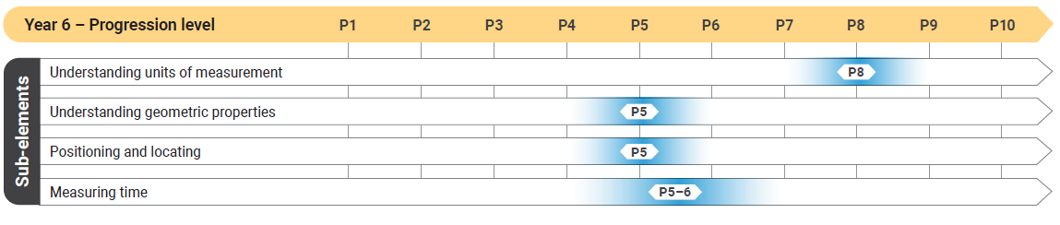
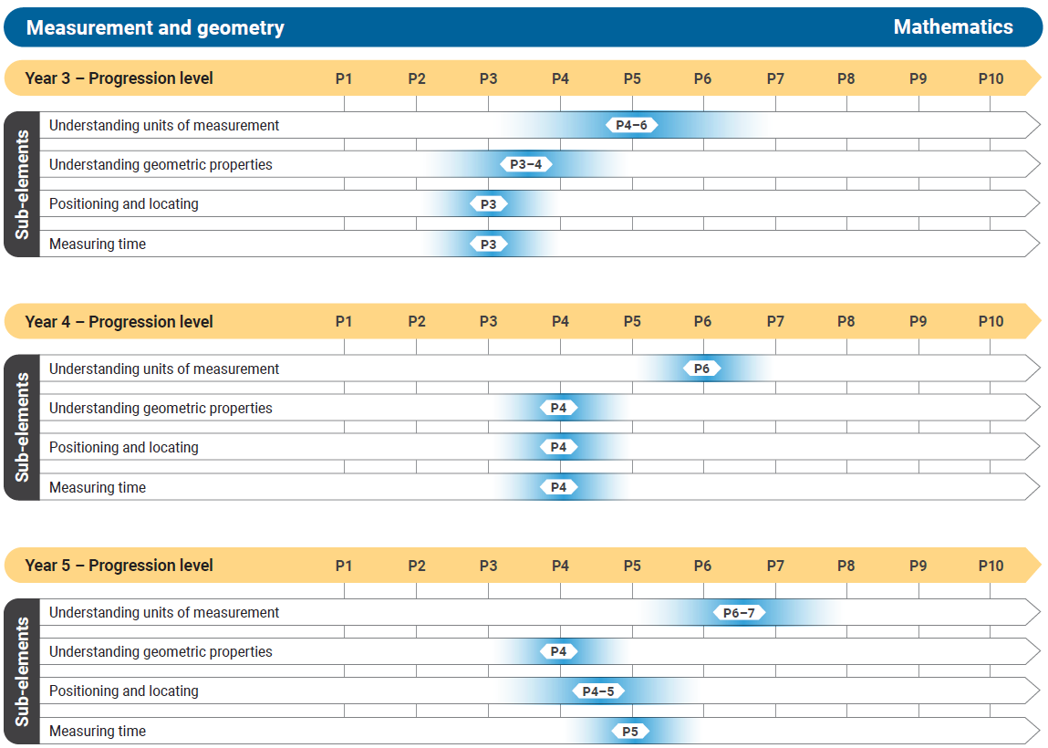
Figure 6: Measurement and geometry Years 3–6

Figure 7 represents the alignment of the Measurement and geometry sub-elements with the Australian Curriculum: Mathematics Years 7–10 levels. There are often multiple Numeracy learning progression levels within a Mathematics curriculum year level. The progression levels may span across year levels of the curriculum. The number of progression levels is determined by the research evidence and is not the same for each sub-element.
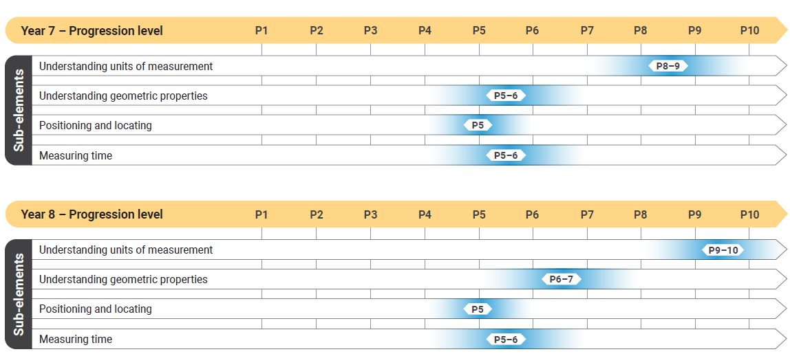
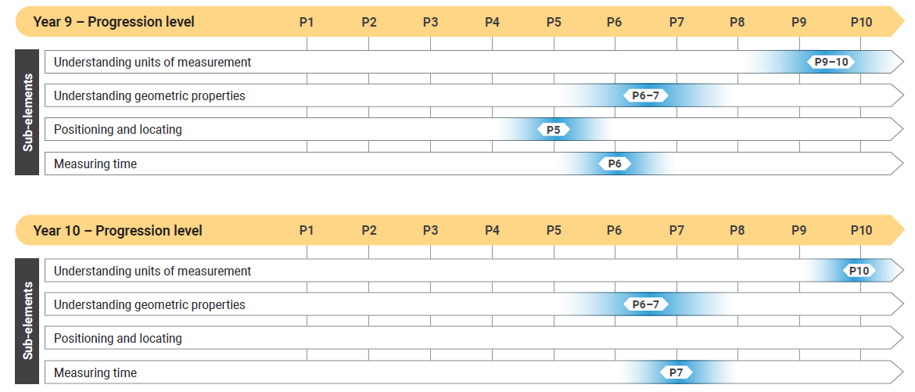
Figure 7: Measurement and geometry Years 7–10

Statistics and probability
The Statistics and probability element includes 2 sub-elements.
These sub-elements are:
- Understanding chance
- Interpreting and representing data.

Understanding chance
This sub-element describes how students become increasingly able to use the language of chance and the numerical values of probabilities when determining the likelihood of an event. They learn to compare chance events in relation to variation and expectation. Students recognise that events may or may not happen and describe familiar events that involve chance. They progress to describe outcomes of chance experiments, develop an understanding of randomness and recognise bias. Students make predictions and explain why expected results may differ from the actual results of chance events.

Interpreting and representing data
This sub-element describes how students become increasingly able to recognise, use and interpret visual and numerical displays to describe data associated with statistical investigations. They also develop the ability to critically evaluate investigations by others. Students learn to employ the sequence of steps involved in a statistical investigation: posing questions, collecting and analysing data, and drawing conclusions.

Figure 8 represents the alignment of the Statistics and probability sub-elements with the Australian Curriculum: Mathematics Years F–2 levels. There are often multiple Numeracy learning progression levels within a Mathematics curriculum year level. The progression levels may span across year levels of the curriculum. The number of progression levels is determined by the research evidence and is not the same for each sub-element.
Note: *The sub-element of Understanding chance does not apply to the F–2 curriculum.

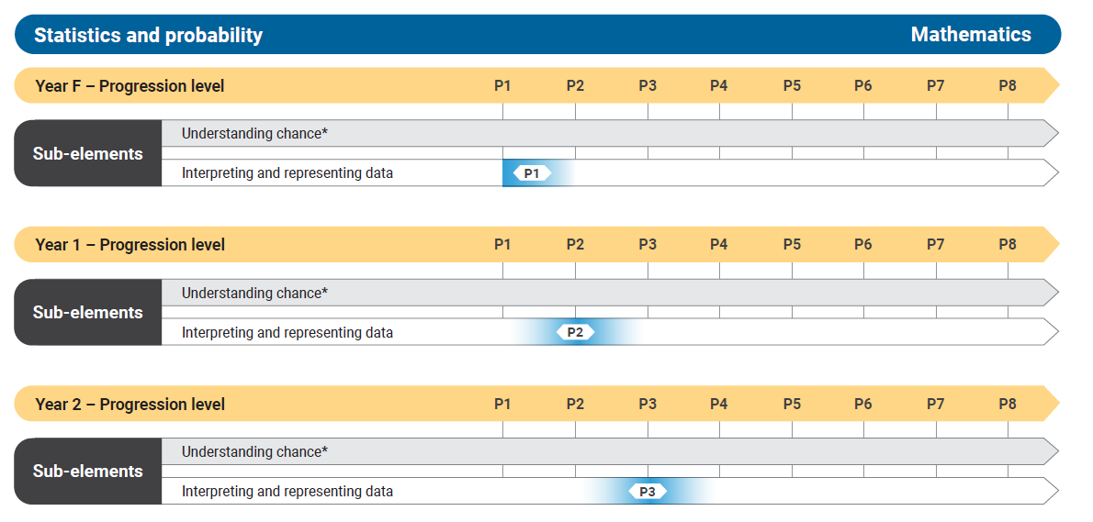
Figure 8: Statistics and probability F–2

Figure 9 represents the alignment of the Statistics and probability sub-elements with the Australian Curriculum: Mathematics Years 3–6 levels. There are often multiple Numeracy learning progression levels within a Mathematics curriculum year level. The progression levels may span across year levels of the curriculum. The number of progression levels is determined by the research evidence and is not the same for each sub-element.

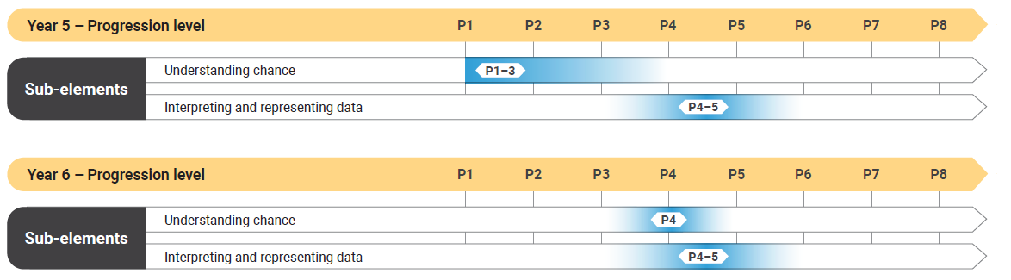
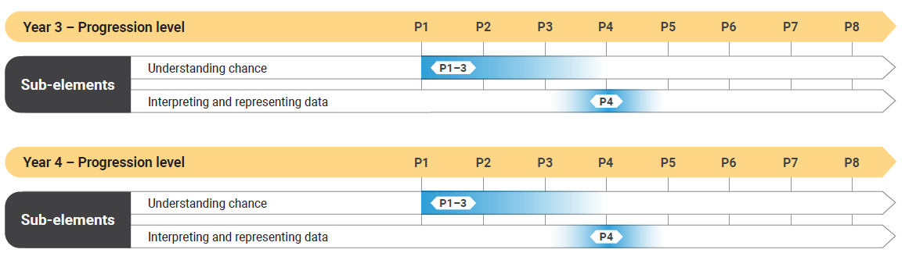

Figure 9: Statistics and probability Years 3–6

Figure 10 represents the alignment of the Statistics and probability sub-elements with the Australian Curriculum: Mathematics Years 7–10 levels. There are often multiple Numeracy learning progression levels within a Mathematics curriculum year level. The progression levels may span across year levels of the curriculum. The number of progression levels is determined by the research evidence and is not the same for each sub-element.

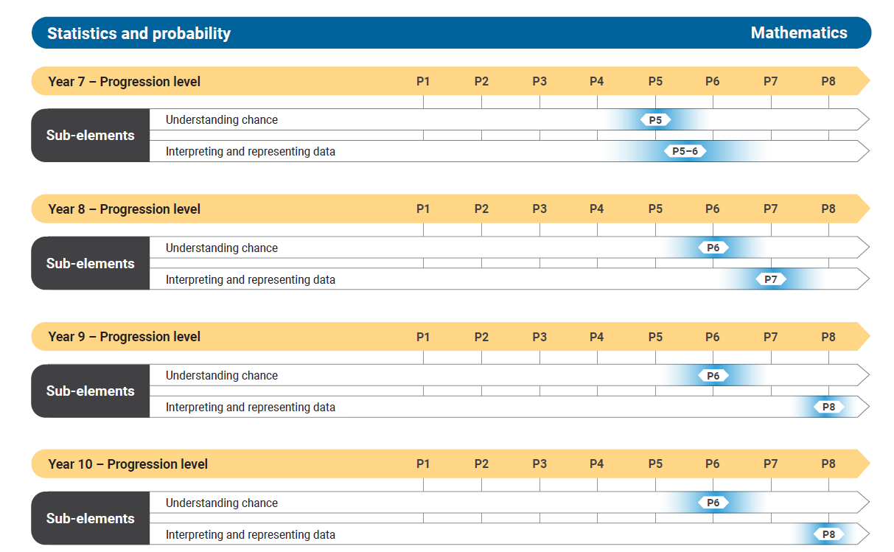

Figure 10: Statistics and probability Years 7–10

APPENDIX 1: NUMERACY learning PROGRESSION

Number sense and algebra

Number and place value
Level | Indicators
P1 |  | Numeral recognition and identification  identifies and produces familiar number names and numerals such as those associated with age or home address, but may not distinguish whether they refer to a quantity, an ordinal position or a label (e.g. “I am 5 and my sister is 7”; “I wear the number 7 jumper”; “I live at 4 Baker Street”; “this is the number 2”)  Pre-place value  compares 2 collections visually and states which group has more items and which group has less  instantly recognises collections up to 3 without needing to count and recognises small quantities as being the same or different  uses language to describe order and place (e.g. understands “who wants to go first?”; in the middle; “who was the last person to read this book?”)
P2 | Numeral recognition and identification  identifies and names numerals in the range of 1–10 (e.g. when asked “which is 3?” points to the numeral 3; when shown the numeral 5, says “that’s 5”)  matches a quantity of items in a collection to the correct number name or numeral in the range of 1–10 (e.g. when shown the numeral 5 and asked to “go and collect this many items”, gathers 5 items)  identifies standard number configurations such as on standard dice or dominos and in other arrangements up to 6, using subitising (e.g. moves a counter the correct number of places on a board game based on the roll of a dice; recognises a collection of 5 items by perceptually subitising 3 and 2)  Developing place value  orders numbers represented by numerals to at least 10 (e.g. uses number cards or a number track and places the numerals 1–10 in the correct order)  indicates the greater or lesser of 2 numerals in the range from one to 10 (e.g. when shown the numerals 6 and 3, identifies 3 as representing the lesser amount)  identifies smaller collections within collections to 10, such as numbers represented in non-standard number configurations (e.g. recognises 7 dots represented in a non-standard configuration by perceptually subitising 4 and 3; represents numbers less than 10 using five- and ten-frames)  demonstrates that one 10 is the same as 10 ones (e.g. using physical or virtual materials such as ten-frames and bundles of 10)
P3 | Numeral recognition and identification  identifies, names, writes and interprets numerals up to 20 (e.g. when shown the numerals 4, 17, 9 and 16 and asked “which is 16?”, points to the numeral 16, or when shown the numeral 17 says its correct name; when role-playing simple money transactions, counts out 9 one-dollar coins to pay for an item that costs $9)  identifies and uses the 1–9 repeating sequence in the writing of teen numerals  identifies a whole quantity as the result of recognising smaller quantities up to 20 (e.g. uses part-part-whole knowledge of numbers to solve problems)  Developing place value  orders numbers from 1–20 (e.g. determines the largest number from a group of numbers in the range from one to 20; students are allocated a number between one and 20 and asked to arrange themselves in numerical order)  represents and describes teen numbers as 10 and some more (e.g. 16 is 10 and 6 more; using ten-frames to represent teen numbers)
P4 | Numeral recognition and identification  identifies, names, writes and interprets numerals up to and beyond 100 (e.g. is shown the numerals 70, 38, 56 and 26 and when asked “which is 38?”, identifies the numeral 38; writes 18, 81 and 108 with the digits in the correct position; compares the class sizes in a particular year level to determine which class has the greatest number of students)  identifies the 1–9 repeating sequence of digits, both in and between the decade numerals to order numbers and to predict the number that comes before or after another number (e.g. uses hundreds charts or vertical number lists)  identifies zero as both a number and a placeholder for reading and writing larger numerals, denoted by the numeral 0  Place value  uses knowledge of place value to order numbers represented as numerals within the range of zero to at least 100 (e.g. locates the number 21 on a number line between 20 and 22; re-orders a set of numerals from least to greatest)  represents and renames two-digit numbers as counts of tens and ones (e.g. 68 is 6 tens and 8 ones, 68 ones, or 60 + 8; uses physical or virtual materials such as bundles of 10 toothpicks or base 10 blocks)
P5 | Numeral recognition and identification  identifies, names, writes and interprets a numeral from a range of numerals up to 1000 (e.g. is shown the numerals 70, 318, 576 and 276 and when asked “which is 276?”, identifies 276; compares the number of kilojoules in different energy drinks by reading the dietary information)  Place value  orders and flexibly renames three-digit numbers according to their place value (e.g. 247 is 2 hundreds, 4 tens and 7 ones or 2 hundreds and 47 ones or 24 tens and 7 ones)  applies an understanding of zero in place value notation when reading and writing numerals that include internal zeros (e.g. says 807 as 8 hundred and 7 or 80 tens and 7 ones, not 80 and 7)
P6 | Numeral recognition and identification  identifies, reads, writes and interprets numerals beyond 1000, applying knowledge of place value, including numerals that contain a zero (e.g. reads 1345 as one thousand, 3 hundred and 45; reads one thousand and 15 and writes as 1015; compares the size of populations of schools, suburbs, cities and ecosystems or the cost of items in shopping catalogues)  Place value  represents, flexibly partitions and renames four-digit numbers into standard and non-standard place value partitions (e.g. uses grid paper to show the size of each digit in 2202; renames 5645 as 3645 and 2000 in order to subtract 1998)  estimates and rounds natural numbers to the nearest 10 or nearest 100 (e.g. pencils come in a pack of 10, estimate the number of packs required for 127 Year 6 students; to check the reasonableness of their solution to the computation 212 + 195, rounds both numbers to 200)  represents and names tenths as one out of 10 equal parts of a whole (e.g. uses a bar model to represent the whole and its parts; uses a straw that has been cut into 10 equal pieces to demonstrate that one piece is one-tenth of a whole straw and 2 pieces are two-tenths of the whole straw)  represents and names one-tenth as its decimal equivalent 0.1, zero point one  extends the place value system to tenths
P7 | Numeral recognition and identification  identifies, reads, writes and interprets numerals, beyond 4 digits in length, with spacing after every 3 digits (e.g. 10 204, 25 000 000; 12 230.25; reads 152 450 as “one hundred and 52 thousand 4 hundred and 50”; compares the size of populations for different countries or the cost of expensive items with an advertised selling price in the millions)  identifies, reads and writes decimals to one and 2 decimal places (e.g. reads 4.75 as “four point seven five” or 4 and 75 hundredths; writes 4 dollars and 5 cents as $4.05)  Place value  estimates and rounds natural numbers to the nearest 10 thousand, thousand etc. recognising the multiplicative relationships between the place value of the digits (e.g. estimates the crowd numbers at a football match; says that the $9863 raised at a charity event was close to $10 000; recognises that 200 years is 10 times as large as 20 years, and applies this to environmental change)  explains that the place value names for decimal numbers relate to the ones place value  explains and demonstrates that the place value system extends beyond tenths to hundredths, thousandths … (e.g. uses decimals to represent part units of measurement for length, mass, capacity and temperature)  represents, compares, orders and interprets decimals up to 2 decimal places (e.g. constructs a number line to include decimal values between zero and one; when asked “which is greater 0.19 or 0.2?”, responds “0.2”; interprets and compares measurements such as the temperature on different days or the change in height of a growing plant observed and recorded during science investigations)  rounds decimals to the nearest natural number in order to estimate answers (e.g. estimates the length of material needed by rounding up the measurement to the nearest natural number)
P8 | Numeral recognition and identification  identifies, reads, writes and interprets decimal numbers applying knowledge of the place value periods of tenths, hundredths and thousandths and beyond  Place value  compares the size of decimals to other numbers, including natural numbers and decimals expressed to different numbers of places (e.g. selects 0.35 as the greatest from the set 0.2, 0.125, 0.35; explains that 2 is greater than 1.845)  describes the multiplicative relationship between the adjacent positions in place value for decimals (e.g. understands that 0.2 is 10 times as great as 0.02 and that 100 times 0.005 is 0.5)  compares and orders decimals greater than one including those expressed to an unequal number of places (e.g. compares the heights of students in the class that are expressed in metres such as 1.6 m is taller than 1.52 m; correctly orders the numbers 1.4, 1.375 and 2 from least to greatest)  rounds decimals to one and 2 decimal places for a purpose
P9 | Numeral recognition and identification  reads, represents, interprets and uses negative numbers in computation (e.g. explains that the temperature −10 °C is colder than the temperature −2.5 °C; recognises that negative numbers are less than zero; locates −12 on a number line)  Place value  identifies that negative numbers are integers that represent both size and direction (e.g. uses a number line to represent, position and order negative numbers; uses negative numbers in financial contexts such as to model an overdrawn account)  understands that multiplying and dividing numbers by 10, 100, 1000 changes the positional value of the digits (e.g. explains that 100 times 0.125 is 12.5 because each digit value in 0.125 is multiplied by 100, so 100 × 0.1 is 10, 100 × 0.02 is 2 and 100 × 0.005 is 0.5; converts between units of centimetres and millimetres when planning, measuring and marking materials for cutting)  rounds decimals to a specified number of decimal places for a purpose (e.g. the mean distance thrown in a school javelin competition was rounded to 2 decimal places; if the percentage profit was calculated as 12.467921% the student rounds the calculation to 12.5%)
P10 | Numeral recognition and identification  identifies, reads and interprets very large numbers and very small numbers (e.g. reads that the world population is estimated to be 7 billion and interprets this to mean 7 000 000 000 or 7 × 10⁹; interprets the approximate mass of protons and neutrons as 1.67 × 10⁻²⁴ g; identifies and interprets the value of national government debt)  Place value  compares and orders very large numbers and very small numbers (e.g. understands the relative size of very large time scales such as a millennium)  relates place value parts to exponents (e.g. 1000 is 100 times greater than 10, and that is why 10 × 10² = 10³ and why 10³ divided by 10 is equal to 10²)  expresses numbers in scientific notation (e.g. when calculating the distance of the Earth from the sun uses 1.5 × 10⁸ as an approximation; a nanometre has an order of magnitude of −9 and is represented as ${10}^{-9}$)

1BCounting processes
Level | Indicators
P1 | Counting sequences  identifies number words when reciting counting rhymes or when asked to count (e.g. holds up 3 fingers to represent 3 little ducks)  Pre-counting  subitises small collections of objects, typically up to 3 items (e.g. recognises and names the number of dots on a card or how many fingers are held up out of one, 2 or 3)
P2 | Counting sequences  counts in stable counting order from one within a known number range (e.g. engages with counting in nursery rhymes, songs and children’s literature)  Perceptual counting  conceptually subitises a collection up to 5 (e.g. recognises a collection of 5 items as a result of perceptually subitising smaller parts such as 3 and 2)  counts a small number of items typically less than 4  engages in basic counting during play-based activities such as cooking or shopping (e.g. places 3 bananas in a shopping basket one at a time and says “1, 2, 3”)
P3 | Counting sequences  counts forward by one using the full counting sequence to determine the number before or after a given number, within the range of 1–10 (e.g. when asked what number comes after 6, counts from one in sequence up to 7 then says “it’s 7”; when asked what number comes before 6, counts from one, 1-2-3-4-5-6 and responds “it’s 5”)  Perceptual counting  matches the count to objects, using one-to-one correspondence (e.g. counts visible or orderly items by ones; may use objects, tally marks, bead strings, sounds or fingers to count; identifies that 2 sirens means it is lunchtime)  determines that the last number said in a count names the quantity or total of that collection (e.g. when asked “how many” after they have counted the collection, repeats the last number in the count and indicates that it refers to the number of items in the collection)
P4 | Counting sequences  uses knowledge of the counting sequence to determine the next number or previous number from a number in the range 1–10 (e.g. when asked what number comes directly after 8, immediately responds with “9” without needing to count from one)  continues a count starting from a number other than 1  Perceptual counting  interprets the count independently of the type of objects being counted (e.g. a quantity of 5 counters is the same quantity as 5 basketball courts)  counts a collection, keeping track of items that have been counted and those that haven’t been counted yet to ensure they are only counted exactly once (e.g. when asked to count a pile of blocks, moves each block to the side as it is counted)
P5 | Counting sequences  uses knowledge of the counting sequence to determine the next number or previous number from any starting point within the range 1–100  Perceptual counting  matches known numerals to collections of up to 20, counting items using a one-to-one correspondence  uses zero to denote when no objects are present (e.g. when asked “how many cards have you got?” and has no cards left, says “zero”)  counts objects in a collection independent of the order, appearance or arrangement (e.g. understands that counting 7 people in a row from left to right is the same as counting them from right to left)
P6 | Counting sequences  continues counting from any number forwards and backwards beyond 100, using knowledge of place value  counts in sequence by twos and fives starting at zero (e.g. counts items using number rhymes “2, 4, 6, 8 Mary’s at the cottage gate …”; skip counts in fives as “5, 10, 15, 20”)  counts in sequence forwards and backwards by tens on the decade up to 100  Perceptual counting  counts items in groups of twos, fives and tens (e.g. counts a quantity of 10-cent pieces as 10, 20, 30 … to give the total value of the coins; counts the number of students by twos when lined up in pairs)
P7 | Counting sequences  counts in sequence forwards and backwards by tens or fives off the decade to 100 and by hundreds up to 1000 and beyond, using knowledge of place value (e.g. 2, 12, 22 … or 8, 13, 18, 23; 100, 200…1000)  Perceptual counting  counts large quantities in groups or multiples (e.g. groups items into piles of 10, then counts the piles, adding on the residual to quantify the whole collection)  estimates the number of items to count to assist with determining group sizes (e.g. decides that counting in twos would not be the most efficient counting strategy based on a quick estimate of the quantity and decides instead to use groups of 10)
P8 | Counting sequences  counts forwards and backwards from any number  applies counting processes flexibly to count in rational numbers (e.g. counts in thirds such as $\frac{1}{3}$ , $\frac{2}{3}$, 1, 1$\frac{1}{3}$, 1$\frac{2}{3}$ , 2 …; starting from 4 counts backwards by 0.3 (e.g. 4, 3.7, 3.4, 3.1 …)  counts backwards from zero understanding that the count can be extended in the negative direction (e.g. 0, −1, −2, −3, −4)  Abstract counting  applies counting processes to quantify any type of conceivable collection (e.g. systematically counts the number of possible outcomes of an event; applies a frequency count ; estimates and compares the difference between a word or character count in a text)

Additive strategies
Level | Indicators
P1 | Emergent strategies  describes the effects of “adding to” and “taking away from” a collection of objects  combines 2 groups of objects and attempts to determine the total
P2 | Perceptual strategies  represents additive situations involving a small number of items with objects, drawings and diagrams  counts or subitises all items to determine the result when 2 collections are combined or when a quantity is taken away from a collection (e.g. when told “I have 3 red bottle tops in this pile and 2 blue bottle tops in this pile; how many do I have altogether?” student counts each bottle top “one, 2, 3” then “4, 5”, responding “5”)  changes a quantity by adding to or taking from an initial quantity, using physical or virtual materials or fingers  combines 2 or more objects to form collections up to 10 and partitions collections of up to 10 items, to identify smaller quantities within the collection
P3 | Figurative  solves additive tasks involving 2 concealed collections of items by visualising the numbers, then counts from one to determine the total (e.g. constructs a mental image of 5 and of 3 but when asked to combine to give a total, counts from one and may use head gestures to keep track of the count)
P4 | Counting on (by ones)  represents and uses a range of counting strategies to solve addition problems such as counting-up-to and counting-up-from (e.g. to solve “I have 7 apples. I want 10. How many more do I need?” counts the number of apples needed to increase the quantity from 7 to 10; uses a counting on strategy to calculate 6 + 3, says “6, 7, 8, 9 it's 9”; to solve 6 + ? = 9, says “6 ... 7, 8, 9 it's 3”)  uses the additive property of zero, that a number will not change in value when zero is added to or taken away from it (e.g. when asked what is 5 + 0 the student responds “5’”
P5 | Counting back (by ones)  represents and uses a range of counting strategies to solve subtraction problems such as counting-down-from, counting up from, counting-down-to (e.g. to solve “Mia had 10 cupcakes. She gave 3 cupcakes away. How many cupcakes does Mia have left?” counts back from 10, “9, 8, 7, Mia has 7 left”; to solve 12 take away something equals 8, responds “12 take away one is 11, then 10, 9, 8 ... It's 4”)
P6 | Flexible strategies with combinations to 10  describes subtraction as the difference between numbers rather than taking away using diagrams and a range of representations (e.g. using a number line to represent 8 − 3 as the difference between 8 and 3)  uses a range of strategies to add or subtract 2 or more numbers within the range of 1–20 (e.g. bridging to 10; near doubles; adding the same to both numbers 7 + 8 = 15 because double 8 is 16 and 7 is one less than 8; 8 + 6 = 14 because 8 + 2 = 10 and 4 more is 14; 15 − 8 = 7 because I can add 2 to both to give 17 − 10 = 7)  uses knowledge of part-part-whole number construction to partition natural numbers into parts to solve addition and subtraction problems (e.g. to solve 6 + ? = 13, says “6 plus 4 makes 10, and 3 more … so it’s 7”)  represents additive situations using number sentences and part-part-whole diagrams including when different parts or the whole are unknown (e.g. uses the number sentence 8 − 3 = 5 to represent the problem “I had 8 pencils. I gave 3 to Max. I now have 5 remaining”; matches the number sentence 4 + ? = 9 to the problem, “I have 9 cups and only 4 saucers, how many more saucers do I need?”)
P7 | Flexible strategies with two-digit numbers  chooses from a range of known strategies to solve additive problems involving two-digit numbers (e.g. uses place value knowledge, known addition facts and part-part-whole number knowledge to solve problems like 24 + 8 + 13, partitions 8 as 6 and 2 more, then combines 24 and 6 to rename it as 30, combines it with 13 to make 43, and then combines the remaining 2 to find 45); adds the same quantity to both numbers 47 − 38 = 49 − 40)  identifies that the same combinations and partitions to 10 are repeated within each decade (e.g. knowing that 8 + 2 = 10, knows 18 + 2 = 20 and 28 + 2 = 30 etc.)  identifies addition as associative and commutative, and that subtraction is neither  applies the commutative and associative properties of addition to simplify mental computation (e.g. to calculate 23 + 9 + 7 adds 23 to 7 to get 30, then adds 9 to give 39)  applies inverse relationship of addition and subtraction to solve problems, including solving problems with digital tools, and uses the inverse relationship to justify an answer (e.g. when solving 23 − 16 chooses to use addition 16 + ? = 23; when using a calculator to solve 16 + ? = 38 decides to use subtraction and inputs 38 − 16)  represents a wide range of additive problem situations involving two-digit numbers using appropriate addition and subtraction number sentences
P8 | Flexible strategies with three-digit numbers and beyond  uses place value, standard and non-standard partitioning, trading or exchanging of units to mentally add and subtract numbers with 3 or more digits (e.g. to add 250 and 457, partitions 250 into 2 hundreds and 5 tens, says 457 plus 2 hundreds is 657, plus 5 tens is 707; to add 184 and 270 partitions into 150 + 34 + 250 + 20 = 400 + 34 + 20 = 454)  chooses and uses strategies including algorithms and technology to efficiently solve additive problems (e.g. develops total costings for ingredients or materials for a task, or combines measurements to determine the total amount of materials required)  uses estimation to determine the reasonableness of the solution to an additive problem (e.g. when asked to add 249 and 437 says “250 + 440 is 690”)  represents a wide range of familiar real-world additive situations involving large numbers as standard number sentences, explaining their reasoning
P9 | Flexible strategies with fractions and decimals  uses knowledge of place value and how to partition numbers in different ways to make the calculation easier when adding and subtracting decimals with up to 3 decimal places  identifies and justifies the need for a common denominator when solving additive problems involving fractions with related denominators  represents a wide range of familiar real-world additive situations involving decimals and common fractions as standard number sentences, explaining their reasoning
P10 | Flexible strategies with rational numbers  uses knowledge of equivalent fractions, multiplicative thinking and how to partition fractional numbers to make calculations easier when adding and subtracting fractions with different denominators  solves additive problems involving the addition and subtraction of rational numbers, including fractions with unrelated denominators and integers  chooses and uses appropriate strategies to solve multi-step problems involving the addition and subtraction of rational numbers

Multiplicative strategies
Level | Indicators
P1 | Forming equal groups  shares collections equally by dealing (e.g. distributes all items one-to-one until they are exhausted, checking that the final groups are equal)  makes equal groups and counts by ones to determine the total
P2 | Perceptual multiples  uses groups or multiples in counting and sharing physical or virtual materials (e.g. skip counts by twos, fives or tens with all objects visible)  represents authentic situations involving equal sharing and equal grouping with drawings and physical or virtual materials (e.g. draws a picture to represent 4 tables that seat 6 people to determine how many chairs they will need; uses 8 counters to represent sharing $8 between 4 friends)
P3 | Figurative  uses perceptual markers to represent concealed quantities of equal amounts to determine the total number of items (e.g. to count how many whiteboard markers are in 4 packs, knows they come in packs of 5, and counts the number of markers as 5, 10, 15, 20)
P4 | Repeated abstract composite units  uses composite units in repeated addition using the unit a specified number of times (e.g. interprets “4 lots of 3” additively and calculates 3 + 3 + 3 + 3 answering “12”)  uses composite units in repeated subtraction using the unit a specified number of times (e.g. when asked “how many groups of 4 can be formed from our class of 24?”, repeatedly takes away 4 from 24 and counts the number of times this can be done. Says “20, 16, 12, 8, 4 and zero so we can form 6 groups of 4”)
P5 | Coordinating composite units  identifies and represents multiplication in various ways and solves simple multiplicative problems using these representations (e.g. represents multiplication as equal groups and arrays)  identifies and represents division in various ways such as sharing division or grouping division (e.g. to share a carton of 12 eggs equally between 4 people, draws 12 dots and circles 3 groups of 4 with 3 in each share)  identifies and represents multiplication and division abstractly using the symbols × and ÷ (e.g. represents 3 groups of 4 as 3 × 4; uses 9 ÷ 3 to represent 9 pieces of fruit being equally shared by 3 people)
P6 | Flexible strategies for single-digit multiplication and division  draws on the structure of multiplication to use known multiples in calculating related multiples (e.g. uses multiples of 4 to calculate multiples of 8)  interprets a range of multiplicative situations using the context of the problem to form a number sentence (e.g. to calculate the total number of buttons in 2 containers, each with 5 buttons, uses the number sentence 2 × 5 = ?; if a packet of 20 pens is to be shared equally between 4, writes 20 ÷ 4 = ?)  demonstrates flexibility in the use of single-digit multiplication facts (e.g. 7 boxes of 6 donuts is 42 donuts altogether because 7 × 6 = 42; multiplying any factor by one will always give a product of that factor i.e. 1 × 6 = 6; if you multiply any number by zero the result will always be zero)  uses the commutative and distributive properties of multiplication to aid computation when solving problems (e.g. 5 × 6 is the same as 6 × 5; calculates 7 × 4 by adding 5 × 4 and 2 × 4)  applies mental strategies for multiplication to division and can justify their use (e.g. to divide 64 by 4, halves 64 then halves 32 to get an answer of 16)  explains the idea of a remainder as what is “left over” from the division (e.g. an incomplete group, lot of, next row or multiple)
P7 | Flexible strategies for multiplication and division  uses multiplication and division as inverse operations to solve problems including solving problems with digital tools and to justify a solution (e.g. when solving 14 × ? = 336 chooses to use division 336 ÷ 14 = ?; determines how long it will take to save up for a purchase and tests the effect of changing the amount saved each period)  uses known mental and written strategies, such as using the distributive property, partitioning into place value or factors to solve multiplicative problems involving numbers with up to 3 digits, and can justify their use (e.g. 7 × 83 equals 7 × 80 plus 7 × 3; to multiply a number by 48, first multiplies by 12 and then multiplies the result by 4; to solve 16 × 15, uses double and half, such as 16 × 15 = 8 × 30)  uses estimation and rounding to check the reasonableness of products and quotients (e.g. multiplies 200 by 30 to determine if 6138 is a reasonable answer to 198 × 31)
P8 | Flexible strategies for multi-digit multiplication and division  solves multi-step problems involving multiplicative situations using appropriate mental strategies, digital tools and algorithms (e.g. uses a rate of application to determine the amount of paint required to cover a large area and determines how many tins of paint are required) interprets, represents and solves multifaceted problems involving all 4 operations with natural numbers
P9 | Flexible strategies for multiplication and division of rational numbers  expresses a number as a product of its prime factors for a purpose  expresses repeated factors of the same number in exponent form (e.g. 2 × 2 × 2 × 3 × 3 = $2^{3}$ × $3^{2}$)  identifies and describes products of the same number as square or cube numbers (e.g. 3 × 3 is the same as $3^{2}$ which is read as 3 squared)  describes the effect of multiplication by a decimal or fraction less than one (e.g. when multiplying natural numbers by a fraction or decimal less than one such as 15 × $\frac{1}{2}$ = 7.5)  connects and converts decimals to fractions to assist in mental computation involving multiplication or division (e.g. to calculate 16 × 0.25, recognises 0.25 as a quarter, and determines a quarter of 16 or determines 0.5 ÷ 0.25, by reading this as “one half, how many quarters?” and gives the answer as 2)  calculates the percentage of a quantity flexibly using multiplication and division (e.g. to calculate 13% of 1600 uses 0.13 × 1600 or 1600 ÷ 100 × 13)  uses multiplicative strategies efficiently to solve problems involving rational numbers including integers (e.g. calculates the average temperature for Mt Wellington for July to be −1.6 ˚C)
P10 | Flexible strategies for working multiplicatively  uses knowledge of place value and multiplicative partitioning to multiply and divide decimals efficiently (e.g. 0.461 × 200 = 0.461 × 100 × 2 = 46.1 × 2 = 92.2)  flexibly operates multiplicatively with extremely large or very small numbers expressed in scientific notation (e.g. calculates the area of a computer chip measuring 2.56 × 10⁻⁶ m in width by 1.4 × 10⁻⁷ m in length)  chooses and uses appropriate strategies to solve multi-step problems and model situations involving rational numbers  represents and solves multifaceted problems in a wide range of multiplicative situations including scientific notation for those involving very small or very large numbers (e.g. chooses to calculate the percentage of a percentage to determine successive discounts; determines the time it takes for sunlight to reach the earth)

Interpreting fractions
Level | Indicators
P1 | Creating halves  demonstrates that dividing a whole into 2 parts can create equal or unequal parts  identifies the part and the whole in representations of one-half (e.g. joins 2 equal pieces back together to form the whole shape and can identify the pieces as equal parts of the whole shape)  creates equal halves of collections and physical and virtual materials using all of the whole (e.g. folds a paper strip in half to make equal pieces by aligning the edges; cuts a sandwich in half diagonally; partitions a collection into 2 equal groups to represent halving)
P2 | Repeated halving  makes quarters and eighths by repeated halving (e.g. locates halfway on a strip of paper then halves each half; finds a quarter of an orange by halving and then halving again; 8 counters halved and then halved again into 4 groups of 2)  identifies the part and the whole in representations of halves, quarters and eighths (e.g. identifies the fractional parts that make up the whole using fraction puzzles)  represents known fractions using various fraction models (e.g. discrete collections, continuous linear and continuous area)
P3 | Repeating fractional parts  accumulates fractional parts (e.g. knows that two-quarters is inclusive of one-quarter and twice one-quarter, not just the second quarter)  checks the equality of parts by iterating one part to form the whole (e.g. when given a representation of one-quarter of a length and asked, “what fraction is this of the whole length?”, uses the length as a counting unit to make the whole)  identifies fractions in measurement situations and solves problems using halves, quarters and eighths (e.g. quarters in an AFL match; uses 2 $\frac{1}{2}$-cup measures in place of a single one-cup measure)  demonstrates that fractions can be written symbolically and interprets using part-whole knowledge (e.g. interprets $\frac{3}{4}$ to mean 3 one-quarters or 3 lots of $\frac{1}{4}$)
P4 | Re-imagining the whole  creates thirds by visualising or approximating and adjusting (e.g. imagines a strip of paper in 3 parts, then adjusts and folds)  identifies examples and non-examples of partitioned representations of fractions  divides a whole into different fractional parts for different purposes (e.g. explores the problem of sharing a cake equally between different numbers of guests)  demonstrates that the more parts into which a whole is divided, the smaller the parts become
P5 | Equivalence of fractions  identifies the need to have equal wholes to compare fractional parts (e.g. compares the pieces of pizza when 2 identical pizzas are cut into 6 and 8 and describes how one-sixth is greater than one-eighth)  creates fractions greater than one by recreating the whole (e.g. when creating four-thirds, demonstrates that three-thirds corresponds to the whole and the fourth third is part of an additional whole)  creates equivalent fractions by dividing the same-sized whole into different parts (e.g. shows two-sixths is the same as one-third of the same whole; creates a fraction wall)  uses partitioning to establish relationships between fractions (e.g. creates one-sixth as one-third of one-half)
P6 | Fractions as numbers  connects the concepts of fractions and division: a fraction is a quotient, or a division statement (e.g. two-sixths is the same as 2 ÷ 6 or 2 partitioned into 6 equal parts or to solve “how to share 2 chocolate bars equally between 3 people”, understands that it is 2 divided by 3, therefore each person gets two-thirds of a chocolate bar)  justifies where to place fractions on a number line (e.g. to show two-thirds on a number line, divides the space between zero and one into 3 equal parts and indicates the correct location)  uses and explains the equivalence of decimals to benchmark fractions (e.g. $\frac{1}{4}$ = 0.25, $\frac{1}{2}$ = 0.5, $\frac{3}{4}$ = 0.75, $\frac{1}{10}$ = 0.1, $\frac{1}{100}$ = 0.01; converts cup measures to millilitres)
P7 | Comparing fractions  understands the equivalence relationship between a fraction, decimal and percentage as different representations of the same quantity (e.g. $\frac{1}{2}$ = 0.5 = 50% because 5 is half of 10 and 50 is half of 100)  identifies a fraction as a rational number that has relative size (e.g. describes a position as $\frac{2}{3}$ of the way up a ladder or varies a movement by performing it at half speed; understands “a quarter turn” as turning 90˚ rather than turning once every four steps)  reasons and uses knowledge of equivalence to compare and order fractions of the same whole (e.g. compares two-thirds and three-quarters of the same collection or whole, by converting them into equivalent fractions of eight-twelfths and nine-twelfths; explains that three-fifths must be greater than four-ninths because three-fifths is greater than a half, and four-ninths is less than a half)
P8 | Operating with fractions  adds or subtracts fractions with the same denominators and justifies the need for a common denominator  uses strategies to calculate a fraction of a quantity (e.g. to find a time-point two-thirds of the way through a music video or animation, determines one-third then doubles; locates a position a third of the way across the stage by measuring the width of the stage and dividing by 3)  explains the difference between multiplying and dividing fractions (e.g. recognises$\frac{1}{2}$ × $\frac{1}{4}$ as one-half of a quarter and $\frac{1}{2}$ ÷ $\frac{1}{4}$ as how many quarters are in one half)  expresses one quantity as a fraction of another (e.g. 12 defective items from the 96 that were produced represents one-eighth of all items produced)  demonstrates why dividing by a fraction can result in a larger number
P9 | Operating with fractions proportionally  demonstrates that a fraction can also be used as a ratio to compare the size of 2 sets (e.g. if the colour ratio of a black and white pattern is 2:3, $\frac{2}{5}$ is black and $\frac{3}{5}$ is white and the representation of black is $\frac{2}{3}$ of the white)

Proportional thinking
Level | Indicators
P1 | Understanding percentages and relative size  explains that a percentage is a proportional relationship between a quantity and 100 (e.g. 25% means 25 for every one hundred)  demonstrates that 100% is a complete whole (e.g. student explains that in order to get 100% on a quiz, you must answer every question correctly)  uses percentage to describe, represent and compare relative size (e.g. selects which beaker is 75% full, describes an object as 50% of another object; describes and represents clean air as having 21% oxygen)  recognises that complementary percentages add to give 100% and applies to situations (e.g. if 10% of the jellybeans in a jar are black then 90% are not black)
P2 | Determines a percentage as a part of a whole  explains and fluently uses interchangeably the equivalence relationship between a fraction, decimal and percentage (e.g. $\frac{1}{2}$ = 0.5 = 50%; explains that at quarter time, 75% of the game is left to play; interchangeably refers to a response from 50%, 0.5 or half of the audience when evaluating how an audience responded to an aspect of a performance)  uses key percentages and their equivalences to determine the percentage of a quantity (e.g. to solve 75% of 160, I know that 50% [half] of 160 is 80, and 25% [quarter] is 40 so 75% is 120)  calculates a percentage of an amount (e.g. interprets that a 15% discount on an $80 purchase means 15% × $80 and determines 10% × $80 is $8, so 5% × $80 is $4 therefore 15% × $80 is $8 + $4 = $12; calculates the amount of sugar/fat in a breakfast cereal to make a recommendation on a healthy choice, such as 12% of 250 grams = 30 grams)  expresses one quantity as a percentage of another (e.g. determines what percentage 7 is of 35; determines what percentage 10 millilitres is of 200 millilitres when calculating appropriate doses of medicine)  uses the complement of the percentage to calculate the amount after a percentage discount (e.g. to calculate how much to pay after a 20% discount, calculates 80% of the original cost)
P3 | Identifies ratios as a part-to-part comparison  represents ratios using diagrams, physical or virtual materials (e.g. in a ratio 1:4 of red to blue counters, for each red counter there are 4 blue counters; uses physical or virtual materials to represent the ratio of hydrogen atoms to oxygen atoms in water molecules as 2:1, 2 hydrogen for every oxygen)  interprets ratios as a comparison between 2 like quantities (e.g. ratio of students to teachers in a school is 20:1; ratio of carbohydrates to fat to protein in a food; interprets ratios such as debt equity ratio or savings-income ratio)  interprets a rate as a comparison between 2 different types of quantities (e.g. water flow can be measured at a rate of 5 litres per second; change of concentration of reactants per time; the relationship between beats per minute and the pulse/rhythm of a dance phrase)  expresses a ratio as equivalent fractions or percentages (e.g. the ratio of rainy days to fine days in Albany is 1:2 and so $\frac{1}{3}$ of the days are rainy; in a ratio of 1:1 each part represents one $\frac{1}{2}$ or 50% of the whole; when interpreting food labels and making healthy eating choices)
P4 | Using ratios and rates  uses a ratio to create, increase or decrease quantities to maintain a given proportion (e.g. creates mixtures such as adhesives, finishes, salad dressings; scales a recipe up or down; makes 100 litres of cordial given instructions for making 5 litres using one part cordial to 6 parts water;)  uses rates to determine how quantities change (e.g. when travelling at a constant speed of 60 km/h, determines the distance travelled in 30 minutes; uses price rate of change to measure the direction and speed of a financial trend, such as an upward momentum in stock prices; compares the effect of different frame rates, frames per second, when producing a slow-motion sequence)
P5 | Proportionality and the whole  determines the whole given a percentage (e.g. given 20% is 13 millilitres, determines the whole is 65 millilitres; given 20% is 1300 kilojoules, determines the whole is 6500 kilojoules when calculating the amount of energy consumed as part of a daily recommended intake)  identifies the common unit rate to compare rates expressed in different units (e.g. calculating the best buys; comparing the relative speed of 2 vehicles)  identifies, compares, represents and solves problems involving different rates in real world contexts (e.g. measures heart rate and breathing rate to monitor the body’s reaction to a range of physical activities)  determines the equivalence between 2 rates or ratios by expressing them in their simplest form  describes how the proportion is preserved when using a ratio (e.g. uses the ratio 1:4:15 for the composition of silver, copper and gold to determine the mass of copper in a rose gold ring that weighs 8 grams; applies an aspect ratio when resizing images of an artwork such as if the aspect ratio is 3:2 then a picture that is 600 pixels wide would be 400 pixels tall)
P6 | Applying proportion  recognises that percentages can be greater than 100% (e.g. the entry price to the show has gone up from $20 last year to $25 this year, that’s a 125% of last year’s price; examines food labels and nutritional tables to determine whether the percentage of a fast-food meal exceeds a recommended daily intake for sugar/fats)  uses common fractions and decimals for proportional increase or decrease of a given amount  increases and decreases quantities by a percentage and expresses a percentage increase or decrease using a multiplier (e.g. calculates 70% or 0.7 of the original marked price to apply a 30% discount; multiplies by 1.03 when predicting a 3% future capital gain; calculates percentage increase or decrease in international migration in Australia)  models situations and solves problems using percentages, rates and ratios (e.g. calculates interest payable on loans; compares taxation rates and the effect of a pay increase on how much annual income tax is payable; mixes chemical solutions using ratios; uses Mendelian inheritance to predict the ratio of offspring genotypes and phenotypes in monohybrid crosses)  identifies and interprets situations where direct proportion is involved (e.g. hours worked and payment received; increase in income and increase in demand for branded products; increasing the mass will increase the force provided that acceleration remains constant)  identifies and interprets situations where inverse proportion is involved (e.g. number of people working on a job and time taken to complete the job; speed and time taken to travel, recognising that travelling at a greater speed will mean the journey takes less time; decrease in price and increase in demand)  uses ratio and scale factors to enlarge or reduce the size of objects (e.g. interprets the scale used on a map and determines the real distance between 2 locations; draws engineering drawings to scale)
P7 | Flexible proportional thinking  identifies proportional relationships in formulas and uses proportional thinking flexibly to explore this relationship (e.g. recognises the proportional relationship between concentration and volume of a solution in the formula c = $\frac{n}{v}$ and uses this relationship to make decisions when diluting solutions)  identifies, represents and chooses appropriate strategies to solve percentage problems involving proportional thinking (e.g. percentage of a percentage for calculating successive discounts; uses percentages to calculate compound interest on loans and investments; uses percentage increases or decreases as an operator, such as a 3% increase is achieved by multiplying by 1.03, and 4 successive increases is achieved by multiplying by (1.03)⁴ to make meaning of the formula)

Number patterns and algebraic thinking
Level | Indicators
P1 | Recognises patterns  identifies and describes patterns in everyday contexts (e.g. brick pattern in a wall or the colour sequence of a traffic light)  identifies “same” and “different” in comparisons  copies simple patterns using shapes and objects  identifies numbers in standard pattern configurations without needing to count individual items (e.g. numbers represented on dominos or a standard dice)
P2 | Identifying and creating patterns  identifies the pattern unit with a simple repeating pattern (e.g. identifies the repeating pattern red, blue, red, blue with red then blue; identifies the repeating patterns in everyday activities, days of the week or seasons of the year)  continues and creates repeating patterns involving the repetition of a pattern unit with shapes, movements, sounds, physical and virtual materials and numbers (e.g. circle, square, circle, square; stamp, clap, stamp, clap; 1,2,3 1,2,3 1,2,3)  identifies, continues and creates simple geometric patterns involving shapes, physical or virtual materials  determines a missing element within a pattern involving shapes, physical or virtual materials  conceptually subitises by identifying patterns in standard representations (e.g. patterns within ten-frames, uses finger patterns to represent a quantity)
P3 | Continuing and generalising patterns  represents growing patterns where the difference between each successive term is constant using physical or virtual materials, then summarising the pattern numerically (e.g. constructs a pattern using physical materials such as toothpicks, then summarises the number of toothpicks used as 4, 7, 10, 13 ...)  describes rules for replicating or continuing growing patterns where the difference between each successive term is the same (e.g. to determine the next number in the pattern 3, 6, 9, 12 … you add 3; for 20, 15, 10 … the rule is described as each term is generated by subtracting 5 from the previous term)  Relational thinking  uses the equals sign to represent “is equivalent to” or “is the same as” in number sentences (e.g. when asked to write an expression that is equivalent to 5 + 3, responds 6 + 2 and then writes 5 + 3 = 6 + 2)  solves number sentences involving unknowns using the inverse relationship between addition and subtraction (e.g. 3 + ? = 5 and knowing 5 − 3 = 2 then ? must be 2)
P4 | Generalising patterns  represents growing patterns where each successive term is determined by multiplying the previous term by a constant, using concrete materials, then summarises the pattern numerically (e.g. constructs a pattern using concrete materials such as tiles then summarises the pattern as 2, 6, 18, 54 ...)  describes rules for copying or continuing patterns where each successive term is found by multiplying or dividing the previous term by the same factor (e.g. to determine the next term in the pattern 1, 3, 9, 27 … multiply by 3)  Relational thinking  uses relational thinking to determine the missing values in a number sentence (e.g. 6 + ? = 7 + 4)  uses equivalent number sentences involving addition or subtraction to calculate efficiently or to find an unknown (e.g. 527 + 96 = ? is the same as 527 + 100 − 4 = ? ; If 6 + ? = 8 + 3, then as I know 8 = 6 + 2, I can write 8 + 3 as 6 + 2 + 3, which is the same as 6 + 5 therefore ? is 5)  solves numerical equations involving unknowns using the inverse relationship between multiplication and division (e.g. to determine the missing number in 2 × ? = 10 knowing 10 ÷ 2 is equal to 5 then ? must be 5)
P5 | Generalising patterns  creates and interprets tables used to summarise patterns (e.g. the cost of hiring a bike based on the cost per hour)  identifies a single operation rule in numerical patterns and records it in words (e.g. European dress size = Australian dress size + 30)  relates the position number of shapes within a pattern to the rule for the sequence (e.g. number of counters = shape number + 2)  determines a higher term of a pattern using the pattern’s rule  extends number patterns to include rational numbers (e.g. 2, 2$\frac{1}{4}$ , 2$\frac{1}{2}$ , 2$\frac{3}{4}$ , 3 …; 2, −4, 8, −16 …; 10, 9.8, 9.6, 9.4 …)  Relational thinking  solves numerical equations involving one or more operations following conventions of order of operations (e.g. 5 × 2 + 4 = 4 × 2 + ?; 6 +? × 4 = 9 × 2)  identifies and uses equivalence in number sentences to solve multiplicative problems involving numerical equations (e.g. uses a number balance or other materials to represent the number sentence 6 × 4 = 12 × ? in order to model or solve a problem)
P6 | Representing unknowns  creates algebraic expressions to represent relationships involving one or more operations (e.g. when n = number of egg cartons, then the number of eggs can be represented by the expression 12$n$; to find the number of neutrons $n$ given the atomic mass $A$ and number of protons $p$ uses $n = A - p$)  uses words or symbols to express relationships involving unknown values (e.g. total number of apples = 48 × number of boxes; $C$ = 20 + 10$h$, where $C$ is the total cost and $h$ is the hours of labour; uses $v=\frac{d}{t}$ to represent the relationship between velocity, distance and time)  evaluates an algebraic expression or equation by substitution (e.g. uses the formula for force $F$, $F = ma$ to calculate the force given the mass $m$ and the acceleration $a$)
P7 | Algebraic expressions  creates and identifies algebraic equations from word problems involving one or more operations (e.g. if a taxi charges $5 call-out fee then a flat rate of $2.30 per km travelled, represents this algebraically as $C$ = 5 + 2.3$d$where $d$is the distance travelled in km and $C$ is the total cost of the trip)  identifies and justifies equivalent algebraic expressions  interprets a table of values in order to plot points on a graph
P8 | Algebraic relationships  interprets and uses formulas and algebraic equations that describe relationships in various contexts (e.g. uses $A= πr^{2}$ to calculate the area of a circular space; uses $v = u + at$ to calculate the velocity of an object; uses Body Mass Index representing the relationship between body weight and height when developing healthy eating and fitness plans)  plots relationships on a graph using a table of values representing authentic data (e.g. uses data recorded in a spreadsheet to plot results of a science experiment)
P9 | Linear and non-linear relationships  identifies the difference between linear and non-linear relationships in everyday contexts (e.g. explains that in a linear relationship, the rate of change is constant such as the cost of babysitting by the hour, whereas in a non-linear relationship the rate of change will vary and it could grow multiplicatively or exponentially, such as a social media post going viral)  describes and interprets the graphical features of linear and non-linear growth in authentic problems (e.g. in comparing simple and compound interest graphs; describes the relationship between scientific data plotted on a graph; analyses a graph to identify the inverse relationship between price and quantity demanded or the relationship between Human Development Index (HDI) and standards of living)

Understanding money
Level | Indicators
P1 | Face value  identifies situations that involve the use of money  identifies and describes Australian coins or notes based on their face value
P2 | Sorting money  sorts and orders Australian coins or notes based on their face value  sorts and then counts the number of Australian coins or notes with the same face value
P3 | Counting money  determines the equivalent value of coins or notes sorted into one denomination  counts small collections of coins or notes according to their value  writes the value of a small collection of coins or notes in whole dollars, or whole cents using numbers and the correct dollar sign or cent symbol
P4 | Equivalent money  understands that the Australian monetary system includes both coins and notes and how they are related (e.g. orders a collection of money based on its monetary value)  determines the equivalent value of coins to $5 using any combination of 5c, 10c, 20c or 50c coins  represents different values of money in multiple ways
P5 | Counting money  counts a larger collection of coins by making groups (e.g. counts the coins in a money box by sorting the 5c, 10c and 20c pieces into $1 groups)  determines the amount of money in a collection, including both notes and coins, using basic counting principles and the standard form of writing dollars and cents in decimal format, to 2 decimal places
P6 | Working with money additively  calculates the total cost of several different items in dollars and cents  counts the change required for simple transactions to the nearest 5 cents  calculates the change, to the nearest 5 cents, after a purchase using additive strategies (e.g. adds change to obtain the amount tendered)  determines the conditions for a profit or a loss on a transaction
P7 | Working with money multiplicatively  calculates the total cost of several identical items in dollars and cents  connects the multiplicative relationship between dollars and cents to decimal notation (e.g. explains that a quarter of dollar is equal to $0.25 or 25 cents; calculates what 150 copies will cost if they are advertised at 15c a print and expresses this in dollars and cents as $22.50)  solves problems, such as repeated purchases, splitting a bill or calculating monthly subscription fees, using multiplicative strategies  makes and uses simple financial plans (e.g. creates a classroom budget for an excursion; planning for a school fete)
P8 | Working with money proportionally  calculates the percentage change (10, 20, 25 and 50%) with and without the use of digital tools (e.g. using GST as 10% multiplies an amount by 0.1 to calculate the GST payable or divides the total paid by 11 to calculate the amount of GST charged; calculates the cost after a 25% discount on items)  calculates income tax payable using taxation tables  interprets an interest rate from a given percentage and calculates simple interest payable on a short-term loan (e.g. calculates the total interest payable on a car loan)
P9 | Working with money proportionally  applies proportional strategies for decision making, such as determining “best buys”, currency conversion, gross domestic product (e.g. comparing cost per 100 g or comparing the cost of a single item on sale versus a multi-pack at the regular price)  determines the best payment method or payment plan for a variety of contexts using rates, percentages and discounts (e.g. decides which phone plan would be better based on call rates, monthly data usage, insurance and other upfront costs)  calculates the percentage change including the profit or loss made on a transaction (e.g. profit made from on-selling second-hand goods through an online retail site)
P10 | Working with money proportionally  makes decisions about situations involving compound interest (e.g. compares total outlay and time taken to pay off a credit card debt as soon as possible as opposed to making minimum monthly repayments)  choosing and using proportional strategies for decision-making (e.g. in purchasing a car calculates the depreciation, ongoing maintenance, insurance and the effect of loan repayments on disposable income, evaluates the benefits of “buy now pay later” schemes)

Measurement and geometry

Understanding units of measurement
Level | Indicators
P1 | Describing the size of objects  uses gestures and informal language to identify the size of objects (e.g. holds hands apart and says “it’s this big”)  uses everyday language to describe attributes in absolute terms that can be measured (e.g. “my tower is tall”, “this box is heavy”, “it is warm today”)
P2 | Comparing and ordering objects  uses direct comparison to compare 2 objects and indicates whether they are the same or different based on attributes such as length, height, mass or capacity (e.g. compares the length of 2 objects by aligning the ends; pours sand or water from one container to another to decide which holds more; hefts to decide which is heavier)  uses comparative language to compare 2 objects (e.g. states which is shorter or longer, lighter or heavier)  orders 3 or more objects by comparing pairs of objects (e.g. decides where to stand in a line ordered by height by comparing their height to others directly)
P3 | Using informal units of measurement  measures an attribute by choosing and using multiple identical, informal units (e.g. measures the distance from one goal post to the other by counting out footsteps; chooses to count out loud to 30 to give enough time for people to hide in a game of hide and seek)  selects the appropriate size and dimensions of an informal unit to measure and compare attributes (e.g. chooses a linear unit such as a pencil to measure length, or a bucket to measure the capacity of a large container)  chooses and uses appropriate uniform informal units to measure length and area without gaps or overlaps (e.g. uses the same sized paper clips to measure the length of a line; uses tiles, rather than counters, to measure the area of a sheet of paper because the tiles fit together without gaps)  uses multiple uniform informal units to measure and make direct comparisons between the mass or capacity of objects (e.g. uses a balance scale and a number of same-sized marbles to compare mass; uses a number of cups of water or buckets of sand to measure capacity)  counts the individual uniform units used by ones to compare measurements (e.g. counts the number of matchsticks and says, “I used 4 matchsticks to measure the width of my book and the shelf is 5 matchsticks wide, so I know my book will fit”)  Estimating measurements  estimates a measurement based on a number of uniform informal units (e.g. estimates the measurement as “about 4 handspans” or it takes about 2 buckets of water)  checks an estimate using informal units to compare to predicted measurement
P4 | Repeating a single informal unit to measure  measures length using a single informal unit repeatedly (e.g. uses one paper clip to measure the length of a line, making the first unit, marking its place, then moving the paper clip along the line and repeating this process)  measures the area of a surface using an informal single unit of measure repeatedly (e.g. uses a sheet of paper to measure the area of a desktop)  measures an attribute by counting the number of informal units used  Estimating measurements  uses familiar household items as benchmarks when estimating length, mass and capacity (e.g. compares capacities based on knowing the capacity of a bottle of water such as, “it will take about 3 bottles to fill”)  Describing turns  describes a turn in both direction and the amount of turn (e.g. a quarter turn to the right, a full turn on the spot)
P5 | Introducing metric units  recognises standard metric units are used to measure attributes of shapes objects and events (e.g. identifies units used to measure everyday items; recognises that distances in athletic events are measured in metres such as the 100 and 200 metre races)  uses the array structure to calculate area measured in square units (e.g. draws and describes the column and row structure to represent area as an array, moving beyond counting of squares by ones)  estimates the measurement of an attribute by visualising between known informal units (e.g. uses a cup to measure a half cup of rice; determines that about 3 sheets of paper would fit across a desk, and close to 6 might fit along it, so the area of the desk is about 18 sheets of paper)  explains the difference between different attributes of the same shape or object and their associated metric units (e.g. length, mass and capacity)  Angles as measures of turn  describes the size of an angle as a measure of turn and compares familiar measures of turn to known angles (e.g. the angle between the blades gets bigger as you open the scissors; a quarter turn creates a right angle)
P6 | Using metric units  measures, compares and estimates length, perimeter and area of a surface using standard metric units (e.g. traces around their hand on centimetre grid paper and counts the number of squares to estimate the area of their hand print to be about 68 square centimetres)  uses scaled instruments to measure length, mass, capacity and temperature, correctly interpreting any unlabelled calibrations (e.g. 3 marks between the numbered marks for kilograms means each gap represents 250 grams, so it’s divided into quarter kilogram intervals)  estimates measurements of an attribute using appropriate formal units (e.g. estimates the width of their thumb is close to a centimetre; compares the mass of 2 bags of fruit by hefting and says :this one feels like it weighs more than a kilogram”; approximates capacities based on the known capacity of a 600-millilitre bottle of water)  Angles as measures of turn  compares angles to a right angle and classifies them as equal to, less than or greater than a right angle (e.g. directly compares the size of angles to a right angle, by using the corner of a book; uses reference to a right angle to describe body positions during a choreographed dance or when practising a skill for a particular sport)
P7 | Using metric units  calculates perimeter using properties of two-dimensional shapes to determine unknown lengths  measures and calculates the area of different shapes using formal units and a range of strategies  Angles as measures of turn  estimates and measures angles in degrees up to one revolution (e.g. uses a protractor to measure the size of an angle; estimates angles, such as those formed at the elbows when releasing an object; determines the effect of angles on the trajectory, height and distance of flight during jumps and throws in athletics)
P8 | Converting units  converts between metric units of measurement of the same attribute (e.g. converts cm into mm by multiplying by 10; uses the consistent naming of metric prefixes to convert between adjacent units)  describes and uses the relationship between metric units of measurement and the base 10 place value system to accurately measure and record measurements using decimals  Using metric units and formulas  establishes and uses formulas and metric units for calculating the area of rectangles and triangles  Angles as measures of turn  measures and uses key angles (45˚, 90˚, 180˚, 360˚) to define other angles according to their size (e.g. measures a right angle to be 90˚ and uses this to determine if 2 lengths are perpendicular)
P9 | Using metric units and formulas  establishes and uses formulas for calculating the area of parallelograms, trapeziums, rhombuses and kites  establishes and uses formulas for calculating the volume of a range of right prisms  Circle measurements  informally estimates the circumference of a circle using the radius or diameter  establishes the relationship between the circumference and the diameter of a circle as the constant (pi)  calculates the circumference and the area of a circle using pi and a known diameter or radius
P10 | Using metric units and formulas  uses dissection, rearrangement and estimation to calculate or approximate the area and volume of composite shapes and objects  uses formal units and formulas to calculate the volume and surface area of prisms, cylinders, cones and pyramids  uses the conversion between units of volume and capacity to calculate the capacity of objects based on the internal volume and vice versa  identifies appropriate units to use according to the level of precision required (e.g. building plans show measurements in mm, but to purchase enough carpet you need to measure the length and width of the room and round up to the nearest whole metre)  uses and applies Pythagoras’ theorem to authentic contexts (e.g. determines the length of a cross brace, given the width of the gate is 1050millimetres and its height is 1450millimetres)  uses and applies properties of congruent and similar triangles to authentic contexts to determine the size of unknown angles and lengths of sides  uses trigonometry to calculate the unknown lengths or angles in authentic problems  chooses an appropriate method to solve problems involving right triangles in authentic contexts

Understanding geometric properties
Level | Indicators
P1 | Familiar shapes and objects  uses everyday language to describe and compare shapes and objects (e.g. round, small, flat, pointy)  locates and describes similar shapes and objects in the environment (e.g. when playing a game of netball or football, describes and locates the centre circle; uses a collection of objects with a similar shape or objects as subject matter for a visual artwork, and documents the similarities and differences between each object that has inspired their work)  names familiar shapes in the environment (e.g. recognises circles, triangles and rectangles in the design of the school)  Angles  identifies and describes a turn in either direction (e.g. turn the doorknob clockwise; turn to your left)
P2 | Features of shapes and objects  identifies and describes features of shapes and objects (e.g. sides, corners, faces, edges and vertices)  sorts and classifies familiar shapes and objects based on obvious features (e.g. triangles have 3 sides; a sphere is round like a ball)  Transformations  identifies features of shapes and objects of different sizes and in different orientations in the environment (e.g. identifies a rotated view of an object made out of centicubes; compares representation of familiar shapes and objects in visual artworks from different cultures, times and places, commenting on their features )  explains that the shape or object does not change when presented in different orientations (e.g. a square remains a square when rotated)  Angles  identifies angles in the environment (e.g. an angle formed when a door is opened; identifies that there are 4 angles in a square)
P3 | Properties of shapes and objects  identifies the relationship between the number of sides of a two-dimensional shape and the number of vertices (e.g. if the shape has 4 sides, it has 4 vertices)  describes and identifies the two-dimensional shapes that form the faces of three-dimensional objects (e.g. recognises the faces of a triangular prism as triangles and rectangles)  represents shapes and objects (e.g. drawing and sketching; model building such as skeletal models and centicubes; using digital drawing packages; manipulates body to create shapes and objects when choreographing dance)  Transformations  determines whether a shape has line symmetry (e.g. folds paper cut-outs of basic shapes to demonstrate which has line symmetry and which does not)  identifies symmetry in the environment  identifies and creates geometric patterns involving the repetition of familiar shapes (e.g. uses pattern blocks to create a pattern and describes how the pattern was created; manipulates familiar shapes in a visual artwork by elongating, inverting, repeating, and documents this in an artist’s journal)  Angles  compares angles to a right angle, classifying them as greater than, less than or equal to a right angle
P4 | Properties of shapes and object  identifies, names and classifies two-dimensional shapes according to their side and angle properties (e.g. describes a square as a regular rectangle)  identifies key features of shapes (e.g. explains that quadrilaterals have 2 diagonals; however, they are not always equal in length)  aligns three-dimensional objects to their two-dimensional nets  identifies the relationship between the number of faces, edges and the number of vertices of a three-dimensional object (e.g. uses a table to list the number of faces, edges and vertices of common three-dimensional objects and identifies the relationships in the data)  Transformations  identifies that shapes can have rotational symmetry (e.g. “this drawing of a flower is symmetrical as I can spin it around both ways and it always looks exactly the same”)  creates symmetrical designs using a range of shapes and identifies the type of symmetry as appropriate (e.g. uses symmetry as a stimulus for choreographing a dance; analyses the symmetrical qualities, shapes and lines in examples of Islamic art)  creates tessellating patterns with common shapes, deciding which will tessellate and which will not by referring to their sides and angles  Angles  estimates, compares and constructs angles (e.g. uses a ruler and protractor to construct a 45˚ angle; compares the size of angles in the environment and estimates their size)  describes angles in the environment according to their size as acute, obtuse, right, straight, reflex or a revolution and identifies them in shapes and objects (e.g. identifies slope as angles in the environment such as the ramp outside of the school block)
P5 | Properties of shapes and objects  classifies three-dimensional objects according to their properties (e.g. describes the difference between a triangular prism and a triangular pyramid)  creates two-dimensional nets for pyramids and prisms  Transformations  uses combinations of reflecting, translating and rotating shapes to describe and create patterns and solve problems  identifies tessellations used in the environment and explains why some combinations of shapes will tesselate while others will not (e.g. tiling a wall using a combination of different shaped tiles; exploring regular and semi-regular tessellations in architectural design)  explains the result of changing critical and non-critical properties of shapes (e.g. “if I enlarge a square, it’s still a square, or if I rotate a square, it remains a square, but if I change the length of one of its sides, it’s no longer a square”)  Angles  identifies supplementary and complementary angles and uses them to solve problems  identifies that angles at a point add to 360° and that vertically opposite angles are equal, and reasons to solve problems
P6 | Properties of shapes and objects  investigates and uses reasoning to explain the properties of a triangle (e.g. explains why the longest side is always opposite the largest angle in a triangle; recognises that the combined length of 2 sides of a triangle must always be greater than the length of the third side)  uses relevant properties of common geometrical shapes to determine unknown lengths and angles  Transformations  enlarges and reduces shapes according to a given scale factor and explains what features change and what stay the same (e.g. says “when I double the dimensions of the rectangle, all of the lengths are twice as long as they were, but the size of the angles stay the same”)  applies angle properties to solve problems that involve the transformation of shapes and objects and how they are used in practice (e.g. determines which shapes tessellate)  Angles  uses angle properties to identify perpendicular and parallel lines (e.g. develops a computer-aided design drawing involving the creation of parallel and perpendicular lines)  demonstrates that the angle sum of a triangle is 180˚ and uses this to solve problems  identifies interior angles in shapes to calculate angle sum  uses angle properties to identify and calculate unknown angles in familiar two-dimensional shapes
P7 | Geometric properties  uses Pythagoras’ theorem to solve right-angled triangle problems  determines the conditions for triangles to be similar  determines the conditions for triangles to be congruent  Transformations  uses the enlargement transformation to explain similarity and develop the conditions for triangles to be similar  solves problems using ratio and scale factors in similar figures  Angles  uses angle properties to reason geometrically, in order to solve spatial problems (e.g. applies an understanding of the relationship between the base angles of an isosceles triangle to determine the size of a similar shape in order to solve a problem)  uses trigonometry to calculate the unknown angles and unknown distances in authentic problems (e.g. measures the height of a tree using a clinometer to measure the angle of inclination and trigonometry to approximate the vertical height; calculates the angle of inclination for a ramp)

Positioning and locating
Level | Indicators
P1 | Position to self  locates positions in the classroom relevant to self (e.g. hangs their hat on their own hook, puts materials in their own tray; says “my bag is under my desk”)  orients self to other positions in the classroom (e.g. collects a box of scissors from the shelf at the back of the classroom)  follows simple instructions using positional language (e.g. “please stand near the door”, “you can sit on your chair”, “put your pencil case in your bag”, “crawl through the tunnel”)
P2 | Position to other  uses positional terms with reference to themselves (e.g. “sit next to me”, “you stood in front of me”, “this is my left hand”)  interprets a simple diagram or picture to describe the position of an object in relation to other objects (e.g. “the house is between the river and the school”)  gives and follows simple directions to move from one place to another using familiar reference points (e.g. “walk past the flagpole, around the vegetable patch and you will find Mr Smith’s classroom”)
P3 | Using informal maps and plans  draws an informal map or sketch to provide directions (e.g. draws a dance map when planning choreography; sketches the pathway to provide directions for a robotic vehicle to move from one location to another within a space)  describes and locates relative positions on an informal map or plan (e.g. locates the starting position for the cross-country race using an informal map of the course; uses a seating plan to describe where they sit relative to the teacher’s desk)  orients an informal map using recognisable landmarks and current location (e.g. orients a map to show the location of the audience and locates the entry and exit points of the school gymnasium)  locates self on an informal map to select an appropriate path to a given location
P4 | Using formal maps and plans  locates position on maps using grid references (e.g. locates the school in cell E5; uses grid references to identify specific locations on a stage and when creating a stage plan, lighting design or prompt script)  describes routes using landmarks and directional language including reference to quarter, half, three-quarter turns; turns to the left and right; clockwise and anticlockwise turns (e.g. communicates strategic plays in relation to coaching a team game or sport)  interprets keys, simple scales and compass directions contained within a map to locate features (e.g. uses a map and compass directions when bush walking or orienteering)
P5 | Using proportional thinking for scaling  interprets the scale used to create plans, drawings or maps (e.g. interprets scale to determine the approximate distance between two locations when orienteering)  interprets and uses plans and maps involving scale (e.g. creates and interprets scale drawings when designing and making set pieces for a production)  describes and interprets maps to determine the geographical location and positioning of states and territories within Australia and of countries relative to Australia  interprets and uses more formal directional language such as compass bearings, degrees of turn, coordinates and distances to locate position or the distance from one location to another (e.g. identifies coordinates using GPS technologies)

Measuring time
Level | Indicators
P1 | Sequencing time  uses the language of time to describe events in relation to past, present and future (e.g. “yesterday I …”, “today I …”, “tomorrow I will …”, “next week I will …”)  applies an understanding of passage of time to sequence events using everyday language (e.g. “I play sport on the weekend and have training this afternoon”; “the bell is going to go soon”; “we have cooking tomorrow”)  uses direct comparison to compare time duration of 2 actions, knowing they must begin the actions at the same time (e.g. who can put their shoes on in the shortest time)  measures time duration by counting and using informal units (e.g. counts to 30 while children hide when playing hide and seek)
P2 | Units of time  uses and justifies the appropriate unit of time to describe the duration of events (e.g. uses minutes to describe time taken to clean teeth; uses hours to describe the duration of a long-distance car trip)  identifies that the clockface is a circle subdivided into 12 parts and uses these to allocate hour markers  identifies that hour markers on a clock can also represent quarter-hour and half-hour marks, and shows that there is a minute hand and an hour hand on a clock  identifies the direction of clockwise and anticlockwise, relating it to the hands of the clock  reads time on analog clocks to the hour, half-hour and quarter-hour  names and orders days of the week and months of the year  uses a calendar to identify the date and determine the number of days in each month
P3 | Measuring time  uses standard instruments and units to describe and measure time to hours, minutes and seconds (e.g. measures time using a stopwatch; sets a timer on an appliance; estimates the time it would take to walk to the other side of the school oval and uses minutes as the unit of measurement)  reads and interprets different representations of time (e.g. reads the time on an analog clock, watch or digital clock; uses lap times on a stop watch or fitness app)  identifies the minute hand movement on an analog clock and the 60-minute markings, interpreting the numbers as representing lots of 5 (e.g. interprets the time on an analog clock to read 7:40, reads the hour hand and the minute hand and explains how they are related)  uses smaller units of time such as seconds to record duration of events (e.g. records reaction times in sports or in relation to safe driving)  uses a calendar to calculate time intervals in days and weeks, bridging months (e.g. develops fitness plans, tracks growth and development progress, and sets realistic personal and health goals using a calendar)
P4 | Relating units of time  identifies the relationship between units of time (e.g. months and years; seconds, minutes and hours)  uses am and pm notation to distinguish between morning and afternoon using 12-hour time  determines elapsed time using different units such as hours and minutes, weeks and days (e.g. when developing project plans, time schedules and tracking growth)  interprets and uses a timetable  constructs timelines using a time scale (e.g. chronologically sequences the history of the school)
P5 | Converting between units of time  interprets and converts between 12-hour and 24-hour digital time, and analog and digital representations of time to solve duration problems  converts between units of time, using appropriate conversion rates, to solve problems involving time (e.g. uses that there are 60 seconds in a minute to calculate the percentage improvement a 1500m runner made to their personal best time), uses rates involving time to solve problems (e.g. “travelling at 60 km/h, how far will I travel in 30 minutes?”; adjusts cooking or baking times based on weight or the size of the container)
P6 | Measuring time with large and small timescales  uses appropriate metric prefixes to measure both large and small durations of time (e.g. millennia, nanoseconds)  constructs timelines using an appropriate scale (e.g. chronologically sequences historical events)
P7 | Measuring how things change over time  investigates, describes and interprets data collected over time (e.g. uses a travel graph to describe a journey; interprets data collected over a period of time using a graphical representation and makes a prediction for the future behaviour of the data)

Statistics and probability

Understanding chance
Level | Indicators
P1 | Describing chance  describes everyday occurrences that involve chance (e.g. chance of it raining tomorrow, choosing a name from a hat, making it to the grand final)  makes predictions on the likelihood of simple, everyday occurrences as to it will or won’t, might or might not happen, based on experiences (e.g. “the plant will die if we don’t water it”, “next year I will be … years old”; “my tower might not fall down if I add one more brick but it won’t reach the roof”, “we might see a pelican at the lake”)
P2 | Comparing chance  describes and orders the likelihood of events in non-quantitative terms such as certain, likely, highly likely, unlikely, impossible (e.g. “if there are more blue than red marbles in a bag, blue is more likely to be selected”; “I am certain that I won’t win the competition because I didn’t enter”)  records outcomes of chance experiments in tables and charts  demonstrates that outcomes of chance experiments may differ from expected results (e.g. “we will not get the same results every time we roll a dice”)  draws conclusions that recognise variation in results of chance experiments (e.g. “you rolled a lot of sixes this game, I hope I get more sixes next time”)
P3 | Fairness  identifies all possible outcomes of one-step experiments and records outcomes in tables and charts  explains why outcomes of chance experiments may differ from expected results (e.g. “just because there are 6 numbers on a dice doesn’t mean you are going to roll a 6 every 6 rolls, you may not roll a 6 in the entire game”)  explains the difference between the notion of equal likelihood of possible outcomes and those that are not equally likely (e.g. explains the use of phrases such as fifty-fifty when there are 2 outcomes and when 2 events occurring are equally likely, as opposed to head and tail are more likely than 2 heads or 2 tails)  identifies unfair elements in games that affect the chances of winning (e.g. having an unequal number of turns; weighted dice)  explains that the outcomes of chance events are either “certain to happen”, “certain not to happen” or lie somewhere in between and knows that impossible events are events that are “certain not to happen”  identifies events where the chance of one event occurring will not affect the occurrence of the other (e.g. if a coin is tossed and heads have come up 7 times in a row, it is still equally likely that the next toss will be either a head or a tail)
P4 | Probabilities  expresses the theoretical probability of an event as the number of ways an event can happen out of the total number of possibilities  identifies a range of chance events that have a probability from 0 – 1 (e.g. you have zero probability of rolling a 7 with one roll of a standard 6-sided dice; the probability that tomorrow is Wednesday given today is Tuesday is 1)  describes probabilities as fractions of one (e.g. the probability of an even number when rolling a dice is $\frac{3}{6}$ )  expresses probabilities as fractions, decimals, percentages and ratios recognising that all probabilities lie on a measurement scale of zero to one (e.g. uses numerical representations such as 75% chance of rain or 4 out 5 people liked the story; explains why you can’t have a probability less than zero)
P5 | Calculating probabilities  determines the probability of compound events and explains why some results have a higher probability than others (e.g. the results from tossing 2 coins)  represents diagrammatically all possible outcomes (e.g. tree diagrams, two-way tables, Venn diagrams)  measures and compares expected results to the actual results of a chance event over a number of trials, and compares and explains the variation in results (e.g. uses probability to determine expected results of a spinner prior to trial)  recognises that the chance of something occurring or its complement has a total probability of one (e.g. the probability of rolling a 3 is $\frac{1}{6}$ and the probability of not rolling a 3 is $\frac{5}{6}$ )  calculates and explains the difference between the probabilities of chance events with and without replacement (e.g. “if we put all of the class names in a hat and draw them out one at a time without putting the name back in, the probability of your name getting called out increases each time because the total number of possible outcomes decreases”)  calculates the probabilities of future events based on historical data (e.g. uses historical rainfall data to plan the date for an outdoor event)
P6 | Probabilistic reasoning  recognises combinations of events and the impact they have on assigning probabilities (e.g. and, or, not, if not, at least)  solves conditional probability problems informally using data in two-way tables and authentic contexts  evaluates chance data reported in media for meaning and accuracy  applies probabilistic/chance reasoning to data collected in statistical investigations when making decisions acknowledging uncertainty

Interpreting and representing data
Level | Indicators
P1 | Emergent data collection and representation  poses and answers simple questions and collects responses (e.g. collects data from a simple yes/no question by getting respondents to form a line depending upon their answer)  displays information using real objects, drawings or photographs (e.g. collects leaves from outside the classroom and displays them in order of size)  sorts and classifies shapes and objects into groups based on their features or characteristics and describes how they have been sorted (e.g. sorts objects by colour)  identifies things that vary or stay the same in everyday life (e.g. “it is always dark at night”; “although jellybeans are the same size, they can be different colours”)
P2 | Basic one-to-one data displays  poses questions that could be investigated from a simple numerical or categorical data set (e.g. number of family members, types of pets, where people live)  displays and describes one-variable data in lists or tables  communicates information through text, picture graphs and tables, using numbers and symbols (e.g. creates picture graphs to display one-variable data)  responds to questions and interprets general observations made about data represented in simple one-to-one data displays (e.g. responds to questions about the information represented in a simple picture graph that uses a one-to-one representation)
P3 | Collecting, displaying and interpreting categorical data  designs simple survey questions to collect categorical data (e.g. creates a suite of survey questions to plan the end of year class party)  collects, records and displays one-variable data in variety of way such as tables, charts, plots and graphs using the appropriate digital tools (e.g. uses a spreadsheet to record data collected in a class survey and generates a column graph to display the results)  displays and interprets categorical data in one-to-many data displays  interprets and represents categorical data in simple displays such as bar and column graphs, pie charts, models, maps, colour wheels, pictorial timelines, and makes simple inferences from such displays  makes comparisons from categorical data displays using relative heights from a common baseline (e.g. compares the heights of the columns in a simple column graph to determine the tallest and recognises this as the most frequent response)
P4 | Collecting, displaying and interpreting numerical data  collects and records discrete numerical data using an appropriate method for recording (e.g. uses a frequency table to record the experimental results for rolling a dice; records sample measurements taken during a science investigation)  constructs graphical representations of numerical data and explains the difference between continuous and discrete data (e.g. explains that measurements such as length, mass and temperature are continuous data whereas a count such as the number of people in a queue is discrete)  explains how data displays can be misleading (e.g. whether a scale should start at zero; not using uniform intervals on the axes)  interprets visual representations of data displayed using a multi-unit scale, reading values between the marked units and describing any variation and trends in the data
P5 | Collecting, displaying, interpreting and analysing numerical data  poses questions based on variations in continuous numerical data and chooses the appropriate method to collect and record data (e.g. collects information on the heights of buildings or daily temperatures, tabulates the results and represents these graphically; uses a survey to collect primary data or secondary data extracted from census data)  uses numerical and graphical representations relevant to the purpose of the collection of the data and explains their reasoning (e.g. “I can’t use a frequency histogram for categorical data because there is no numerical connection between the categories”; converts their data to percentages in order to compare the girls’ results to those of the boys, as the total number of boys and girls who participated in the survey was different)  determines and calculates the most appropriate statistic to describe the spread of data (e.g. when creating an infographic, uses the mean of the data to describe household income and the median of the data for house prices)  calculates simple descriptive statistics such as mode, mean or median as measures to represent typical values of a distribution (e.g. describes the mean kilojoule intake and median hours of exercise of a sample population when investigating community health and wellbeing; describes central tendency when analysing road safety statistics)  compares the usefulness of different representations of the same data (e.g. chooses to use a line graph to illustrate trends, a bar graph to compare the living standards of different economies or a histogram to show income distribution)  describes the spread of a data distribution in terms of the range, clusters, skewness and symmetry of the graphical display, and determines and makes connections to the mode, median and mean of the data
P6 | Interpreting graphical representations  uses features of graphical representations to make predictions (e.g. predicts audience numbers based on historical data; interprets a range of graphs to identify possible trends and make predictions such as economic growth, stock prices, interest rates, population growth)  summarises data using fractions, percentages and decimals (e.g. $\frac{2}{3}$ of a class live in the same suburb; represents road safety and sun safety statistics as a percentage of the Australian population)  explains that continuous variables depicting growth or change often vary over time (e.g. creates growth charts to illustrate impacts of financial decisions; describes patterns in inflation rates, employment rates, migration rates over time; represents changes to fitness levels following the implementation of a personal fitness plan; interprets temperature charts)  interprets graphs depicting motion such as distance–time and velocity–time graphs  interprets and describes patterns in graphical representations of data from real-life situations such as the motion of a rollercoaster, flight trajectory of a basketball shot and the spread of disease  investigates the association of 2 numerical variables through the representation and interpretation of bivariate data (e.g. uses scatter plots to represent bivariate data when investigating the relationship between 2 variables, such as income per capita, population density and life expectancy for different socio-economic groups)  investigates, represents and interprets time series data (e.g. interrogates a time series graph showing the change in costs over time; uses a maximum daily temperature chart to determine the average temperature for the month)  interprets the impact of changes to data (e.g. recognises the impact of outliers on a data set such as the income of a world-class professional athlete on the average income of players at the state/territory level; uses digital tools to enhance the quality of data in a science investigation)
P7 | Sampling  considers the context when determining whether to use data from a sample or a population  determines what type of sample to use from a population (e.g. decides to use a representative sample when conducting targeted market research or when researching beliefs about a health-related issue)  makes reasonable statements about a population based on evidence from samples (e.g. considers accuracy of representation of marginalised individuals or population groups)  plans, executes and reports on sampling-based investigations, taking into account validity of methodology and consistency of data, to answer questions formulated by the student
P8 | Recognising bias  applies an understanding of distributions to evaluate claims based on data (e.g. recognises that the accuracy of using a sample for predicting population values depends on both the relative size of the sample and how well the characteristics of the sample reflect the characteristics of the population; critically analyses statistics that reinforce stereotypes; evaluates claims made by the media regarding young people in relation to drugs and/or risk-taking behaviours)  identifies and explains bias as a possible source of error in media reports of survey data (e.g. uses data to evaluate veracity of review headlines such as “everybody’s favourite game”; investigates media claims on attitudes to government responses to market failure or income redistribution)  justifies criticisms of data sources that include biased statistical elements (e.g. inappropriate sampling from populations; identifies sources of uncertainty in a scientific investigation; checks the authenticity of a data set)

APPENDIX 2: planning for teaching Mathematics

The Australian Curriculum: Mathematics and the Numeracy learning progression
When planning for teaching Mathematics, including numeracy, the content descriptions in the Australian Curriculum: Mathematics for each year level are essential and should be the starting point. It is expected that teachers will provide opportunities for students to learn all the content descriptions. This will enable students to provide evidence of the achievement standard, and ensure continuity of skill and mathematical process development and understanding across the year levels. Almost all the content descriptions in the Mathematics curriculum are aligned to one or more sub-element levels in the Numeracy learning progression, demonstrating a complementary connection between the curriculum and the progression.
The Numeracy learning progression has more fine-grained detail about specific aspects of numeracy that may provide useful information to expand on the content descriptions. It also provides additional numeracy contexts for learning as identified in the other learning areas of the curriculum. The Numeracy learning progression guides planning for teaching the curriculum content by supporting teachers to focus on specific aspects of the content and to differentiate teaching.
The alignment of progression levels to particular content descriptions may focus on a discreet skill or understanding in that content description. It is likely that the content description will relate to some, but not necessarily all, of the indicators in the progression level. As the progression levels are not tied to curriculum year levels, the content within the year level curriculum may link to more than one level of a progression. In most levels of the progression, a number of separate threads are described.
For example, in the Number sense and algebra element, the Number and place value sub-element includes separate threads on number recognition and place value. The indicators describe specific numeracy skills that students demonstrate at each level of a sub-element. It is likely that students could be demonstrating skills across more than one level.
For example:
On entry to Foundation, some students may already be well advanced in the early levels of the Numeracy learning progression as, in some cases, 2 to 3 levels span across Foundation.
Several levels of the learning progressions can relate to one year level, particularly in the early years when the trajectory of development is more rapid; for example, Counting processes levels 1–4 in Foundation.
Some levels of the learning progression bridge 2 or more year levels; for example, Understanding money level 7 bridges Years 4 and 5.

Using the Numeracy learning progression with the Australian Curriculum: Mathematics
The Numeracy learning progression can provide guidance for teaching related content descriptions that rely on the same behaviours. For example, the following Year 2 content descriptions are related within the Mathematics curriculum and all 3 are aligned to the sub-element Interpreting fractions of the Numeracy learning progression.
identify common uses and represent halves, quarters and eighths in relation to shapes, objects and events AC9M2M02
recognise and read the time represented on an analog clock to the hour, half-hour and quarter-hour AC9M2M04
identify, describe and demonstrate quarter, half, three-quarter and full measures of turn in everyday situations AC9M2M05
As teachers work through these skills, they might consider indicators from the Interpreting fractions
sub-element of the Numeracy learning progression to understand the sub-skills involved, such as:

Creating halves
demonstrates that dividing a whole into 2 parts can create equal or unequal parts
identifies the part and the whole in representations of one-half

Repeated halving
makes quarters and eighths by repeated halving
identifies the part and the whole in representations of halves, quarters and eighths

Repeating fractional parts
accumulates fractional parts (e.g. knows that two-quarters is inclusive of one-quarter and twice one-quarter, not just the second quarter)
demonstrates that fractions can be written symbolically and interprets using part-whole knowledge
The Numeracy learning progression can also provide guidance for teaching content with related indicators across more than one sub-element. For example, teaching Year 2 content:
add and subtract one- and two-digit numbers, representing problems using number sentences, and solve using part-part-whole reasoning and a variety of calculation strategies AC9M2N04
can be supported by:
indicators from the sub-element Number and place value (specifically level 5)
indicators from the sub-element Additive strategies (specifically level 7 and 8)
the Relational thinking thread from Number patterns and algebraic thinking (specifically level 4).
For those students who need further support to engage in a specific year’s content, as in the case of Year 2 AC9M2N04, indicators from prior levels can be used as a guide to progress learning.

