Numeracy Glossary
A
acute angle
An angle that measures between 0 and 90 degrees, i.e. less than one right angle.
addition facts
The results associated with the sums of pairs of natural numbers from 0 to 9. They are foundational to arithmetic.
additive
A situation or relationship that involves addition, subtraction or both, e.g. giving change from a simple money transaction.
algebra
The process of manipulating variables and constants in a mathematical expression according to laws, properties or rules, e.g. simplifying an expression or solving an equation.
algebraic expression
A mathematical statement formed by combining numbers and algebraic symbols using arithmetic operations, e.g. $a^{2}+3ab-2b^{2}$.
algorithm
A process that can be carried out systematically, using a well-defined set of instructions, to perform a particular task or solve a type of problem.
am
Any time before midday when using 12-hour time. An abbreviation of the Latin term ante meridiem.
amount of turn  The degree of rotation around a fixed point. |  | 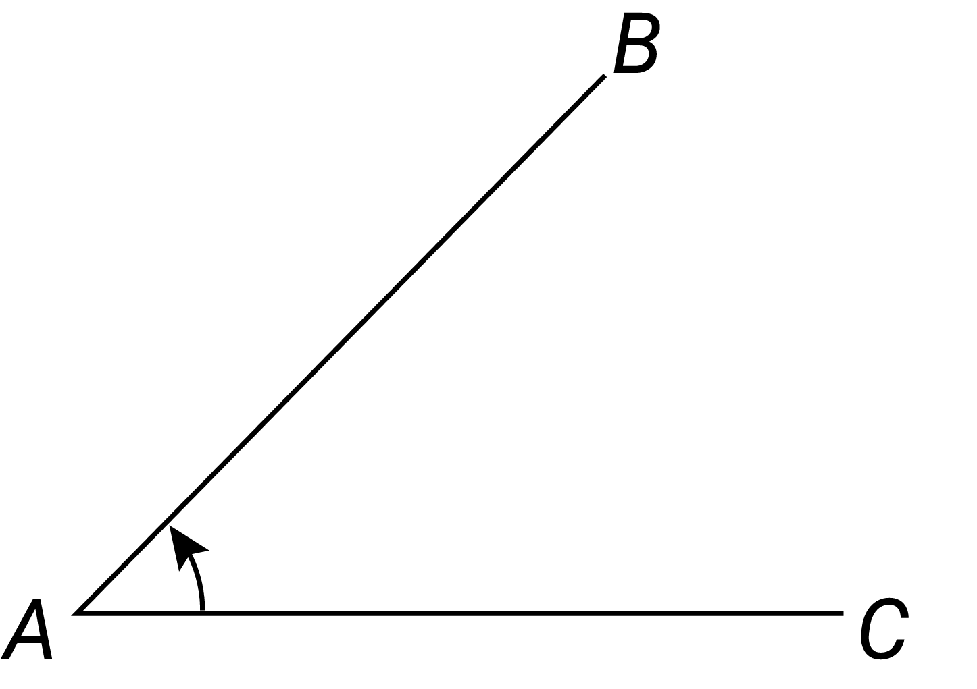
analog clock
A clock with hours marked from 1 to 12 arranged in a circle and moving hands to show you the time.
angle  The figure formed at the intersection of 2 rays in the plane with a common endpoint, called its vertex. It is typically indicated with an arc. | 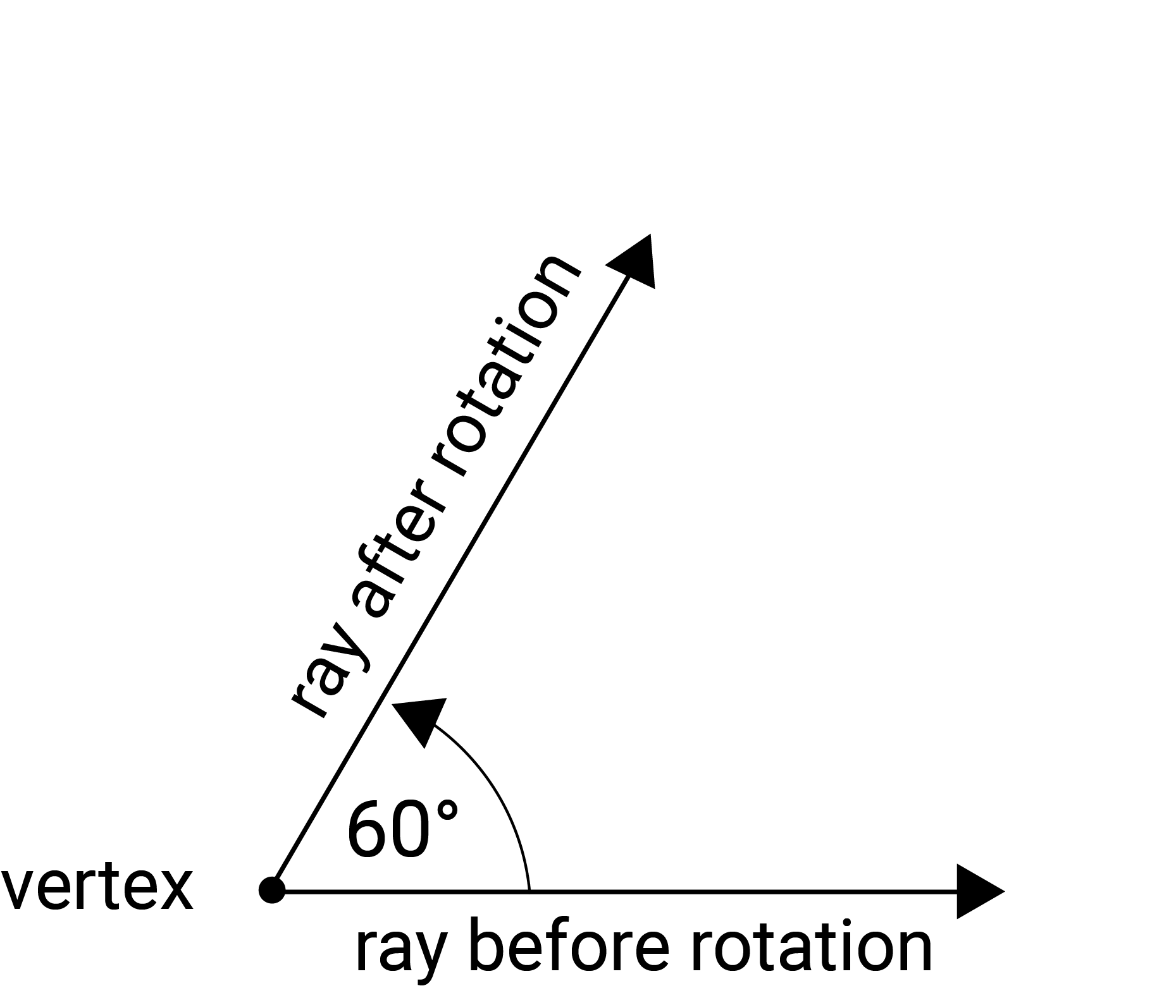
angles at a point  The sum of the angles with vertices at a common point in the plane is equivalent to 4 right angles or 360 degrees. This spatial fact can be applied to determine the size of missing angles. | 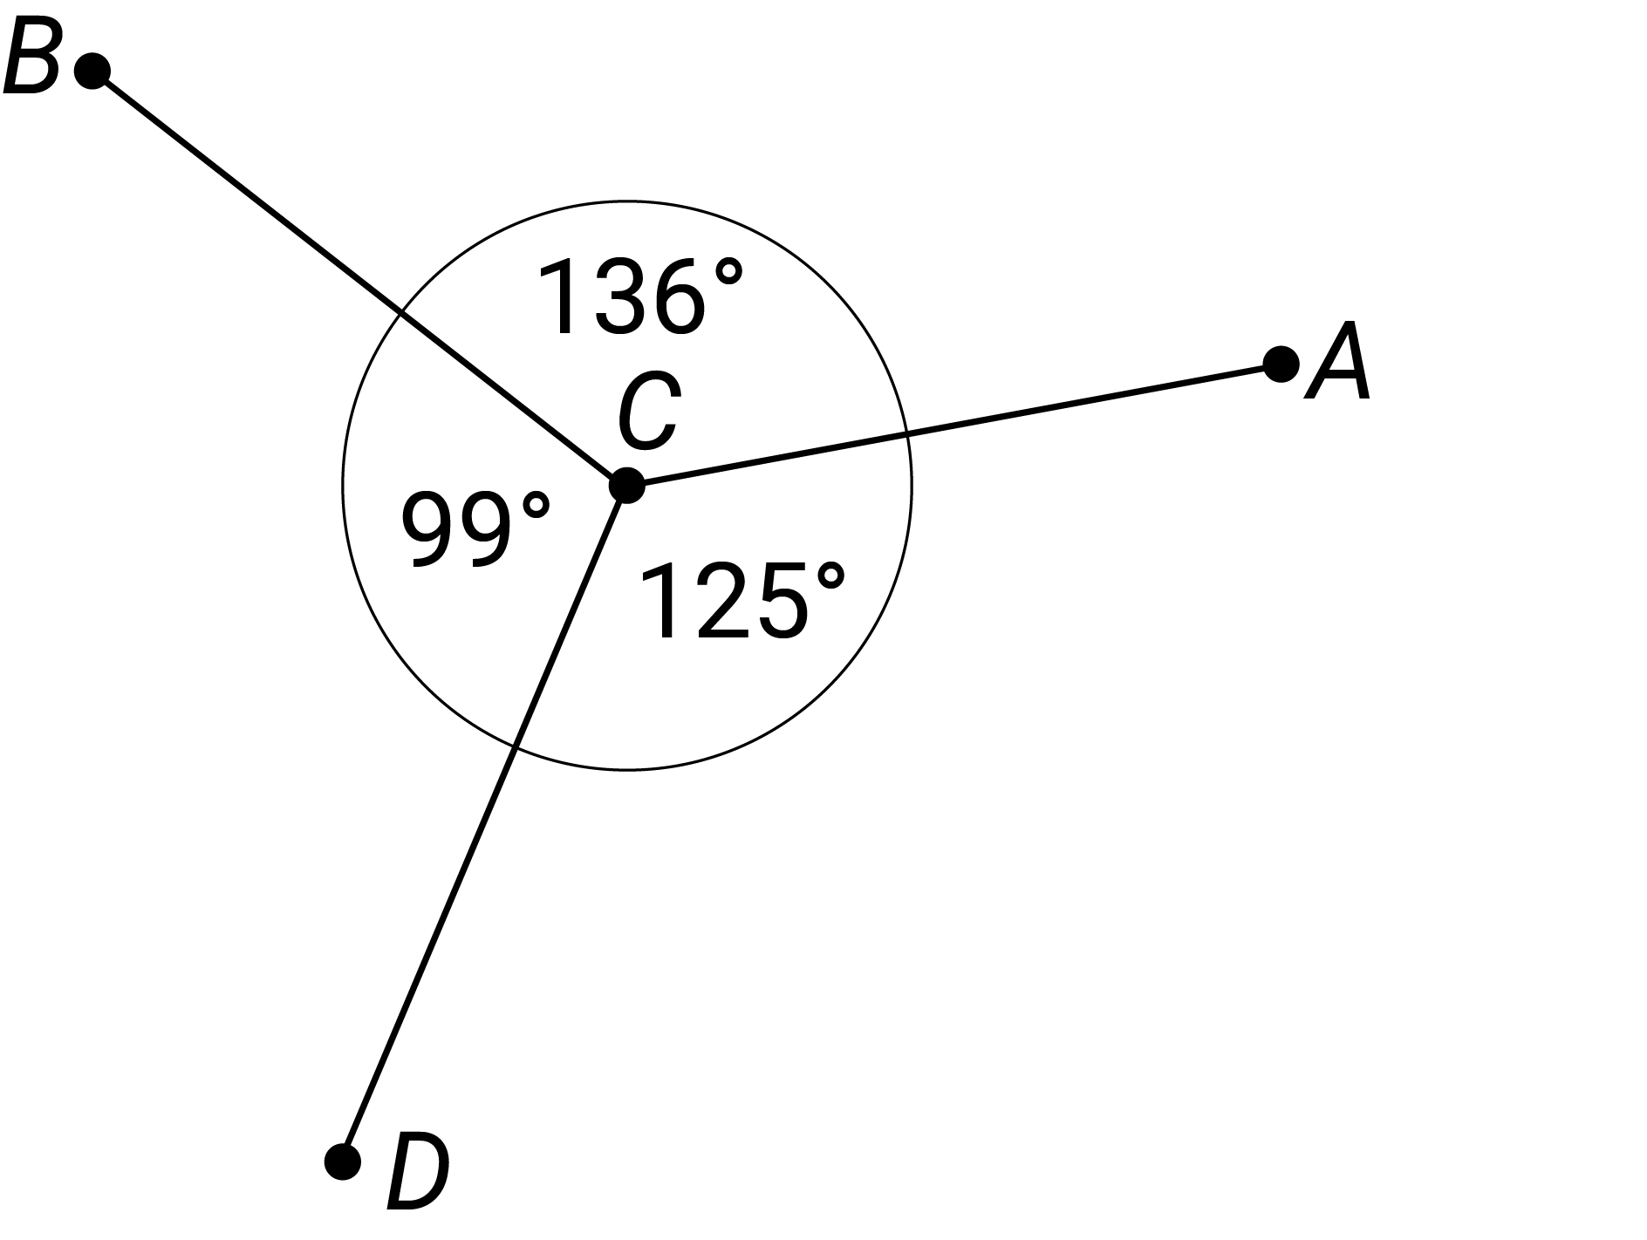
approximate
To obtain or state a value to a particular accuracy.
approximation
A result which is not exact, but is close enough for a given purpose, e.g. giving an approximation of the area of a complex shape by using a combination of basic shapes.
area  The amount of interior space bounded by the perimeter of a shape. It is usually measured in square units. For example, the area of this rectangle is given by $8×2=16$ units. | 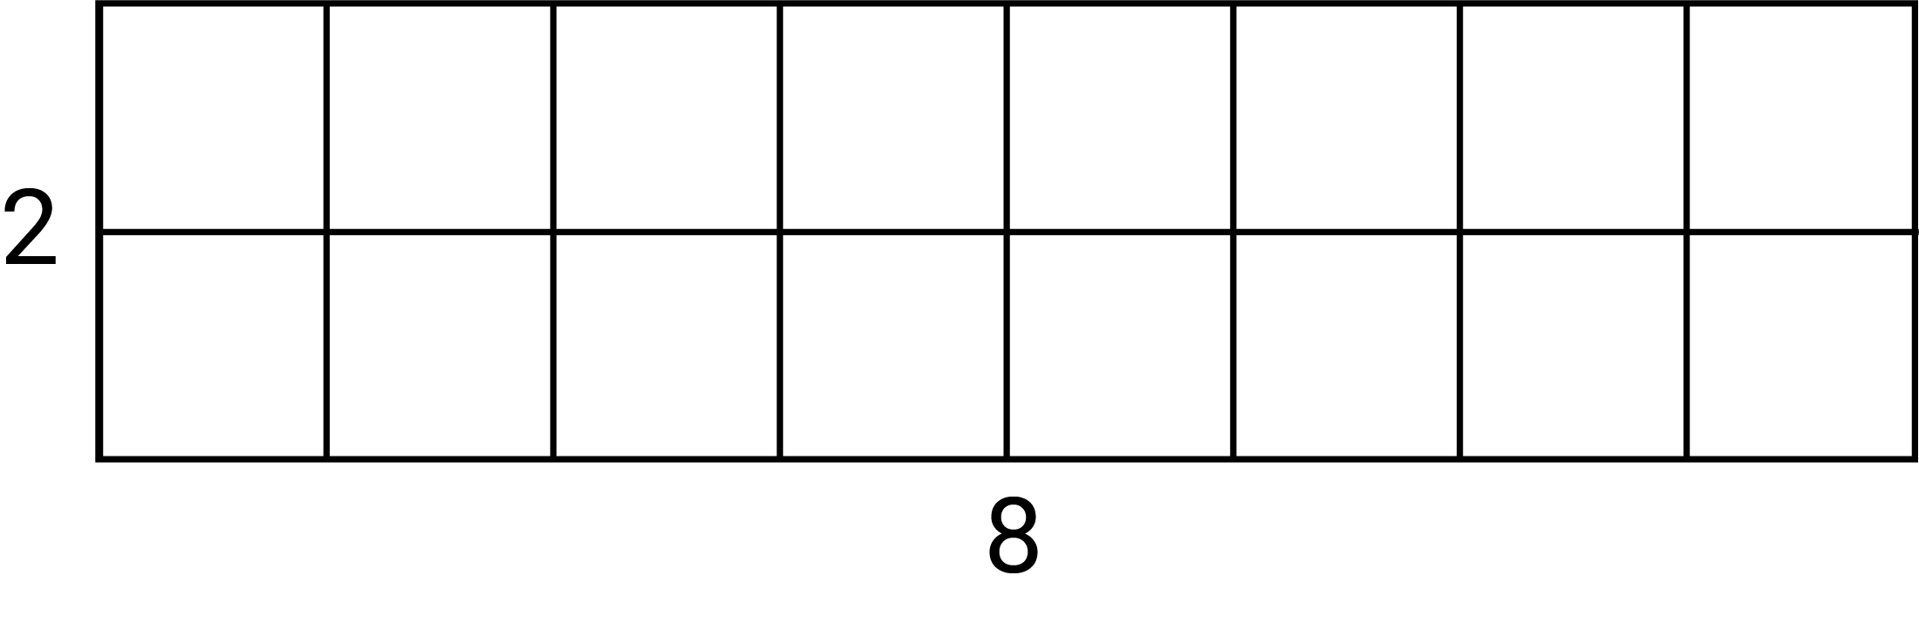
array  An ordered collection of discrete objects or numbers, e.g. rectangular arrangements of rows and columns such as 2 arrays of dots ($4×6$ and $8×3)$ produce 2 different representations of the number $24$. | 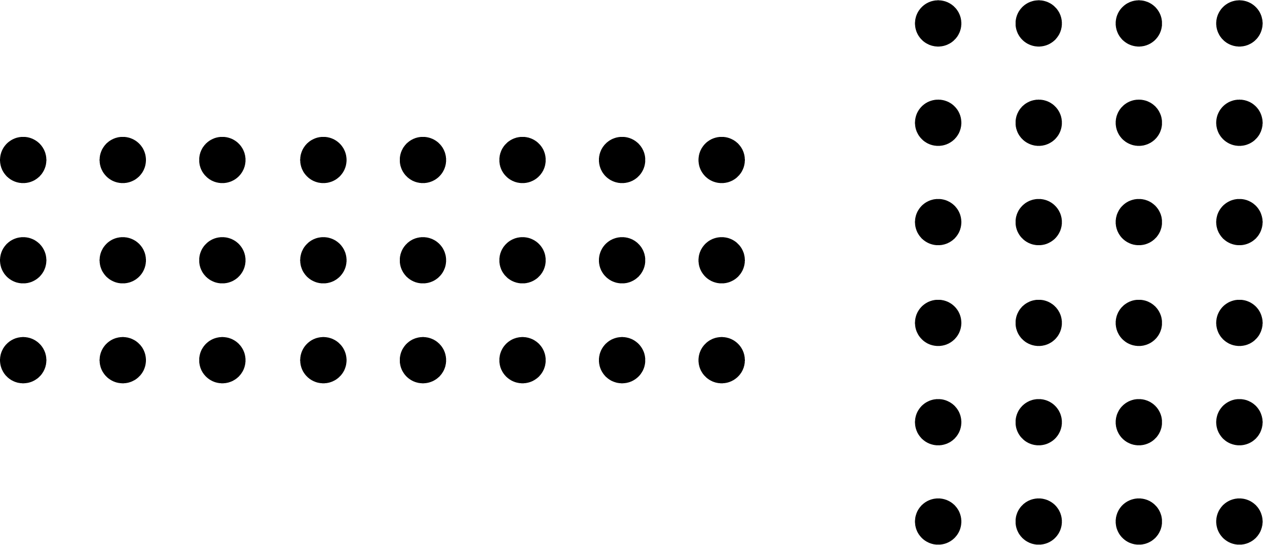
association(s)
Relationships between pairs of variables for different data types, e.g. in terms of strength, form and direction.
associative
Of or relating to an operation that when applied to any 3 elements of an expression is the same regardless of which pair of elements (without changing their order) is combined first.
attribute
A property of an object or event that can be measured and/or directly or indirectly compared.
B
base-10
A number system which uses the digits 0–9 and the value of the digit is determined by its face value and its place value, e.g. $283=2×100+8×10+3×1$ and $283=200+80+3$.
benchmark fractions
Fractions commonly used in estimating and for making comparisons with other numbers, e.g. $\frac{1}{2}, \frac{1}{4}, \frac{3}{4}$
benchmarks
Reference points against which something can be measured or compared, e.g. a carton of milk for 1 litre, a block of butter for 250 grams.
bias (statistics)
A measure being systematically moved away from the true value, leading to overestimating or underestimating that value.
bivariate data
Data relating to measurement of 2 variables. It can be categorical data, numerical data or a combination of both.
C
capacity
The amount a container will hold. It is often used in relation to the volume of fluids. Units of capacity (volume of fluids or gases) include litres (L) and millilitres (mL).
categorical data
Data in discrete categories, e.g. data on blood groups with values of type A, B, AB or O.
chance experiment (trial)
A repeatable activity that has more than one possible outcome and for which the outcome is not known in advance. Also called a trial.
check the reasonableness
The process of determining whether a solution, calculation or result is appropriate for the context of the problem.
circle  The set of all points in the plane that are a fixed distance (the radius) from a given point (the centre of the circle). | 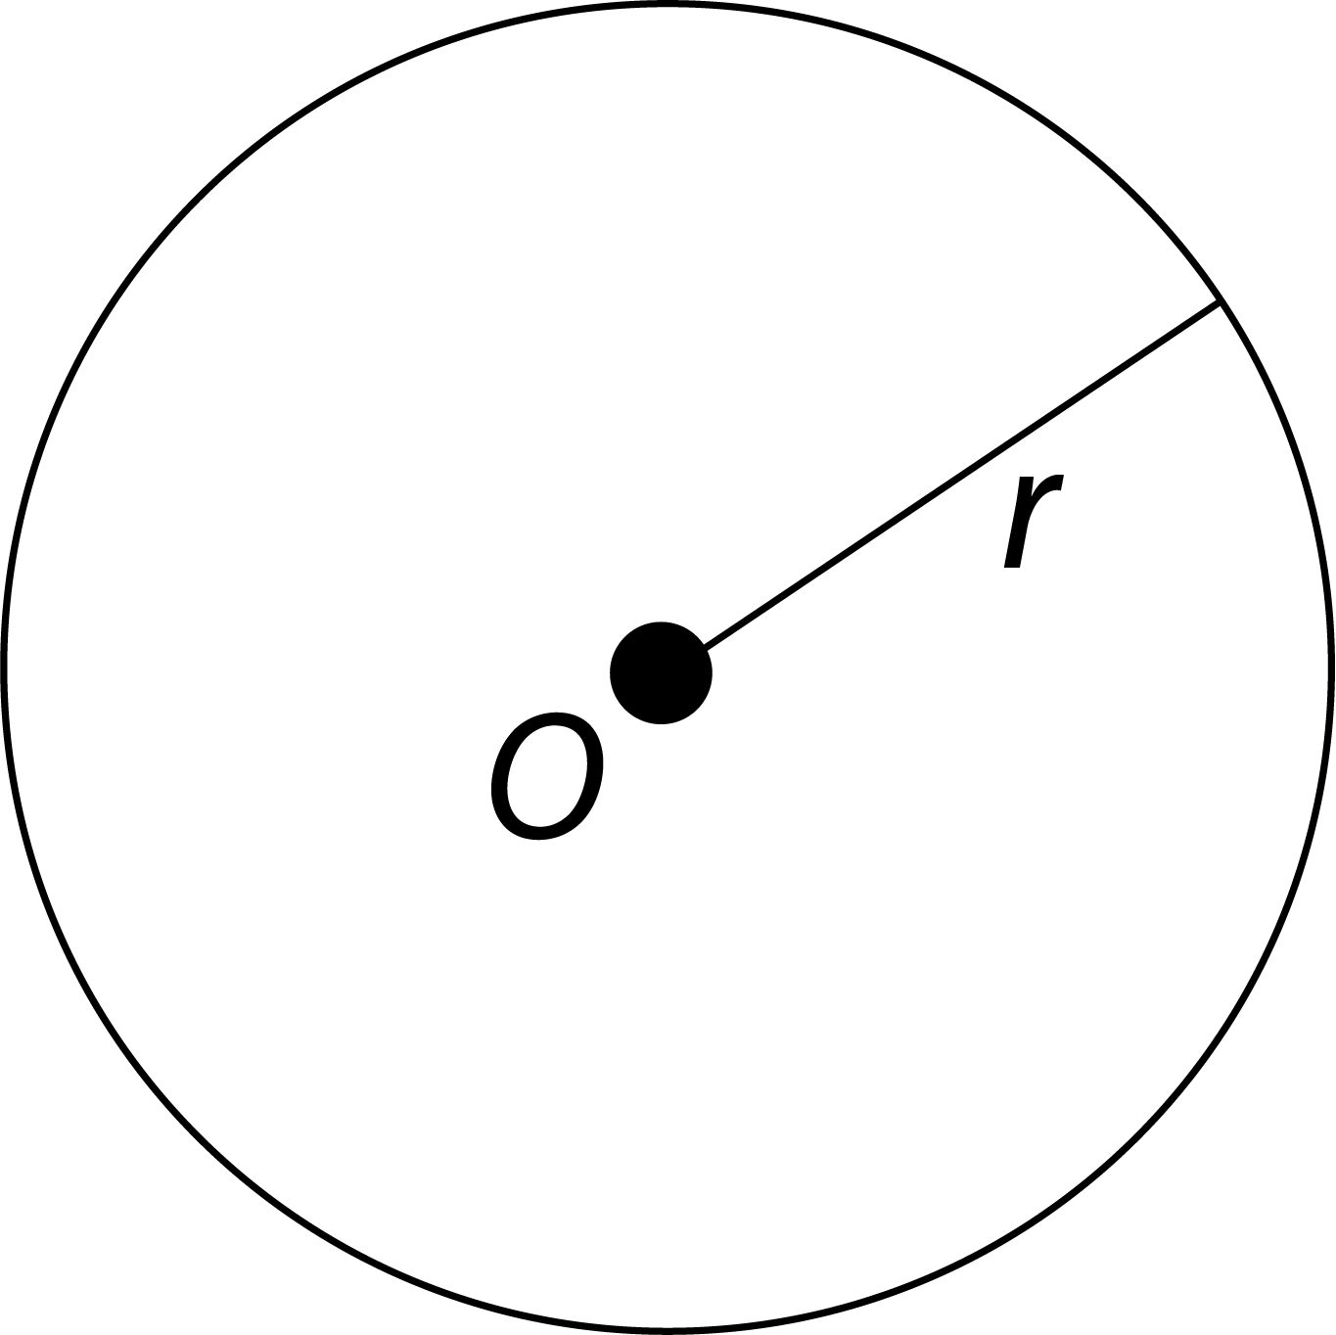
circumference
The boundary (perimeter) of a circle. The length of the circumference $C$ is given by $C=πd$, where $d$ is the diameter. Alternatively, it is given by $C=2πr,$ where$r$ is the radius.
column graph  A graph for organising and displaying categorical data. Equal-width rectangular bars are constructed for each category with height equal to the observed frequency of the category. | 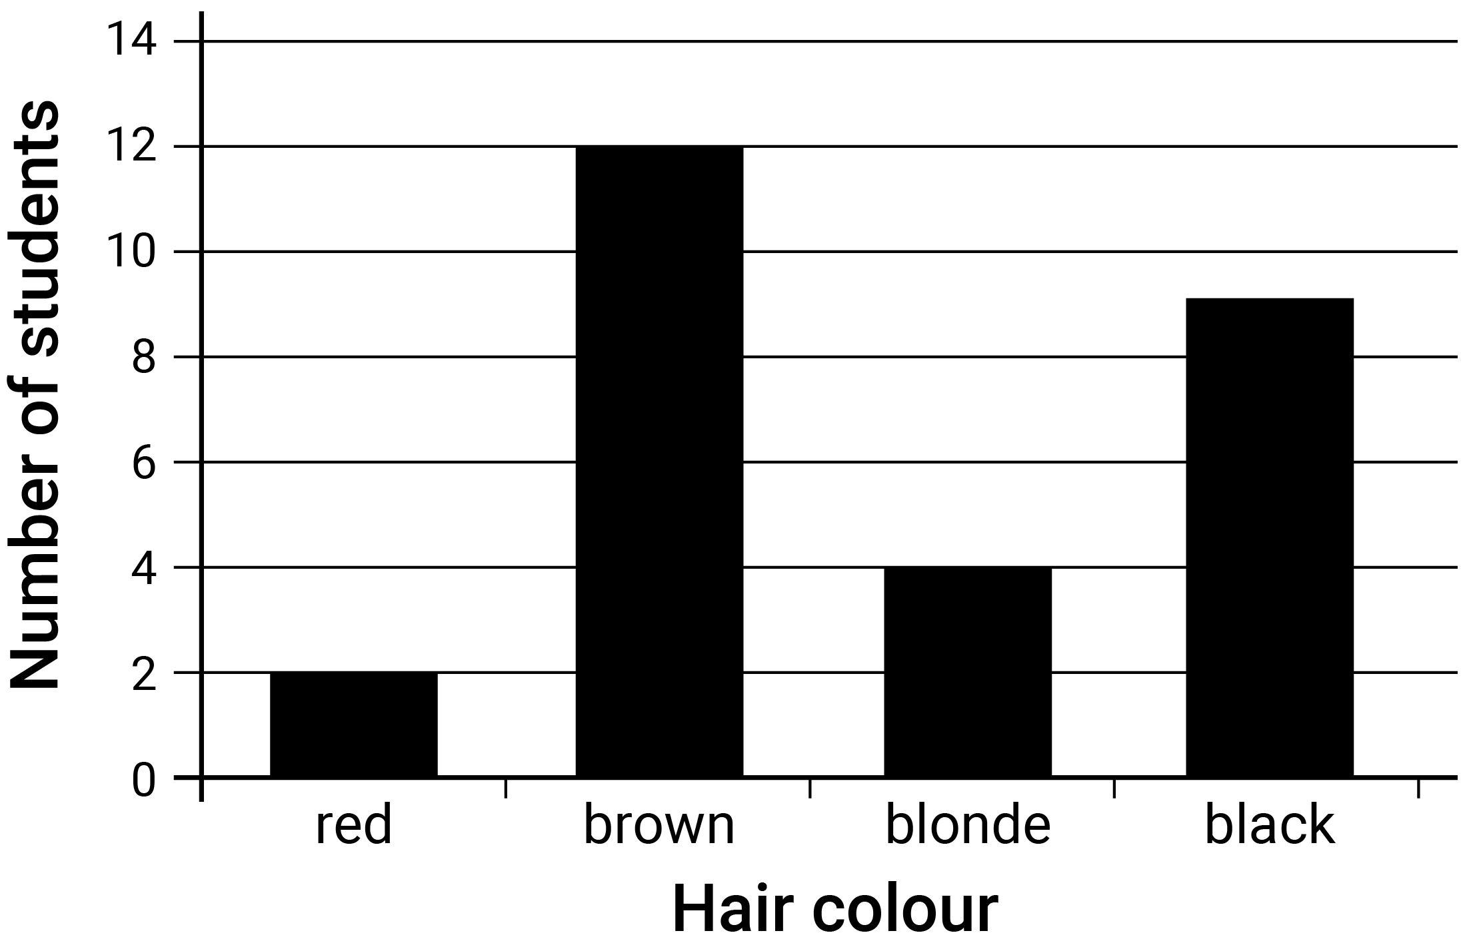
commutative property
In general, the commutative property of addition and multiplication of real numbers is that for all real numbers $a$ and $b$, $a + b = b + a$ and $a × b = b × a$ respectively.
complement (probability)
For 2 mutually exclusive events A and B, event B is the complement of event A, and the probability of event B is denoted as P(B) = 1 - P(A), e.g. P(not getting a 6) is 1 - P(6) = 1-1/6 = 5/6.
complementary angles
Two adjacent angles that form a right angle, i.e. the sum of the angles measured in degrees is $90°$.
compound event
In probability, an event that consists of more than one event occurring at the same time, e.g. tossing a coin and selecting a card.
compound interest
The interest earned by investing a sum of money (the principal) when each successive interest payment is added to the principal for calculating the next interest payment.
conceptually subitise
The ability to recognise a whole quantity as the result of recognising smaller quantities, e.g. 5 can be seen as 3 and 2 or 4 and 1.
concrete materials
Manipulative materials designed to represent explicitly and concretely mathematical ideas that are abstract. They can be manipulated by learners through hands-on experiences.
conditional probability
Consideration of whether the knowledge of the occurrence of one event, A, affects the probability of occurrence of another event, B.
cone  An object that is formed by taking a circular base and a point not in the plane of this circle called the vertex, and joining the vertex to each point on the circumference of the base. | 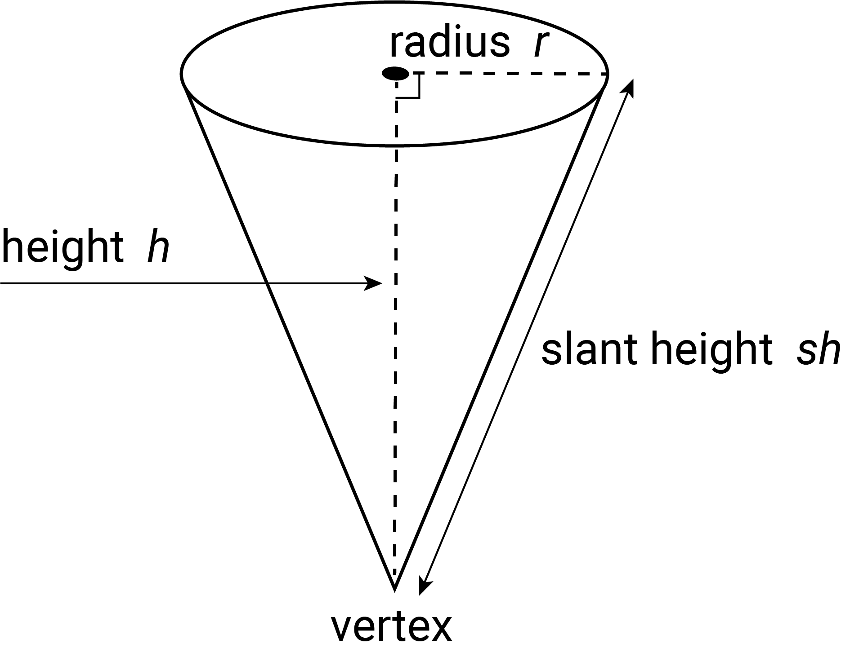
congruent  An exact match between every part of one figure with the corresponding part of the other figure, i.e. congruent figures can be exactly superimposed on each other. | 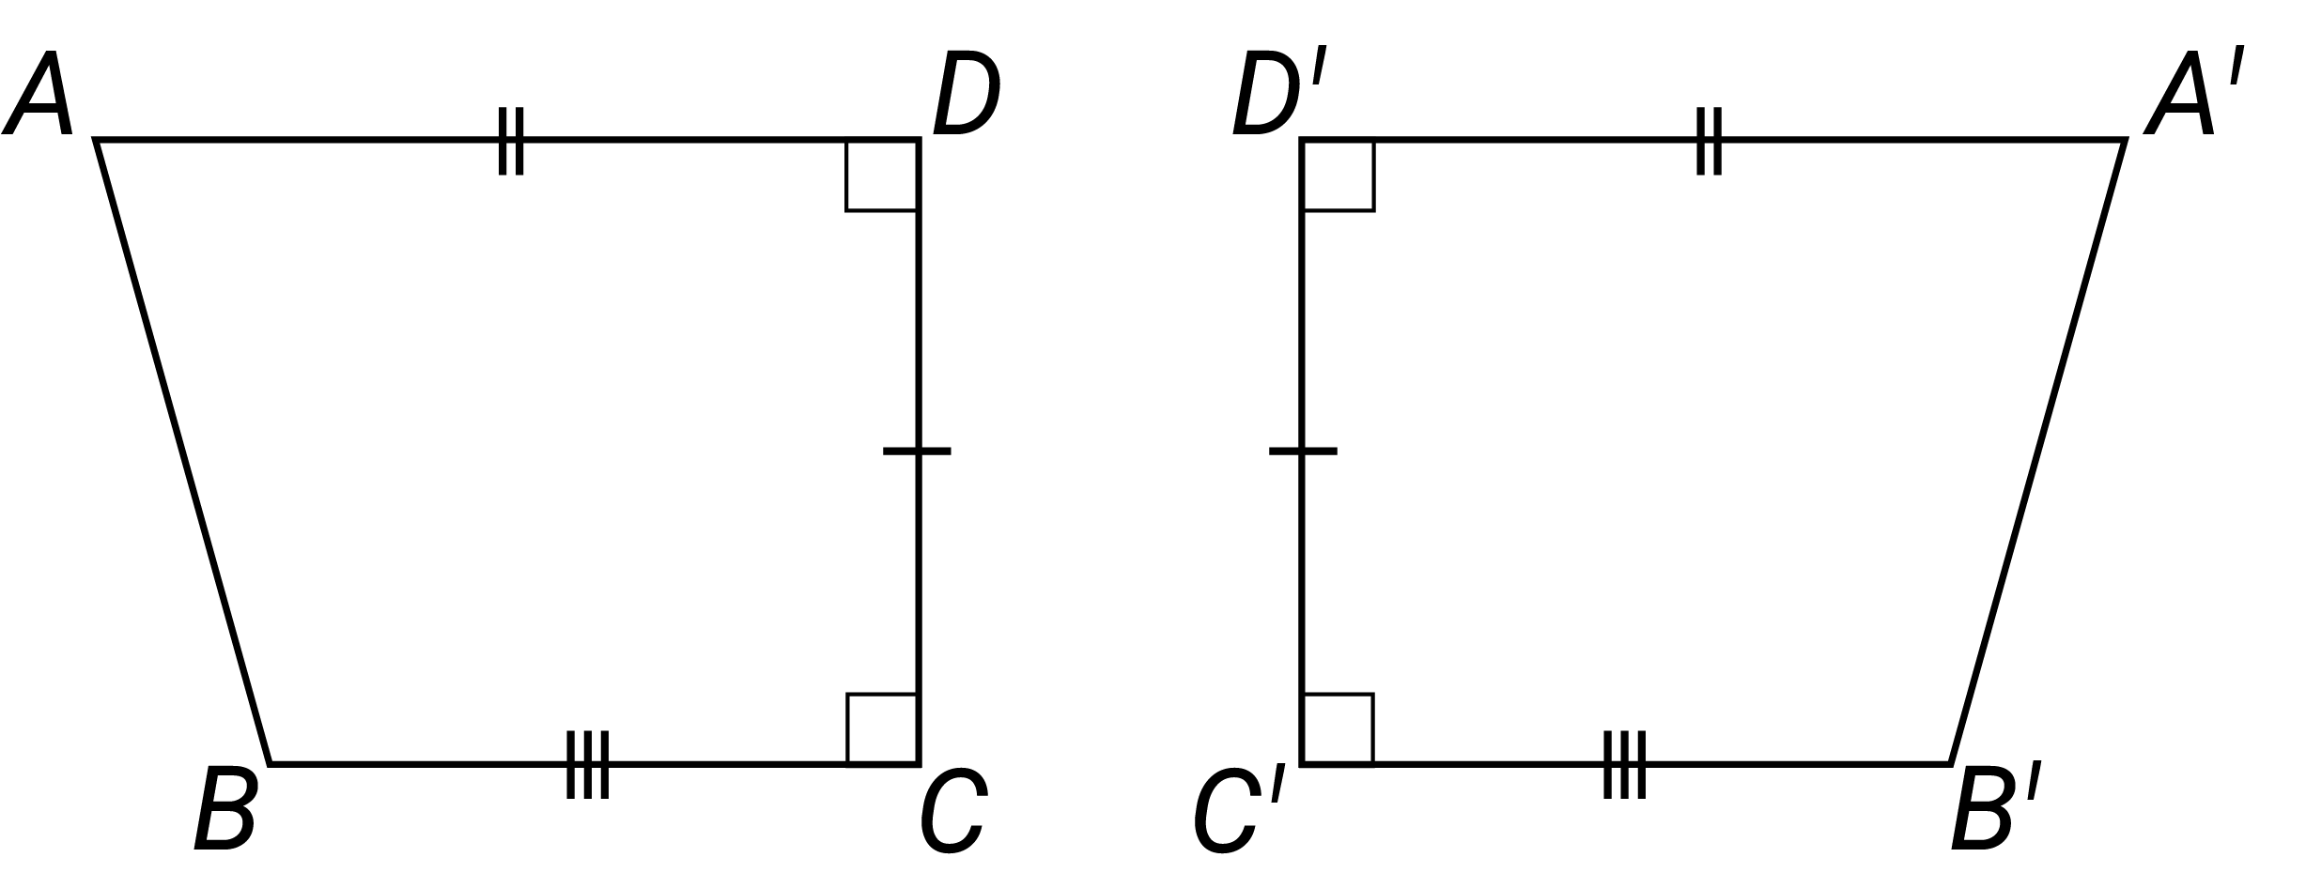
congruent triangles  Triangles that have the same size and shape. When not all measures are known, the determination can be made using the 4 standard congruence tests for triangles (SSS, SAS, AAS, RHS). | 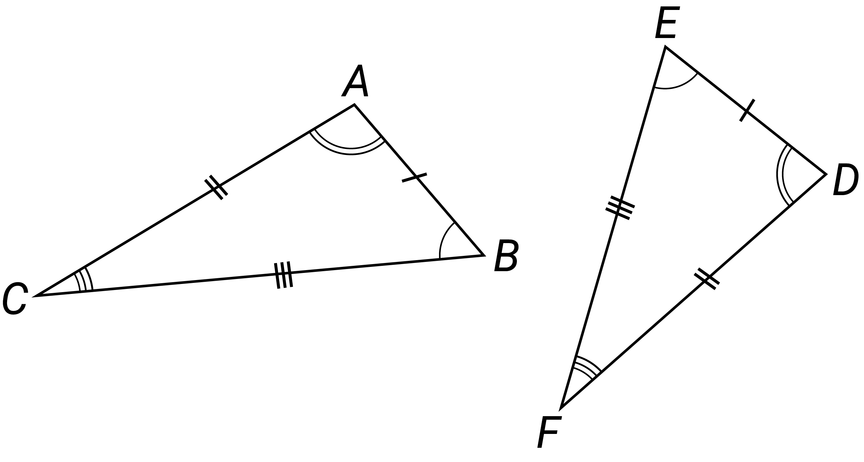
construct
To draw, make or build a mathematical object such as a shape, pattern, algorithm or proof.
context
The situation or setting of an event, problem or application. Contexts can be real world or constructed.
continuous numerical variable
A numerical variable that can take any value that lies within an interval. In practice, the values taken are recorded to the accuracy of measurement of the instrument used to obtain these values.
coordinates
A set of values that define the position of a point or an object in a space. The coordinate system being used will govern the nature of the coordinates.
counting
The process of quantifying the number of objects in a set or collection.
counting down strategy
To answer a question such as, “I have 9 grapes and I eat 3 grapes. How many remain?” the student says “Nine … eight, seven, six … six!” This strategy is described as counting down from a number.
cylinder  An object that has parallel circular discs of equal radius at the ends that are joined by a curved surface. | 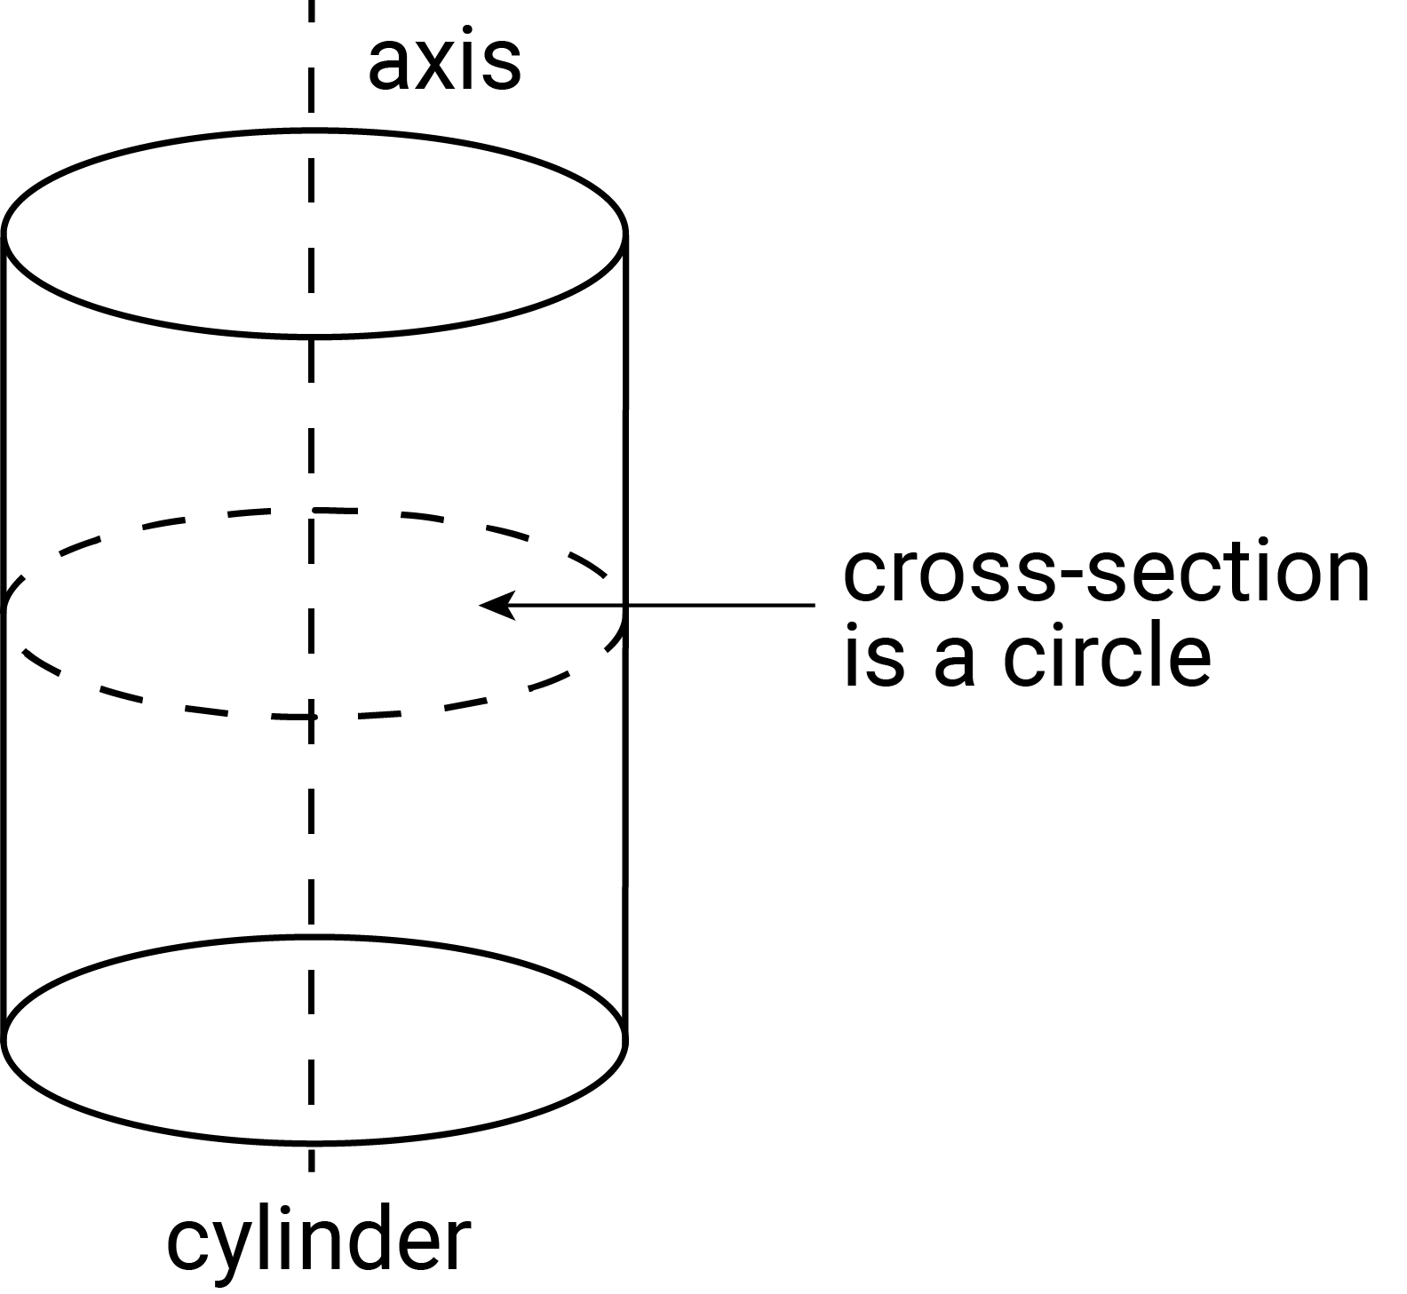

D
data
A general term for a set of observations or measurements collected during an investigation. Primary data is collected by the user; secondary data is collected by others.
data displays
Visual formats for organising, representing and summarising data. Also called visualisations.
decimal
Used to describe aspects of the base-10 number system. The decimal point (. or ,) separates the whole number part of a number from its decimal part.
degrees
A unit of measurement for measuring an angle. Angles are measured as a proportion of a full turn which is equivalent to $360$ degrees, so that one degree is equal to $\frac{1}{360}$ of a full turn. Written as $α$°.
denominator
In the fraction $\frac{a}{b}$, $b$ is the denominator. It is the number of equal parts into which the whole is divided.
diagonal
A line segment joining 2 vertices of a polygon that do not share an edge.
diameter  A chord passing through the centre of a circle. The word is also used for the length of the diameter. | 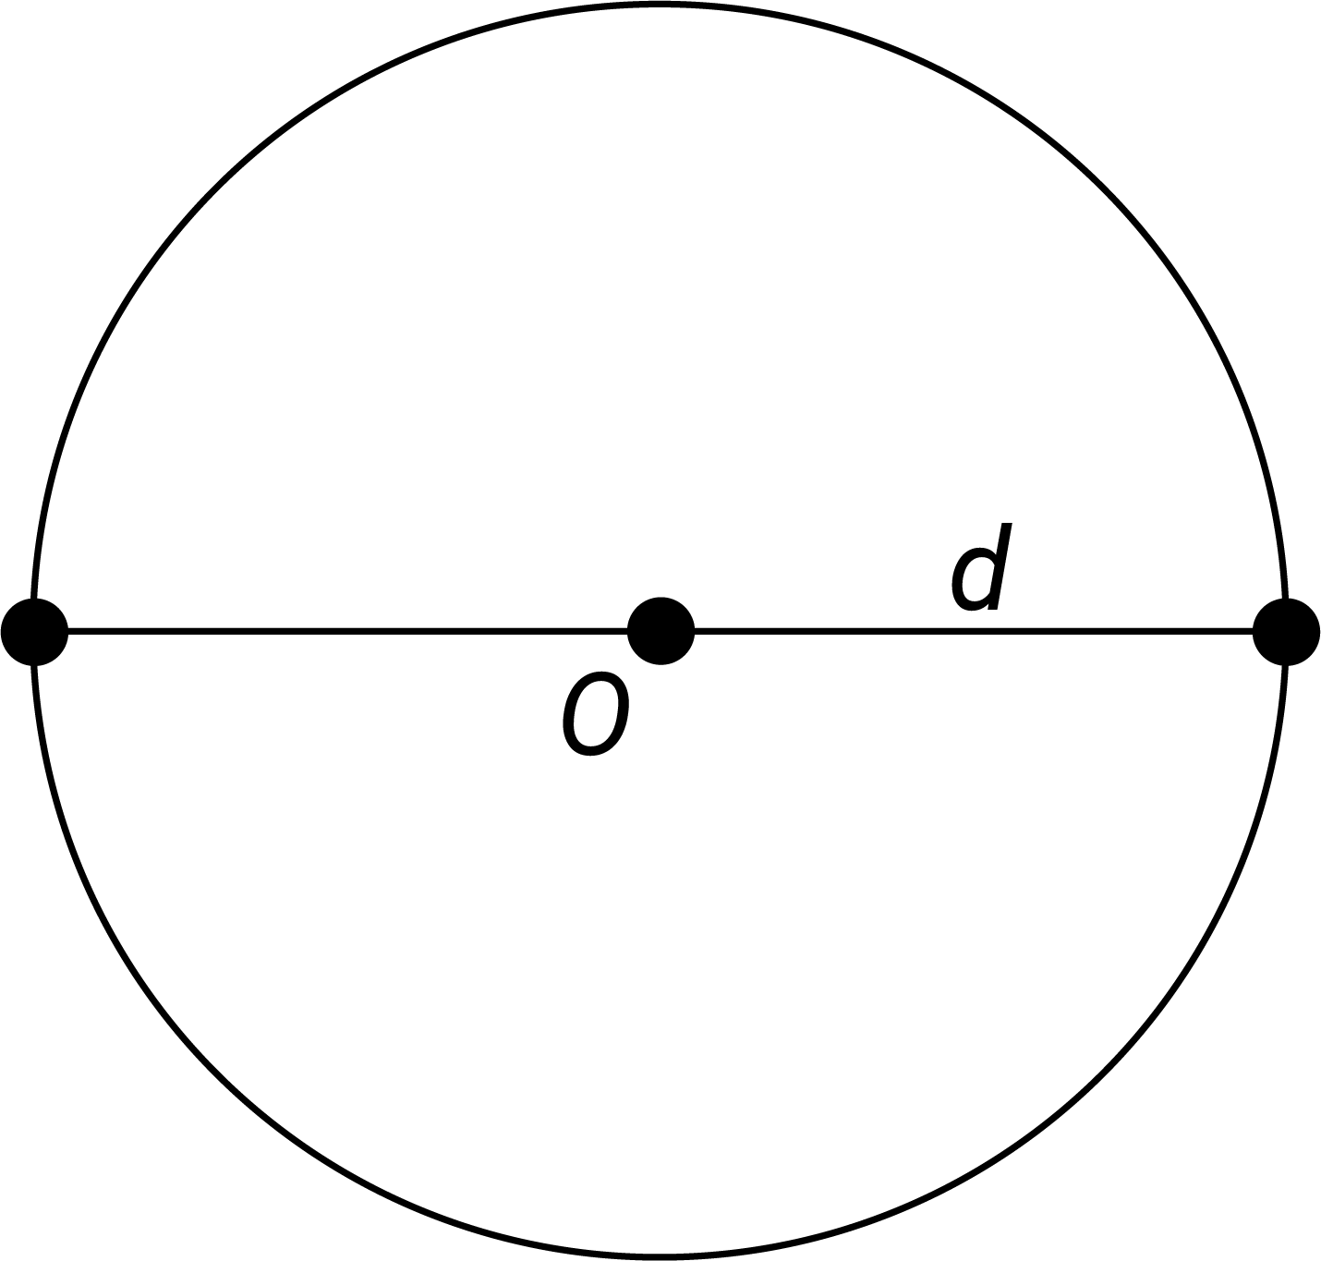
digit
A single symbol that is used to represent a number as a numeral. In the base-10 number system there are 10 digits: 0, 1, 2, 3, 4, 5, 6, 7, 8 and 9.
digital tools
Electronic devices, programs, websites or online resources that can be used to support the learning and doing of mathematics.
direct comparison
Comparing objects and events using a particular attribute, e.g. measuring the length of 2 pencils by placing them side by side or starting 2 events at the same time to compare duration.
direct proportion
The relationship between corresponding values of 2 variables in a fixed ratio relative to each other; i.e. for variables $x$ and $y$, $\frac{y}{x}=k$; and $y=kx$, where $k ≠ 0$.
directional language
Words that communicate position, location and movement within a space.
discrete numerical data
Numerical data that can take only a countable number of values, e.g. the number of people in a car, or clothing sizes.
dissection and rearrangement
The act or result of the partitioning of a shape into smaller parts and sometimes rearranging it to make a familiar shape.
distribution (statistics)  The shape of a graph when all data values are plotted, e.g. the dot plot shown displays the number of passengers observed in 32 cars stopped at a set of traffic lights. | 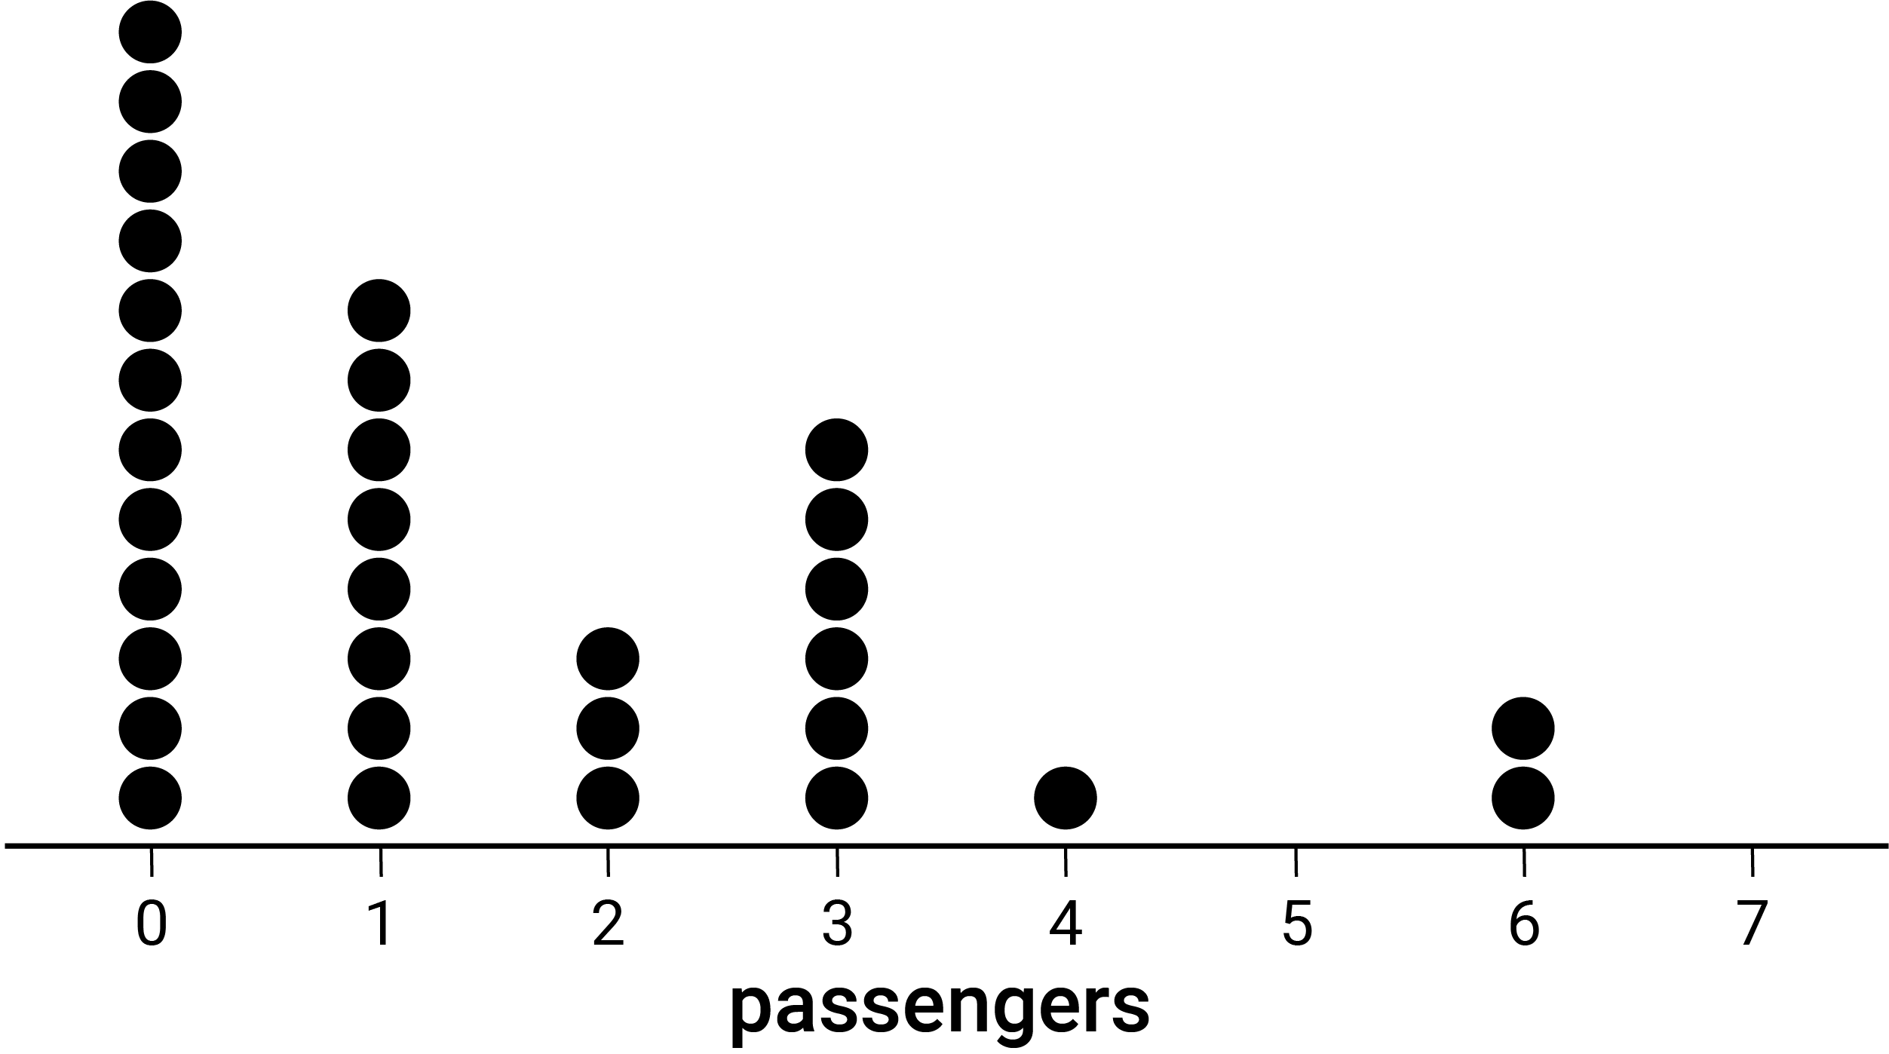
distributive property
In general, the distributive law (property) for multiplication over addition for real numbers states that for all real numbers $a, b$ and $c$: $a\left(b+c\right)=a×b+a×c$.
division
For a finite set, the process of partitioning the set into subsets of equal size. For natural numbers, it expresses a given number as a multiple of a smaller number and any remainder.
division facts
Facts that draw on the inverse relationship between division and multiplication and are directly related to the multiplication facts, e.g. $2×5=10$, so $\frac{10}{2}=5$ and $\frac{10}{5}=2$.
duration
A measure of time that an event or activity takes to complete.
E
enlargement transformation  A scaling of a figure in which the corresponding lengths in the transformed figure are increased or decreased in proportion to the original figure. The 2 figures are similar. | 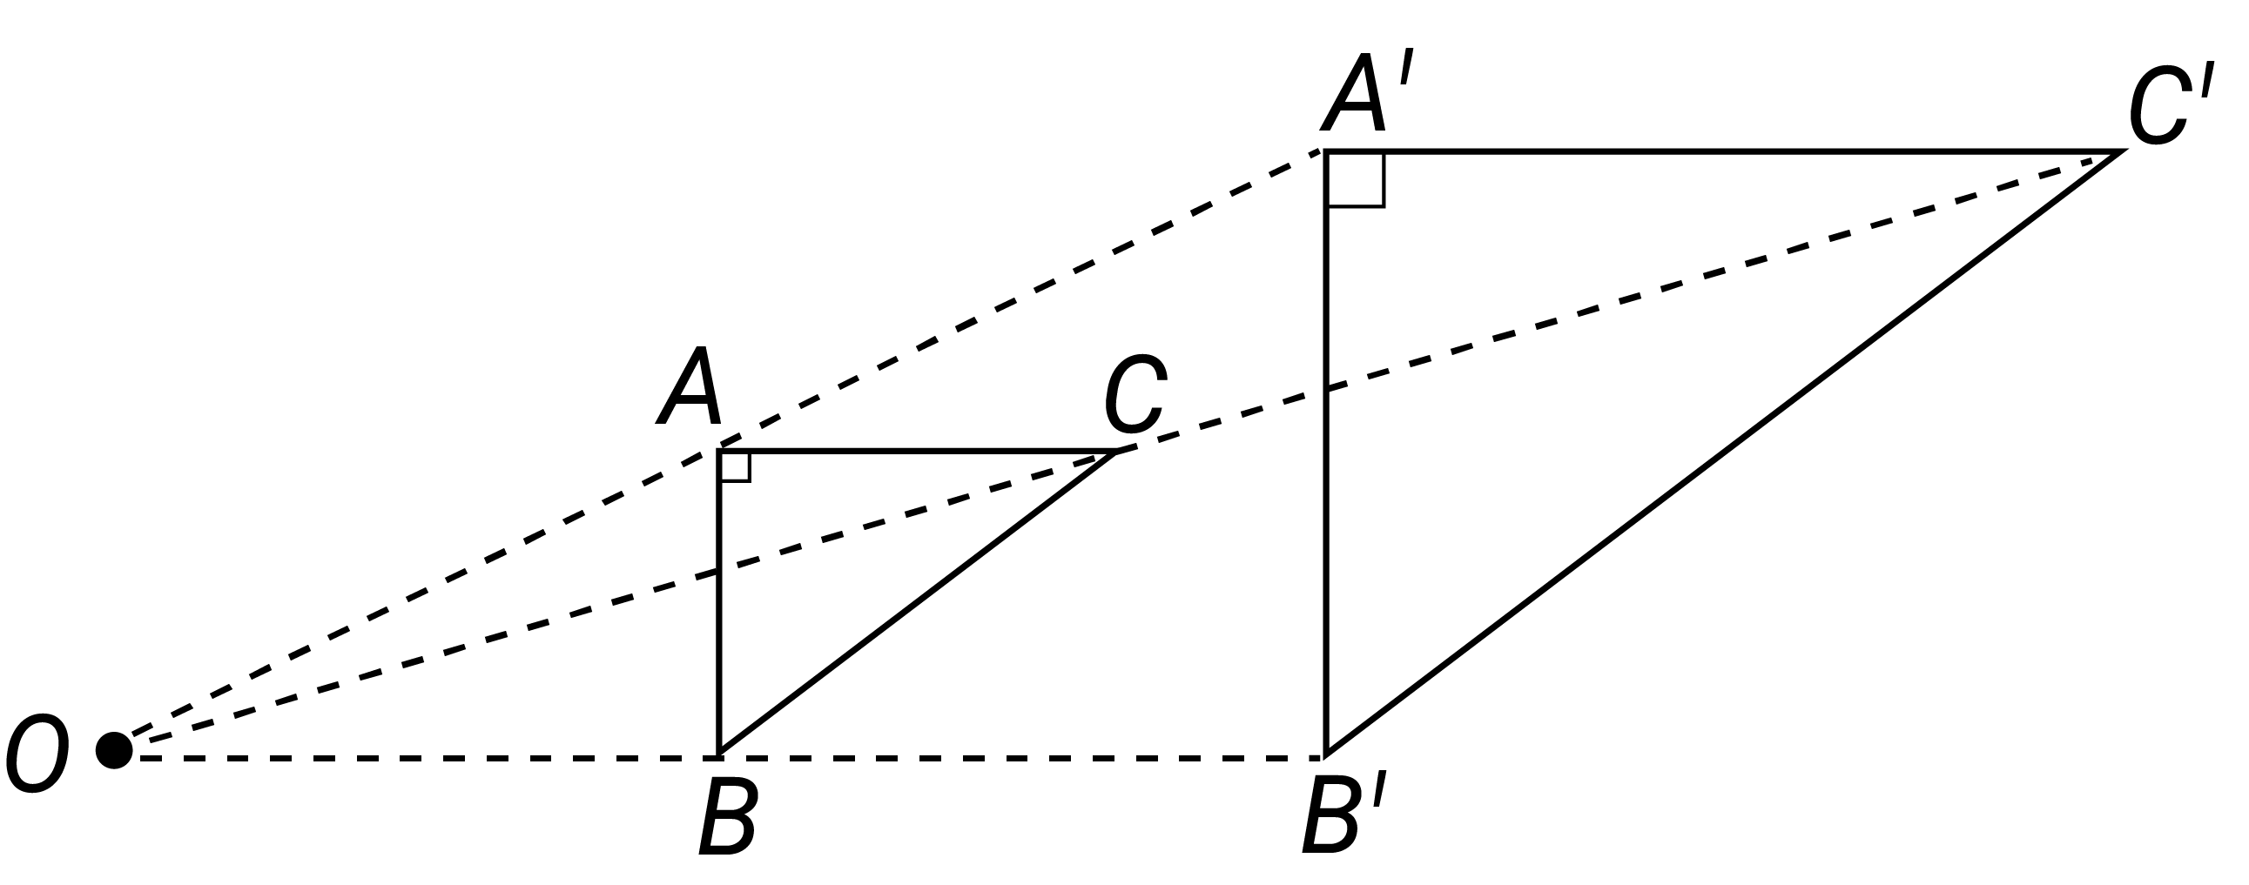
equal grouping
Dividing a collection, shape or object into a number of parts of equal shares.
equal sharing
Dividing a collection, shape or object into equal parts.
equivalence
Equal in value or meaning. Something such as an expression or statement that is essentially the same. Two or more sets that are capable of being mapped in a one-to-one relationship.
equivalent algebraic expressions
Expressions that are essentially the same, e.g. 3(x + 2) and 3x + 6 are equivalent expressions because the value of both the expressions remains the same for any value of x.
equally likely outcomes
An event for which all outcomes have the same probability of occurring.
equation
A statement that includes the ‘=’ symbol. Equations are used to show the equality of 2 expressions.
equivalent
Equal in value or meaning. Something such as an expression or statement that is essentially the same. Two or more sets that are capable of being mapped in a one-to-one relationship.
equivalent fractions
Fractions that are different representations of the same value, e.g. $\frac{1}{2}=\frac{2}{4}=\frac{4}{8}$.
equivalent number sentences
Number sentences which have the same value, e.g. $527+96=527+100-4$
error
The difference between an actual value and its measured or estimated value.
estimation
The skill of conceptualising and mentally manipulating numbers or measurements to find an approximate answer. The capacity to make reasonable adjustments to estimates is essential in estimating.
even number
An integer that is divisible by 2. The even natural numbers are $\{0, 2, 4, 6, …\}$
event
A subset of the sample space of a random experiment.
expected results
The results that would be expected based on a calculation of probability.
exponent
The power (or index) to which a number or algebraic expression is raised, shown using superscript, e.g. in the following expressions the exponent is $3: 2^{3}, 2x^{3}, 2({x+5)}^{3}$.
exponentially  Increasing or decreasing at a rapid rate. The rate of change increases or decreases multiplicatively. |  | 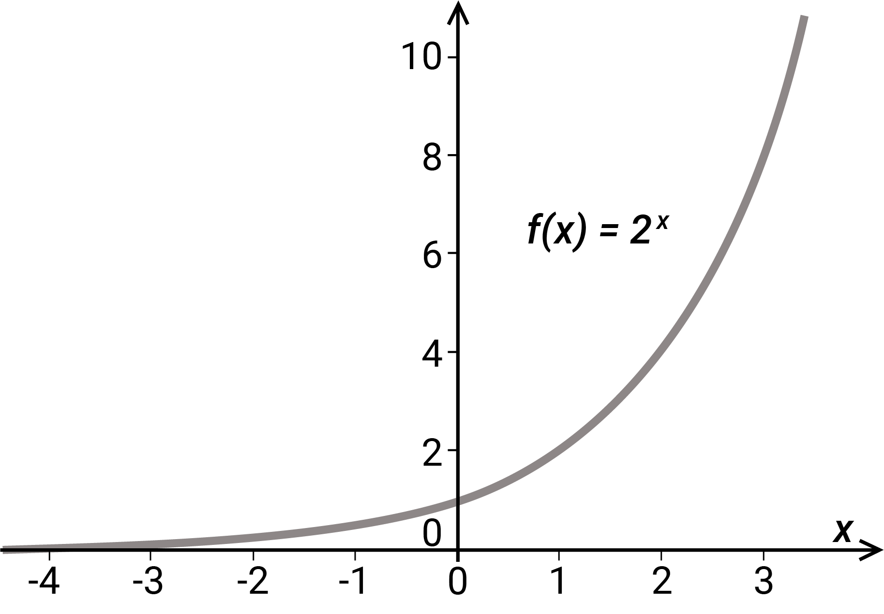
expression
Two or more numbers or variables connected by operations.
F
factors
Let a, b and c be natural numbers such that $a×b=c$, then $a$ and $b$ are factors (or divisors) of $c$, e.g. $3×4=12$, so $3$ and $4$ are factors (divisors) of $12$.
financial plans
Documentation of current money situations and financial goals, as well as strategies to achieve these goals, e.g. saving up to purchase a desired item, planning for an excursion.
formal units
Units of measurement based on an agreed fixed standard, e.g. metre, second, gram.
fraction
A number of the form $\frac{a}{b}$ where $a$ is an integer and $b$ is a non-zero integer, e.g. $\frac{4}{6}, \frac{11}{5}, \frac{-3}{7}$. A fraction is said to be in simplest form when $a$ and $b$ have no common divisor greater than $1$.
frequency
The number of times that a particular value occurs in a data set. For grouped data, it is the number of observations that lie in that group or class interval.
frequency table
A table listing the frequency (number of occurrences) of observations, measurements or outcomes in different ranges, called class intervals. Sometimes referred to as frequency chart.
G
grid reference  A way of identifying a region on a map. Coordinates and grid lines are used to refer to specific features or locations, e.g. in the map shown, the school is located at the grid reference C4. | 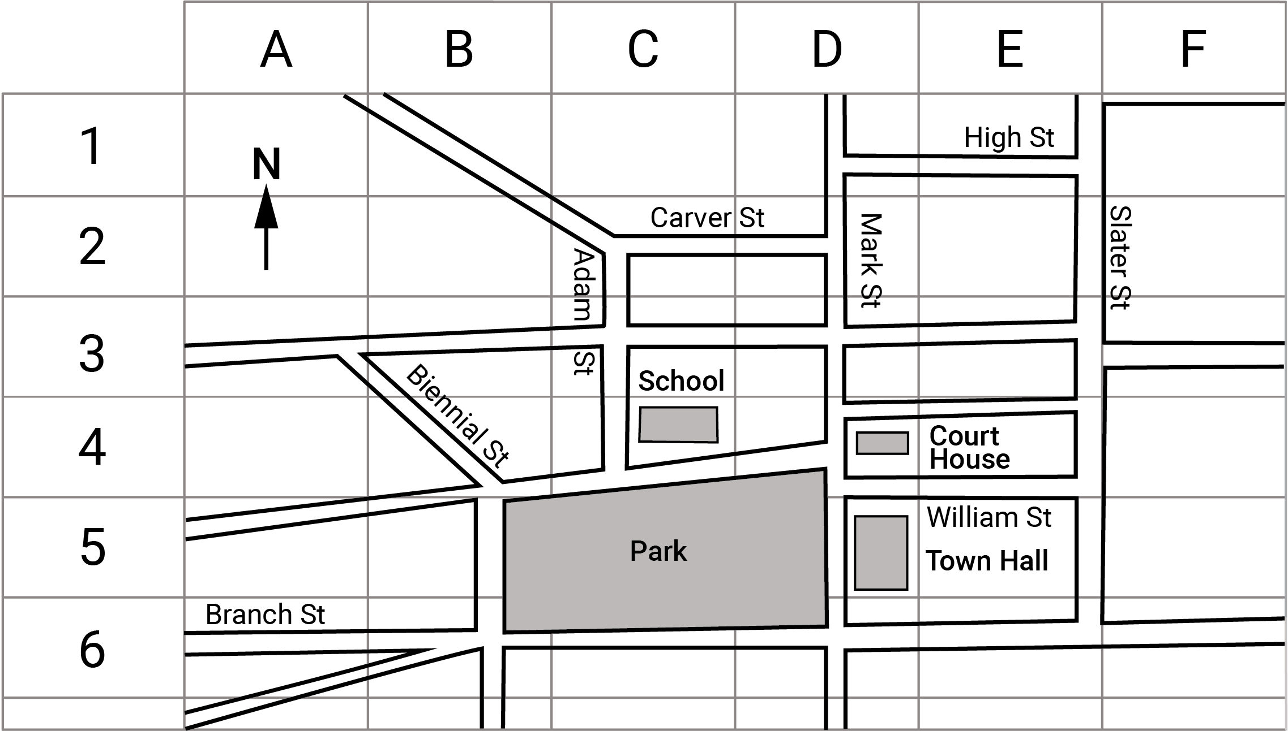
grouping
A process of partitioning a set into subsets according to a given criterion, e.g. a class of students according to eye colour. Equal grouping means each subset has the same number of elements.
growing pattern
A pattern where each term is either an increase or a decrease on the previous term. Change from term to term is predictable if the pattern is growing additively, multiplicatively or exponentially.
H
halving
Partitioning of a collection, region or object into 2 equal parts.
histogram  A statistical graph for displaying the frequency distribution of continuous data. It is also a graphical representation of the information contained in a frequency table. | 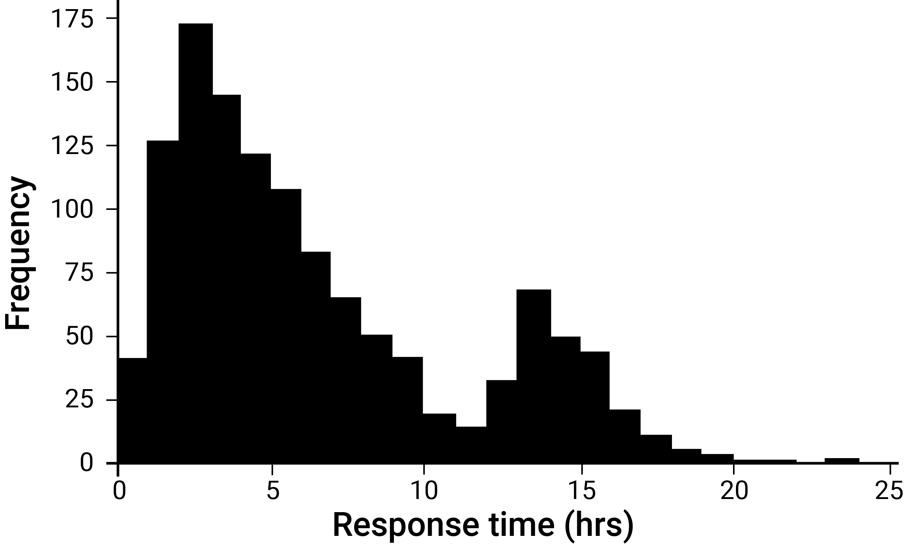
I
indirect proportion
As one quantity increases, the other quantity decreases by the same percentage or ratio, e.g. the lengths and widths of rectangles with the same area.
inequality
A mathematical expression containing the terms ‘less than’, ‘less than or equal to’, ‘greater than’, or ‘greater than or equal to’ and their respective symbolic representations <, ≤, > and ≥.
Inference (statistics)
The process for determining consequences or conclusions based on assumptions, evidence and reasoning.
informal map
A sketch which shows relative position and direction of objects.
informal units
Units whose values are decided on in a given context, e.g. the use of a pace to measure distance (non-uniform unit); the use of paperclips to measure length (uniform unit).
integer
An element of the infinite set of numbers $Z = \{... -3, -2, -1, 0, 1, 2, 3 ...\}$.
interest rate
A percentage of an amount of money or asset (principal) that is borrowed for a given time interval.
interval(s)
A continuous subset of the real number line, e.g. ‘the set of all real numbers greater than or equal to 10’.
inverse operation
An operation in arithmetic which undoes the effect of another operation. Multiplication and division are inverse operations, as are addition and subtraction.
J
K
kite  A quadrilateral with 2 pairs of adjacent sides equal, and hence an axis of line symmetry. | 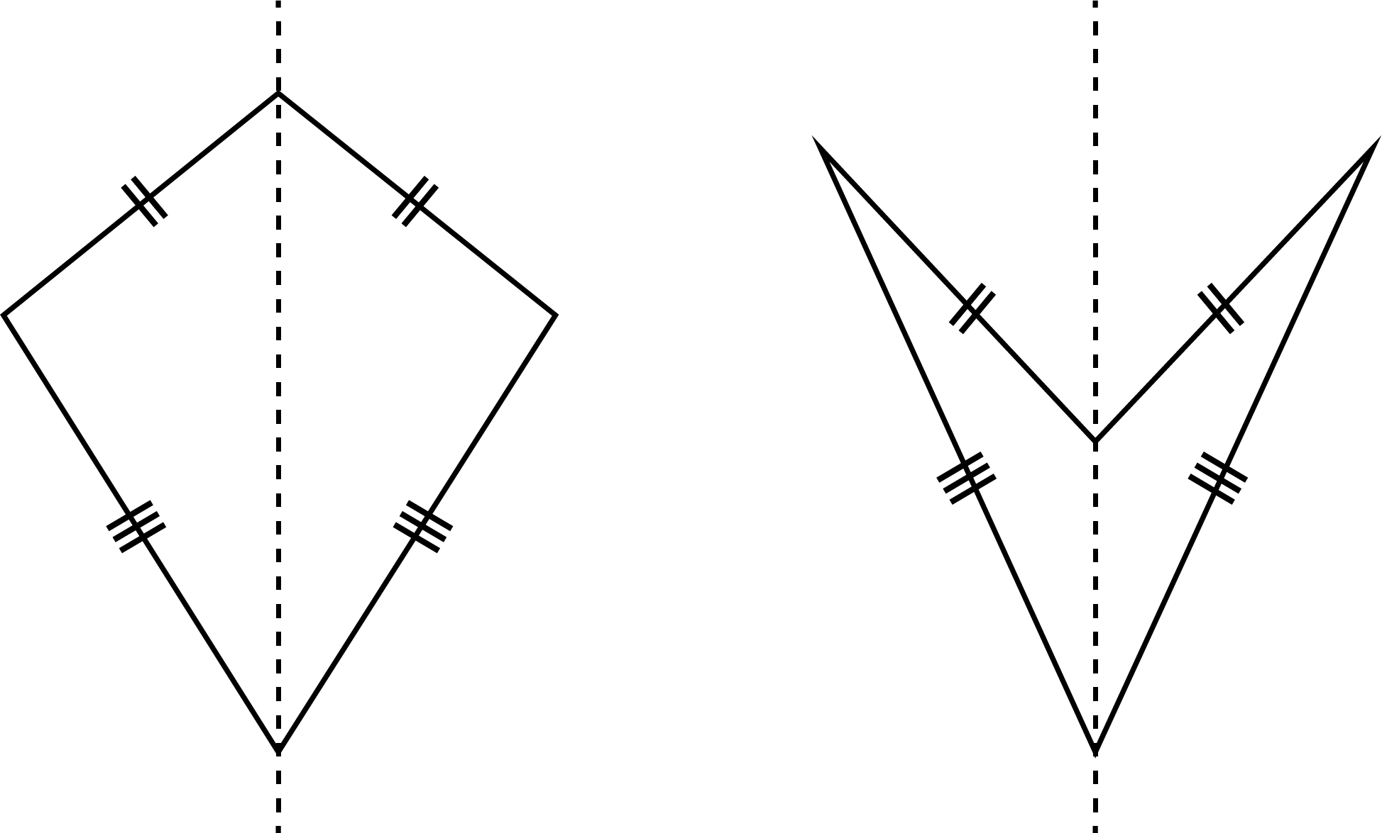
L
line
A model of what is perceived visually as straight. It has one dimension and extends indefinitely in the plane.
line symmetry  A line in which a shape is symmetrical such that if you were to fold the shape about this line it would map onto itself exactly. | 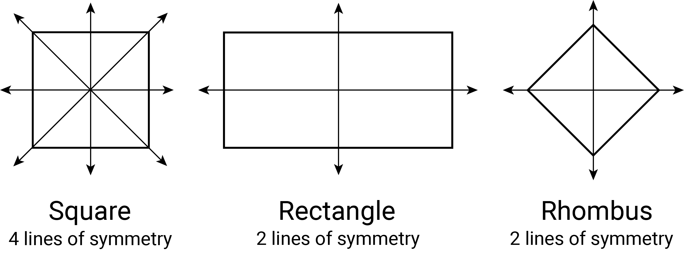
linear relationship
A relationship between 2 variables where there is a constant rate of change.
M
mass
The measure for how much matter an object contains. The SI unit for mass is the kilogram (kg).
mean
The sum of values in a data set divided by the total number of values in the data set. Also called the average.
measure
A record of the magnitude of an attribute (such as weight, length, duration and likelihood) associated with an object or event.
measure of turn
A measurement of rotation from an initial starting position. A turn can be a fraction of a circle (quarter turn) or complete rotation (revolution). It can be directional (clockwise or anti-clockwise).
median
The value in a set of ordered data that divides the data into 2 equal parts. It is often called the ‘middle value’.
metric prefixes
Unit prefixes that precede a basic unit of measure to indicate a multiple or part of the unit, e.g. one kilogram is equal to 1000 grams, one centimetre is equal to one hundredth of a metre.
metric units
Measurement units based on the metre, gram or second and decimal (power of 10) multiples or sub-multiples of these.
mode
The most frequently occurring value in a set of data. There can be more than one mode. When there are 2 modes, the data set is said to be bimodal.
modelling
Using mathematical concepts, structures and relationships to describe and characterise, or model, a situation in a way that captures its essential features.
multifaceted problems
Problems which involve information from multiple sources, e.g. text, table of data, graph, diagram, web.
multiples
A multiple of a number is the product of that number and an integer. A multiple of a real number $x$ is any number that is a product of $x$ and an integer.
multiple-step problems
Problems which involve more than one calculation or process to solve them.
multiplication facts
The results associated with the products of pairs of natural numbers from 0 to 9, associated with reasons. They are foundational to arithmetic.
multiplicative
Problems or contexts that involve multiplication or division, e.g. calculating the number of seats in a theatre that has 30 rows of 24 seats.
multi-unit scale
A scale where values between the marked units are to be read, e.g. a scale which is marked every 5 mm for the height of a plant.
N
natural numbers
The set $N = \{0, 1, 2, 3 …\}$ or $N = \{1, 2, 3 …\}$ depending on whether counting is started at $0$ or $1$. The elements of $N$ are also called the counting numbers, used to count the number of elements in finite sets.
nets  Plane figures that can be folded to form a polyhedron. More specifically, 2-dimensional representations comprising joined shapes (the faces) that can be folded (along edges) to form the object. | 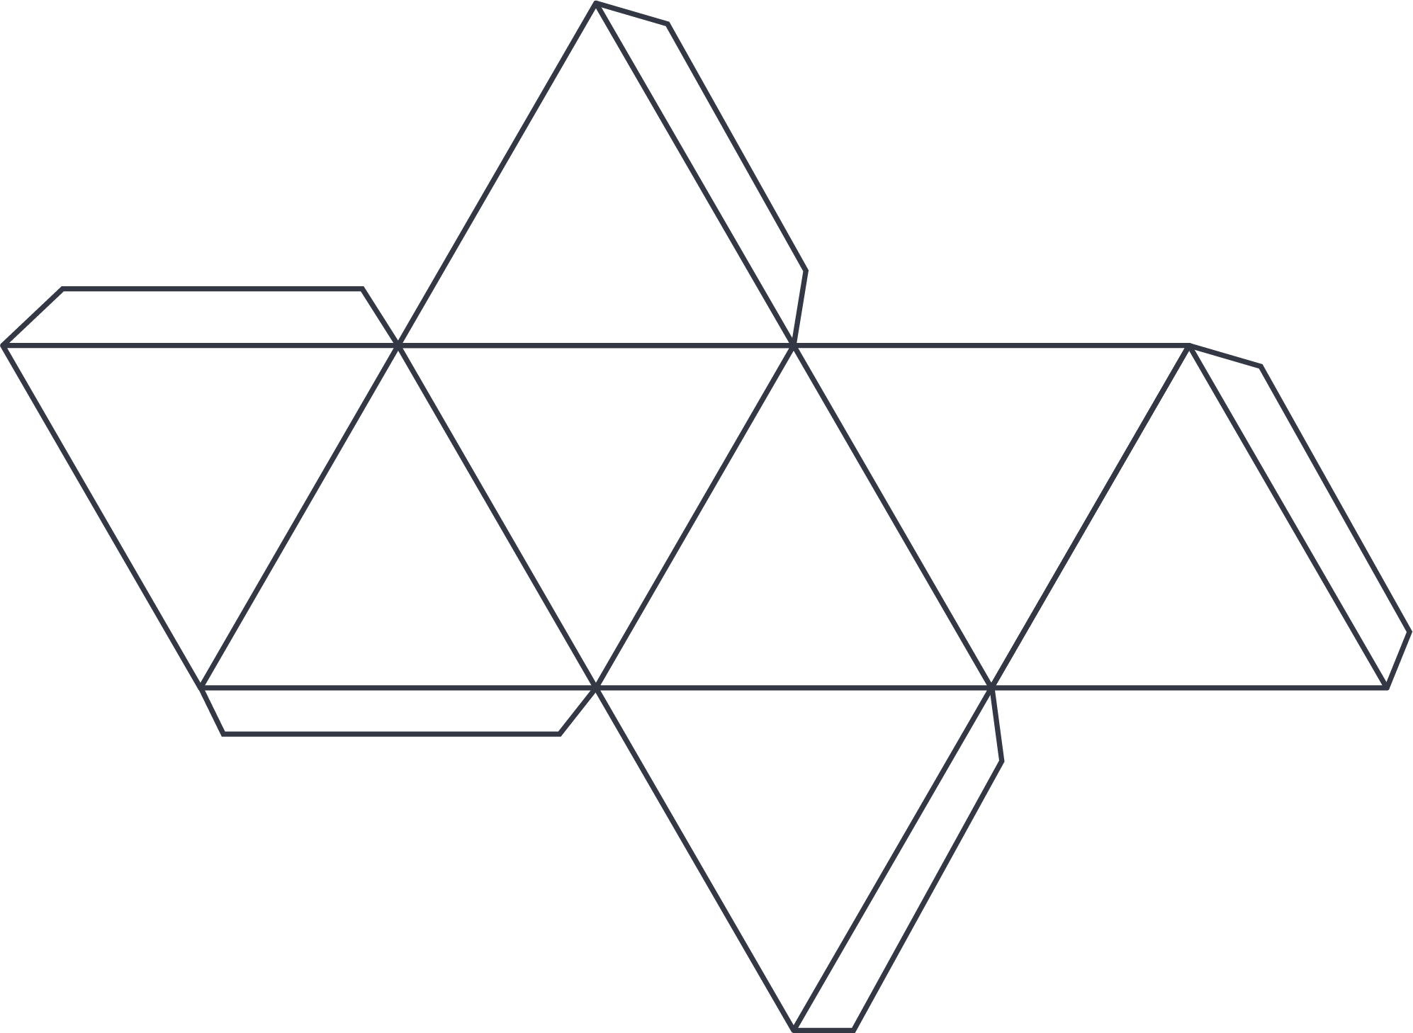
non-linear relationship
A relationship between 2 variables where the rate of change will vary.
non-standard partitioning
Partitioning of numbers into non-standard place value partitions such as 62 as 50 + 10 + 2 or 270 as 250 and 20.
non-unit fractions
A fraction of the form a/n, where n is a non-zero natural number, and a is a natural number greater than 1, such as 2/3, 3/4, 3/5.
number line
A line that gives a pictorial representation of real numbers.
number sentence
A statement of equality or inequality using numbers, operations and common symbols,
e.g. $8+5=13$ and $16 – ☐= 10$
numeral
The designation of a number in a given language, e.g. the number ‘three’ is designated by the Hindu-Arabic numeral 3, the Roman numeral III, and the Chinese numeral 三.
numerical data
Data associated with a numerical variable. It can be discrete or continuous, e.g. number of siblings in a family or heights of students in the class.
numerical variables
Variables with values that are numbers, and for which measuring and arithmetic processes such as adding and subtracting, or calculating an average, make sense.
O
object
A solid or 3-dimensional skeletal representation composed of a number of faces, edges, vertices or closed surfaces, such as a prism, pyramid, cylinder or sphere. The term 3-dimensional shape is also used.

obtuse angle
An angle that measures between 90 and 180 degrees, i.e. between one and 2 right angles.
one step transformation
A transformation that involves only one translation, reflection, rotation or dilation.
one-to-one correspondence
Each number word in the count is matched to an object as it is being counted.
operation
The process of combining numbers or expressions. Operations are arithmetic – addition, subtraction, multiplication and division – and also include exponentiation and substitution.
order of operations
A set of conventions for evaluating expressions involving several operations. Operations in brackets are first, followed by exponents, multiplication/division, then addition/subtraction left to right.
ordinal
A number that indicates the position or order of something in relation to other numbers, e.g. the first one to submit their work, or the cups are kept on the second shelf.
outlier  A data value that appears to stand out from the other members of the data set by being unusually high or low. | 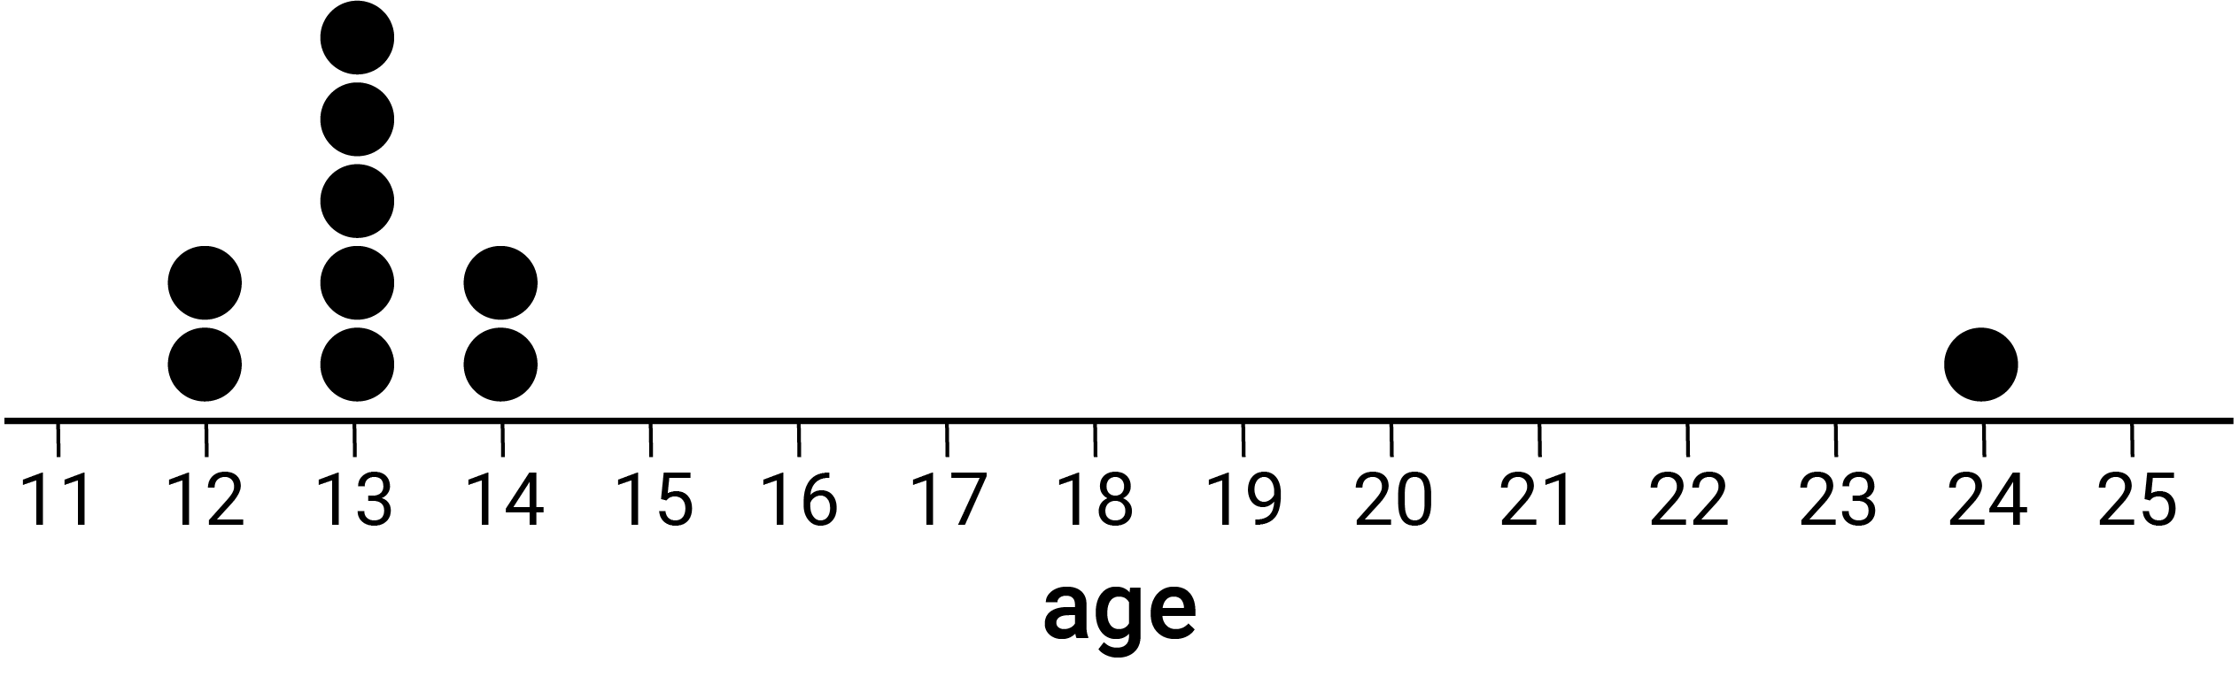
P
parallel lines  Two lines L and M in a plane that have no point of intersection in that plane, written L $||$ M. | 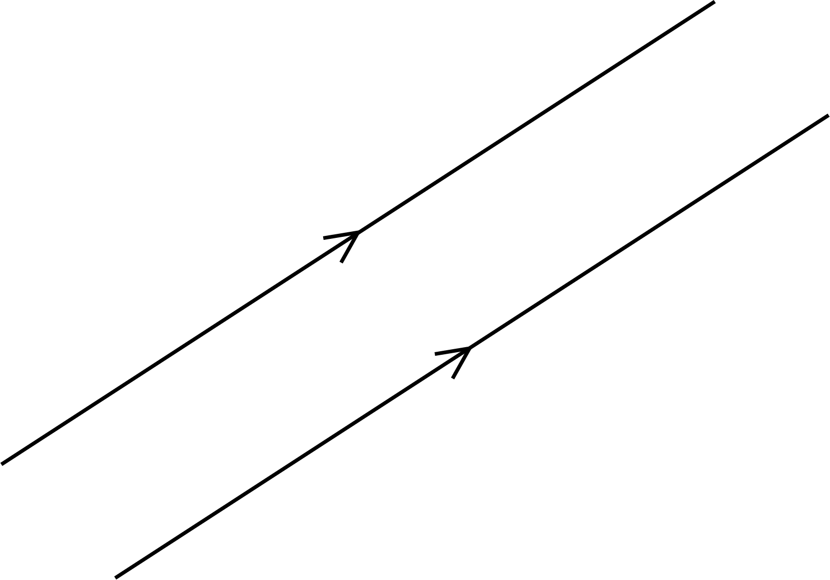
parallelogram  A quadrilateral in which opposite sides are parallel and equal in length. The quadrilateral ABCD shown is a parallelogram because BA $||$ CD and AD $||$ BC. | 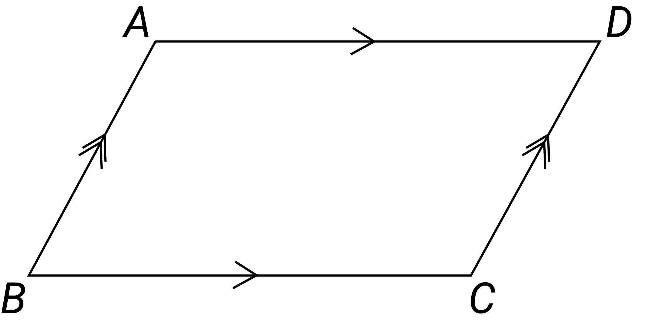
partition numbers
Separating numbers additively or multiplicatively into 2 or more parts, e.g. $10$ is $8+2$,
is $3+3+2$; $12$ divided into $6$ equal parts of $2$, $12=6×2, 12÷6=2, 12=3×4, 12÷3=4$.
partitioning
The ability to think about numbers as made up of 2 or more parts. Numbers can be partitioned into standard or non-standard place value partitions such as $248$ as $200+40+8$ or $62$ as $50+10+2.$
part-part-whole reasoning
A model used to recognise relationships between a whole number and its parts, e.g. $7=5+2$ or $7=4+3$.
percentage
A ratio to 100 or a fraction whose denominator is 100.
perimeter
The total length of the boundary of a plane figure or space.
perpendicular
Two lines, rays, line segments, vectors, planes or other objects that intersect at a 90° angle (a right angle) are considered perpendicular.
pi ($π$)
The ratio of the circumference of any circle to its diameter. It is denoted by the Greek letter $π$ (pi). Approximate values are $3.14$ or $\frac{22}{7}$.
picture graph (pictographs)  A statistical graph for organising and displaying categorical data. | 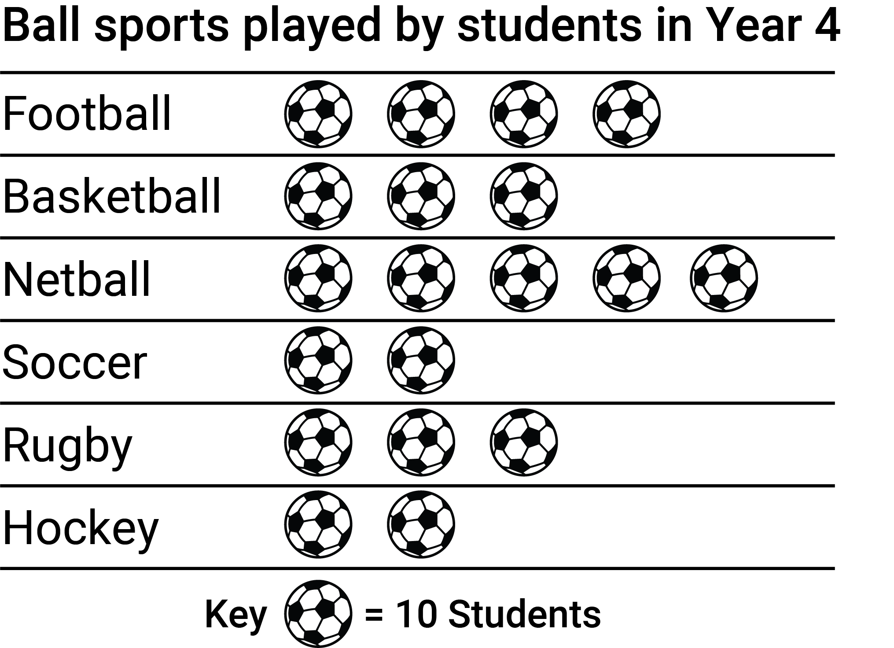
place value
The value of a digit as determined by its position in a number relative to the ones (or units) place. For integers, the ones place is occupied by the rightmost digit in the number.
point
Representation of a location in space that has zero dimensions. Lines, curves, shapes, surfaces and objects are constructed from sets of points. Points in the Cartesian plane are specified by coordinates.
population
The complete set of individuals, objects, places, etc. that we want information about. A census collects information about the whole population.
prime number
A natural number that is greater than 1 and its only factors are 1 and itself.
prism
A convex polyhedron that has 2 congruent and parallel polygonal faces; all its other faces are parallelograms. It is named according to these 2 congruent faces, e.g. a triangular prism.
probability
The chance of something happening shown on a scale from 0 and 1 (inclusive), e.g. the probability that a fair coin toss will come up ‘heads’ is 0.5.
product
The result of multiplying together 2 or more numbers or algebraic expressions.
proportion
A constant ratio between corresponding elements of 2 sets, e.g. the circumference and diameter of a circle are in proportion as their ratio is the constant $π$ (pi).
proportional relationship
The connection between 2 elements that have a constant ratio.
proportional thinking
Thinking or reasoning about multiplicative relationships or comparing ratios, e.g. how a speed of 50 km/h is the same as a speed of 25 km/30 min.
Pythagoras's theorem  The square of the length of the hypotenuse, $c$, of a right-angled triangle equals the sum of the squares of the lengths of the other 2 sides, $a$ and $b$, such that $c^{2}=a^{2}+b^{2}$. | 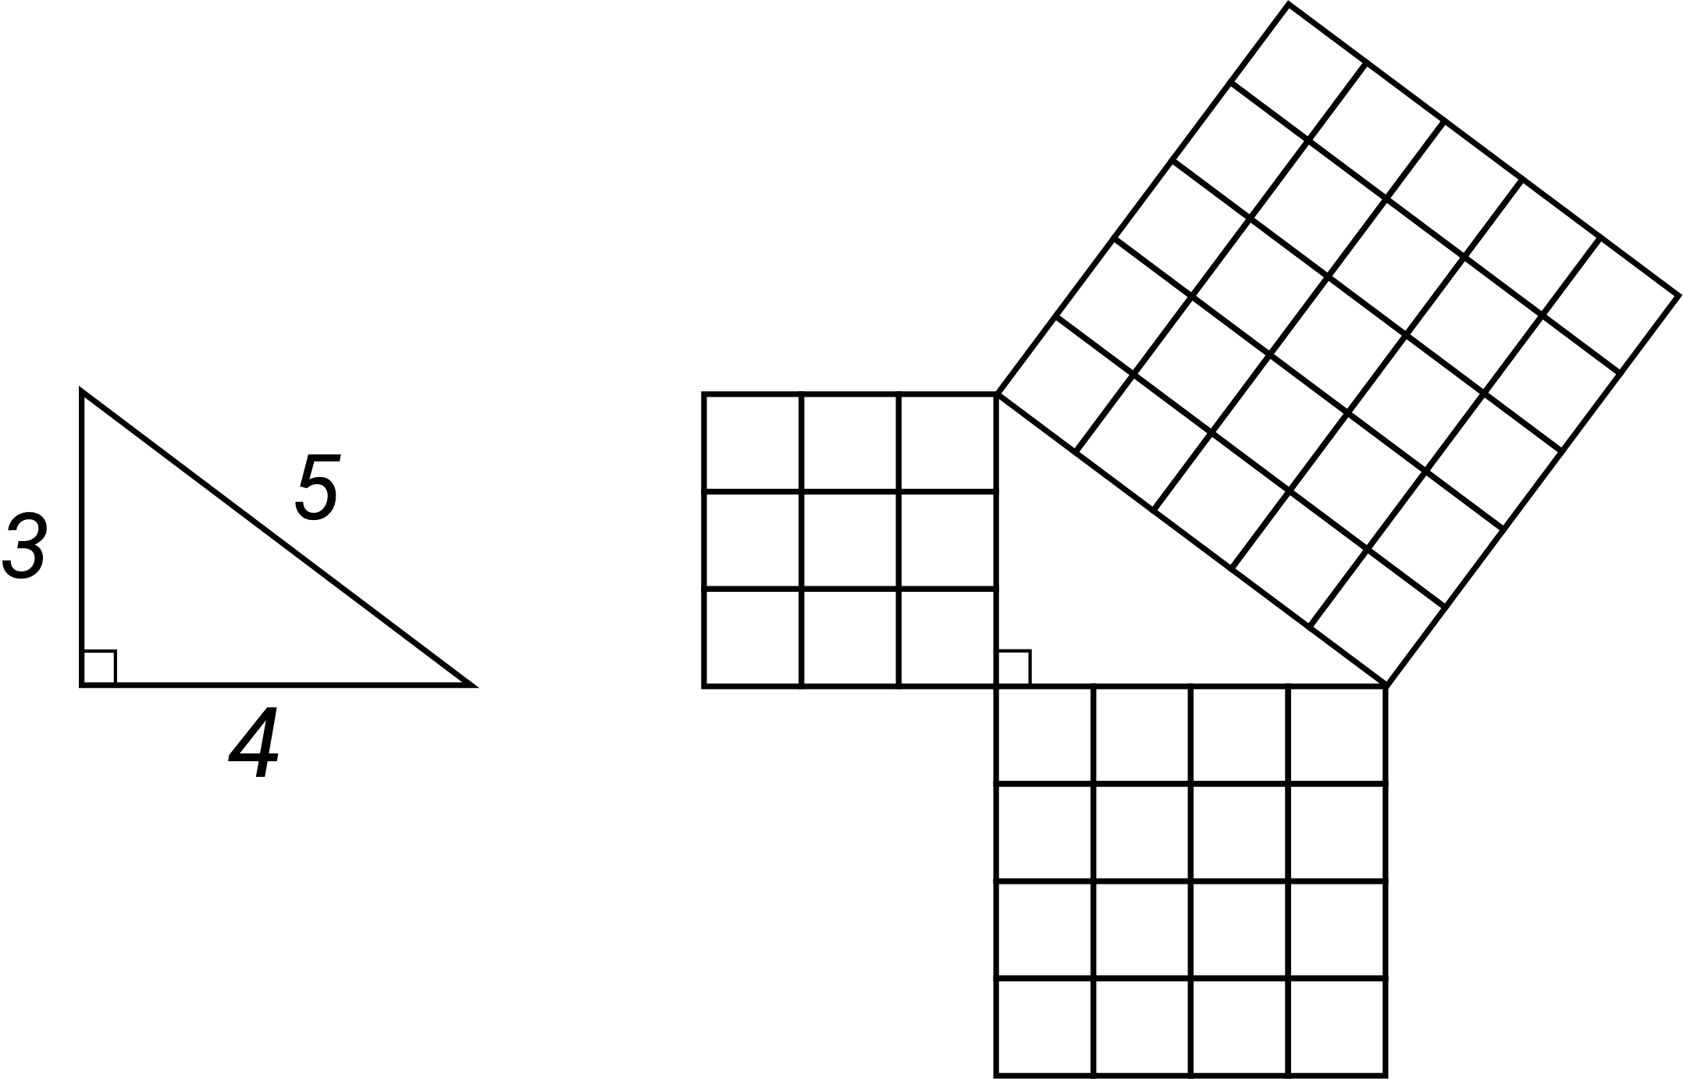
Q
quadratic expression
An expression that contains one or more of the terms in which the variable is raised to the second power, but no variable is raised to a higher power. Its general form is $ax^{2}+bx+c$, where $a≠0$.
quadratic function
A function in which the rule is a quadratic expression. When graphed in the Cartesian plane it produces a parabola and algebraically it can be represented in the form $y=ax^{2}+bx+c$ where $a≠0$.
quadrilateral
A four-sided polygon. Examples include square (a regular quadrilateral, all sides and angles equal), rectangle, kite and trapezium.
quotient
The result of dividing one number or algebraic expression by another.

R
radius
The distance from the centre to the circumference of a circle, as shown by the line segment $OA$ (interval $OA$) in the diagram.
range
The difference between the largest and smallest numerical values in a data set. It can be used as a measure of spread in a data set. It is sensitive to outliers and should be interpreted with care.
rate
A comparison of 2 quantities measured in different units, e.g. the rate of distance to time, known as speed, because distance and time are measured in different units (such as kilometres and hours).
ratio
A comparison of magnitudes of sets, quantities of the same kind or algebraic expressions. It is often used as a comparison $a∶b$ of the size of 2 (or more) quantities relative to each other.
rational number
An element of the infinite set of numbers $Q=$ {$\frac{m}{n}$, where$m$ and $n$ are integers and $n$ ≠ zero}. It may be expressed in decimal form, e.g. $\frac{1}{8}=0.125$and $\frac{4}{9}=0.444…$
reasonableness (calculation)
Checking the results of calculations or operations to see if they are reasonable in the context, e.g. the sum of 2 odd natural numbers must be an even number.
rectangle
A quadrilateral in which all angles are right angles.
reflection
A transformation where each point of a shape is mirrored to a position the same distance from an axis of symmetry
reflex angle  An angle that measures between 180 and 360 degrees, i.e. between 2 and 4 right angles. | 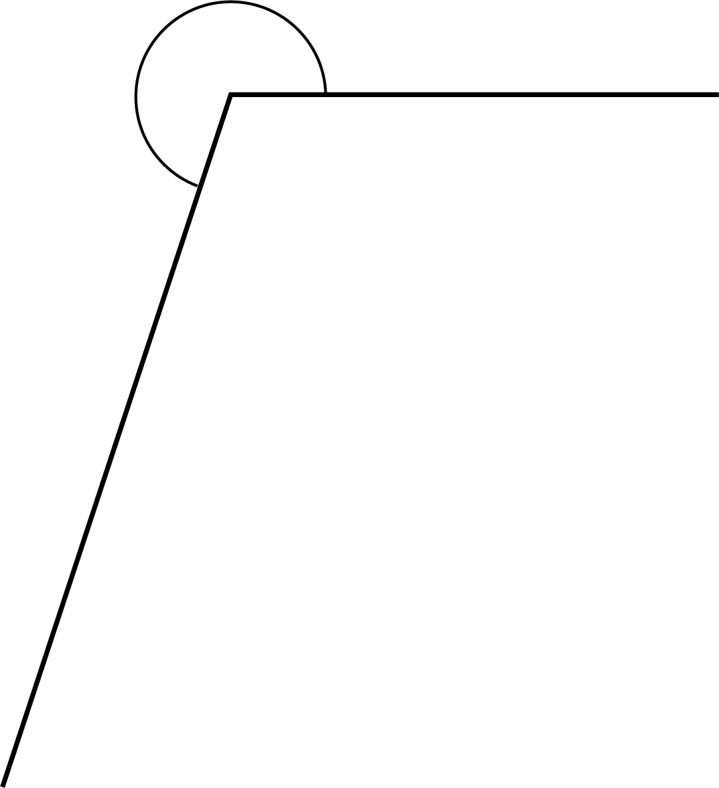
regular shape
A shape that has all sides of equal length, and all interior angles equal.
related denominators
One of the denominators is a multiple of the other denominator of a pair of fractions.
rename
To express a number according to the relationship between the place value powers of 10, e.g. 263 can be renamed 2 hundreds and 63 ones or 1 hundred, 16 tens and 3 ones.
repeated addition
Adding the same number several times, e.g. $3+3+3+3=4×3=12$. A strategy sometimes used for multiplication.
repeating pattern
A pattern where there is an identifiable repeating unit such as beads arranged in a sequence of red, green, blue, red, green, blue …; days of the week or months of the year.
revolution
A complete turn around a point.
rhombus  A quadrilateral with all sides equal. | 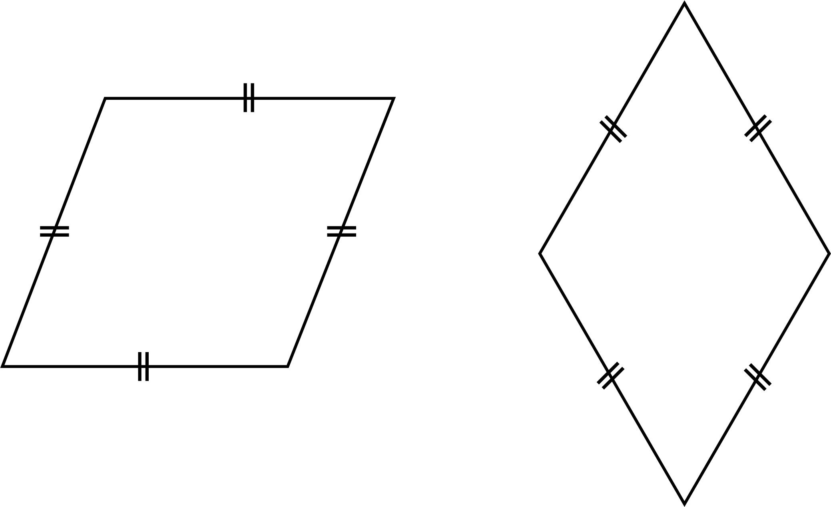
right angle
An angle formed by a quarter turn of a revolution. It is equal to 90 degrees. If 2 lines are at a right angle, they may also be referred to as being perpendicular.
rotation  A transformation where each point in the plane is rotated through a given angle about a fixed point in the plane (the point or centre of rotation). For example, the point A is rotated 120$°$ clockwise and 60$°$ anti-clockwise. | 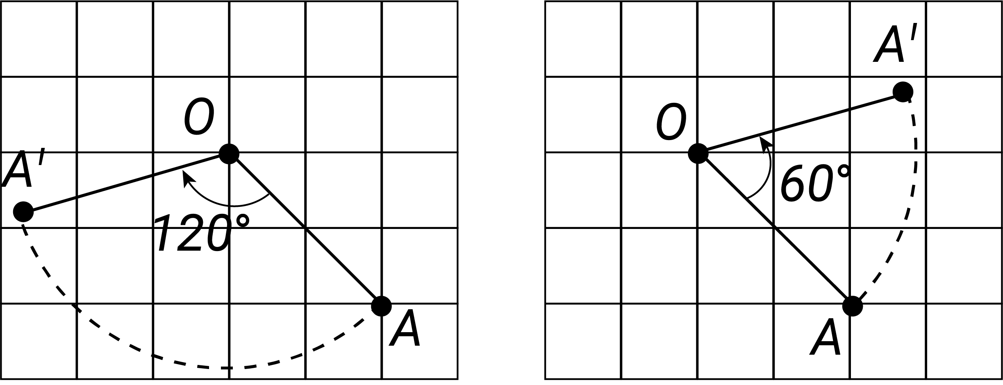
rotational symmetry  A quality of some shapes and objects to appear the same when turned around their centre for less than a full turn, e.g. a square has quarter-turn rotational symmetry. | 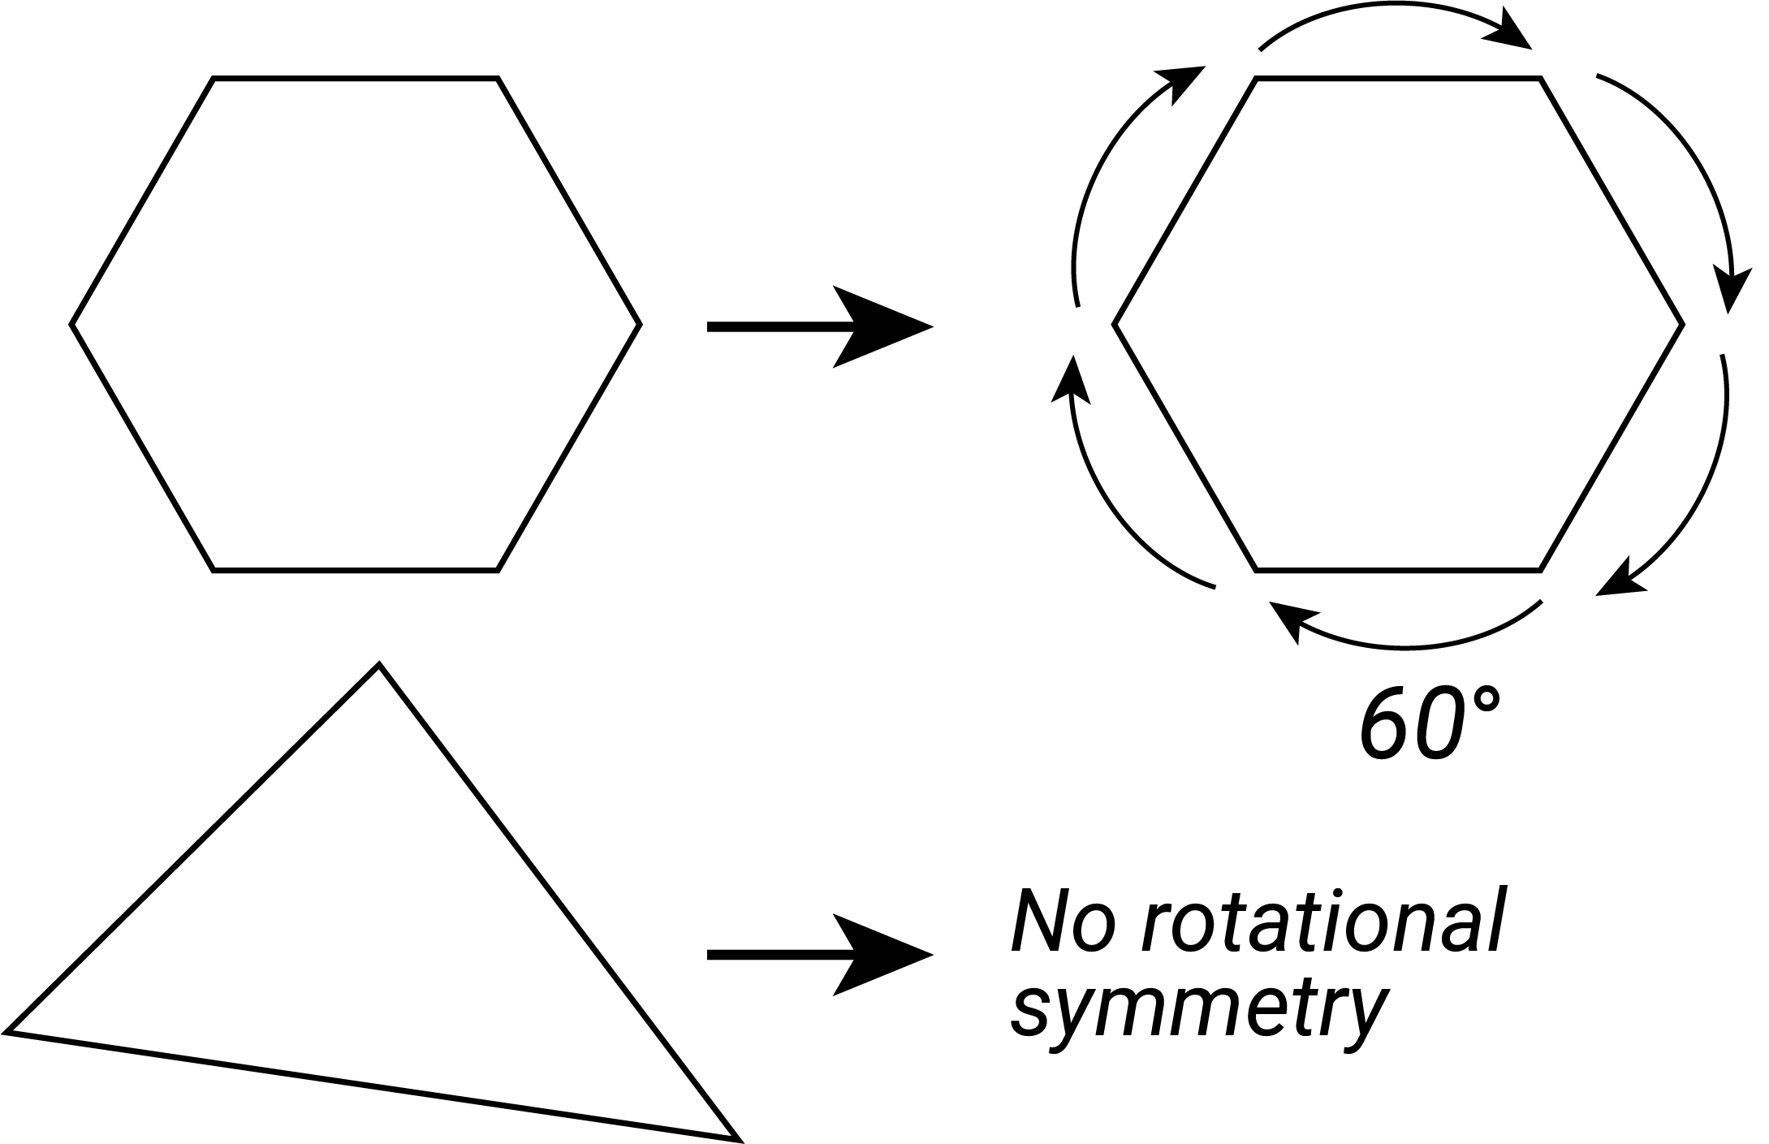
rounding
The process for approximating a value that lies between 2 known values. It is used to specify a number correct to a given accuracy, e.g. 4.027 becomes 4.03 when rounded to 2 decimal places.
rules
Descriptions in words or symbols for the nth term of a sequence of numbers.
S
sample
A subset of a population used to estimate characteristics of the population, e.g. a randomly selected group of 8 year olds (sample) selected to estimate the height of 8 year olds in Australia (population).
sampling
A process by which a subset of a population is selected for the purposes of data analysis. This subset is called a sample.
sampling-based investigation
A statistical investigation which involves collecting and analysing data from a sample of a population in response to a question about the population.
scientific notation
A way of writing numbers that are too big or too small to be written in an accessible way. It uses powers of 10, e.g. the scientific notation for 34 590 is $3.459 × {10}^{4}$.
set
A collection of objects or elements, usually specified by listing its elements, e.g. $\{1, 2, 3, 4\}$; by describing it in words, e.g. ‘the set of primes’; or by using a rule such as $\{( x, y ): y= 2x+1, x∈N \}$.
shape (Space)
A geometric figure in 2-dimensional space, such as a freehand closed curve, a triangle or square. It can be regular or irregular, simple or complex.
shape (Statistics)
The form of the visual representation of the distribution of numerical data, which may be symmetrical, skewed or multimodal.
similar triangles
Two triangles are called similar if an enlargement of one triangle is proportional to the other. Similar triangles thus have the same shape, but not necessarily the same size.
simple interest
Interest accumulated when the interest payment in each period is a fixed proportion of the principal, e.g. the total accumulated interest for principle $P at the rate of i% after n periods is calculated as $Pni/100.
side-by-side column graph  A type of column graph that can be used to organise and display the data that arises when a group of individuals or things are categorised according to 2 or more criteria. | 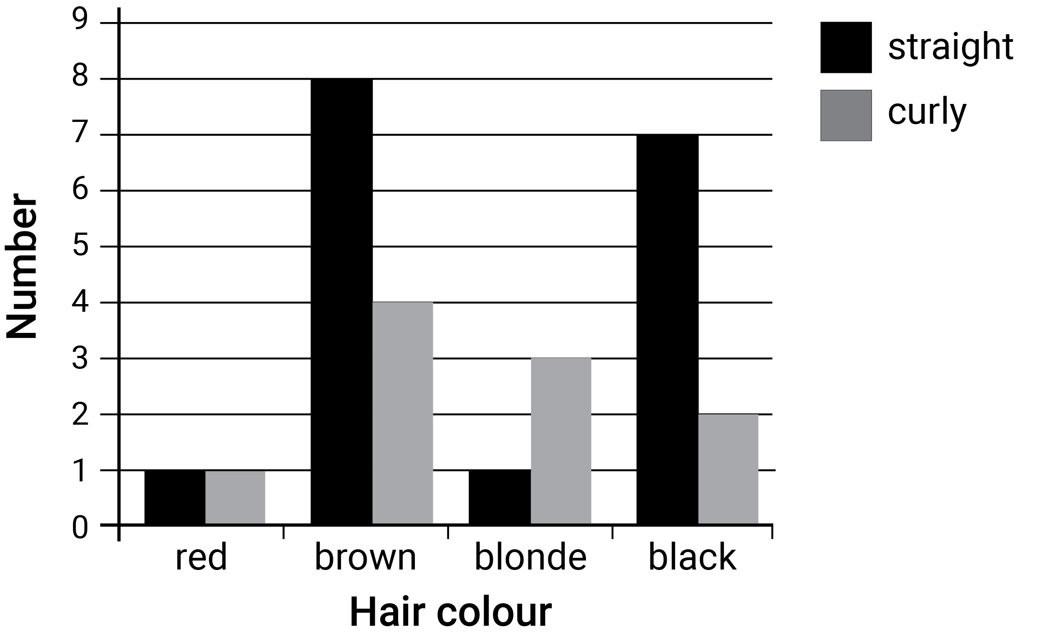
skip counting
Counting from a given starting value using multiples of a fixed natural number, e.g. {2, 4, 6, ...} or {7, 12, 17...}.
spread
A statistic that indicates how widely the values of a data set are distributed. Common measures of spread include range, interquartile range, quantiles and percentiles.
standard number sentences
Number sentences that are derived from semantic number sentences, i.e. how you think about a situation, e.g. 146 cm + ? = 160 cm, becomes ? = 160 – 146.
standard partitioning
Partitioning of numbers into standard place value partitions such as 248 as 200 + 40 + 8.
statistical investigation
An investigation in response to the posing of a question or identification of a problem that needs data collection, analysis and interpretation to form a conclusion or make a decision.
square root
A value that when multiplied by itself gives the original number. The positive square root of a given real number $x$ is the positive real number $y$such that $y^{2}=x$.
straight angle  The angle formed by 2 opposite rays on a straight line from a common point. A straight angle is also formed by a half turn of ray about its endpoint. It measures 180 degrees. | 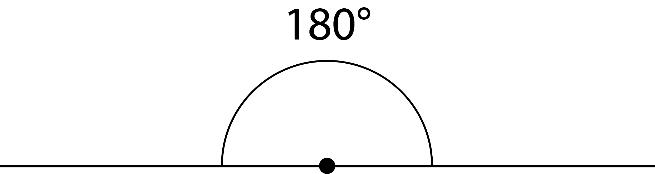
subitising
The capacity to visually recognise the size of a small set of objects without counting.
supplementary angles
Two adjacent angles that form a straight angle and their sum is 180 degrees (a straight angle).
surface area
The measure of the total area of the surface(s) of a 3-dimensional shape or object.
survey
A tool for collecting data that comprises a series of questions, which can be constructed to collect quantitative or qualitative data, numerical or categorical responses.
T
table of values
A table which summarises the values of a rule or relationship.
tessellation  A repeated pattern in the plane or on a surface where shapes completely fill all of the space around a given point where their boundaries meet, e.g. a honeycomb is a tessellation using hexagons. | 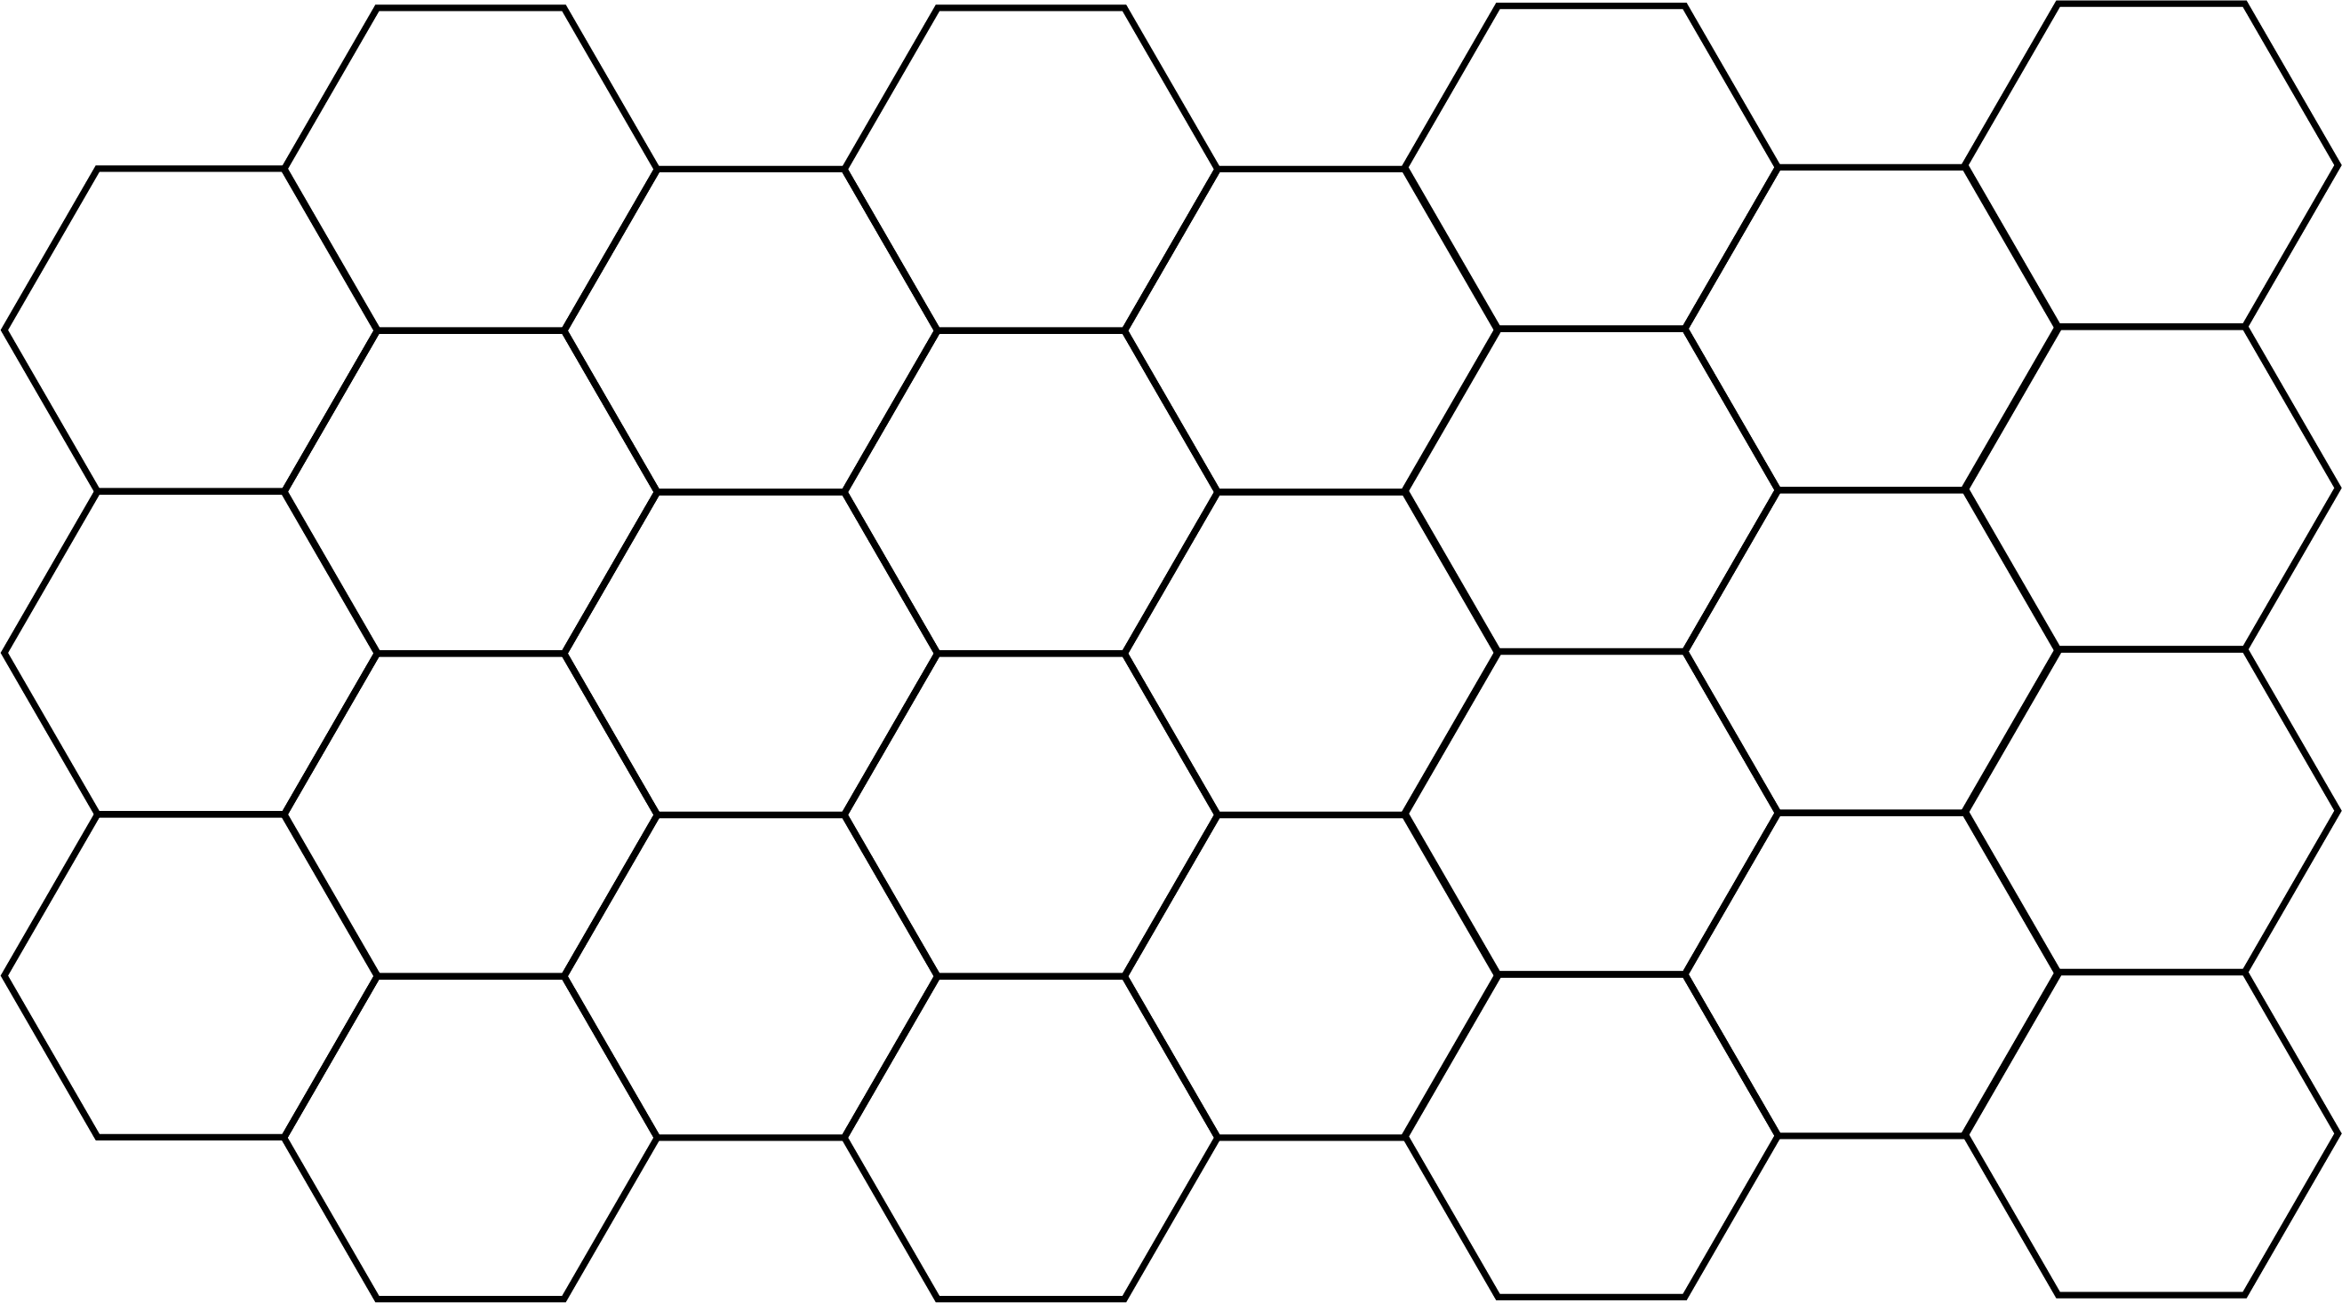
theoretical probability
The chance of events happening under ideal circumstances, expressed as a ratio of the number of desired outcomes to the number of possible outcomes e.g. a 1/6 chance of rolling a 4 on a dice.
three-dimensional
An object that has 3 independent dimensions of length, width (breadth) and depth, or a space in which position is specified by 3 independent coordinates.
times by ten relationship
Each successive digit to the right of a number indicates a multiple of 10, e.g. in the number 2594 the 9 denotes 9 x 10 and the 5 denotes 50 x 10, and 326 = 10 × 32.6 or 326 = 100 × 3.26.
time zones
The 24 divisions of the globe, where each change of 15 degrees longitude corresponds to one hour. As time zones often align with national or regional boundaries this is an approximate relationship.
transformation
A map of the plane onto itself. Transformations include dilation (enlargements or compressions), reflections, rotations and translations.
translation
Shifting a figure in the plane without turning it. Translations can be specified as a combination of a horizontal shift and a vertical shift.
trapezium  A quadrilateral with one pair of opposite sides parallel. | 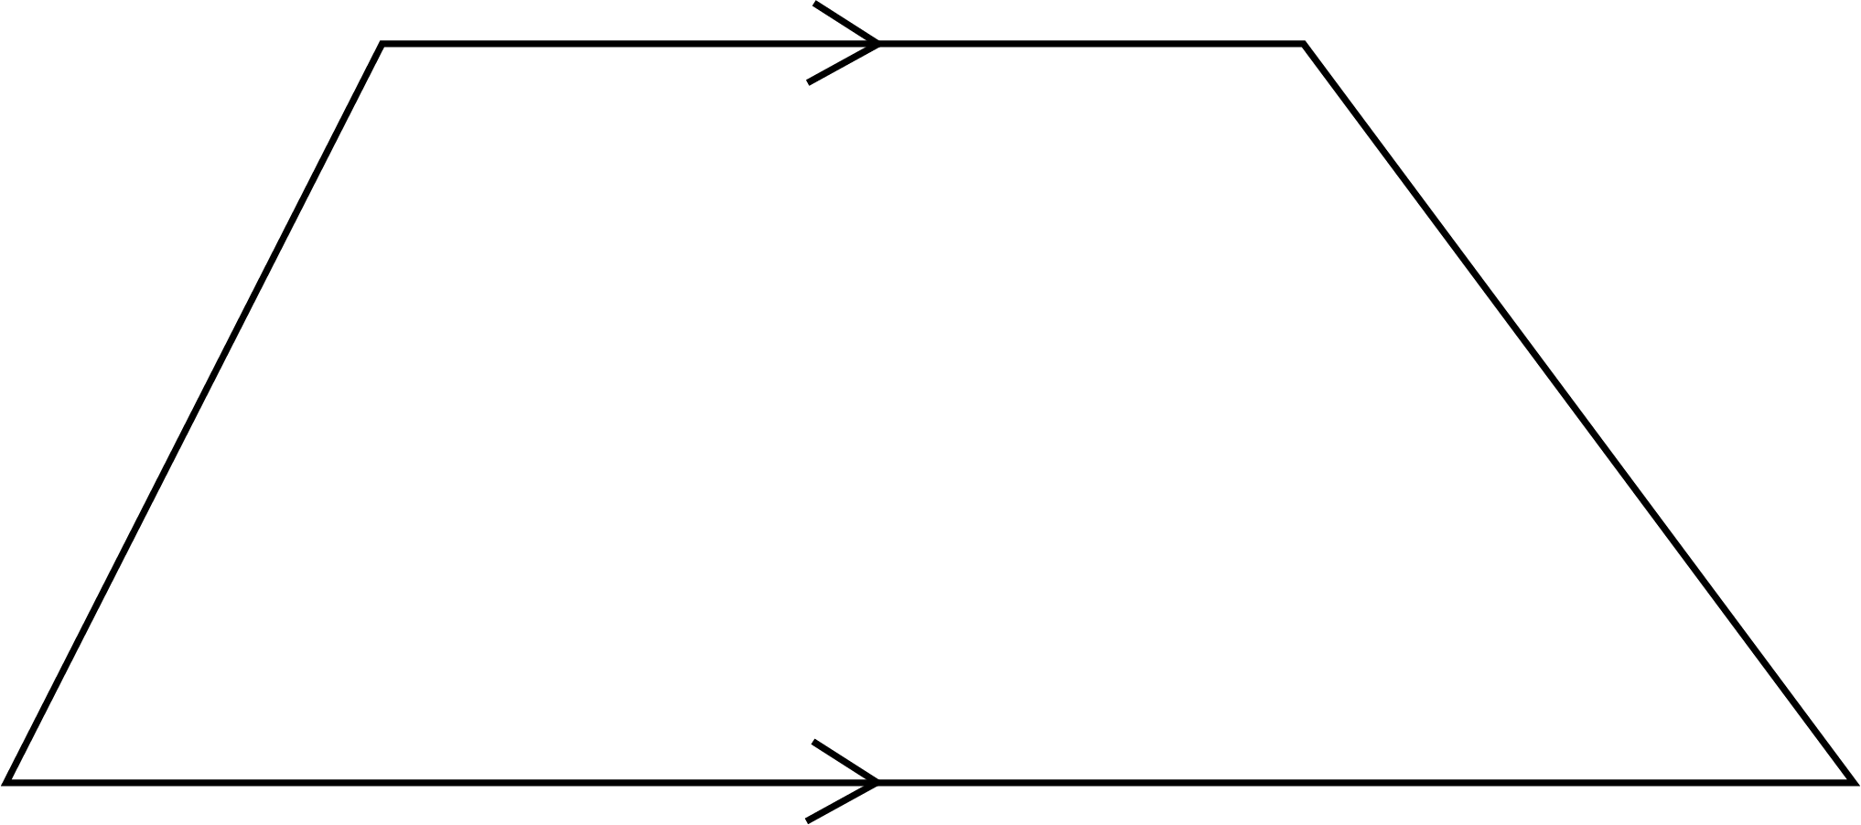
tree diagram  A diagram consisting of line segments (edges) connected to points (vertices) like the branches of a tree. It shows the relationship between sets, events, or the set of outcomes of a multi-step random experiment. | 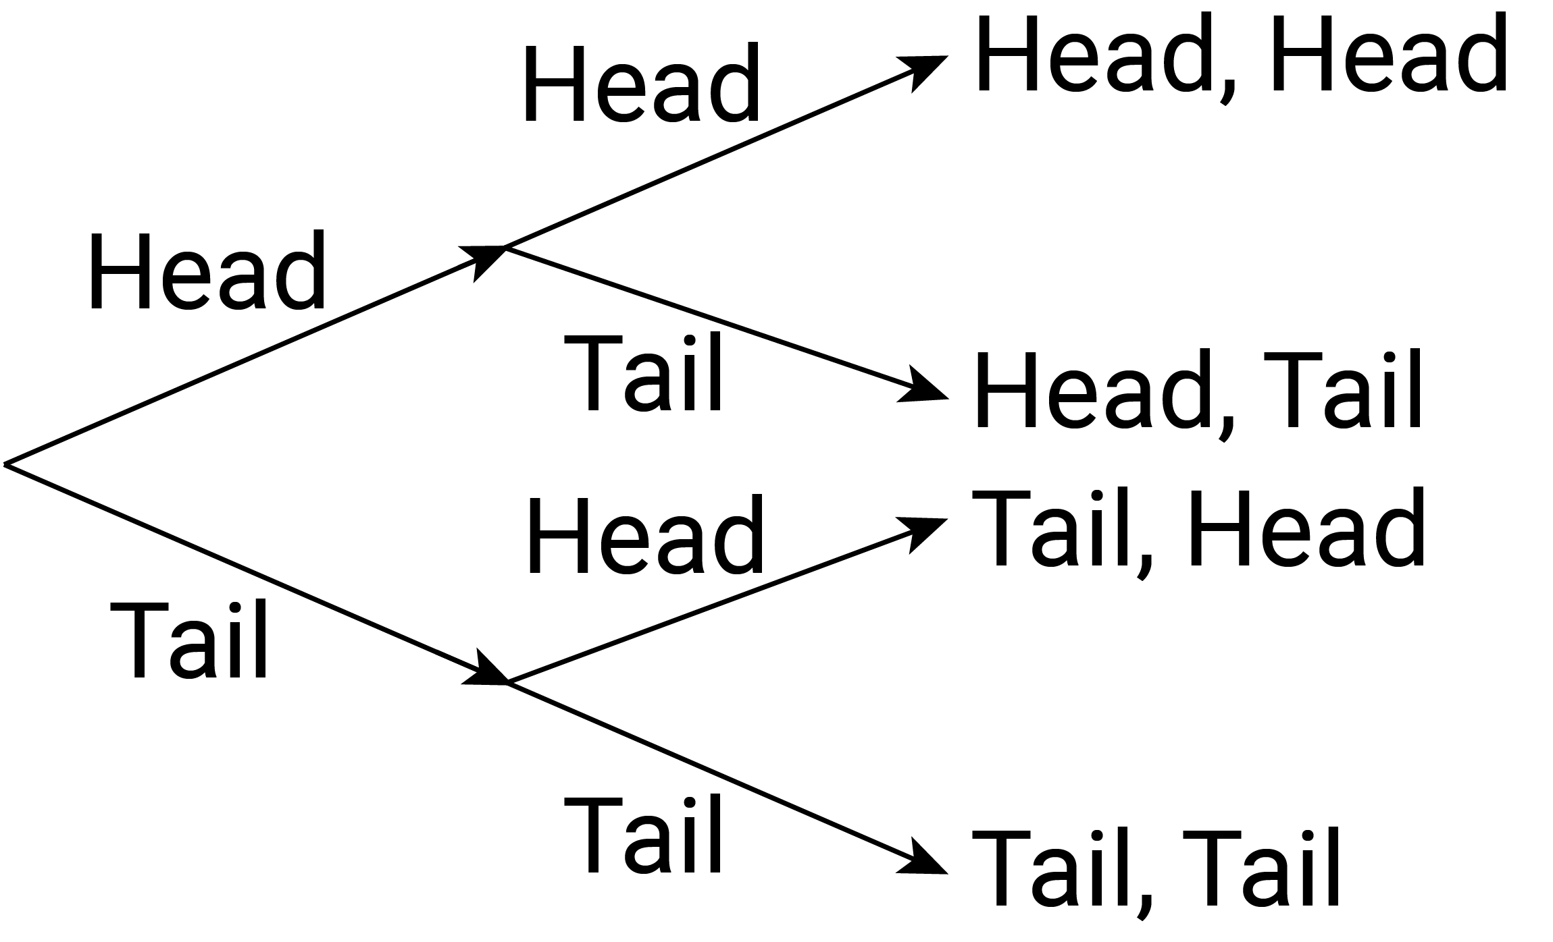
trials
Any repeatable procedures with a well-defined set of possible outcomes, known as the sample space, e.g. for the flipping of a coin the sample space would be {H, T}.
trigonometry
The study of relations between angles and sides in triangles.
trigonometric ratios
Relationships between the angles and sides of right triangles. The 3 basic trigonometric ratios in this curriculum are: sine ($sin$), cosine ($cos$) and tangent ($tan$).
turn
A rotation from an initial starting position. A turn can be a fraction of a circle (quarter turn) or complete rotation (revolution). It can be directional (clockwise/anti-clockwise).
two-dimensional
A shape that has 2 independent dimensions of length and width (breadth) is 2 dimensional, as is a space in which position is specified by 2 independent coordinates, such as the plane.
two-way tables  A common way of displaying the two-way frequency distribution that arises when a group is categorised according to 2 criteria. | 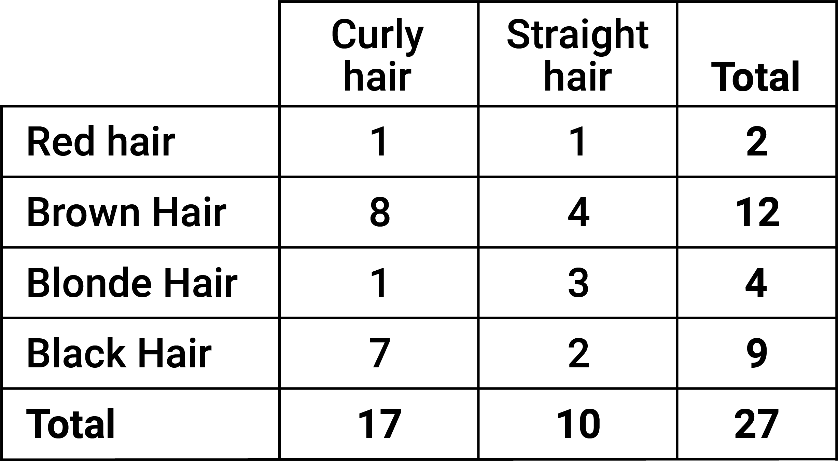
typical values
In statistics, a measure of central tendency is a central or typical value for a data distribution. The most common measures of central tendency are the arithmetic mean, the median and the mode.
U
unit fraction
A fraction of the form $\frac{1}{n}$, where $n$ is a non-zero natural number, such as $\frac{1}{2}, \frac{1}{3} , \frac{1}{4}$...
units
The basis for counting or measurement or both, e.g. the number 1 is the unit for counting; the metre is the standard unit for measurement of length in the metric system.
V
variable
Things that are measurable or observable that are expected to either change over time or between individual observations. They are often designated by symbols, such as $n$, $x$ and $y$, to represent members of a set.
variation in data
The characteristic that elements of a data set differ, e.g. the maximum temperature recorded at different suburbs of a town on a given day.
Venn diagrams  Graphical representations, using several typically overlapping circles, showing elements of sets in relation to properties or attributes. They are drawn for some specified universal set. | 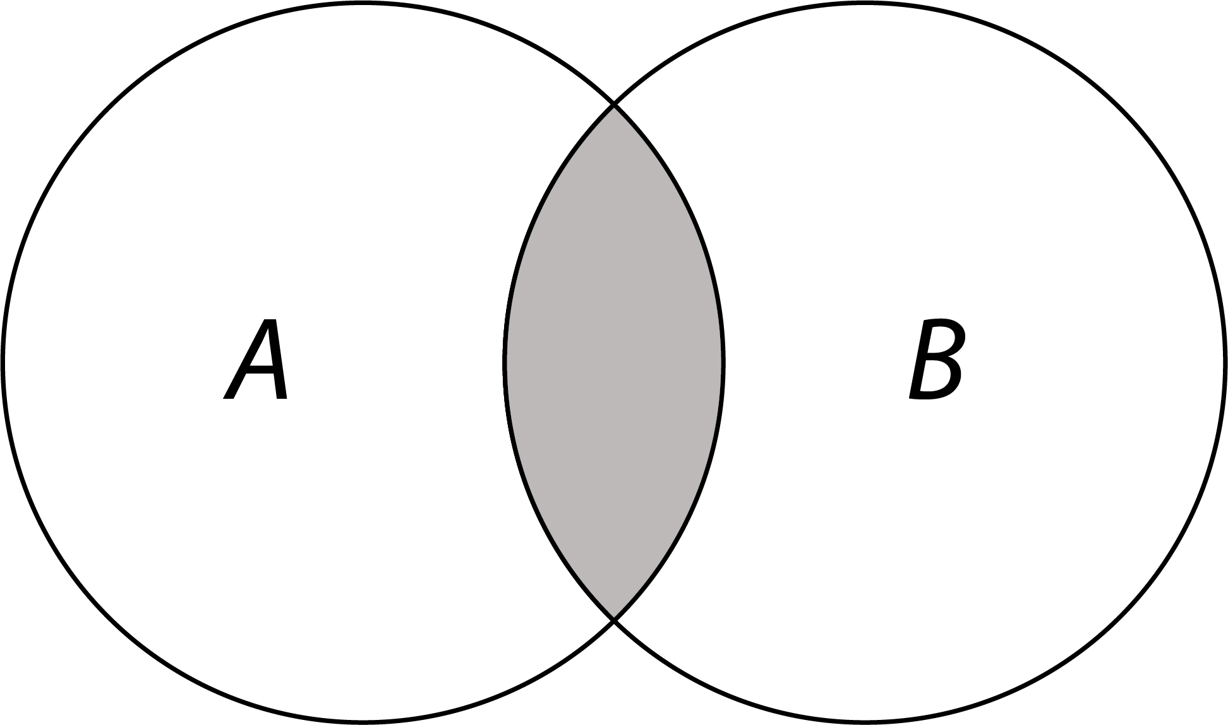
vertically opposite angles  Two pairs of vertically opposite angles formed at the point of intersection of 2 lines in the plane. Vertically opposite angles are equal. | 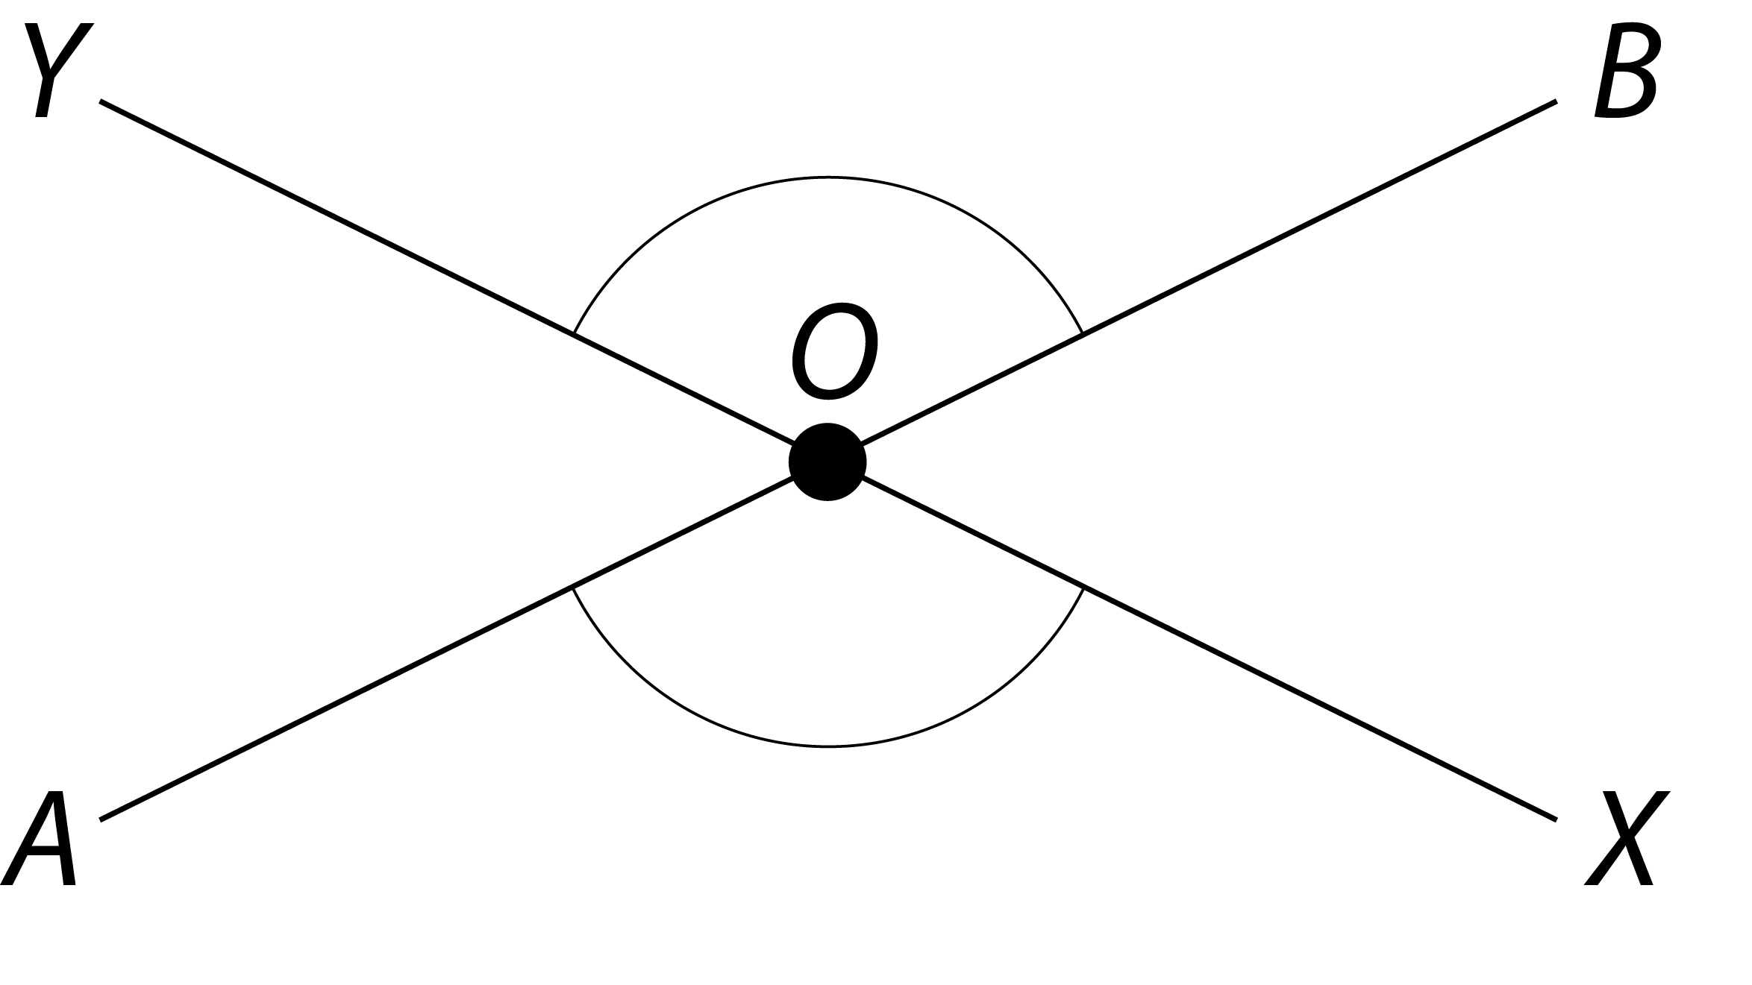
virtual materials
Dynamic digital representations of physical materials (sometimes called virtual manipulatives).
visualisations
Visual formats for organising, representing and summarising data. Also called data displays.
volume
The amount of space bounded by the surface of an object. It is usually measured in cubic units.
W
with and without replacement
A sampling unit which is drawn from a finite population and is returned before the next unit is drawn is said to be 'with replacement'. Otherwise it is 'without replacement'.
X
Y
Z
zero
The number represented by the numeral or the symbol 0, e.g. the origin on a number line. It also functions as an empty place-holder digit in the decimal expansion of numbers, e.g. 205.

