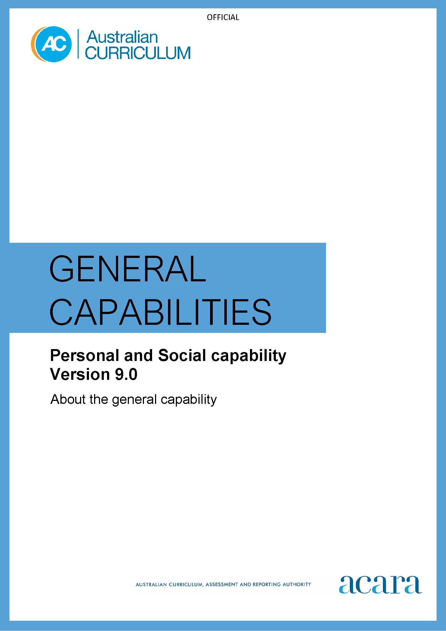

Copyright and Terms of Use Statement
© Australian Curriculum, Assessment and Reporting Authority 2022
The material published in this work is subject to copyright pursuant to the Copyright Act 1968 (Cth) and is owned by the Australian Curriculum, Assessment and Reporting Authority (ACARA) (except to the extent that copyright is held by another party, as indicated).
The viewing, downloading, displaying, printing, reproducing (such as by making photocopies) and distributing of these materials is permitted only to the extent permitted by, and is subject to the conditions imposed by, the terms and conditions of using the ACARA website (see, especially, clauses 2, 3 and 4 of those terms and conditions). The terms and conditions can be viewed at https://www.acara.edu.au/contact-us/copyright

F–10 AUSTRALIAN CURRICULUM: general capabilities – personal and social capability

Introduction
The Personal and Social capability provides a foundation for students to understand themselves and others, and navigate their relationships, lives, work and learning. Students with well-developed social and emotional skills find it easier to manage themselves, relate to others, collaborate, develop empathy, set goals and resolve conflict. They feel positive about themselves and the world around them.

The Personal and Social capability supports students to build their ability to regulate their thoughts, emotions and behaviours. This ability assists students to effectively engage with new ways of thinking, knowing and doing in an increasingly demanding and diverse global society.

The Personal and Social capability learning continuum Level 1a supports students with disability to access age-equivalent content and participate in learning on the same basis as their peers.

Structure
The Personal and Social capability learning continuum is organised into 4 elements, as shown in Figure 1:
- Self-awareness
- Self-management
- Social awareness
- Social management.

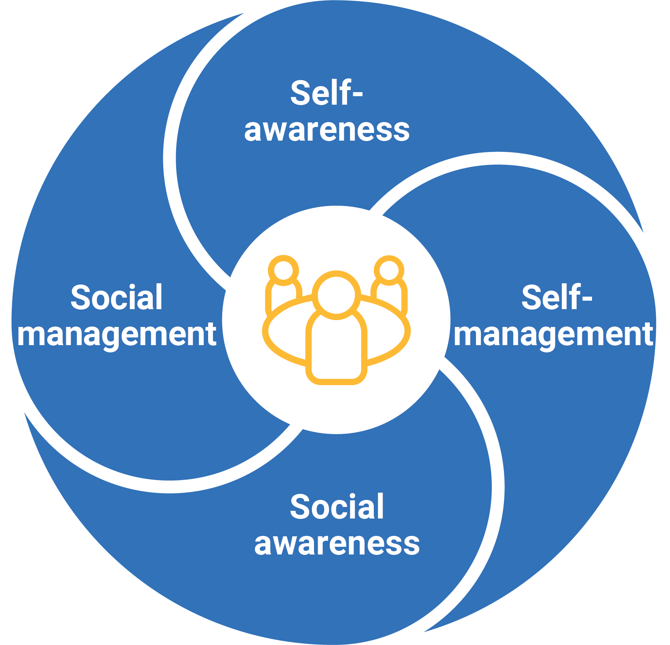
Figure 1: Personal and Social capability elements

Self-awareness
This element is organised into 3 sub-elements:
- Personal awareness – students develop an appreciation of their personal qualities and areas for growth. Through acknowledgment and assessment of their thoughts, feelings, actions and abilities, students can plan for growth across a range of contexts.
- Emotional awareness – students explore the factors that influence emotions in themselves and in others, and how emotional responses affect behaviour in a range of contexts.
- Reflective practice – students reflect cyclically on feedback and self-assessment to evaluate their learning and the factors, personal or otherwise, that influence this learning.
Self-management
This element is organised into 3 sub-elements:
- Goal setting – students develop the organisational and planning behaviours needed to set, adapt and achieve goals.
- Emotional regulation – students constructively express, manage, monitor and evaluate their emotional responses in a range of contexts.
- Perseverance and adaptability – students persist in the face of setbacks and frustrations. They learn to review and modify their approaches when faced with challenges and to build strategies to complete tasks and overcome obstacles.
Social awareness
This element is organised into 3 sub-elements:
- Empathy – students recognise the emotions, abilities, needs and concerns of others. They develop their understanding about how respecting the perspectives, emotional states and needs of others is essential to social interactions.
- Relational awareness – students recognise the value of their relationships and examine what makes their relationships work. They learn to participate in positive, safe and respectful relationships, defining and accepting individual and group roles and responsibilities.
- Community awareness – students gain an understanding of the role of advocacy in contemporary society. They learn to build their capacity to take responsibility for their social, physical and natural environments.
Social management
This element is organised into 5 sub-elements:
- Communication – students learn to negotiate and communicate effectively with others through verbal and non-verbal means in a range of contexts.
- Collaboration – students cooperate in groups and constructively contribute to ways of working and outputs. They develop the ability to initiate and manage successful personal relationships through participation in a range of group activities.
- Leadership – students explore the ways that they can lead themselves and others. Students build their leadership capacity by examining a range of approaches and learn to select appropriate strategies in different situations.
- Decision-making – students choose from possibilities to solve problems. They develop their understanding around factors that influence decisions and learn to evaluate the outcomes of decisions.
- Conflict resolution – students develop and apply strategies to prevent, defuse and resolve conflict to reach constructive outcomes.
Version 9.0 of the Personal and Social capability learning continuum is set out in Table 1.

Table 1: Personal and Social capability learning continuum version 9.0
Sub-element | Level 1a | Level 1b (Foundation) | Level 2  (Years 1–2) | Level 3  (Years 3–4) | Level 4  (Years 5–6) | Level 5  (Years 7–8) | Level 6  (Years 9–10)
SELF-AWARENESS
Personal awareness | identify their likes, dislikes, strengths, abilities and interests when showing a personal preference | identify their likes, dislikes, strengths, abilities and interests, and describe how these influence choices | describe personal qualities and how these contribute to growth | explain influences on personal qualities and how these contribute to personal growth | analyse the influence that choices have on developing personal qualities and identify areas for growth | evaluate strategies for developing personal qualities and describe how they assist achieving growth | devise personally appropriate strategies to achieve growth
Emotional awareness | identify a range of emotions across different situations | identify their own emotional responses | describe the emotional responses of themselves and others | explain the influence that their own behaviour has on the emotional responses of others | analyse the influence of different factors and situations on their emotional responses | evaluate how emotional responses influence behaviour and consider the consequences of these responses | reflect on their emotional responses to different situations
Reflective practice | identify how their choices can impact their participation in or completion of a task | identify how their choices affect the development of personal abilities and achievements | describe what they have discovered about themselves by engaging with feedback | build on personal abilities and achievements using feedback and self-assessment | analyse personal abilities and achievements by seeking feedback | plan a personal response to a range of contexts using feedback from previous experiences | evaluate goals set for their own personal, social and cognitive development, reflecting on feedback

SELF-MANAGEMENT
Goal setting | learn a range of strategies to participate in class activities | co-create goals to assist learning when working independently or collaboratively | collaboratively develop goals to improve learning | plan for learning by setting improvement goals | select and use strategies to monitor own learning and refine goals to plan for further improvement | use and refine strategies that contribute to regulating behaviour and achieving learning goals | adapt goals and plans, and apply strategies, evaluating their suitability and effectiveness
Emotional regulation | recognise how emotions influence the way we feel and act | express emotions in familiar settings, demonstrating consideration for others | describe ways to moderate emotions in familiar contexts | manage and moderate emotions in familiar contexts, using provided strategies | manage personal factors influencing emotions in a range of contexts including learning | manage emotional responses, designing strategies to self-manage in a range of contexts | regulate emotions in a range of contexts, evaluating and refining their own self-management strategies
Perseverance and adaptability | persevere when attempting to complete tasks | demonstrate perseverance with familiar tasks when first attempts are unsuccessful, and adapt attempts as needed | demonstrate perseverance and adaptability with unfamiliar tasks | demonstrate perseverance when faced with challenges, adapting approaches based on successes, and learning from setbacks and failure | adapt approaches to tasks to support perseverance when faced with challenging or unfamiliar tasks | select, apply and refine strategies to persevere when faced with unexpected or challenging contexts | devise, evaluate and adapt strategies to engage with unexpected or challenging situations

SOCIAL AWARENESS
Empathy | acknowledge that people have different needs, emotions and abilities | demonstrate an awareness of the needs, emotions, cultures and backgrounds of others | describe similarities and differences between the needs, emotions, cultures and backgrounds of themselves and others | discuss the value of different needs, emotions, cultures and backgrounds | explain how the ability to appreciate others’ needs, emotions, cultures and backgrounds assists in the development of social awareness | acknowledge the emotions, needs, cultures and backgrounds of different groups and compare with their own | evaluate the effect of people’s actions towards others’ needs, emotions, cultures and backgrounds, acknowledging the influence empathy has on developing social awareness
Relational awareness | demonstrate an awareness of how shared interests and behaviours help build relationships | share feelings, needs and interests with others through play and working within diverse groups | describe ways they can initiate and develop relationships, including identifying how others may feel in a range of contexts | identify how they can contribute to healthy relationships and manage challenging relationships | identify and describe a variety of relationships, and the roles and responsibilities of people within them | analyse indicators of healthy and challenging relationships, and how to manage the differences | evaluate how relationships can differ among groups of people and reflect on the skills needed to manage diverse types of relationships
Community awareness | identify different groups within their community | describe the ways they are connected, and can contribute, to their community groups | describe how they contribute to their communities and how others care for and assist them | describe the various communities beyond their own and what they can do to support them | explain the way their actions and the actions of others influence communities | analyse roles and responsibilities of citizens within communities | evaluate ways of contributing to communities at local, regional, national and global levels

SOCIAL MANAGEMENT
Communication | communicate intentionally (verbally and non-verbally) with a range of people in familiar and unfamiliar contexts | develop positive communication skills by initiating, joining or contributing to conversations | use a range of skills to enhance verbal and non-verbal communication | apply verbal and non-verbal communication skills when responding to others | apply skills to address factors that influence verbal and non-verbal communication | demonstrate communication skills in a range of contexts, responding to the enablers of, and barriers to, effective verbal and non-verbal communication | devise strategies that apply effective verbal and non-verbal communication in response to feedback
Collaboration | engage with peers and other community members | engage with others and participate in group play, tasks and activities | participate cooperatively in groups on common tasks and activities | perform designated roles within groups, appreciating everyone’s contributions to a shared outcome | coordinate contributions of group members, suggesting improvements to ways of working and collaborative outputs | appreciate diverse perspectives in a range of collaborative contexts, demonstrating negotiation skills to improve ways of working and outputs | devise strategies for collaborative work and outputs in a range of contexts, building on the perspectives, experiences and capabilities of group members
Leadership | show an awareness of personal responsibility | practise self-leadership by taking responsibility for their own actions | practise ways that they can lead self and others, and describe when it is appropriate to adopt a leadership approach | guide and make leadership decisions with a view to how these influence others | select and use different leadership approaches when acting as a sole leader or leading with others | devise a plan for leading action and evaluate the appropriateness of various leadership approaches in the process | propose, implement and evaluate strategies to address needs at local, regional, national or global levels
Decision-making | make choices that address their needs and wants | identify choices that meet the needs of themselves and others when making decisions | practise individual and group decision-making | describe factors that influence decision-making and predict outcomes of individual and group decisions | explain factors that influence individual and group decision-making and consider the usefulness of these factors when making decisions | devise and analyse individual and group decision-making processes | develop and apply criteria to evaluate the outcomes of individual and group decisions
Conflict resolution | demonstrate understanding that others have feelings when conflict occurs | listen to conflicting perspectives and apply strategies to calm situations | practise solving simple interpersonal problems, acknowledging there are many ways to prevent and solve conflict | apply a range of conflict resolution strategies to negotiate positive outcomes in a range of contexts | practise different strategies to prevent, defuse or resolve conflict, assessing the causes and effects of conflict | select and apply conflict prevention and resolution strategies in a range of contexts, based on an evaluation of suitability and effectiveness | generate, apply and evaluate strategies to prevent and/or resolve interpersonal and intergroup conflicts

