I once created and taught a university course called "How to Lie With Statistics". I devoted one of the chapters to what is called "Cherry Picking". This is a tactic that people use to "prove" their point. "Cherry Picking" goes like this: First find something that seems to be true, something that everyone agrees with. Then quickly extrapolate in a non logical way, with no evidence to end up with what you wanted to prove. The foremost characteristic of "Cherry Picking" is the dismissal of mounds of evidence, each one of which disproves your theory. The justification for the dismissal of any evidence that would disprove your theory is that there is a conspiracy by people in power to fake the evidence.

The video that I suggested is about the flat earth people. They start with a fact that everyone agrees upon. For example, look out at the land or ocean and it looks flat. Or start with the notion that if the earth were spinning at over 1,000 mph, people would fly off the surface. Or look at the bottom of clouds and see that they are flat. Once these common sense observations have been established, bring in an explanation that is based on a flat earth. What about all the scientific evidence and photos that show the contrary? The scientists lie because they work for corrupt governments that do not want the population to know the truth.

So for the above reasons, I view the two videos as examples of the same theme. In my video at the 5:05 mark, the interviewer asks the question: "..they ( the flat earth people) all have the evidence right in front of them and they still choose not to believe in it...".

The tactic of "Cherry Picking" was used by the tobacco companies to derail tobacco legislation. "My father smoked 2 packs a day and lived to 96". Or, "I just finished a cigarette and it didn't kill me". This arguments were used by the tobacco companies to effectively combat the mounds of scientific evidence that showed otherwise. The tactic finds a few shreds of evidence to support the theory and completely ignores the overwhelming evidence that shows the contrary.

If you haven't noticed by now, the person in your video, Peter Temple, has chosen to take the "Cherry Picking" tactic. He starts with something that everyone agrees upon: The earth's climate is (somewhat) cyclical.

In fact, a scientist named Milutin Milankovitch in the early 1900's developed a mathematical model that calculates the fluctuations in the amount of energy from the sun that the earth receives. His motivation for devoting his life to climate study was to somehow explain the ice ages. He used his model to calculate results for the past 600,000 years. He used three major cyclical factors to develop his model:

- The eccentricity of the earth's orbit around the sun. Eccentricity is the measure of the "elongation" of an ellipse. The higher the eccentricity, the less time the earth spends near the sun, hence the earth receives less solar radiation. The cyclic period of the earth's eccentricity is about 100,000 years.
- The obliquity (tilt) of the earth's axis with respect to its planar orbit. The cyclic period of the obliquity is about 41,000 years.
- The precession (wobble) of the earth's axis. the cyclic period of the precession is about 26,000 years.
So we see that the earth's climate is determined by the interaction of these three major cycles.

The graphs below show the shapes of the three cycles over a time period of one million years. This graph also shows the apsidal precession (cyclical precession of the earth’s orbit) which is a minute contributor.
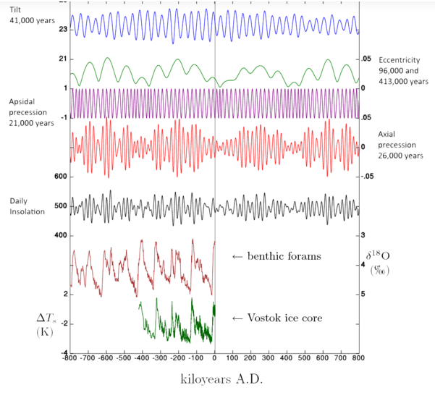
When the Milankovitch cycles are normalized and added, their sum produces the 4th graph which is shown in black. The term “Daily Insolation” just refers to the energy that the earth receives from the sun. The 6th graph labeled “benthic forams” represents the data collected from the sediment on ocean bottoms that measures the oxygen isotope ratio which correlates to ocean surface temperatures. The 7th graph labeled “Vostok ice core” are data collected from ice core samples where changes in temperature can be measured.

Whereas the top 5 graphs are the theoretical calculations from Milankovitch cycles, the last two graphs represent actual data collected from two unrelated sources ( sea shells and ice cores) that confirm the validity of the Milankovitch cycles. Notice that there is an anomaly that occurred about 450k years ago that is not explained by the Milankovitch cycles.

It is important to be aware that the Milankovitch cycles have been known to scientists for about 90 years, and in 1976 three scientists set out to prove/disprove his theory with collected data. Here is a glimpse of the first page of that famous paper:

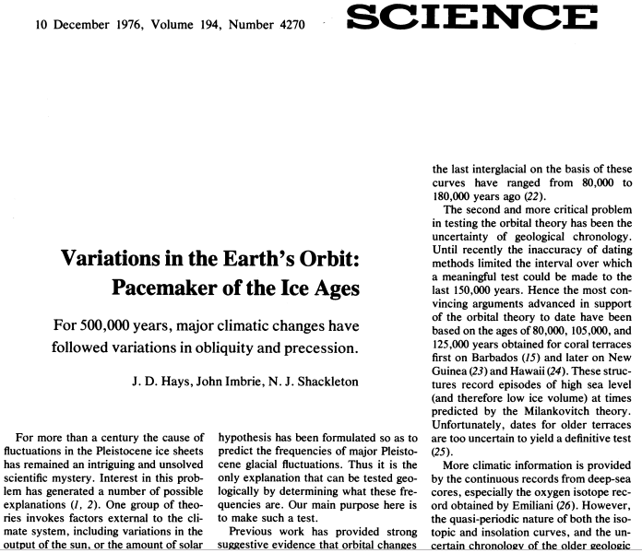
This famous paper was the first to validate the Milankovitch cycles. All of the climate models that have been developed since this paper was published include the Milankovitch cycles as the baseline.
Let’s return to the statements contained in your video. Mr. Temple initially shows a graph that everyone agrees with. The graph shows temperature fluctuations between warm and cold periods, but only for the last 11,000 years:

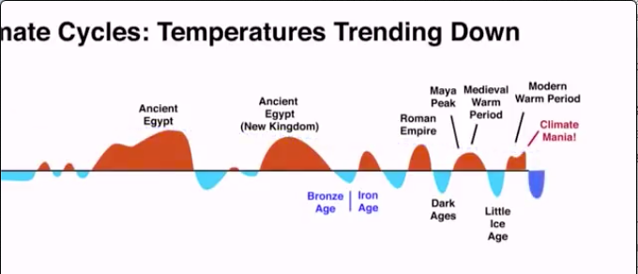
His video pans this graph from left to right with the lowest time axis value of -9000. By the time we see the present, the time axis is not visible. He then circles the present “Modern Warm Period” and adds the comment of “Climate Mania”. He implies that we are presently in another one of those re-occurring warm periods, and I guess that the term “Climate Mania” is supposed to imply some fuss about nothing. Then he makes the conclusion that we are headed into another cool period by adding a cold blue area to his graph.

At this point Mr. Temple reveals the source of his cyclical temperature data-Raymond Wheeler (Not the Milankovitch cycles). I do not want to get into a discussion of Wheeler’s work because the motivation for his study was to link climate to economics and political science. That is too vast a discussion to have here. The bottom line is that any projection of climate change based on whatever cycles you wish to use is totally irrelevant to the discussion. The reason is that cyclic models totally ignore the effects of human production of CO2. If the earth had no humans, these cyclic models would probably give accurate results.

It is like saying that “The earth is flat because just look at the flat surface”. The flat earth people ignore simple facts like--if the earth were flat, then everywhere on its surface would experience sunrise at the same time. The problem then with Mr. Temple’s video is that he deliberately leaves out the most important data because that data would invalidate his argument.

In order to see what was left out of his argument, let’s start by looking at some temperature data. Take a look at some ice core data that gives temperature as well as CO2 levels over the last 400,000 years:

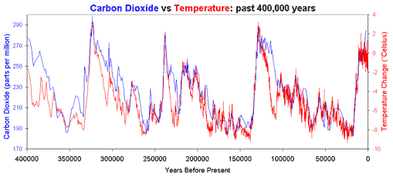
The red part of the graph represents temperatures as the Earth went into and came out of ice ages. Let’s look at a steep increase in temperature, say between 137,500 and 125,000 years ago. The temperature rose from about -9 C up to +3 C in about 12,500 years. That would give a rate of temperature increase of 0.00096 C per year. Now look at recent temperature readings:
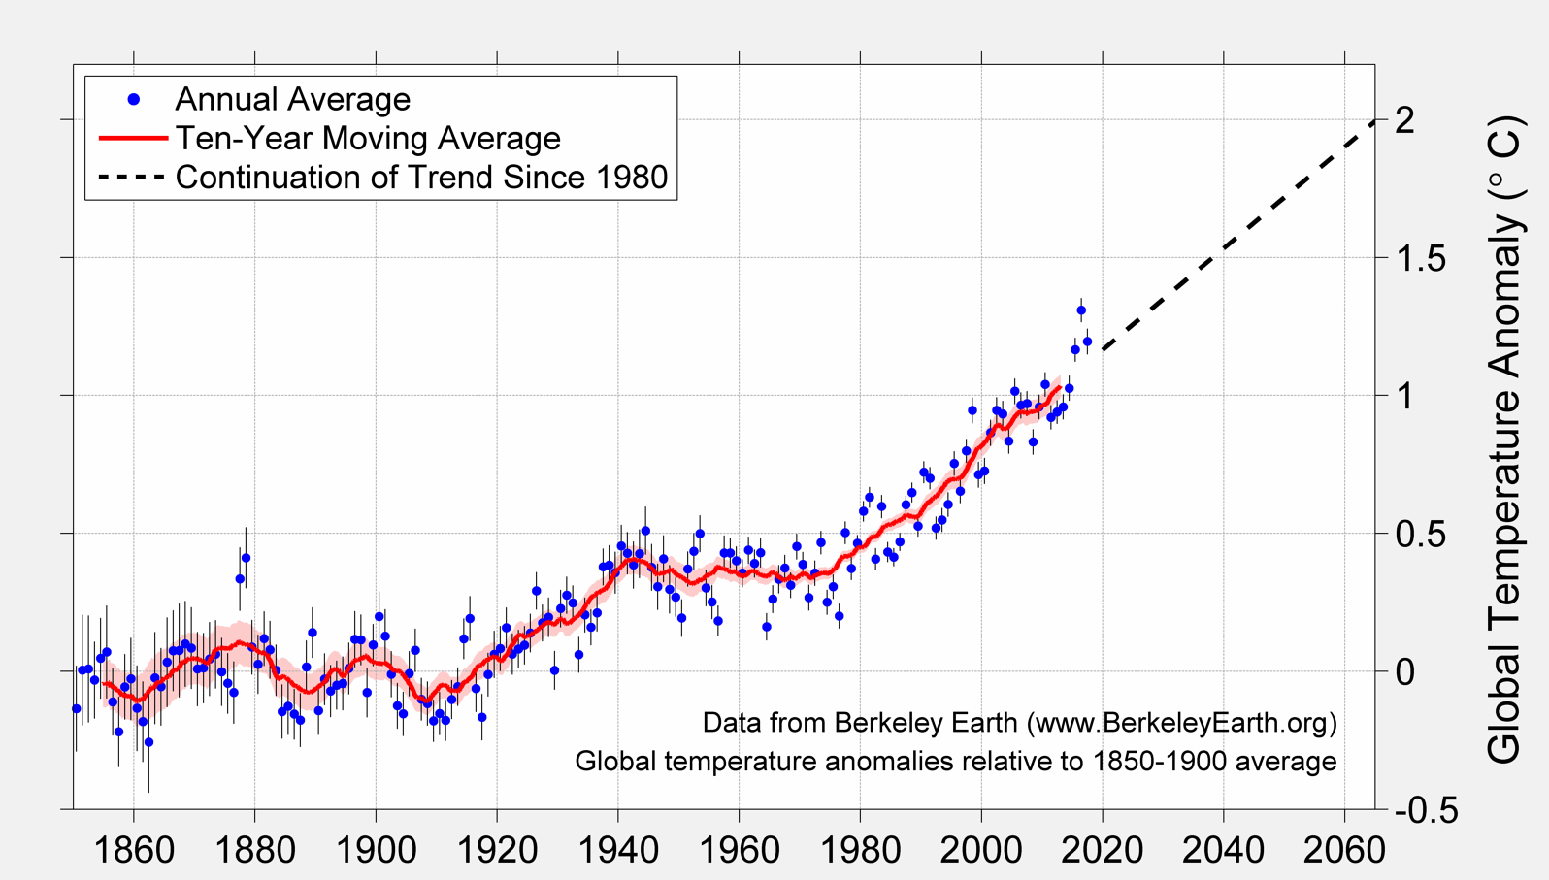
So from about 1920 to 2019 the temperature rose about 1.1 C. That works out to 0.01 C per year. So the most rapid rise in temperature in the last 400,000 years was 0.00096 C per year versus the rise in temperature for the last 99 years, 0.01 C per year. That makes the rise in temperature for the last 99 years 10.4 times more rapid than any other temperature increase in the last 400,000 years.

That is a significant piece of information that the Temple video conveniently left out. Now, anyone truly investigating this unprecedented jump in warming would want to know what caused the jump? Can it be explained with cyclic models? Remember that the cyclic models are driven by energy forcing factors. That is, changes in energy that the Earth receives from the sun cause the cycles. Thanks to satellite data, we can answer the cyclic question.

Take a look at a simplified schematic of the Earth’s atmosphere:
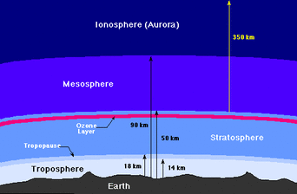
The upper atmosphere is called the stratosphere and the lower part is called the troposphere. If the energy forcing factors were higher, we would expect both parts of the atmosphere to warm up. The satellites use microwave sounders to provide a continuous record of upper air temperature. Measurements are made at different microwave frequencies and are sensitive to the temperature of different atmospheric layers. Here is a graph of the satellite data:

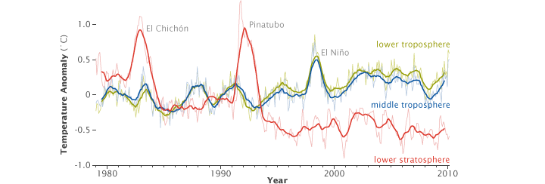
The red line indicates temperatures anomalies over time in the stratosphere and the green and blue lines are the temperatures for lower and upper troposphere respectively. If we were to ignore the temperature spikes caused by the two volcano eruptions of El Chichon and Pinatubo, we see that the stratosphereic temperature anomalies have been decreasing since the satellites were put into service. The data clearly shows that the stratosphere anomalies are lower than those of the troposphere after the mid 1990’s. So why would the stratosphere be cooler than expected?

There are three factors that contribute to stratosphere warming:

- Direct sunlight interacts with the ozone layer and warms it. This heat is transferred to the stratosphere layer.
- Direct sunlight passes through the stratosphere and in a slight way warms that layer.
- As the Earth’s surface is warmed by direct sunlight, that warmth is radiated back outwards in the form of infrared radiation. The stratosphere is warmed as the infrared radiation passes through it.

Factor 3 contributes most of the heat that warms the stratosphere. If the satellite data shows that the stratosphere is not being warmed as is the troposphere with the same direct sunlight, then factor 3 somehow is being impeded. If there were something in the troposphere that prevented the infrared radiation from reaching the stratosphere, then we have the explanation. A greenhouse gas has the property of absorbing infrared radiation. If we had evidence of an increase in greenhouse gases in the troposphere, then that would account for the temperature anomaly difference.

It has been suggested carbon dioxide (CO2) is the greenhouse gas that prevents the infrared radiation from reaching the stratosphere. So let’s look at what scientists have found.

What about this CO2 stuff?

One of the first ice core extractions for the measurement of recent historical CO2 was done in the East Antarctica from 1987 and 1993. These extractions resulted in atmospheric CO2 records from 1006 A.D. to 1978 A.D.

Pre-industrial CO2 levels range from 275 to 284 ppm. As you can see in the data plot below, that in 1978, the CO2 levels were at about 338 ppm.
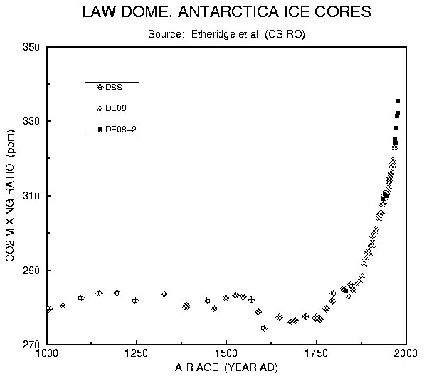

Just before this historical extraction (1958), Ralph Keeling, a researcher at Scripps Institute Oceanography, started measuring CO2 levels directly in the atmosphere at the Mauna Loa Observatory on top of the mountain.

The graph below shows measured CO2 levels from 1958 through present:

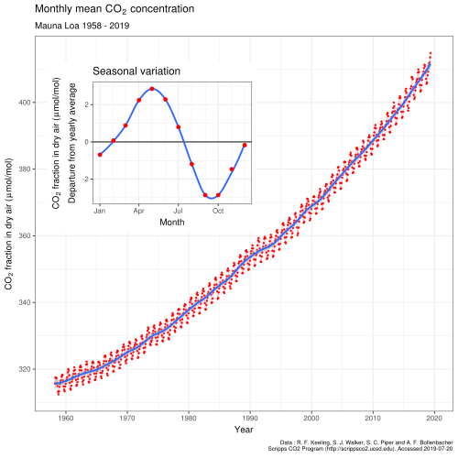

As you can see, the CO2 levels went from about 315 ppm in 1958 up to their current levels of about 410 ppm. You can also get a sense of the accuracy of the data since the CO2 levels fluctuate by about ±3 ppm in a well defined cyclic pattern during any given year since CO2 levels in the atmosphere vary according to seasons (seasonal temperatures).

It is easier to understand the significance of the 410 ppm current CO2 level by putting that reading on the same graph scale with the 800,000 year record.

The graph below shows that ice core samples have revealed that in the last 800,000 years, CO2 levels fluctuated between 180 and 290 parts per million (ppm) with the lows occurring during cold periods and highs occurring during warm periods.
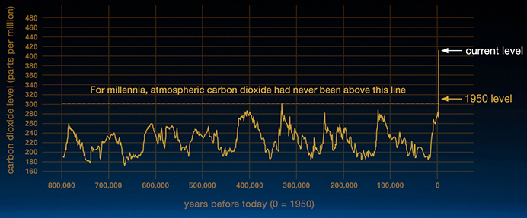

When the current CO2 level is compared with the historical values of the last 800,000 years, one can see that the current level of 410 ppm is far out of the historical range between 180 and 290 ppm.

Now let’s look at global CO2 emissions. The Environmental Systems Science Data Infrastructure maintains data archives for such data. Here is a graph of the CO2 emissions data:

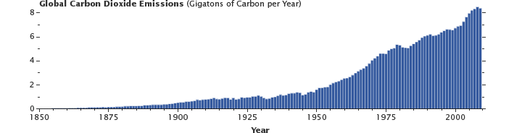
This graph completes the trail of evidence that explains how the unprecedented warming spike is caused by an unprecedented spike in atmospheric CO2 which is in turn caused by an unprecedented spike in CO2 emissions created by humans. There is no cyclic explanation of these unprecedented spikes.

Just to tighten up the case for human created CO2 emissions, how do we know that the spike in atmospheric CO2 is caused by humans? Thanks to chemistry, scientists are able to identify the CO2 that is created by humans as opposed to CO2 that is created by non-human processes.

There are three naturally occurring isotopes of carbon: C12, C13, and C14. C12 is the most common of the isotopes., C13 accounts for about 1% of the total, and C14 is only about 1 in 1 trillion carbon atoms. Note that all three of these isotopes of carbon form carbon dioxide. So we can have a carbon dioxide molecule made of C12 or C13 or C14.

Plants, which are the source of fossil fuels have a preference for the lighter isotope of carbon (C12). So plant material has a lower C13/C12 ratio than the atmosphere (about 2% lower). Just think of plants as having a filter that filters out C13, so their C13/C12 ratio is lower than that of the atmosphere that they breathe. When we burn the plant, the chemical reaction is to produce carbon dioxide(among other chemicals). So that carbon dioxide produced from burning the plant will have a lower C13/C12 ratio as compared to the atmosphere in which it grew.

So in a world where we burn plant material for energy, the atmosphere will have a lower C13/C12 ratio. Ice core and tree ring data have confirmed this logic:
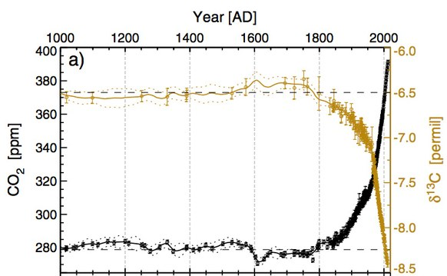
The gold part of the graph shows the C13/C12 ratio over time while the black graph shows the total CO2 concentration in the atmosphere. There is clearly an inverse relation between the two concentrations. So this graph demonstrates that the increase in atmospheric CO2 is caused by the burning of plants, and does not come from any other source. In other words, the human finger prints are all over the dramatic increase in CO2
Finally, there is another amazing graph that Mr. Temple shows his viewers:

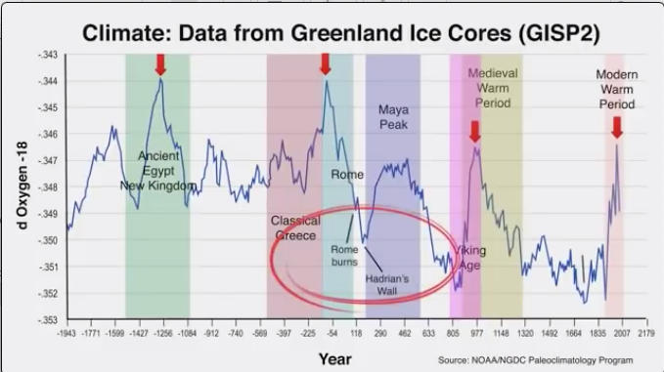
This goes into the Twilight Zone as he attempts to correlate rise and fall of Earth’s civilizations with warm/cold periods. I do not want to use time trying to track down the validity of this claim. However, I will comment on the data that is used for the graph. The data called GISP2 is a well known data set that Is derived from one ice core sample in Greenland. The ice core data that I have referred to in this presentation is a combination of many ice cores drawn from many locations around the world, including Greenland.

So using data from one ice core to attempt a validation of the civilization correlation all over the world is, again, a “Cherry Picking” tactic. By the way, this correlation idea has never been publish in a peer reviewed journal.

The data that I have presented in this article represents only a fraction of the data from experiments conducted in the last 25 years by scientists all over the world. I have only addressed one climate myth: that Earth’s climate is cyclical and is not affected by human contributions. There are many other indicators that show an unprecedented, rapid change in our climate. There are peer reviewed papers that have been published recently that show data on ocean heat content, sea ice, ice sheets, sea level, sea surface temperature, humidity, glaciers, snow cover, tree-line shifting northward, spring season coming earlier, species migrating poleward, etc. I just do not have time to summarize all of those papers. However, here is a good link that discusses the most widely cited papers.

I do not know why a person such as Mr Temple would deliberately cherry pick some data and completely ignore the overwhelming body of data that by itself refutes his claims. In the same way I do not understand why the Flat Earth people ignore an overwhelming body of data that refutes their claims. Similarly, I do not understand why anti-immunization people ignore the overwhelming body of data that refutes their claims and why they would put their children at risk. I know that since I look at the world in scientific terms, people who deny science findings seem illogical to me. Therefore I do not understand their motivation.

Finally, I would ask that you take 12 minutes and watch this video. It is a Ted Talk video that has much better graphics than I can produce. Please compare the Temple video with this one that is presented by Gavin Schmidt who is a climatologist. Whereas Temple excludes information, Dr. Schmidt includes everything that one could imagine that has an influence on climate, including the cyclical influences that Temple talks about.

I would be curious about which explanation you think is more complete.

If you are interested in what I read about climate modeling, I welcome you to read this..

