How to Set Up and Run the Program

In this document we will follow a set of steps in order to run the program properly and with no errors.

First of all, we will need to open the project using Netbeans. In case we don't have it installed in our system we can easily download it from its web page. (https://netbeans.org/downloads/)

Right after opening the project in Netbeans, we need to execute the database server. This can be easily done executing the scripts provided for Unix/Windows systems (runAerofoil.sh and runAerofoil.bat respectively).
In Unix we open a console, navigate to the project folder and there we type ./runAerofoil.sh
In Windows we just make double click on the runAerofoil.bat file.

After this, we will have to connect the database with the program using Netbeans. We can do it following the next instructions.

- In Netbeans, go to “Window” → “Services”
- Click on “Databases” and check whether “jdbc:hsqldb:hsql://localhost/aerofoil [ on PUBLIC]". If it doesn't exist, we have to add it following the next steps

  - Right click on “Drivers” and select “New Driver...”
  - After this, a new window called “New JDBC Driver” will appear. We click on “Add...” and look for the hsqldb.jar file. This file is in PROJECT_FOLDER/hsqldb/lib/hsqldb.jar
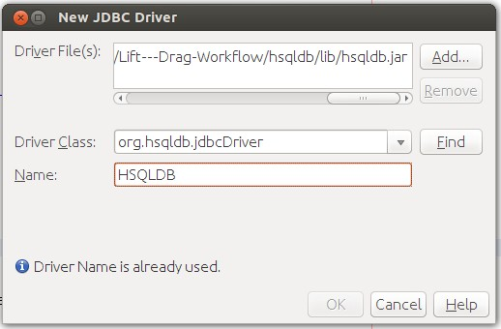

  - We click “OK”. After this we'll see a new element in the “Drivers” folder called “HSQLDB”
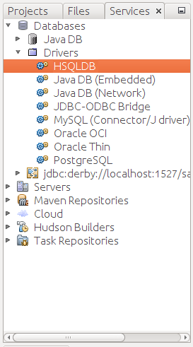

  - Right click on “HSQLDB” and select “Connect Using...”
  - A new window will appear called “New Connection Wizard”. Select the “HSQLDB (Server)” in the “Driver Name”. Leave the “UserName” and “Password” fields empty and the “Remember Password” unchecked. In the “JDBC URL” field we will write “jdbc:hsqldb:hsql://localhost/aerofoil”
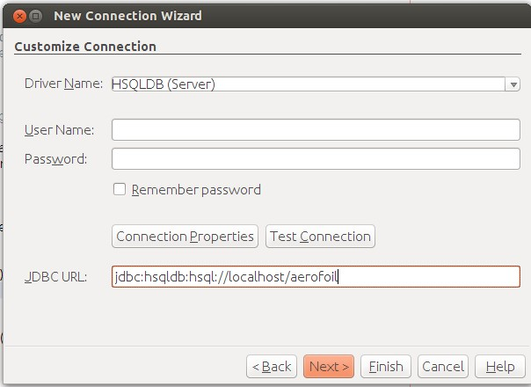

  - Click “Next” and select “PUBLIC” en the “Select schema” field. After this click “Finish”
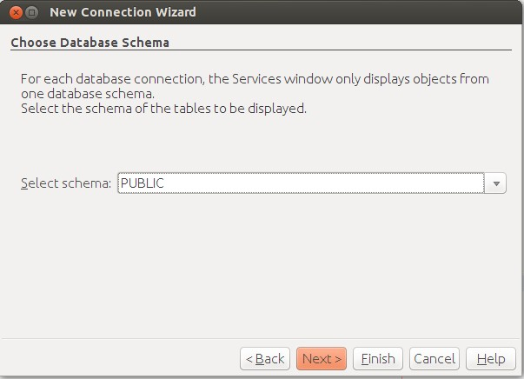

  - Now we have our database created and connected.

- If the database exists and it's disconnected (the icon is broken in two pieces) right click on it (jdbc:hsqldb:hsql://localhost/aerofoil [ on PUBLIC]) and click on “Connect...”. When it asks for “Username” and “Password” we leave the fields empty and just click “OK”

Finally, our database is ready and connected. Now all we have to do is run the code.

