|  |  |  |
| --- | --- | --- |
| **Project** | MRI-guided PT | **M-ID** | … | **Date** | May 2nd, 2014 |
| XRayTracing_script.py, a Semi analytical Simulation tool to compute dose from X-rays | | |
| **Prepared by** | | **Verified by** | | **Validated by** | |
| Damien Prieels |  |
|  |  |  |
| **Keywords** | | | |

**Executive summary**

This document describes XRayTracing_script.py, a Python program I am developing to compute dose in uniform pallets irradiated with X-rays. XRayTracing_script.py is a semi-analytical simulation tool: it uses an extended XR sources computed by RayXpert and compute the dose using the flux and the attenuation specific to this source. This python script is an extended version of original XRayTracing.py file and enables to design the geometry and density of conveyor, products (left, right, middle), wooden pallets (left, right, middle) and mother pallets (left, right, middle). It also enables to compute multiple parameter set ups thanks to an input in excel file format.

**Revision record**

|  |  |  |  |  |  |
| --- | --- | --- | --- | --- | --- |
| **Rev.** | **Date** | **Author** | **Approval** | **Description** | **Modified pages** |
| 0 | July 27, 2024 | Damien Prieels |  | 1st Draft | New |

|  |
| --- |
| PROPRIETARY INFORMATION |
| THE INFORMATION CONTAINED IN THIS DOCUMENT IS THE EXCLUSIVE PROPERTY OF IBA S.A. BELGIUM  WITHOUT THE EXPRESS WRITTEN PERMISSION OF IBA, THIS DATA MAY ONLY BE USED FOR THE  SPECIFICATION, OPERATION, REPAIR AND MAINTENANCE OF THE EQUIPMENT IN ACCORDANCE WITH THE  TERMS OF THE PURCHASE CONTRACT WITH IBA, PROVIDED FURTHER THAT SUCH DISCLOSURE BE SUBJECT  TO PROHIBITION AGAINST FURTHER USE AND DISCLOSURE. THE REPRODUCTION, TRANSMISSION OR USE OF  THIS DOCUMENT FOR ANY OTHER PURPOSE IS FORBIDDEN WITHOUT THE WRITTEN PERMISSION OF IBA. |

Table of Contents

1. Objective 3

2. Introduction 3

3. Modelisation 4

3.1. X-ray source 4

3.2. Dose from X-rays 4

3.2.1. Depth dose 4

3.2.2. Beam width 4

3.3. The product and the slave pallet 4

4. References 5

# Objective

This document describes XRayTracing_script.py, a Python program I am developing to compute dose in uniform pallets irradiated with X-rays. XRayTracing_script.py is a semi-analytical simulation tool: it uses an extended XR sources computed by RayXpert and compute the dose using the flux and the attenuation specific to this source. This python script is an extended version of original XRayTracing.py file and enables to design the geometry and density of conveyor, products (left, right, middle), wooden pallets (left, right, middle) and mother pallets (left, right, middle). It also enables to compute multiple parameter set ups thanks to an input in excel file format.

# Introduction

Dose from X-rays irradiation is usually performed by Monte Carlo simulation. However, those simulations are relatively slow which may become a blocking point when numerous simulations are required.

In order to optimize the X-ray process, many design variables could be adjusted requiring many more simulations. Among the design variables, we have:

* the gap between the pallets,
* the gap between the pallet and the XR horn
* The electron beam density on the target (I;e. the shape of the variable scan)
* the overscan
* the pseudo-parallel
* The X-ray converter: steel, flange, tantale bending orientation,

We may want to look at different configuration:

* product density
* the product geometry (height, width, length)
* the product orientation (long side leading vs. short side leading)

For example, such simulations would allow answering the following questions:

* What is the optimal DUR if variable scan is allowed? This would required an optimization tool that would make numerous call to a, objective function that must compute the dose at some points in a pallet. Does the DUR depends on the pallet height?
* How does the optimal variable scan shape varies with the product density and the target-pallet distance?
* What is the optimal overscan? What is the impact of the PP?
* What is the optimal target shape?
  + What is the impact of the steel flange? As we know the flange improves the DUR, could we even improve it / add a collimator?
  + What if we flip the target to get the tantal close to the pallet. It may worsen the DUR?
  + What is the impact of the distance target-pallet on the DUR. Probably the short the distance, the better the DUR; How sensitive is this parameter vs product density?
* What is the influence of processing parameters such as the gap between the pallets

Also, the IBA sales team complain we are too conservative or pessimistic concerning the DUR value that we announce.

# Modelisation

The idea is to develop a semi-empirical model that would use reasonable assumptions to simplify the computation. Simplification are made for the X-ray source and for the dose computation for the x-rays

## X-ray source

The source will be based on Monte Carlos simulations. A point…

## Dose from X-rays

The dose from X-rays on a specific point P(x, y, z) is computed by adding the contribution from each point (xi, yj) of a 2-D extend source. The dose from each point is computed by the following method:

* A line is drawn from the point of interest to a point of the 2-D source. *r [cm]* is the distance from the point to the source.
* The material crossed by the line are identified and the total thickness *t [g/cm²]* is computed.
* The dose is at P from () is assumed to be = *D(q,f)/r² exp(-t/t0)*
* Where *(q,f)* are the … & azimuthal angle computed for the line

This method considers the following assumptions / simplification:

…

### Depth dose

The Depth dose only depends on the material density, not the atomic composition

### Beam width

The beam width only depends on the distance to the target, not on the material agancemen,t

## The product and the wooden/mother pallet

The conveyor is the first modelized. We place on it the right/left/middle mother pallets. Centered around those, we place the three wooden pallets. Finally centered around those pallets we place all three products. The space between products is defined by a left and right gap. Note each product and wooden pallets can be different (geometry, density), however all mother pallets are the same.

# Implementation / code

## Intersection of a line with a cube

* <https://math.stackexchange.com/questions/3775806/finding-the-side-of-a-cube-intersecting-a-line-using-the-shortest-computation>

# Coordinate system

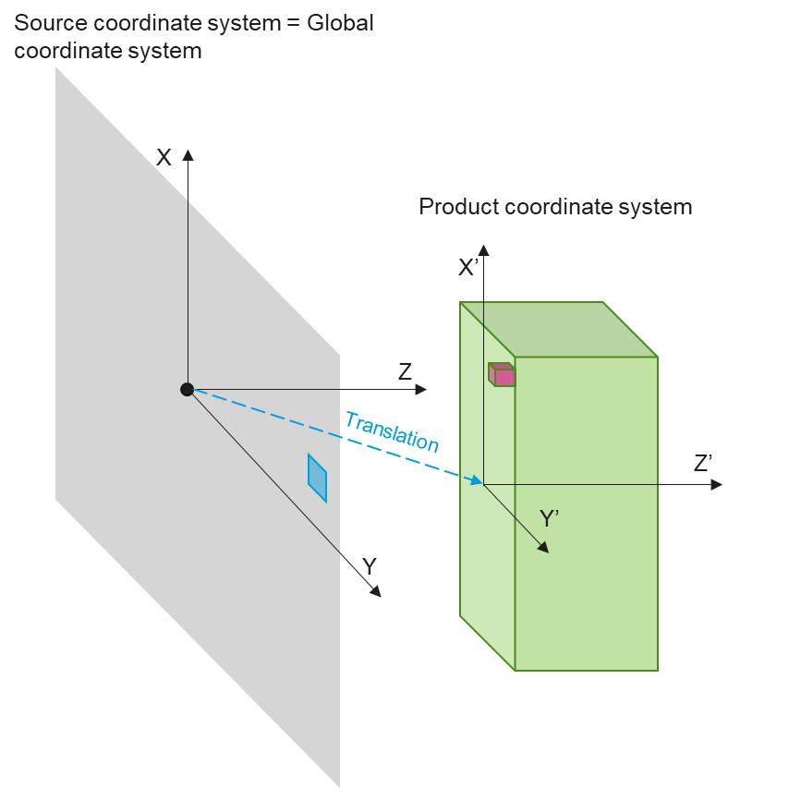

**XRayTracing_Input.xlsx**

XRayTracing_Input.xlsx is an input file for which each row corresponds to an experiment and where each column corresponds to an experiment parameter. The data of this file to fill in should be scrupulously followed. In order to help the user check his input data, a Checking_input_file.py file can be run to test the XRayTracing_Input.xlsx file. Failure to Checking_input_file.py test should be fixed before executing RayTracing.py in order to avoid running errors or biased results. This chapter details how to handle XRayTracing_Input.xlsx file. An example of input file is given in annex

## Source related parameters

The source is centred on (0,0,0). The source section contains the following lines:

* File name (without extension) of the dose mapping file (not used for now)
* Nominal source length [cm]: Size of the extended X-ray source in Y-direction
* Scan width [cm]: Size of the extended X-ray source in X-direction
* Current (mA): self-explanatory
* Source resolution (x,y) [cm]: self-explanatory.

## Product related parameters

The product section contains the following lines:

* Density [g/cubic cm] : self-explanatory
* Product size (x,y,z) [cm]: self-explanatory
* Product resolution (x,y,z) [cm]: self-explanatory
* Translation [cm]: position of the product wrt the source (see sketch in section 5)

## Conveyor related parameters

The product section contains the following lines:

* Conveyor speed [m/min]: self-explanatory
* Gap between pallets [cm]: self-explanatory
* Processing type (single side, double side, 4 passes): not yet available (by default single side is performed)

## Computation related parameters

The computation section contains the following lines:

* Units (Gy/h) (kGy/h) (Gy) (kGy): # between 0 and 3
* Dmin [kGy]: Requested minimum dose
* Operation [hours/year]: self-explanatory
* One-D profiles (x,y,z) [cm]: 1-D mapping profile (in product coordinate system)
* # Depth dose (x,y,z) to plot: self-explanatory
* One line per depth dose: X - Y - Z [cm]: point that the depth dose must intercept (the depth dose is in Z-direction =+> the Z-value is useless (for now)

## Parameters for the plots

The third section scontains the parametrers for the plot.

* 1 line of comments (column names)
* Axis limits : Upper & lower limits of X-plot. If 0 is mentioned, the axis will be automaticall adjusted
* Axis limits : Upper & lower limits of Y-plot. If 0 is mentioned, the axis will be automaticall adjusted
* Axis limits : Upper & lower limits of Z-plot. If 0 is mentioned, the axis will be automaticall adjusted
* Legend and grid: “1” to show legend/grid. Any other value will hide legend/grid.

# References

1. **C. Golnik et al.** Range assessment in particle therapy based on PGT measurements.

2. **J. Smeets et al.** *Brainstorming on PGT.*

Annex: example of input file

$$$$$$$$$$$$$$$$$$$$$$$$$$$$$$$$$$$$$$$$$$$$$$$$$$$$$$$$$$$$$$$$$$$

$$$ XRayTracing.inp is an input file that is read by XRayTracing.py $$$

$$$ D. Prieels, IBA Industrial $$$

$$$ 07/07/22 $$$

$$$$$$$$$$$$$$$$$$$$$$$$$$$$$$$$$$$$$$$$$$$$$$$$$$$$$$$$$$$$$$$$$$$

C:\Users\dp\OneDrive - IBA Group\My Documents - Operationnel\1. My Projects\Y21 RayXpert\Y22_03 - XR Source Definition

1) Source:

==========

XR horn 220_V02-03

Nominal source length [cm]: 340

Scan width [cm]: 210

Current (mA): 1

Source resolution (x,y) [cm]: 10 10

2) Product:

===========

Density [g/cubic cm] : 0.46

Product size (x,y,z) [cm]: 160 100 120

Product resolution (x,y,z) [cm]: 10 10 10

Translation [cm]: -9 0 17

3) Conveyor:

============

Conveyor speed [m/min]: 3.

Gap between pallets [cm]: 10.

Processing type (single side, double side, 4 passes): 0

4) Computation:

===============

Units (Gy/h) (kGy/h) (Gy) (kGy): 0

Dmin [kGy]: 25

Operation [hours/year]: 8000

One-D profiles (x,y,z) [cm]: 0 0 99

# Depth dose (x,y,z) to plot: 3

X - Y - Z [cm]: 0 0 1

X - Y - Z [cm]: 0 0 60

X - Y - Z [cm]: 0 0 119

5) Plots:

=========

$$$ XYZ plots: Xlow Xhigh Ylow Yhigh

Axis limits : 0 00 0 2000

Axis limits : 0 0 0 2000

Axis limits : 0 0 0 2000

Legend and grid: 1 1