# Frame2d

This is a Matlab scripts for the analysis and design of planar truss structures. The parameters are input using an ASCII file with .fem extension. They write the .out ASCII file with results. Both files use keywords which have * as the first character.

## Input File

The following keywords are used in .fem input file.

### COORDINATES

This keyword starts the input of nodal coordinates of the mesh.

Syntax:

**\*COORDINATES**

<number of nodes>

for each node in ascendant order based on the node number:

<node number><X and Y coordinates>

Example: truss with 6 nodes.

*COORDINATES

6

1 0.0 0.0

2 0.0 4.0

3 3.0 0.0

4 3.0 4.0

5 6.0 0.0

### ELEMENT_GROUPS

A finite element group is a set of elements with the same material and geometric properties.. Groups of finite elements are required when it is necessary to define trusses with different material and/or geometrical properties.

Syntax:

**\*ELEMENT_GROUPS**

<number of groups>

for each group in ascendant order based on the group number:

<group number><number of elements in the group>

Example: 3 groups, the first with three bars, the second with four bars and the third with two bars.

*ELEMENT_GROUPS

3

1 3

2 4

3 2

### INCIDENCES

This keyword is used to define the nodes of the finite elements (incidences).

Syntax:

**\*INCIDENCES**

for each element in crescent order:

<local number of the element in the group> <incidence of the element>

Example: incidences of the three finite element groups of the previous section.

*INCIDENCES

1 1 2

2 3 4

3 5 6

4 1 3

5 3 5

6 2 4

7 4 6

8 1 4

9 5 4

### MATERIALS

This keyword specifies the Young modulus and the yield admissible stresses for each material. The number of materials is equal to the number of finite element groups.

**\*MATERIALS**

<number of materials>

for each of material:

<Young modules> <admissible yield stress>

Example: materials for the example.

*MATERIALS

3

210E9 120E6

80E9 70E6

70E9 85E6

### GEOMETRIC_PROPS

This keyword specifies the external diameter and the thickness for the pipe elements. The number of geometric property sets is equal to the number of finite element groups.

Example: materials for the example.

*GEOMETRIC_PROPERTIES

3

12E-3 2E-3

20E-3 4E-32

30E-3 3E-3

### BCNODES

This keyword specifies nodes for which the degrees of freedom are prescribed with zero value. Those degrees of freedom are eliminated of the model in the assembling procedure.

Syntax:

**\*BCNODES**

<number of support reactions>

for each of these reactions:

<node number > <DOF label =1 for UX and =2 for UY>

Example: boundary conditions for the example.

*BCNODES

5

1 1

1 2

3 2

5 1

5 2

### LOADS

This keyword specifies the concentrated loads on nodes.

Syntax:

**\*LOADS**

<number of applied forces>

for each of these forces:

<node number> <DOF label =1 for UX and =2 for UY and load value>

Example: loads for the example.

*LOADS

4

2 2 -5000

4 2 -10000

6 2 -5000

6 1 3000

## Output File

The following keywords are used in .out output file.

### DISPLACEMENTS

This keyword collects the nodal displacements.

Syntax:

**\*DISPLACEMENTS**

<number of nodes for the truss>

for each of truss node:

<node number><UX and UY displacements>

Example:

*DISPLACEMENTS

3

1 0.0000 0.0000

2 0.0000 0.0000

3 0.0018 -0.0035

### REACTION_FORCES

This keyword collects the reaction forces on the supports.

Syntax:

**\*REACTION_FORCES**

for each node with supports:

<node number><FX = or FY = > <reaction value>

Example:

*REACTION_FORCES

1 FX = 6.000000e+004

1 FY = 8.000000e+004

2 FX = -1.000000e+005

### ELEMENT_STRAINS

This keyword collects the strains on each element.

Syntax:

**\*ELEMENT_STRAINS**

<number of design iterations>

for each element:

<element number><strain for each iteration>

Example:

*ELEMENT_STRAINS

2

1 0.000000e+000 0.000000e+000

2 8.333333e-004 6.000000e-004

3 -4.000000e-004 -3.500000e-004

### ELEMENT_STRESSES

This keyword collects the stresses on each element.

Syntax:

**\*ELEMENT_STRESSES**

<number of design iterations>

for each element:

<element number><stress for each iteration>

Example:

*ELEMENT_STRESSES

2

1 0.000000e+000 0.000000e+000

2 1.666667e+008 1.200000e+008

3 -8.000000e+007 -7.000000e+007

### AREAS

This keyword collects the areas of each element.

Syntax:

**\*AREAS**

<number of design iterations>

for each element:

<element number><area for each iteration>

Example:

*AREAS

2

1 1.000000e-003 1.000000e-003

2 6.000000e-004 8.333333e-004

3 1.250000e-003 1.428571e-003

### VOLUMES

This keyword collects the volumes of the truss.

Syntax:

**\*VOLUMES**

<number of design iterations>

for the truss:

<truss volume for each iteration>

Example:

*VOLUMES

2

1.205000e-002 1.364286e-002

## Example

The input .fem file for Example 3.27 of the book is given below.

*COORDINATES

3

1 0 0

2 0 4

3 3 4

*ELEMENT_GROUPS

3

1 1

2 1

3 1

*INCIDENCES

1 1 2

2 2 3

3 1 3

*MATERIALS

3

200e9 120e6 70e6

200e9 120e6 70e6

200e9 120e6 70e6

*GEOMETRIC_PROPERTIES

3

10.0e-4

6.0e-4

12.5e-4

*BCNODES

3

1 1

1 2

2 1

*LOADS

2

3 1 40000

3 2 -80000

*DESIGN_ITERATIONS

3

The input parameters is presented below.

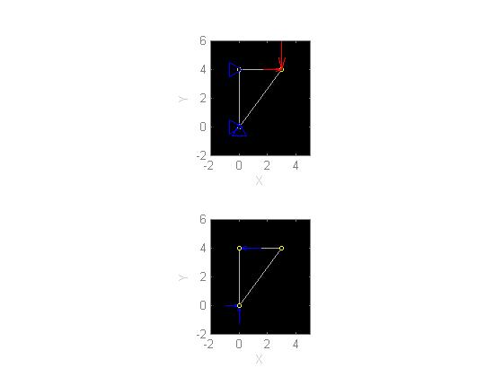

The output file and the plot of the results for the truss2d_design script are given below.

*DISPLACEMENTS

1 0.0000 0.0000

2 0.0000 0.0000

3 0.0018 -0.0035

*REACTION_FORCES

1 FX = 6.000000e+004

1 FY = 8.000000e+004

2 FX = -1.000000e+005

*ELEMENT_STRAINS

2

1 0.000000e+000 0.000000e+000

2 8.333333e-004 6.000000e-004

3 -4.000000e-004 -3.500000e-004

*ELEMENT_STRESSES

2

1 0.000000e+000 0.000000e+000

2 1.666667e+008 1.200000e+008

3 -8.000000e+007 -7.000000e+007

*AREAS

2

1 1.000000e-003 1.000000e-003

2 6.000000e-004 8.333333e-004

3 1.250000e-003 1.428571e-003

*VOLUMES

2

1.205000e-002 1.364286e-002

