Extending the bioMOBY protocol at the INB

Contributions

GNV5: García de la Nava, J.; Ramírez, S. Antonio J.Pérez
GNV1-4
GH1-2

and Trelles, O.

Abstract. Services, data and computational power integration in the bioinformtics domain has been addressed by the National Institute for Bioinformatics (INB) in Spain. A major decision was make to use bioMOBY as integration protocol. However, several of the desirable functionalities for an integration (launching-task?) protocol were not available in this protocol, specially important from the INB perspective were the ability to launch large-CPU tasks using asynchronous messaging for high demanding computational loads and semantic specifications to deal with objects collections (large sets of biological elements). In this document we report our proposals in these important issues together with some other minor improvements such as a normalised protocol to report services’ errors and a way to produce automatic help documentation, which have been successfully implemented under the INB-architecture and can be used to extend the protocol providing an extended, robust and efficient functionality.

Introduction

Motivation paragraph

The integrated exploitation of services, data and computational resources has become an effervescent field of research and development in bioinformatics. It is well known that the main bioinformatics characteristics, apart from the ever mentioned spectacular growing rates of data, are dispersion, heterogeneity and diversity of available data repositories and services providers.

INB paragraph
The INB project arise with the aim to bridge the gap between resources providers (data, services and computational power) and end-users. To do that, a virtual institution have been created by linking together several research nodes under a grid architecture that provides generic functionalities to support a wide range of traditional and novel applications. After a careful analysis, bioMOBY –included its pros and cons- was chosen as the protocol to sustain inter-operational conjunction of nodes.
Although from the beginning we were awarded of some limitations in the protocol, the advantages for a rapid deployment of results as well as the increasing number of services becoming available under this platform were on top of benefits.

BioMOBY drawbacks paragraph
Synchronous services and progress status / error control / generic help system / collections
A potential source of problems arise due to current BioMOBY services calls work in synchronous mode, this is to say, the same connection is used to request a service and wait for results, and the system remains occupied in the meanwhile.
Massive exploitation of services is equivalent to launch the same service for a large set of input data (of the same type; i.e. perform a Blast search for a collection of sequences), This functionality is specially attractive in several bioinformatics studies. Although BioMOBY protocol defines the use of collections as input to the services, a semantic meaning is not provided, which avoids using intensive exploitation of services.
When integrating disperse and heterogeneous services it is desirable –as much as possible- the deployment of automatic production and control engines. When new services become available in the system they should be incorporated into the system in an standardised way in order to simplify the installation tasks . Error management and building services help documentation fall in this kind of required functionalities.

Obtained results’ paragraph

In this work we report the extensions to bioMOBY protocol and their implementation in the INB platform. Results shown that the additional functionality improve the ability of the protocol to cope with high computational demanding task (as is frequent in the application domain); contribute to fill the gap in the semantic description of collections; and allows the development of more user friendly client interfaces assisting in the use of the different services and providing detailed information about incidences during the service execution.

Content paragraph
In the following sections we will firstly discuss the proposals for each of the mentioned drawbacks, next we will present implementation details and results obtained at the INB platform and finally we will discuss extensions.
2.- System and Methods

Introductory paragraph ?
2.1.- Asynchronous job control.
BioMOBY services calls, in its current available version (v. 0.8), is built on top of SOAP protocol which is supported by http protocol that uses TCP/IP. The main drawback arise from the use of http as this is a synchronous protocol, this is to say, the same connection is used to request a service and wait for results, and the system remains occupied in the meanwhile.
Certainly, SOAP protocol supports different Message Exchange Patterns (MEPs) over HTTP, however, BioMOBY (as most of the current developments under SOAP) use the request/response pattern (just the first example in SOAP description) [SOAP ref.]
A first alternative could be extend BioMOBY to use other most appropriated MEPs, however several risk situations would arise: i.e. BioMOBY is able to request more than one service in the same call (more than one service call in one SOAP request) hence the resulting MEP would have inherent difficulties since each request would be processed in independent way
On the other hand, each time is more frequent to set a connection timeout both in server and clients, producing that for long services (some time as long as only few minutes) the socket is closed breaking the communication.
To avoid the synchronism problem the simplest way is decouple request and response, making each one in a separate connection (named asynchronous communications). Unfortunately, none of the involved protocols (SOAP, HTTP, TCP/IP) support synchronous calls. Since bioMOBY is the upper protocol, is the best candidate to extend and modify the protocol without changing the underlying software.

Proposal: extending the protocol
Since BioMOBY is a XML-based protocol, it is possible to incorporate new elements or new attributes for existing elements. This new tags (?) will be ignored by old synchronous clients and servers and used by the new generation. Only two new attributes are suggested to be incorporated in the mobyData element:
The async attribute that will be used by asynchronous clients with:
- value “yes” to request for an asynchronous service (a unique queryID is supplied by client)
- value “poll” to request for task(queryID)-status to an asynchronous service
The status attribute will be used by asynchronous servers with:
- value “x%” to inform about the task-status to an asynchronous client, where x% means the percentage of evolution; and specifically 0% means service just launched and 100% (or not status attribute) means service complete and the <mobyData> contains the output from the service.
The proposed (and implemented) protocol to manage this new attributes is:
- The client init the session
  - Synchronous clients are not prepared to use async attribute, thus servers (sync and async) will properly work in current synchronous mode
  - A (new) asynchronous client uses the attribute async=”yes” to inform that is able to cope with asynchronous services. Rest of the mobyData contains the requested data.
- Server accept client request.
  - Synchronous servers will work properly with synchronous clients, and will not interpret the new attributes from async clients) thus, they will proceed synchronously with the service, returning back an output object without status attribute: as previously was established, no status attribute is equivalent to 100% of evolution -the job has end- which is true for synchronous services and the <mobyData> element contains the output (which is also true for synchronous clients).
  - New asynchronous servers will accept the task and return back an object where the <mobyData> will contain the new attribute status=”0%” (service just launched).
- At this point both client and server will work in asynchronous mode. Two ways to obtain results have been analysed: notification and polling.
- Notification means the service provider taking the initiative to inform to the client about the progress status of a given task. For a notification to be sent, there has to be some form of trigger. Such a trigger is defined as an “Event”, the service informing about a given step has been completed, or the task has finished, or they can also be in time intervals, it’s up to the designer. All of the events for a notification service must be defined in the service.
  - A new functionality needs to be incorporated, both on the client and server side. In the server to behave as a client (initiating communication) and in the client to act as a server to receive the notification. This Notification Server is a new system infrastructure component that is separate from and independent of the services and can demand a substantial modification on clients and servers.
  - Client and server must share information to identify univocally the task.
- The client, using polling can request periodically information to the server on the progress status. When the service has ended, the server also returns the output object.
  - Asynchronous clients will issue a request (by their own initiative) with attribute async=”poll” to request the task status
  - Asynchronous servers should be able to accept the polling request and inform about the task-status.
  - Client must provide an unique task identifier that will be keep by the server and used to identify client requests.
  - Request and response are cheaper object since only contains the URL of the function call and the task ID. It can be estimated a polling request in consuming about 200 bytes of bandwidth. That is not very much at all, even with a thousand clients polling once per hour the total bandwidth cost in a month will be about 137MB. Even more, since scheduling module at INB architecture records information about the average elapsed time of services, polling can be issued a couple of times during service execution.
  - There is not syntactic modification of bioMOBY protocol; just a new attribute and a new simple functionality in (asynchronous) servers and clients. Asynchronous servers should include a way to notify (by their own initiative) that the service has end.

(it is noteworthy to observe that when a collection is spitted in simple-in / simple-out services synchronous calls each task will be launched sequentially, or distribute one-by-one among the different service providers)
(an additional simple modification to the bioMOBY protocol consist in including a new tag to specify when the service is able to attend asynchronous requests)
The proposal is simple and flexible enough to include new notification information (i.e. “step 2: sequence alignment done”) to report progress status of the requested service.
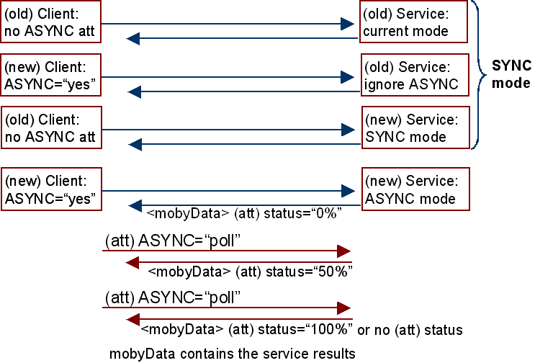
Figure X.- the four different combinations between sync and async clients and servers and the way in which they will behave.

2.2.- Establishing a semantic for using collections

BioMOBY protocol includes the use of collections as input to the services, although a semantic meaning is not provided for this type of data. Even more, collections are not only homogeneous (only one object type) but also they can have a limited heterogeneity (containing only those object types defined during register step, for an specific service). Full heterogeneous collections (any data type can be included) are possible from the specifications but not allowed during the service registration.
Additionally, the order in collection is not important. This meant if a collection is used as input for a given service whose output is also a collection, nothing in the protocol ensures that the first object in the output collection correspond to the first object from the input. The same is valid for anonymous articles.
Under this scenario, the best choice is deal with collections at the client side rather than in the server side
BioMOBY does not establish a semantic specification for clients dealing with collections. This proposal formulates this semantic. The basic idea is managing collections as simple objects but supplying functionality for basic operations on them: incorporate new objects to the collection; create a collection from simple objects; extract objects from a collection; split a collection in their simple objects; delete objects from a collection; delete the collection, etc.
Apart from the edition support, a client should extend the service calls to include simple-input o simple-output services to cope with collection when possible. The following operational modes are proposed:
Formal registry of the service |  | Using the service with: |  | Status
Input | Output | Input | Output | Status
Simple | Simple | Simple | Simple | Normal
Simple | Simple | Collection | Collection (1) | New
Simple | Collection | Simple | Collection | Normal
Simple | Collection | Collection | Note 2 | forbidden
Collection | Simple | Collection | Simple | Normal
Collection | Simple | Simple | Simple (3) | New
Collection | Collection | Collection | Collection | Normal
Collection | Collection | Simple | Collection (3) | New
Table 1: First two columns describe the input/output of the service (when it is registered). Next two columns describe the output of the service when is called using a simple or a collection. Last column points out the behavior of clients. Notes are described below in the main text.
The first row correspond to a service that receive a simple as input and return a simple as output
- When a simple-input service receive a simple object, it coherently will return a simple as normal case. This normal situations will no be additionally commented.
- [Note 1]: A simple-in / simple-out service could return a collection when it is invoked with a collection. The client behaviour would be split the collection in simple components, call the service for each simple; and re-ensemble the service output to conform the output collection. The no-order problem should be addressed by identifying the output elements (by using the input articleName’s).
- Another question is how to proceed when an error is reported by an individual call of the service (the service fails for a simple coming from the collection). A first approach could be abort the service (restrictive approach); or complete the work when at least one of the services calls was successful (permissive approach). The service will report an error when all simple calls fail, and will supply a warning for individual fails.
The second case describe the simple-in / collection-out service under collections.
- [Note 2] The coherent behaviour should be “return a collection of collections”, however the later does not exist. Thus when a simple-in / collection-out service is invoked with a collection as input the process is forbidden. Moreover, the no-order problem poses additional difficulties to identify each of the resulting collections (which is not so easy as it seems).
Third and fourth cases correspond to collection-in services that return a simple or a collection respectively.
- [Note 3]: the simple way is to built as input a collection with only one simple component.
In all cases the client is in charge of dividing the collections in their simple components; call the service for each simple and ensemble simple results into a collection. Services retain original behaviour.
An additional problem arise when a service request more than one input article or when the service returns more than one simple article. Input / output collections should be supplied or returned coherently. To standardise this situation the following rules are proposed:
- This proposal is valid to cope with services that deal with simple-objects when receive an homogeneous collection (of the same type that the expected simple)
- Using heterogeneous collections will only be valid for those services registered for this type of collections.
- It is always possible to built a collection from a simple object. Types must be consistent.
- Only one of the simple articles in a service call can be replaced by a collection: one collection will be returned for each simple-output (note 2 avoid collection of collections). This operational mode will be called “factorisation of the input object”).
- Secondary input parameters can not be factorised (this would demand multi-dimensional objects)
- All factorisation must be correct from the point of view of the object type.
Advantages. The protocol remains un-altered. The client supports major changes, but it will remain compatible with previous versions

Drawbacks.- Establishing a semantic guide for collections, not only makes the clients more complex, but also limited to that semantic. New modifications on the semantic of collections will have influence in new clients, and also will not so easy to implement.
Remains un-specified for more than one input or output article.

2.3.- Errors notification protocol

We are working on this protocol from the client side… volunteers from the service side?
BioMOBY protocol for errors in the service are reported as an empty object, without additional information about the error. In version 8, the new element (o attribute?) “moby:serviceNote” has been added. However, to contribute in the standardisation of the error protocol a more detailed description of the error would be necessary.

Proposal 1: Element <mobyFail> (la propuesta 1 me la he cargado porque ha dejado de tener sentido)
A new specific element to report error will be added containing the message type, the queryID, and the error description.
(especificar la semántica del error: tipo, descripción, etc.)

Although the protocol needs a slight modification, additional information on errors will become available

2.4.- Help system

BioMOBY catalogue includes a field in the database to store a brief description to help human discovering of the service. From our perspective a complex platform demands the design of a more informative and detailed help system. There are several points that propel this initiative: platforms such as the INB are though to integrate geographically distributed services, and it is expected –or wished- to be successful at least to some extend, this is to say, we expect a continuous flow of services being installed at the INB. Under these circumstances designing a useful, up-to-date, as uniform as possible help system is of outstanding importance.
Of course, a simple alternative is to include in the bioMOBY field (COMO SE LLAMA?) an implicit URL pointing to a detailed web-based help provided by the service’s authority. This is easy and fast to implement and present no compatibility problems. However, our experience suggest this method derive in a set of non-uniform, own-syntaxes, out-of-date and frequently broken-linked web pages for the help system. Moreover, responsibility and authority on the help system remains distributed around the service’s providers with a high risk for un-supported help.
To cope with this problem we have tackle it in two main fronts: (a) enforcing the quality during the registration procedure which allows us to built the help pages by an automatic engine and (b) providing a generic help server (including mirrors) with a explicit URL. In this way the help system, under one authority, reduces the risk for broken links, becomes fault-tolerant and offers an homogeneous view of the help system, independent of the status of particular servers (it is worthy to observe that the same service can be replicated in different servers, but refereeing always to a common service-help.

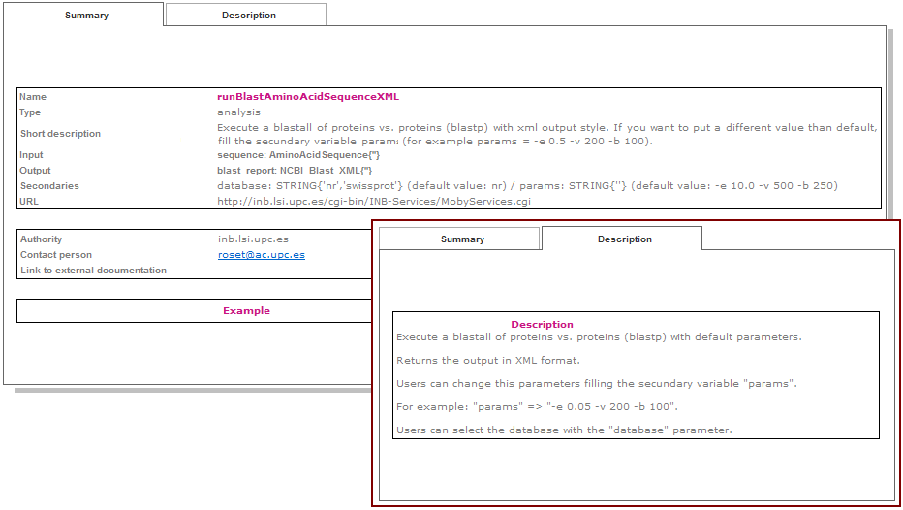
The main drawbacks of this proposal is the need for a simple pre-processing on the help system, nut only during the registration procedure. A short delay could arise during the help updating since the modifications need to be authorised.

Figure 2.- Automatic service help: the main window correspond to information displayed automatically from the registry definition, and the short windows shows an example of specific and more detailed information supplied for the service provider. (quizá haya que cambiarla con el del pupas)

Results

Implementation details: Asynchronous mode
El cliente está prácticamente listo para pruebas. JMFernandez y Enrique están preparando servicios que aceptan conexión ASYNC

Implementation details: Collections
Para estas pruebas usaremos los servicios existentes (el servicio ni se entera de cómo le están llamando).
Collections are stored as a simple objects in the database thus from the client interfase they can be treated in the same way.
  - A new field defines the object type as: simple | Homogeneous collection | Heterogeneous collection.
  - No additional tables are required to describe the simple objects that conform the collection.
- Monitoring, visualization and service discovering.
  - Los monitores mantienen su funcionalidad; mostrarán el nuevo campo indicando que se trata de una colección o –por defecto- de un objeto simple. No se visualizan los componentes.
  - Para visualizar, editar (extraer, eliminar, etc) componentes se dispondrá de un procedimiento (disponible para colecciones). Al invocarlo, se desplegará la colección y se podrán realizar operaciones de edición sobre ellos)
  - Si se desea lanzar un servicio sobre uno de los componentes de la colección, hay necesidad de extraerlo explícitamente de la colección. Esta interpretación es más clara ya que el usuario expresa sus acciones sobre los componentes y no se asume nada desde el sistema.
  - Los procedimientos de carga y descarga (up / down-load) se mantienen al estar todos los componentes en un solo fichero en disco.
  - El descubrimiento de servicios será aplicable a colecciones homogéneas usándose el tipo de los objetos que la componen (tipo único) para descubrir los servicios que las acepten.
- Task management:
  - Las tareas que devuelven colecciones se tratan como si fuera una llamada normal y se guarda la colección devuelta por el servicio en un solo fichero como si de un objeto simple se tratara.
  - Para el uso de servicios que reciben un simple y se les pasa una colección se procede de la siguiente forma:
  - La interfaz de usuario:
    - Crea una tarea “compuesta” y tantas tareas simples como simples haya en la colección: en realidad una tarea “compuesta” no es más que una tarea con dependencias de otras tareas –las simples asociadas a ella. La tarea compuesta, tiene como dependencias la completitud de sus tareas simples.
    - Las tareas complejas no se planifican (debido a la dependencia de sus tareas simples). Las tareas simples se planifican (esto permitirá al scheduler distribuir las tareas simples de una colección en diferentes servidores si fuera el caso)
    - Todas las tareas crean inicialmente (como hasta ahora) sus objetos de salida vacíos, con la indicación de estado “en proceso”. Los objetos vacíos aunque aparecen en los visualizadores, no tienen aún activo sus correspondientes visualizadores. Por tanto el sistema se comporta de forma natural (como hasta ahora) en cada tarea simple.
    - El scheduler lanza un worker asociado a cada tarea (tal como se hace ahora). Al finalizar el servicio, el worker comprueba si se trataba de una tarea con la que tiene dependencias y las va resolviendo.
    - Al resolverse todas las dependencias (las tareas simples han concluido) la tarea compuesta está lista para planificarla y su proceso (no necesita ser un servicio) verifica si se han completado todas sus tareas simples; se encarga de construir el fichero colección con el resultado de las simples (completa la entrada en la BD y el contenido del fichero en disco); borra las tareas hijas (actualiza las estadísticas) junto con sus objetos y completa la entrada correspondiente a la tarea compuesta y le asocia el fichero con la colección de salida.
- Ventajas
  - Se reduce el número de entradas y de ficheros en el sistema.
- Desventajas
  - Mayor complejidad en los casos de error, en las visualizaciones y en los estado intermedios de las tareas.

Implementation details: error handling

Implementation details: help system

Conclusions
Capturing, generating, gathering, integrating, sharing, processing, analysing, weeding, cleaning, correlating, archiving, and retiring knowledge has become a principal issue in bioinformatics. In the aim to assist in this process, the INB has develop a consistent, robust and as automatic as possible brokering platform. Assumable proposals have been explained in this document to contribute to extend one of the more successful protocols.
The INB solution enables bioinfomrmatic’s organizations to start the move to a vastly more efficient Grid-based infrastructure without the pain associated with a revolutionary type migration.
The proposal described in this document allows to built up a core Grid infrastructure for compute-bound applications, providing a number of options for scheduling and interacting with the whole system.

Ventajas de: asíncrono, help, errores y colecciones
Discusion del polling:
Drawbacks.- The protocol is modified, thus conformity from bioMOBY consortium is needed, because –although is unlikely- some servers could apply a strict XML conformation protocol (against an DSL schema) .
Getting progress-status information needs periodic polling to the service which represent additional communication overload.

Advantages.- It is compatible and can be easily extended for job-status notification.

Acknowledgments
This work has been supported by the Genoma-España Foundation under the National Institute for Bioinformatics programme.

References
- SOAP reference (http://www.w3.org/TR/soap/)
- Wilkinson M.D., Gessler D., Farmer A., Stein L. (2003). The BioMOBY Project Explores Open-Source, Simple, Extensible Protocols for Enabling Biological Database Interoperability. Proc Virt Conf Genom and Bioinf (3):16-26. (ISSN 1547-383X)
- Oinn, Tom; Matthew Addis, Justin Ferris, Darren Marvin, Martin Senger, Mark Greenwood, Tim Carver, Kevin Glover, Matthew R. Pocock, Anil Wipat and Peter Li. Taverna: A tool for the composition and enactment of bioinformatics workflows Bioinformatics Journal 20(17) pp 3045-3054, 2004
- Wilkinson, MD, Links, M. (2002), “BioMOBY: an open-source biological web services proposal”, Briefings In Bioinformatics 3:4. 331-341 (www.biomoby.org)
- MOBY-S 0.8 API (web-services based)
http://www.biomoby.org/twiki/bin/view/Moby/MobySAPI)
- myGRID & Taverna: http://www.ebi.ac.uk/mygrid/
- R. Stevens, A. Robinson y C. A. Goble. myGrid: Personalised Bioinformatics on the Information Grid. In proceedings of 11th International Conference on Intelligent Systems in Molecular Biology, 2003. Brisbane, Australia. Bioinformatics vol. 19 Sup. 1 2003.
Other comments

SOAP is an approach to application development that breaks down business applications into "services" -- specific pieces of functionality -- which can be combined and re-used. This modular approach allows businesses to build applications that can provide more flexibility and efficiently be built, combined and re-used.
Architecture: Designed to assess a company's overall map of all services layers and how these layers could interoperate to address issues such as manageability, availability and scalability.

