APPLICATIONS NOTE
Developing Moby Web services to support promoter analysis protocols
Arnaud Kerhornou¹ and Roderic Guigó^{*1}
¹Centre de Regulacio Genomica, Pg. Maritim de la Barceloneta, 08003 Barcelona, Catalonia, Spain.

abstract
Summary: Here we present a computational protocol to analyse the promoter regions of a given set of co-expressed genes, and its implementation by developing a set of Web services that are compliant with MOBY specifications. The main goal of this study is to show that in-silico experiments of genomic data can be done in an automatized manner using Web resources.
Availability: http://genome.imim.es/webservices/index.html
Contact: arnaud.kerhornou@crg.es, roderic.guigo@crg.es
Supplementary information: http://genome.imim.es/webservices/index.html

introduction
With the completion of many sequencing projects, there are a tremendous amount of data and, coming along, of analysis methods that are being made available through the Web to the scientific community. If these resources are of great help for retrieval of data, or quick hypothesis verification, they are mostly used through manual execution and can not be applied for automated tasks. This implies some drawbacks, such as slowness and being error-prone when executed repeatedly.
In-silico experiments are described in a protocol that can be seen as an orchestrated execution of atomic steps. A computational protocol is commonly implemented using a script language such as Perl. The various steps that will be executed are local resources, but could also well be remote resources.
In this regard, Web services architecture (Web Services Architecture specifications document, http://www.w3.org/TR/ws-arch/) have emerged to provide programmatic access to remote resources, thus allowing users to perform in-silico experiments through the Web in an automatic manner (Stevens et al., 2004).
We have applied such technology to the problem of gene promoter regulation. Promoter analysis is essential to understand the regulation of the expression of genes. It has already been shown that co-expressed genes present similar regulatory elements. These elements, known as Transcription Factor Binding Sites (TFBSs), are located in the intergenic sequence, upstream of the transcription start site (TSS) of a gene (Wray et al., 2003). Because TFBSs are short DNA motifs (8 to 15bp in range), they can occur by chance very often in DNA sequences, thus producing a high level of false positives. To differentiate false positive predictions from truly functional elements, new methods have been proposed (for a review, see Wasserman et al., 2004).
Here we present a protocol (Figure 1) based on the processing of the pairwise alignments of TFBSs maps, using the implementation of an algorithm that has been described by Blanco et al., 2005.

PROTOCOL
The purpose of this procedure is to group together genes that are regulated by the same transcription factors, and to define, for each of these groups, a consensus transcriptional regulatory pattern. In the first step, the upstream sequences of a list of gene identifiers are automatically extracted from the Ensembl database (Birney et al., 2006). It is also possible to give directly upstream sequences in FASTA format. The second step is the search for putative TFBSs in the upstream sequences. Two public position weight matrices (PWMs) libraries are available, Jaspar (Vlieghe et al., 2006) and Transfac (v6.4) (Matys et al., 2006). This step is performed using MatScan software (E. Blanco, unpublished). The third step performs the pairwise alignments of the TFBSs maps using meta-alignment software (Blanco et al., 2005). In the fourth step, the pairwise alignment scores are parsed to generate a score matrix. In the fifth step, a K-means clustering is applied to partition the gene space into clusters according to the the score of the alignments of the TFBSs maps. This step is performed using Cluster v3.0 software (de Hoon et al., 2004). Finally, for each gene cluster, the sixth step consists in running the multiple meta-alignment software (E. Blanco, unpublished) to define a consensus “transcriptional regulatory pattern”.

IMPLEMENTATION
At each step of this procedure corresponds a Web service that have been implemented following the BioMOBY specifications (Wilkinson et al., 2002). This project provides a framework written in various languages to facilitate the implementation of Web services. It also provides a set of ontologies to define data types and service types. These ontologies support the creation of catalogues in MOBY registries so services can be searched by types of data and types of services.
To facilitate the execution of the procedure, a data submission Web page has been setup at the following URL, {http://genome.imim.es/webservices/workflows/gene_clustering.html}. It is also possible to use the stand-alone application called Taverna (Hull et al., 2006) or the Web-based tool called Remora (Carrere et al., 2006). The advantage of these applications is the possibility of producing and executing user-defined workflows, by combining any MOBY Web services compliant with the specifications of the procedure.

DISCUSSION
Web services technology look promising to federate computational Bioinformatics resources through the Web. Here we have applied the MOBY framework to develop a set of Web services that can be combined together to allow the execution of a pipeline of analysis of the promoter regions of co-expressed genes. Such developments would strongly contribute to the reproducibility of in-silico experiments. Furthermore, Because Web services are formally described and their description is published in a central repository, this would also contribute in facilitating their discovery. Finally, unified framework would facilitate programmatic access to remote resources.
acknowledgements
The quick brown fox jumps over the lazy dog. The quick brown fox jumps over the lazy dog. The quick brown fox jumps over the lazy dog. The quick brown fox jumps over the lazy dog. The quick brown fox jumps over the lazy dog. The quick brown fox jumps over the lazy dog.

Fig. 1. Co-expressed genes promoter analysis protocol description

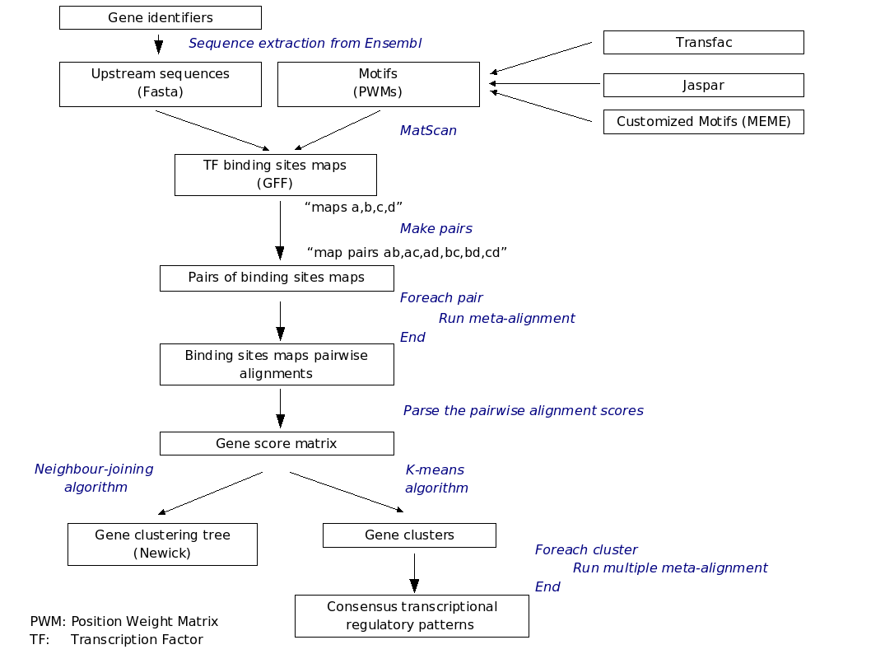

References
Birney, E. et al. (2006) Ensembl 2006. Nucleic Acids Res., 34, Database issue, D556-61.
Blanco, E. et al. (2006) Transcription factor map alignment of promoter regions. PLoS Comput. Biol., 2006, 2, e49.
Carrere, S. et al. (2006) REMORA: a pilot in the ocean of BioMoby web-services. Bioinformatics, 22, 900-1.
de Hoon, M.J.L. et al. (2004) Open source clustering software. Bioinformatics, 20, 1453-4.
Hull, D. et al. (2006) Taverna: a tool for building and running workflows of services. Nucleic Acids Res., 34, Web Server issue, W729-32.
Matys, V. et al. (2006) TRANSFAC and its module TRANSCompel: transcriptional gene regulation in eukaryotes. Nucleic Acids Res., 34, Database issue, D108-10.
Stevens, R.D. et al. (2004) Exploring Williams-Beuren syndrome using myGrid. Bioinformatics, 20 Suppl 1, I303-I310.
Vlieghe, D. et al. (2006) A new generation of JASPAR, the open-access repository for transcription factor binding site profiles. Nucleic Acids Res., 34, Database issue, D95-7.
Wasserman, W.W. et al. (2004) Applied bioinformatics for the identification of regulatory elements. Nat. Rev. Genet., 5, 276-87.
Wilkinson, M.D. et al. (2004) BioMOBY: an open source biological web services proposal. Brief. Bioinform., 3, 331-41.
Wray, G.A. et al. (2003) The evolution of transcriptional regulation in eukaryotes. Mol. Biol. Evol., 20, 1377-419.

* To whom correspondence should be addressed.

