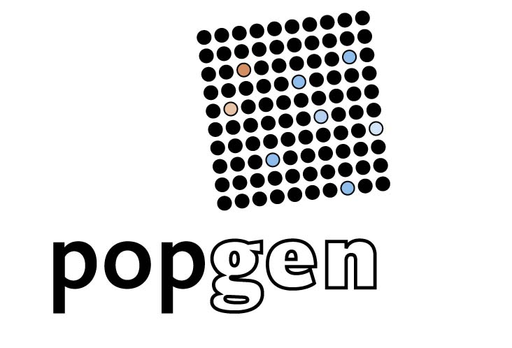
To the Biobank popgen
Project Management
Institute Epidemiology
Niemannsweg 11
D- 24105 Kiel
Germany
FAX: +49/431/597 3730
APPLICANT / PROJECT SPECIFICATION ref. no.
(to be filled in by administration) |________|_______/___|
Application of Data Access

Date of Application: 23.07.2015
Project Title:
Aging: Micorobiom, Metabolom und Metagenom

Responsible Scientist:
Name: ___Friederike Flachsbart und Almut Nebel__________________________
Institution: _IKMB_____________________________________________________

Address: ___Schittenhelmstr. 12______________________________________________________

_________________________________________________________________________

Other Scientist(s) involved:
Wolfgang Lieb
Andre Franke
Matthias laudes
Femke Heinsen
Malte Rühlemann
Guillermo Torres

Time Schedule for Project / Data Usage:

5.1. Duration of Project / Data Usage
(note that data must be deleted within two years after the end of the project):

From (dd,mm,yyyy): ___19.05.2015________________________________________

To (dd,mm,yyyy): ___19.05. 2020__________________________________________

Project Description: (approximately 1 page)

Durchführung des bewilligten Cluster-Projektes (Kooperation mit Bosch und Roeder)

4.) Analytical approaches in human samples
Study participants:
Five age groups will be studied (Group 1: 20-40 years, Group 2: 40-60 years, Group 3: 60-80 years, Group 4: 80-90 years, Group 5: 90+ years), each consisting of about 30 individuals, generating a total sample of about 150 study participants. The FOXO3A longevity-enabling allele is present at a frequency between 36-54% depending on age group (Flachsbart et al. 2009). Fecal as well as blood samples of 108 young and elderly individuals (25 - 85 years of age) are already available from the PopGen Biobank (in collaboration with Prof. Wolfgang Lieb, Director of Institute of Epidemiology / PopGen, Kiel). Furthermore, 16S rRNA gene data from these individuals have been already generated by the applicants’ laboratory and can be used for this project (pers. com. with Prof. Andre Franke, Institute of Clinical Molecular Biology, Kiel). Metagenome data (all present microbial genes) will be also available for a subset of these individuals. The recruitment for 42 study participants aged 80+ is currently ongoing.
Data generation:
DNA from fecal samples will be extracted. Bacterial 16S rRNA gene libraries for next generation sequencing will be generated and sequenced on the in-house Illumina MiSeq. Metagenome data will be generated for a subset of the 80+ study participants (n = 8) by shot gun sequencing on the in-house Illumina HiSeq. The data generation will be conducted in collaboration with Dr. Femke-Anouska Heinsen (RA V, Environmental Exposition of Barriers: Microbiome, Virome and Mucosa). The genetic variation in FOXO3A of all 150 study participants will be determined by the typing of single nucleotide polymorphisms (SNPs) known to be associated with human longevity. FOXO3A gene expression will be measured in a genotype-dependent manner via quantitative real time PCR (qRT-PCR) in a target.
Data analysis: FOXO3A-dependent microbial profiles, metagenomes and metabolomes will be investigated within and between the different age groups, monitoring changes throughout human life span.
Scientific Background / Questions/ Goals
Do microbial profiles, metagenomes and metabolomes influence human life span??

Research Hypothesis
Microbial profiles, metagenomes and metabolomes inluence and are influenced by human life span and longevity.
Power
Sufficient (about 150 probands)

Study Design and Analysis Methods
Analyses of microbial profiles, metagenomes and metabolomes dependent on FoxO activity as well as on oxidative and inflammatory status will be performed. To this end, the 16S rRNA gene analyses using USEARCH and in-house tools provide insight into the microbial composition (richness / diversity) of certain individuals / groups of individuals. Furthermore, the 16S rRNA gene data can be used to predict the functional content using PICRUST, which generates metagenome results in silico. Metagenomes are the collection of all genes present in the microbiota of a single individual and can help to understand the metabolic pathways present in the community. In addition, the “real” metagenome data of the subset of study participants will unravel the functional properties in more detail.

Potential Conclusions, Relevance of Outcome
Investigation in which regard microbial profiles, metagenomes and metabolomes inluence and are influenced by human life span and longevity.

SPECIFICATION OF DATA

Target Group: (exact description of patients/probands for whom data items are requested)
- Erweiterte Gruppenzusammenstellung für Probanden älter als 60 Jahre, nachdem wir die Phänotypinformationen von Lukas erhalten haben (wir haben jetzt aus den Gruppen 60-79 und 80plus die Gesunden ausgewählt)
- Hierfür müsste Femke eine Liste von IDs bekommen (center code), um uns die Rohsequenzdaten geben zu können und an die Alter- und Geschlechtsinformationen müssten wir so auch rankommen können...
60-79
FOC_083
FOC_105
FOC_114
FOC_138
FOC_145
FOC_166
FOC_177
FOC_194
FOC_197
FOC_212
FOC_213
FOC_214
FOC_220
FOC_224
FOC_225
FOC_236
FOC_241
FOC_249
FOC_253
FOC_254
FOC_259
FOC_270
FOC_271
FOC_273
FOC_291
FOC_297
FOC_306
FOC_311
FOC_321
FOC_322
FOC_325
FOC_329
FOC_331
FOC_334
FOC_341
FOC_343
FOC_346
FOC_350
FOC_356
FOC_364
FOC_366
BSPSPC_008
BSPSPC_020
BSPSPC_034
BSPSPC_039
BSPSPC_044
BSPSPC_049
BSPSPC_056
BSPSPC_090
BSPSPC_096
BSPSPC_098
BSPSPC_100
BSPSPC_135
BSPSPC_141
BSPSPC_147
BSPSPC_159
BSPSPC_162
BSPSPC_163
BSPSPC_165
BSPSPC_168
BSPSPC_171
BSPSPC_173
BSPSPC_186
BSPSPC_189
BSPSPC_190
BSPSPC_233
BSPSPC_245
BSPSPC_250
BSPSPC_253
BSPSPC_263
BSPSPC_272
BSPSPC_274
BSPSPC_278
BSPSPC_288
BSPSPC_300
BSPSPC_310
BSPSPC_318
BSPSPC_349
BSPSPC_366
BSPSPC_388
BSPSPC_389
BSPSPC_393
BSPSPC_398
BSPSPC_404
BSPSPC_421
BSPSPC_443
BSPSPC_446
BSPSPC_462
BSPSPC_468
BSPSPC_475
BSPSPC_489

80plus
FOC_398
FOC_399
BSPSPC_490
BSPSPC_492
BSPSPC_493
BSPSPC_494
BSPSPC_495
BSPSPC_496
BSPSPC_497
BSPSPC_499
BSPSPC_500
BSPSPC_501
BSPSPC_502
BSPSPC_503
BSPSPC_504
BSPSPC_505
BSPSPC_506
BSPSPC_509
BSPSPC_510
BSPSPC_511
BSPSPC_513
BSPSPC_514
BSPSPC_515
BSPSPC_516
BSPSPC_517
BSPSPC_518

Requested Genotype Data:
16S-RNA data

Requested Phenotype Data Items:

Alter und Geschlecht (würde dann ja über den center code und Xptools gehen) der Rest kommt später – jetzt müssten wir über Femke auf die 16S-Roh-Seq-Daten zugreifen können.

Statistical Resources for Data Usage: (e.g. personnel, know-how, software, equipment)
Bioinformatische Analyse über Doktorand Guillermo Torres mit support von Femke Heinsen und Malte Rühlemann (Andre Franke weiss Bescheid)

Shipment address (if notwithstanding to Pos. 3):
Name: _____________________________________________________________

Institution: ___________________________________________________________

Address: _____________________________________________________________

_____________________________________________________________

_____________________________________________________________

Favoured shipment way:

___________________________________________________

Favoured shipper:

Name: ____________________________________________________

Customer code: ____________________________________________

ADDITIONAL INFORMATION

Anticipated Publications:
Any publication of results with a significant contribution by popgen must involve the co-authorship of one or more popgen representatives.

The following sentence should appear in the acknowledgement: “popgen 2.0 network is supported by a grant from the German Ministry for Education and Research (01EY1103)”

Finances/ Billing Information:

Estimated Costs:

Sources of Funding: gefördertes Clusterprojekt

Applicants agree to cover all costs

incurred by the transfer of the data.

Further Remarks:
Access to, and handling of, the data have to comply with the following regulations:
- Data Management Concept for popgen (Version 0.4 of 19 May 2006),
- Cooperation Agreement between popgen and Cooperating Scientists
- Positive Vote by local Ethics Committee (or equivalent)
The applicant(s) recognize the above regulations and will obey all their terms and conditions. The applicant(s) recognize that the right to use popgen data is limited to the contracted cooperation. Any transfer of data to a third party or commercial usage of the data is prohibited. popgen will not be subject to any liability arising from the transfer. All popgen data have to be deleted within two years after the end of the cooperative project.

Further Remarks by the Applicant(s):

SIGNATURES

Applicant(s)

Kiel, 27.07.2015 F.Flachsbart
Location, Date

Released

---------------------------------------------- ----------------------------------------------
Date popgen Project Management

---------------------------------------------- ----------------------------------------------
Date popgen Scientific Board

---------------------------------------------- ----------------------------------------------
Date Subproject Leader (if necessary)

