There should be four images below:

0. 

1. 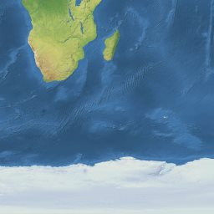

2. 

3. desc

…and the same in a table

| Name |
| --- |
| 0. desc |
| 1. desc |
| 2. desc |
| 3. desc |