LeetCode20 ：easy

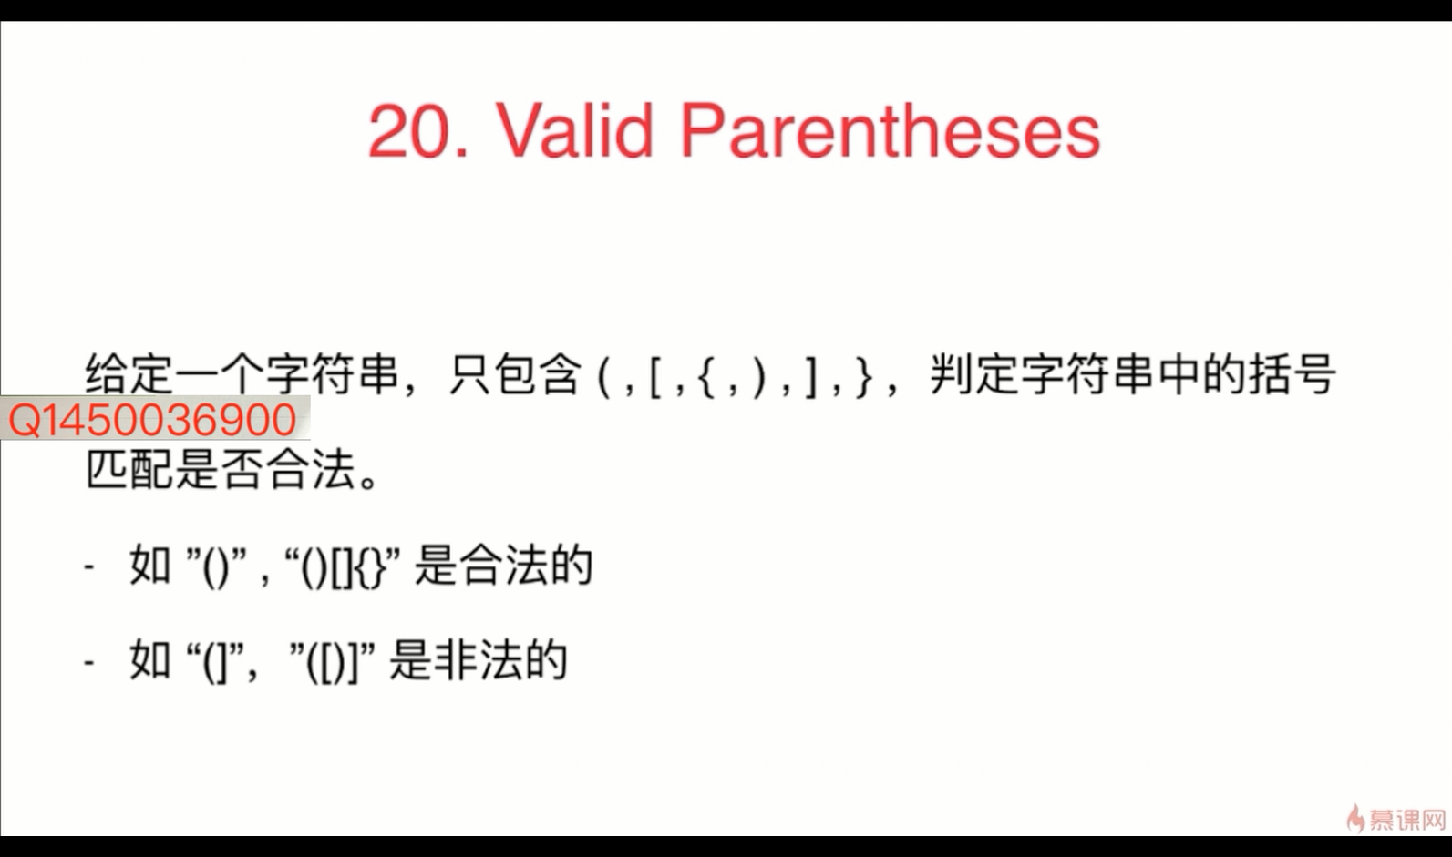
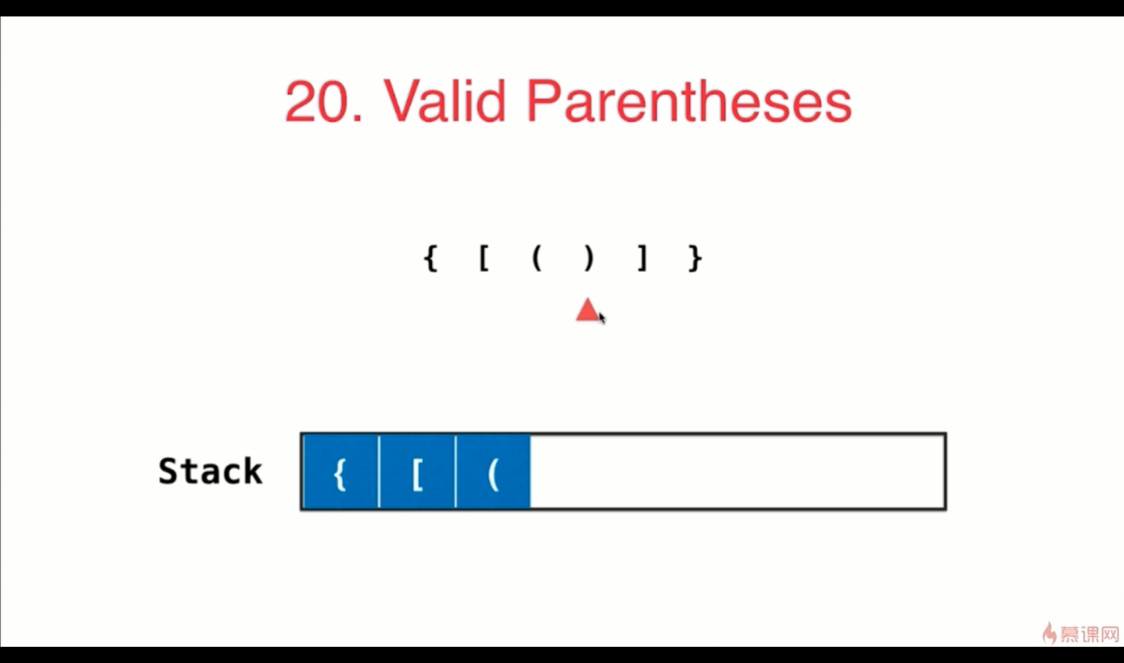

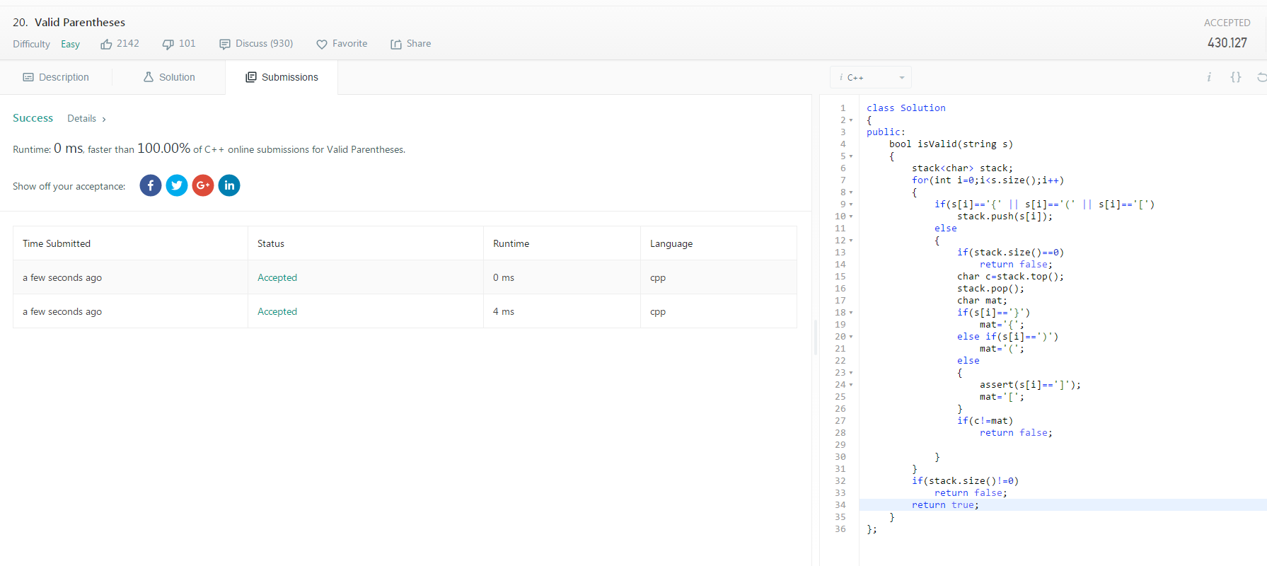

class Solution
{
public:
bool isValid(string s)
{
stack<char> stack;
for(int i=0;i<s.size();i++)
{
if(s[i]=='{' || s[i]=='(' || s[i]=='[')
stack.push(s[i]);
else
{
if(stack.size()==0)
return false;
char c=stack.top();
stack.pop();
char mat;
if(s[i]=='}')
mat='{';
else if(s[i]==')')
mat='(';
else
{
assert(s[i]==']');
mat='[';
}
if(c!=mat)
return false;

}
}
if(stack.size()!=0)
return false;
return true;
}
};

LeetCode150 ：medium
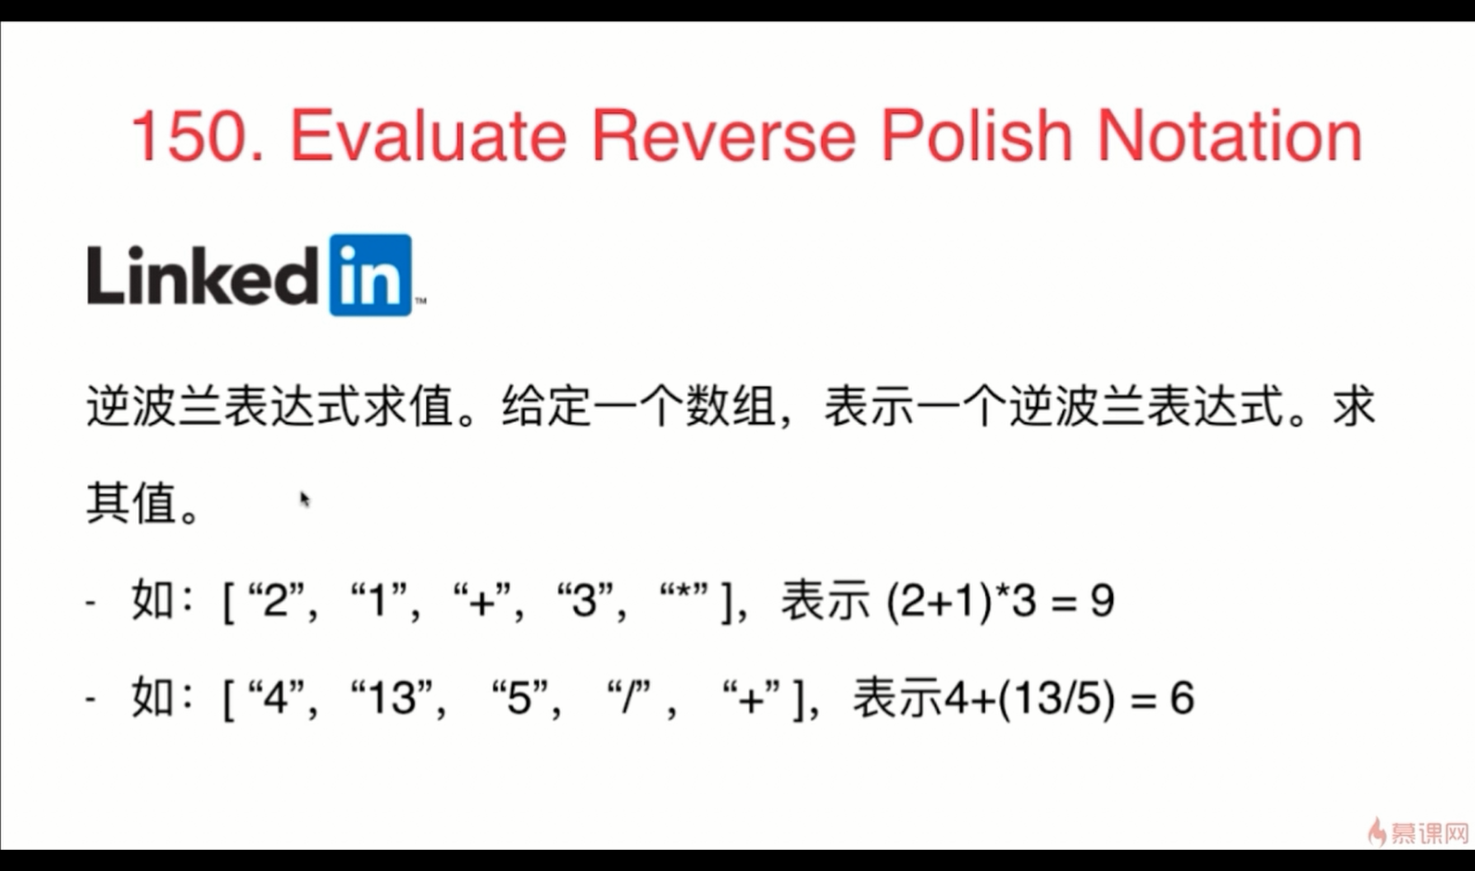
Evaluate the value of an arithmetic expression in Reverse Polish Notation.
Valid operators are +, -, *, /. Each operand may be an integer or another expression.
Note:
- Division between two integers should truncate toward zero.
- The given RPN expression is always valid. That means the expression would always evaluate to a result and there won't be any divide by zero operation.
Example 1:
Input: ["2", "1", "+", "3", "*"]Output: 9Explanation: ((2 + 1) * 3) = 9
Example 2:
Input: ["4", "13", "5", "/", "+"]Output: 6Explanation: (4 + (13 / 5)) = 6
Example 3:
Input: ["10", "6", "9", "3", "+", "-11", "*", "/", "*", "17", "+", "5", "+"]Output: 22Explanation:
((10 * (6 / ((9 + 3) * -11))) + 17) + 5
= ((10 * (6 / (12 * -11))) + 17) + 5
= ((10 * (6 / -132)) + 17) + 5
= ((10 * 0) + 17) + 5
= (0 + 17) + 5
= 17 + 5
= 22

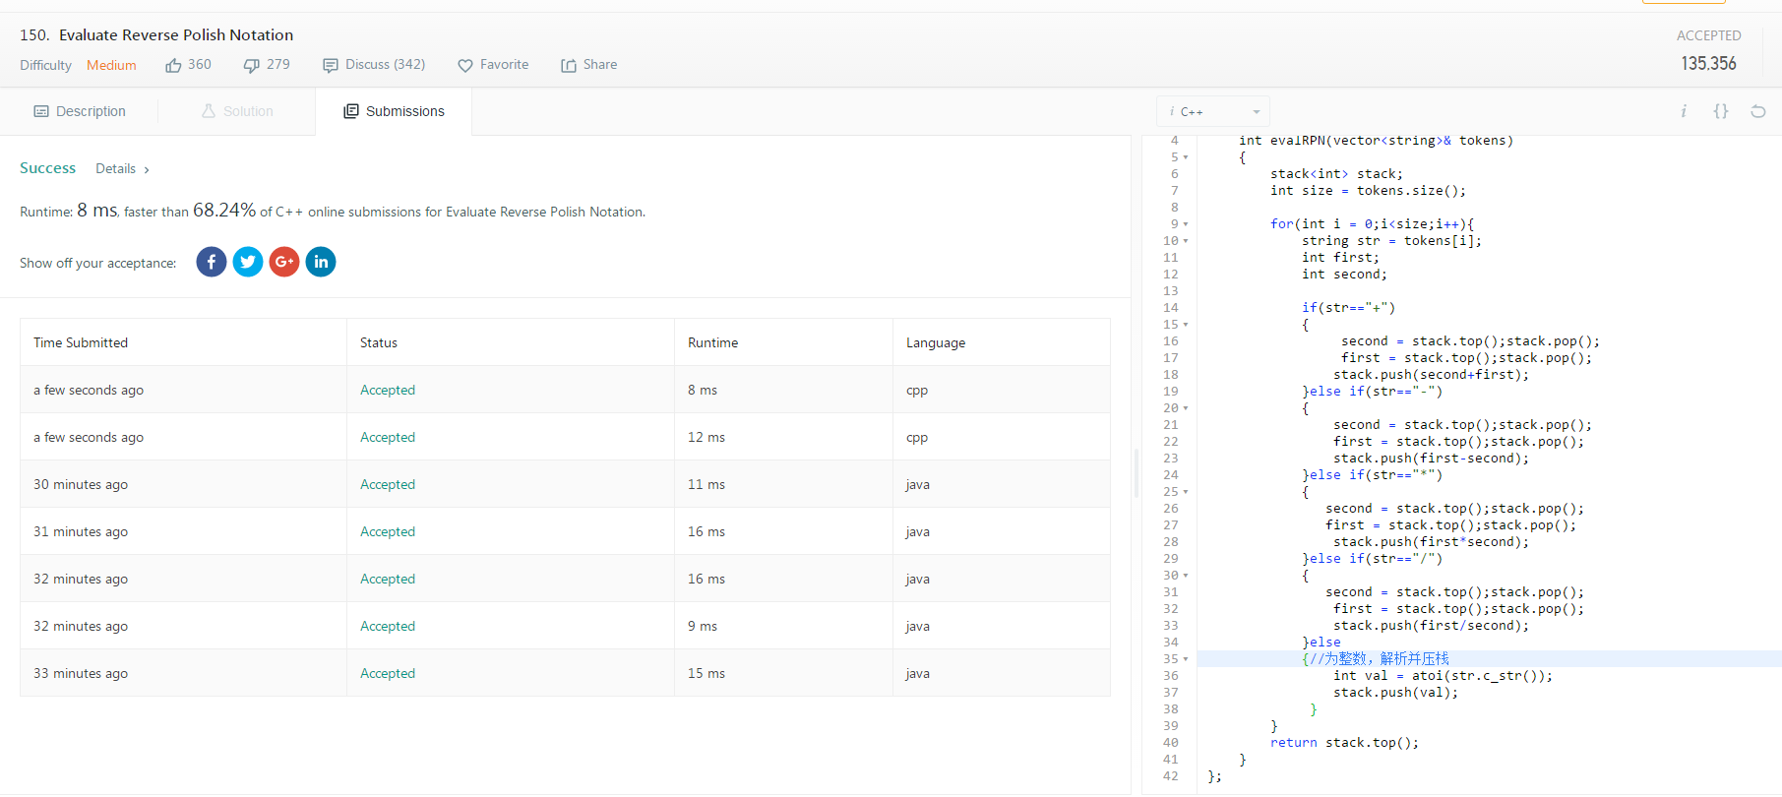

class Solution
{
public:
int evalRPN(vector<string>& tokens)
{
stack<int> stack;
int size = tokens.size();

for(int i = 0;i<size;i++){
string str = tokens[i];
int first;
int second;

if(str=="+")
{
second = stack.top();stack.pop();
first = stack.top();stack.pop();
stack.push(second+first);
}else if(str=="-")
{
second = stack.top();stack.pop();
first = stack.top();stack.pop();
stack.push(first-second);
}else if(str=="*")
{
second = stack.top();stack.pop();
first = stack.top();stack.pop();
stack.push(first*second);
}else if(str=="/")
{
second = stack.top();stack.pop();
first = stack.top();stack.pop();
stack.push(first/second);
}else
{//为整数，解析并压栈
int val = atoi(str.c_str());
stack.push(val);
}
}
return stack.top();
}
};

class Solution
{
public int evalRPN(String[] tokens)
{

int len = tokens.length;

if( len == 0)
return 0;
Stack<Integer> stack = new Stack<Integer>();
for( int i = 0 ; i < len ; i ++ ){

if( tokens[i].equals("+") ){
int num1 = stack.pop();
int num2 = stack.pop();
stack.push(num1+num2);
}
else if( tokens[i].equals("-") ){
int num1 = stack.pop();
int num2 = stack.pop();
stack.push(num2-num1);
}
else if( tokens[i].equals("*") ){
int num1 = stack.pop();
int num2 = stack.pop();
stack.push(num1*num2);
}
else if( tokens[i].equals("/") ){
int num1 = stack.pop();
int num2 = stack.pop();
stack.push(num2/+num1);

}else{
stack.push(Integer.valueOf(tokens[i]));
//Integer.valueOf(s)把字符串s解析成Integer对象类型，返回的integer 可以调用对象中的方法
}

}
return stack.pop();
}
}

LeetCode20 ：easy

LeetCode20 ：easy

LeetCode20 ：easy

