LeetCode24 ：medium

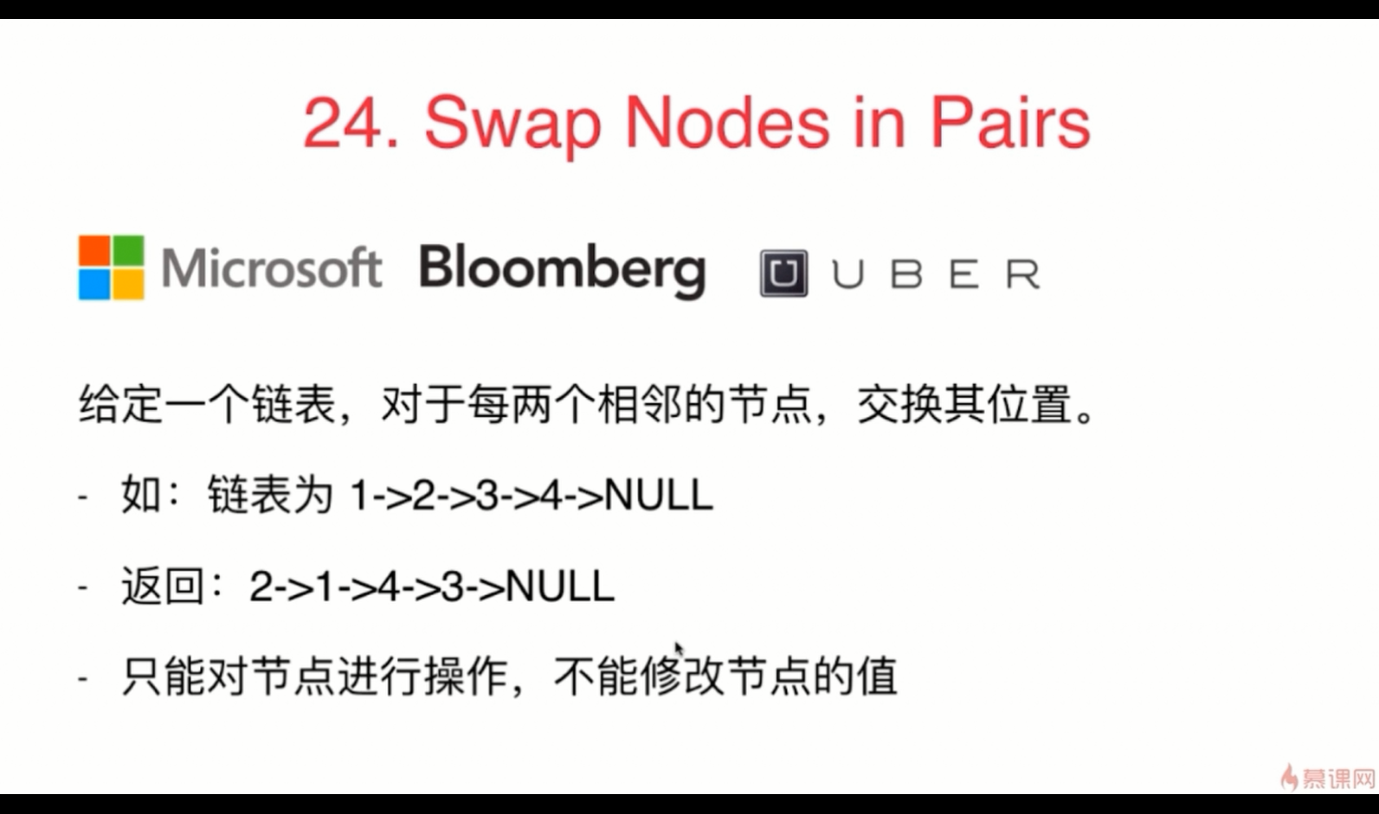

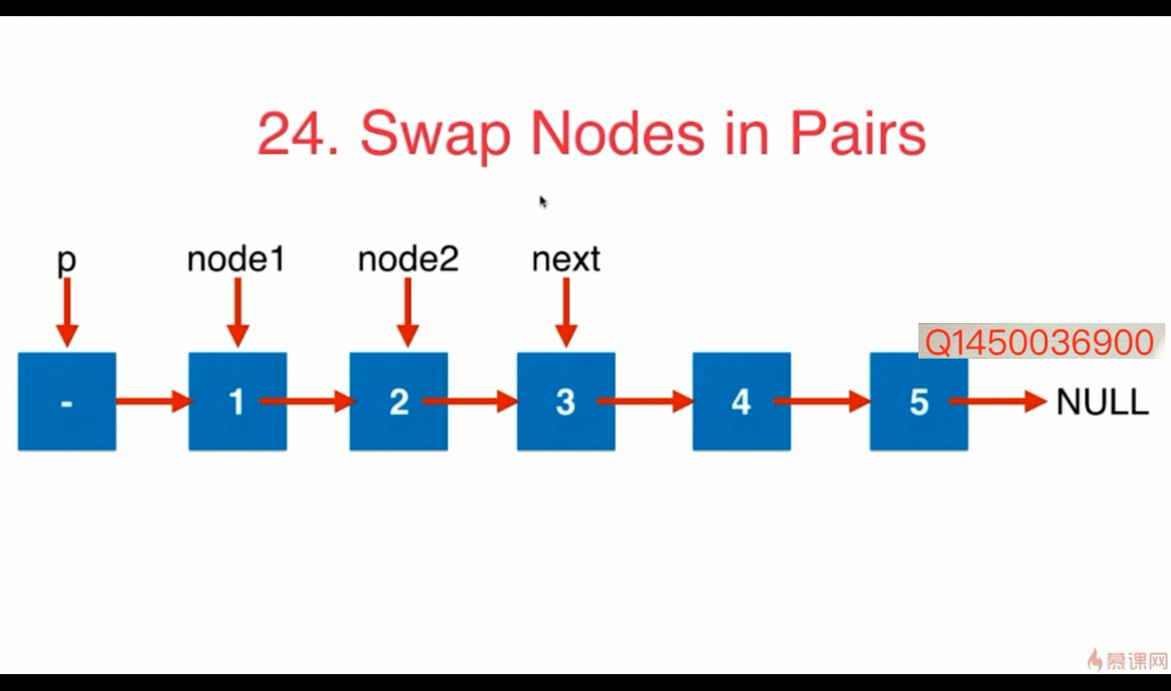

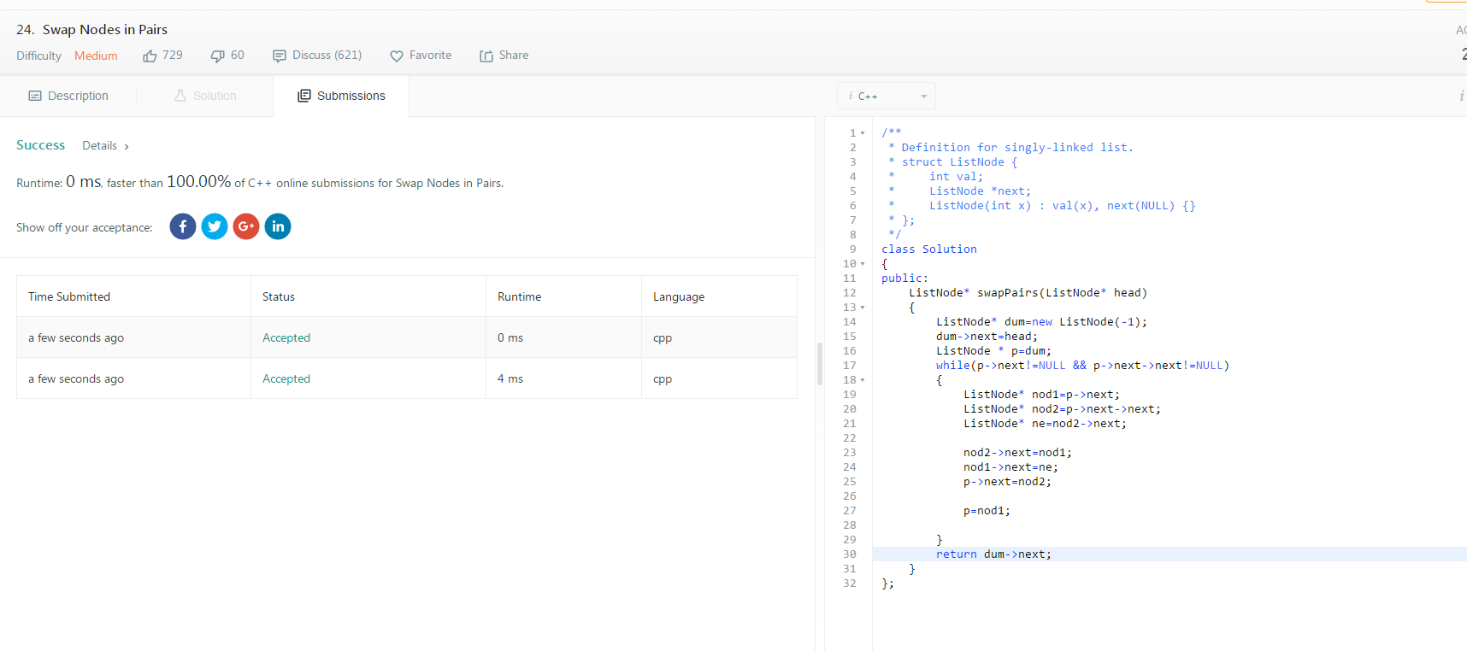

/**
* Definition for singly-linked list.
* struct ListNode {
* int val;
* ListNode *next;
* ListNode(int x) : val(x), next(NULL) {}
* };
*/
class Solution
{
public:
ListNode* swapPairs(ListNode* head)
{
ListNode* dum=new ListNode(-1);
dum->next=head;
ListNode * p=dum;
while(p->next!=NULL && p->next->next!=NULL)
{
ListNode* nod1=p->next;
ListNode* nod2=p->next->next;
ListNode* ne=nod2->next;

nod2->next=nod1;
nod1->next=ne;
p->next=nod2;

p=nod1;

}
return dum->next;
}
};

LeetCode25 ：hard

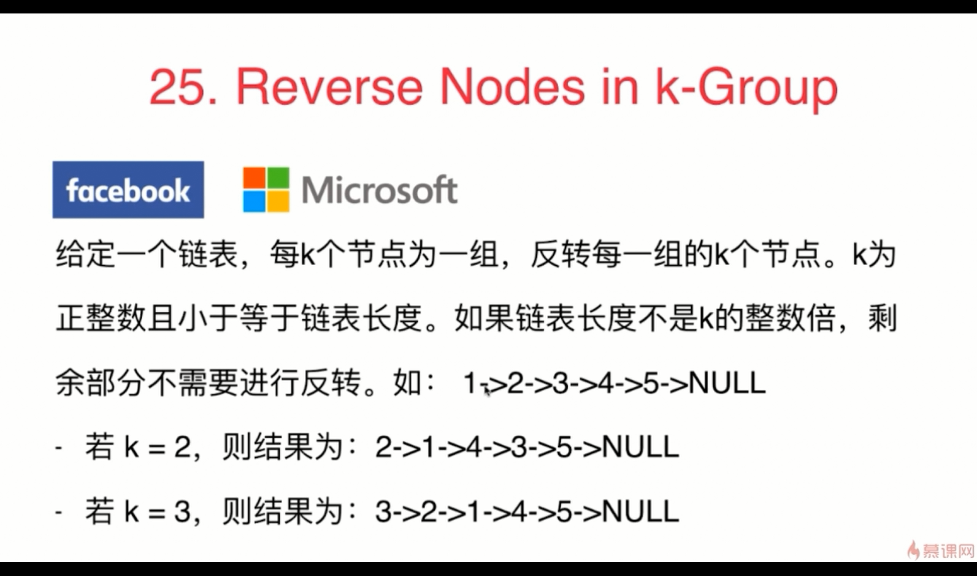

/**
* Definition for singly-linked list.
* public class ListNode {
* int val;
* ListNode next;
* ListNode(int x) { val = x; }
* }
*/
class Solution
{
public ListNode reverseKGroup(ListNode head, int k)
{
if(head == null)
return null;
ListNode fake=new ListNode(0);
fake.next = head;
ListNode l = head;
int count = 0;
while(l != null)
{
count++;
l = l.next;
}
if(k>count)
return head;
ListNode after = null;
l = head;
ListNode pre = l.next;
for(int i=0; i<k ; i++)
{
fake.next = l;
l.next = after;
after = l;
l = pre;
if(pre != null)
pre = pre.next;
}
head.next=reverseKGroup(l,k);
return fake.next;
//1. 取链表的前K个节点，如果够K个节点，就截断后进行反转，不够K个节点，说明处理完了，return
//2. 反转完前K个节点后，使用递归，处理后面的链表
}

}

LeetCode147 ：medium

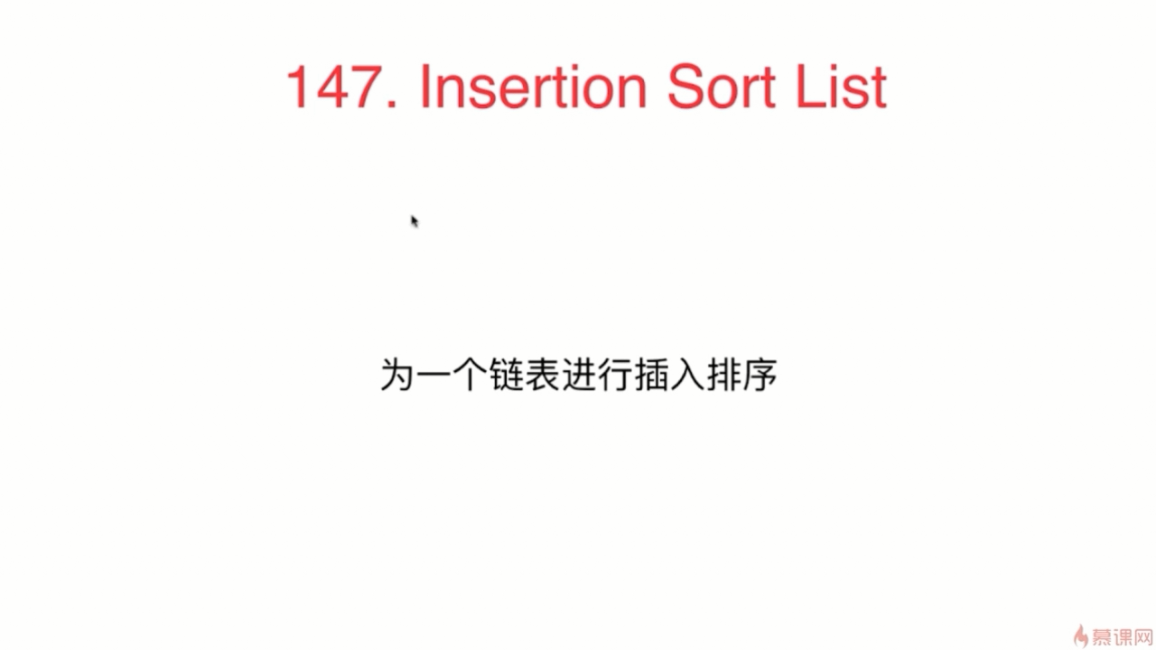

/**
* Definition for singly-linked list.
* struct ListNode {
* int val;
* ListNode *next;
* ListNode(int x) : val(x), next(NULL) {}
* };
*/
class Solution
{
public:
ListNode* insertionSortList(ListNode* head)
{
if(head==NULL||head->next==NULL) //bug1:特殊情况处理。
return head;
ListNode* cur=head;
ListNode* next=head;
ListNode* new_head=NULL;
ListNode* new_tail=NULL;
while(cur!=NULL)
{
next=cur->next;
if(new_head==NULL)
{ //如果新链表的头结点为空
new_head=cur;
new_tail=cur;
new_tail->next=NULL;
}
else
{
ListNode* tmp_pre=NULL;
ListNode* tmp_cur=new_head;
while(tmp_cur!=NULL&&cur->val>tmp_cur->val)
{ //bug2:注意不能少了判断语句tmp_cur!=NULL
tmp_pre=tmp_cur;
tmp_cur=tmp_cur->next;
}
if(tmp_pre==NULL)
{//假如旧元素放入新链表的表头
cur->next=new_head;
new_head=cur;
}
else if(tmp_cur==NULL)
{ //就如旧元素放入新链表的表尾
new_tail->next=cur;
new_tail=cur;
new_tail->next=NULL; //bug3:不要忘了tail节点还要用NULL表示节点
}
else
{//假如旧元素放入新链表的表中
cur->next=tmp_cur;
tmp_pre->next=cur;
}
}
cur=next;
}
return new_head;
}
};
/*
1 要记得把排序好的新链表和待排序的旧链表断开，也就是排序好的新链表的尾节点要赋值NULL。否则最后就乱了。
2 什么叫做插入排序，从A[1]到A[n]，依次把旧链表中的旧元素放入新链表的正确位置中，新链表是从没有元素开始逐渐排好序的，每加入一个旧元素，就把它放入正确的位置中。有三种可能的位置，新链表的表头，新链表的表中，新链表的表尾，因为在不同的位置会造成对head和tail指针做不同的处理，所以需要分情况讨论。
*/

LeetCode148 ：medium

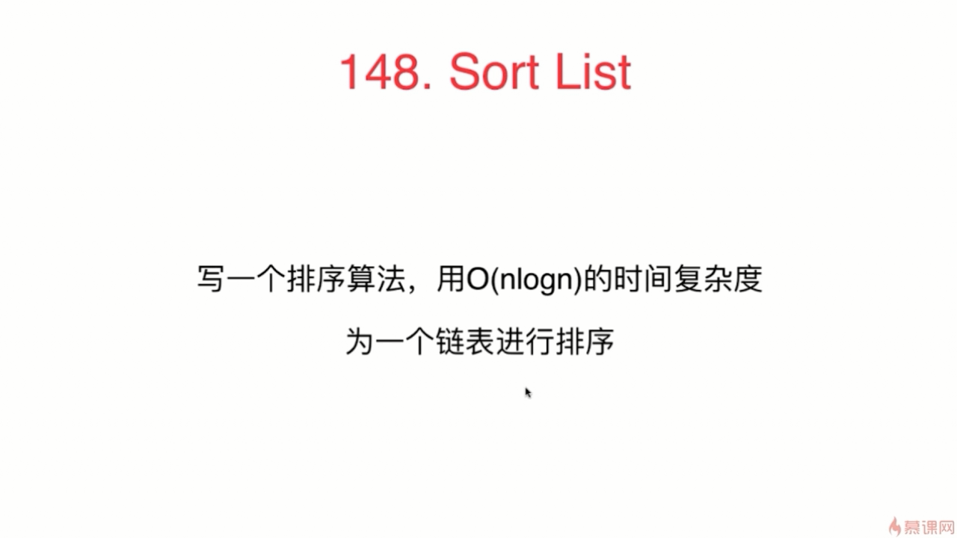

//题目要求：对链表进行排序
//解题思路：归并排序，再Merge
//归并排序的基本思想是：找到链表的中间节点，然后递归对前半部分和后半部分分别进行归并排序，最后对两个排好序的链表进行Merge
class Solution {
public:
ListNode* sortList(ListNode* head) {
if (head == NULL || head->next == NULL) return head;

//快慢指针找到中间节点
ListNode *fast = head, *slow = head;
while (fast->next != NULL && fast->next->next != NULL)
{
fast = fast->next->next;
slow = slow->next;
}
//断开
fast = slow;
slow = slow->next;
fast->next = NULL;

ListNode *l1 = sortList(head); //前半段排序
ListNode *l2 = sortList(slow); //后半段排序
return mergeTwoLists(l1, l2);
}

//Merge Two Sorted Lists
ListNode *mergeTwoLists(ListNode *l1, ListNode *l2){
ListNode dummy(-1);
for (ListNode* p = &dummy; l1 != NULL || l2 != NULL; p = p->next)
{
int val1 = l1 == NULL ? INT_MAX : l1->val;
int val2 = l2 == NULL ? INT_MAX : l2->val;
if (val1 <= val2)
{
p->next = l1;
l1 = l1->next;
}
else
{
p->next = l2;
l2 = l2->next;
}
}
return dummy.next;
}
};

LeetCode237 ：easy

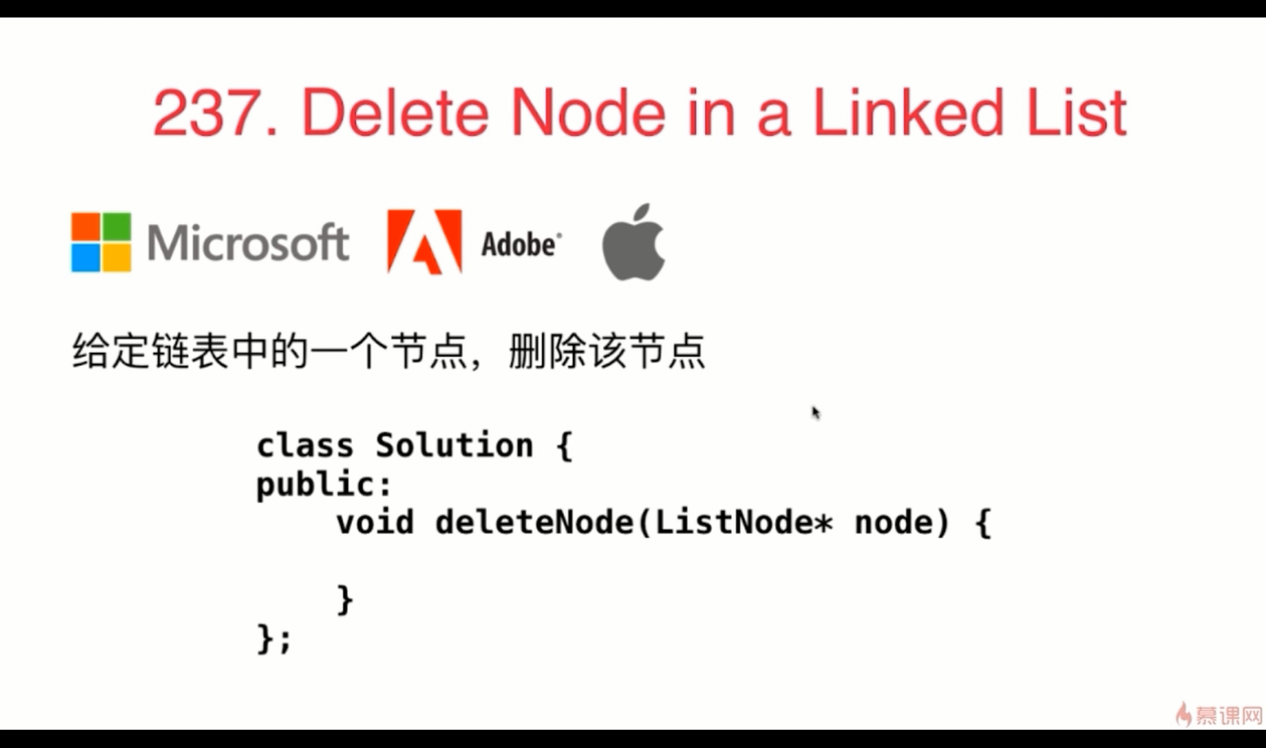

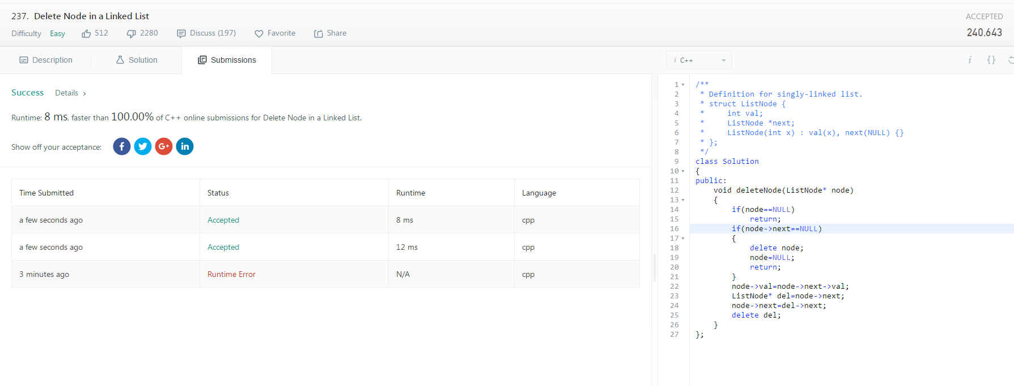

/**
* Definition for singly-linked list.
* struct ListNode {
* int val;
* ListNode *next;
* ListNode(int x) : val(x), next(NULL) {}
* };
*/
class Solution
{
public:
void deleteNode(ListNode* node)
{
if(node==NULL)
return;
if(node->next==NULL)
{
delete node;
node=NULL;
return;
}
node->val=node->next->val;
ListNode* del=node->next;
node->next=del->next;
delete del;
}
};

LeetCode19 ：medium

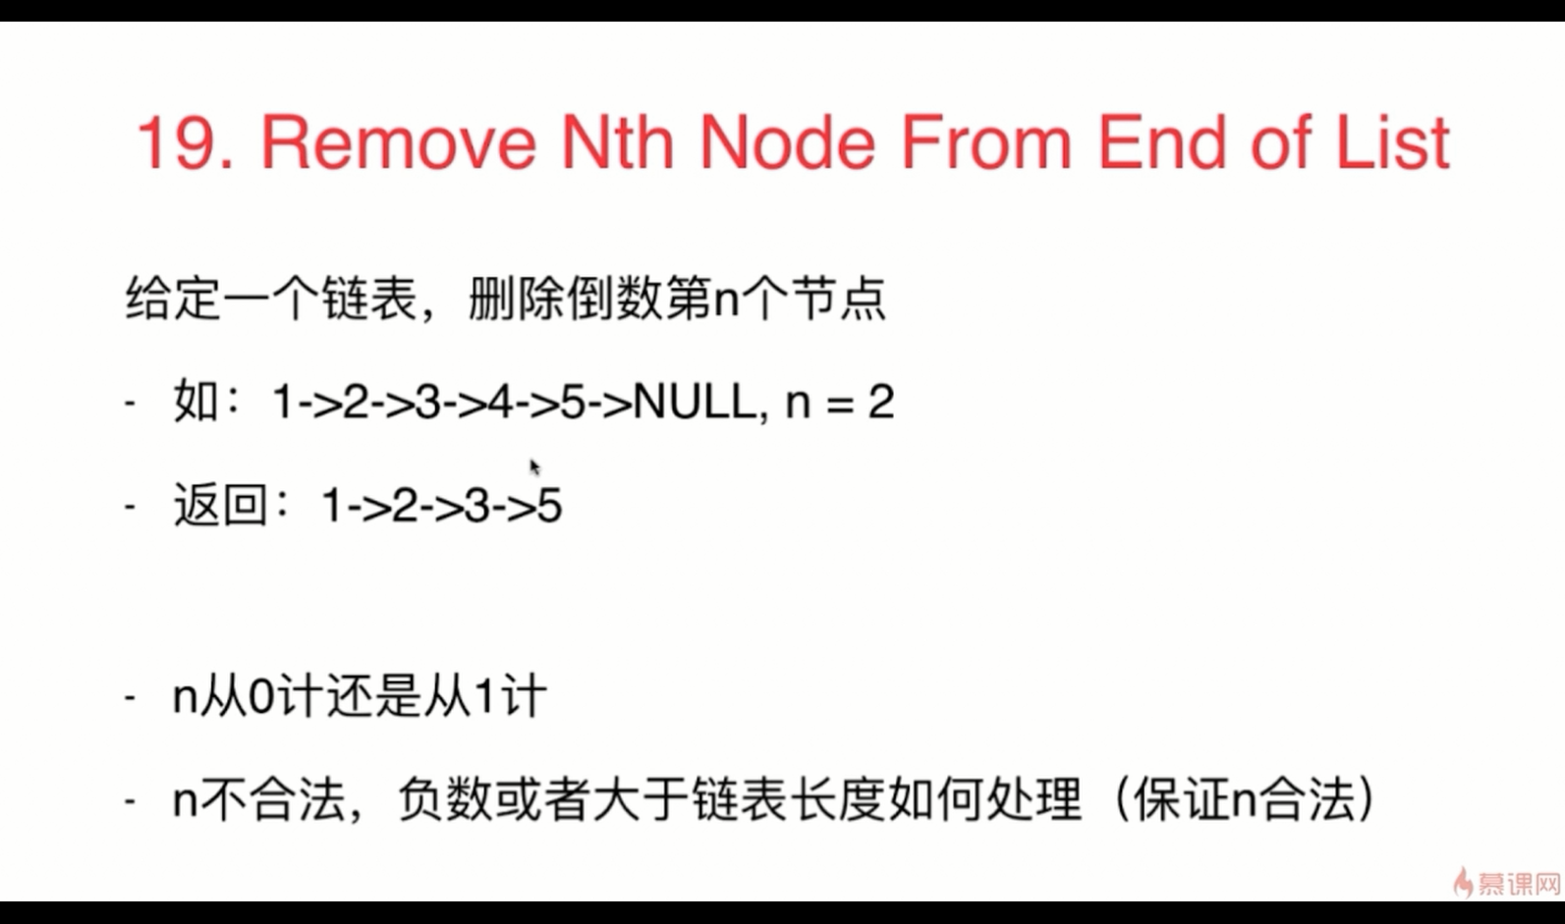

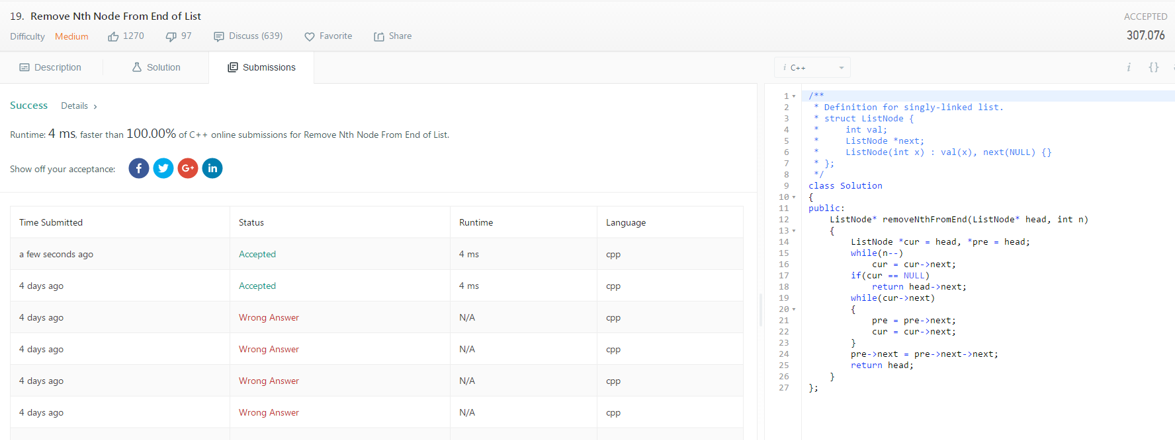

/**
* Definition for singly-linked list.
* struct ListNode {
* int val;
* ListNode *next;
* ListNode(int x) : val(x), next(NULL) {}
* };
*/
class Solution
{
public:
ListNode* removeNthFromEnd(ListNode* head, int n)
{
ListNode *cur = head, *pre = head;
while(n--)
cur = cur->next;
if(cur == NULL)
return head->next;
while(cur->next)
{
pre = pre->next;
cur = cur->next;
}
pre->next = pre->next->next;
return head;
}
};

LeetCode61 ：medium

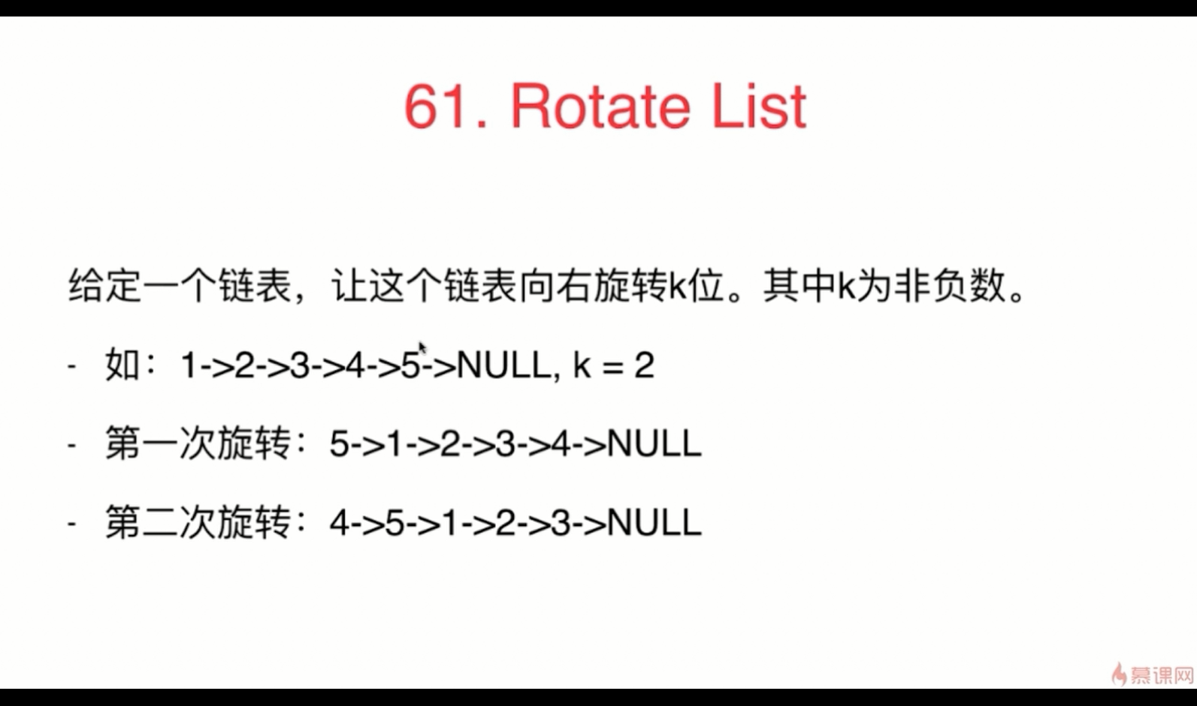

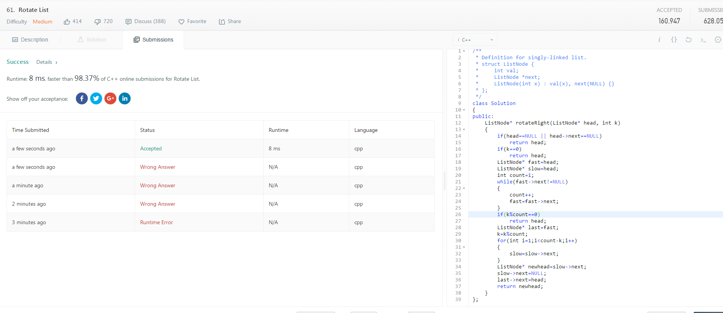

/**
* Definition for singly-linked list.
* struct ListNode {
* int val;
* ListNode *next;
* ListNode(int x) : val(x), next(NULL) {}
* };
*/
class Solution
{
public:
ListNode* rotateRight(ListNode* head, int k)
{
if(head==NULL || head->next==NULL)
return head;
if(k==0)
return head;
ListNode* fast=head;
ListNode* slow=head;
int count=1;
while(fast->next!=NULL)
{
count++;
fast=fast->next;
}
if(k%count==0)
return head;
ListNode* last=fast;
k=k%count;
for(int i=1;i<count-k;i++)
{
slow=slow->next;
}
ListNode* newhead=slow->next;
slow->next=NULL;
last->next=head;
return newhead;
}
};

LeetCode143 ：medium
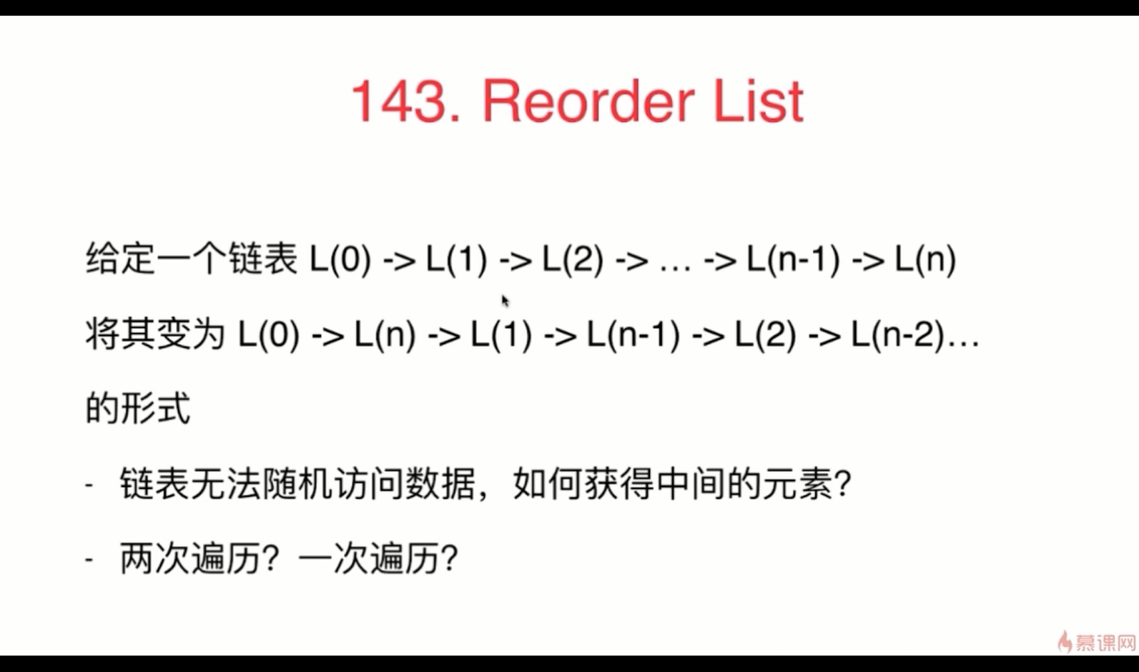

/**
* Definition for singly-linked list.
* struct ListNode {
* int val;
* ListNode *next;
* ListNode(int x) : val(x), next(NULL) {}
* };
*/
class Solution
{
private:
ListNode* reverse(ListNode* head)
{
if(head==NULL || head->next==NULL)
return head;
ListNode* cur=head;
ListNode* nex1=head->next;
head->next=NULL;
while(nex1!=NULL)
{
ListNode* nex2=nex1->next;
nex1->next=cur;
cur=nex1;
nex1=nex2;
}
return cur;
}
public:
void reorderList(ListNode* head)
{
if(head==NULL || head->next==NULL)
return;
ListNode* slow=head;
ListNode* fast=head->next;
while(fast!=NULL && fast->next!=NULL)
{
slow=slow->next;
fast=fast->next->next;
}
fast=slow->next;
slow->next=NULL;
ListNode* l1=head;
ListNode* l2=fast;
ListNode* l3=reverse(l2);
head=l1;
ListNode* l1ne=l1->next;
ListNode* l3ne=l3->next;
while(l3!=NULL)
{
l1->next=l3;
l3->next=l1ne;
l1=l1ne;
if(l1ne==NULL || l3ne==NULL)
break;
l1ne=l1ne->next;
l3=l3ne;
l3ne=l3ne->next;
}
}
};

LeetCode234 ：easy

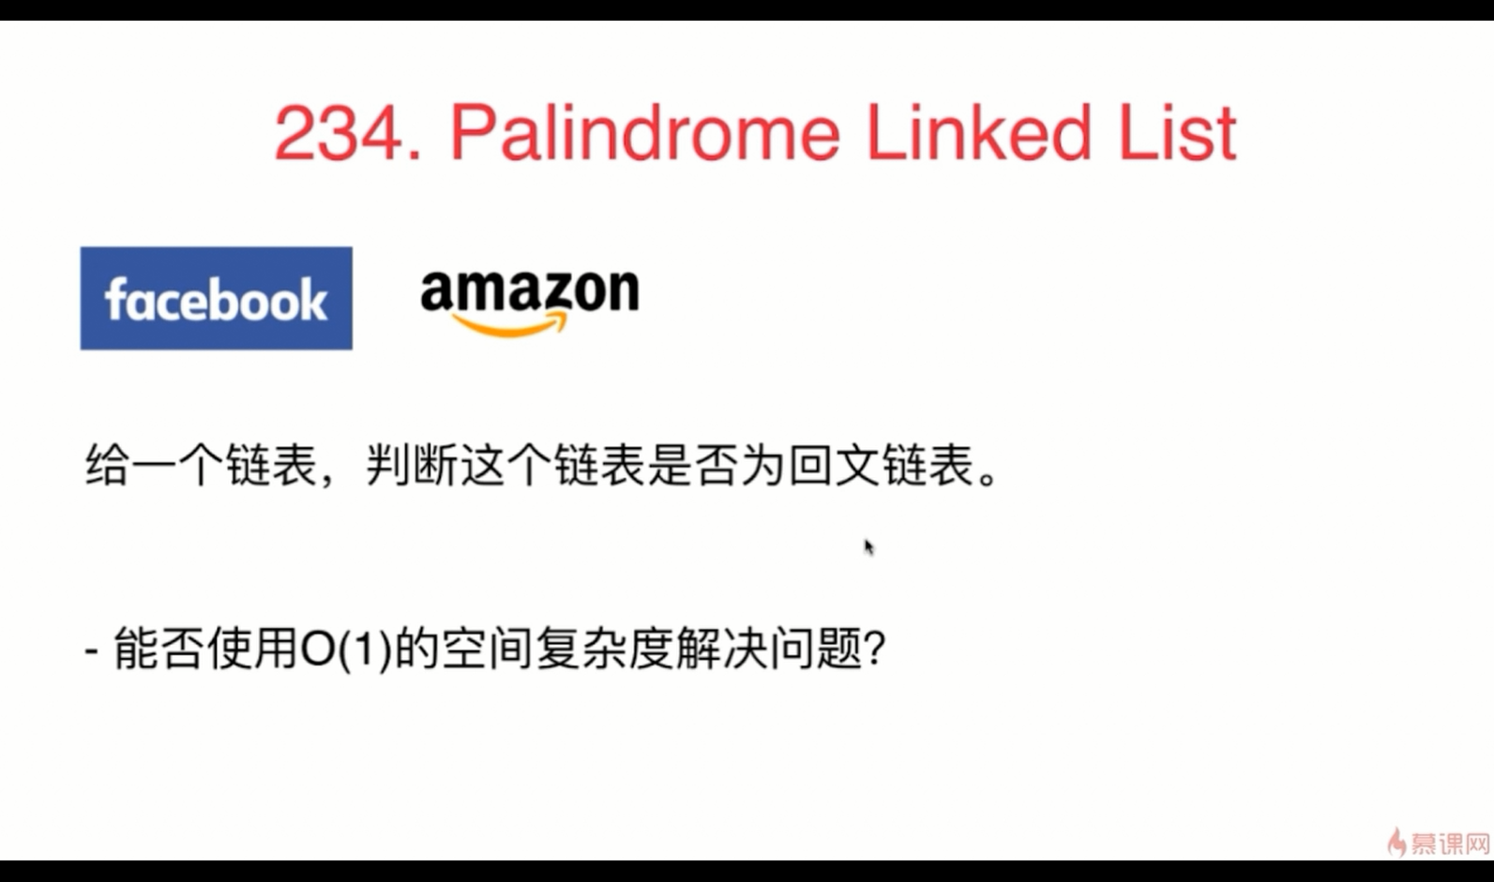

Given a singly linked list, determine if it is a palindrome.
Example 1:
Input: 1->2Output: false
Example 2:
Input: 1->2->2->1Output: true
Follow up:
Could you do it in O(n) time and O(1) space?

/**
* Definition for singly-linked list.
* struct ListNode {
* int val;
* ListNode *next;
* ListNode(int x) : val(x), next(NULL) {}
* };
*/
class Solution
{
private:
ListNode* reverse(ListNode* head)
{
if(head==NULL || head->next==NULL)
return head;
ListNode* cur=head;
ListNode* nex1=head->next;
head->next=NULL;
while(nex1!=NULL)
{
ListNode* nex2=nex1->next;
nex1->next=cur;
cur=nex1;
nex1=nex2;
}
return cur;
}
public:
bool isPalindrome(ListNode* head)
{
if(head==NULL || head->next==NULL)
return true;
ListNode* slow=head;
ListNode* fast=head->next;
while(fast!=NULL && fast->next!=NULL)
{
slow=slow->next;
fast=fast->next->next;
}
fast=slow->next;
slow->next=NULL;
ListNode* l1=head;
ListNode* l2=fast;
ListNode* l3=reverse(l2);
while(l1!=NULL && l3!=NULL)
{
if(l1->val!=l3->val)
return false;
else
{
l1=l1->next;
l3=l3->next;
}
}
return true;
}
};

