**1. This query retrieves the names of all hospitals and their operation hours.**

**Query**:  
SELECT h_name AS hospital_name, operation_hours

FROM Hospital;

**Result:**

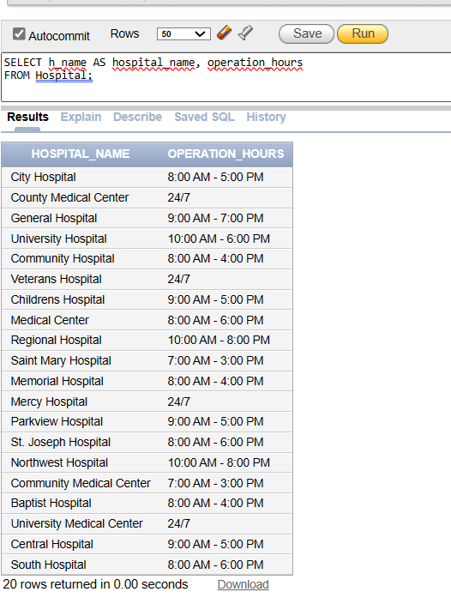

**2. This query retrieves the names of patients along with the names of the hospitals they are admitted to.**

**Query:**  
SELECT p.FirstName || ' ' || p.LastName AS patient_name, h.h_name AS hospital_name

FROM Patient p

JOIN Hospital h ON p.hos_id = h.hospital_id;

**Result:**

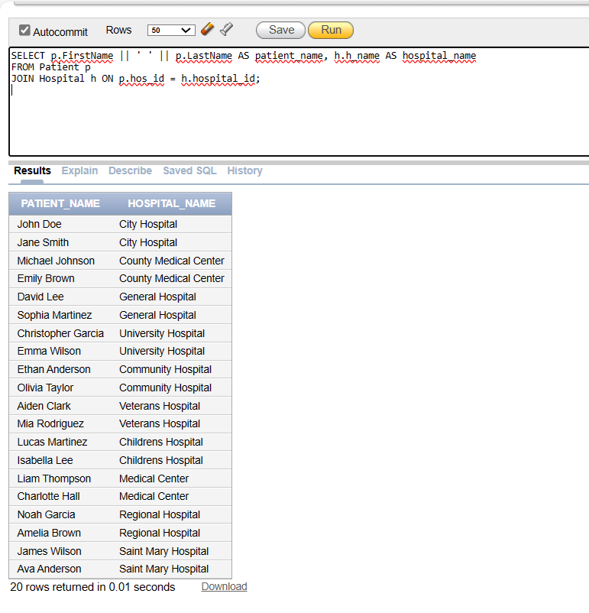

**3. Query to count the number of patients in each hospital**

**Query:**

SELECT h.h_name, COUNT(p.patient_id) AS patient_count

FROM Hospital h

JOIN Patient p ON h.hospital_id = p.hos_id

GROUP BY h.h_name;

**Result:**

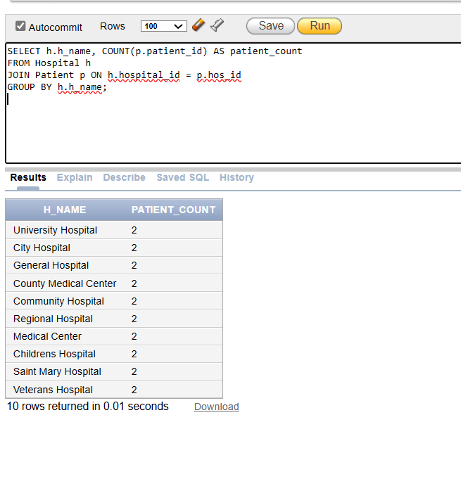

**4. This query calculates the total blood donation quantity by gender.**

**Query:**

SELECT

d.gender,

SUM(bs.stored_blood_quantity) AS total_donation_quantity

FROM Donor d

JOIN Blood_stored bs ON d.bc_id = bs.bc_id

GROUP BY d.gender;

**Result:**

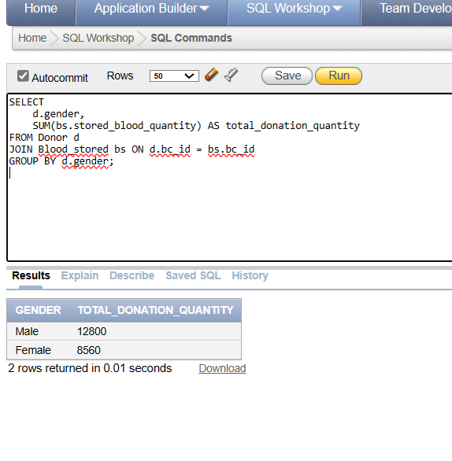

**5. Retrieves distinct requested blood groups that are available at specific blood donation camps with a stored quantity greater than zero, and provides the names of those camps.**

**Query:**

SELECT

DISTINCT bs.blood_type as Requested_blood_group,

bc.bc_name as Available_at_blood_camps

FROM blood_camp bc,blood_stored bs

WHERE bs.bc_id = bc.bc_id

AND bs.blood_type in

(SELECT

DISTINCT r.blood_group

FROM request r)

AND bs.stored_blood_quantity > 0

GROUP by bs.blood_type,bc.bc_name

ORDER by bs.blood_type;

**Result:**

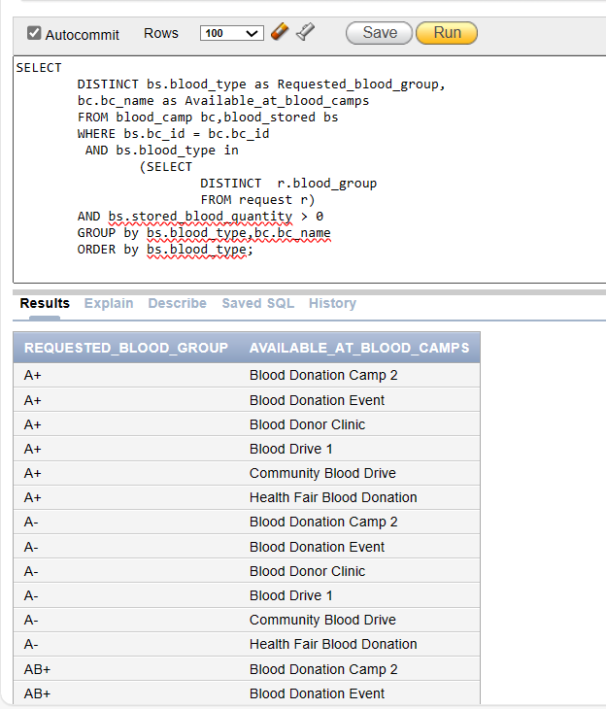

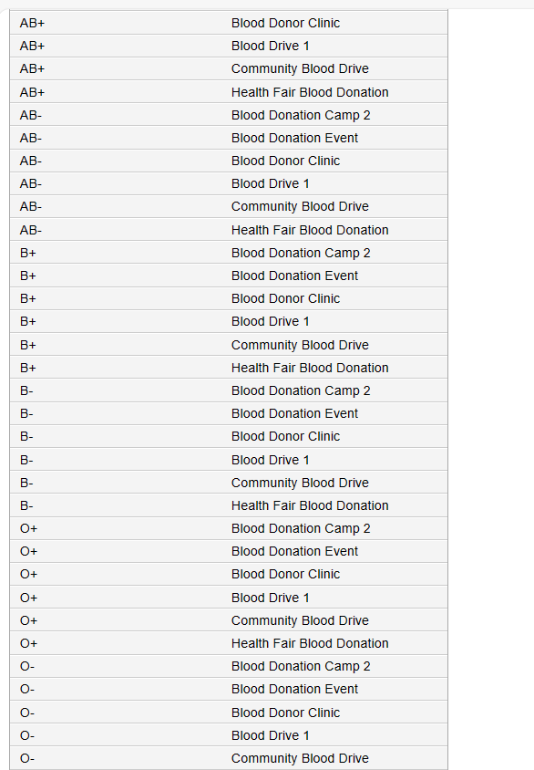

**6.** **Retrieves distinct requested blood groups that are not available at specific blood donation camps due to a stored quantity of zero, along with the names of those camps.**

**Query:**

SELECT

DISTINCT bs.blood_type as Requested_blood_group,

bc.bc_name as Not_Available_at_blood_camps

FROM blood_camp bc,blood_stored bs

WHERE bs.bc_id = bc.bc_id and bs.blood_type in

(SELECT

DISTINCT r.blood_group

FROM request r)

AND bs.stored_blood_quantity = 0

GROUP BY bs.blood_type,bc.bc_name

ORDER BY bs.blood_type;

**Result:**

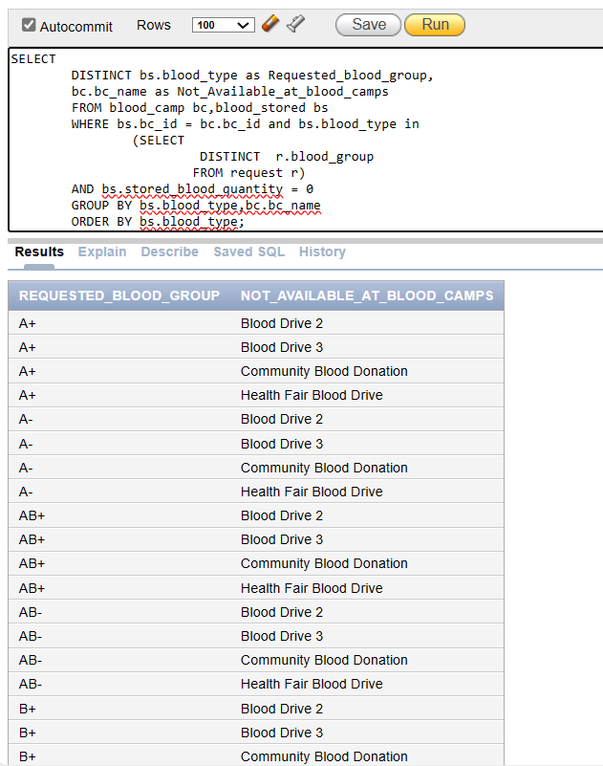

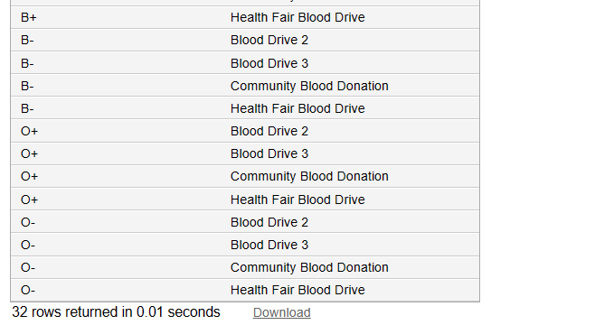

**7. Identifying Blood Requests for Specific Blood Group and Hospital**

**Query:**

SELECT r.req_id, r.req_quantity, r.blood_group, h.h_name

FROM Request r

JOIN Hospital h ON r.hospital_id = h.hospital_id

WHERE r.blood_group = 'A+';

**Result:**

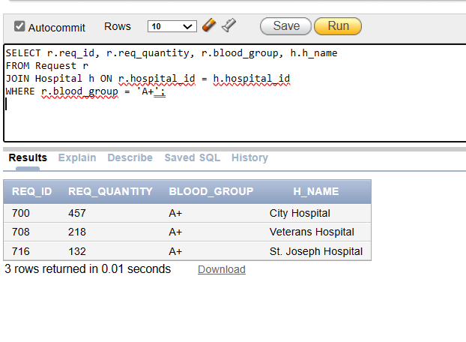

**8.** **Fetch all admissions with corresponding patient and hospital**

**Query:**

SELECT

a.*,

p.FirstName AS patient_first_name,

p.LastName AS patient_last_name,

h.h_name AS hospital_name

FROM

Admits a

INNER JOIN

Patient p ON a.patient_id = p.patient_id

INNER JOIN

Hospital h ON a.hospital_id = h.hospital_id;

**Result:**

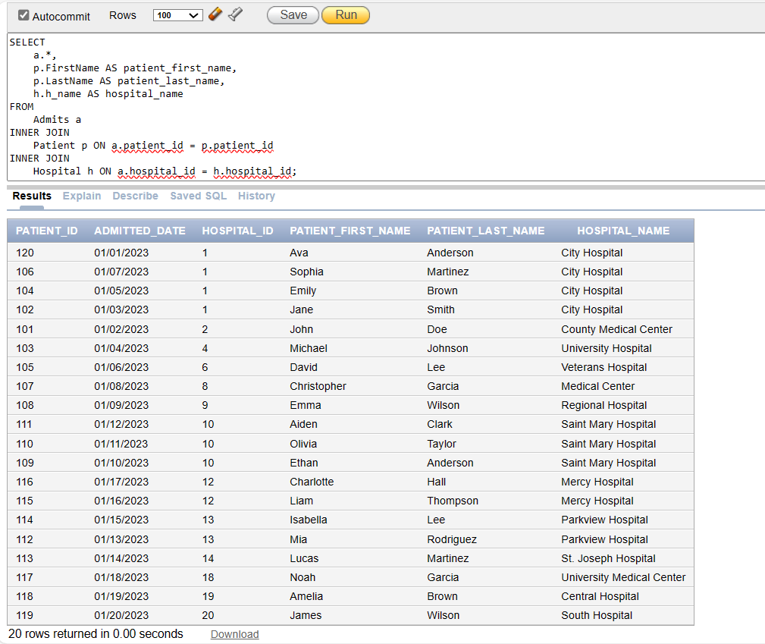

**9. Fetch all donors with corresponding blood bank and blood camp**

**Query:**

SELECT

d.*,

bb.bb_name AS blood_bank_name,

bc.bc_name AS blood_camp_name

FROM

Donor d

LEFT JOIN

Blood_Bank bb ON d.bb_id = bb.bb_id

LEFT JOIN

Blood_Camp bc ON d.bc_id = bc.bc_id;

**Result:**

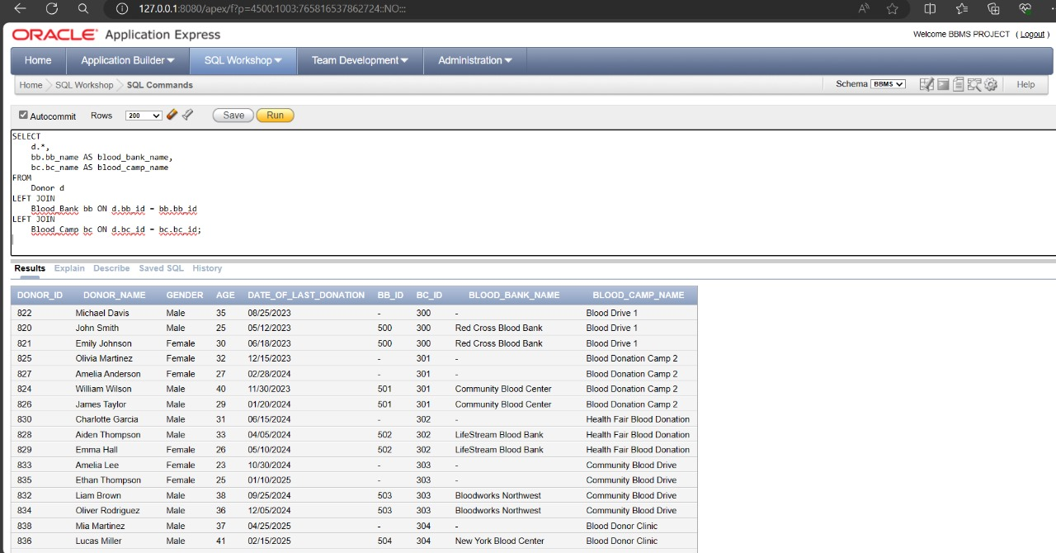

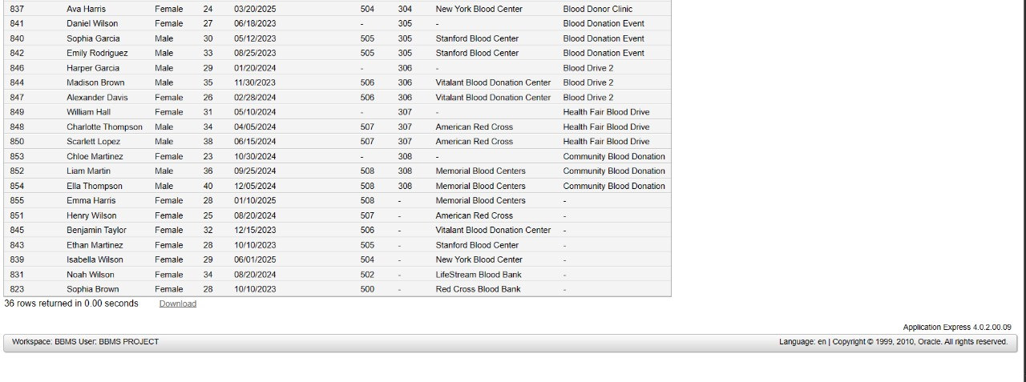

**10What is the requested blood quantity, blood group, blood bank name, and the request sent date to the blood bank for all the request_id?**

**Query:**

SELECT req.req_id, req.req_quantity, req.blood_group, bb.bb_name, stb.bb_sent_date

FROM Request req

JOIN Blood_Bank bb ON req.bb_id = bb.bb_id

JOIN Send_to_bb stb ON req.req_id = stb.req_id;

**Result:**

