GALACTOSE

PKA

Atom pKa
13 7.486
15 11.622
16 11.831
14 13.284
17 13.523

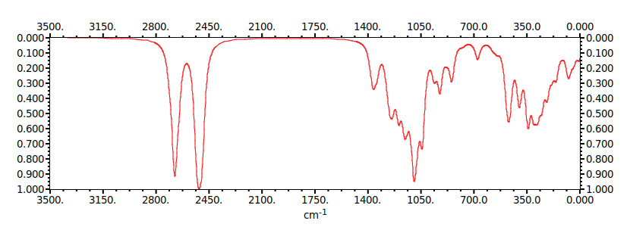

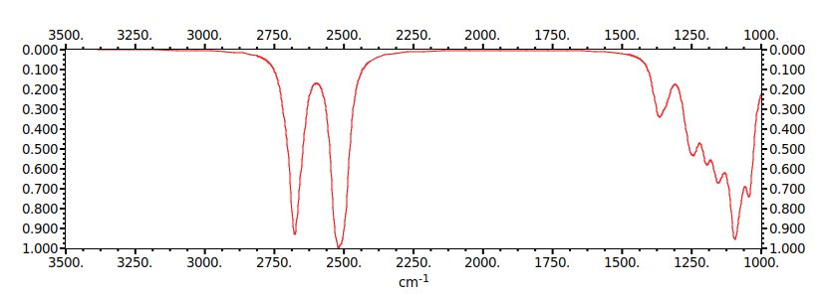
GLICOSE

PKA
Atom pKa
13 7.707
15 11.833
16 11.923
14 12.490
17 13.119

