**GALACTOSE**

**PKA**

**Atom pKa**

**13 7.486**

**15 11.622**

**16 11.831**

**14 13.284**

**17 13.523**

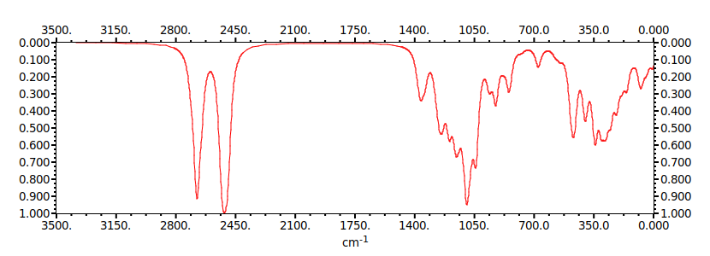

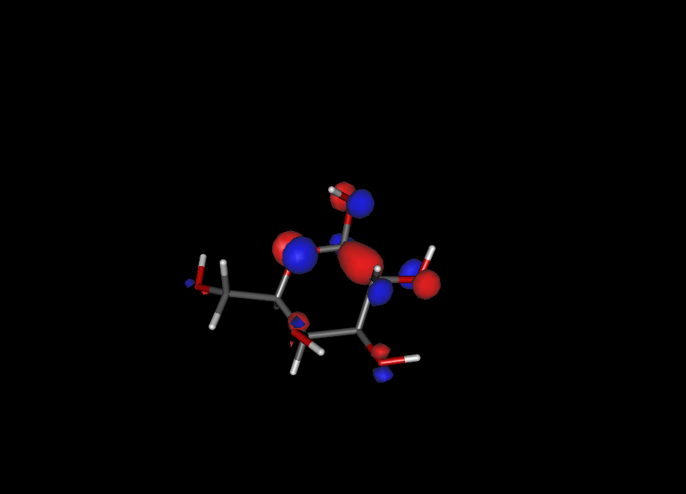

**GLICOSE**

**PKA**

**Atom pKa**

**13 7.707**

**15 11.833**

**16 11.923**

**14 12.490**

**17 13.119**

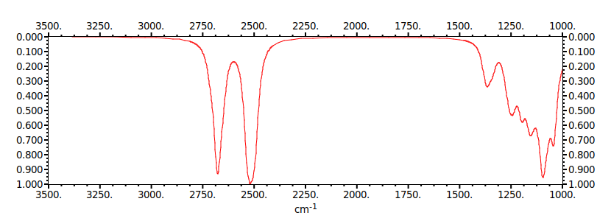

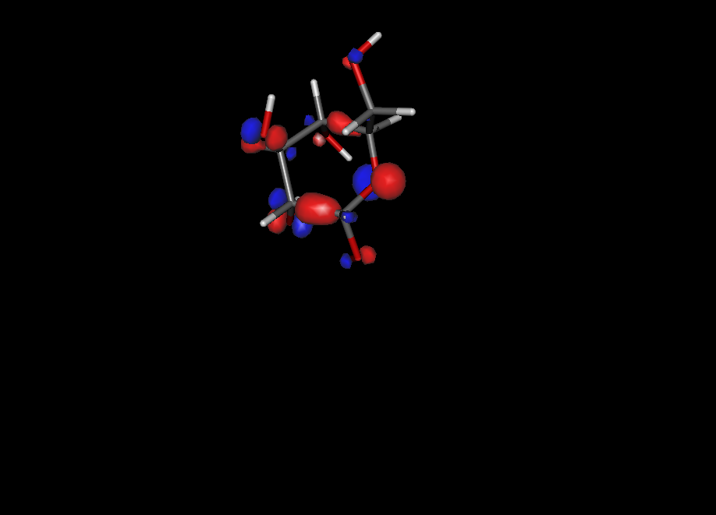

**PKA – ja fiz**

**DELTA HG -**

**PI - ionization**

**IR - infravermelho**

**M – polaridade**

|  |  |  |
| --- | --- | --- |
|  | GALACTOSE | GLICOSE |
| PKA |  |  |
| ΔHG |  |  |
| PI | 10.467837 EV | 10.419647 EV |
| M | 1.381 | 2.932 |