Lista 05 Exercício Prático

Aluno: Guilherme Gomes de Brites

Experiência 1

|  |  |  |  |  |  |  |  |
| --- | --- | --- | --- | --- | --- | --- | --- |
|  |  | i = i op 3 | i = i op 3 | i = i op 3 | i = i op j | i = i op j | i = i op j |
| Tipo | Tempo Base | Soma | Or | Mult | Soma | Or | Mult |
| Byte | 2462944 | 2526092 | 2526092 | 2652156 | 2652156 | 2652380 | 2841596 |
| Int | 2715292 | 2841592 | 2778444 | 3031032 | 3094168 | 3220468 | 3599348 |
| Float | 3220696 | 12437600 | xxxxx | 10356164 | 12690176 | xxxxx | 10608751 |

## MIPS ARDUINO

|  |  |  |  |  |  |  |
| --- | --- | --- | --- | --- | --- | --- |
| Tipo | MIPS | MIPS | MIPS | MIPS | MIPS | MIPS |
|  | Constante | Constante | Constante | Variável | Variável | Variável |
|  | Soma | Or | Mult | Soma | Or | Mult |
| Byte | 15,835 | 5,28 | 5,27 | 5,28 | 2,62 | 2,60 |
| Int | 7,913 | 1,32 | 3,1670 | 2,7 | 1,98 | 1,19 |
| Tipo | ------------- | ------------- | ------------- | ---------- | ---------- | ---------- |
|  | MFLOPS | MFLOPS | MFLOPS | MFLOPS | MFLOPS | MFLOPS |
| Float | 1,1314 | xxxxxx | 1,472 | 1,0694 | xxxxxx | 1,4278 |

Tabela CPI

|  |  |  |  |  |  |  |
| --- | --- | --- | --- | --- | --- | --- |
|  | CPI | CPI | CPI | CPI | CPI | CPI |
| Tipo | Soma | Or | Mult | Soma | Or | Mult |
| Byte | 10,13 | 3,59 | 3,13 | 3,05 | 2,252 | 6,2 |
| Int | 2,22 | 1,07 | 5,08 | 6,10 | 8,14 | 14,17 |
| Float | 14,34 | xxxxxx | 11 | 13,97 | xxxxxx | 11,15 |

Experiência 2

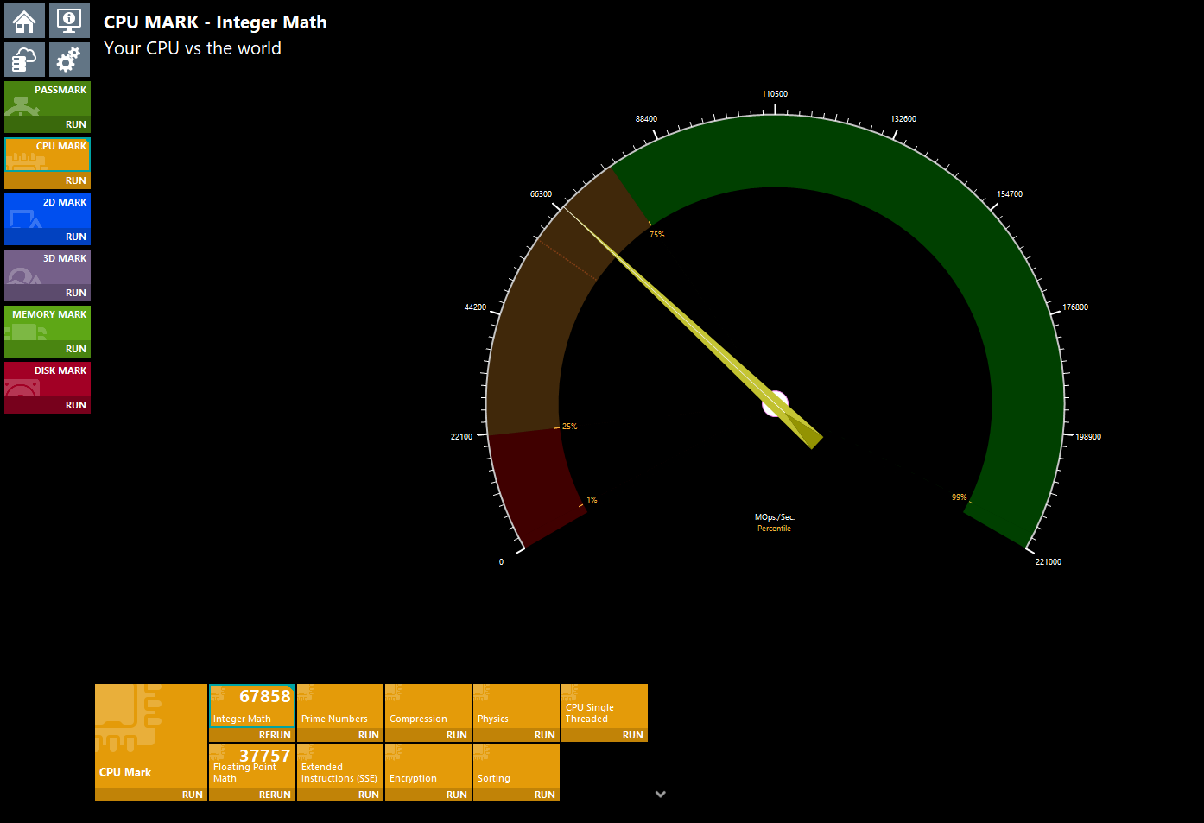

# Tabela Programa em C

|  |  |  |  |  |  |  |  |
| --- | --- | --- | --- | --- | --- | --- | --- |
|  |  | I=i op 3 | I=i op 3 | I=i op 3 | I = i op j | I = i op j | I = i op j |
| Tipo | Tempo Base | Soma | Or | Mult | Soma | Or | Mult |
| Char | 13.5ms | 19,3ms | 14,9ms | 13,9ms | 34,2ms | 17.5ms | 31.3ms |
| Int | 4,7ms | 12,9ms | 11.2ms | 10,8ms | 25,6ms | 21,7ms | 14,5ms |
| Float | 51,9ms | 79ms | xxxxx | 82,2ms | 54,6ms | xxxxxx | 57,5ms |

# Tabela Mips(Meu PC)

|  |  |  |  |  |  |  |
| --- | --- | --- | --- | --- | --- | --- |
|  | MIPS | MIPS | MIPS | MIPS | MIPS | MIPS |
|  | Constante | Constante | Constante | Variável | Variável | Variável |
| Tipo | Soma | Or | Mult | Soma | Or | Mult |
| Char | 1,714 | 6,666 | 20 | 480,78 | 2 | 558,65 |
| Int | 1,23 | 1,56 | 1,66 | 480,7 | 591,7 | 970,8 |
| --- | MFLOPS | MFLOPS | MFLOPS | MFLOPS | MFLOPS | MFLOPS |
|  | Constante | Constante | Constante | Variável | Variável | Variável |
| Tipo | Soma | Or | Mult | Soma | Or | Mult |
| Float | 369 | xxxxx | 331,125 | 3.703 | xxxxx | 1,818 |

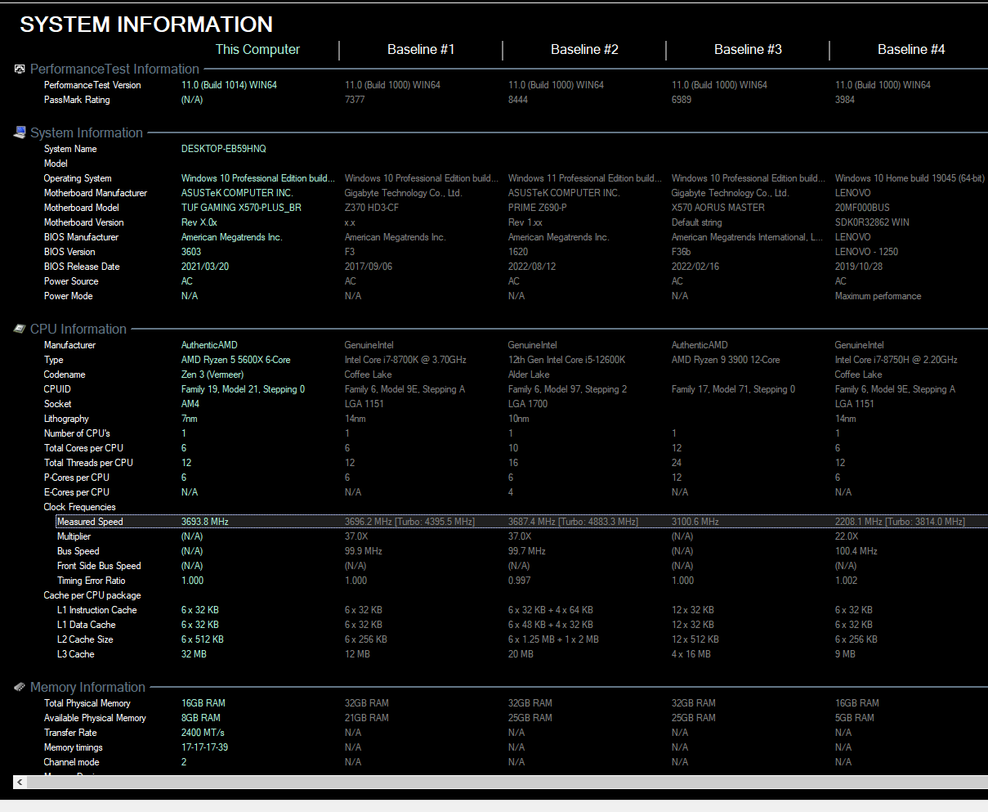

FREQUENCIA: 3693.8MHz

Tabela CPI

|  |  |  |  |  |  |  |
| --- | --- | --- | --- | --- | --- | --- |
| Tipo | Soma | Or | Mult | Soma | Or | Mult |
| Char | 1,467 | 6,7 | 1,34 | 5,23 | 10,4 | 4,79 |
| Int | 2,12 | 1,64 | 1,69 | 5,25 | 5,1 | 2,47 |
| Float | 6,36 | xxxxx | 7,57 | 7,7 | xxxxx | 1,84 |

Tabela Speed up

|  |  |  |  |  |
| --- | --- | --- | --- | --- |
| Identificação | Programa em C | | Performance Test | |
| ------- | Speed up (inteiros/FP) | | Speed up (inteiros/FP) | |
| 12th Gen  Intel(R)  Core(TM) i5 | 1 | 1 | 1 | 1 |
| AMD  Ryzen 5  5600x 6-Core | 1.02 | 1.003 | 1.938 | 1.788 |

# Tabela Speed up Sistema Operacional

|  |  |  |  |
| --- | --- | --- | --- |
| Identificação | Programa em C | | Speed up |
| Apple M1, 3200 MHz | Sonoma 14.4.1 | Sistema operacional de 64 bits, Windows | 1,484 |

Tabela Speed up Compilador

|  |  |  |  |
| --- | --- | --- | --- |
| Identificação | Programa em C | | Speed up |
| Intel® Core™ i5 | Compilador  Online de C | gcc (MinGW.org  GCC-6.3.0-1)  6.3.0 | 0,540 |
| AMD Ryzen 5  5600x 6-Core | Compilador  Online de C | Gcc(MinGW.org  GCC-6.3 0-1)  6.3.0 | 0,639 |

Tabela Speed up Máquina

|  |  |  |  |
| --- | --- | --- | --- |
| Identificação | Programa em C | | Speed up |
| 2208.1 MHz, Windows | Inter® Core™ i5 | AMD Ryzen 5  5600x 6-Core | 1,183 |