HOMEWORK ASSIGNMENT #3 – EBS270

Spring, 2019

Student: Guilherme De Moura Araujo

MATLAB CODE

%% Biological and Agricultural Engineering Department

% Modeling and Analysis of Physical and Biological Processes: EBS 270

% Homework No. 3 - Due Date: May 28, 2019

% Student: Guilherme De Moura Araujo

%%

clear all; clc;

global T_Harvest T_Storage rho cp a a0 a1 k h w he

T_Harvest = 26.7; % Ambiente Temperature at Harvest, (oC)

T_Storage = 3; % Storage temperature (oC)

rho = 998; % Density of orange (km/m3)

cp = 3900; % Specific heat of orange (J/kg/oC)

a = 0.036; % Radius of fruit (m)

a0 = 4.71;

a1 = 3.55;

%A = a0 + a1*T; % Heat production due to respiration (J/(s-m3))

k = 0.47; % Thermal Conductivity of the fruit (W/m/oC)

h = 6; % Convective heat transfer coefficient at the fruit surface (W/m2/oC)

w = sqrt(a1/k);

he = h-k/a;

dr = 0.001; %Random value adopted by student

%% Analytical Solution from Homework #1

% Harvesting condiions

T_Inf = T_Harvest;

alpha = -(a0 + a1*T_Inf)/a1;

A = -(alpha*(k+he*a))/(he*sin(w*a)+k*w*cos(w*a));

j = 1;

for r=0:dr:a

if r == 0

T_H(j) = A*w-((a0+a1*T_Inf)/a1)+T_Inf;

else

u_H(j) = A*sin(w*r)+alpha*r;

T_H(j) = u_H(j)/r+T_Inf;

end

j = j+1;

end

%--------------------------------------------------------------------------

% Storage conditions

T_Inf = T_Storage;

alpha = -(a0 + a1*T_Inf)/a1;

A = (-alpha*(k+he*a))/(he*sin(w*a)+k*w*cos(w*a));

j = 1;

for r=0:dr:a

if r == 0

T_S(j) = A*w-((a0+a1*T_Inf)/a1)+T_Inf;

else

u_S(j) = A*sin(w*r)+alpha*r;

T_S(j) = u_S(j)/r+T_Inf;

end

j = j+1;

end

%% Finite Difference Solution

N = 37; % Number of nodes

dr = a/(N-1); % Delta r -> Same used for analytical solution

alpha = k/(dr*dr); % Constant

beta = a1-2*alpha;

AN = zeros(10,10);

for i=1:N

for j=1:N

if i>=2

if i==j

AN(i,j) = beta;

AN(i,j-1) = (alpha-alpha/(i-1));

if i<N

AN(i,j+1) = (alpha+alpha/(i-1));

end

end

end

end

end

AN(1,1) = a1-6*alpha;

AN(1,2) = 6*alpha;

AN(N,N-1) = 2*alpha;

AN(N,N) = -2*(alpha+h/a+h/dr)+a1;

FNH = -a0*ones(N,1);

FNH(N)= -a0-2*h*(1/a+1/dr)*T_Harvest;

FNS = -a0*ones(N,1);

FNS(N)= -a0-2*h*(1/a+1/dr)*T_Storage;

TNH = inv(AN)*FNH;

TNS = inv(AN)*FNS;

j = 0:dr:a;

subplot(1,2,1)

plot(0:a/(length(T_H)-1):a,T_H,'bo');

hold on

plot(j,TNH,'r--');

legend('Simplified Analytical Solution','Finite Difference Solution')

title('Temperature distribution during harvesting');

xlabel('Fruit radii (m)');ylabel('Temperature oC');

grid

subplot(1,2,2)

plot(0:a/(length(T_H)-1):a,T_S,'bo');

hold on

plot(j,TNS,'r--');

legend('Simplified Analytical Solution','Finite Difference Solution');

title('Temperature distribution during storage');

xlabel('Fruit radii (m)');ylabel('Temperature oC');

grid

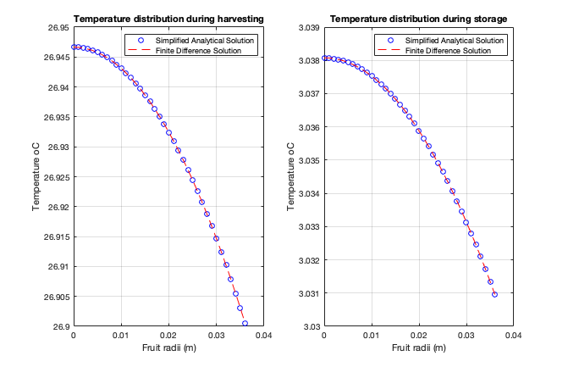

%% Problem 1 comments

% After plotting Simplified Analytical Solution vs. Finite Difference we can notice that both results are in perfect accord with each other.

%% Alternative hand written solution (PLEASE DON'T RUN THIS SECTION IF YOU RAN THE PREVIOUS SECTION)

N = 10; % Total number of Nodes (From T0 to T9)

dr = a/(N-1);

alpha = k/(dr*dr); % Constant

beta = a1-2*alpha;

A = [a1-6*alpha 6*alpha 0 0 0 0 0 0 0 0;

0 beta 2*alpha 0 0 0 0 0 0 0;

0 alpha/2 beta 3/2*alpha 0 0 0 0 0 0;

0 0 2/3*alpha beta 4/3*alpha 0 0 0 0 0;

0 0 0 3/4*alpha beta 5/4*alpha 0 0 0 0;

0 0 0 0 4/5*alpha beta 6/5*alpha 0 0 0;

0 0 0 0 0 5/6*alpha beta 7/6*alpha 0 0;

0 0 0 0 0 0 6/7*alpha beta 8/7*alpha 0;

0 0 0 0 0 0 0 7/8*alpha beta 9/8*alpha;

0 0 0 0 0 0 0 0 2*alpha -2*(alpha+h/a+h/dr)+a1];

FH = [-a0;-a0;-a0;-a0;-a0;-a0;-a0;-a0;-a0;-a0-2*h*(1/a+1/dr)*T_Harvest];

TH = inv(A)*FH;

FS = [-a0;-a0;-a0;-a0;-a0;-a0;-a0;-a0;-a0;-a0-2*h*(1/a+1/dr)*T_Storage];

TS = inv(A)*FS;

j = 0:a/(N-1):a;

subplot(1,2,1)

plot(0:a/(length(T_H)-1):a,T_H,'bo');

hold on

plot(j,TH,'r--');

legend('Simplified Analytical Solution','Finite Difference Solution')

title('Temperature distribution during harvesting');

xlabel('Fruit radii (m)');ylabel('Temperature oC');

grid

subplot(1,2,2)

plot(0:a/(length(T_H)-1):a,T_S,'bo');

hold on

plot(j,TS,'r--');

legend('Simplified Analytical Solution','Finite Difference Solution');

title('Temperature distribution during storage');

xlabel('Fruit radii (m)');ylabel('Temperature oC');

grid

%% Transient Orange Cooling using PDEPE

global Q ER

Q = 11.6e+12;

ER = 7569;

r = 0:dr:a;

m = 2;

t = 0:(259200/71):259200; %3600 s/h * 24/day * 3days = 259200 s

sol = pdepe(m, @pdefun, @pdeic, @pdebc, r, t);

% Surface plot

surf(r, t, sol)

title('Orange Cooling over 72 hours (Cold Storage in 36 hours)')

xlabel('Radius [m]')

ylabel('Time [s]')

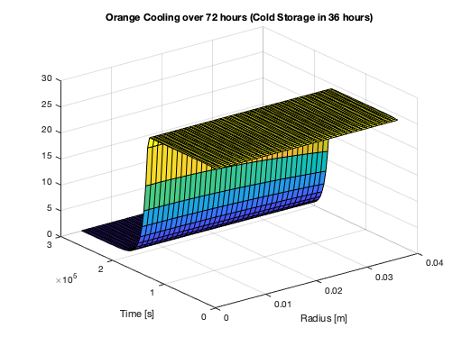

%% Problem 2a

figure

plot(r, T_S, 'bo', r, TNS, 'r--', r, sol(end,:), 'g--o');

title('Steady state solutions')

xlabel('Radius, [m] ');

ylabel('Temperature [ oC]');

legend('Analytical Solution', 'Finite Difference', 'Pdepe');

grid;

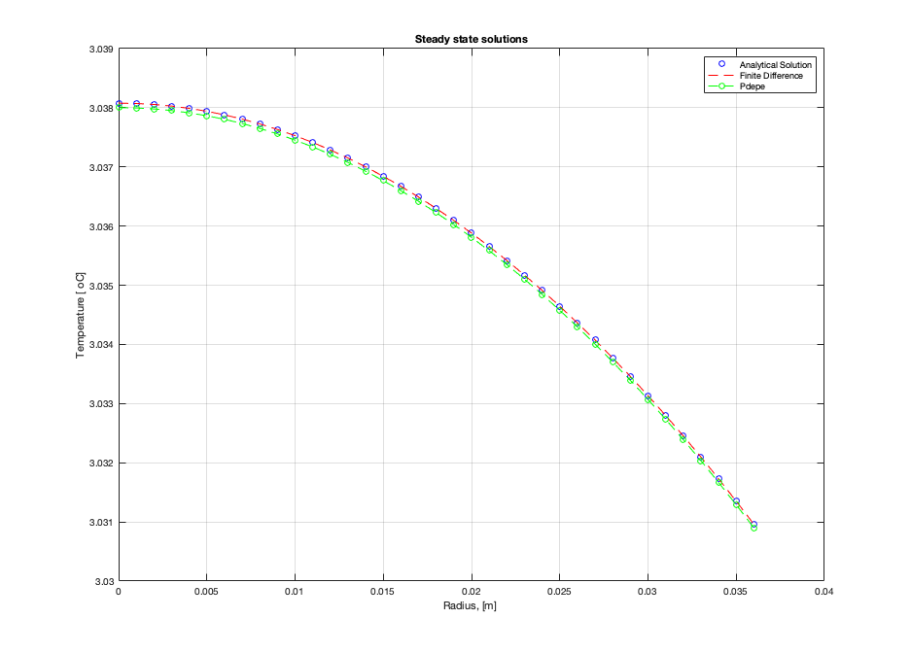

% Comments:

% We can see that all three methods in accord with each other.

%% Temperature as a function of time for the last node (orange outer surface)

figure

plot(t, sol(:,end))

title('Temperature of Orange Surface over Time (outer surface)')

xlabel('Time [s]')

ylabel('Temperature [oC]')

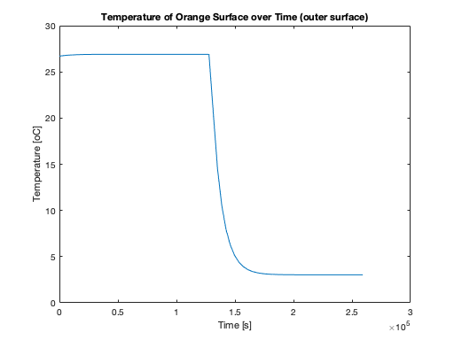

%% Problem 2b

T_Linear = sol(end,:); % Comment out for 2b

T_Arrhenius = sol(end,:);

DiffT = T_Linear - T_Arrhenius;

avgT = mean(DiffT(:));

fprintf('Average difference temperature in the steady state: %.5f oC\n',avgT);

% Comments: after running pdepe two times, the average temperature

% difference between the linear assumption and the equation of Arrhenius

% was calculated as 0.0027 oC, which is slightly insignificant. Therefore

% we conclude that our previous assumption was good.

%% Problem 3b

T_homogenous = sol(end,:); % Comment out for 3b

T_descontinuity = sol(end,:);

DiffT2 = T_homogenous - T_descontinuity;

avgT2 = mean(DiffT2(:));

fprintf('Average difference temperature in the steady state: %.5f oC\n',avgT2);

% Comments: after running pdepe two times, the average temperature

% difference between the homogenous assumption and the more complex model

% (material descontinuity flesh-rind) was calculated as -0.00111 oC, which

% is slightly insignificant. Therefore we conclude that our previous

% assumption (material is homogenous) was good.

%% Problem 3c

T = sol(end,end);

area = 4*pi*a^2;

Qremoved = h * area * (T-T_Storage);

fprintf('Heat required to be removed: Q = %.5f J/s\n',Qremoved);

% Comments: From homework 1 we calculated Q = 0.003 J/s; and now we found Q = 0.028 J/s. Again, the difference is very small. Suggesting that a simpler model yields good results just as a more complex model.

%% Problem 3d

V = 4/3*pi*a^3;

Q2 = rho * cp * V * (T_Harvest - T) % calculates E for 3d

fprintf('Heat required to be removed: Q = %.2f J/s\n',Q2);

% Comments: From homework 1 we calculated Q = 18,100 J/s; and now we found

% Q = 18,000 J/S. Again, the difference is very small. Suggesting that a

% simpler model yields good results just as a more complex model.

%% Functions Required for PDEPE

% pdepe

function [c,f,s] = pdefun(x,t,u,DuDx)

global a0 a1 cp h he Q ER rho k

c = rho * cp;

% Uncomment the if statement for parts 3b, 3c and 3d

% if x <= 0.033

% k = 0.47;

% else

% k = 0.23;

% end

f = k * DuDx;

s = a0 + a1 * u; % comment this out for 2b and after

% s = Q * exp(-ER/(u + 273)); % uncomment this out for 2b and after

end

% IC

function u0 = pdeic(x)

global T_Harvest

u0 = T_Harvest;

end

% BC

function [pl,ql,pr,qr] = pdebc(xl,ul,xr,ur,t)

global T_Harvest T_Storage h

pl = 0;

ql = 1;

if t < 129600

pr = h * (ur - T_Harvest);

else

pr = h * (ur - T_Storage);

end

qr = 1;

end

%% Problem 4

clear all; clc;

global A B Ea1 Ea2 R a b k1 k2 h rho cp Tinf

A = 2.694 * 10^11;

B = 1.3 * 10^47;

Ea1 = 70225;

Ea2 = 283356;

R = 8.31447;

a = 0.53;

b = 0.58*10^-5;

k1 = 0;

k2 = 18;

h = 10.14;

rho = 0.7;

cp = 4.19;

Tinf = 35;

m = 1;

x = linspace(0,3,30);

t = linspace(0,80,30);

sol = pdepe(m, @pdefun, @pdeic, @pdebc, x, t);

u1 = sol(:,:,1);

u2 = sol(:,:,2);

%% Plot Results

figure

surf(x, t, u1);

title('Concentration of Microorganism');

xlabel('Radius [m]');

ylabel('Time [h]');

figure

surf(x, t, u2);

title('Temperature [oC]');

xlabel('Radius [m]');

ylabel('Time [h]');

%% Comments:

% We can see that the microorganisms grow until a certain point and then

% mantain its concentration constant, where the growth of new microbes

% offsets the death of old ones. Therefore, we conclude that upon a certain

% point, the concentration of microorganisms stays constant as time goes.

% It makes sense if we look at the system equation, in which we have a term

% umax*X*[1-X/Xmax], suggesting that after X = Xmax there's no change in

% the concentration.

% The temperature has somehow a similar behavior. As the original

% concentration of microorganisms goes up the heat generation also goes up,

% which increases the temperature. As the concentration of microorganisms

% stabilizes the temperature goes down and remain constant, mostly due to

% the convective heat loss between the bioreactor surface and the water

% jacket (which acts as a cooling jacket everytime the bioreactor

% temperatures is above 35 oC). The steady state temperature is maintained

% at 35 oC, which is the temperature of the water jacket.

%% Functions

% pdepe

function[c, f, s] = pdefun(x, t, u, DuDx)

global A B Ea1 Ea2 R a b k2 rho cp

c = [1; rho*cp];

f = [0; k2].*DuDx;

exp1 = exp(-Ea1/(R * (u(2) + 273)));

exp2 = exp(-Ea2/(R * (u(2) + 273)));

umax = A * exp1/(1 + B * exp2);

xmax = (-127.08 + 7.95*u(2) - 0.016*u(2)^2 - 4.03*10^(-3)*u(2)^3 + 4.73*10^(-5)*u(2)^4)/100;

DxDt = umax*u(1)*(1-u(1)/xmax);

mCO2 = 674000/(6*44)*(a*DxDt+b*u(1));

s = [DxDt; mCO2];

end

% IC

function u0 = pdeic(x)

u0 = [8.74*10^-4; 25];

end

% BC

function [p1, q1, pr, qr] = pdebc(x1, u1, xr, ur, t)

global h Tinf

p1 = [0;0];

q1 = [1;1];

pr = [0;h*(ur(2)-Tinf)];

qr = [1;1];

end

