HOMEWORK ASSIGNMENT #4 – EBS270

Spring, 2019

Student: Guilherme De Moura Araujo

P.1 – Orange Cooling Modeling with FEM.

Please find the development of the FEM matrix attached in the hand written solutions.

MATLAB CODE

%% Biological and Agricultural Engineering Department

% Modeling and Analysis of Physical and Biological Processes: EBS 270

% Homework No. 4 - Due Date: Jun 13, 2019

% Student: Guilherme De Moura Araujo

%% Start

clear all; clc;

%% Initialization of variables

T_Harvest = 26.7; % Ambiente Temperature at Harvest, (oC)

T_Storage = 3; % Storage temperature (oC)

rho = 998; % Density of orange (km/m3)

cp = 3900; % Specific heat of orange (J/kg/oC)

R = 0.036; % Radius of fruit (m)

a0 = 4.71;

a1 = 3.55;

%A = a0 + a1*T; % Heat production due to respiration (J/(s-m3))

k = 0.47; % Thermal Conductivity of the fruit (W/m/oC)

h = 6; % Convective heat transfer coefficient at the fruit surface (W/m2/oC)

w = sqrt(a1/k);

he = h-k/0.036;

beta = (a0+a1*T_Harvest)/k;

u1 = 0.0;

Q = beta*0.036;

G = -w^2;

%% Analytical Solution from Homework1

% Storage conditions

dr = 0.001; %Random value adopted by student

T_Inf = T_Storage;

alpha = -(a0 + a1*T_Inf)/a1;

A = (-alpha*(k+he*R))/(he*sin(w*R)+k*w*cos(w*R));

j = 1;

TAnalytic = zeros(1,length(0:dr:R));

u = zeros(1,length(0:dr:R));

for r=0:dr:R

if r == 0

TAnalytic(j) = A*w-((a0+a1*T_Inf)/a1)+T_Inf;

else

u(j) = A*sin(w*r)+alpha*r;

TAnalytic(j) = u(j)/r+T_Inf;

end

j = j+1;

end

TAnalytic = TAnalytic';

%% Finite Differences from Homework3

N = 37; % Number of nodes

dr = R/(N-1); % Delta r -> Same used for analytical solution

alpha = k/(dr*dr); % Constant

beta = a1-2*alpha;

A = zeros(N,N);

for i=1:N

for j=1:N

if i>=2

if i==j

A(i,j) = beta;

A(i,j-1) = (alpha-alpha/(i-1));

if i<N

A(i,j+1) = (alpha+alpha/(i-1));

end

end

end

end

end

A(1,1) = a1-6*alpha;

A(1,2) = 6*alpha;

A(N,N-1) = 2*alpha;

A(N,N) = -2*(alpha+h/R+h/dr)+a1;

F = -a0*ones(N,1);

F(N)= -a0-2*h*(1/R+1/dr)*T_Storage;

TFinDiff = A\F;

%% Finite Element

T_Inf = T_Storage;

N = 37; % Number of nodes

L = 0.036/(N-1);

beta = (a0+a1*T_Inf)/k;

a = 1/L+G*L/3;

b = 1/L+G*L/6;

R = zeros(1,length(0:N-1));

for i=0:N-1

R(i+1) = i*0.036/(N-1);

end

S = zeros(N-1,N-1);

for i=1:N-1

for j=1:N-1

if i>=2

if i==j

S(i,j) = 2*a;

S(i,j-1) = -b;

if i<N-1

S(i,j+1) = -b;

end

end

end

end

end

S(1,1) = 2*a;

S(1,2) = -b;

S(N-1,N-2) = -b;

S(N-1,N-1) = a+he/k;

F = zeros(N-1,1);

F(1) = ((R(1)+R(3))/6+2*R(2)/3+b*u1);

for i=2:N-2

F(i) = (R(i)+R(i+2))/6+2*R(i+1)/3;

end

F(N-1) = R(N-1)/6+R(N)/3;

F = beta*L*F;

u = S\F;

R2 = R(2:end)';

TFinEl = u./R2;

TFinEl = TFinEl + T_Inf;

%% PLOTS

plot(0:.036/36:0.036,TAnalytic,'b--');

hold on;

plot(0:.036/36:0.036,TFinDiff,'go');

plot(R2,TFinEl,'r*');

legend('Analyical Solution','Finite Difference','Finite Element');

title('Temperature distribution during storage');

xlabel('Fruit radii [m]');ylabel('Temperature [oC]'); grid

RESULTS

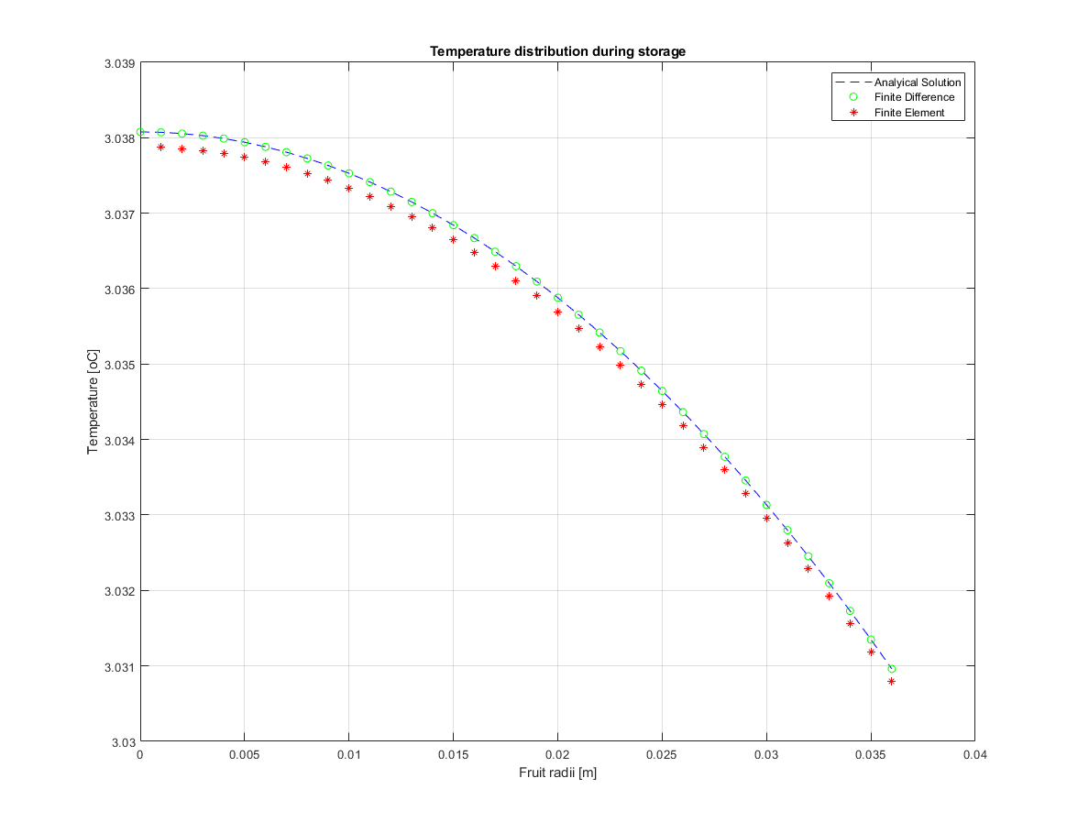

Problem 1 comments

After plotting Simplified Analytical Solution, Finite Difference and Finite Element we can notice that all results are in perfect accord with each other. We can state that the Finite Difference approach gives you a pretty good estimation but makes solution harder when there’s material discontinuity, whereas Finite Element deals with this issue in an elegant fashion. The only bottom line of FEM for this specific case is that a solution @ r = 0 is not achievable. However, the number of nodes can be easily set up by the user. In other words, if the temperature @ r = 0 is of ultimate importance we can just increase the number of nodes such that the spacing between nodes (Δr) is almost zero. Therefore we can have a pretty good estimation of the temperature @ r = 0.

P.2 – Orange Cooling Modeling with COMSOL.

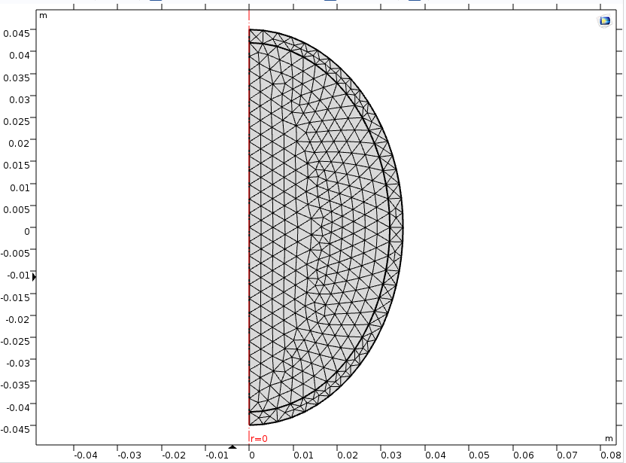

(a) Mesh

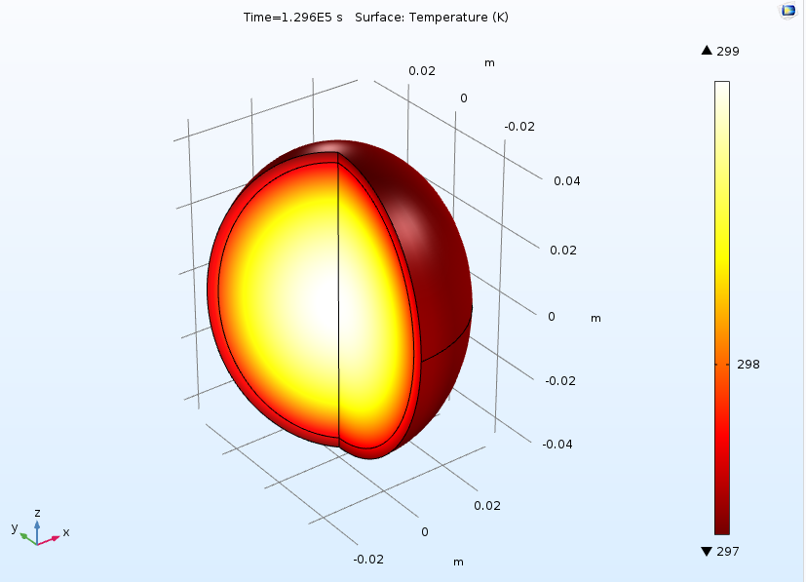 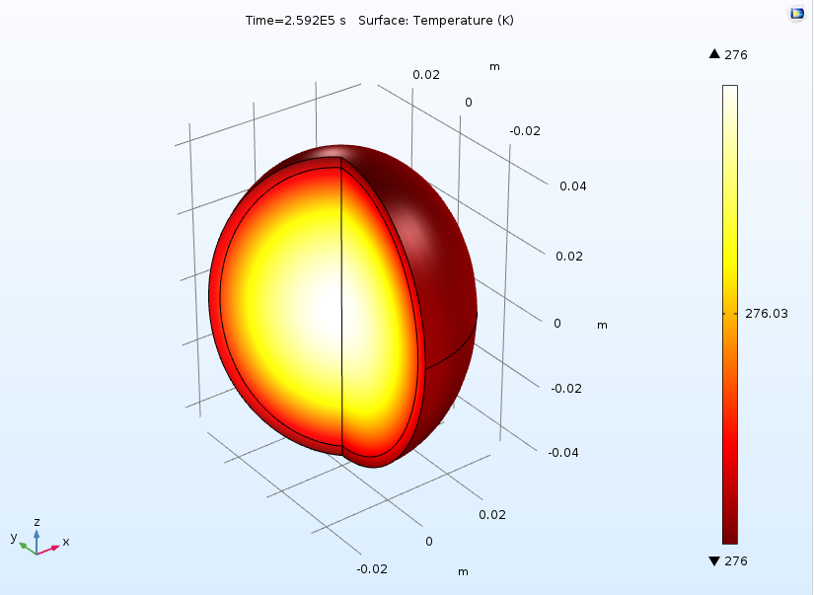

(b) T = T Harvest (c) T = T Cold storage

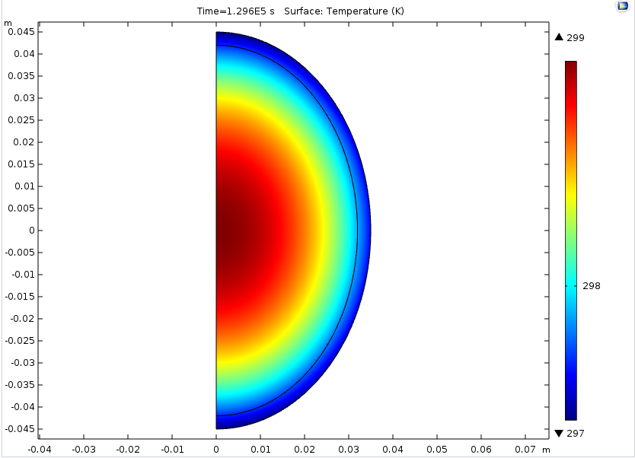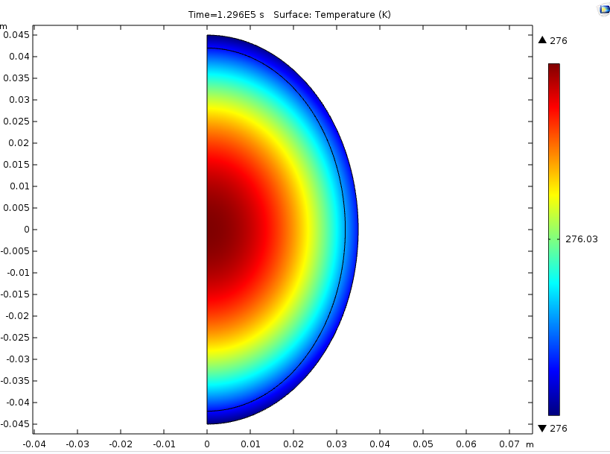

(d) Steady state distribution at Harvest (e) Steady state distribution at Storage

Steady state temperature @ z = 0

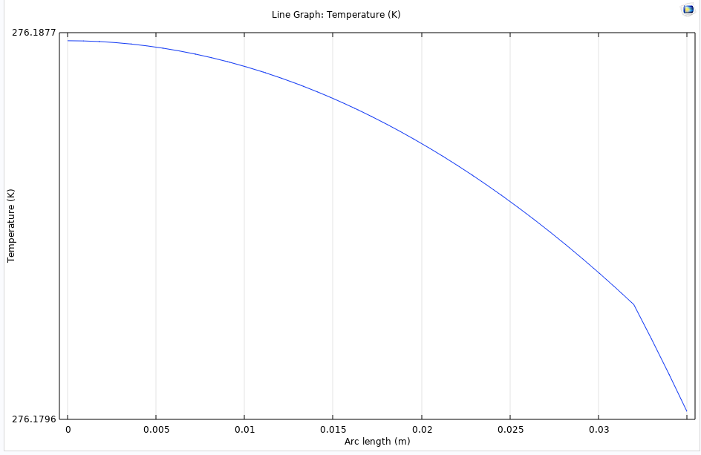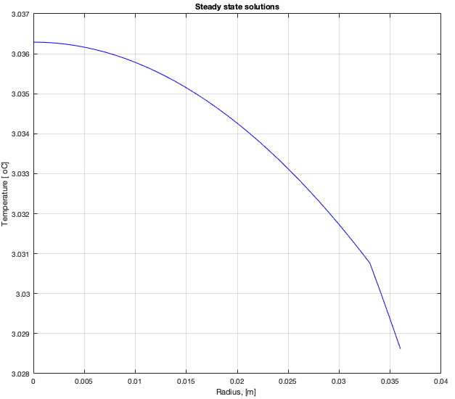

(f) COMSOL (g) MATLAB

We can see that both plots are practically identical. The differences in the temperature values are so small that we can consider them to be negligible.

1. In order to calculate the amount of heat that needs to be removed per orange after it reaches the steady state we need to know what is temperature at the outer radius of the orange. In order to simplify the problem I calculated the average temperature around the orange surface. The average temperature in the surface turns out to be: 3.0294 ± 0.0009 oC.

Therefore we calculate Q = h*A*(Tsurf - TStorage).

Surface area of ellipsoid

; a = 0.045m; b = c = 0.035m.

A = 0.01839m2

Q = 6 * 0.01839 * (3.0294-3) = 0.0032 J/s. This value is very close to the values found before (0.003 J/s for homework 1 and 0.0028 J/s for homework 3).

P.3 – Peanut Butter Modeling with FEM.

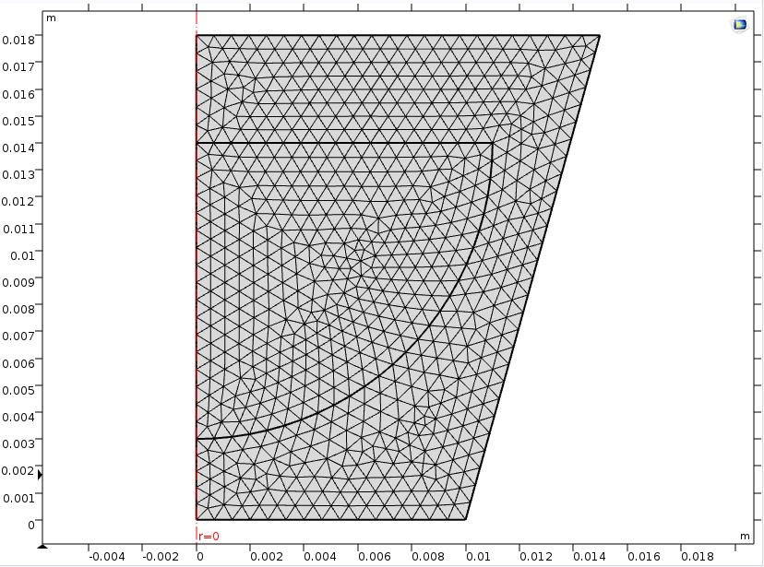

(a) Mesh

Concentration distribution (t = 5 years).

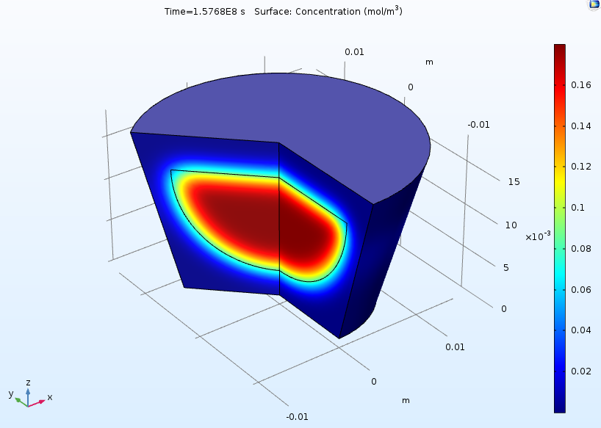 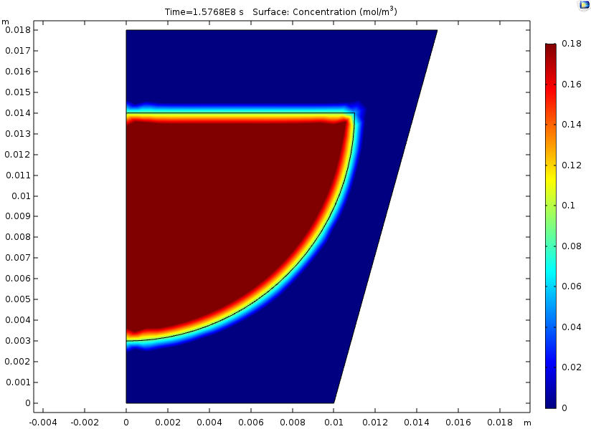

(b) Spatial representation (c) 2D representation

Concentration distribution along the z direction for all times.

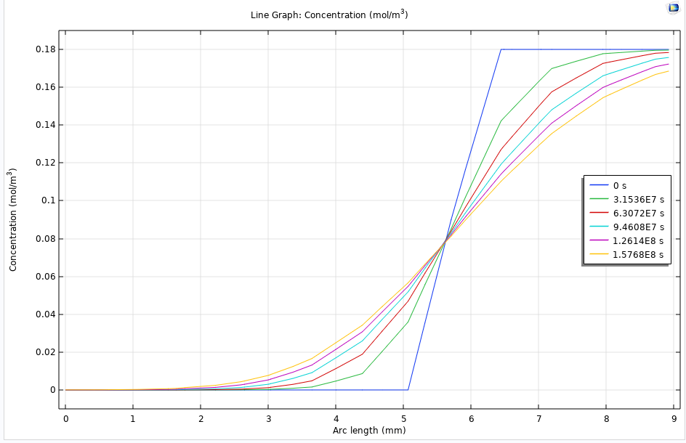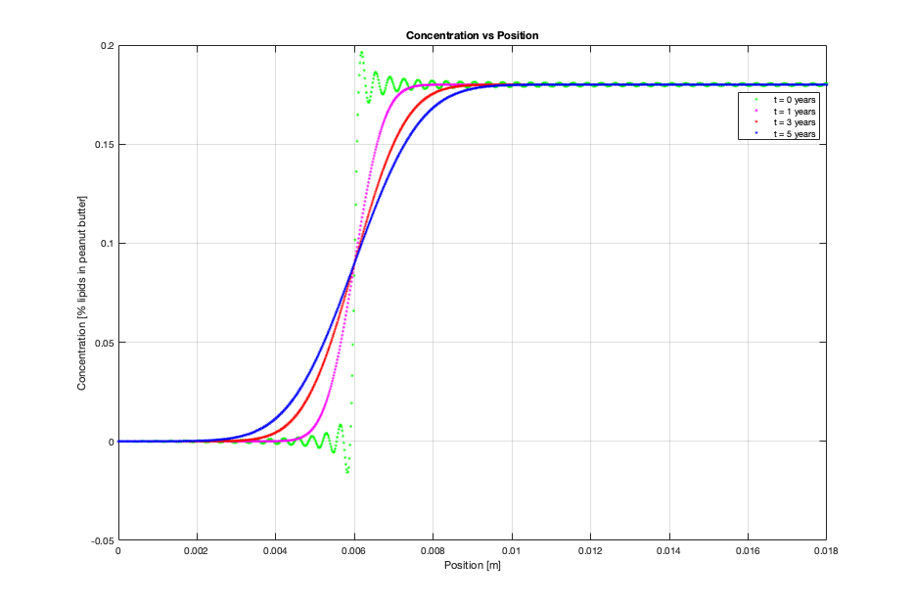

(d) COMSOL (e) MATLAB

We can see that both plots are practically identical. The small differences in concentration are due to geometry considerations, but still pretty similar results.

P.4 – Bioreactor Modeling with FEM.

The key point to this problem regarding the others was the consideration in the physics of the problem. It was used heat transfer in liquids, instead of solids.

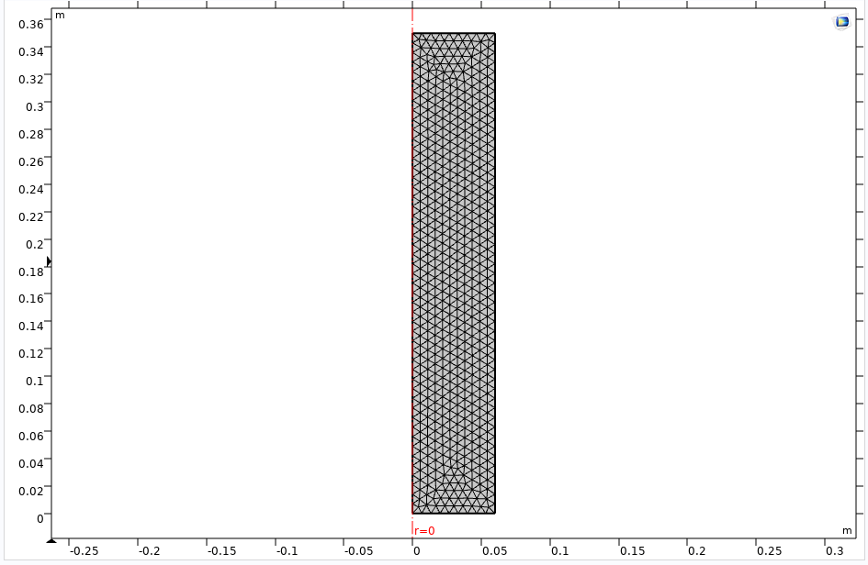

(a) Mesh

Temperature distribution 3D

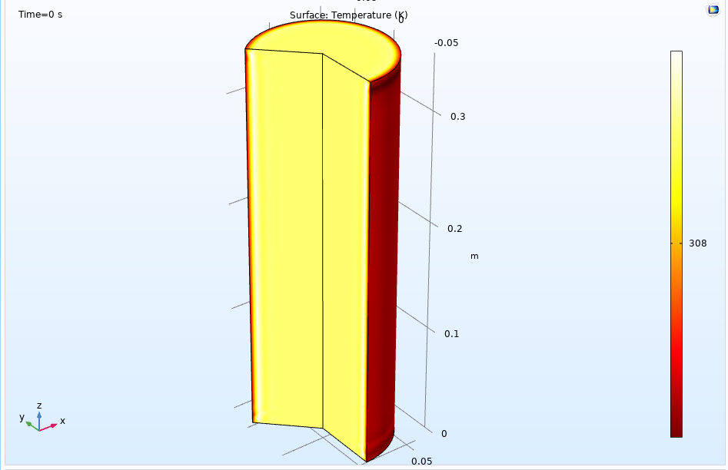 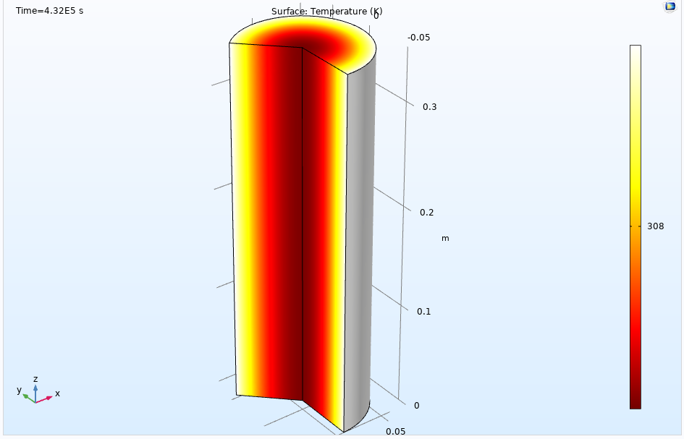

(b) t = initial condition (0h) (c) t = Steady state (120h)

Temperature distribution 2D

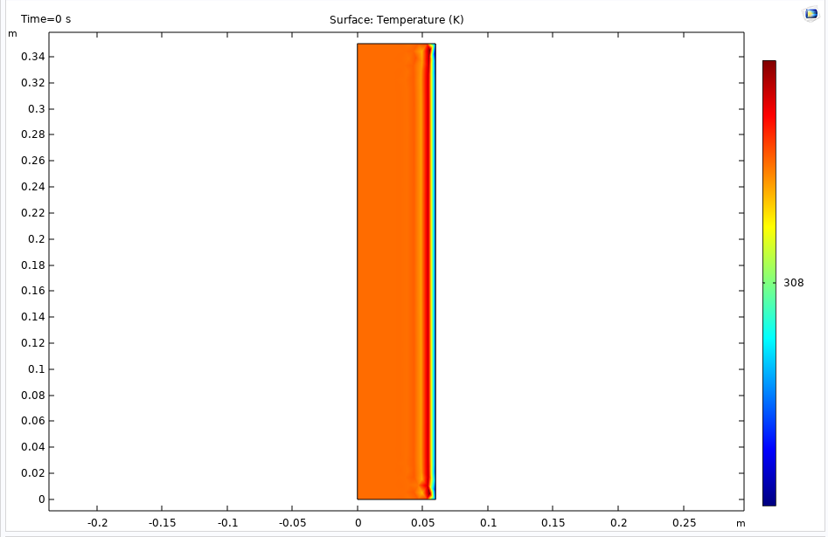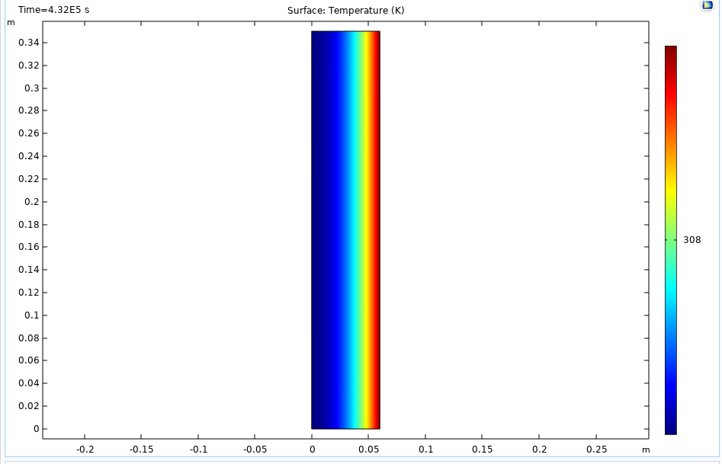

(d) t = initial condition (0h) (e) t = Steady state (120h)

Temperature distribution along the radial direction (all time steps)

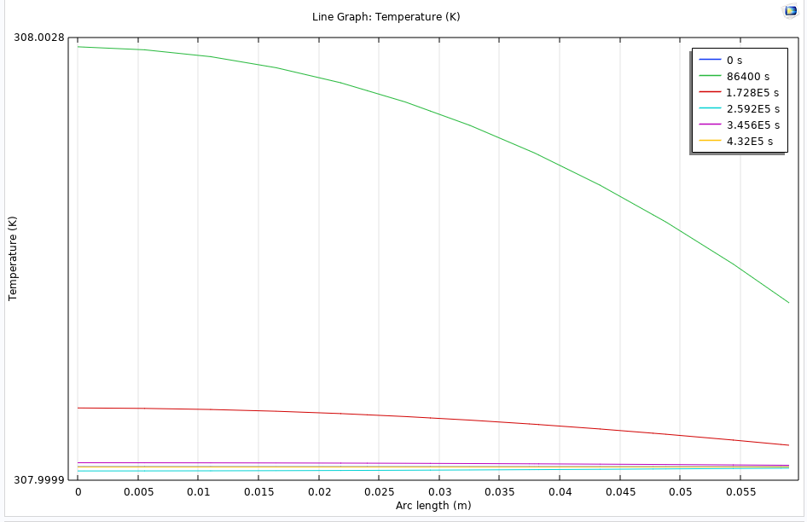 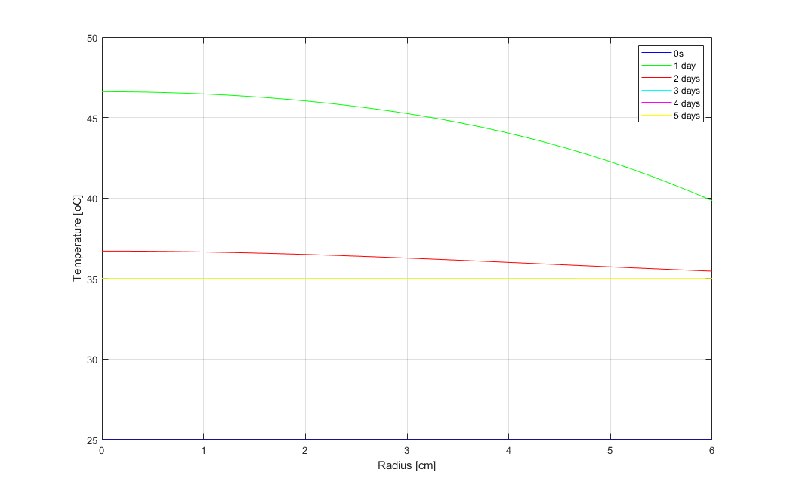

(f) COMSOL (g) MATLAB

We can see that both plots follow the same path.

Temperature distribution along the z direction (all time steps)

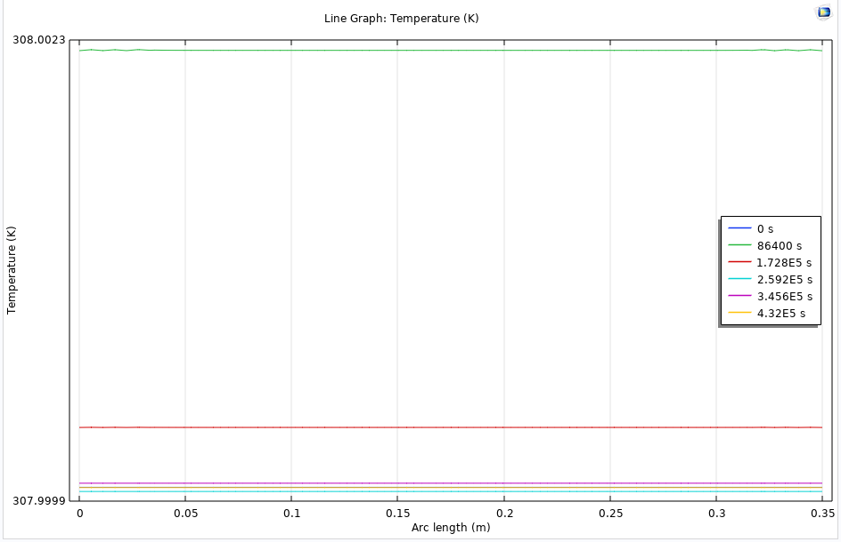

(h) Temperature along z direction

We can notice that temperature does not change in the z direction, which ratifies the assumption of a 1D problem adopted in the previous homeworks.