**Concepts**

CSV - (according to English Comma-Separated Values) file format in which values are separated by commas, for storing data for tables. This format is widely used on many computer platforms.

R - is a free, very high-end software product for statistical data processing.

**Theme**

The theme of this research is to analyze life expectancy at birth across different countries, focusing on variations between sexes. The study aims to provide insights into how life expectancy differs between male and female populations globally.

**Goals**

* Explore Global Trends: Analyze life expectancy trends across a diverse set of countries.
* Sex Disparities: Investigate differences in life expectancy between males and females.
* Identify Factors: Seek correlations between life expectancy, healthcare access, GDP, and other socio-economic factors.
* Visualization: Create informative graphs to visually represent the data and trends.
* Conclusions: Draw conclusions on the factors influencing life expectancy and potential implications for public health policies.

**General Information about the Sample**

The research uses data about Life Expectancy at Birth by Sex and Country – yearly data from Eurostat.

The dataset comprises a comprehensive collection of life expectancy data from various countries, allowing for a thorough examination of global trends. Data points include life expectancy at birth for both males and females, spanning multiple years. The sample encompasses countries with diverse socioeconomic backgrounds, offering insights into how factors such as healthcare access and GDP impact life expectancy. By analyzing this dataset, researchers gain valuable information to inform public health policies and initiatives aimed at improving population health outcomes.

**Tasks**

* Explore Global Trends: Analyze life expectancy trends across a diverse set of countries to identify patterns and variations. Visualize the data using graphs and charts to facilitate understanding and interpretation.
* Sex Disparities: Investigate differences in life expectancy between males and females to understand the extent of the gender gap and its implications. Compare trends over time and across different regions to identify factors contributing to disparities.
* Identify Factors: Seek correlations between life expectancy and various socio-economic factors such as healthcare access, GDP, education levels, and healthcare infrastructure. Conduct statistical analyses to determine the significance of these factors in influencing life expectancy outcomes.
* Visualization: Create informative graphs, charts, and maps to visually represent the data and trends identified during analysis. Use clear and concise visualizations to communicate findings effectively to stakeholders and policymakers.

**Average Life Expectancy by Country (Total – Female and Male)**

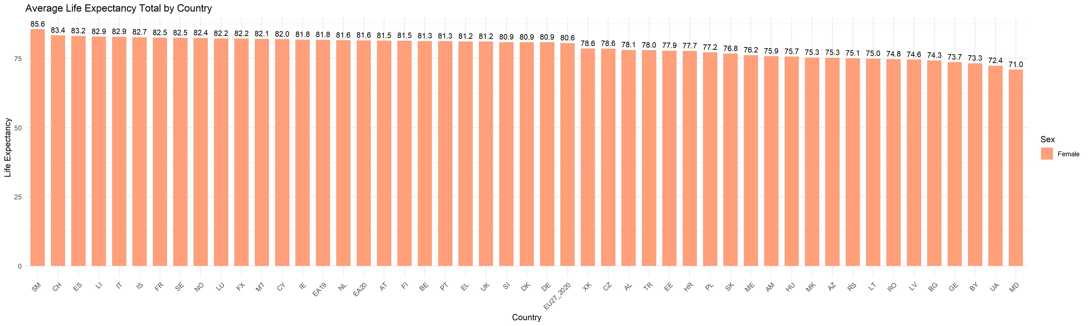

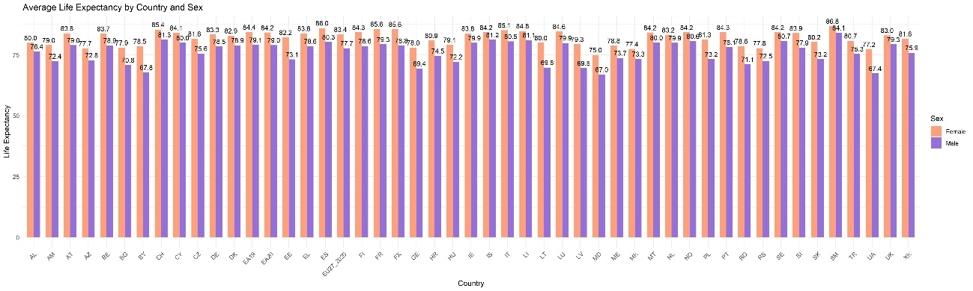

From the graphs above we can see that the countries with the highest average life expectancies, for both females and males (average), are as follows:

* San Marino (SM): 85.6 years
* Switzerland (CH): 83.4 years
* Spain (ES): 83.2 years
* Lithuania (LT): 82.9 years
* Italy (IT): 82.9 years
* Iceland (IS): 82.7 years
* France (FR): 82.5 years

These figures represent the average life expectancy at birth for the populations of each respective country. San Marino stands out with the highest average life expectancy at 85 years, followed closely by Switzerland and Spain at 83 years each. Lithuania, Italy, Iceland, and France all share an average life expectancy of 82 years.

**Life Expectancy Over Time by Sex**

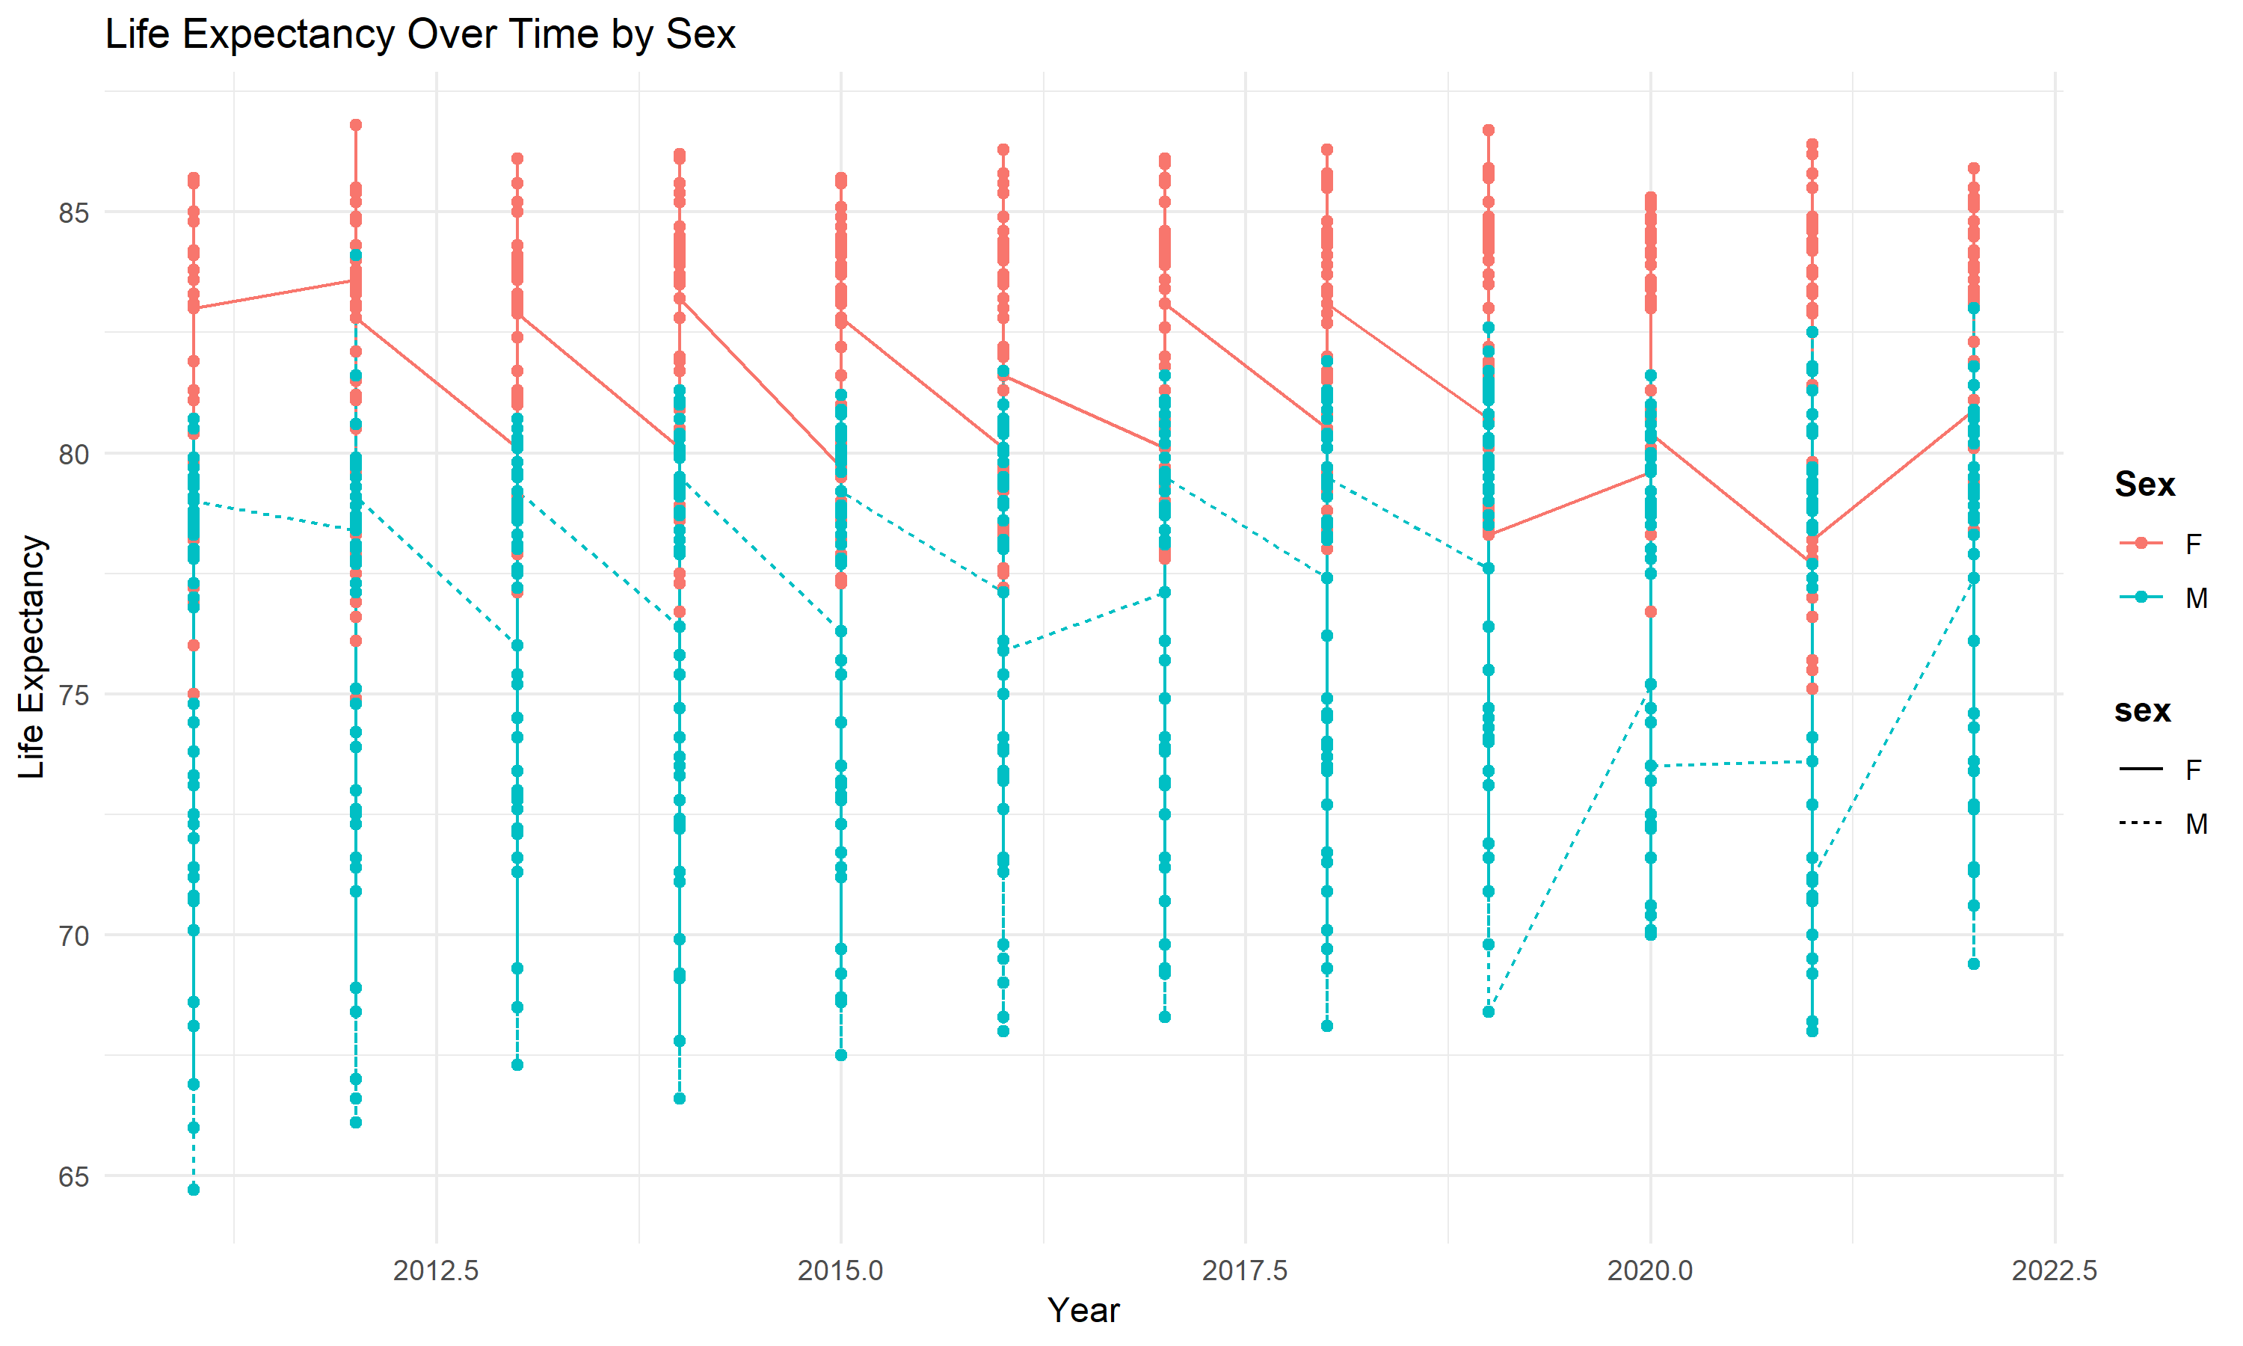

The graph illustrates the life expectancy trends over the years for both females and males. Here are the key points:

* Male Life Expectancy Trend: The line graph for males consistently shows lower life expectancy compared to females across all years. The difference remains nearly constant at around 4 years.
* Female Life Expectancy Trend: Females consistently exhibit higher life expectancy, maintaining an average of 83 years in 2022.
* Male Average in 2022: The average life expectancy for males in 2022 is almost 78 years, highlighting the persistent gap between female and male life expectancies.

This trend suggests that while both male and female life expectancies have increased over time, males continue to lag behind females by approximately 4 years on average.

**Conclusions**

The analysis of life expectancy across various countries underscores several key conclusions. Firstly, there exists a significant disparity between male and female life expectancies globally, with females consistently outliving males by an average of approximately 4 years. This gender gap persists despite overall improvements in life expectancy for both sexes over time. Additionally, the data reveals notable variations in life expectancy among countries, with San Marino leading with the highest average life expectancy at birth of 85.6 years. Factors influencing life expectancy disparities include access to healthcare, socioeconomic status, and public health policies. Addressing these factors is crucial for narrowing the gender gap and improving overall life expectancy rates worldwide.