**Supplementary information**

**Physicochemical and microbial changes during composting of vegetable and animal-derived agro-industrial wastes**

Guilherme Lucio Martinsa, Adijailton José de Souzaa, Lucas William Mendesb, Júlia Brandão Gontijob, Mayra Maniero Rodriguesa, Aline Renée Coscionec, Fernando Carvalho Oliveirad, Jussara Borges Regitanoa

aLuiz de Queiroz College of Agriculture (ESALQ), University of São Paulo (USP), Piracicaba, SP, Brazil

bCenter for Nuclear Energy in Agriculture (CENA), University of São Paulo (USP), Piracicaba, SP, Brazil

cSoil Quality Laboratory, Instituto Agronômico de Campinas (IAC), Campinas, SP, Brazil

dBiossolo Agricultura & Ambiente S/S, Piracicaba, SP, Brazil

*Corresponding author: Jussara Borges Regitano ([regitano@usp.br](mailto:regitano@usp.br))

**Table S1.** Chemical attributes of the agroindustry organic residues in fresh and composted state. Mean values (*n = 3*) ± standard deviation.

|  |  |  |  |  |  |  |  |
| --- | --- | --- | --- | --- | --- | --- | --- |
| **Attributes** | **Agroindustry Organic Residues** | | | | | | |
| **Filter cake (FC)** | | **Poultry litter (PL)** | | **Chicken manure (CM)** | | |
| **Fresh** | **Composted** | **Fresh** | **Composted** | **Fresh** | **Composted** | |
| Humidity (%) | 54.23 ± 0.87 | 22.83 ± 1.79 | 7.43 ± 0.12 | 28.53 ± 0.15 | 17.1 ± 0.62 | 12.8 ± 0.53 | |
| Total solids (%) | 45.77 ± 0.87 | 77.17 ± 1.79 | 92.57 ± 0.12 | 71.47 ± 0.15 | 82.9 ± 0.62 | 87.2 ± 0.53 | |
| Volatile solids (%) | 28.57 ± 1.79 | 16.93 ± 2.59 | 75 ± 1.71 | 16.23 ± 0.29 | 35.93 ± 1.40 | 18.07 ± 0.25 | |
| Fe (mg kg-1) | 16043 ± 2576 | 24171 ± 3460 | 649 ± 226 | 19656 ± 600 | 972 ± 80 | 28164 ± 1556 | |
| Mn (mg kg-1) | 487.67 ± 8.14 | 476.33 ± 36.67 | 398.33 ± 37.53 | 503.33 ± 74.57 | 534.67 ± 82.50 | 495.67 ± 37.07 | |
| B (mg kg-1) | nq | nq | 40.43 ± 8.57 | nq | 64.87 ± 6.65 | nq | |
| Al (mg kg--1) | 6149 ± 1244 | 9483 ± 1645 | 385 ± 128 | 9161 ± 786 | 294 ± 24 | 11805 ± 317 | |
| Cd (mg kg-1) | 0.37 ± 0.29 | 0.8 ± 0.00 | 0.67 ± 0.06 | 0.97 ± 0.06 | 0.47 ± 0.06 | 0.83 ± 0.06 | |
| Pb (mg kg-1) | 5.43 ± 1.46 | 9.57 ± 0.57 | 3.1 ± 0.28 | 20.67 ± 10.25 | nq | 10.97 ± 1.86 | |
| Cr (mg kg-1) | 13.13 ± 2.83 | 18.63 ± 2.14 | 7.27 ± 0.90 | 21.6 ± 3.51 | 3.13 ± 0.29 | 17.97 ± 0.91 | |
| Mo (mg kg-1) | nq | nq | 4.6 ± 0.36 | 1.55 ± 0.07 | 8.3 ± 0.26 | 1.7 ± 0.14 | |
| Ba (mg kg-1) | 37.77 ± 2.66 | 45.27 ± 2.35 | 14.97 ± 2.34 | 45.7 ± 0.87 | 51.57 ± 0.76 | 56.4 ± 1.56 | |
| Ni (mg kg-1) | nq | nq | 5.43 ± 2.70 | 5.97 ± 1.24 | 3.53 ± 0.15 | 3.8 ± 0.46 | |
| Fe = iron; Mn = manganese; B = boron; Al = aluminum; Cd = cadmium; Pb = lead; Cr = chrome; Mo = molybdenum; Ba = barium; Ni = nickel; nq = not quantified (below detection limit). | | | | | | |

**Table S2.** Mean values of sequences at the end of data processing by the DADA2 algorithm.

|  |  |  |  |  |  |  |
| --- | --- | --- | --- | --- | --- | --- |
| **Group** | **Filter cake (FC)** | | **Poultry litter (PL)** | | **Chicken manure (CM)** | |
| **Type** | **Fresh** | **Composted** | **Fresh** | **Composted** | **Fresh** | **Composted** |
| input | 60,941 | 48,356 | 52,082 | 46,993 | 51,690 | 37,008 |
| filtered | 53,852 | 42,424 | 45,810 | 41,116 | 44,556 | 32,219 |
| denoisedF | 52,818 | 40,472 | 44,759 | 39,172 | 44,081 | 30,784 |
| denoisedR | 52,986 | 40,771 | 44,993 | 39,658 | 44,133 | 31,106 |
| merged | 51,357 | 36,774 | 41,855 | 35,879 | 42,383 | 28,164 |
| nonchim | 51,119 | 36,772 | 40,247 | 35,216 | 41,593 | 27,902 |

**Fig. S1.** Changes in temperature during composting between the different groups of agro-industrial organic waste. Data expressed as mean ± standard deviation (*n = 3*). Ambient = ambient temperature; FC = sugarcane filter cake; PL = poultry litter; CM = chicken manure.



**Fig. S2.** Differential abundance of the agro-industry organic waste between fresh and composted, calculated by the ALDEx2 algorithm. (A) FC = sugarcane filter cake; (B) PL = poultry litter; (C) CM = chicken manure. Asterisks indicate significant difference at Kruskal-Wallis test (“***” = p < 0.001; “**” = p < 0.01; “*” = p <0.05).

**Fig. S3.** Heatmap showing the 30 most relative abundant genera in all evaluated agro-industrial organic waste samples. FC = sugarcane filter cake; PL = poultry litter; CM = chicken manure.

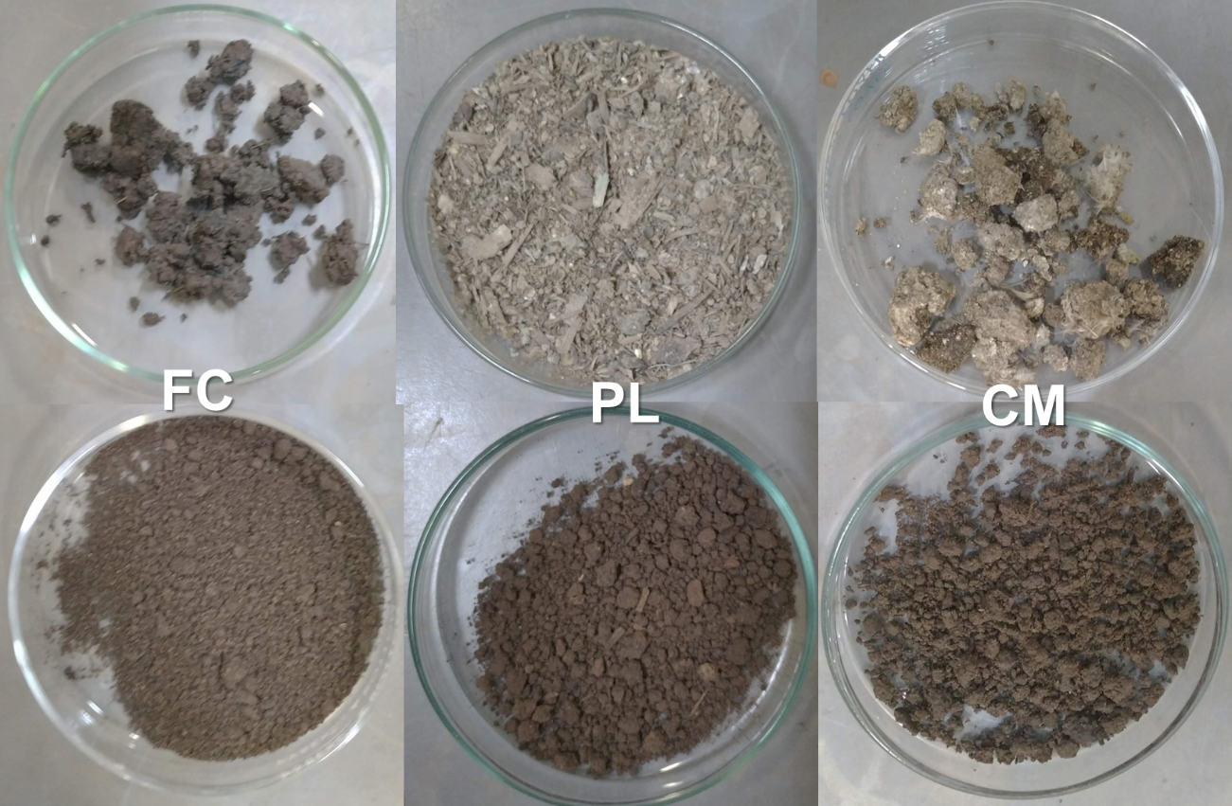**Fig. S4.** Agro-industrial organic waste in fresh state in the first line and their respectively composted state in the second line. FC = sugarcane filter cake; PL = poultry litter; CM = chicken manure.

**Table S3.** The LDA discriminant histogram counts of the top 30 microbial groups that have significant effects in multiple groups. The score obtained through analysis (linear regression analysis), the greater the LDA score, the greater the impact of species abundance on the difference effect.

|  |  |  |  |  |  |
| --- | --- | --- | --- | --- | --- |
| **Comparison** | **Taxa** | **Group** | **LDA** | **P.adj** | **Signific.** |
| Composted - Fresh | p__Firmicutes | Fresh | 5.197271 | 0.006021 | ** |
| f__Microscillaceae | Composted | 4.578984 | 0.005788 | ** |
| o__Rhizobiales | Composted | 4.338228 | 0.006094 | ** |
| f__Thermomonosporaceae | Composted | 4.283405 | 0.006021 | ** |
| o__Micromonosporales | Composted | 4.265624 | 0.006021 | ** |
| f__Micromonosporaceae | Composted | 4.265624 | 0.006021 | ** |
| o__Kiloniellales | Composted | 4.191616 | 0.006021 | ** |
| c__Clostridia | Fresh | 4.156887 | 0.006021 | ** |
| o__Steroidobacterales | Composted | 4.130452 | 0.006021 | ** |
| c__Acidimicrobiia | Composted | 4.046074 | 0.006021 | ** |
| p__Planctomycetota | Composted | 4.018154 | 0.006021 | ** |
| f__Woeseiaceae | Composted | 3.949027 | 0.005788 | ** |
| f__Mycobacteriaceae | Composted | 3.901747 | 0.006021 | ** |
| f__Mycobacteriaceae | Composted | 3.901747 | 0.006021 | ** |
| o__Propionibacteriales | Composted | 3.871436 | 0.006021 | ** |
| f__Woeseiaceae | Composted | 3.847299 | 0.006094 | ** |
| c__Thermoleophilia | Composted | 3.845053 | 0.006094 | ** |
| c__S0134 terrestrial group | Composted | 3.813885 | 0.006021 | ** |
| c__Planctomycetes | Composted | 3.803081 | 0.009742 | ** |
| o__Microtrichales | Composted | 3.791458 | 0.006021 | ** |
| k__Archaea | Composted | 3.780709 | 0.006021 | ** |
| k__Bacteria | Fresh | 3.780614 | 0.006021 | ** |
| f__Streptosporangiaceae | Composted | 3.777484 | 0.005788 | ** |
| f__Streptosporangiaceae | Composted | 3.768346 | 0.005788 | ** |
| f__Nocardioidaceae | Composted | 3.767753 | 0.006021 | ** |
| p__Crenarchaeota | Composted | 3.750696 | 0.005788 | ** |
| c__Nitrososphaeria | Composted | 3.750696 | 0.005788 | ** |
| o__Nitrososphaerales | Composted | 3.750696 | 0.005788 | ** |
| f__Nitrososphaeraceae | Composted | 3.750696 | 0.005788 | ** |
| o__Solirubrobacterales | Composted | 3.708562 | 0.00853 | ** |

**Table S4**. The relationship between agroindustry organic residues bacterial community structures and the environmental variables expressed using Redundancy Analysis (RDA).

|  |  |  |  |  |  |  |  |  |  |
| --- | --- | --- | --- | --- | --- | --- | --- | --- | --- |
| **Constrained axe** | **Attributes** | **F** | **Pr(>F)** | **Signif.** | **F** | **Pr (>F)** | **Signif.** | **R²** | **Adjusted R²** |
| RDA1 | pH | 116.34 | 0.001 | *** | 98.5914 | 0.001 | *** | 0.972 | 0.920 |
| RDA2 | C-org | 37.50 | 0.001 | *** | 34.007 | 0.001 | *** |  |  |
| RDA3 | N-total | 29.31 | 0.001 | *** | 32.2533 | 0.001 | *** |  |  |
| RDA4 | N-inorg | 16.55 | 0.002 | ** | 1.6161 | 0.207 |  |  |  |
| RDA5 | P | 5.30 | 0.234 |  | 20.6394 | 0.001 | *** |  |  |
| RDA6 | K | 2.18 | 0.8 |  | 10.606 | 0.001 | *** |  |  |
| RDA7 | Ca | 0.75 | 0.995 |  | 4.4108 | 0.009 | ** |  |  |
| RDA8 | Mg | 0.43 | 1 |  | 0.5133 | 0.735 |  |  |  |
| RDA9 | S | 0.20 | 1 |  | 1.4784 | 0.225 |  |  |  |
| RDA10 | Cu | 0.17 | 0.998 |  | 3.9454 | 0.02 | * |  |  |
| RDA11 | Zn | 0.09 | 0.99 |  | 0.8319 | 0.487 |  |  |  |