CAPSTONE PROJECT STEP 2

DIAL ALERT Data Collection and Understanding
Dataset overview and complete data dictionary
1,072  PUBLIC PATIENT RECORDS | 165,986  SESSION ROWS | 4.37M  MONITOR RECORDS | 106,758  ELIGIBLE SESSIONS

PREPARED BY | Franklin Guillano
PROJECT | DIAL ALERT Early Warning for Intradialytic Hypotension
SOURCE DATASET | HEMOBP Version 3
REPORT DATE | September 2026

ACADEMIC DECISION SUPPORT STUDY NOT FOR CLINICAL CARE
This report documents dataset provenance, structure, completeness, validity checks, cohort construction, and variable definitions before model development. It does not establish clinical safety or readiness for patient care.

Executive Summary
DIAL ALERT uses HEMOBP Version 3, a public, de-identified hemodialysis dataset released on Figshare under CC BY 4.0 and described in Scientific Data. The source combines patient characteristics, session-level treatment records, and time-stamped blood-pressure and dialysis-machine measurements. This longitudinal structure is well aligned with the proposed classification task: estimate, at the start of a dialysis session, the probability of a later blood-pressure-defined intradialytic hypotension event. [1,2]
The downloaded public files contain 1,072 patient records, 165,986 session rows, and 4,366,298 monitor records. After deterministic patient-date linkage and preregistered eligibility checks, the analysis-ready table contains 106,758 sessions from 830 patients. The primary label occurs in 9,067 sessions, a prevalence of 8.493%. All counts in this report come from the actual files, not from values copied from the publication.
The dataset is strong enough for a rigorous academic capstone, but it is not a deployment-grade clinical dataset. It is retrospective and single-center; the public files do not contain symptoms, interventions, medications, laboratory results, or broad comorbidity profiles. Accordingly, the primary outcome is explicitly described as BP-defined IDH rather than a complete symptomatic clinical diagnosis.
830  ANALYTIC PATIENTS | 40  ANALYTIC VARIABLES | 8.493%  PRIMARY EVENT RATE | CC BY  DATA LICENSE

Rubric Evidence
Rubric expectation | Evidence in this deliverable
High-quality dataset and source cited | Peer-reviewed data descriptor, DOI-stable Figshare release, license documented, and file hashes verified.
Comprehensive dataset overview | Grain, dimensions, date coverage, linkage keys, cohort flow, missingness, duplicates, ranges, and outlier policy are reported.
Complete data dictionary | All 23 raw fields and all 40 analysis-table fields are defined with type, unit, values, missingness, meaning, and analytic role.
Reproducibility | Raw files are immutable; transformation rules are code-based; checksums, paths, and commands are documented.

Dataset Selection and Justification
HEMOBP was selected because its three linked tables support the exact temporal structure required by DIAL ALERT. Patient characteristics and predialysis measurements are available before or at the index time, while subsequent blood-pressure observations can define the outcome. This separation permits an auditable prediction-time boundary and reduces the risk of post-index data leakage.
- Industry relevance: hemodialysis is a repeated, safety-critical treatment process in which hypotension risk must be assessed session by session.
- Modelling relevance: the data support supervised binary classification, longitudinal history features, class-imbalance analysis, explainability, and patient-grouped validation.
- Scale: more than four million monitor records provide enough repeated observations for robust preprocessing and model comparison.
- Transparency: the peer-reviewed descriptor and versioned public archive make the acquisition route, license, and data-generating context traceable.

Source and Provenance
File | Grain | Rows x columns | Coverage | Size | Verified MD5
idp.csv | One row per patient | 1,072 x 5 | First dialysis 1990-01 to 2016-02 | 0.03 MB | 31d269f59bf4acc719f392ad9164d08a
d1.csv | One row per recorded dialysis session | 165,986 x 8 | 2013-06-01 to 2018-05-31 | 10.62 MB | 7db3b48bae2c73e3ecd731dbcd452233
vip.csv | One row per time-stamped dialysis monitor state | 4,366,298 x 10 | 2013-06-01 14:56:40 to 2018-07-01 06:22:57 | 250.67 MB | ff1589610cf7aa3b3e01ba979b6bdc44

Integrity result. Each local MD5 checksum exactly matches the checksum published in the Figshare Version 3 metadata. This verifies that the audited files are byte-for-byte copies of the cited public release.
Source-count discrepancy. The Scientific Data article reports 1,075 outpatients, whereas the released Idp file contains 1,072 rows and 1,072 unique patient identifiers, a difference of three. No undocumented records were reconstructed. All analyses use the public file contents, and the discrepancy remains an explicit provenance limitation. [1,2]

Collection Context and Governance
Element | Documented context
Care setting | Retrospective outpatient chronic hemodialysis care at a tertiary center in Taiwan
Observation window | June 2013 to July 2018 across the released tables
Ethics record | Institutional review board identifier 16MMHIS044, as reported in the data descriptor
Privacy | De-identified patient identifiers; dates and times retained for longitudinal linkage
Reuse conditions | Figshare Version 3 distributed under Creative Commons Attribution 4.0

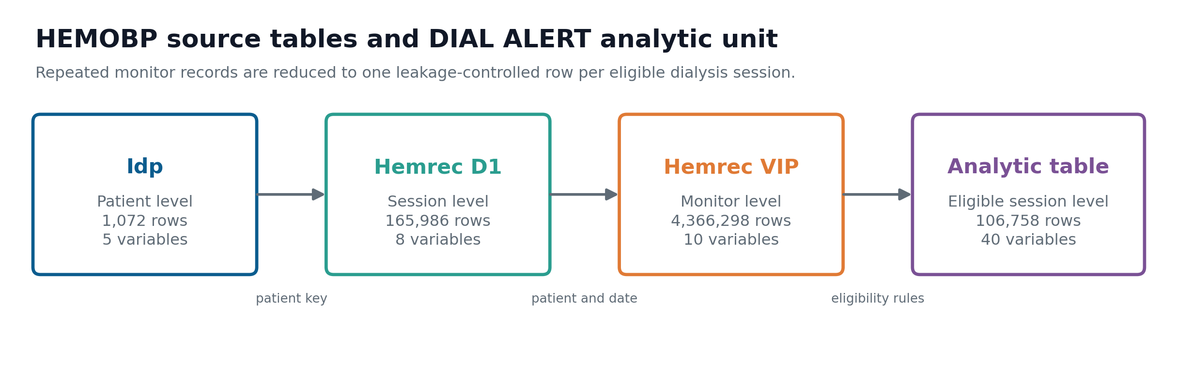
Figure 1. Three source tables are linked by de-identified patient ID and calendar date, then collapsed to one prediction row per eligible dialysis session.

Data Architecture and Linkage
The source has three different grains. Idp contains one row per patient. Hemrec D1 contains one row per recorded dialysis session. Hemrec VIP contains repeated, time-stamped monitor states within a session. The analytic unit is one eligible patient-session, not one monitor reading and not one patient.
- Normalize D1 and VIP dates and link records on de-identified patient ID plus calendar date.
- Use the earliest valid active-dialysis VIP record within the first 30 elapsed minutes as the index record. Active treatment requires blood flow greater than zero.
- Require index SBP from 90 to 200 mmHg, index DBP from 30 to 150 mmHg, at least two later distinct elapsed-minute values, and an observation at or beyond dialysis minute 120.
- Derive the primary outcome only from records after the index observation. Retain outcome and post-treatment fields for audit, but exclude them from predictors.
- Derive prior-session features with chronological shifts and cumulative calculations so the current or future session cannot enter its own history.
Linkage assumption. Calendar date is the shared session key available in the public tables. Duplicate patient-date D1 rows are resolved deterministically after stable ordering. If a patient had two distinct treatments on one calendar date, this key could conflate them; that risk cannot be fully tested because no public session ID is provided.
Sampling pattern. VIP observations are not perfectly regular. The paper notes routine blood-pressure collection at approximately 30-minute intervals with additional measurements according to clinical need. Measurement density may therefore contain information about clinician concern and should not be treated as random. [1]

Feature Type Summary
Data type | Raw fields | Analytic fields
Binary | 1 | 5
Categorical | 1 | 1
Date | 1 | 2
Datetime | 2 | 1
Integer | 2 | 5
Numeric | 11 | 23
String | 3 | 1
Time | 2 | 2

Cohort Construction
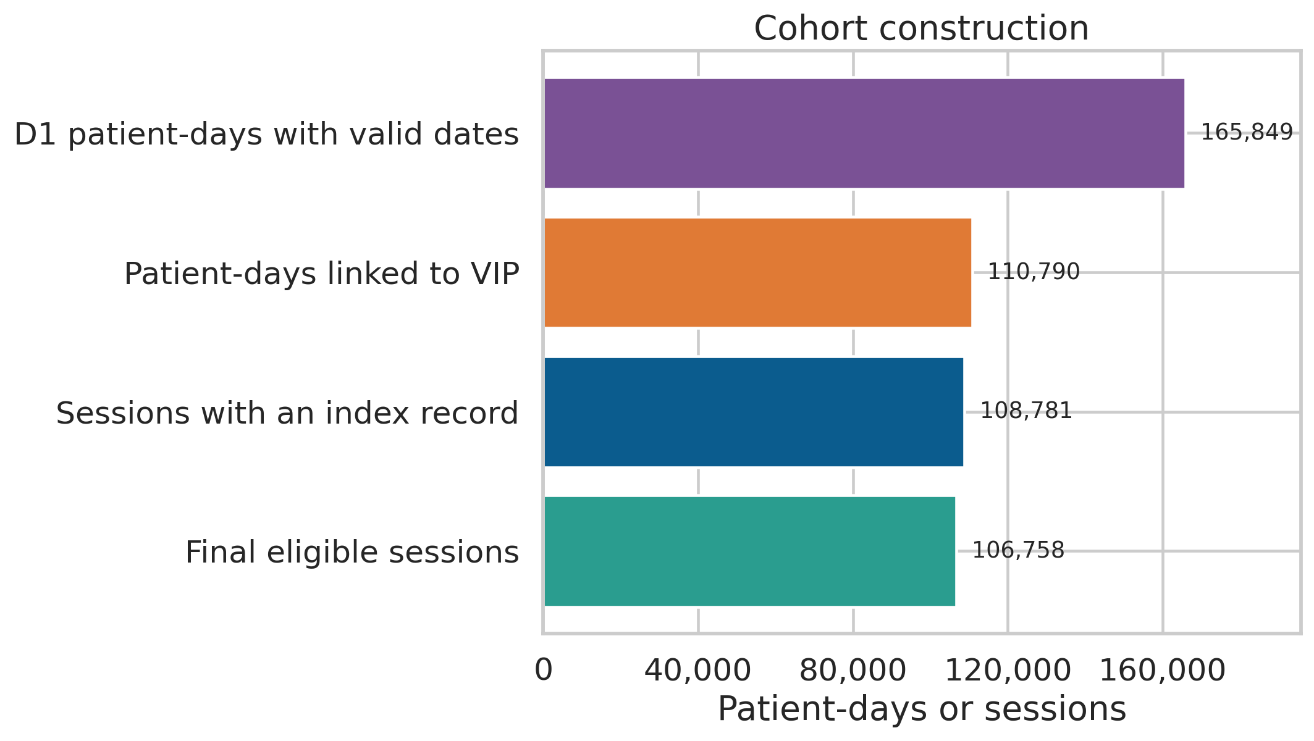
Figure 2. Deterministic cohort flow from the three public source files to 106,758 eligible session-level observations.

Stage | Count | Rule or interpretation
Patient records in Idp | 1,072 | Patient roster available for linkage
D1 raw session rows | 165,986 | Includes 128 rows without a usable session date
Valid unique patient-days in D1 | 165,849 | After invalid-date removal and patient-date deduplication
VIP rows linked to D1 | 2,228,411 | Monitor rows with a matching patient-date session
Linked patient-days | 110,790 | At least one linked VIP record
Patient-days with valid index | 108,781 | Earliest active record within 30 minutes and valid index BP
Final eligible sessions | 106,758 | Baseline SBP at least 90 and adequate post-index follow-up

Selection implication. The final cohort includes 830 of the 1,072 public patients. Excluding baseline hypotension, short or sparsely measured sessions, and unlinked patient-days improves label validity but may make the analytic cohort systematically healthier, more observable, or operationally different from excluded sessions. External validation is therefore required before clinical use.

Data Quality and Missingness
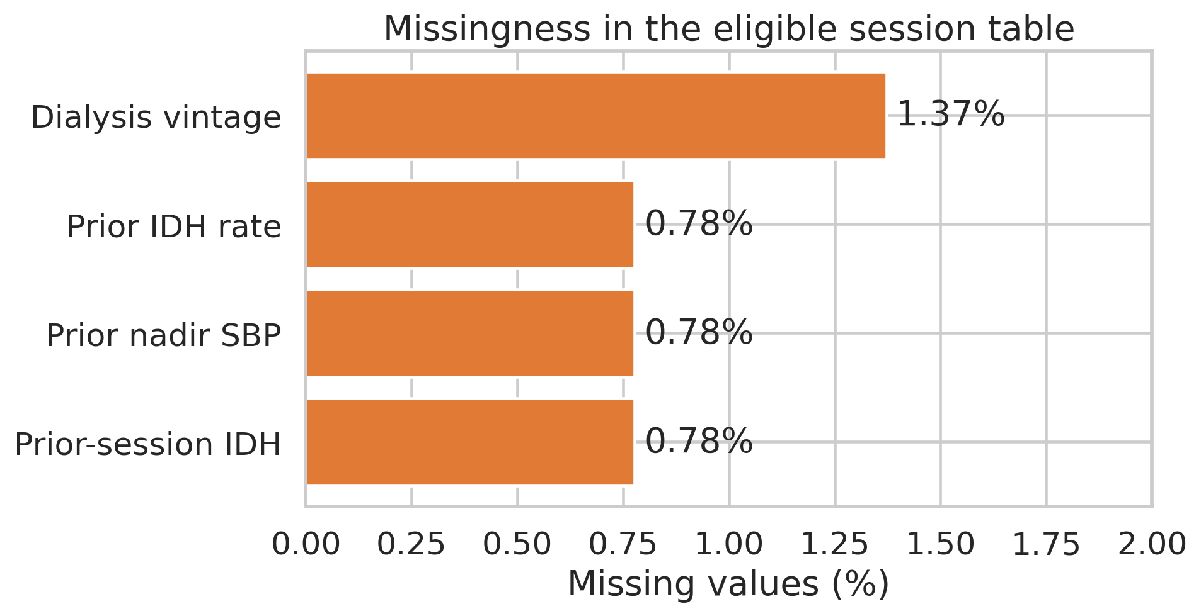
Figure 3. Missingness is concentrated in 128 D1 rows and in history or dialysis-vintage variables in the final analytic table.

Table | Variable group | Missing n | Missing percent | Interpretation
Idp | All 5 variables | 0 | 0.000% | No source missingness detected
Hemrec D1 | All fields except pid | 128 each | 0.077% | The same 128 rows lack all session details
Hemrec VIP | All 10 variables | 0 | 0.000% | No encoded nulls detected
Analytic | dialysis_vintage_years | 1,465 | 1.372% | Unavailable or invalid chronology
Analytic | prior_session_idh | 830 | 0.777% | First eligible session per patient
Analytic | prior_nadir_sbp | 830 | 0.777% | First eligible session per patient
Analytic | prior_idh_rate | 830 | 0.777% | First eligible session per patient
Analytic | Remaining 36 variables | 0 | 0.000% | Complete after eligibility filters

- Null handling is rule-based. D1 rows without a session date cannot be linked and are excluded before cohort construction.
- History-feature missingness is structural, not evidence of poor source quality: the first eligible session has no earlier eligible session.
- Dialysis-vintage missingness remains explicit and will be handled inside the modelling pipeline, fitted on training data only.
- No complete-case deletion is applied merely because a predictor is missing; the modelling stage will compare transparent imputation and missing-indicator strategies.

Duplicates and Referential Integrity
Table | Finding | Disposition
Idp | 0 exact duplicates; 0 duplicate patient IDs | Patient key is unique
Hemrec D1 | 5 exact duplicates; 9 duplicate patient-date rows | Stable order retained and first row kept for one session per patient-date
Hemrec VIP | 0 exact duplicates after linkage and validity screening | No linked analytic monitor row removed as an exact duplicate
Analytic table | One row per eligible patient-date | Patient-date is unique by construction

Outliers and Plausibility
Outlier detection separates validity from rarity. Clearly unusable values are screened through predefined physiological and operational bounds before index selection. The interquartile-range rule is then used only to describe unusual but potentially valid observations; it is not used as an automatic deletion rule. This protects clinically important extremes and prevents data-dependent trimming from silently changing the target population.
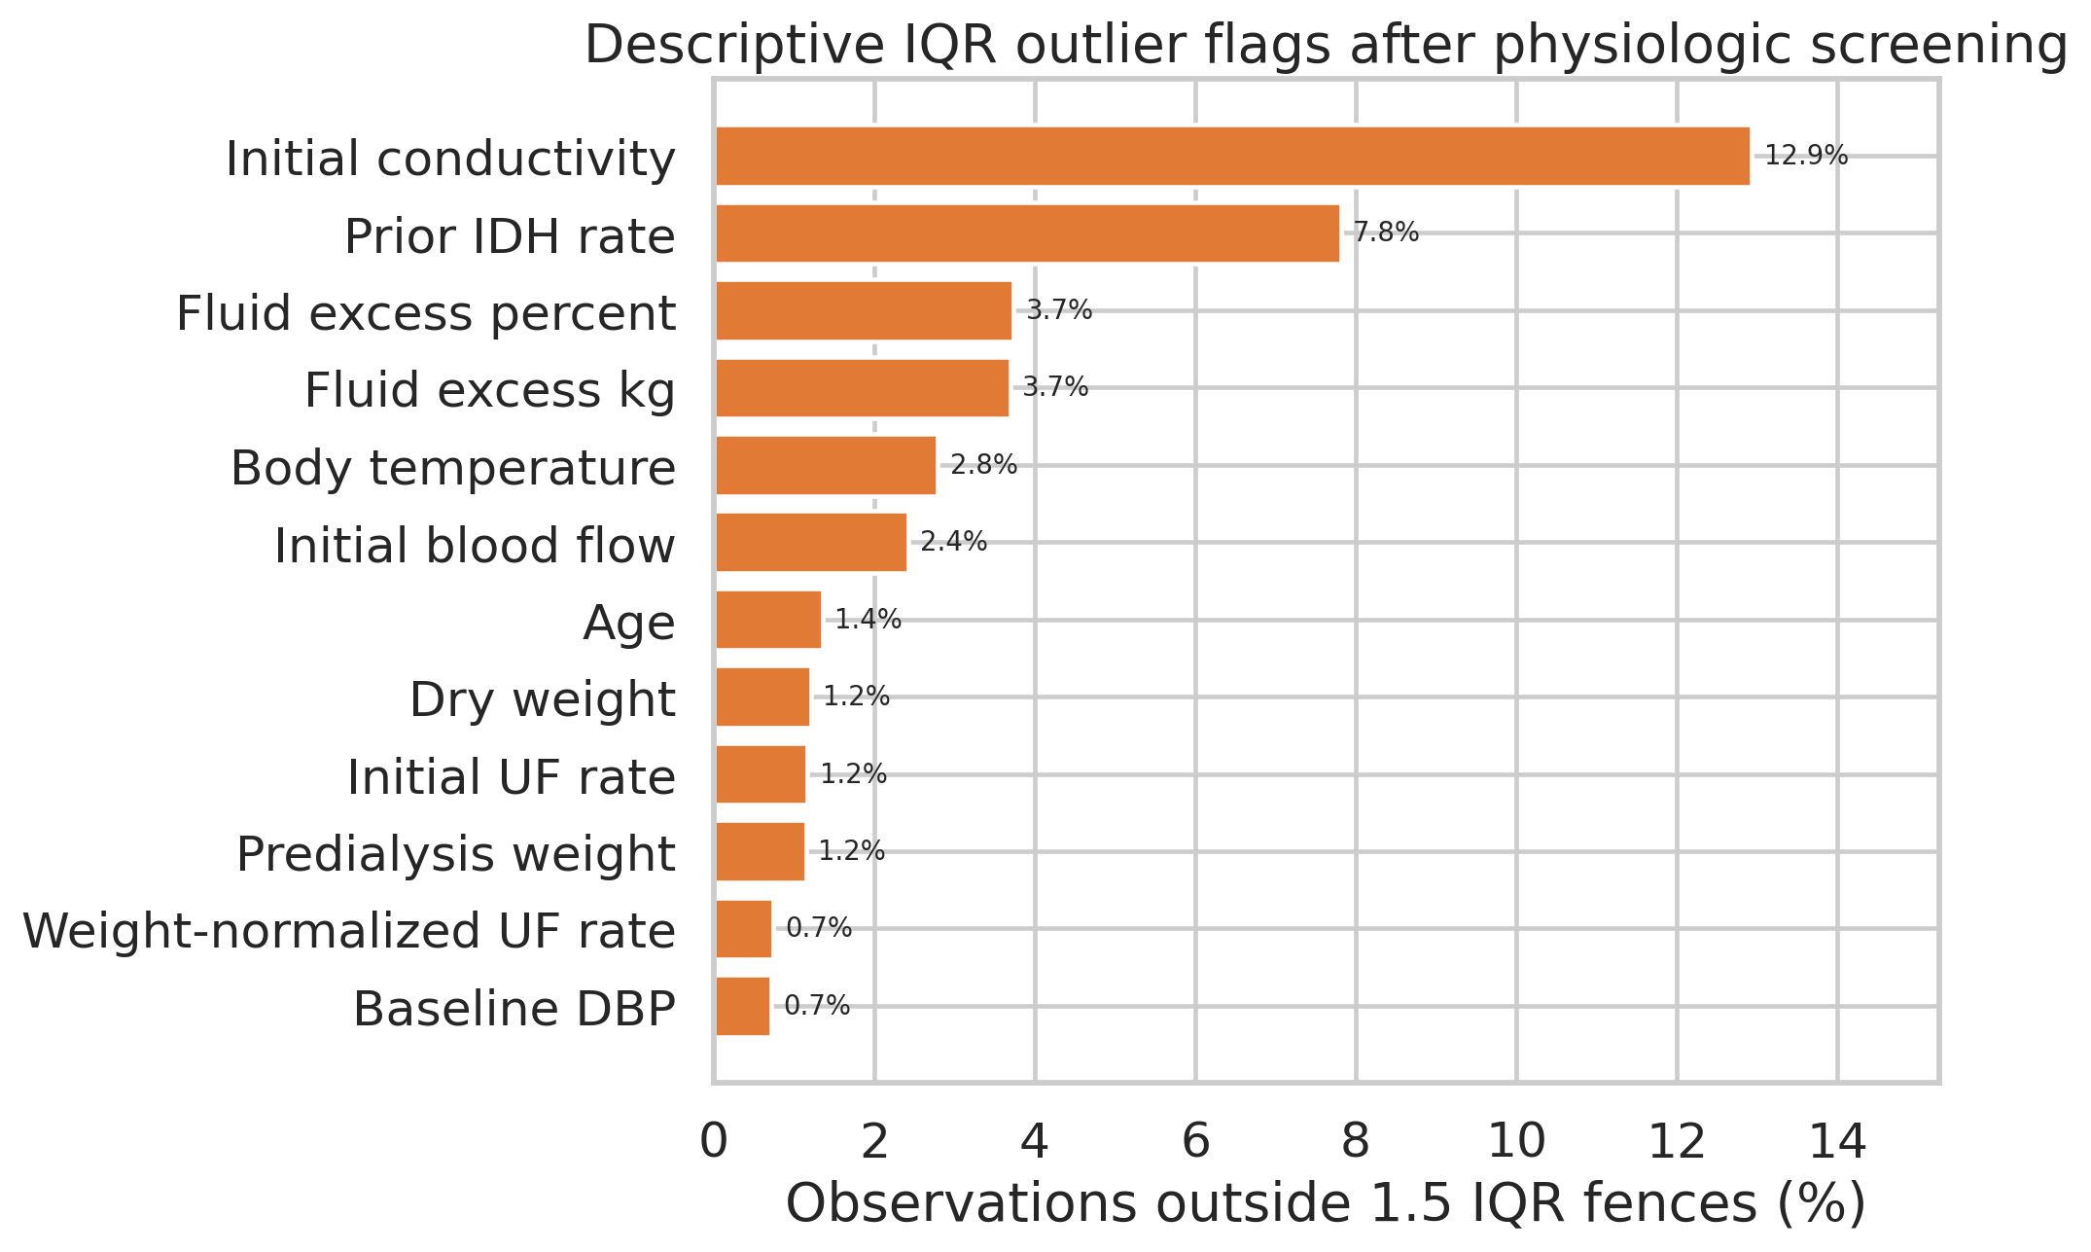
Figure 4. IQR flags among candidate predictors. High flag rates can reflect narrow central distributions rather than invalid records.

Feature | Min | Median | Max | IQR flags | Flag rate
initial_conductivity_ms_cm | 10.00 | 14.00 | 20.00 | 13,813 | 12.94%
prior_idh_rate | 0.00 | 0.04 | 1.00 | 8,275 | 7.81%
fluid_excess_pct | -28.74 | 3.93 | 64.95 | 3,987 | 3.73%
fluid_excess_kg | -23.80 | 2.20 | 37.70 | 3,945 | 3.70%
temperature | 35.00 | 36.40 | 39.50 | 2,981 | 2.79%
initial_blood_flow_ml_min | 2.00 | 210.00 | 400.00 | 2,589 | 2.43%
age_years | 18.00 | 66.00 | 94.00 | 1,450 | 1.36%
dryweight | 30.00 | 55.30 | 136.00 | 1,294 | 1.21%
initial_uf_l_h | 0.00 | 0.60 | 3.00 | 1,247 | 1.17%
weightstart | 30.60 | 57.80 | 172.70 | 1,232 | 1.15%

Priority quality checks. Conductivity has the largest IQR flag rate, 12.94%, because most readings are tightly concentrated near 14 mS/cm. Derived fluid-excess values range from -23.8 to 37.7 kg, and normalized ultrafiltration reaches 92.88 mL/kg/hour. These values are retained for transparency but will receive sensitivity checks, robust scaling or winsorization fitted only on training data, and individual-record review where feasible.

Outcome Definition and Dataset Fitness
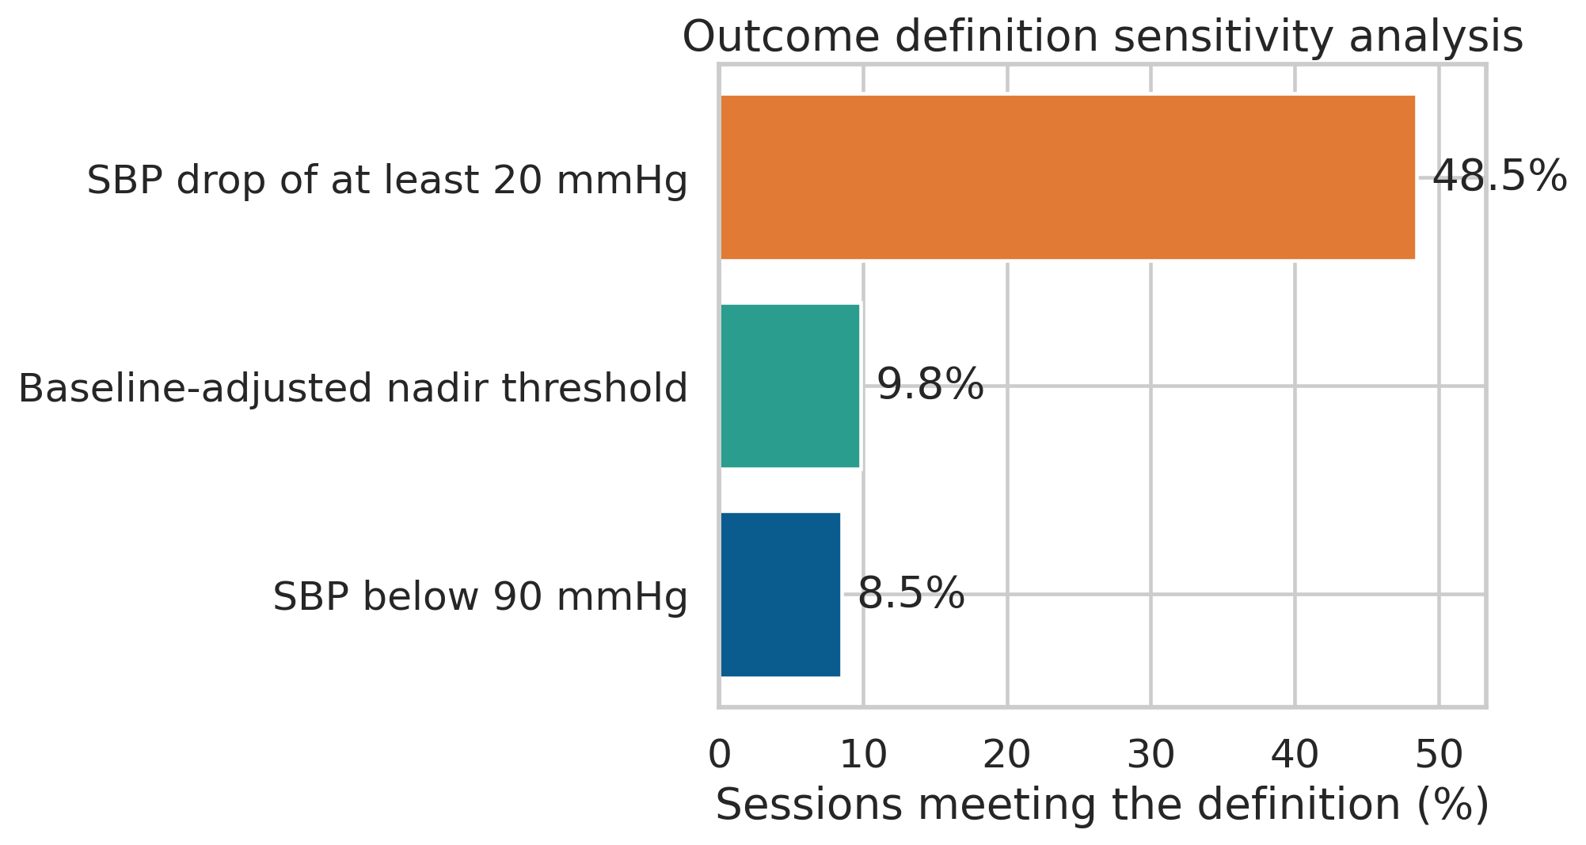
Figure 5. Outcome prevalence varies substantially by blood-pressure definition, reinforcing the need to preregister a primary label and report sensitivity analyses.

Status | Variable | Operational definition | Events | Prevalence
Primary | idh_absolute | Any later SBP below 90 mmHg | 9,067 | 8.493%
Sensitivity | idh_flythe | Later nadir below 90 if baseline below 160; otherwise below 100 | 10,508 | 9.843%
Sensitivity | idh_drop_20 | Any later SBP at least 20 mmHg below baseline | 51,753 | 48.477%

Fitness conclusion. HEMOBP is fit for an academic study of early, BP-defined risk prediction. It is not sufficient to claim prediction of the full clinical syndrome of IDH because symptoms and interventions are absent. It also does not support causal claims about treatment settings: dialysate temperature, conductivity, ultrafiltration, and blood flow were assigned in routine care rather than randomized.

Known Limitations and Controls
Limitation | Why it matters | Planned control
Single center and country | Transportability to other dialysis units, devices, and populations is unknown. | Use patient-grouped internal validation and require independent external validation.
Repeated sessions | A random row split would place the same patient in training and testing. | Use patient-grouped splits and report patient-level bootstrap uncertainty.
Outcome incompleteness | No symptoms or rescue interventions are available. | Name the label BP-defined IDH and present alternate BP definitions.
Informative sampling | Extra BP readings may occur when clinicians are concerned. | Exclude post-index count features from prediction and discuss measurement-process bias.
Limited clinical covariates | Most laboratory, medication, and comorbidity data are absent. | Constrain claims and document omitted-variable risk.
Sensitive attributes | Public data include recorded sex and age but not race or socioeconomic status. | Audit available subgroups and state that unobserved-group fairness cannot be assessed.

Reproducibility Record
The source CSV files remain immutable in data/raw. The session-level table is generated by code, and every exclusion and feature definition is encoded rather than performed manually. The workbook supplied with this report contains the full audit fields and can be filtered by source table, modelling role, or prediction-time availability.
Purpose | Command or path
Build analytic table | python src/build_session_dataset.py
Regenerate audit and figures | python src/generate_step2_assets.py
Regenerate dictionary workbook | node src/create_step2_dictionary_workbook.mjs
Regenerate this report | python src/create_step2_report.py
Analysis-ready dataset | data/processed/hemobp_session_level.csv.gz
Machine-readable audit | artifacts/step2_dataset_audit.json

References
[1] Lin CJ, Chen YY, Pan CF, Wu V, Wu CJ. Dataset supporting blood pressure prediction for the management of chronic hemodialysis. Scientific Data. 2019;6:313. https://doi.org/10.1038/s41597-019-0319-8
[2] Chien CY. HEMOBP. Figshare. Version 3. Dataset. 2019. CC BY 4.0. https://doi.org/10.6084/m9.figshare.6260654.v3

Data Dictionary Conventions
The appendices list every field in the three public source files and every field in the session-level analytic table. Observed ranges describe this specific release; they are not universal physiological limits. Missing percentages use the row count of the relevant table as the denominator. Role and availability state whether a field may be used by a model at the index time. The companion spreadsheet preserves additional provenance and quality-note columns for all 63 variables.
Dictionary element | Interpretation
Variable | Exact column name used in the corresponding CSV file
Type | Logical data type after parsing; source files may store values as text
Unit | Physical or coding unit; source-defined index is used where the publication does not document a unit
Values or observed range | Allowed codes for categories or minimum-to-maximum values observed in the audited release
Missing | Number and percentage of rows encoded as null after parsing
Role and availability | Purpose in the analytic design and whether it exists before, at, or after prediction time

Appendix A Raw Source Data Dictionary
The raw dictionary contains 23 variables across Idp, Hemrec D1, and Hemrec VIP. Raw values are never overwritten.

Idp
Variable | Type | Unit | Values or observed range | Missing | Definition | Analytic role
pid | string | none | 1,072 unique de-identified IDs | 0 (0.000%) | De-identified patient identifier | Primary patient key
gender | categorical | none | F or M | 0 (0.000%) | Recorded sex field | Patient characteristic and fairness attribute
birthday | integer | year | 1920 to 1998 | 0 (0.000%) | Recorded birth year | Source for age derivation
first_dialysis | date | year-month | 1990-01 to 2016-02 | 0 (0.000%) | Month of first hemodialysis treatment | Source for dialysis vintage
DM | binary | 0 or 1 | 0 = no diabetes; 1 = diabetes | 0 (0.000%) | Recorded diabetes status | Patient characteristic

Hemrec D1
Variable | Type | Unit | Values or observed range | Missing | Definition | Analytic role
pid | string | none | 1,072 unique de-identified IDs | 0 (0.000%) | De-identified patient identifier | Patient linkage key
keyindate | datetime | timestamp | 2013-06-01 to 2018-05-31 | 128 (0.077%) | Date and time used to identify the dialysis session | Session linkage key
dialysisstart | time | HH:MM | 24-hour clock time as stored | 128 (0.077%) | Recorded dialysis start clock time | Session audit field
dialysisend | time | HH:MM | 24-hour clock time as stored | 128 (0.077%) | Recorded dialysis end clock time | Post-session audit field
weightstart | numeric | kg | 30.6 to 172.7 | 128 (0.077%) | Body weight before dialysis | Baseline predictor source
weightend | numeric | kg | 30 to 164.1 | 128 (0.077%) | Body weight after dialysis | Post-session field
dryweight | numeric | kg | 30 to 136 | 128 (0.077%) | Prescribed dry weight | Baseline predictor source
temperature | numeric | degrees Celsius | 35 to 39.6 | 128 (0.077%) | Body temperature recorded for the session | Baseline predictor source

Hemrec VIP
Variable | Type | Unit | Values or observed range | Missing | Definition | Analytic role
pid | string | none | 1,072 unique de-identified IDs | 0 (0.000%) | De-identified patient identifier | Patient linkage key
datatime | datetime | timestamp | 2013-06-01 14:56:40 to 2018-07-01 06:22:57 | 0 (0.000%) | Timestamp of the monitor record | Patient-date linkage and ordering
measuretime | integer | source-defined index | 0 to 98 | 0 (0.000%) | Blood-pressure measurement index as stored | Ordering audit; source unit not documented
sbp | numeric | mmHg | 31 to 200 | 0 (0.000%) | Systolic blood pressure | Index predictor and later outcome source
dbp | numeric | mmHg | 30 to 192 | 0 (0.000%) | Diastolic blood pressure | Index predictor source
dia_temp_value | numeric | degrees Celsius | 33 to 40 | 0 (0.000%) | Dialysate temperature setting | Index predictor source
conductivity | numeric | mS/cm | 10 to 20 | 0 (0.000%) | Dialysate conductivity, a proxy for dialysate sodium concentration | Index predictor source
uf | numeric | L/hour | 0 to 3 | 0 (0.000%) | Ultrafiltration rate | Index predictor source
blood_flow | numeric | mL/min | 0 to 400 | 0 (0.000%) | Blood-flow rate through the extracorporeal circuit | Index predictor source
time | numeric | minutes | 0 to 370 | 0 (0.000%) | Elapsed dialysis time | Index selection and later outcome window

Interpretation note. In the source documentation, measuretime is an undocumented measurement index, whereas time is elapsed dialysis time in minutes. They are not treated as interchangeable. Raw minimum and maximum values describe this release; separate index-eligibility checks define the analysis-ready cohort.

Appendix B Analytic Data Dictionary
The analytic table contains 40 variables. Fields marked audit, eligibility, outcome, or post-index are retained for traceability but are excluded from model predictors.

Identifiers and Index Documentation
Variable | Type | Unit | Values or observed range | Missing | Definition | Role and availability
pid | string | Identifier | 830 unique IDs in the analytic cohort | 0 (0.000%) | De-identified patient identifier | Grouping and split only; never a predictor; Identifier only
session_date | date | Date | 2013-06-01 to 2018-05-31 | 0 (0.000%) | Date used to link a dialysis session across source tables | Identifier and temporal audit; Audit only
index_datetime | datetime | Timestamp | 2013-06-01 19:53:40 to 2018-05-31 20:41:17 | 0 (0.000%) | Timestamp of the earliest valid active-dialysis record within 30 minutes | Index-time documentation; Audit only
index_minute | numeric | minutes | 0 to 30 | 0 (0.000%) | Elapsed dialysis minute at the index record | Cohort audit; not a predictor; Audit only

Index and Predialysis Predictors
Variable | Type | Unit | Values or observed range | Missing | Definition | Role and availability
baseline_sbp | numeric | mmHg | 90 to 200 | 0 (0.000%) | Systolic BP at the index record | Predictor; Known at index
baseline_dbp | numeric | mmHg | 30 to 150 | 0 (0.000%) | Diastolic BP at the index record | Predictor; Known at index
initial_dialysate_temp_c | numeric | degrees Celsius | 35 to 39 | 0 (0.000%) | Dialysate temperature at the index record | Predictor; Known at index
initial_conductivity_ms_cm | numeric | mS/cm | 10 to 20 | 0 (0.000%) | Dialysate conductivity at the index record | Predictor; Known at index
initial_uf_l_h | numeric | L/hour | 0 to 3 | 0 (0.000%) | Ultrafiltration rate at the index record | Predictor; Known at index
initial_blood_flow_ml_min | numeric | mL/min | 2 to 400 | 0 (0.000%) | Blood-flow rate at the index record | Predictor; Known at index
weightstart | numeric | kg | 30.6 to 172.7 | 0 (0.000%) | Body weight before dialysis | Predictor; Known before treatment
dryweight | numeric | kg | 30 to 136 | 0 (0.000%) | Prescribed dry weight | Predictor; Known before treatment
temperature | numeric | degrees Celsius | 35 to 39.5 | 0 (0.000%) | Body temperature recorded for the session | Predictor; Known at session start
gender | categorical | F or M | F or M | 0 (0.000%) | Recorded sex field in the source data | Predictor and fairness audit; Known before treatment
DM | binary | 0 or 1 | 0 = no diabetes; 1 = diabetes | 0 (0.000%) | Recorded diabetes status | Predictor and subgroup audit; Known before treatment
age_years | numeric | years | 18 to 94 | 0 (0.000%) | Session year minus birth year | Predictor and fairness audit; Known before treatment
dialysis_vintage_years | numeric | years | 0 to 27.28 | 1,465 (1.372%) | Time from first dialysis to session date | Predictor; Known before treatment
fluid_excess_kg | numeric | kg | -23.8 to 37.7 | 0 (0.000%) | Predialysis weight minus dry weight | Engineered predictor; Known before treatment
fluid_excess_pct | numeric | percent of dry weight | -28.74 to 64.95 | 0 (0.000%) | Fluid excess divided by dry weight | Engineered predictor; Known before treatment
initial_uf_ml_kg_h | numeric | mL/kg/hour | 0 to 92.88 | 0 (0.000%) | Initial UF rate normalized by predialysis weight | Engineered predictor; Known at index
baseline_map | numeric | mmHg | 50.67 to 165.67 | 0 (0.000%) | DBP plus one-third of pulse pressure | Engineered predictor; Known at index
baseline_pulse_pressure | numeric | mmHg | 5 to 162 | 0 (0.000%) | Baseline SBP minus DBP | Engineered predictor; Known at index

Prior Session Predictors
Variable | Type | Unit | Values or observed range | Missing | Definition | Role and availability
prior_session_idh | binary | 0 or 1 | 0 = no; 1 = yes | 830 (0.777%) | Primary outcome in the immediately preceding observed session | History predictor; earlier sessions only; Prior sessions only
prior_nadir_sbp | numeric | mmHg | 37 to 198 | 830 (0.777%) | Later nadir SBP in the preceding observed session | History predictor; earlier sessions only; Prior sessions only
prior_session_count | integer | sessions | 0 to 735 | 0 (0.000%) | Number of earlier eligible sessions for the patient | History predictor; log transformed; Prior sessions only
prior_idh_rate | numeric | 0 to 1 | 0 to 1 | 830 (0.777%) | Cumulative BP-defined IDH rate across earlier sessions | History predictor; earlier sessions only; Prior sessions only

Outcome and Post Index Audit
Variable | Type | Unit | Values or observed range | Missing | Definition | Role and availability
later_records | integer | records | 2 to 1,364 | 0 (0.000%) | Number of records after the index measurement | Outcome-quality audit; not a predictor; Post-index audit only
later_distinct_minutes | integer | distinct minutes | 2 to 242 | 0 (0.000%) | Distinct elapsed-time values after the index measurement | Eligibility; not a predictor; Post-index eligibility only
last_observed_minute | numeric | minutes | 120 to 370 | 0 (0.000%) | Latest elapsed dialysis time recorded after index | Eligibility; not a predictor; Post-index eligibility only
nadir_sbp | numeric | mmHg | 37 to 198 | 0 (0.000%) | Lowest SBP recorded after index | Outcome derivation; never a predictor; Post-index outcome derivation only
mean_later_sbp | numeric | mmHg | 64.74 to 198.67 | 0 (0.000%) | Mean SBP after index | Outcome description; never a predictor; Post-index outcome description only
idh_absolute | binary | 0 or 1 | 0 = no; 1 = yes | 0 (0.000%) | Later SBP below 90 mmHg | Primary outcome; Primary outcome
idh_drop_20 | binary | 0 or 1 | 0 = no; 1 = yes | 0 (0.000%) | Later SBP at least 20 mmHg below baseline | Sensitivity outcome; Sensitivity outcome
idh_flythe | binary | 0 or 1 | 0 = no; 1 = yes | 0 (0.000%) | Later nadir below 90 mmHg when baseline is below 160, otherwise below 100 | Sensitivity outcome; Sensitivity outcome
dialysisstart | time | Clock time | 24-hour clock time as stored | 0 (0.000%) | Recorded dialysis start time | Audit; not a predictor; Audit only
dialysisend | time | Clock time | 24-hour clock time as stored | 0 (0.000%) | Recorded dialysis end time | Post-index field; excluded; Post-index field; excluded
weightend | numeric | kg | 30 to 164.1 | 0 (0.000%) | Body weight after dialysis | Post-index field; excluded; Post-treatment field; excluded
birthday | integer | year | 1,920 to 1,998 | 0 (0.000%) | Recorded birth year | Used to derive age; excluded directly; Source only; replaced by age
first_dialysis | date | Year and month | 1990-01-01 to 2016-01-01 | 0 (0.000%) | Recorded month of first dialysis | Used to derive vintage; Source only; replaced by vintage
session_year | integer | year | 2,013 to 2,018 | 0 (0.000%) | Calendar year of the session | Temporal audit; excluded from model; Temporal audit only

