DIAL ALERT EDA and Feature Engineering Report
  - Capstone Project Step 3
Explainable early prediction of blood pressure defined intradialytic hypotension
Prepared by Franklin Guillano
September 2026
Academic clinical decision support prototype. The output is not a diagnostic device and requires external and prospective validation before clinical use.

Executive Summary
This report documents the reproducible transformation of the HEMOBP source files into a leakage-controlled session-level modelling table. The final analytic cohort contains 106,758 haemodialysis sessions from 830 patients. The primary blood-pressure-defined outcome occurred in 9,067 sessions, giving a prevalence of 8.49%. Missingness was limited to dialysis vintage and first-session history variables. Physiologically impossible monitoring records were removed before feature construction, while plausible extreme values were retained and described rather than deleted automatically.
Exploratory analysis identified strong longitudinal and treatment-related associations. A lower previous-session nadir, a higher previous IDH rate, greater fluid excess, and higher initial ultrafiltration intensity were associated with greater observed event prevalence. These relationships informed domain-derived features but are not interpreted as causal effects.
The preprocessing pipeline applies training-fold median imputation, categorical mode imputation, one-hot encoding, and model-specific scaling. Embedded L1 selection retained 12 of 24 transformed features. PCA retained 11 numeric components to exceed the selected 85% variance threshold, but the PCA candidate underperformed the interpretable non-PCA alternatives. Global permutation importance, aggregate SHAP values, and dependence curves based on synthetic reference profiles provide complementary explanations of the selected model.

Rubric Evidence
Requirement | Evidence in this report
Clean data | Nulls, dates, duplicates, linkage, physiologic bounds, index-time rules, and follow-up eligibility are documented.
Engineer features | Scaling, encoding, diagnostic binning, longitudinal history, haemodynamic, and dialysis-dose features are reproduced in code.
Applied EDA | Outcome distributions, predictor distributions, correlations, subgroup prevalence, nonlinear decile relationships, and index timing are shown.
Feature importance | Permutation importance, aggregate SHAP, a synthetic local explanation, and synthetic-profile dependence analyses are included.
Feature selection | Embedded L1 logistic regression selects 12 of 24 transformed predictors inside the training workflow.
Dimensionality reduction | PCA is fitted after imputation and scaling; 11 components explain 87.6% of numeric-feature variance.
Reproducibility | Source scripts, configuration, random seed, generated tables, and commands are listed.

1 Analysis Objective
DIAL-ALERT is a supervised binary-classification project. Each eligible haemodialysis session receives a risk probability for a later systolic blood-pressure reading below 90 mmHg. The index observation is the earliest valid active-dialysis record within the first 30 minutes, and the outcome is derived only from later measurements. Sessions already below 90 mmHg at the index time are excluded.
The endpoint is described as blood-pressure-defined IDH because HEMOBP does not contain the symptoms and intervention data required to reconstruct a complete clinical IDH definition. Two alternative labels are retained for sensitivity analysis: a systolic decrease of at least 20 mmHg and a baseline-adjusted nadir threshold.

Analysis Unit and Prediction Boundary
Element | Operational definition
Unit | One linked patient-day haemodialysis session
Prediction time | Earliest active-dialysis record from minute 0 through minute 30
Primary target | Any later SBP below 90 mmHg
Eligibility | Index SBP at least 90 mmHg, at least two later distinct minutes, and observation through at least minute 120
Leakage rule | No measurement or outcome recorded after the index time is used as a predictor
Validation grouping | All sessions from a patient remain within one data split

2 Cohort Construction
The source dataset contains 1,072 patient rows, 165,986 session-summary rows, and 4,366,298 time-stamped monitoring records. Patient identifier and calendar date link the session and monitoring tables. Of 165,849 valid unique patient-days, 110,790 linked to monitoring data. The index and follow-up rules produced 106,758 sessions from 830 patients.
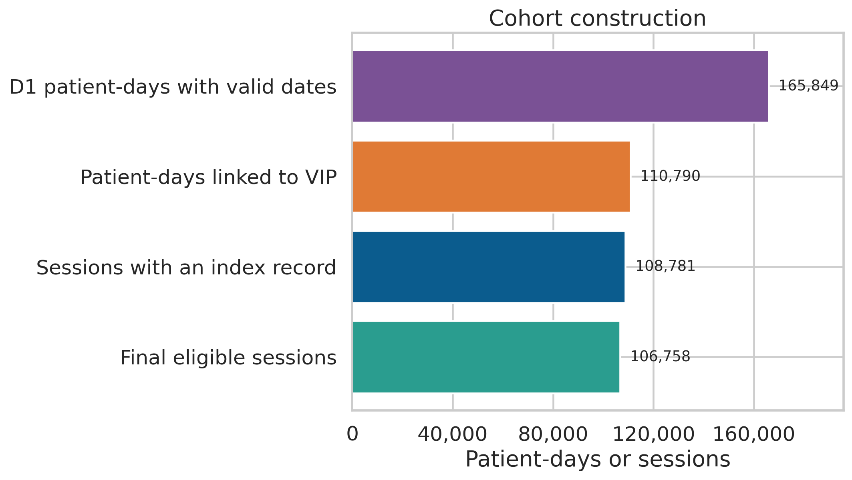
Figure 1. Cohort construction from valid session dates to the final eligible analytic cohort.
Stage | Count | Action
Raw patient table | 1,072 | Retained as the source of patient-level characteristics
Raw session table | 165,986 | Inspected dates and patient-day keys
Session rows with missing dates removed | 128 | Excluded because no session date was available for linkage
Duplicate patient-day session rows removed | 9 | Stable chronological rule retained the first row per patient-day
Valid unique patient-days | 165,849 | Used as the session linkage frame
Raw monitoring records | 4,366,298 | Linked by patient and calendar date
Linked monitoring records | 2,228,411 | Screened against the documented SBP, DBP, and elapsed-time envelope
Linked monitoring rows outside bounds removed | 0 | Excluded only when outside the documented source envelope
Exact linked monitoring duplicates removed | 0 | Exact duplicate records only; repeated valid readings were preserved
Linked patient-days | 110,790 | Required a valid active-dialysis index record
Patient-days with index record | 108,781 | Required at least one record after the index time
Sessions with post-index records | 108,680 | Applied sequential outcome-eligibility criteria
Sessions removed for baseline SBP below 90 | 1,375 | Excluded prevalent hypotension at prediction time
Sessions removed for fewer than two later minutes | 116 | Reduced false negatives from sparse follow-up
Sessions removed for follow-up below 120 minutes | 431 | Reduced false negatives from truncated observation
Final eligible sessions | 106,758 | Used for EDA and modelling

3 Data Cleaning

Dates Linkage and Duplicates
The session table contained 128 rows without usable dates and nine duplicate patient-day keys. Invalid-date rows were excluded, and stable chronological sorting retained the first row for duplicate patient-day keys. Monitoring records were then linked many-to-one to the deduplicated session frame. No exact duplicate monitoring rows remained after linkage and physiologic screening.

Physiologic and Timing Bounds
- Monitoring SBP was restricted to 31 through 200 mmHg, DBP to 30 through 192 mmHg, and elapsed dialysis time to 0 through 370 minutes.
- The index record required active blood flow, elapsed time from 0 through 30 minutes, SBP from 60 through 200 mmHg, and DBP from 30 through 150 mmHg.
- Primary-outcome eligibility required index SBP of at least 90 mmHg and adequate later observation, preventing already-present hypotension and truncated follow-up from being treated as prediction cases.

Missing Values
Dialysis vintage was missing in 1.37% of eligible sessions. The three prior-session features were missing in 0.78%, corresponding primarily to each patient's first eligible observed session. All other modelling fields were complete in the eligible table. Numeric values are median-imputed and categorical values are mode-imputed inside the fitted training pipeline, so validation and test information cannot influence imputation parameters.
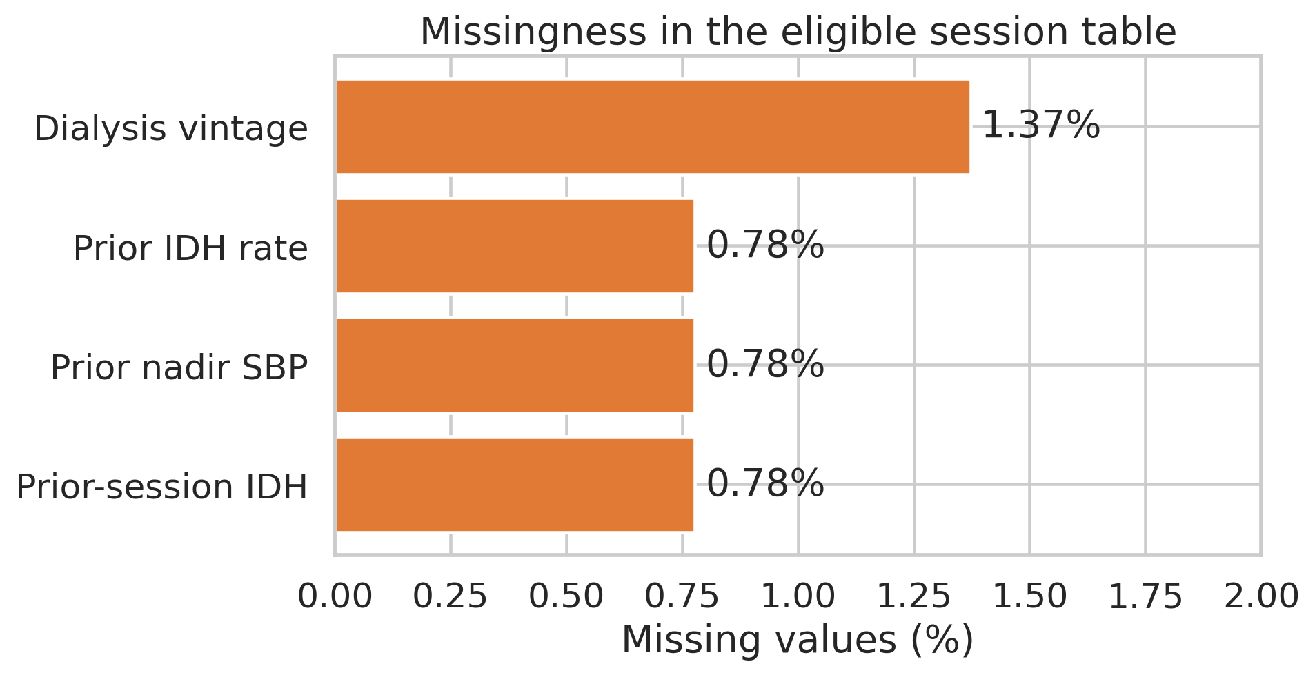
Figure 2. Percentage of missing values among eligible sessions before model-pipeline imputation.

4 Outlier Assessment
Outlier handling separates impossible measurements from unusual but potentially valid clinical observations. Hard physiologic and timing bounds remove invalid monitoring values before the index and outcome are defined. For the resulting predictors, the 1.5-IQR rule is used only as a descriptive flag. Flagged values are not automatically removed because narrow-distribution variables, such as dialysate conductivity, can produce many statistical flags that remain clinically possible.
Tree-based models use the screened values directly. Linear and PCA candidates receive imputation and standardisation within each training fold. The report retains the full outlier audit in artifacts/outlier_summary.csv so that alternative clipping or winsorisation can be evaluated as a sensitivity analysis without silently changing the primary cohort.
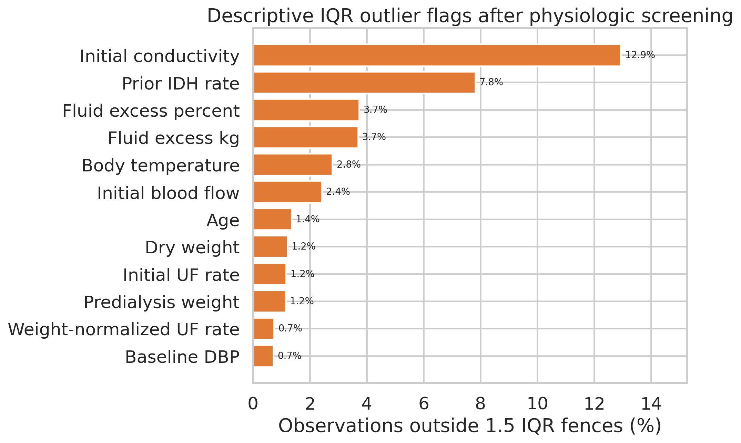
Figure 3. Descriptive IQR flags after physiologic screening. These flags identify distribution tails and are not automatic exclusion rules.

5 Outcome and Prediction Timing
The primary outcome occurred in 9,067 of 106,758 sessions (8.49%). The baseline-adjusted threshold occurred in 10,508 sessions (9.84%), while a decrease of at least 20 mmHg occurred in 51,753 sessions (48.48%). The large difference confirms that the event rate depends strongly on the operational definition and supports retaining multiple sensitivity outcomes.
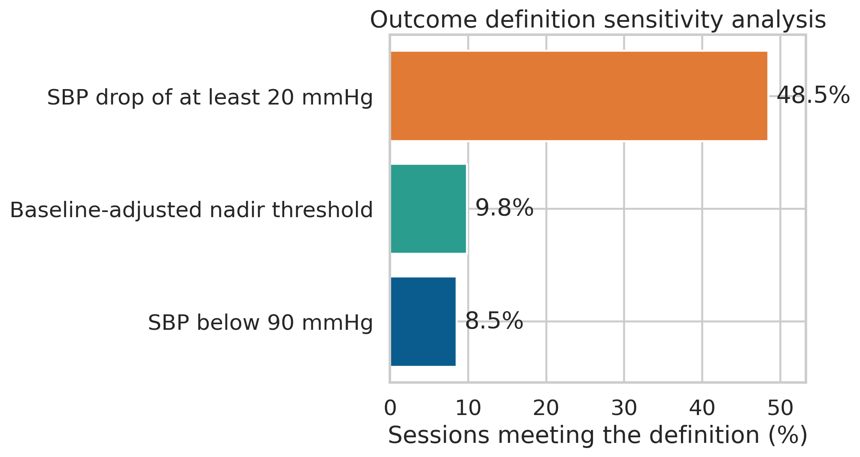
Figure 4. Outcome prevalence under the primary and two sensitivity definitions.
The median index time was 0 minutes. 94.0% of sessions were indexed at minute 0 and 99.5% by minute 5. The 30-minute allowance therefore covers a small tail of sessions rather than defining the typical prediction time.
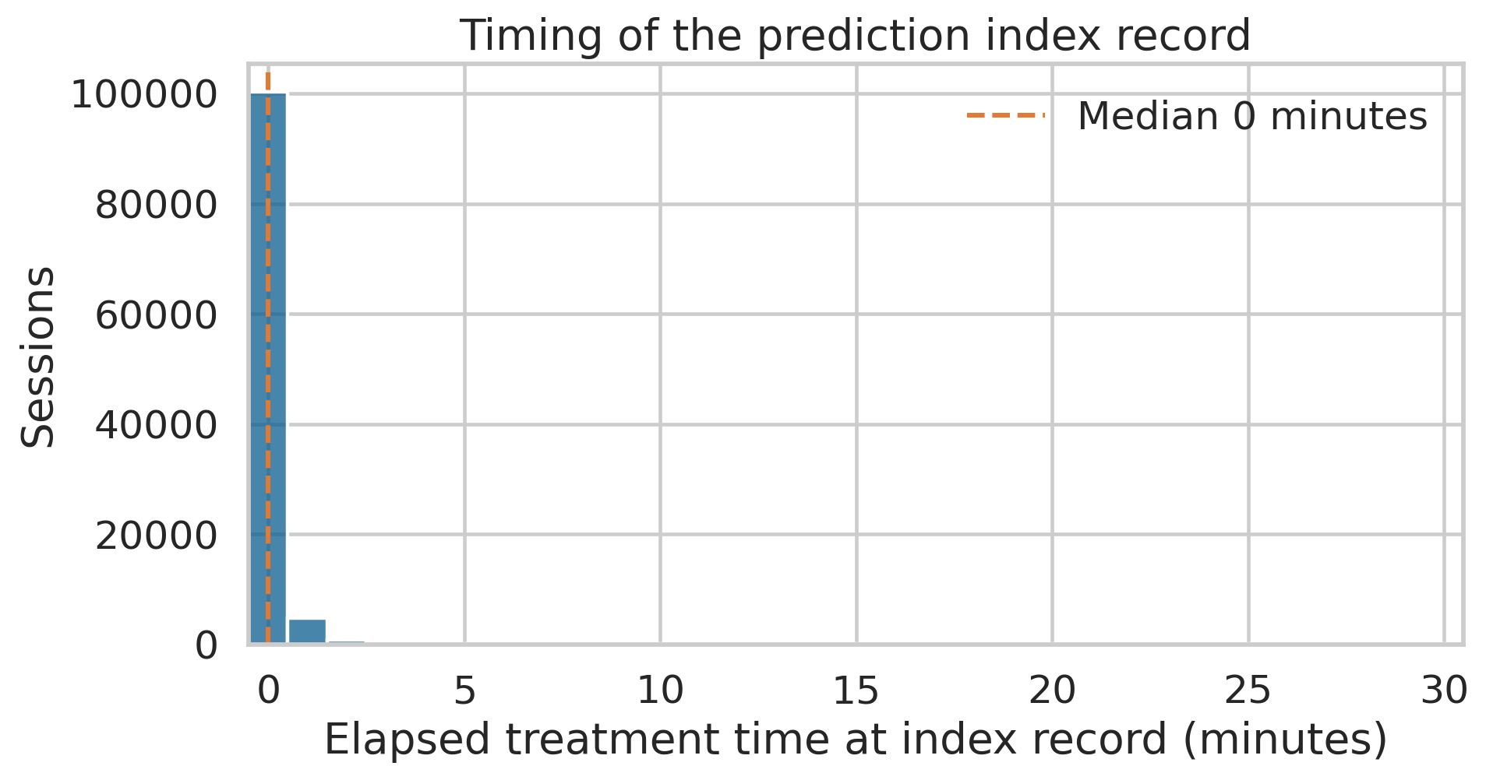
Figure 5. Distribution of elapsed treatment time at the selected index record.

6 Applied Exploratory Data Analysis

Predictor Distributions
Outcome-stratified distributions show the clearest separation for previous-session nadir SBP and prior IDH rate. Sessions with the primary outcome also tend to have lower baseline SBP, greater fluid excess, and higher initial weight-normalised ultrafiltration. The plotted range is limited to the 0.5th through 99.5th percentiles for visual readability; the analysis table retains all values that pass physiologic screening.
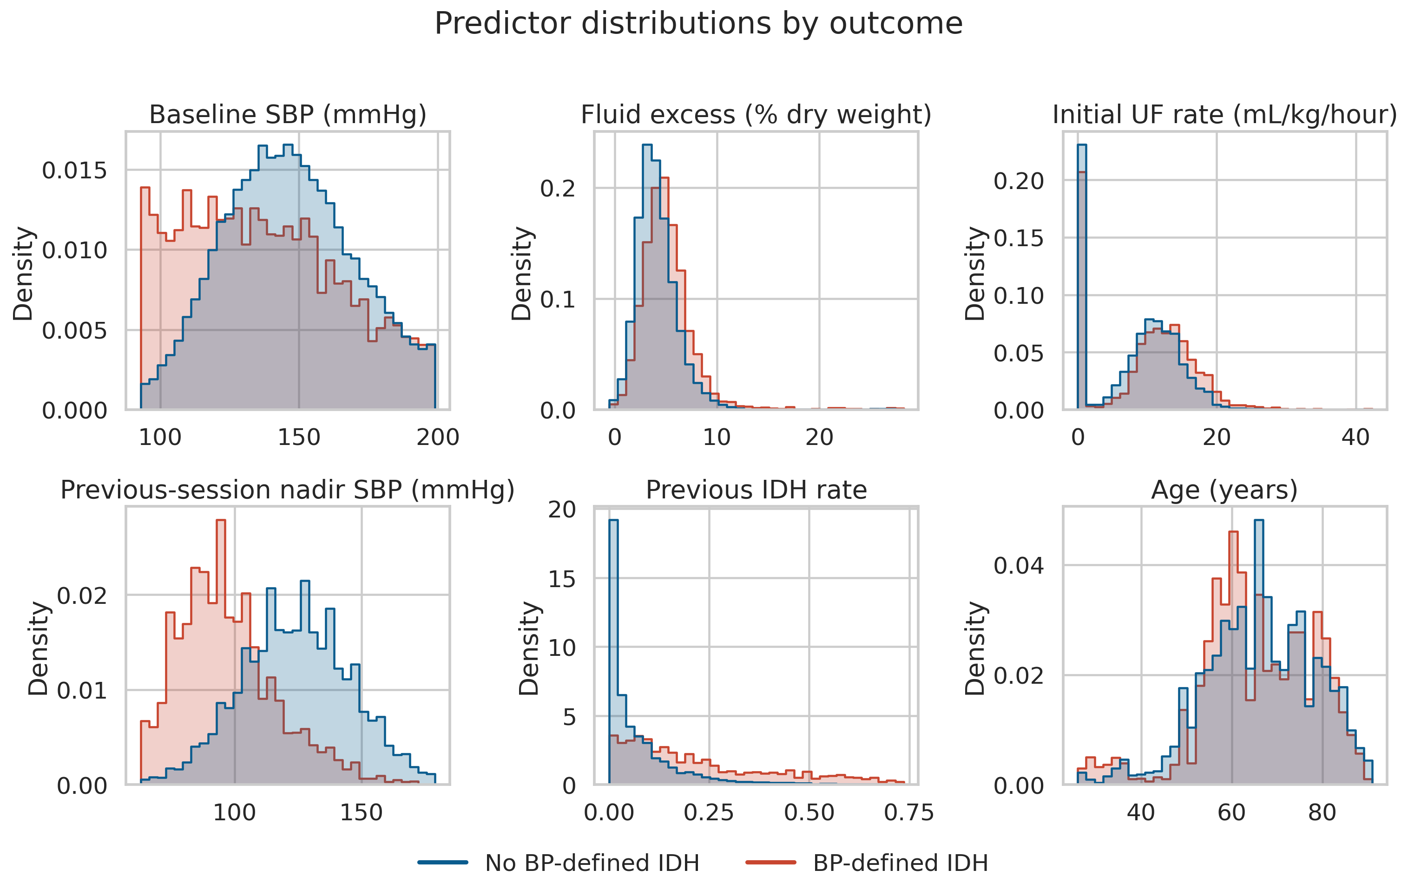
Figure 6. Selected predictor distributions stratified by the primary outcome.

Nonlinear Relationships
Quantile binning was used for EDA only and was not supplied to the final model. The lowest previous-session nadir decile had a 37.5% observed event rate, compared with 1.0% in the highest decile. Event prevalence rose from 4.8% to 16.3% across fluid-excess deciles and reached 15.9% in the highest initial ultrafiltration-rate decile. Baseline SBP showed a nonlinear relationship, with the greatest prevalence in the lowest decile.
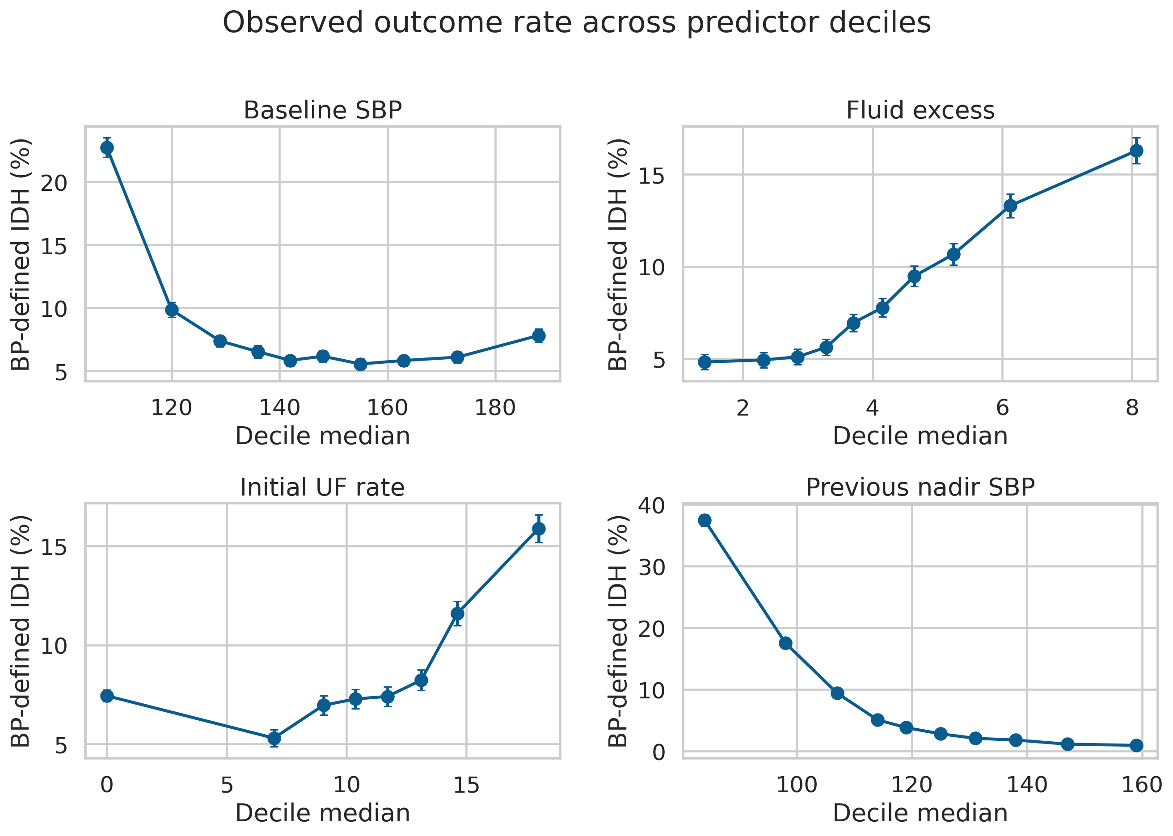
Figure 7. Observed primary-outcome prevalence across predictor deciles with approximate 95% binomial intervals.
The decile plots are descriptive. They do not adjust for patient clustering, treatment decisions, or correlated predictors and must not be interpreted as causal dose-response relationships.

Correlations and Subgroup Patterns
Spearman correlation was chosen because several predictors were skewed and relationships were not strictly linear. Previous-session nadir SBP had the largest absolute univariable correlation with the outcome (rho = -0.320), followed by prior IDH rate (rho = 0.288), fluid excess percentage (rho = 0.127), and baseline SBP (rho = -0.117). Correlated haemodynamic features were retained for model comparison, then examined through regularisation, embedded selection, and permutation analysis.
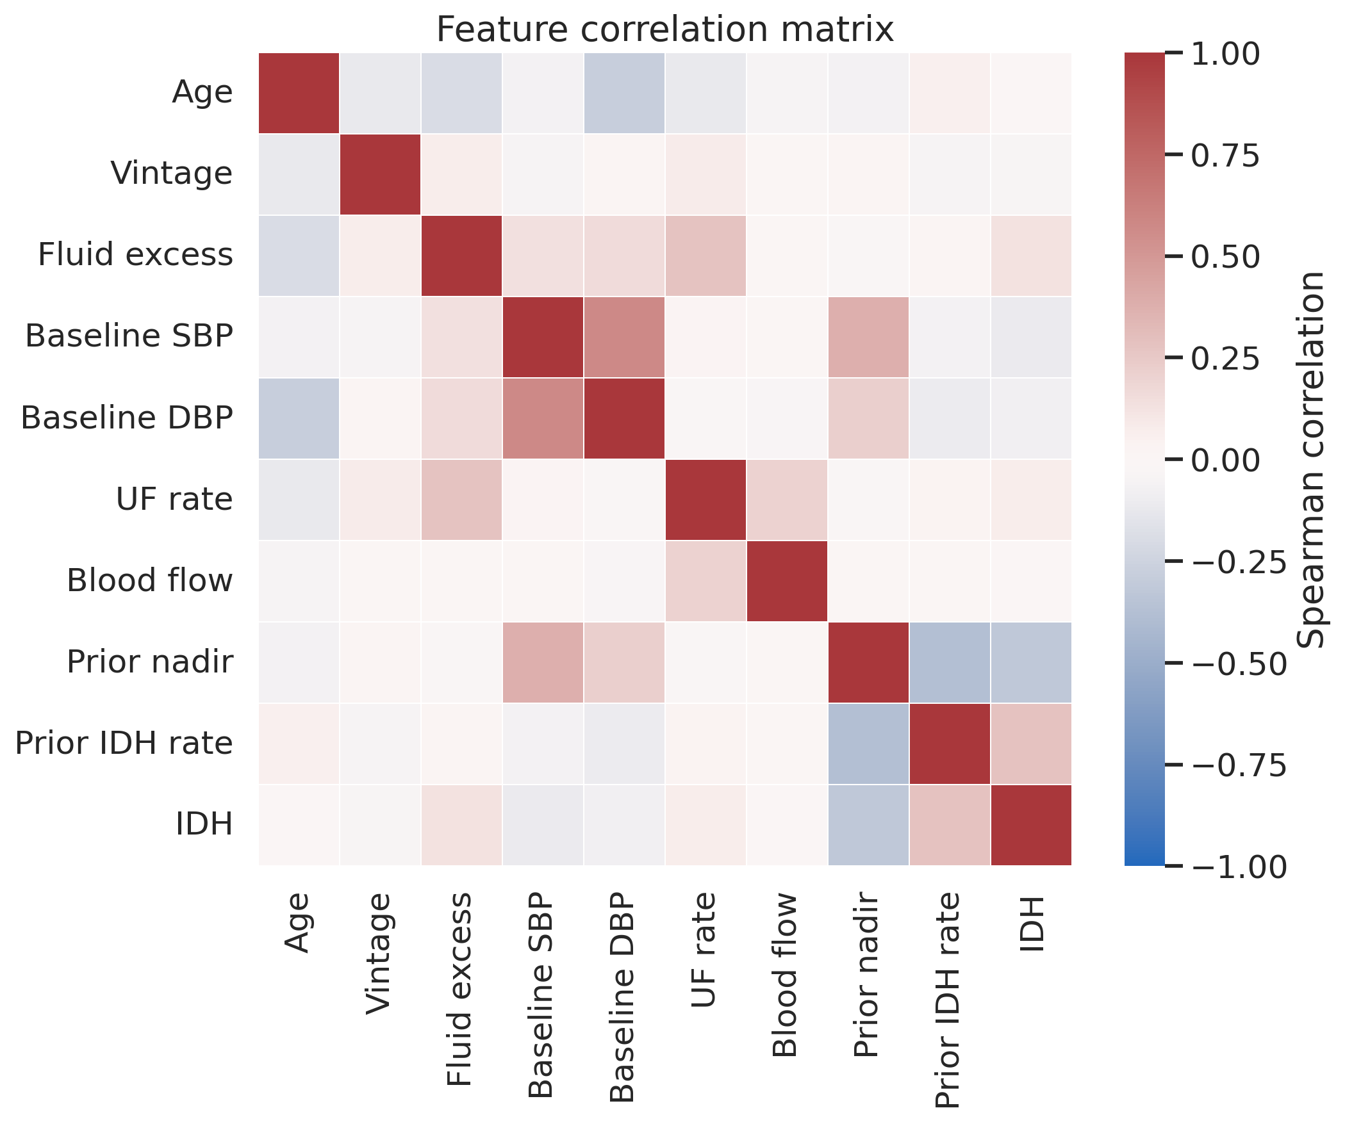
Figure 8. Spearman correlation matrix for selected predictors and the primary outcome.

Subgroup Patterns
Observed prevalence varied by recorded sex, age group, and diabetes status. These descriptive differences motivated the later fairness audit; they do not establish unfair model treatment or biological causation. Repeated sessions also give frequent attenders more influence than patients with fewer observations, so patient-grouped validation remains essential.
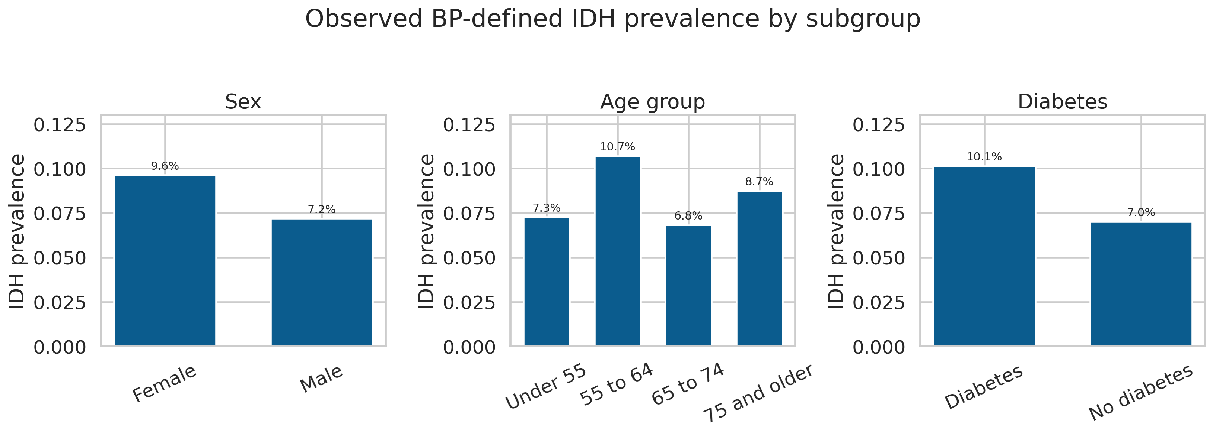
Figure 9. Observed BP-defined IDH prevalence by recorded sex, age group, and diabetes status.

7 Feature Engineering
Feature engineering used information available by the index time and earlier sessions only. Domain-derived features express volume burden, haemodynamic state, treatment intensity, dialysis exposure, and patient-specific history. Outcome fields, later blood pressures, post-dialysis weight, dialysis end time, identifiers, and audit variables are excluded from the model feature list.
Feature | Definition | Rationale
age_years | session year - birth year | Age at each treatment session
dialysis_vintage_years | (session date - first dialysis date) / 365.25 | Duration of dialysis exposure
fluid_excess_kg | predialysis weight - prescribed dry weight | Absolute excess fluid before treatment
fluid_excess_pct | 100 x fluid excess / dry weight | Patient-size-normalized fluid excess
initial_uf_ml_kg_h | 1000 x initial UF L/hour / predialysis weight | Patient-size-normalized initial UF intensity
baseline_map | DBP + (SBP - DBP) / 3 | Mean arterial pressure approximation
baseline_pulse_pressure | SBP - DBP | Arterial pulse-pressure estimate
prior_session_idh | previous eligible session outcome | Recent within-patient instability history
prior_nadir_sbp | previous eligible session later nadir SBP | Previous-session BP tolerance
prior_idh_rate | cumulative earlier IDH events / earlier sessions | Longitudinal recurrence burden
prior_session_count | number of earlier eligible sessions | Available history depth; log transformed before modelling

History variables are calculated after chronological sorting within each patient. A one-session shift ensures that the current outcome cannot enter its own predictors. Because the train, validation, and test splits are patient-disjoint, no patient's history crosses a split boundary.

8 Preprocessing Pipeline
Input | Transformation | Justification
Numeric missing values | Median imputation | Fitted inside each training fold
Categorical missing values | Most-frequent imputation | Fitted inside each training fold
Recorded sex and diabetes | One-hot encoding | Unknown categories ignored safely
Numeric linear-model inputs | Standard scaling | Required for regularised logistic regression and PCA
Tree-model inputs | No scaling | Preserves natural split thresholds
Prior session count | log(1 + count) | Reduces strong right skew
EDA relationship plots | Quantile bins | Diagnostic only; not model inputs
Outliers | Physiologic bounds plus retention of plausible extremes | Avoids arbitrary deletion of rare clinical observations

Leakage Controls
- Only later records define the outcome; later measurements are never candidate predictors.
- Imputation, scaling, one-hot encoding, L1 selection, and PCA are fitted within scikit-learn pipelines rather than before cross-validation.
- Cross-validation uses patient groups, preventing sessions from the same patient from appearing in both fitting and validation folds.
- Feature importance on the test set is used only for final explanation, not for tuning or feature selection.

Clustering Tendency
Clustering tendency was not evaluated because DIAL-ALERT is a supervised classification task with a prespecified outcome. Adding K-means, DBSCAN, t-SNE, or UMAP would not answer the stated prediction question. PCA was retained as the required dimensionality-reduction comparison.

9 Embedded Feature Selection
An embedded selection pipeline used L1-penalised logistic regression through SelectFromModel. The selector retained 12 of 24 transformed features using the median importance threshold. Selection occurred within grouped cross-validation, preventing the holdout test set from determining the feature set.
Selected feature | Selected feature
dialysis vintage years | temperature
fluid excess pct | baseline sbp
baseline map | initial uf ml kg h
initial dialysate temp c | prior nadir sbp
prior idh rate | prior session count
gender M | DM 0

The L1 pipeline provides explicit evidence of feature selection but is treated as a candidate model rather than an automatic filter for every algorithm. Gradient boosting can use nonlinearities and correlated signals differently, so its inputs were not removed based on a linear selector. Test-set permutation importance was also excluded from selection decisions.

10 Principal Component Analysis
PCA was applied only to numeric predictors after median imputation and standardisation. The selected PCA logistic-regression candidate used an 85% variance threshold and retained 11 components, which explained 87.6% of numeric-feature variance. Categorical variables remained one-hot encoded outside the PCA block.
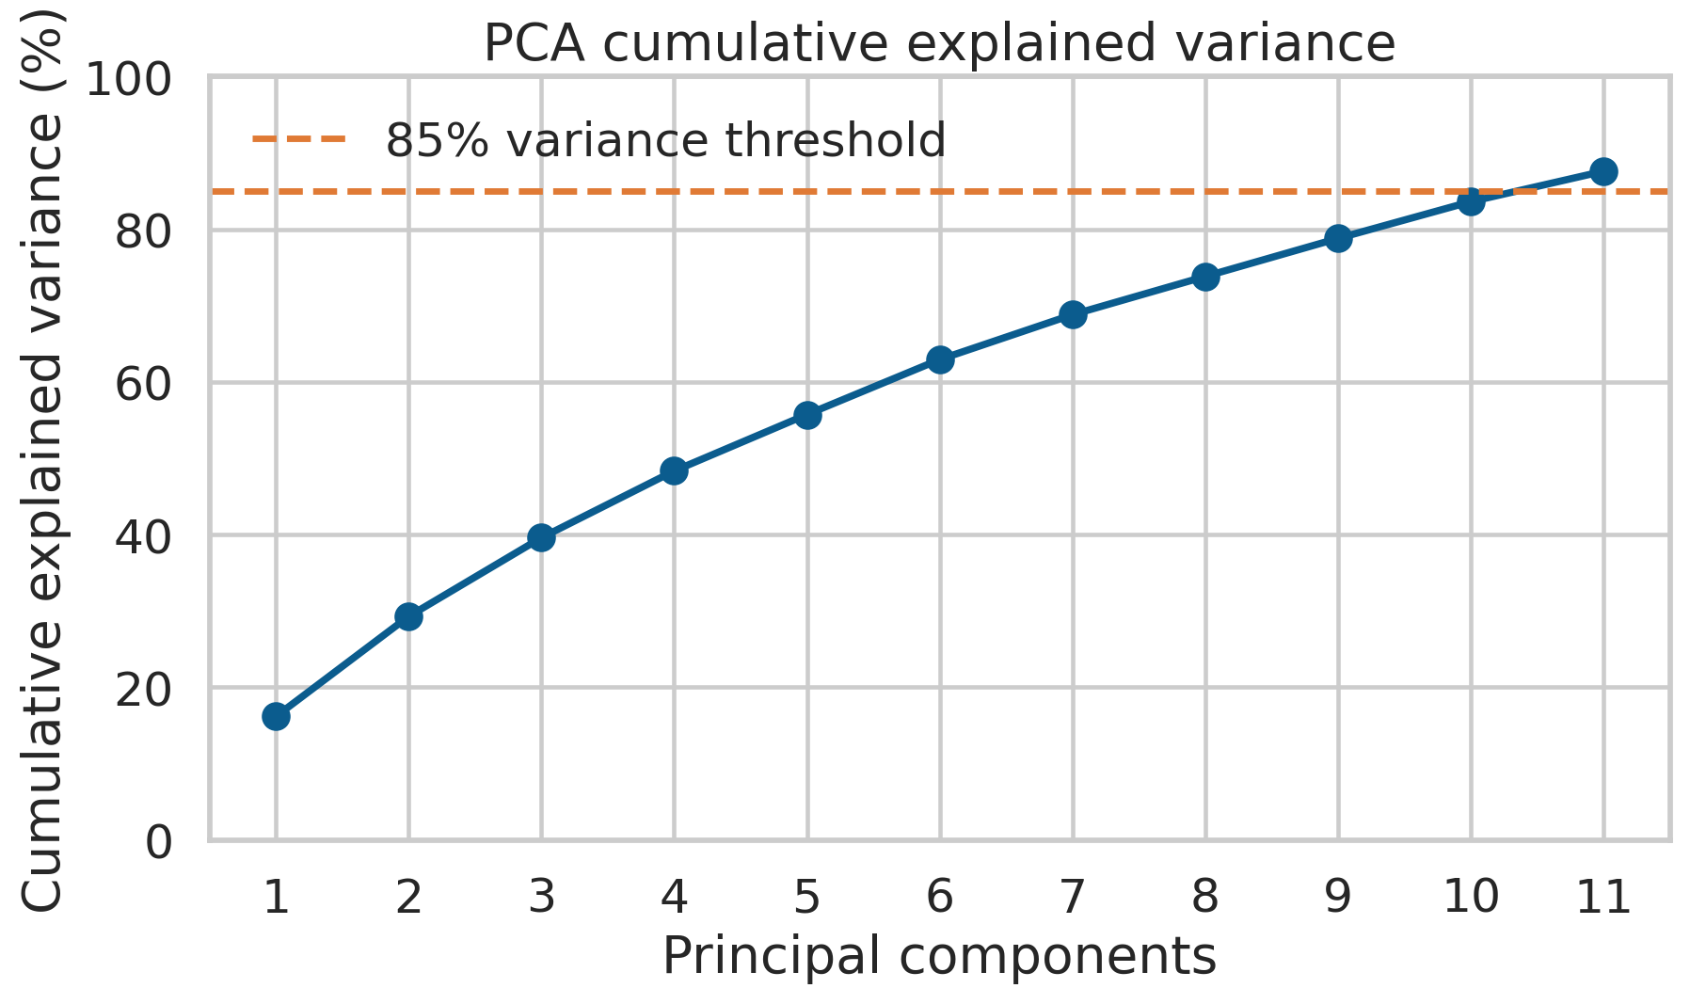
Figure 10. Cumulative explained variance for the PCA candidate selected during grouped cross-validation.
PCA logistic regression achieved grouped cross-validation average precision of 0.410, compared with 0.444 for histogram gradient boosting. PCA was therefore documented as a dimensionality-reduction benchmark rather than selected for the final predictor. Its lower performance and reduced feature-level interpretability outweighed its compression benefit for this dataset.

11 Global Feature Importance
Permutation importance measures the reduction in test-set average precision after a feature is shuffled. Previous-session nadir SBP produced the largest decrease (0.128), followed by prior IDH rate (0.081), fluid excess percentage (0.015), baseline SBP (0.009), and baseline mean arterial pressure (0.004). Near-zero or negative values can occur when predictors are redundant or when finite-sample variation exceeds the feature's unique contribution.
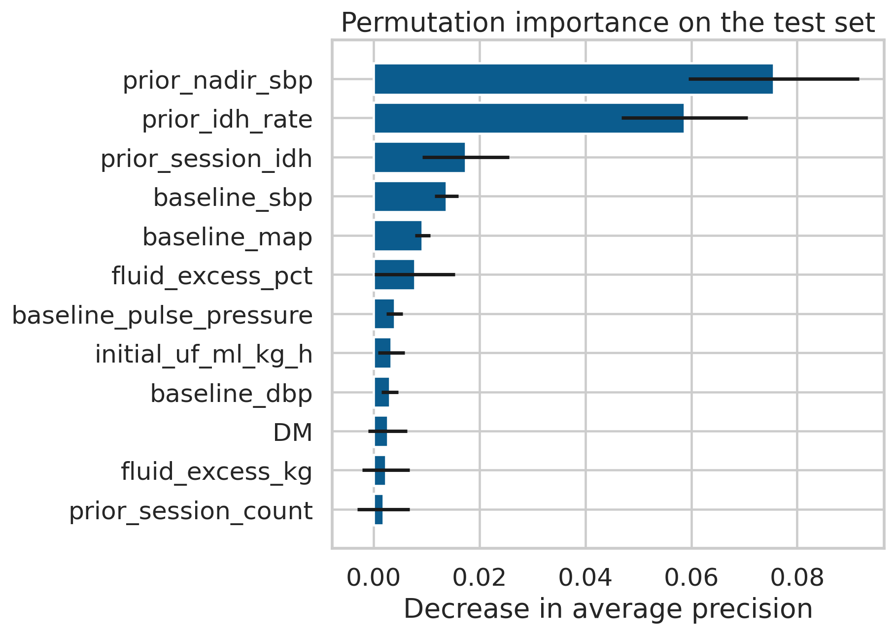
Figure 11. Test-set permutation importance with variability across repeated shuffles.
Feature | Mean decrease | Standard deviation
prior nadir sbp | 0.076 | 0.016
prior idh rate | 0.059 | 0.012
prior session idh | 0.017 | 0.008
baseline sbp | 0.014 | 0.002
baseline map | 0.009 | 0.001
fluid excess pct | 0.008 | 0.008
baseline pulse pressure | 0.004 | 0.002

12 SHAP and Conditional Effects
SHAP explanations were generated for the uncalibrated base model because probability calibration does not change the underlying predictor relationships. Only aggregate mean absolute contributions are published. The summary confirms that previous-session nadir pressure, prior IDH rate, and fluid excess dominate model output. SHAP values describe the fitted model and do not prove that modifying a feature would change a patient's outcome.
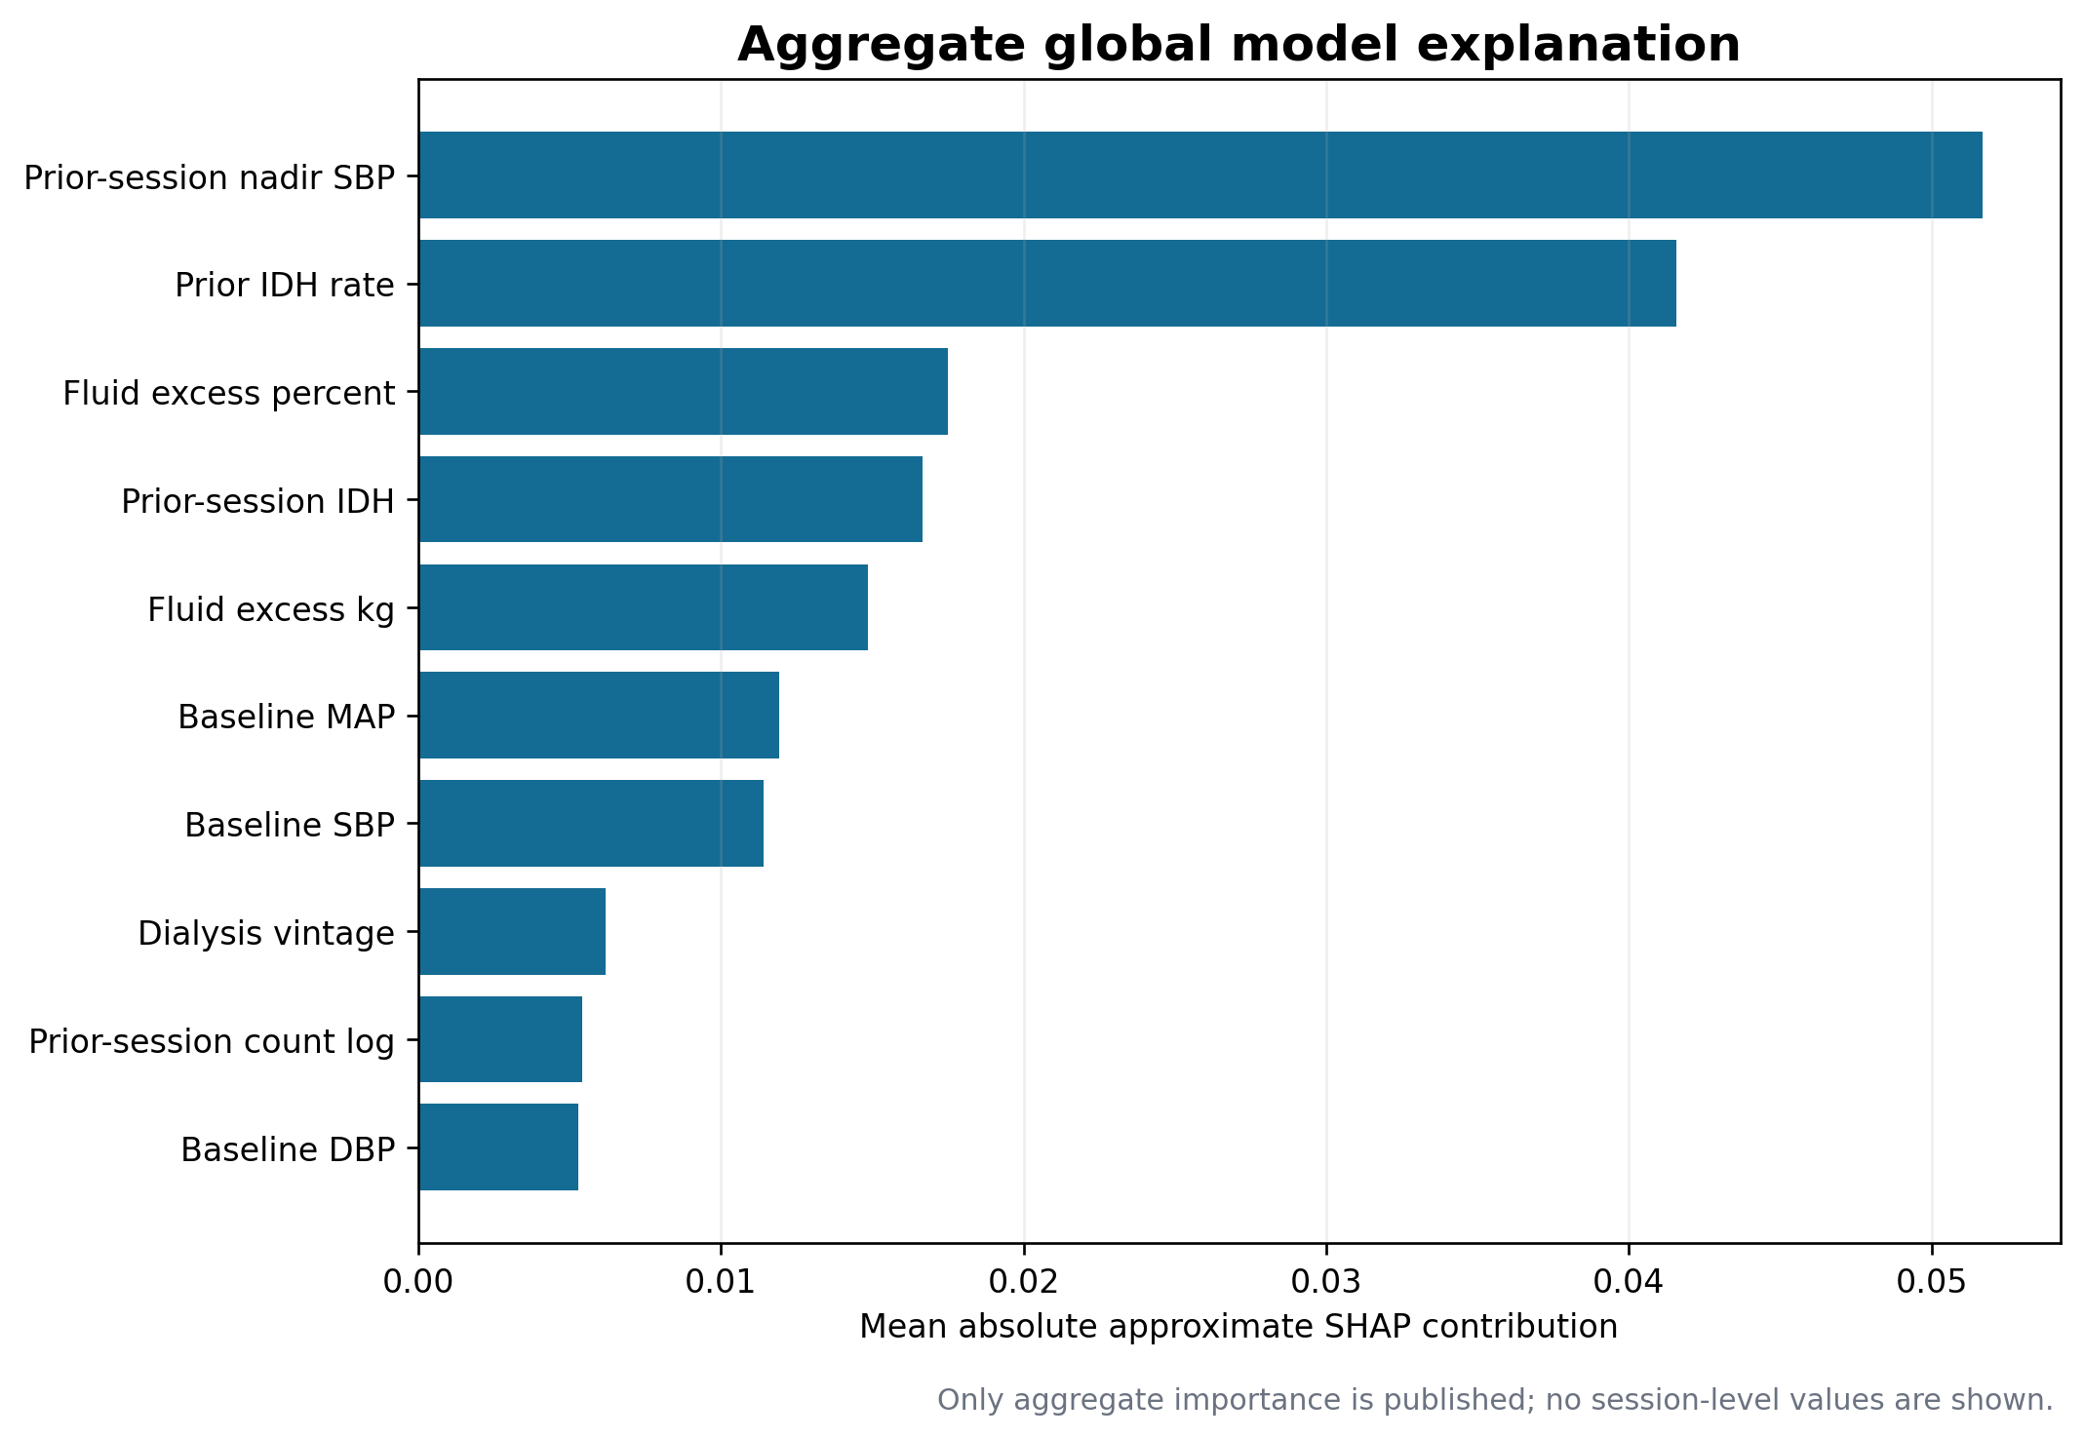
Figure 12. Aggregate approximate SHAP importance for the locked model.
Synthetic-reference-profile dependence curves provide a second check on direction and heterogeneity without publishing patient-level trajectories. Average predicted dependence decreases as previous nadir SBP rises and increases as prior IDH rate or fluid excess rises. Variation across the predefined synthetic profiles illustrates model interactions rather than observed patient histories.
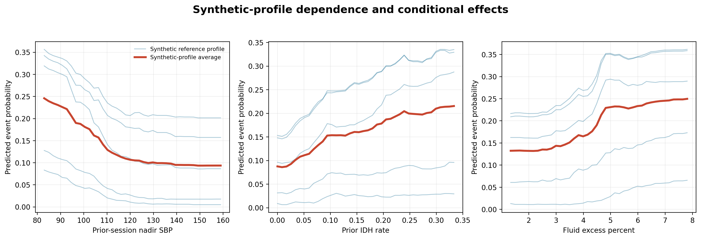
Figure 13. Dependence and conditional-effect curves generated from synthetic reference profiles.

13 Limitations and Mitigations
Issue | Possible effect | Mitigation
BP-defined endpoint | Symptoms and interventions are unavailable, so the study cannot reconstruct the complete clinical syndrome. | Use BP-defined terminology and report alternative threshold definitions.
Informative measurement | Unstable patients may receive more frequent BP measurements and have more opportunities for event detection. | Report this ascertainment risk and consider fixed-time-window sensitivity analyses.
Single-centre historical data | Practice patterns, equipment, and patient mix may not represent other countries or current care. | Require external and prospective validation before clinical use.
Linked subset | Only patient-days with linkable detailed monitoring enter the final cohort. | Show the cohort flow and compare excluded sessions when source fields permit.
Repeated sessions | The effective sample size is smaller than the number of sessions. | Use patient-grouped splits and patient-clustered uncertainty estimates.
History dependence | New patients lack prior-session predictors. | Use pipeline imputation and report separate cold-start performance in later analyses.
Residual extreme values | Statistical outliers may reflect error or true clinical extremes. | Retain plausible values, publish the audit, and test clipping as a sensitivity analysis.
Variable index time | A small minority of predictions occur after minute 5. | Report timing and evaluate fixed prediction windows.

These limitations do not invalidate the capstone. They define the scope of the evidence: retrospective model development and internal validation of a BP-defined operational target. Clinical effectiveness, treatment benefit, and cost savings remain prospective research questions.

14 Reproducibility
The analysis uses configuration-driven feature lists and random state 42. All patient grouping, transformations, feature selection, PCA, and model fitting are implemented in reproducible Python scripts. Raw HEMOBP files should be obtained from the cited Figshare record and placed in data/raw.

Execution Commands
python src/build_session_dataset.py --raw-dir data/raw --output-dir data/processed
python src/train_evaluate.py --data data/processed/hemobp_session_level.csv.gz
python src/generate_eda.py
python src/create_eda_report.py

Primary Reproducibility Files
File | Purpose
src/build_session_dataset.py | Cleaning, linkage, index-time definition, outcomes, and domain features
src/generate_eda.py | EDA figures, cleaning audit, outlier audit, and dictionaries
src/train_evaluate.py | Grouped splitting, preprocessing, feature selection, PCA, explainability, and models
configs/model_config.json | Outcome, features, alert capacity, and random seed
docs/data_dictionary.csv | Complete 40-variable processed-table dictionary
docs/feature_engineering_dictionary.csv | Engineered-feature formula and rationale
artifacts/l1_selected_features.csv | Embedded-selection output
artifacts/pca_explained_variance.csv | PCA variance evidence
artifacts/permutation_importance.csv | Global importance values and uncertainty
artifacts/outlier_summary.csv | Descriptive outlier flags and disposition

Quality Checks
- Processed row count, event count, patient count, and date range are recorded in cohort_flow.json.
- Pipeline transformations are fitted only on training folds and tolerate unseen categorical levels.
- Generated tables preserve numeric values used in every figure, allowing visual claims to be checked directly.
- The final report is rendered to page images and inspected before submission.

15 Conclusions
The Step 3 analysis produced a documented, reproducible, and leakage-controlled session table suitable for supervised model development. Missing data were uncommon and are handled within training pipelines. Invalid readings were removed through explicit bounds, while unusual but plausible values remained visible through a published outlier audit. Domain engineering added clinically interpretable volume, haemodynamic, treatment-intensity, and longitudinal-history predictors.
EDA consistently identified prior haemodynamic instability as the strongest predictive signal, with additional information from fluid excess and baseline blood pressure. Embedded L1 selection and PCA satisfy complementary reduction objectives, but neither was allowed to use the test set for selection. Permutation importance, aggregate SHAP, and synthetic-profile dependence curves provide consistent post hoc explanations while preserving the distinction between prediction and causation.
The resulting evidence supports progression to formal model comparison, calibration, subgroup auditing, and operational threshold evaluation. It does not establish clinical benefit or readiness for deployment.

References
1. Lin CJ, Chen YY, Pan CF, Wu VC, Wu CJ. Dataset supporting blood pressure prediction for the management of chronic hemodialysis. Scientific Data. 2019;6:313. https://doi.org/10.1038/s41597-019-0319-8
2. Lin CJ and colleagues. Hemrec VIP csv. Figshare dataset version 3. https://doi.org/10.6084/m9.figshare.6260654.v3
3. Lundberg SM, Lee SI. A unified approach to interpreting model predictions. Advances in Neural Information Processing Systems. 2017;30.
4. Jolliffe IT, Cadima J. Principal component analysis a review and recent developments. Philosophical Transactions of the Royal Society A. 2016;374:20150202. https://doi.org/10.1098/rsta.2015.0202
5. Pedregosa F and colleagues. Scikit-learn machine learning in Python. Journal of Machine Learning Research. 2011;12:2825-2830.
6. Flythe JE, Xue H, Lynch KE, Curhan GC, Brunelli SM. Association of mortality risk with various definitions of intradialytic hypotension. Journal of the American Society of Nephrology. 2015;26:724-734. https://doi.org/10.1681/ASN.2014020222

