DIAL ALERT Capstone Final Report
  - Early prediction of blood pressure defined intradialytic hypotension
Franklin B. Guillano
September 2026

Analytic cohort | Primary event rate | Test ROC AUC | Test average precision
106,758 sessions | 8.49% | 0.852 | 0.395

Academic clinical decision support prototype. The model is not a diagnostic device and is not ready for clinical deployment.
This report consolidates problem framing, data understanding, preprocessing, exploratory analysis, feature engineering, model comparison, explainability, fairness auditing, business translation, and reproducibility.

Report Structure
The report follows the machine-learning lifecycle and the seven graded capstone steps. Each section distinguishes observed evidence from interpretation and proposed future work.
Section | Purpose
Executive Summary | Main result, operational meaning, and recommendation
1 Problem Understanding and Framing | Clinical context, task type, metrics, and business KPIs
2 Data Collection and Understanding | Provenance, cohort, variables, quality, and license
3 Preprocessing EDA and Feature Engineering | Cleaning, leakage control, relationships, selection, and PCA
4 Model Implementation and Comparison | Algorithms, grouped validation, locked test performance, and capacity
5 Critical Thinking Ethical AI and Bias Auditing | Explanations, limitations, fairness metrics, and mitigations
6 Final Communication and Business Translation | Workflow, ROI framework, risks, and pilot design
7 Reproducibility and GitHub Repository | Environment, artifacts, tests, CI, and repository structure
8 Conclusions and Next Steps | Decision, validation gates, and research priorities

Executive Summary
DIAL-ALERT tests whether information available early in a haemodialysis session can identify sessions that later develop a systolic blood-pressure reading below 90 mmHg. The project uses HEMOBP Version 3, a public longitudinal dataset released under CC BY 4.0. Deterministic linkage and eligibility rules produced 106,758 sessions from 830 patients, with 9,067 primary events. [1,2]
Seven supervised modelling configurations were compared using patient-grouped cross-validation and patient-disjoint validation. Random forest was selected under a locked rule that prioritized grouped-CV average precision and then validation Brier score when models were within 0.01 of the best result. The untouched test set contained 21,354 sessions from 170 patients.
On the locked test set, the selected model achieved average precision 0.395, ROC AUC 0.852, and Brier score 0.062. At the validation-selected threshold of 0.143, sensitivity was 66.1%, specificity 86.1%, and precision 30.6%. At a 20% alert capacity, the model captured 69.1% of observed events with 29.4% precision and 3.46-fold lift over prevalence.
The model concentrates retrospective risk but does not prove that an alert prevents an event or produces a financial return. The appropriate decision is to continue development through external validation and a governed prospective silent-mode pilot. Clinical use should remain prohibited until performance, calibration, workload, subgroup outcomes, and human factors meet prespecified acceptance criteria.
Decision area | Conclusion
Technical feasibility | Supported for continued validation; discrimination and risk concentration are promising
Clinical effectiveness | Unknown; no alert-triggered intervention was tested
Operational feasibility | Requires capacity testing because false alerts remain substantial
Fairness | Partially auditable; recorded-sex and age disparities require monitoring, while key attributes are absent
Deployment readiness | Not ready; external and prospective validation remain mandatory

1 Problem Understanding and Framing

Clinical and Operational Problem
Intradialytic hypotension can interrupt treatment and require rapid reassessment. Routine haemodialysis already generates demographic, session, machine, and blood-pressure data. DIAL-ALERT asks whether those existing data can support early risk ranking so that limited clinical attention is directed toward sessions with the greatest observed risk.
The intended user is a dialysis clinician or nurse. The proposed output is a probability and a capacity-aware alert, not a treatment order. The model should supplement observation and judgment; it should never suppress routine monitoring or direct an intervention without a clinician.

Data Science Task
Element | Prespecified definition
Task | Supervised binary classification
Analysis unit | One eligible patient-day haemodialysis session
Prediction time | Earliest valid active-dialysis observation during minutes 0 to 30
Target | Any later systolic blood-pressure measurement below 90 mmHg
Predictors | Index-time variables and patient history derived only from earlier sessions
Exclusions | Index SBP below 90 mmHg, inadequate later measurements, or follow-up shorter than 120 minutes

Success Measures
Type | Measure | Reason
Primary technical | Average precision | Assesses event ranking under 8.49% prevalence and is more informative than accuracy alone
Secondary technical | ROC AUC, Brier score, and log loss | Assesses ranking and probability quality
Threshold performance | Sensitivity, specificity, precision, and F1 | Quantifies misses and false alerts at the operating threshold
Operations and business | Capacity metrics, review time, intervention rate, outcomes, and net cost | Measures workload and future real-world value without assuming savings
Equity | Selection, error, calibration, and disparity measures | Checks whether overall performance hides subgroup differences

2 Data Collection and Understanding

Provenance and License
HEMOBP Version 3 was selected because it links patient characteristics, session summaries, and time-stamped dialysis-machine measurements. The public release is versioned on Figshare, has stable checksums, and is licensed under CC BY 4.0. The peer-reviewed data descriptor documents the collection context. [1,2]
Source file | Grain | Rows | Verified MD5
idp.csv | Patient | 1,072 | 31d269f59bf4acc719f392ad9164d08a
d1.csv | Dialysis session | 165,986 | 7db3b48bae2c73e3ecd731dbcd452233
vip.csv | Time-stamped monitor record | 4,366,298 | ff1589610cf7aa3b3e01ba979b6bdc44

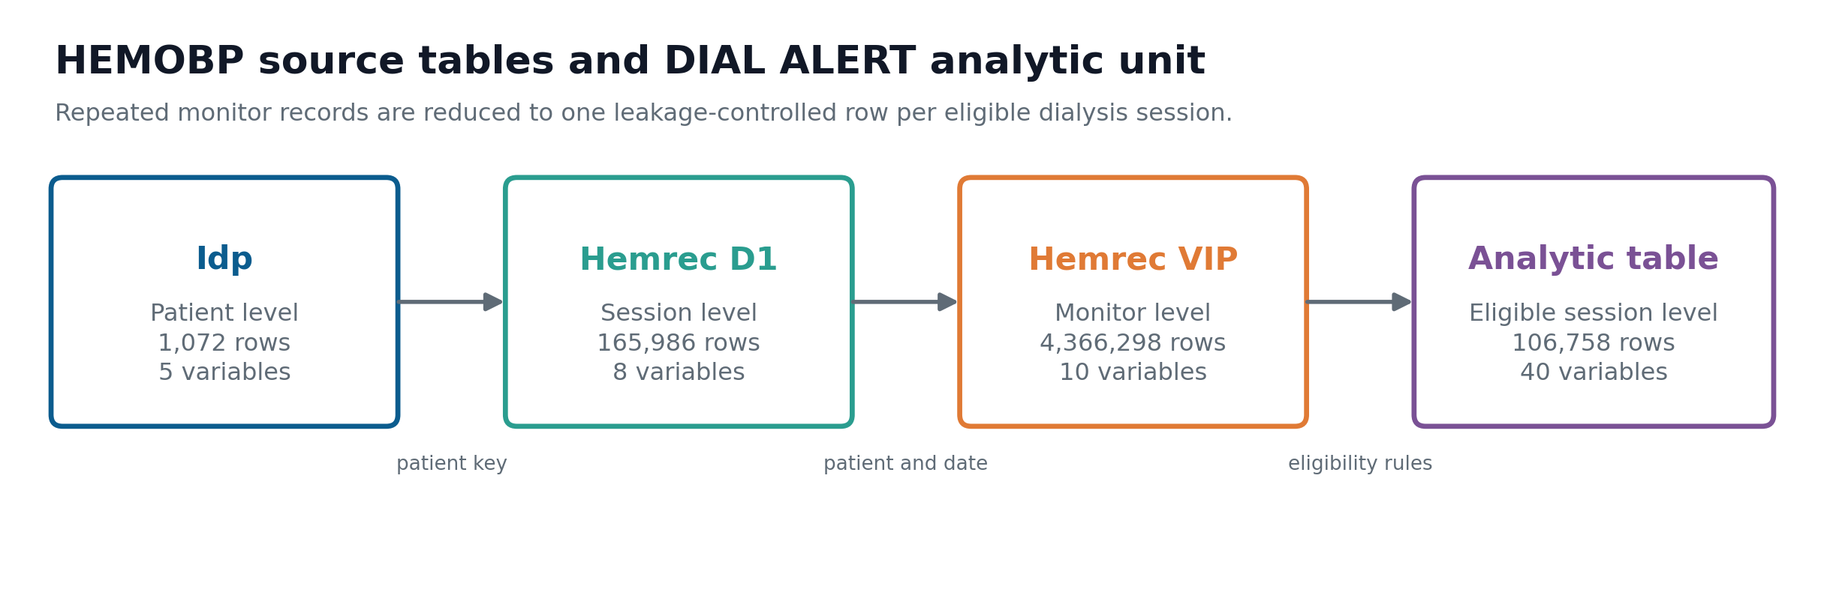
Figure 1. HEMOBP source tables and the DIAL-ALERT session-level analytic table.

Cohort Construction
The source tables are joined on patient identifier and normalized session date. The earliest valid active-dialysis reading in the first 30 minutes defines the index record. Later readings define outcomes. Sessions require at least two later measurement minutes and observation through minute 120.
Cohort stage | Count
Valid unique patient days | 165,849
Patient days linked to monitoring | 110,790
Sessions with an index record | 108,781
Final eligible sessions | 106,758
Unique analytic patients | 830
Primary events | 9,067

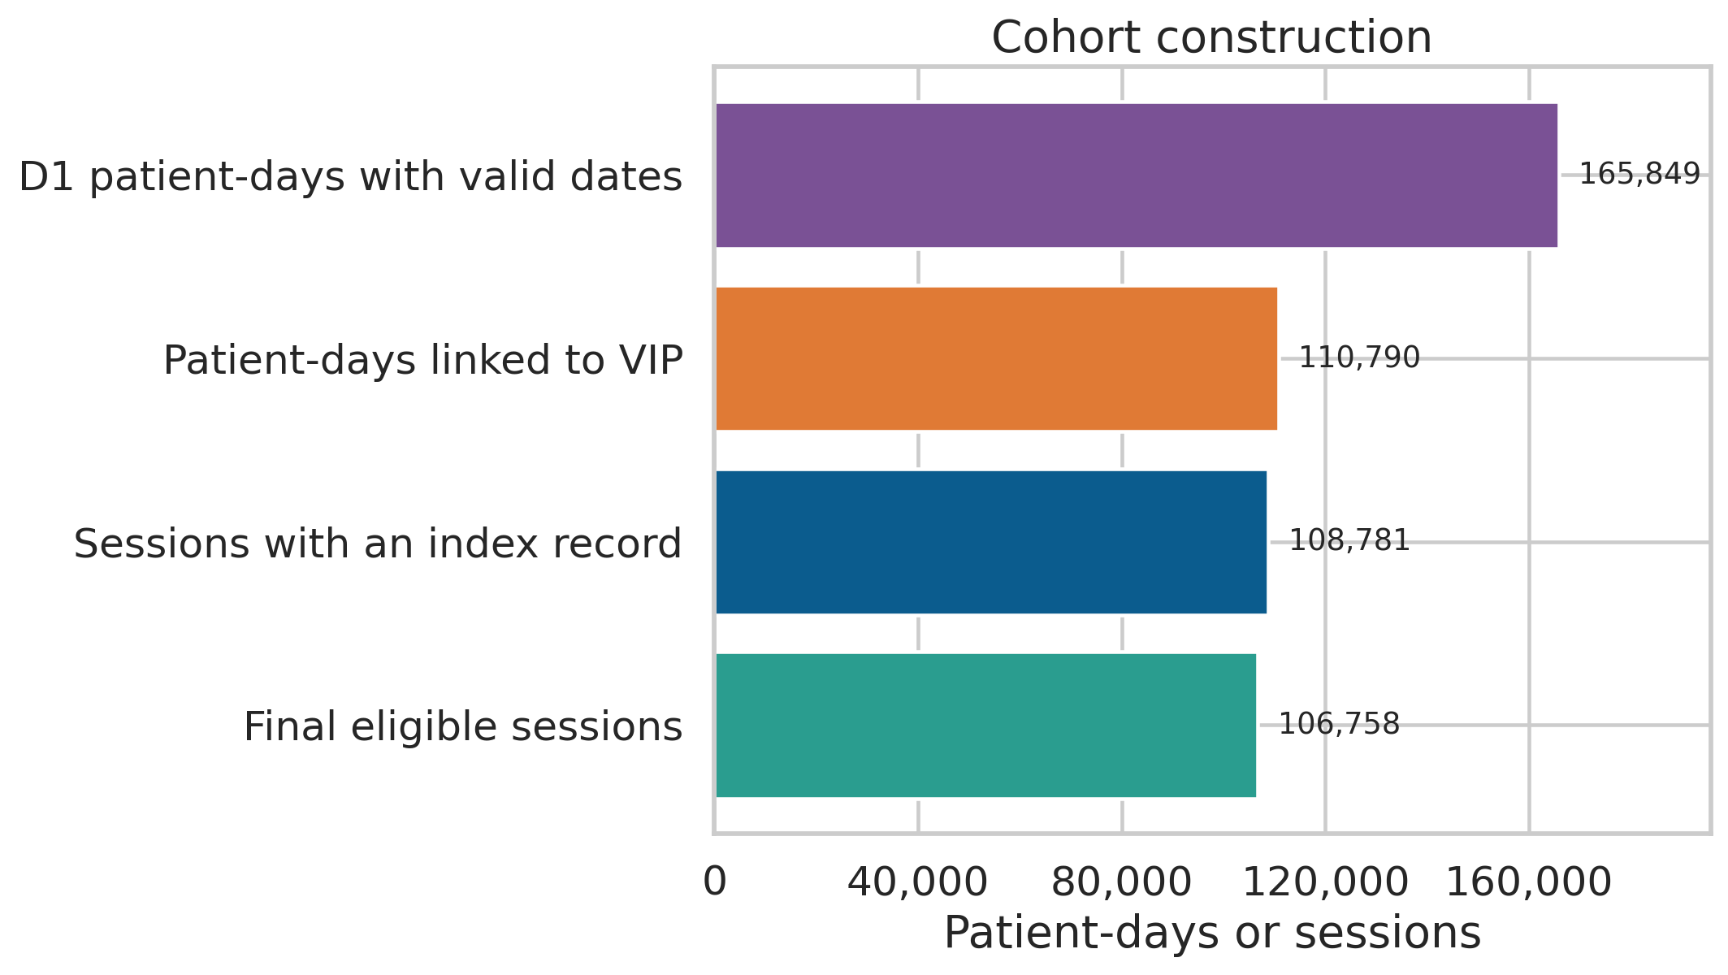
Figure 2. Deterministic cohort flow from valid session dates to the final eligible cohort.

Data Quality and Dictionary
Dates, linkage, duplicate patient-days, exact monitor duplicates, documented physiologic bounds, and follow-up completeness were audited before modelling. Missing values occur mainly in dialysis vintage and first-session history features. Plausible extremes were retained; removing unusual but possible dialysis sessions could hide clinically important risk.
The complete machine-readable dictionary in docs/data_dictionary.csv and docs/data_dictionary.md records each variable's source, data type, unit, allowed values, missingness, modelling role, and prediction-time availability. A separate feature-engineering dictionary documents the derived variables.
- The publication reports 1,075 outpatients, while the released patient file contains 1,072 unique rows; the analysis uses the actual public files and records this discrepancy.
- Symptoms, interventions, medication timing, laboratory data, and broad comorbidity data are unavailable.
- The target is therefore described as BP-defined IDH rather than a complete symptomatic clinical diagnosis.

3 Preprocessing EDA and Feature Engineering

Cleaning and Leakage Control
Step | Implementation and justification
Missing values | Median imputation for numeric variables and mode imputation for categorical variables inside each training fold
Duplicates | Stable removal of duplicate patient-days and exact duplicate monitor records
Outliers | Documented monitoring bounds remove impossible values; plausible extremes remain for audit and sensitivity analysis
Encoding | One-hot encoding for recorded sex and diabetes within the fitted pipeline
Scaling | Standardization for linear, L1, and PCA candidates; tree models retain original numeric scale
Temporal boundary | Only index-time variables and shifted prior-session history enter the feature matrix
Split boundary | Imputation, encoding, scaling, selection, PCA, and fitting occur within grouped training folds

Domain Derived Features
Derived variables translate raw dialysis records into quantities that can be interpreted clinically: fluid excess in kilograms and percent of dry weight, ultrafiltration intensity in mL/kg/h, mean arterial pressure, pulse pressure, dialysis vintage, and longitudinal history of prior IDH and nadir SBP. The count of prior sessions is log transformed for modelling.
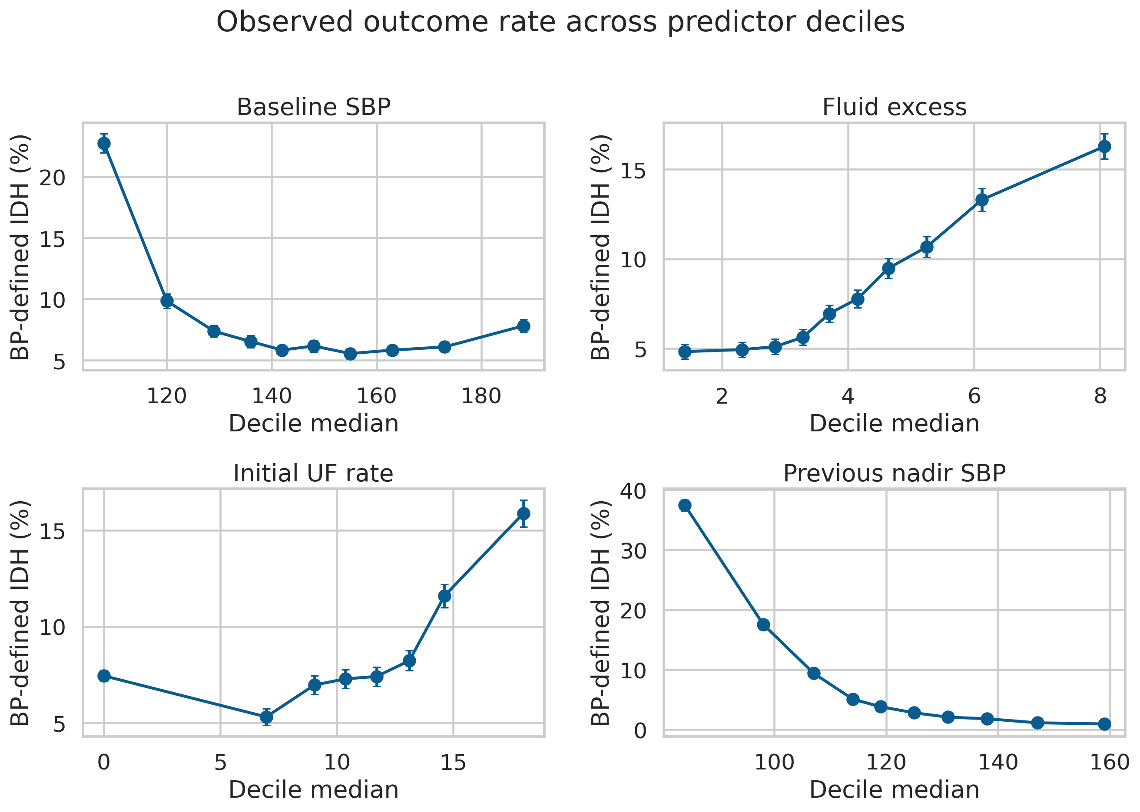
Figure 3. Observed outcome prevalence across bins of selected predictors. These are associations, not causal effects.

Feature Selection and Dimensionality Reduction
Embedded L1 logistic regression retained 12 of 24 transformed predictors. This candidate tested whether sparse selection could simplify the model without using test outcomes. PCA was fitted after numeric imputation and standardization; 11 components explained 87.6% of numeric-feature variance, exceeding the prespecified 85% threshold.
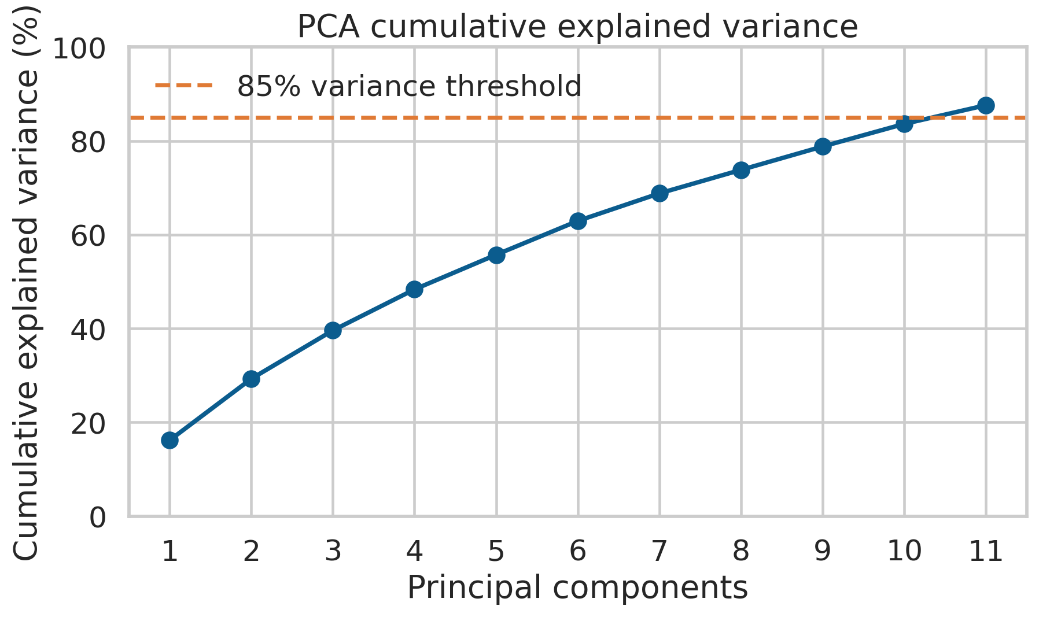
Figure 4. Cumulative explained variance of the numeric PCA candidate.
PCA was retained as a required dimensionality-reduction experiment rather than assumed to be beneficial. Its logistic-regression candidate had lower grouped-CV average precision than the selected random forest, showing that a lower-dimensional representation did not improve the primary objective.

4 Model Implementation and Comparison

Candidate Models and Validation
The comparison includes a prevalence baseline, logistic regression, embedded L1 feature selection, decision tree, PCA logistic regression, random forest, and histogram gradient boosting. Deep learning was not added because the inputs are structured tabular variables, there are only 830 independent patients, and calibration and interpretability are more important than model complexity.
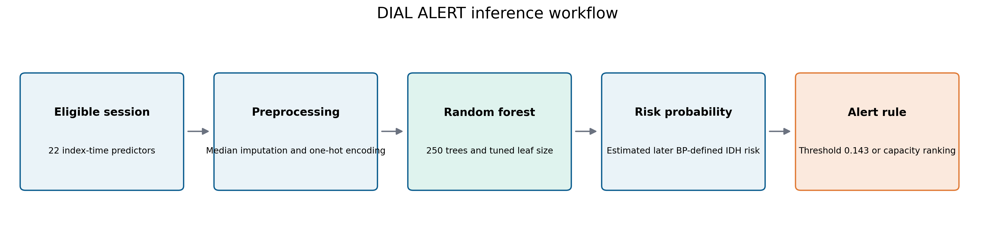
Figure 5. End-to-end model workflow from eligible session predictors to probability and alert output.
Partition | Patients | Sessions | Events | Prevalence
Training | 496 | 64,053 | 5,440 | 8.49%
Validation | 164 | 21,351 | 1,813 | 8.49%
Test | 170 | 21,354 | 1,814 | 8.49%

Model Selection
Histogram gradient boosting had the highest grouped-CV average precision at 0.446, while random forest achieved 0.440. Because the two were within the prespecified 0.01 tolerance, validation Brier score determined the choice. Random forest had a validation Brier score of 0.058 compared with 0.134 for histogram gradient boosting and was selected.
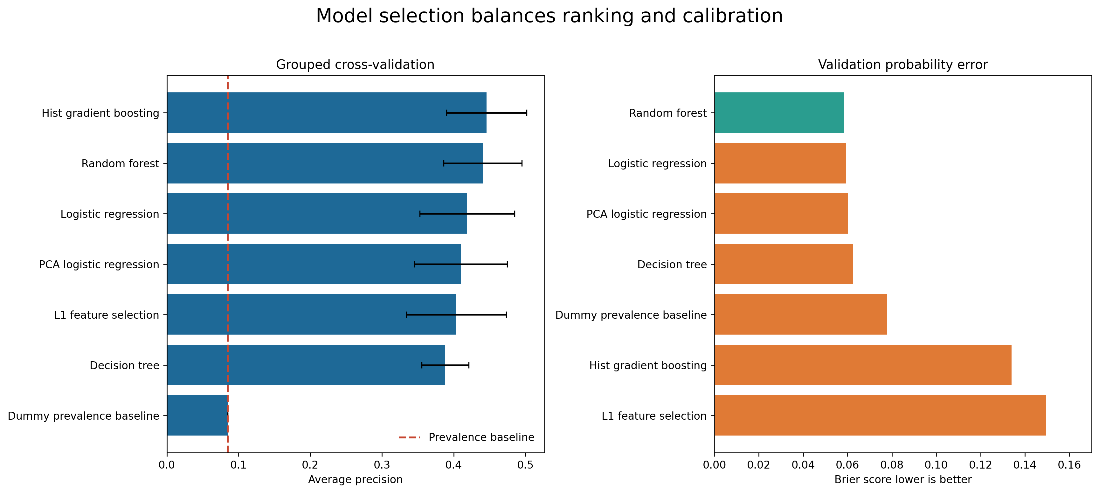
Figure 6. Candidate model comparison using grouped-CV average precision and validation Brier score.

Locked Test Performance
Metric | Estimate | Patient-bootstrap 95% interval
Average precision | 0.395 | 0.306 to 0.478
ROC AUC | 0.852 | 0.821 to 0.876
Brier score | 0.062 | 0.049 to 0.077
Sensitivity | 0.661 | 0.550 to 0.745
Specificity | 0.861 | 0.806 to 0.903
Precision | 0.306 | 0.260 to 0.353

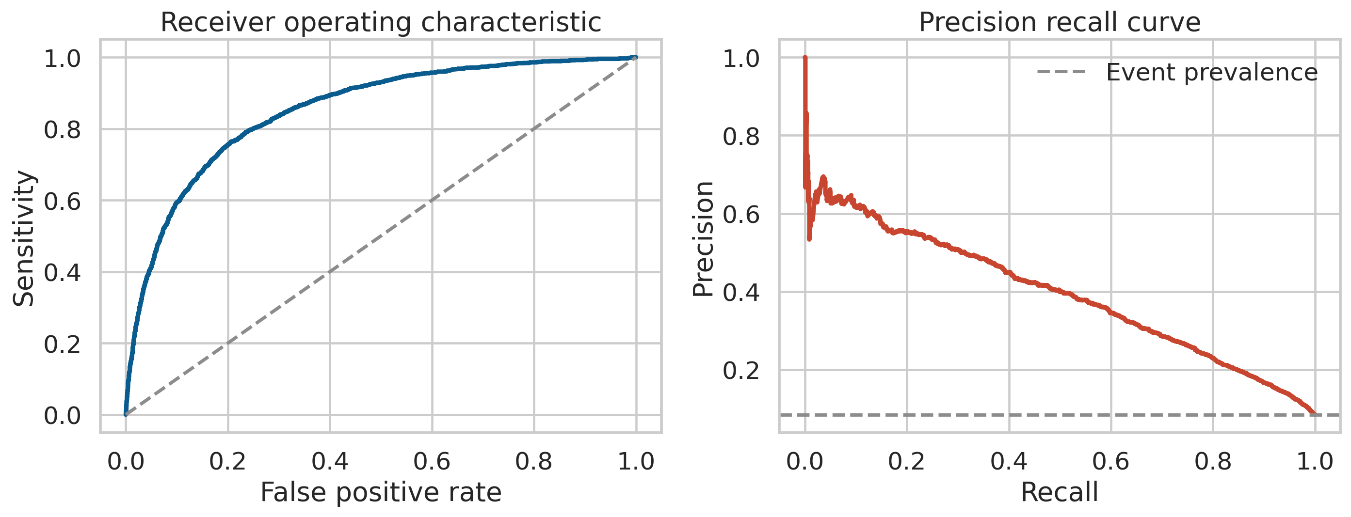
Figure 7. Locked test ROC and precision-recall curves.
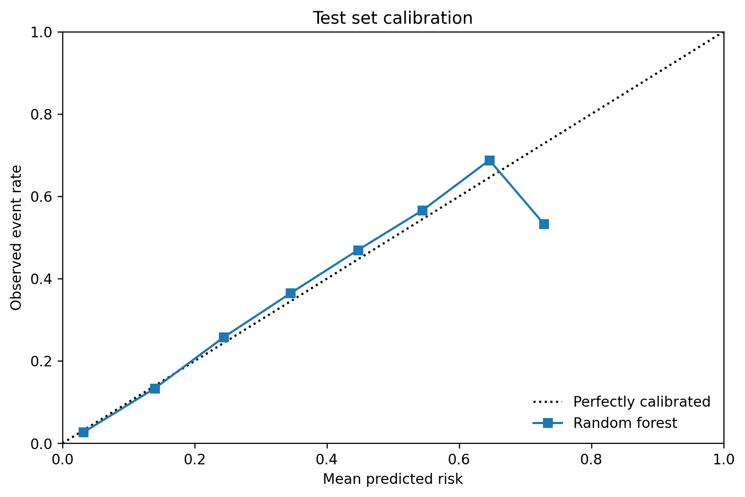
Figure 8. Test calibration curve. Sparse high-risk bins require cautious interpretation.

Operational Capacity
At the validation-selected probability threshold of 0.143, the model alerts on 18.3% of test sessions. A separate ranking analysis fixes the review capacity at 20% of sessions. Under that constraint, the highest-risk group contains 69.1% of events, but 14.1 non-event sessions per 100 total sessions would also be reviewed.
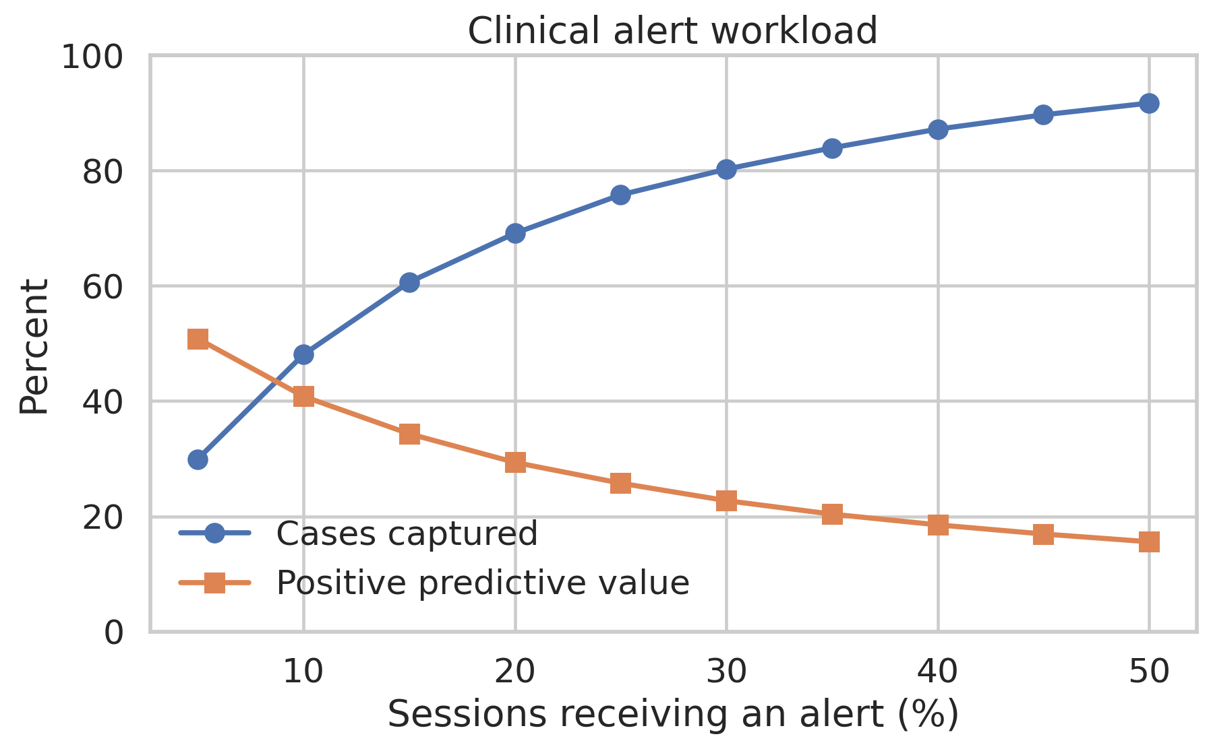
Figure 9. Recall, precision, lift, and false-alert workload across review capacity levels.

5 Critical Thinking Ethical AI and Bias Auditing

Model Explanations
Permutation importance, aggregate approximate interventional SHAP values, synthetic SHAP and LIME local explanations, and dependence curves across synthetic reference profiles provide complementary views of the fitted model without publishing patient-level explanation records. Prior-session nadir SBP and prior IDH rate were the strongest permutation features. Explanation outputs describe learned associations; they do not identify safe treatment targets or causal mechanisms. [5-7]
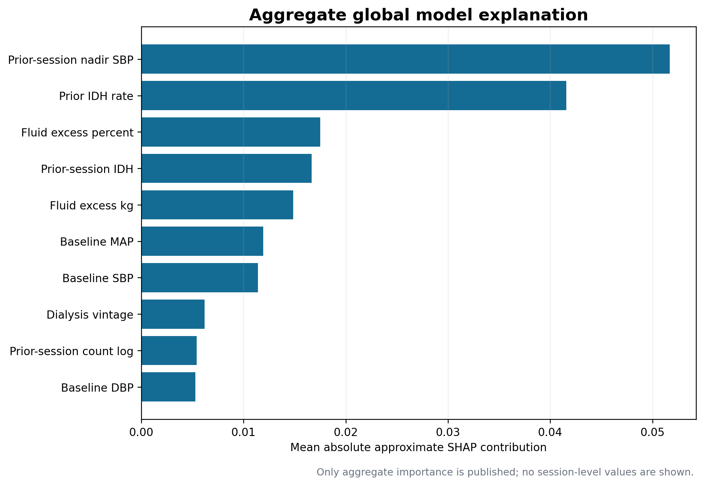
Figure 10. Aggregate approximate interventional SHAP importance for the locked model.
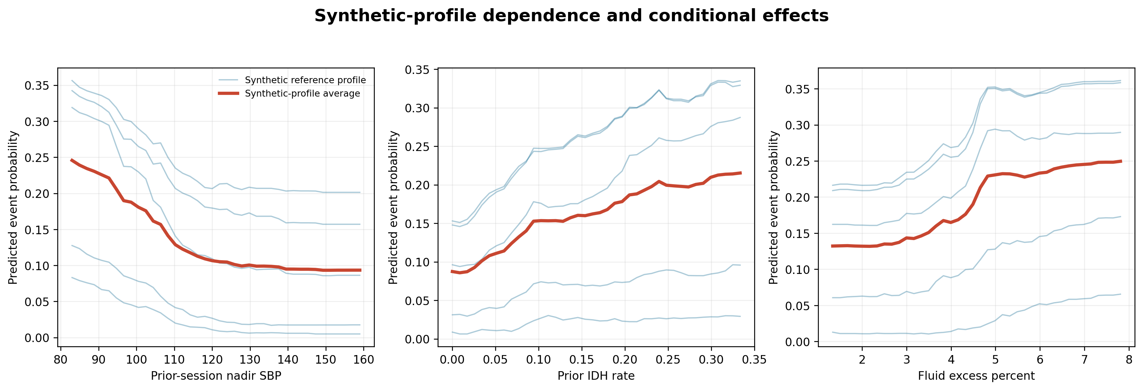
Figure 11. Dependence and conditional-effect patterns across synthetic reference profiles.

Limitations and Robustness
Risk | Evidence | Response
Class imbalance | Test prevalence is 8.49% | Use average precision, precision, sensitivity, calibration, and workload rather than accuracy alone
Patient leakage | No patient overlaps training, validation, and test | Retain grouped splitting in every future evaluation
Temporal leakage | Outcomes occur after the index time; history is shifted | Preserve the feature timestamp contract in production
Optimism | Grouped-CV AP 0.440, validation AP 0.470, test AP 0.395 | Report patient-bootstrap uncertainty and require external validation
Repeated sessions | 21,354 test sessions come from 170 patients | Use patient-cluster bootstrap and patient-equal-weight sensitivity analyses
Outcome validity | Symptoms and interventions are unavailable | Describe the endpoint as BP-defined IDH

Fairness Audit
Attribute | Disparate impact ratio | Sensitivity gap | FPR gap | Brier gap
Recorded sex | 0.705 | 0.076 | 0.049 | 0.014
Age group | 0.541 | 0.105 | 0.094 | 0.021
Diabetes status | 0.988 | 0.110 | 0.010 | 0.009

Recorded sex and age are the only available protected-characteristic audits. Diabetes is a clinical subgroup and is not used as a socioeconomic proxy. Race, ethnicity, socioeconomic status, and gender identity are absent, so fairness across those groups cannot be assessed. The 0.80 disparate-impact ratio is treated as a descriptive screening heuristic, not a fairness certificate. [8]
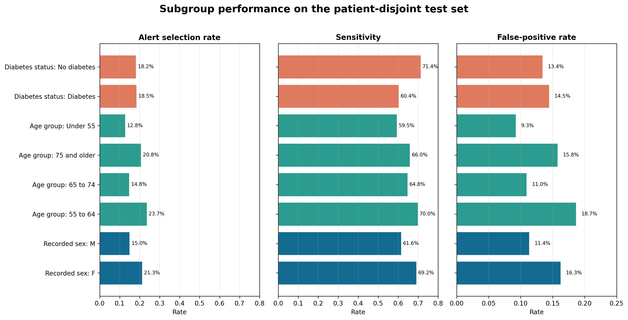
Figure 12. Selection and error metrics across available groups.

Mitigation Experiments
Strategy | Average precision | Precision | Sex impact ratio | Equalized odds gap
Original model | 0.395 | 0.306 | 0.705 | 0.076
Sex outcome reweighting | 0.394 | 0.309 | 0.764 | 0.058
Sex specific thresholds | 0.395 | 0.278 | 0.665 | 0.139

Outcome-by-sex training weights improved the recorded-sex impact ratio from 0.705 to 0.764 and reduced the equalized-odds gap from 0.076 to 0.058, while average precision changed from 0.395 to 0.394. Sex-specific thresholds worsened held-out fairness and precision and are rejected. Reweighting remains a candidate for external testing, not an automatic deployment choice.
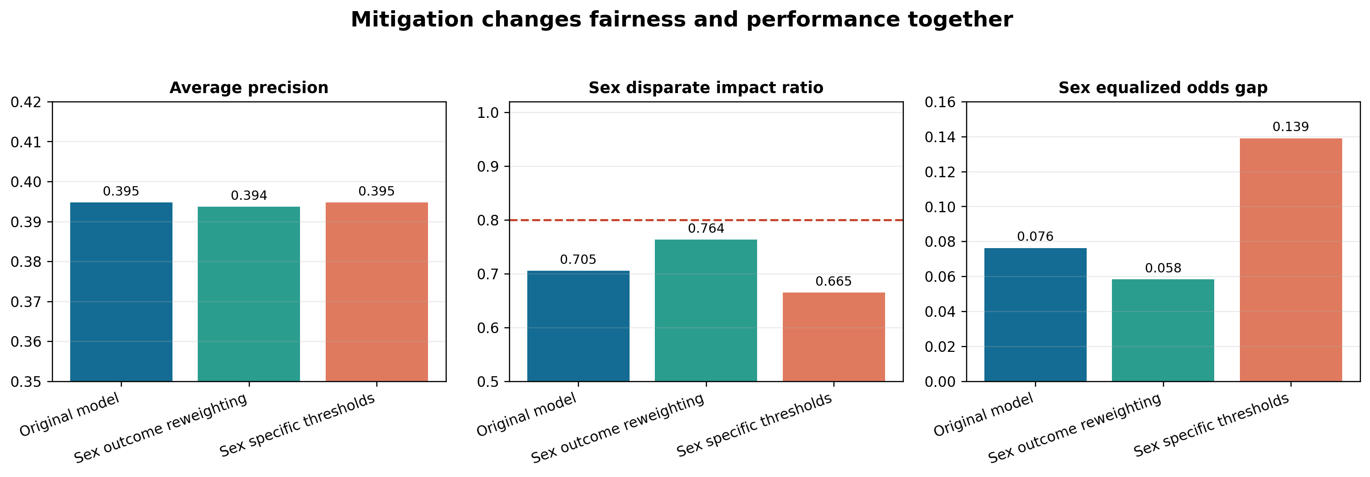
Figure 13. Performance and fairness tradeoffs across mitigation strategies.

6 Final Communication and Business Translation

Proposed Workflow
A future silent-mode pilot would calculate risk after the index observation, place the highest-risk sessions on a review list, and compare predictions with subsequent BP measurements without changing care. Only after prespecified safety and workload review should a later phase test whether presenting alerts changes clinician action or patient outcomes.
Per 100 eligible sessions at 20% capacity | Retrospective estimate
Sessions selected for review | 20.0
Observed events in the cohort | 8.5
Observed events concentrated in the selected group | About 5.9
Observed events outside the selected group | About 2.6
Selected sessions without the event | About 14.1

These values describe risk concentration in retrospective data. They are not prevented events. Every selected session still requires clinical interpretation, and some unselected sessions will experience the outcome.

ROI Measurement Framework
The pilot should measure net value rather than assume it. A transparent calculation is: net pilot value equals the number of events causally prevented multiplied by the local value of avoiding one event, less review time, implementation, maintenance, and monitoring costs. The prevention rate and local cost inputs are currently unknown.
Input | Pilot measurement
Alert workload | Alerts per 100 sessions and median review minutes
Clinical response | Proportion reviewed, action taken, action type, and override reason
Patient outcome | BP-defined events, symptoms, interventions, interrupted treatment, and recovery time
Safety | Missed events, delayed treatment, inappropriate action, and incident reports
Equity | Selection, sensitivity, false-positive rate, precision, and calibration by governed groups
Cost | Staff time, implementation, infrastructure, training, maintenance, and event-related utilization

Governance and Pilot Gates
Gate | Minimum evidence before progression
External validity | Acceptable discrimination and calibration in a different centre or later time period
Operational fit | Review volume and response time remain within agreed staffing capacity
Safety | No unacceptable harm signal, with defined clinician override and escalation
Fairness | Prespecified subgroup metrics and uncertainty reviewed by governance
Human factors | Clinicians understand the score, avoid automation bias, and document decisions
Monitoring | Data quality, drift, calibration, alert burden, incidents, and rollback are operational

The final communication package includes a twelve-slide technical deck for peers and a ten-slide business deck for executives. Both decks state the evidence boundary and recommend validation rather than deployment.

7 Reproducibility and GitHub Repository
The public repository is organized as an open-source project. Raw and processed data are excluded from Git because the source is large and patient-level. A version-pinned acquisition script downloads HEMOBP Version 3 and verifies MD5 checksums. The selected compressed predictor is retained so that inference can be tested without retraining.
Repository path | Contents
src | Acquisition, cohort construction, EDA, training, audit, inference, and report builders
notebooks | Guided end-to-end workflow
data | Acquisition instructions and empty tracked directories
models | Selected predictor, threshold specification, and manifest
artifacts | Metrics, uncertainty intervals, audit tables, and figures
docs | Data dictionary, preprocessing specification, and model card
reports | Final report, component reports, and technical and business presentations
tests | Contract and saved-model inference tests
.github workflows | Automated tests on each push and pull request

Reproduction Commands
python -m pip install -r requirements.txt
python src/download_data.py
python src/build_session_dataset.py --raw-dir data/raw --output-dir data/processed
python src/train_evaluate.py --data data/processed/hemobp_session_level.csv.gz --config configs/model_config.json --artifacts artifacts --models models
python src/generate_eda.py
python src/generate_step4_assets.py
python src/audit_bias_fairness.py
python src/create_final_report.py
pytest -q
The model manifest records the data and configuration SHA-256 hashes, Python and package versions, selected model, random seeds, and hashes of saved artifacts. Continuous integration runs repository and prediction smoke tests. The notebook presents the same sequence with explanatory text.

8 Conclusions and Next Steps
DIAL-ALERT demonstrates the complete machine-learning lifecycle on a real, industry-relevant dataset. The project frames an auditable clinical question, constructs a leakage-controlled cohort, compares multiple models, evaluates an untouched patient-disjoint test set, explains model behavior, audits available groups, tests mitigation, and translates performance into operational workload.
The main finding is useful but limited: the random forest concentrates 69.1% of observed BP-defined events within the highest-risk 20% of sessions. This supports further validation. It does not demonstrate prevented events, safer dialysis, reduced cost, or transportability to another centre.

Recommended Sequence
- Validate the locked model on an external centre and a later time period without retuning.
- Collect symptoms, interventions, medication timing, broader comorbidities, and governed demographic attributes.
- Run a prospective silent-mode study to measure data availability, calibration, workload, and drift.
- Prespecify subgroup and safety thresholds, clinician override, incident response, and rollback rules.
- Only then test whether visible alerts change actions and improve patient outcomes in a controlled implementation study.

Final Decision
Continue DIAL-ALERT as a validation-stage clinical decision-support research project. Do not deploy it for patient-care decisions at this stage.

References
1. Lin CJ, Chen YY, Pan CF, Wu VC, Wu CJ. Dataset supporting blood pressure prediction for the management of chronic hemodialysis. Scientific Data. 2019;6:313. https://doi.org/10.1038/s41597-019-0319-8
2. Chien CY. HEMOBP Version 3. Figshare dataset. 2019. CC BY 4.0. https://doi.org/10.6084/m9.figshare.6260654.v3
3. Breiman L. Random forests. Machine Learning. 2001;45:5-32. https://doi.org/10.1023/A:1010933404324
4. Saito T, Rehmsmeier M. The precision-recall plot is more informative than the ROC plot when evaluating binary classifiers on imbalanced datasets. PLoS ONE. 2015;10:e0118432. https://doi.org/10.1371/journal.pone.0118432
5. Lundberg SM, Lee SI. A unified approach to interpreting model predictions. Advances in Neural Information Processing Systems. 2017;30. https://papers.nips.cc/paper/7062-a-unified-approach-to-interpreting-model-predictions
6. Ribeiro MT, Singh S, Guestrin C. Why should I trust you Explaining the predictions of any classifier. Proceedings of KDD. 2016:1135-1144. https://doi.org/10.1145/2939672.2939778
7. Goldstein A, Kapelner A, Bleich J, Pitkin E. Peeking inside the black box Visualizing statistical learning with plots of individual conditional expectation. Journal of Computational and Graphical Statistics. 2015;24:44-65. https://doi.org/10.1080/10618600.2014.907095
8. Hardt M, Price E, Srebro N. Equality of opportunity in supervised learning. Advances in Neural Information Processing Systems. 2016;29. https://arxiv.org/abs/1610.02413
9. World Health Organization. Ethics and governance of artificial intelligence for health. 2021. https://www.who.int/publications/i/item/9789240029200
10. Collins GS and colleagues. TRIPOD plus AI statement Updated guidance for reporting clinical prediction models that use regression or machine learning methods. BMJ. 2024;385:e078378. https://doi.org/10.1136/bmj-2023-078378
11. Flythe JE, Xue H, Lynch KE, Curhan GC, Brunelli SM. Association of mortality risk with various definitions of intradialytic hypotension. Journal of the American Society of Nephrology. 2015;26:724-734. https://doi.org/10.1681/ASN.2014020222

Appendix Rubric Evidence Map
Rubric step | Evidence
1 Problem Understanding and Framing | Clear clinical context, supervised task, target, technical metrics, operational KPIs, and evidence boundary
2 Data Collection and Understanding | Peer-reviewed public dataset, license, checksums, cohort audit, complete dictionaries, and limitations
3 Preprocessing EDA and Feature Engineering | Nulls, duplicates, outliers, encoding, scaling, domain features, visual EDA, L1 selection, PCA, and explainability
4 Model Implementation and Comparison | Seven configurations, grouped tuning, locked selection rule, saved models, test metrics, intervals, and workload analysis
5 Critical Thinking Ethical AI and Bias Auditing | SHAP, local surrogate, PDP and ICE, leakage and overfitting analysis, fairness metrics, uncertainty, and mitigation tests
6 Final Presentation and Communication | Separate technical and business decks with notes, citations, ROI framework, risks, strategy, and pilot recommendation
7 GitHub Profile and Upload | Open-source structure, README, license, citation file, data acquisition, notebooks, tests, CI, final report, and reproducible commands

