DIAL ALERT Bias and Fairness Analysis
  - Capstone Project Step 5
Ethical review of model explanations subgroup performance uncertainty and mitigation tradeoffs
Prepared by Franklin Guillano
September 2026
Academic clinical decision support prototype. This audit does not establish clinical benefit, causal fairness, regulatory compliance, or readiness for deployment.

Executive Summary
The locked Step 4 random forest was audited on 21,354 sessions from 170 patients who were not used for model fitting, hyperparameter selection, calibration choice, or threshold selection. The model achieved test average precision 0.395, ROC AUC 0.852, and Brier score 0.062. The fairness analysis preserves the validation-selected threshold of 0.143 and resamples entire patients when estimating uncertainty.
Point estimates show different fairness concerns across available groups. The recorded-sex disparate impact ratio was 0.705 and the equalized odds gap was 0.076. Age groups had a disparate impact ratio of 0.541, while diabetes status had near-equal alert selection rates but a 11.0% sensitivity gap. Patient-bootstrap intervals were wide, so the audit identifies monitoring priorities rather than proving discrimination or fairness.
Training-sample reweighting improved the recorded-sex disparate impact ratio from 0.705 to 0.764 and reduced the equalized odds gap from 0.076 to 0.058, with average precision changing from 0.395 to 0.394. A separate sex-specific threshold experiment performed worse on the test set and is rejected. The recommended next step is external and prospective validation with purposeful collection of race, ethnicity, socioeconomic, gender-identity, symptom, intervention, and workflow data.

Rubric Evidence
Requirement | Evidence
Explainability | Global permutation evidence, aggregate Monte Carlo SHAP, synthetic SHAP and LIME local explanations, and synthetic-profile dependence plots are compared.
Limitations | Imbalance, patient and temporal leakage, overfitting, calibration, repeated sessions, external validity, and causal limits are addressed.
Bias audit | Recorded sex, age, diabetes, sex-by-age intersections, and patient-equal-weight sensitivity analyses are reported with patient-bootstrap intervals.
Fairness metrics | Demographic parity difference, disparate impact ratio, equal opportunity, false-positive-rate, equalized odds, and predictive parity gaps are calculated.
Mitigation | Outcome-by-sex reweighting and validation-tuned sex-specific thresholds are tested, including accuracy-fairness tradeoffs and governance risks.
Ethical AI | False-negative harm, alert fatigue, automation bias, privacy, accountability, drift, human oversight, and deployment gates are documented.

1 Audit Scope and Data Sufficiency
The fairness question is whether DIAL-ALERT distributes alerts and errors acceptably across clinically and socially relevant groups. It is not enough to ask whether overall discrimination is good. The audit therefore examines who receives alerts, who is missed, who receives false alerts, how reliable the probabilities are, and whether mitigation transfers from validation patients to new patients.
Attribute | Availability | Audit use | Important limitation
Recorded sex | Available | Primary protected-attribute audit | Binary recorded field does not represent gender identity or variation beyond F and M
Age | Available | Four prespecified age bands | Age groups simplify a continuous and time-varying characteristic
Race or ethnicity | Unavailable | Not auditable | Fairness across racial and ethnic groups cannot be assessed
Socioeconomic status | Unavailable | Not auditable | Diabetes and dialysis vintage are not treated as socioeconomic proxies
Diabetes status | Available | Clinical subgroup audit | Clinical risk factor, not a substitute for socioeconomic status

The source field is named gender but contains only F and M. This report describes it as recorded sex because it cannot represent gender identity. Race, ethnicity, and socioeconomic status are absent. Their fairness cannot be inferred from diabetes, dialysis vintage, geography, or another convenient proxy. Missing protected-attribute data are a substantive limitation and a requirement for future data collection.

Audit Population
Element | Specification
Test observations | 21,354 sessions
Independent test units | 170 patients
Patient overlap | Zero across training validation and test partitions
Operating rule | Global probability threshold 0.143 selected on validation patients
Uncertainty | 500 bootstrap resamples of whole patients

2 Ethical Framing and Harm Model
DIAL-ALERT predicts a later systolic blood pressure below 90 mmHg. The target is an auditable blood-pressure event, not a complete clinical diagnosis of intradialytic hypotension because symptoms, treatments, and clinician assessments are unavailable. A risk score should therefore support attention and preparation, not autonomously diagnose, prescribe fluid, change ultrafiltration, or terminate dialysis.
Concern | Meaning | Potential harm | Audit measure
False negative | An at-risk session is not flagged | Delayed recognition or preparation | Sensitivity and missed-event review
False positive | A low-risk session is flagged | Alarm fatigue unnecessary review or intervention | Precision false-positive rate and alert capacity
Unequal false negatives | One group is missed more often | Unequal safety benefit | Equal opportunity difference
Unequal false positives | One group receives more false alerts | Unequal burden and possible overtreatment | False-positive-rate difference
Unequal selection | Alert exposure differs regardless of outcome | Different access to review or intervention | Demographic parity and disparate impact
Miscalibration | The same score means different risk across groups | Misleading urgency and threshold decisions | Brier score and calibration error

No single fairness metric is sufficient. Different outcome prevalence and an imperfect classifier make some fairness goals mutually difficult to satisfy. Metric choice must follow a documented clinical harm model, workflow capacity, and community governance rather than a numerical pass-fail rule alone.

3 Explanation Framework
Four complementary explanation methods were used because each answers a different question. Agreement across methods strengthens confidence in a descriptive model interpretation, while disagreement or low local fidelity is itself evidence that an explanation should not be trusted quantitatively.
Method | Question answered | Main caution
Permutation importance | What information uniquely improves test-set ranking | Can understate correlated or redundant predictors
Approximate SHAP | How features distribute a prediction relative to background sessions | Monte Carlo and background dependent; correlated features complicate attribution
LIME-style surrogate | Which synthetic scenario features influence one nearby linear approximation | Only trustworthy when local fidelity is adequate
PDP | Average prediction change when one feature is varied | Can create unrealistic combinations and hides heterogeneity
Synthetic-profile ICE | How the same feature change affects predefined synthetic profiles | Illustrates model behavior, not observed patients or treatment effects

The SHAP implementation uses random background sessions and feature-order permutations to estimate interventional Shapley contributions. Only aggregate global importance is published. The local path ends at a manually constructed synthetic scenario, so no local explanation represents an actual HEMOBP session. Feature substitution can still form clinically implausible combinations. These values explain the fitted model, not physiology or causation.

4 Global Model Explanation
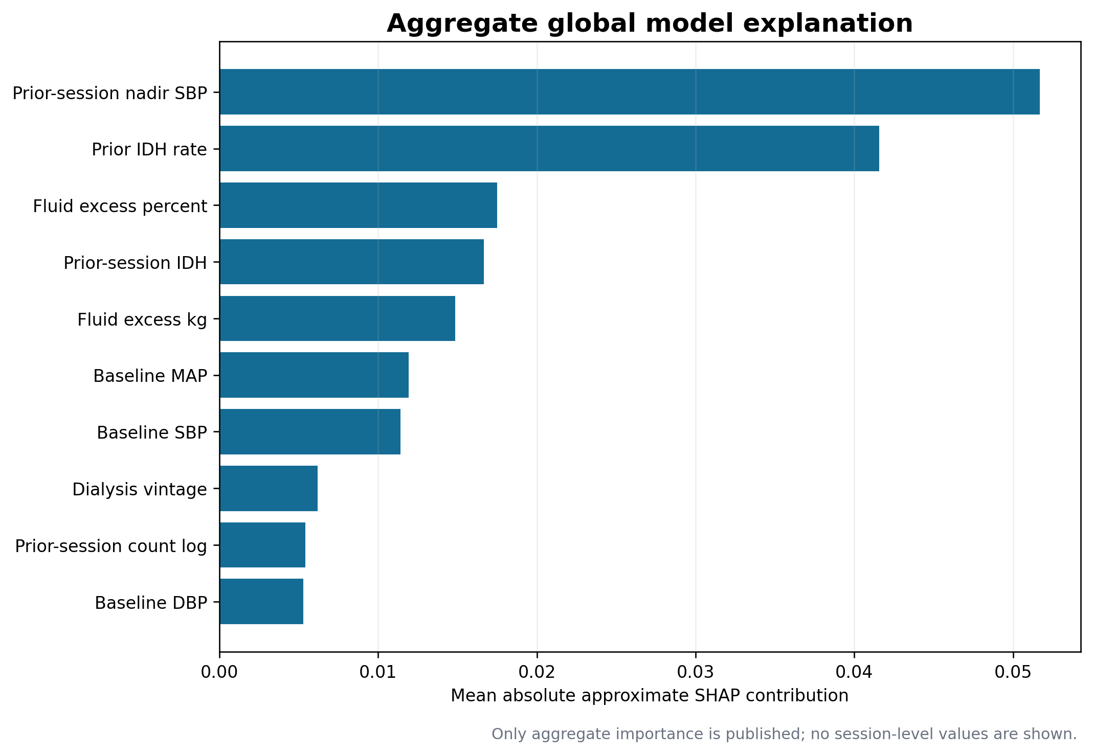
Figure 1. Aggregate mean absolute approximate SHAP contributions from an outcome-balanced analysis sample.
Feature | Mean absolute contribution | Mean signed contribution
Prior Nadir Sbp | 0.052 | +0.026
Prior Idh Rate | 0.042 | +0.025
Fluid Excess Pct | 0.018 | +0.009
Prior Session Idh | 0.017 | +0.007
Fluid Excess Kg | 0.015 | +0.009
Baseline Map | 0.012 | +0.006
Baseline Sbp | 0.011 | +0.006

Lower prior-session nadir SBP and higher prior IDH rate dominate risk predictions, followed by fluid excess and prior-session IDH. The same variables lead the independent permutation analysis. Recorded sex and age contribute little unique global information relative to the longitudinal haemodynamic features, but low feature importance does not rule out subgroup disparity through correlated predictors, threshold effects, or different baseline risk.

5 Synthetic Local Explanations
A predefined synthetic teaching scenario had a predicted probability of 0.691, compared with a background expectation of 0.083. The approximate SHAP contributions sum to the model prediction with local accuracy error 2.22e-16. This scenario is explicitly marked `synthetic` and is not copied from a patient record. Prior IDH rate, prior-session nadir SBP, fluid excess, and a prior-session event produced the largest upward contributions.
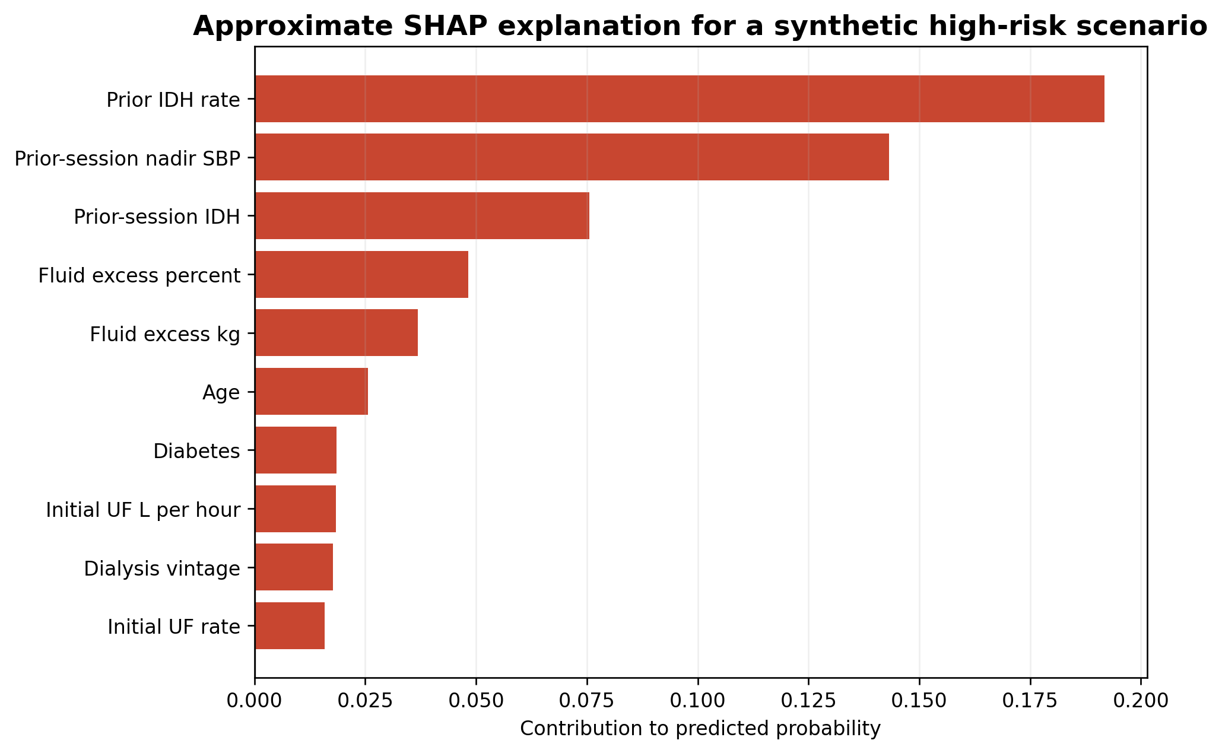
Figure 2. Approximate SHAP contributions for a synthetic high-risk teaching scenario.
The explanation is clinically plausible but not prescriptive. For example, the positive contribution from fluid excess does not prove that changing fluid removal would reduce risk. An actionable recommendation requires causal and prospective evidence that is outside this retrospective prediction study.

6 LIME Style Local Surrogate
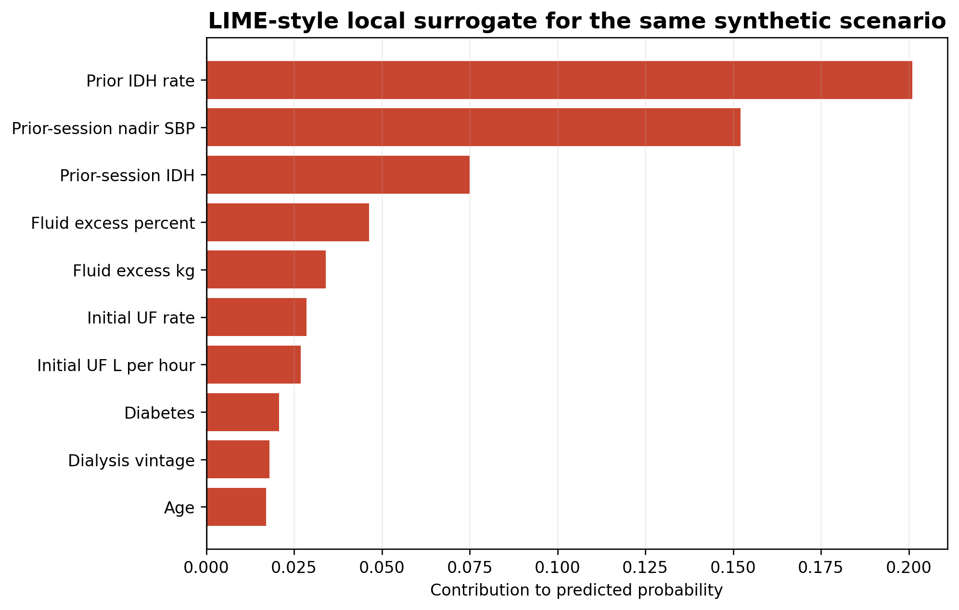
Figure 3. Weighted LIME-style linear surrogate for the same synthetic scenario.
Diagnostic | Result
Perturbation samples | 2,500
Weighted local R squared | 0.678
Random forest probability | 0.691
Surrogate probability | 0.666
Absolute local error | 0.025

The surrogate agrees qualitatively with SHAP on the dominant features, but its weighted R squared of 0.678 and absolute probability error of 0.025 are not strong enough for quantitative reliance. The LIME-style result is therefore reported as corroborating evidence with a fidelity warning, not as a substitute for the random forest. This limitation illustrates why every local explanation requires its own quality check.

7 Synthetic Profile Dependence
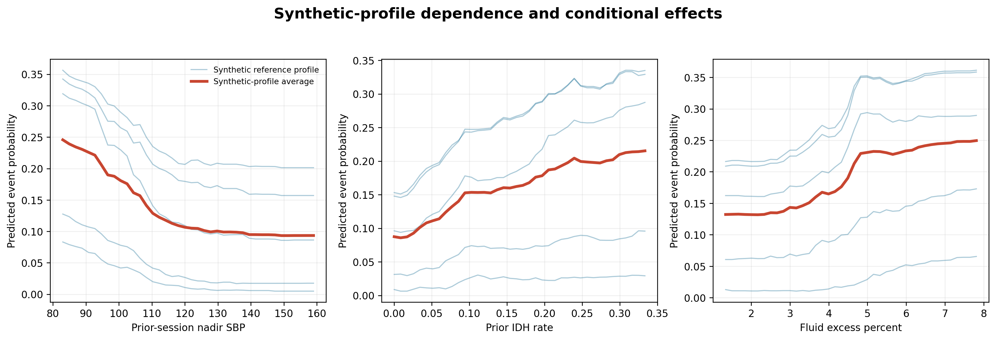
Figure 4. Dependence averages and conditional-effect curves across five synthetic reference profiles.
Average predicted risk falls sharply as prior-session nadir SBP rises from very low values. It increases with prior IDH rate and, more gradually, with fluid excess percentage. The spread of the synthetic-profile curves shows model heterogeneity without displaying any observed patient trajectory.
The curves vary one feature while leaving the other synthetic-profile values fixed. Because blood pressure, dry weight, fluid excess, and ultrafiltration measures are correlated, some combinations may be physiologically uncommon. These plots should be used to inspect model behavior, not to infer a safe treatment target or causal dose-response relationship.

8 Imbalance Leakage and Overfitting
Risk | Observed evidence | Assessment | Required response
Class imbalance | Test prevalence 8.495%; no-skill average precision equals prevalence | Material | Use average precision, sensitivity, precision, calibration, and workload metrics rather than accuracy alone
Patient leakage | Zero patient overlap across training, validation, and test partitions | Controlled in internal evaluation | Retain patient-disjoint splits and grouped cross-validation
Temporal leakage | Only index-time or lagged prior-session predictors are used; subsequent blood pressures define the outcome | Controlled by feature design | Preserve the prediction-time boundary in production feature pipelines
Overfitting or optimism | Grouped-CV AP 0.440, validation AP 0.470, test AP 0.395 | Residual concern | Report patient-bootstrap intervals and require external temporal and geographic validation
Probability miscalibration | Test Brier score 0.062; calibration weakens in sparsely populated high-risk bins | Monitor | Recalibrate only on new local validation data and monitor calibration drift
Repeated-session dominance | 21,354 test sessions arise from 170 patients | Material | Use patient-cluster bootstrap intervals and patient-equal-weight sensitivity analyses

Class imbalance is handled analytically rather than erased. Average precision, sensitivity, precision, calibration, and alert workload remain primary. Accuracy is not used to justify the model because predicting no event would already appear accurate for an outcome with approximately 8.5% prevalence.
Patient leakage is controlled by disjoint patient partitions and patient-grouped cross-validation. Temporal leakage is controlled by using only index-time or earlier-session predictors. Residual risks include patient-date linkage ambiguity, informative monitoring frequency, and the possibility that operational data fields would be recorded differently after deployment.
Overfitting remains plausible because the test average precision of 0.395 is lower than the validation value of 0.470 and because only 170 independent patients are in the test partition. Patient-bootstrap intervals, a locked test, and simpler comparators reduce optimism but do not replace external temporal and geographic validation.

9 Fairness Metrics
Metric | Definition | Ethical interpretation
Demographic parity difference | Maximum minus minimum alert-selection rate | Who receives an alert regardless of outcome
Disparate impact ratio | Minimum divided by maximum selection rate | Relative alert exposure; 0.80 is shown only as a screening heuristic
Equal opportunity difference | Maximum minus minimum sensitivity | Who receives the safety benefit among sessions with events
False-positive-rate difference | Maximum minus minimum FPR | Who bears unnecessary alerts among sessions without events
Equalized odds difference | Larger of sensitivity and FPR gaps | Worst conditional error-rate disparity
Predictive parity difference | Maximum minus minimum precision | Whether an alert has similar meaning across groups
Brier-score difference | Maximum minus minimum probability error | Whether probability quality differs across groups

The 0.80 ratio is a descriptive screening heuristic borrowed from another policy context, not a legal, regulatory, statistical, or clinical fairness certificate for DIAL-ALERT. Direction, uncertainty, prevalence, error severity, and workflow consequences must be reviewed together.
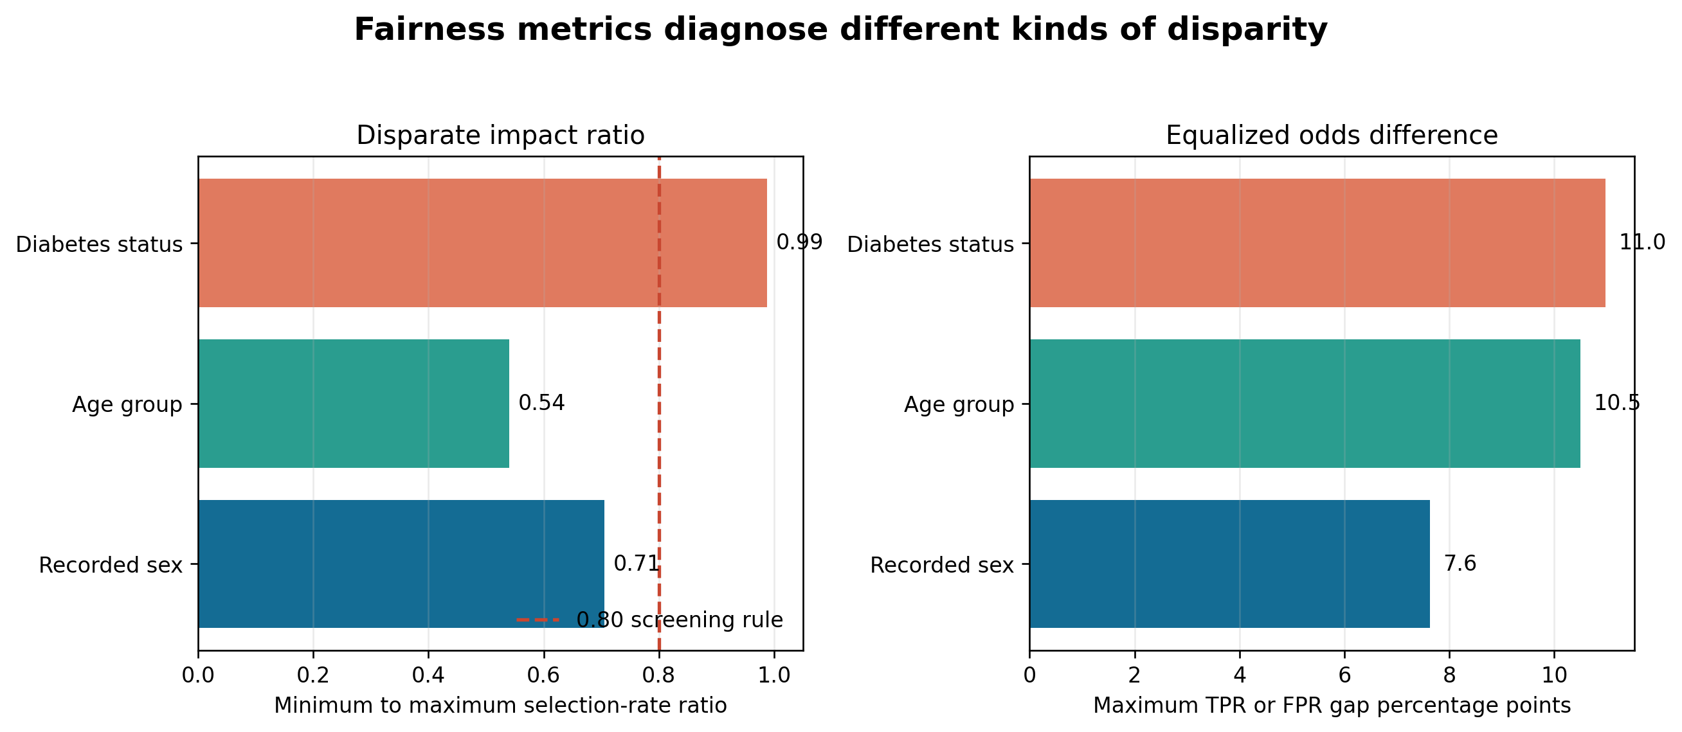
Figure 5. Disparate impact and equalized odds summarize different dimensions of subgroup disparity.

10 Subgroup Audit Results
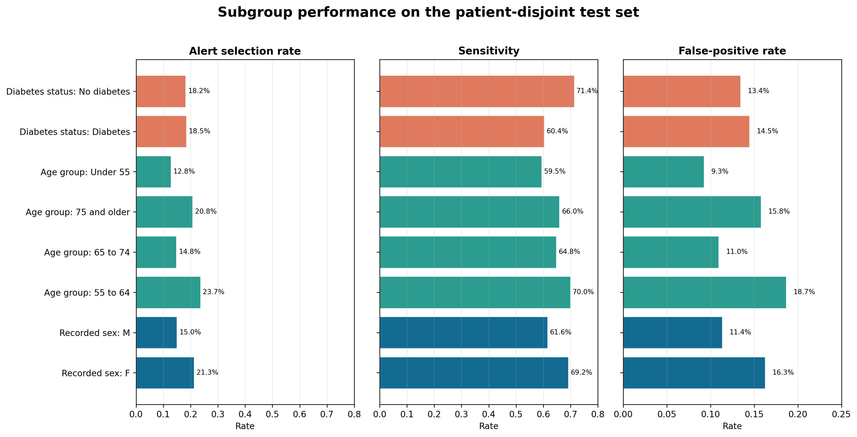
Figure 6. Alert selection sensitivity and false-positive rates by recorded sex age group and diabetes status.
Group | Patients | Prev | Alert | Sens | FPR | PPV
Recorded sex F | 83 | 9.6% | 21.3% | 69.2% | 16.3% | 31.0%
Recorded sex M | 87 | 7.3% | 15.0% | 61.6% | 11.4% | 30.0%
Age under 55 | 41 | 7.0% | 12.8% | 59.5% | 9.3% | 32.8%
Age 55 to 64 | 60 | 9.7% | 23.7% | 70.0% | 18.7% | 28.7%
Age 65 to 74 | 56 | 7.2% | 14.8% | 64.8% | 11.0% | 31.5%
Age 75 and older | 39 | 9.9% | 20.8% | 66.0% | 15.8% | 31.5%
Diabetes | 65 | 8.7% | 18.5% | 60.4% | 14.5% | 28.5%
No diabetes | 105 | 8.3% | 18.2% | 71.4% | 13.4% | 32.5%

11 Interpretation of Subgroup Findings
Recorded sex. Female sessions had higher outcome prevalence (9.6% versus 7.3%), higher alert selection (21.3% versus 15.0%), higher sensitivity (69.2% versus 61.6%), and higher false-positive rate (16.3% versus 11.4%). The disparate impact ratio was 0.705, with a patient-bootstrap interval of 0.349 to 0.988. The equalized odds gap was 0.076, with interval 0.015 to 0.313. These wide intervals preclude a precise fairness conclusion.
Age. Alert selection ranged from 12.8% to 23.7%, producing a disparate impact ratio of 0.541. Sensitivity ranged from 59.5% to 70.0%. Age is both a predictor and a clinically relevant protected characteristic, so an apparent disparity can reflect prevalence, model behavior, threshold choice, or all three. It cannot be labelled unfair or acceptable without a clinical harm analysis.
Diabetes. Alert selection was almost identical (18.5% versus 18.2%), giving a disparate impact ratio of 0.988. Nevertheless, sensitivity was lower with diabetes (60.4% versus 71.4%) and average precision was also lower (0.347 versus 0.442). Selection parity alone would therefore miss an important performance gap.
Patient weighting and intersections. Giving each patient equal total weight changed several point estimates: recorded-sex disparate impact became 0.585, and the age equalized odds gap became 0.367. In the sex-by-age analysis, subgroup patient counts ranged from 19 to 32, and sensitivity ranged from 44.9% to 82.6%. These swings show that frequent attenders and small intersections materially influence results; they justify continued monitoring rather than subgroup-specific deployment claims.

12 Direct Dependence on Recorded Sex
A limited counterfactual diagnostic swapped F and M while holding all other predictors fixed. The mean absolute probability change was 0.007, the median was 0.005, and 1.35% of session classifications changed at the locked threshold. The largest individual probability change was 0.055.
This result suggests that the recorded-sex field has modest direct influence on most predictions. It does not show that the model is free from sex-related bias. Other predictors can encode correlated differences, and changing recorded sex while holding physiology fixed is not a biologically or socially valid causal intervention. The diagnostic must be read together with the observed subgroup error rates.
Diagnostic | Result
Mean absolute probability change | 0.0070
Median absolute probability change | 0.0048
Maximum absolute probability change | 0.0549
Alert classifications changed | 1.35%

13 Mitigation Experiments
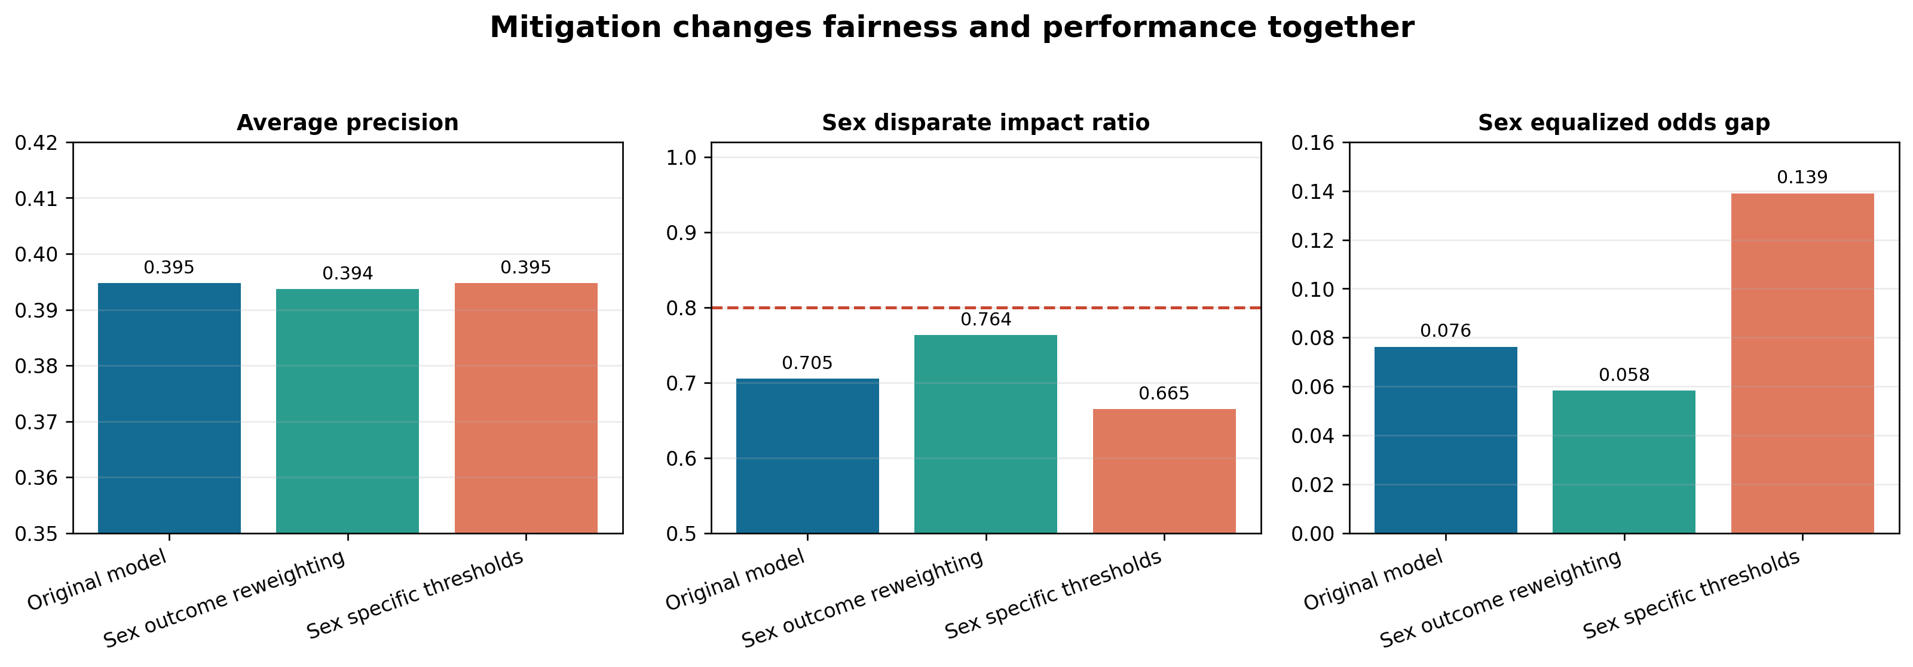
Figure 7. Overall performance and recorded-sex fairness metrics for two experimental mitigations.
Strategy | AP | Sens | PPV | DI ratio | EO gap
Original model | 0.395 | 66.1% | 30.6% | 0.705 | 0.076
Sex-outcome reweighting | 0.394 | 66.6% | 30.9% | 0.764 | 0.058
Sex-specific thresholds | 0.395 | 68.5% | 27.8% | 0.665 | 0.139

Reweighting. Training rows were weighted so recorded-sex and outcome combinations contributed according to their marginal frequencies. This improved both recorded-sex fairness summaries with negligible overall performance change, but the disparate impact ratio remained below 0.80. Reweighting is the most promising tested option and should be re-evaluated with external data and broader attributes.
Sex-specific thresholds. Validation-tuned thresholds were 0.181 for F and 0.088 for M, targeting equal sensitivity on validation patients. On the test set, the equalized odds gap worsened from 0.076 to 0.139, precision fell from 30.6% to 27.8%, and the disparate impact ratio fell to 0.665. The approach failed to generalize and is rejected. It also requires a protected attribute at inference, which raises additional legal and ethical governance questions.

14 Mitigation and Governance Plan
Stage | Action | Purpose
Before modelling | Collect race ethnicity gender identity socioeconomic indicators symptoms treatments and site variables with consent and governance | Enables missing audits and improves target validity
Pre-processing | Evaluate patient-balanced and sex-outcome reweighting using validation data only | Reduces overrepresentation and selected error gaps
In-processing | Constrain sensitivity and FPR gaps during model selection when sample size supports it | Makes fairness part of optimisation rather than a late check
Post-processing | Use a single capacity-aware threshold by default; test group thresholds only under explicit governance | Avoids unstable or opaque differential treatment
Human factors | Display probability uncertainty key drivers data quality and a documented override path | Reduces automation bias and supports accountability
Monitoring | Track overall and subgroup calibration sensitivity precision FPR selection rate and alert burden | Detects drift and emergent disparity
Rollback | Suspend alerts when data drift calibration failure or subgroup harm thresholds are breached | Limits harm while the model is reviewed

A mitigation should not be accepted merely because one metric improves. The acceptance decision should require stable external results, preserved clinical utility, acceptable alert burden, transparent governance, and no material worsening in another subgroup or error type. DIAL-ALERT should remain decision support with accountable clinician override.

15 Ethical Risk Register
Hazard | Affected party | Severity | Control | Residual risk
Missed high-risk session | Patient | High | Clinician review, conservative sensitivity target, outcome monitoring | Residual false negatives remain
Alert fatigue | Nurses and physicians | High | Capacity-based alerting, configurable thresholds, burden dashboard | 20% capacity still produces substantial false-alert burden
Unequal access to review | Protected or underserved groups | High | Subgroup monitoring, reweighting study, governance review | Race and socioeconomic fairness are unmeasured
Automation bias | Patients and clinicians | High | Decision-support-only label, explanation, override and documentation | Human factors require prospective testing
Privacy and re-identification | Patients | High | Minimum necessary data, access controls, audit logs, retention limits | Public data do not remove future deployment privacy duties
Performance drift | Future patients | Medium | Calibration and subgroup drift monitoring with rollback | No prospective drift evidence yet

Deployment Gates
- External temporal and geographic validation with patient-level uncertainty.
- Prospective silent-mode evaluation before any alert is shown to clinicians.
- Predefined subgroup sample-size and performance thresholds, including currently unavailable groups.
- Human-factors testing for alert comprehension, automation bias, alarm fatigue, and override documentation.
- Privacy, security, access-control, audit-log, incident-response, rollback, and model-change procedures.
- Clinical governance approval that specifies intended use, excluded uses, accountable owner, monitoring frequency, and stopping rules.
Until these gates are met, DIAL-ALERT should be presented only as a retrospective academic prototype. It must not determine treatment, deny care, or substitute for clinical assessment.

16 Conclusions
The audit identifies a clinically coherent but imperfect model. Aggregate global evidence and synthetic local explanations consistently emphasize prior haemodynamic instability and fluid status. Synthetic-profile dependence curves show nonlinear and heterogeneous behavior. The LIME-style surrogate supports the broad feature ranking but has only moderate local fidelity, so it should not be treated as a precise explanation.
Fairness conclusions depend on the metric. Recorded sex and age show notable alert-selection differences; diabetes has near-parity in selection but lower sensitivity and discrimination. Patient-bootstrap intervals are wide, patient-equal weighting changes point estimates, and small intersections are unstable. Race, ethnicity, socioeconomic status, and gender identity remain unaudited because the data do not contain them.
Sex-outcome reweighting is the only tested mitigation that improved both recorded-sex disparity summaries while preserving overall performance, although it did not eliminate disparity. Sex-specific thresholds failed on the held-out test patients and should not be used. The defensible decision is to continue research with broader data, external validation, patient and staff participation, and explicit deployment controls rather than claim fairness or clinical readiness.

Reproducibility
python src/audit_bias_fairness.py
python src/create_bias_fairness_report.py

References
1. Lin CJ, Chen YY, Pan CF, Wu VC, Wu CJ. Dataset supporting blood pressure prediction for the management of chronic hemodialysis. Scientific Data. 2019;6:313. https://doi.org/10.1038/s41597-019-0319-8
2. Lundberg SM, Lee SI. A unified approach to interpreting model predictions. Advances in Neural Information Processing Systems. 2017;30. https://papers.neurips.cc/paper/7062-a-unified-approach-to-interpreting-model-predictions
3. Ribeiro MT, Singh S, Guestrin C. Why should I trust you Explaining the predictions of any classifier. Proceedings of KDD. 2016:1135-1144. https://doi.org/10.1145/2939672.2939778
4. Goldstein A, Kapelner A, Bleich J, Pitkin E. Peeking inside the black box Visualizing statistical learning with plots of individual conditional expectation. Journal of Computational and Graphical Statistics. 2015;24:44-65. https://doi.org/10.1080/10618600.2014.907095
5. Hardt M, Price E, Srebro N. Equality of opportunity in supervised learning. Advances in Neural Information Processing Systems. 2016;29. https://arxiv.org/abs/1610.02413
6. Chouldechova A. Fair prediction with disparate impact A study of bias in recidivism prediction instruments. Big Data. 2017;5:153-163. https://doi.org/10.1089/big.2016.0047
7. World Health Organization. Ethics and governance of artificial intelligence for health. 2021. https://www.who.int/publications/i/item/9789240029200
8. Collins GS and colleagues. TRIPOD plus AI statement Updated guidance for reporting clinical prediction models that use regression or machine learning methods. BMJ. 2024;385:e078378. https://doi.org/10.1136/bmj-2023-078378

