DIAL ALERT Model Implementation Report
  - Capstone Project Step 4
Patient grouped model comparison for early prediction of blood pressure defined intradialytic hypotension
Prepared by Franklin Guillano
September 2026
Academic clinical decision support prototype. External and prospective validation are required before clinical use.

Executive Summary
Seven modelling configurations were compared using patient-grouped cross-validation and a patient-disjoint validation set. Random forest was selected under the locked rule: maximize grouped cross-validation average precision, then among models within 0.01 of the best result choose the model with the lower validation Brier score. This rule selected random forest using the candidates as fitted. It does not establish superiority after equal calibration of both finalists.
On the untouched test set of 21,354 sessions, the selected model achieved average precision 0.395, ROC AUC 0.852, and Brier score 0.062. At the validation-selected F2 threshold of 0.143, sensitivity was 66.1%, specificity 86.1%, precision 30.6%, and F1 score 0.418. Patient-cluster bootstrap intervals quantify uncertainty from repeated sessions within patients.
If operational capacity limits alerts to the highest-risk 20% of sessions, DIAL-ALERT captures 69.1% of observed events with 29.4% positive predictive value and 3.46-fold lift over prevalence. These results support continued internal development, not clinical deployment.

Rubric Evidence
Requirement | Evidence
Multiple models | Dummy, logistic, L1-selected logistic, decision tree, PCA logistic, random forest, and histogram gradient boosting were compared.
Appropriate tuning | Grid or randomized searches were nested within three-fold patient-grouped cross-validation.
Relevant metrics | Average precision is primary; ROC AUC, Brier score, log loss, sensitivity, specificity, precision, F1, and alert-capacity metrics are reported.
Fair comparison | Every candidate uses the same cohort, feature boundary, patient splits, and outcome.
Reproducibility | The final predictor, threshold, configuration and version records are included. Candidate pipelines and patient-level split assignments must be regenerated.
Model choice | The selection rule was locked before final testing and is explained using discrimination, calibration, and operational needs.

1 Prediction Task
DIAL-ALERT is a supervised binary-classification task. For each eligible haemodialysis session, the model estimates the probability of a later systolic blood-pressure measurement below 90 mmHg using 22 fields available at the index time or from earlier sessions. The target is operationally useful for risk ranking but is described as BP-defined IDH because symptoms and interventions are unavailable in HEMOBP.
Element | Definition
Analysis unit | One eligible patient-day haemodialysis session
Prediction time | Earliest valid active-dialysis record during minutes 0 to 30
Target | Any later SBP below 90 mmHg
Primary metric | Average precision because event prevalence is 8.49%
Secondary metrics | ROC AUC, Brier score, log loss, sensitivity, specificity, precision, and F1
Operational measure | Recall, precision, lift, and false-alert burden at fixed alert capacity

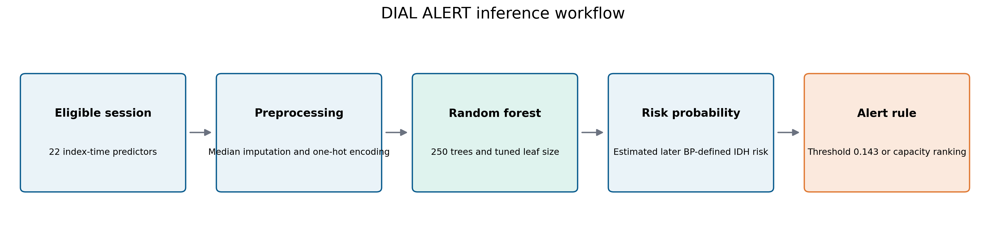
Figure 1. End-to-end inference workflow from eligible session predictors to an actionable alert rule.

2 Validation Design
The split unit is the patient rather than the session. This prevents a patient with many treatments from contributing sessions to both training and evaluation partitions. A deterministic search over split seeds selected seed 30 because it produced balanced row counts and outcome prevalence across five patient-grouped folds. Fold 0 became the test set, fold 1 the validation set, and folds 2 through 4 the training set.
Partition | Patients | Sessions | Events | Prevalence
Training | 496 | 64,053 | 5,440 | 8.49%
Validation | 164 | 21,351 | 1,813 | 8.49%
Test | 170 | 21,354 | 1,814 | 8.49%

Leakage Controls
- Outcome measurements occur after the index record and are never candidate predictors.
- Longitudinal history features use only earlier sessions and are shifted within patient.
- Imputation, encoding, scaling, L1 selection, and PCA are fitted inside each training fold.
- Hyperparameters use training patients only; validation patients select calibration and the operating threshold.
- The test set remains untouched until the model, calibration method, and threshold are fixed.

3 Candidate Models
Candidate | Role | Reason included
Dummy prevalence baseline | No-skill reference | Confirms that model performance exceeds event prevalence
Logistic regression | Regularized linear classifier | Transparent baseline with stable probabilities
L1 feature selection | Embedded sparse linear pipeline | Tests whether a smaller feature set preserves performance
Decision tree | Single nonlinear tree | Interpretable nonlinear benchmark with pruning controls
PCA logistic regression | Dimensionality-reduced linear model | Tests compression after imputation and scaling
Random forest | Bagged tree ensemble | Captures nonlinearities and interactions while resisting single-tree variance
Histogram gradient boosting | Boosted tree ensemble | Strong tabular benchmark with efficient native implementation

Methods Not Selected
Kernel SVM was not prioritized because probability calibration and tuning scale poorly across more than 100,000 repeated session records, while regularized logistic regression already supplies a linear-margin benchmark. Clustering and recommender methods do not address a prespecified binary outcome. RNNs, CNNs, LSTMs, and transformers were not justified because the input is a compact tabular snapshot rather than raw images, waveforms, text, or a uniformly sampled sequence; the effective independent sample is 830 patients, and explainability is a clinical requirement. XGBoost can be evaluated later, but native histogram gradient boosting provides the same broad boosted-tree comparison with fewer external dependencies.

4 Preprocessing and Tuning
Input | Transformation | Reason
Numeric fields | Median imputation | Fitted independently within every fold
Categorical fields | Most-frequent imputation and one-hot encoding | Unknown categories are ignored safely
Linear candidates | Standard scaling | Supports regularization and comparable coefficient scales
Tree candidates | No scaling | Preserves natural clinical split values
Prior session count | log one plus count | Reduces strong right skew using a deterministic transformation
PCA candidate | Imputation scaling and 85% or 95% variance threshold | Dimensionality reduction remains inside the pipeline

The training partition uses three-fold StratifiedGroupKFold cross-validation. Grid search is used for the smaller linear and PCA spaces. Randomized search is used for the larger tree ensembles. All searches optimize average precision with random state 42 and two parallel workers.
Candidate | Tuned parameters
Logistic regression | C and class weight
L1 selection | Selector C and final-model C
Decision tree | Depth, leaf size, class weight, and pruning alpha
PCA logistic | Variance threshold, C, and class weight
Random forest | Depth, leaf size, feature fraction, and class weight with 250 trees
Histogram gradient boosting | Learning rate, leaf nodes, leaf size, L2 penalty, and class weight

5 Model Comparison
Average precision was the selection metric because it directly summarizes precision-recall performance under class imbalance. Brier score was the probability-quality tie-breaker. Accuracy was not used for selection because a no-skill classifier already achieves approximately 91.5% accuracy by predicting no event for every session.
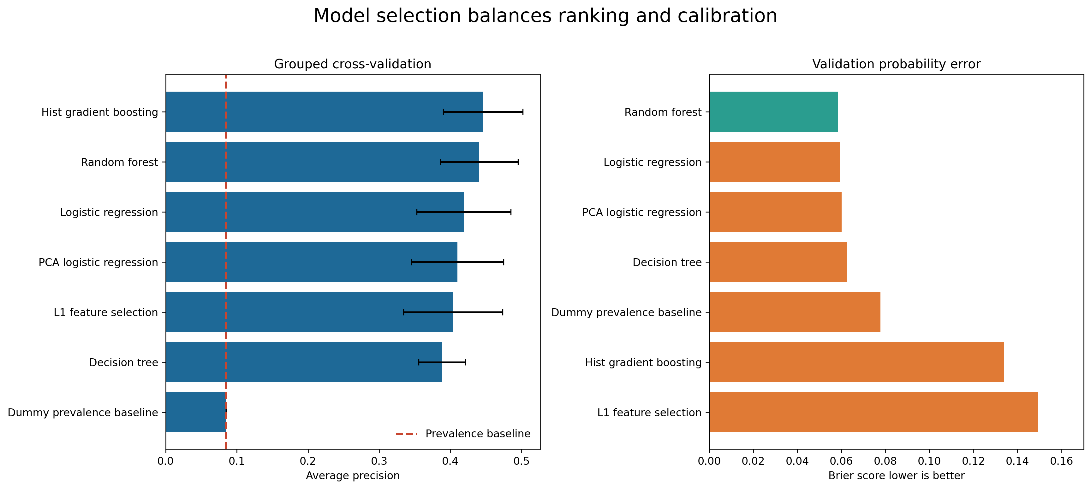
Figure 2. Grouped cross-validation average precision and validation Brier score across modelling candidates.
Model | Grouped CV AP | Validation AP | Validation AUC | Validation Brier
Histogram gradient boosting | 0.446 +/- 0.056 | 0.455 | 0.882 | 0.134
Random forest | 0.440 +/- 0.054 | 0.470 | 0.882 | 0.058
Logistic regression | 0.419 +/- 0.066 | 0.456 | 0.875 | 0.059
PCA logistic regression | 0.410 +/- 0.065 | 0.448 | 0.866 | 0.060
L1 feature selection | 0.404 +/- 0.070 | 0.442 | 0.876 | 0.149
Decision tree | 0.388 +/- 0.033 | 0.366 | 0.856 | 0.063
Dummy prevalence baseline | 0.085 +/- 0.000 | 0.085 | 0.500 | 0.078

6 Model Selection
Histogram gradient boosting produced the highest grouped cross-validation average precision at 0.446. Random forest reached 0.440, a difference of only 0.005, and therefore entered the prespecified 0.01 shortlist. On the patient-disjoint validation set, random forest had higher average precision (0.470 versus 0.455) and substantially lower Brier score (0.058 versus 0.134). Random forest was consequently selected before any test labels were examined.
Setting | Selected value
Number of trees | 250
Maximum depth | Unlimited with leaf-size regularization
Minimum samples per leaf | 15
Features considered at each split | sqrt
Class weighting | None
Random state | 42

This choice is defensible because DIAL-ALERT needs both useful risk ranking and probabilities that can support threshold or capacity decisions. It is not a claim that random forest will remain best in another centre. External validation may change the preferred model or its tuning.

7 Calibration and Operating Threshold
Validation patients were split again by patient. One half fitted sigmoid and isotonic calibration mappings; the other half compared those mappings and selected the F2 threshold. The unmodified random-forest probabilities had the lowest decision-subset Brier score, so no post-hoc calibration was applied.
Method | Brier | Log loss | Average precision
None | 0.0585 | 0.2030 | 0.463
Isotonic | 0.0588 | 0.2179 | 0.444
Sigmoid | 0.0597 | 0.2100 | 0.463

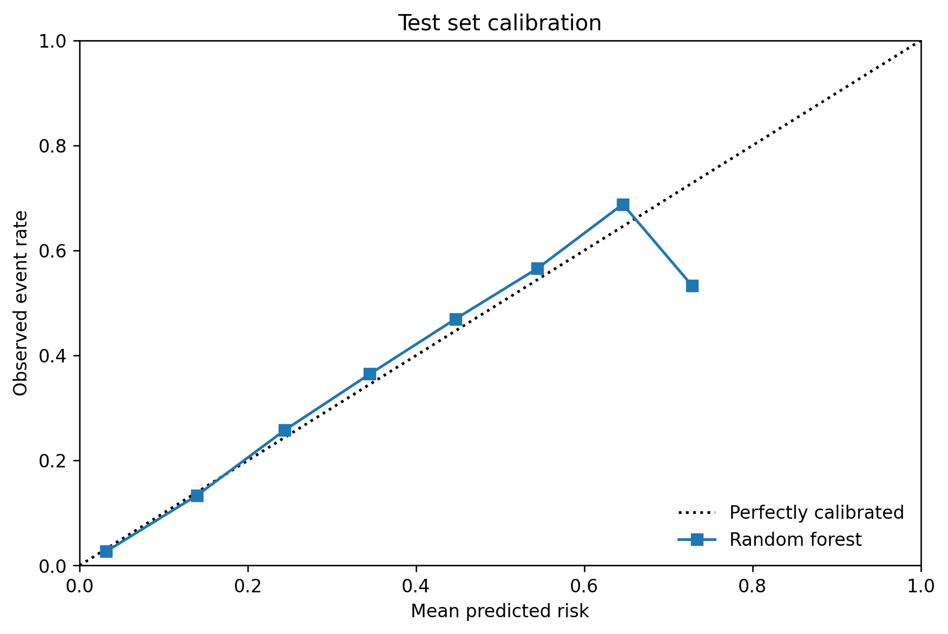
Figure 3. Test-set calibration curve for the selected random-forest probabilities.
The threshold of 0.143 maximized F2 on the held-out validation decision subset. F2 weights recall more heavily than precision, matching the safety-oriented aim of identifying more at-risk sessions while still constraining false alerts. The threshold is a prototype operating point, not a universal clinical cutoff.

8 Final Test Performance
The following results are from the untouched patient-disjoint test set. Confidence intervals use 500 bootstrap resamples of entire patients, preserving the dependence among repeated sessions from the same person. The intervals are wider than row-level intervals and therefore provide a more credible statement of uncertainty.
Metric | Estimate and 95% interval
Average precision | 0.395 (0.306 to 0.478)
ROC AUC | 0.852 (0.821 to 0.876)
Brier score | 0.062 (0.049 to 0.077)
Sensitivity | 0.661 (0.550 to 0.745)
Specificity | 0.861 (0.806 to 0.903)
Precision | 0.306 (0.260 to 0.353)
F1 score | 0.418 (0.359 to 0.473)
Accuracy | 0.844

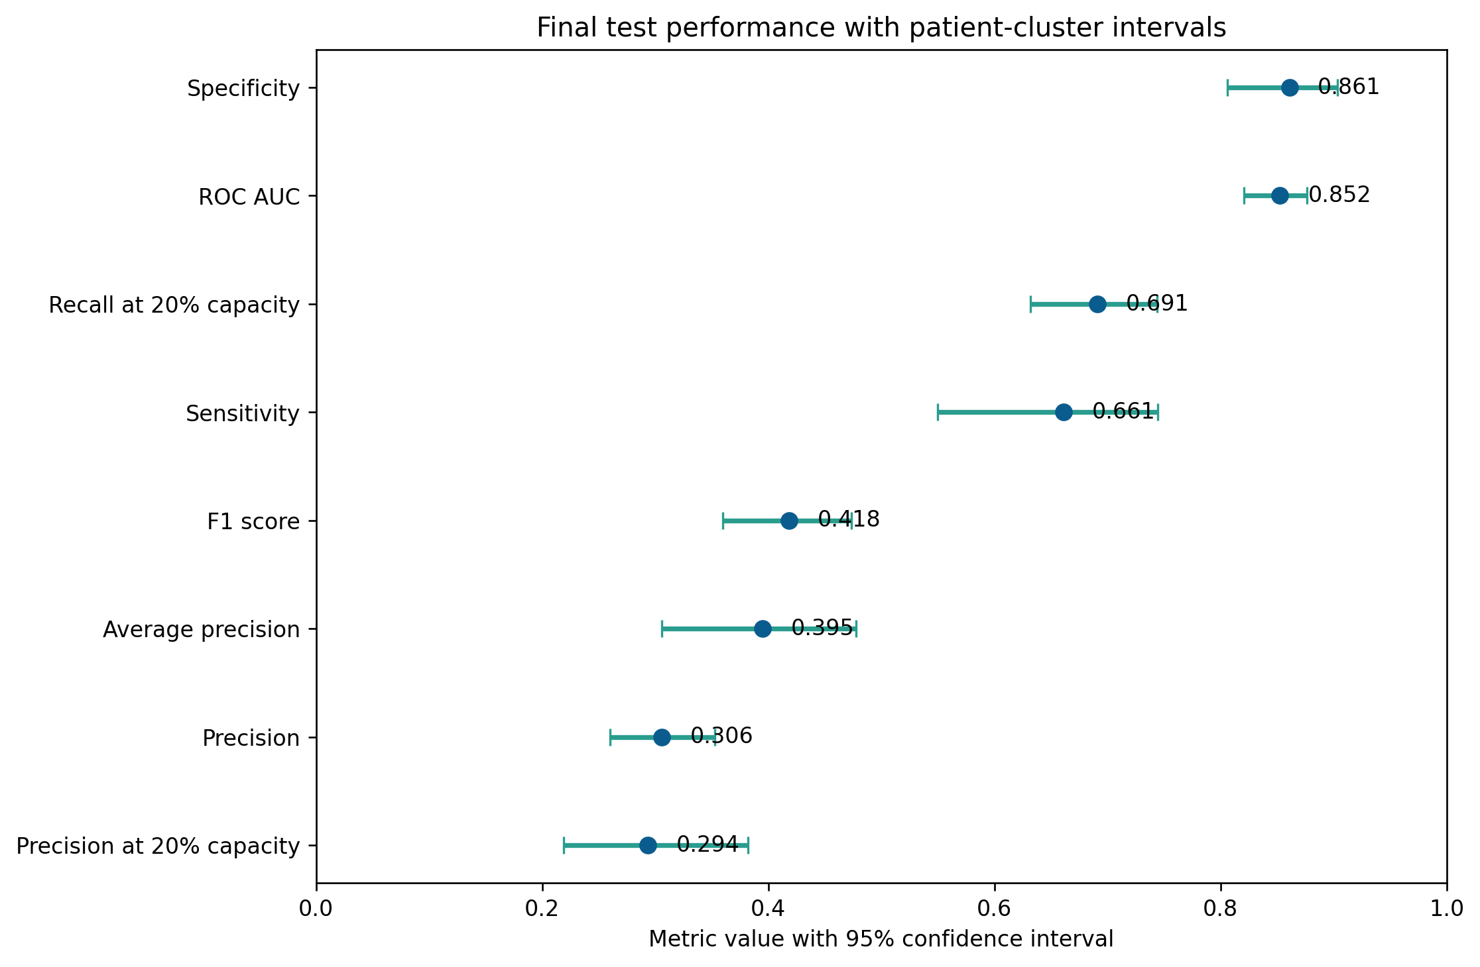
Figure 4. Final performance estimates with patient-cluster bootstrap 95% confidence intervals.

9 Discrimination and Classification
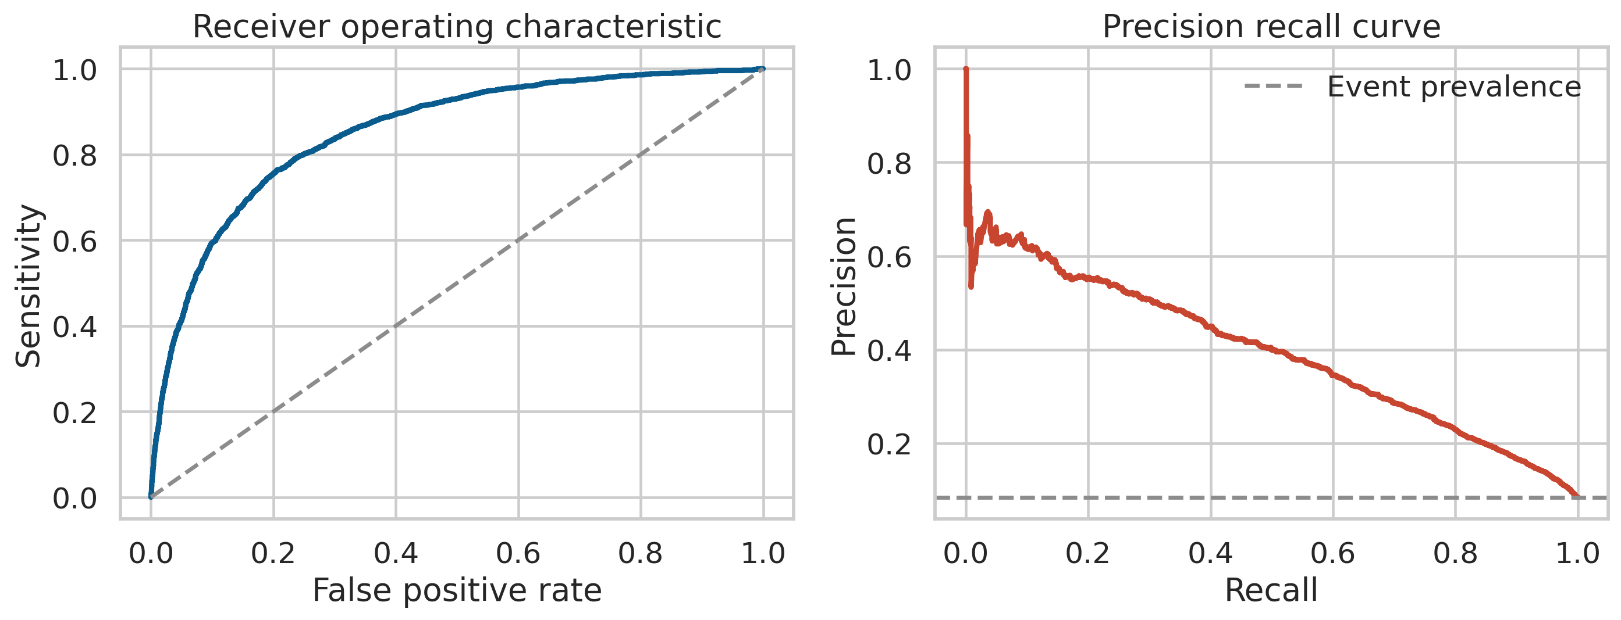
Figure 5. ROC and precision-recall curves on the untouched test set.
ROC AUC of 0.852 indicates good rank discrimination. Average precision of 0.395 is more informative for this imbalanced outcome and is well above the test prevalence of 0.085. The lower test average precision than validation average precision is a reminder that performance varies across patient groups and should not be summarized by a single optimistic split.
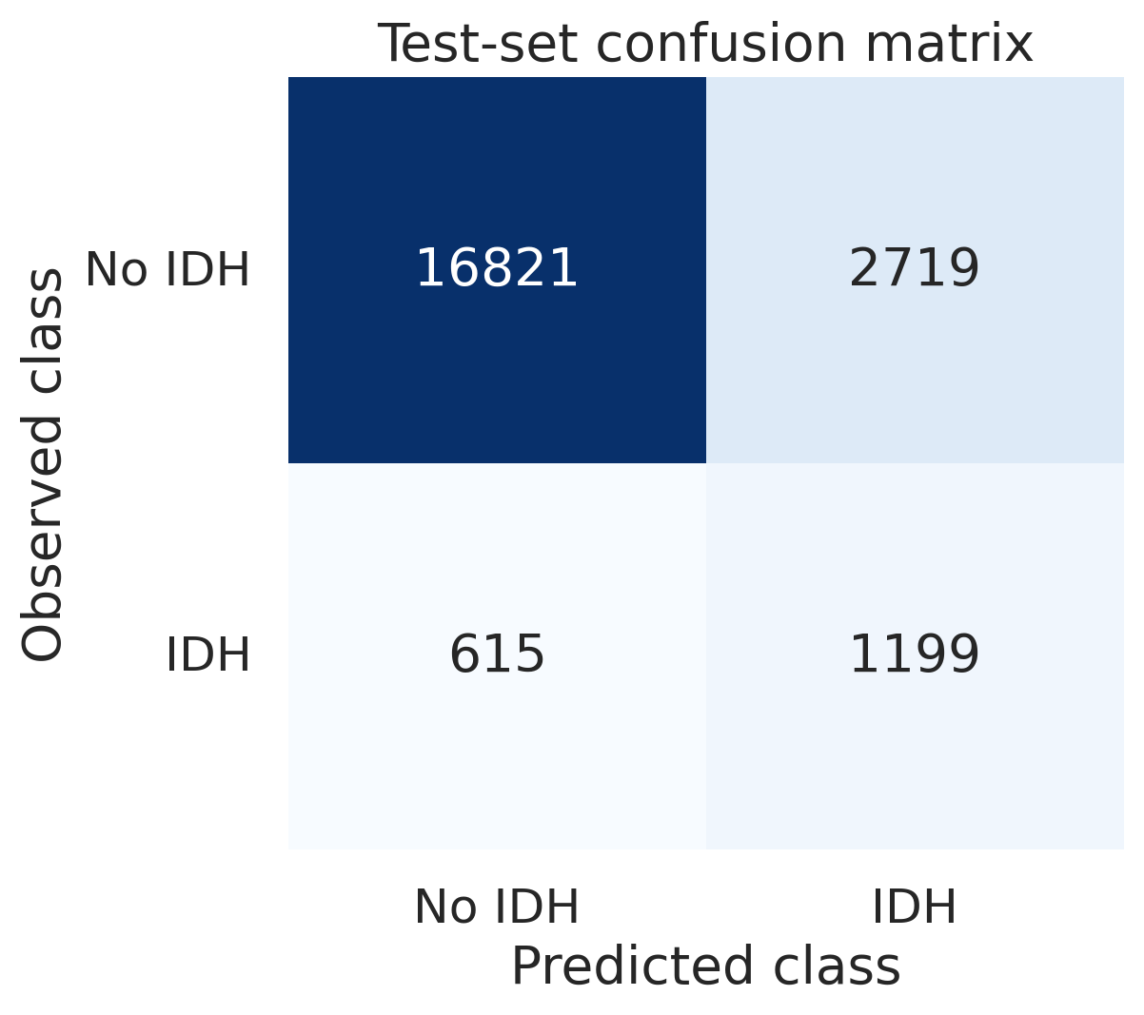
Figure 6. Confusion matrix at the validation-selected threshold of 0.143.
At this threshold, the model identified 1,199 of 1,814 events and produced 2,719 false alerts among 19,540 non-event sessions. This trade-off reflects the F2 objective. A dialysis unit may choose another threshold after defining acceptable missed-event and alert-burden costs.

10 Alert Capacity Analysis
Capacity analysis ranks sessions by risk and asks what happens if staff can review only a fixed fraction. This avoids implying that one threshold fits every unit and converts model performance into workload and captured-event terms.
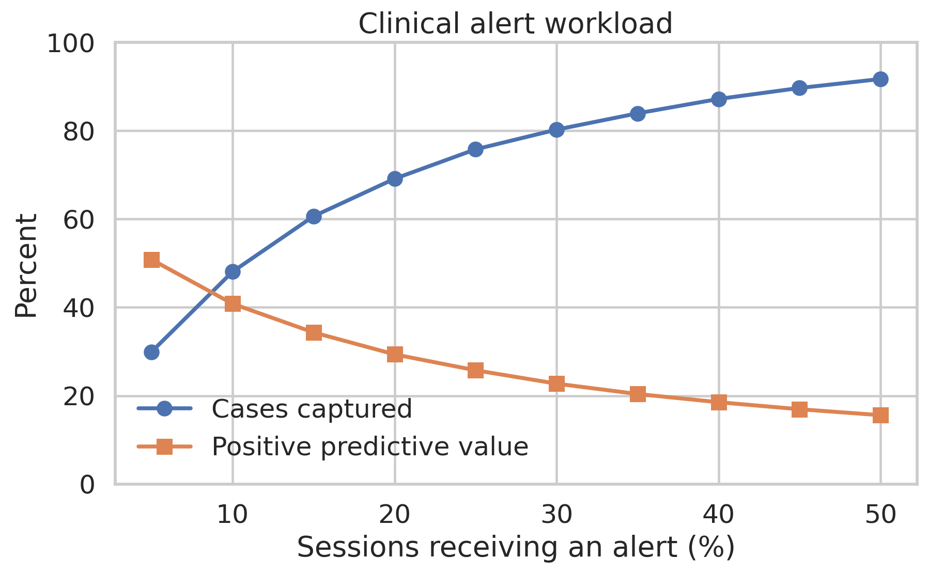
Figure 7. Event recall and positive predictive value as alert capacity increases.
Capacity | Alerts | Precision | Recall | Lift | False alerts per 100
5% | 1,068 | 50.8% | 29.9% | 5.99 | 2.5
10% | 2,136 | 40.8% | 48.1% | 4.81 | 5.9
20% | 4,271 | 29.4% | 69.1% | 3.46 | 14.1
30% | 6,407 | 22.7% | 80.3% | 2.68 | 23.2
50% | 10,677 | 15.6% | 91.7% | 1.83 | 42.2

At 20% capacity, 4,271 test sessions receive an alert. The strategy captures 69.1% of events with 29.4% precision and 3.46-fold lift. It generates approximately 14.1 false alerts per 100 total sessions, which must be assessed against staffing and intervention burden.

11 Model Interpretation
Permutation importance was calculated on a reproducible test-set sample using average precision as the score. Previous-session nadir SBP and prior IDH rate were the strongest unique contributors, followed by fluid excess percentage and baseline haemodynamic measures. This agrees with the Step 3 EDA and supports face validity, but it does not establish causal effects.
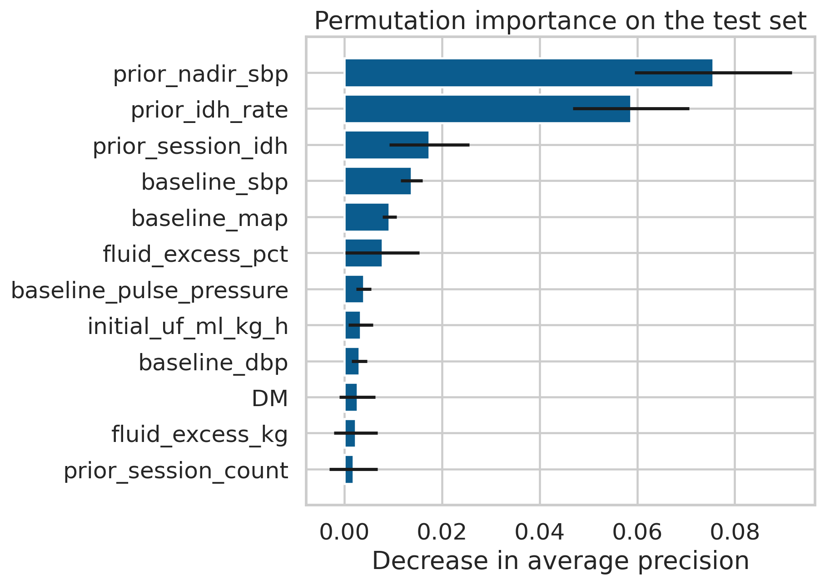
Figure 8. Permutation importance for the selected random-forest pipeline.
Feature | Mean decrease in AP | Standard deviation
Prior Nadir Sbp | 0.076 | 0.016
Prior Idh Rate | 0.059 | 0.012
Prior Session Idh | 0.017 | 0.008
Baseline Sbp | 0.014 | 0.002
Baseline Map | 0.009 | 0.001
Fluid Excess Pct | 0.008 | 0.008

12 Reproducibility and Saved Artefacts
The run used Python 3.12.14, scikit-learn 1.8.0, random state 42, split seed 30, and 3-fold grouped cross-validation. The manifest records SHA-256 hashes for the processed data, configuration, and model files so accidental changes can be detected.
Artefact | Purpose
models/dial_alert_final_predictor.joblib | Selected fitted preprocessing and random-forest pipeline
models/decision_threshold.json | F2 threshold and ordered feature list
models/model_manifest.json | Versions, seeds, sizes, and SHA-256 hashes
artifacts/model_comparison.csv | Grouped-CV and validation metrics for all candidates
artifacts/cv_search_top_results.csv | Top hyperparameter-search results
artifacts/final_test_metrics.json | Locked test-set results
artifacts/test_metric_confidence_intervals.csv | Patient-cluster bootstrap intervals
artifacts/capacity_metrics.csv | Alert workload and captured-event trade-offs
artifacts/split_assignments.csv.gz | Regenerated locally; patient-level assignments are not bundled
configs/model_config.json | Features, target, capacity, seeds, workers, folds, and selection tolerance

Execution Commands
python src/build_session_dataset.py --raw-dir data/raw --output-dir data/processed
python src/train_evaluate.py --data data/processed/hemobp_session_level.csv.gz --config configs/model_config.json --artifacts artifacts --models models
python src/generate_step4_assets.py
python src/predict.py --input new_sessions.csv --output predictions.csv

13 Limitations
Limitation | Effect | Required response
Retrospective single-centre data | Performance may not transport to other dialysis units, eras, or patient populations. | External temporal and geographic validation
BP-defined target | Symptoms and treatments required for a complete clinical syndrome are unavailable. | Prospective data collection with symptom and intervention fields
Informative measurement | Unstable sessions may have more BP readings and more opportunities to detect events. | Fixed-window sensitivity analyses and prospective protocolized measurement
Repeated sessions | A large session count does not equal the same number of independent patients. | Patient-grouped validation and cluster-bootstrap intervals
Cold start | Prior-session features are missing for first observed sessions. | Report cold-start performance and consider a reduced-input model
Threshold dependence | Sensitivity and false-alert burden change with workflow capacity and costs. | Site-specific utility study before threshold adoption
No causal interpretation | Importance and partial effects describe prediction, not treatment benefit. | Prospective impact evaluation before clinical claims

The study demonstrates model development and internal validation. It does not demonstrate that acting on an alert improves patient outcomes, reduces costs, or is safe in routine care.

14 Conclusions
DIAL-ALERT completed the supervised model-implementation stage with a reproducible comparison of seven configurations. Random forest was chosen by a locked rule that considered both grouped cross-validation ranking performance and validation probability error. On patient-disjoint testing, the model achieved ROC AUC 0.852, average precision 0.395, and Brier score 0.062.
The validation-selected threshold detected 66.1% of events at 30.6% precision. A capacity-based policy that alerts on the highest-risk 20% captured 69.1% of events with 3.46-fold lift. These are promising internal results, but the uncertainty intervals and false-alert burden require careful interpretation.
The selected predictor, threshold, configuration, metrics and version records are included; other pipelines and patient-level split assignments require regeneration. The next capstone stage should audit model explanations, limitations, subgroup fairness, and feasible mitigation strategies before any deployment work begins.

References
1. Lin CJ, Chen YY, Pan CF, Wu VC, Wu CJ. Dataset supporting blood pressure prediction for the management of chronic hemodialysis. Scientific Data. 2019;6:313. https://doi.org/10.1038/s41597-019-0319-8
2. Breiman L. Random forests. Machine Learning. 2001;45:5-32. https://doi.org/10.1023/A:1010933404324
3. Saito T, Rehmsmeier M. The precision-recall plot is more informative than the ROC plot when evaluating binary classifiers on imbalanced datasets. PLoS ONE. 2015;10:e0118432. https://doi.org/10.1371/journal.pone.0118432
4. Brier GW. Verification of forecasts expressed in terms of probability. Monthly Weather Review. 1950;78:1-3.
5. Varma S, Simon R. Bias in error estimation when using cross-validation for model selection. BMC Bioinformatics. 2006;7:91. https://doi.org/10.1186/1471-2105-7-91
6. Pedregosa F and colleagues. Scikit-learn machine learning in Python. Journal of Machine Learning Research. 2011;12:2825-2830.

